SALT BASIN
Scenario Repository Portfolio
Governed operational scenarios, metadata variants, implementation approach, and rollout roadmap
ILLUSTRATIVE IMPLEMENTATION REFERENCE • EXPANDED V3.0 • AUTHORITATIVE CHAT CONTEXT • JULY 2026
PORTFOLIO THESIS
This is a governed combination library—not a list of demo cases. Each stable Scenario_ID binds commercial conditions to source events, bounded metadata atoms, rod/branch behavior, generated transactions, reconciliations, metrics, temporal lineage, security policy, and the UI explanation of what changed.
2,400  EXPLICIT SCENARIOS  2,400 unique configuration signatures; no duplicate combinations | 16 / 93  DIMENSIONS / VALUES  Canonical variant vocabulary with stable value codes | 10  EVENT FAMILIES  New sale through reactivation, each with a lineage-root event
139  001A ATOMS / 45 MOLECULES  Enterprise Foundation semantic registry; distinct from the 16 scenario dimensions | 150  GOVERNED METRICS  10 implemented/core definitions plus a 140-metric roadmap | 4  RECONCILIATIONS  Revenue→GL • Invoice→AR • Payment→Cash • Debt rollforward
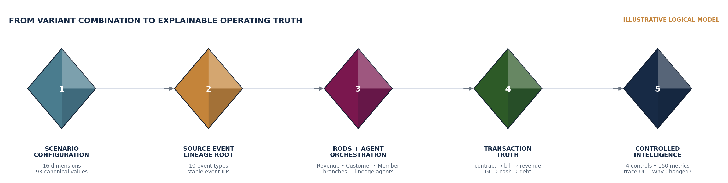
REPOSITORY PROMISE Event-first • transaction-grounded • reconciled • versioned • agent-secured • temporally reproducible • explainable upstream and downstream.
SOURCE NOTE Salt_Basin_2400_Scenario_Repository.xlsx, Salt_Basin_Workbook_001A_Enterprise_Foundation_v4.xlsx, and the SBHOS metadata definition workbook; repository counts reflect the source files reviewed for this portfolio.

PORTFOLIO SECTION 02
Operational Scenario & Metadata Variant Reference
The repository balances commercial-event coverage while preserving the exact dimensions that make each scenario materially different in execution, accounting, evidence, security, and downstream reporting.
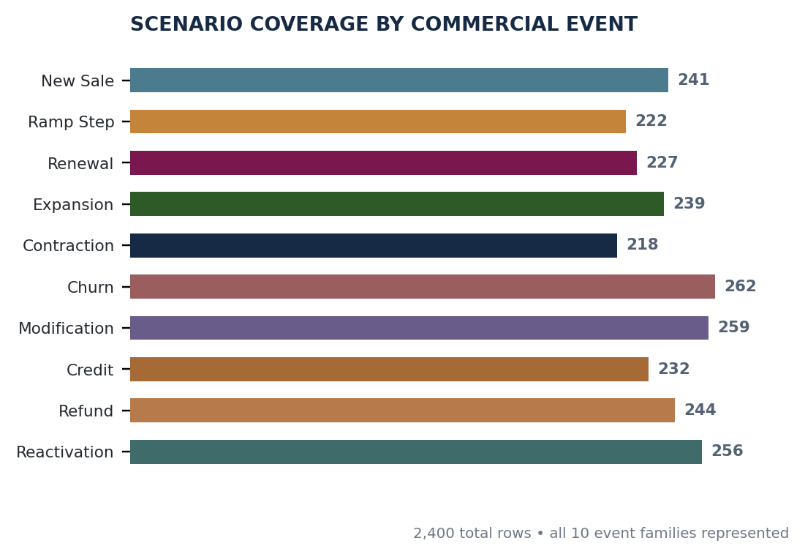 | CANONICAL VARIANT DOMAINS  Customer Segment 4 • State 3  Commercial Product 5 • Pricing 7 • Term 5 • Event 10  Billing & pay Cadence 5 • Timing 4 • Method 5  Usage & revenue Usage state 6 • Revenue pattern 5  Financial state Invoice 6 • Payment 6 • Debt 5  Evidence & access Source system 10 • Security slice 7  All 16 dimensions are populated across all 2,400 scenario rows; values remain queryable as canonical atoms rather than an opaque metadata blob.
ILLUSTRATIVE GOVERNED SCENARIO PATH
SB-SCN-0005 Enterprise Subscription / Block Pricing / Modification • Actual configured repository row; presentation below is illustrative.
CONTEXT | Enterprise • Existing Customer | ECONOMICS | Subscription • Block • Evergreen • In Arrears
EVENT ROOT | CONTRACT_MODIFIED | L3 PATH | Existing Customer → Modification → Paid → Settled → Point-in-Time
PARALLEL RODS | Revenue Lifecycle • Customer Channel • Member Journey | BRANCH | Existing-Customer Branch Rod with preserved merge lineage
GENERATED TRUTH | Contract/line/subscription → usage → invoice/AR → revenue schedule/subledger → GL → payment/cash → debt | CONTROLS | Revenue→GL • Invoice→AR • Payment→Cash • Debt rollforward
GOVERNANCE | Effective dates + stage history + cache freshness + next review | AGENT POLICY | Bank source scope • Org Admin exposure • propose/stage/commit
What a scenario row governs
L1 / L2 / L3 | Journey, variant dimensions, and end-to-end path | Atoms → molecules | Bounded definitions with evidence, validation, time, confidence, and path color
Transactions → controls | Declared entities only; retain source_event_id and generation-rule version | Metrics → UI | Dependency invalidation, recalculation, prior lineage, Customer Trace, Contract Lineage, Why Changed?
SOURCE NOTE Commercial-event counts and dimension cardinalities come directly from the Scenario Repository and Coverage Dashboard sheets; the SB-SCN-0005 path is drawn from its configured row.

PORTFOLIO SECTION 03
Implementation Approach & Rollout Roadmap
Implement the repository as governed configuration plus deterministic proof—not as 2,400 bespoke workflows. Vertical slices should begin with a source event and end only when financial truth, metrics, lineage, security, and user explanation agree.
REPEATABLE IMPLEMENTATION LOOP
01 LOAD CANONICAL  Dimension dictionary • atom/molecule map • event map • controls • metric registry | 02 SELECT + SEED  Choose Scenario_IDs by feature slice; combine stable ID with Fixture_Seed_Key | 03 EMIT EVENT FIRST  Create source event, materialize atoms, assign molecules, rods, branches, and agent scope
04 GENERATE TRUTH  Create only declared entities/transactions; retain source event and rule version | 05 CONTROL + EXPLAIN  Reconcile, calculate, invalidate downstream nodes, recalculate, and render trace UI | 06 REGRESSION GATE  Pass state, controls, metrics, exceptions, time, lineage, propagation, and security
PHASE-BASED ROLLOUT
PHASE | SCOPE | BUILD / PROOF | EXIT GATE
0 • Foundation | Canonical model | 16 dimensions • 93 values • 16 atom paths • 12 molecules • event/control/metric maps | Stable codes load; crosswalk validates; no opaque metadata
1 • Core | 240 Core scenarios | All 10 event families; deterministic fixtures; first 10 metrics; four reconciliations | Expected states and zero/explained control variance reproduce
2 • Extended | 960 Extended scenarios | Broaden systems, security slices, branches, timing/status exceptions, and UI traces | Branch/merge, temporal history, exceptions, and explanation pass
3 • Edge | 1,200 Edge scenarios | Stress corrections, restatements, propagation, distributed permissions, and performance | Recalculation is bounded, secure, reproducible, and regression-safe
4 • Operate + expand | Versioned releases | Scale from 10 to 150 metrics; publish coverage/gap register; add codes and IDs without mutation | Release evidence is reviewable; prior scenarios remain reproducible
EXPANSION CONTRACT
ID IMMUTABILITY | Never change the historical meaning of a Scenario_ID; add a new ID for a new meaning. | DEFINITION FIRST | Add canonical value code, atom path, molecule, evidence rule, and validation before scenario proliferation.
EXPECTED PROOF | Declare event, entities, transactions, controls, metric dependencies, propagation targets, and exception class. | FULL GOVERNANCE | Carry created/effective/updated/stage/cache/review time plus agent and user entitlement behavior.
EXPANDABLE PORTFOLIO | Append family briefs, variant definitions, fixture packs, implementation evidence, and UI screenshots by release. | RELEASE RECORD | Maintain coverage counts, unresolved gaps, formula versions, pass/fail evidence, owners, and next review.
ROADMAP NOTE Phases are deliberately outcome-gated rather than date-based. Owners, dates, budget, margin, and completion percentages should be managed in the Thesis / Tributary Ledger so this portfolio remains the durable reference layer.
SOURCE NOTE Implementation rules consolidate the repository’s Implementation Guide with the transaction-grounded portfolio and DataBasin bridge methodology. © 2026 Salt Basin Holdings. All rights reserved.

PORTFOLIO SECTION 04
Portfolio Map & Source Authority
This expanded edition turns the repository and its surrounding Salt Basin materials into one navigable operating reference. Authority is explicit: current canonical data governs; supporting frameworks explain how to implement it; precursor and visual artifacts supply context without silently redefining the model.
HOW TO USE THIS PORTFOLIO
ORIENT  Begin with the operating model, repository profile, and L1/L2/L3 journey rules. | DESIGN  Use the metadata, rod, branch, temporal, security, and transaction sections as the implementation contract. | PROVE  Use reconciliations, metric dependencies, lineage, and evidence maturity as release gates.
ROLL OUT  Sequence Foundation → Core → Extended → Edge → Operate using outcome-based gates. | EXPAND  Copy the scenario-family brief and release-record templates; never mutate a historical Scenario_ID. | TRACE  Use the full source estate appendix to locate governing, supporting, precursor, and visual artifacts.
AUTHORITY HIERARCHY
AUTHORITY | SOURCE ESTATE | USE
T1 • Current / governing | Repository, metadata definition, enterprise foundation, transaction model, DataBasin, EIDOS / Constitution / Ledger, design system | Defines current codes, counts, rules, controls, governance, and presentation.
T2 • Supporting | Mappings, annotated notes, evidence examples, research memos, current scenario-specific workbooks | Adds implementation detail and worked evidence without overriding T1.
T3 • Precursor / variant | Earlier 2,400 and 10,000-scenario proliferations, duplicated versions, experimental workbooks | Cross-checks coverage and evolution; not a silent source of truth.
T3 • Reference | Proposals, prototypes, experience documents, diagrams, and adjacent research | Explains intent, user experience, and market framing; values remain illustrative.
SOURCE ESTATE SCREEN 122 candidate Salt Basin artifacts were screened with broad, unrestricted query terms. Inclusion in the source register does not imply equal authority; contradictions resolve upward through the hierarchy above.
SOURCE NOTE The complete artifact register appears in Appendix C. Every diagram and worked value in this portfolio is labeled illustrative or conceptual.

PORTFOLIO SECTION 05
Canonical Operating Architecture
The repository is a governed configuration system. A scenario is complete only when commercial conditions, semantic meaning, lineage, generated truth, controls, metrics, temporal states, entitlements, and user explanation remain mutually consistent.
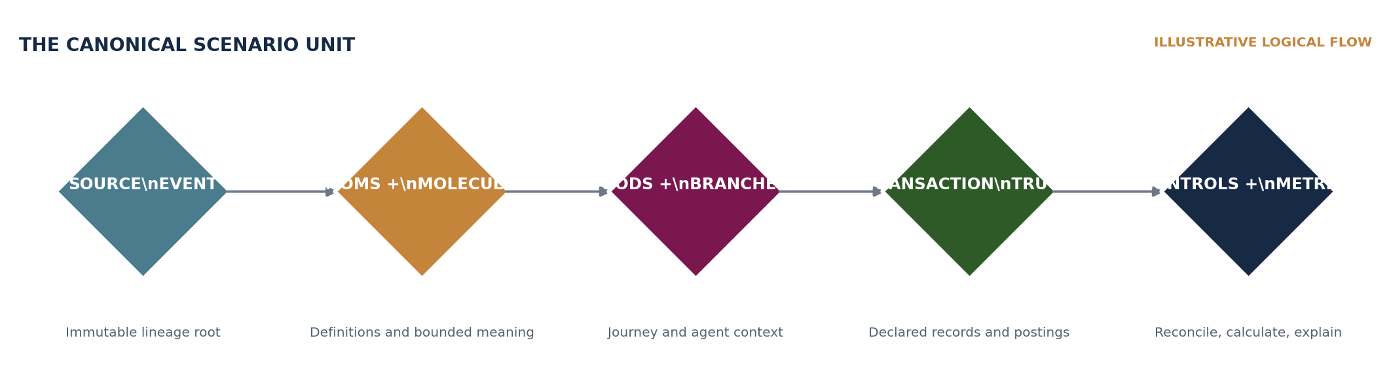
L1 JOURNEY | Channel or operating journey being experienced | L2 VARIANT | Canonical dimension combination that changes execution
L3 PATH | End-to-end state path, including branch and merge behavior | LINEAGE ROOT | Immutable source event and generation-rule version
SEMANTIC UNIT | Atom definition rolled into molecules, clusters, rods, and orbit | PROOF UNIT | Transaction records, reconciliations, metric results, UI trace
POLICY UNIT | Agent source/transform/memory/exposure/action envelope | TIME UNIT | Created, effective, updated, stage, cache, review, and as-of states
CANONICAL SCENARIO UNIT Source event + atom values + molecule groupings + journey/channel implications + generated transactions + controls + metric dependencies + propagation behavior.
SOURCE NOTE Operating architecture consolidates the 2,400-scenario repository, Enterprise Foundation v4, EIDOS, SBHOS metadata definitions, and transaction-grounded portfolio.

PORTFOLIO SECTION 06
Scenario Record Anatomy
Each record is designed to be executable and testable. The minimum contract below can become the schema for configuration, fixture generation, regression evidence, and portfolio documentation.
RECORD LAYER | REQUIRED CONTENT | ACCEPTANCE RULE
Identity | Scenario_ID; title; coverage tier; lifecycle status; owner; release version | Stable ID never changes meaning.
Variant configuration | 16 canonical dimension codes; fixture seed; source system; security slice | No opaque metadata blob.
Journey semantics | L1 channel; L2 scenario; L3 path; stage maturity; branch and merge points | Existing-customer history is preserved.
Lineage root | source_event_id; event type; occurred/effective/ingested time; generation-rule version | Event is created first.
Crystal model | Atoms; molecule membership; cluster/rod/orbit placement; evidence and validation | Definitions remain bounded and queryable.
Generated truth | Declared entities, commercial objects, invoices, AR, revenue, GL, cash, debt | Only scenario-declared records may be generated.
Control proof | Control IDs; expected variance; exception classification; resolution evidence | Zero or fully explained variance.
Metrics and UI | Metric dependencies; invalidation and recalculation targets; prior/current lineage; explanation views | Why Changed? is reproducible.
Policy and time | Agent envelope; user entitlement; created/effective/stage/cache/review/as-of time | Security and temporal truth are first-class.
FIXTURE IDENTITY
SCENARIO KEY | Scenario_ID + Fixture_Seed_Key | SOURCE KEY | source_event_id + generation_rule_version
RESULT KEY | entity_id / transaction_id / metric_run_id | REPRODUCTION | scenario version + as-of time + entitlement context
EXPANSION RULE If meaning changes, add a new Scenario_ID. If implementation evolves without changing meaning, version the rule, expected result, and proof record.
SOURCE NOTE Record fields are a cohesive reference schema derived from the repository implementation guide and surrounding Salt Basin governance materials.

PORTFOLIO SECTION 07
Operational Scenario Coverage
The current canonical repository contains 2,400 unique configuration signatures. Coverage is intentionally distributed across ten commercial-event families and three implementation tiers.
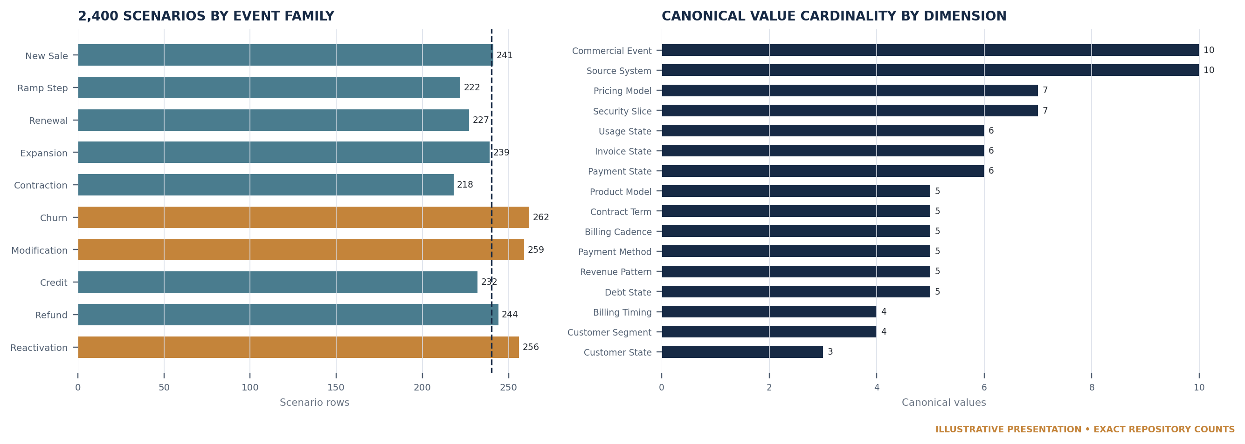
CORE | 240 scenarios • first production proof set | EXTENDED | 960 scenarios • broader branches, states, systems, and policy
EDGE | 1,200 scenarios • corrections, restatements, stress, and exceptions | UNIQUENESS | 2,400 rows • 2,400 signatures • zero duplicates
INTERPRETATION Event-family counts are balanced enough to exercise the lifecycle without forcing equal counts. The canonical dimensions—not event names alone—define material behavioral variance.
SOURCE NOTE Counts come directly from the Scenario Repository and Coverage Dashboard sheets in Salt_Basin_2400_Scenario_Repository.xlsx.

PORTFOLIO SECTION 08
Operational Scenario Family Briefs
A family brief anchors implementation, testing, and future portfolio expansion. Each family begins with a distinct commercial source event but shares the same proof discipline.
FAMILY | PRIMARY BEHAVIOR | FOCUS OF PROOF
New Sale • 241 | Create customer/contract/subscription roots; initialize billing and revenue patterns | Identity, contract, price, bill timing, first value and cash states
Ramp Step • 222 | Apply scheduled quantity, price, capacity, or commitment step | Effective dating, schedule revision, backlog and revenue propagation
Renewal • 227 | Extend, reprice, reterm, or replace expiring rights | Existing-customer branch, history merge, cohort and retention integrity
Expansion • 239 | Add products, seats, usage, entities, or geography | Cross-sell/upsell attribution, contract lineage, ARR and backlog
Contraction • 218 | Reduce scope, price, term, or usage commitment | Partial churn, credits, revenue catch-up, forecast and customer economics
Churn • 262 | End service, rights, or commercial relationship | Final bill, deferred revenue, cash/AR, retention and evidence of cause
Modification • 259 | Change enforceable terms without losing historical truth | Versioned contract lines, accounting treatment, Why Changed?
Credit • 232 | Reduce obligation through approved commercial adjustment | Invoice/AR application, revenue impact, approvals and control evidence
Refund • 244 | Return cash or settle overpayment/exception | Cash movement, AR status, fees, customer/member implications
Reactivation • 256 | Resume a prior relationship, service, or entitlement | Historical lineage merge, new effective state, cohort treatment
BRIEF EXTENSION FIELDS Add owner, representative Scenario_IDs, fixture pack, expected transactions, control results, metric impacts, screenshots, unresolved gaps, and next review date to each family as delivery progresses.
SOURCE NOTE Family counts reflect the canonical 2,400-row repository. Behaviors summarize the configuration and transaction-grounded implementation contract.

PORTFOLIO SECTION 09
Metadata Variant Model
The 16 canonical dimensions provide the stable vocabulary for scenario selection, test coverage, analytics, and future expansion. Together they contain 93 governed values.
DIMENSION | VALUES | WHAT IT CHANGES
Customer_Segment | 4 | Commercial scale / operating context
Customer_State | 3 | Lifecycle relationship state
Product_Model | 5 | Product/service delivery structure
Pricing_Model | 7 | Economic calculation and commercial mechanism
Contract_Term | 5 | Duration and enforceability pattern
Billing_Cadence | 5 | Frequency of invoicing
Billing_Timing | 4 | In advance / in arrears and related timing
Payment_Method | 5 | Settlement channel
Commercial_Event | 10 | Lifecycle event family and lineage root
Usage_State | 6 | Consumption / commitment condition
Revenue_Pattern | 5 | Recognition behavior
Invoice_State | 6 | Invoice lifecycle
Payment_State | 6 | Cash settlement lifecycle
Debt_State | 5 | Financing and balance condition
Source_System | 10 | Authoritative source class
Security_Slice | 7 | Entitlement and exposure context
VARIANT DISCIPLINE Add a canonical value only after definition, code, atom path, molecule placement, evidence, validation, temporal behavior, and policy implications are explicit.
SOURCE NOTE Dimension names and cardinalities are exact canonical repository facts. Descriptions are concise implementation interpretations.

PORTFOLIO SECTION 10
Crystal Metadata Hierarchy
Salt Basin models meaning as an inspectable hierarchy: bounded atoms converge into molecules, clusters, rods, and an evidence orbit. The hierarchy makes definitions, evidence, validation, confidence, time, and lineage visible instead of hiding them in tags.
LEVEL | PURPOSE | GOVERNANCE
Atom | Smallest governed meaning unit | Definition • source • evidence • validation • effective time • confidence • lineage • path color
Molecule | Capability-level semantic grouping | Combines related atoms while preserving each atom’s definition and proof
Cluster | Cross-capability convergence point | Surfaces dependencies, conflicts, and negative-convergence rules
Rod | Journey or operating channel | Revenue • Customer • Member • Data Channel; includes stage and branch behavior
Orbit | Enterprise evidence context | Connects thesis, claims, transactions, metrics, agents, controls, and exit evidence
METADATA PATH TREATMENT
GREEN / VALIDATED  Definition and evidence satisfy current validation policy. | GOLD / REVIEW  Meaning is usable but requires review, stronger evidence, or temporal refresh. | PLUM / CONFLICT  Competing meanings, entitlements, or negative-convergence rules block merge.
SLATE / INACTIVE  Historical, expired, superseded, or out-of-scope for the current as-of view. | PROMPT, DO NOT GUESS  When a material definition is missing, the agent surfaces the gap and requests governed completion. | PRESERVE PROVENANCE  Every rollup retains atom-level lineage and does not erase source authority.
DESIGN PRINCIPLE Convergence yields one governed, defensible truth only when definitions, evidence, time, identity, and policy are compatible.
SOURCE NOTE Hierarchy and maturity treatment consolidate the metadata definition workbook, Enterprise Foundation, annotated notes, and Thesis Evidence Orbit materials.

PORTFOLIO SECTION 11
Journeys, Rods & Stage Maturity
L1 identifies the journey or channel, L2 identifies the variant scenario, and L3 records the end-to-end path. Four rods provide the shared operating frame; branches keep context without duplicating truth.
ROD | PATH | PRIMARY OUTCOME
Revenue Rod | Commercial events through billing, revenue, GL, cash, debt, metrics, and controls | Financial truth and economics
Customer Rod | Account, opportunity, contract, service, renewal, expansion, contraction, churn | Relationship and commercial lifecycle
Member Rod | Eligible member, access, service, encounter, claim, outcome, consent | Human/service journey under native permissions
Data Channel Rod | Belief/Define → Plan → Execute → Realize → Sustain → Exit/Prove | Thesis evidence and maturity
STAGE-STATE RULES
NORMALIZED STATE | 0.00–1.00 represents the principal journey | RENEWAL STATE | Values above 1.00 can represent renewal / subsequent cycle
ADJUSTMENT STATE | Two-decimal state values preserve corrections or exceptions | HISTORY | Stage history is append-only and as-of reproducible
MATURITY | May advance or regress as evidence changes | MERGE | Branches rejoin only when identity, time, and policy align
EXISTING-CUSTOMER RULE Renewal, expansion, contraction, churn, modification, credit, refund, and reactivation must not be reclassified as new leads. They merge with the Historical Lineage Agent so prior relationship and transaction truth remain intact.
SOURCE NOTE Journey rules derive from the Master Recap, HOS scenario workbook, metadata definition work, and standing Salt Basin scenario conventions.

PORTFOLIO SECTION 12
Branch, Merge & Historical Lineage
Branching represents real operating divergence—product, payer, entity, source, security, or journey—not a duplication of master truth. Merge behavior is governed and evidence-preserving.
TRIGGER | BRANCH | LINEAGE CARRIED | MERGE RESULT
New commercial motion | Lead / opportunity branch | Customer identity, product, price, financing, qualification | Contract or disqualified outcome
Existing-customer change | Historical lineage branch | Prior contract, invoices, payments, entitlements, metrics | Modified or renewed state with full prior lineage
Parent price → child purchase | Hierarchy branch | Parent commercial terms; child fulfillment/billing responsibility | Shared contract lineage without identity collapse
Partner → end customer | Channel branch | Reseller economics, end-customer rights, source authority | Visible dual-party relationship and policy
Member / provider / payer | Service branch | Consent, eligibility, service, claim, payment, privacy | Authorized projections only
Correction / restatement | Temporal exception branch | Prior output, cause, new rule/source, approvals | Superseded result retained; downstream recalculated
NEGATIVE CONVERGENCE GATES
EXPIRED ENTITLEMENT  Do not merge or expose data after entitlement expiry. | PRODUCT MISMATCH  Keep semantically incompatible product definitions separate. | LEGAL-ENTITY AMBIGUITY  Do not fuzzy-merge legal entities without governed resolution.
MEMBER CONFLICT  Prevent cross-school or cross-program member collision. | EXPLICIT DENY  A source or policy deny overrides convenience projections. | MISSING CONSENT  No protected member/health projection without valid consent.
ZERO-COPY PRINCIPLE Filter and aggregate at the authoritative source where practical; persist only governed outputs and the lineage required to reproduce them.
SOURCE NOTE Branch/merge patterns are synthesized from the HOS workbook, Enterprise Foundation negative-convergence rules, POC mapping, and Master Recap.

PORTFOLIO SECTION 13
Canonical Scenario 000001 — Multi-Party Healthcare & Education
The enterprise foundation names SB-SCEN-000001 as a multi-party government healthcare and education program. It is the reference scenario for party roles, tributaries, service journeys, permissions, evidence, and multi-system convergence.
DEAL DRIVER | State Department of Education initiates the commercial motion | FINANCING PARTY | State health plan funds / pays; it is not the originating deal driver
CUSTOMERS | State, districts, schools, and related organizations | MEMBERS | Students / eligible participants with protected journey data
PROVIDERS | Mental and physical health service organizations | OPERATIONS | Devices, encounters, claims, payroll, accounting
IDENTITY RULE | Share governed district/student/member references | NO DUPLICATION | Do not create competing master data to serve separate rods
ILLUSTRATIVE EVENT AND SEMANTIC PROGRESSION
STAGE | EVENT / ACTIVITY | SEMANTIC RESULT
1 • Signal | EmailReceived / PhoneCallCompleted / SalesforceOpportunityImported | Commercial Signal atoms
2 • Qualify | QualificationElementValidated / OpportunityQualified | Opportunity Qualification molecule
3 • Finance | FinancingPartyIntroduced | Party Relationship + Financing Connection
4 • Contract | Commercial terms, program, product, price, entitlement | Contract / Product / Organization molecules
5 • Deliver | Eligibility, device, service, encounter, claim | Member and provider rods under native permissions
6 • Settle | Invoice, claim adjudication, payment, payroll, accounting | Revenue rod and control proof
7 • Prove | Outcome, evidence maturity, thesis and exit package | Data Channel rod and evidence orbit
ILLUSTRATIVE SCENARIO RULE All organizations, roles, events, values, and impacts in the worked scenario are illustrative. Production use requires source authority, consent, entitlement, reconciliation, and token-owner validation.
SOURCE NOTE Scenario structure comes from Enterprise Foundation v4 and supporting Salt Basin annotated materials. The role distinction between deal driver and financing party is preserved explicitly.

PORTFOLIO SECTION 14
Representative Scenario Patterns
The repository’s value is not in memorizing 2,400 rows. It is in applying the same deterministic contract to materially different operating patterns.
PATTERN | CONFIGURATION | LINEAGE ROOT | PROOF FOCUS
SB-SCN-0005 • Modification | Enterprise existing customer; subscription; block; evergreen; in arrears | CONTRACT_MODIFIED | Versioned contract line; usage/invoice/AR/revenue/GL/payment/cash/debt; four controls; Why Changed?
Parent price → child purchase | Parent establishes commercial terms; child purchases or consumes | ORDER / CONTRACT lineage | Hierarchy-aware entitlement, billing, fulfillment, revenue, and attribution
Usage with commitment | Committed minimum plus metered or tiered usage | USAGE_RECORDED / BILLING | Usage state, commitment shortfall/overage, invoice timing, revenue pattern, metric propagation
Renewal with reprice | Existing customer enters a new term and pricing version | RENEWAL_EXECUTED | Historical merge, cohort integrity, contract lineage, ARR/backlog and retention
Contraction / partial churn | Seats, products, geography, or commitment reduced | CONTRACT_REDUCED | Credit or catch-up, revenue impact, retention attribution, customer-economics evidence
Refund after settlement | Payment already settled; approved cash return | REFUND_APPROVED / PAID | Cash reversal, AR/invoice status, revenue treatment, approvals and explanation
SCENARIO 0005 CONFIGURED PATH
L3 PATH | Existing Customer → Modification → Paid → Settled → Point-in-Time | RODS | Revenue Lifecycle • Customer Channel • Member Journey
BRANCH | Existing-Customer Branch Rod with historical merge | POLICY | Bank source scope • Org Admin exposure • propose/stage/commit
CONTROLS | Revenue→GL • Invoice→AR • Payment→Cash • Debt rollforward | EXPLANATION | Customer Trace • Contract Lineage • Why Changed?
PATTERN EXTENSION For each pattern, append the exact Scenario_ID set, fixture seeds, expected records, control evidence, metric delta graph, entitlement tests, screenshots, and unresolved exceptions.
SOURCE NOTE SB-SCN-0005 values are drawn from the canonical repository. Other patterns synthesize explicit HOS and POC mapping patterns and remain illustrative.

PORTFOLIO SECTION 15
Event → Transaction → Control → Metric → UI
The implementation begins with an immutable source event and ends with a user-visible explanation. No KPI or visual state is accepted without a reproducible evidence path back to source and rule versions.
STEP | IMPLEMENTATION | PASS CONDITION
1 • Capture | Source event with IDs, party, object, occurred/effective/ingested time, source authority | Immutable lineage root
2 • Interpret | Resolve canonical atoms, molecules, rods, branches, identities, and policy | No hidden semantic assumptions
3 • Generate | Create declared entities and financial/operational transactions only | source_event_id + generation_rule_version retained
4 • Reconcile | Run revenue, AR, cash, and debt controls; classify explainable exceptions | Zero or fully explained variance
5 • Calculate | Execute metric contracts with dependency versions and as-of context | Prior/current values and lineage stored
6 • Propagate | Invalidate downstream nodes; recalculate bounded dependencies; refresh projections | No silent stale results
7 • Explain | Customer Trace, Contract Lineage, Why Changed?, evidence and approval views | User can reproduce the answer
MINIMUM LINEAGE FIELDS
SOURCE  source_event_id • source system • native object ID • event type | RULE  generation_rule_version • formula version • semantic definition version | TIME  occurred • effective • ingested • calculated • reviewed • as-of
IDENTITY  party/entity/object IDs • hierarchy • branch / merge lineage | POLICY  agent ID • entitlement slice • exposure and action policy | OUTCOME  record IDs • control result • metric run • UI explanation ID
NO DEMO KPIS Illustrative values may demonstrate layout or logic, but production KPI claims require governed formulas, source lineage, reconciled inputs, and explicit as-of context.
SOURCE NOTE Sequence is the central contract of the transaction-grounded intelligence portfolio and repository implementation guide.

PORTFOLIO SECTION 16
Reconciliation & Exception Control
Four canonical controls connect operational transactions to financial truth. They are both accounting checks and implementation gates for deterministic scenario reproduction.
CONTROL | RECONCILIATION | SCOPE | PASS
CTL-REV-001 | Revenue Subledger → GL | Recognized / adjusted revenue records to posted general ledger | Zero unexplained variance
CTL-AR-001 | Invoices → AR | Invoice states, credits, write-offs, payments to receivable balance | Zero unexplained variance
CTL-CASH-001 | Payments → Cash | Settled payment records, fees, refunds, reversals to cash movement | Zero unexplained variance
CTL-DEBT-001 | Debt Balance → Debt Activity | Opening balance + draws + accrued interest − repayments ± adjustments | Closing balance mathematically reproduced
EXCEPTION CLASSES
TIMING  Expected latency or close-boundary difference with defined clearing rule. | MAPPING  Unmapped or incorrectly mapped account, entity, product, or event. | SOURCE QUALITY  Missing, duplicated, malformed, or contradictory source record.
RULE DEFECT  Generation, recognition, allocation, or formula implementation error. | ENTITLEMENT  Projection or action blocked because policy/consent is absent or expired. | APPROVED ADJUSTMENT  Governed correction with owner, reason, effective time, and evidence.
CONTROL EVIDENCE RECORD Control ID • scenario and source-event scope • expected/actual • variance • exception class • owner • evidence links • resolution • approval • calculated/reviewed time • rule version.
SOURCE NOTE Control names and pass conditions are exact canonical repository definitions. Exception taxonomy is an implementation-ready extension.

PORTFOLIO SECTION 17
Governed Metric Registry
The repository contains 150 governed metrics across ten families. Ten are Implemented/Core; 140 form the Registry Roadmap. Metrics behave as executable semantic contracts, not dashboard labels.
FAMILY | COUNT | OPERATING SCOPE
Billing & AR | 15 | Invoice state, receivables, aging, credits, collections
Bookings & Backlog | 15 | Commitments, remaining performance, contracted pipeline
Cash & Payments | 15 | Settlements, cash timing, refunds, payment performance
Controls & Data Quality | 15 | Reconciliation, completeness, exceptions, freshness
Customer Economics | 15 | Acquisition, service, margin, payback, profitability
Debt & Leverage | 15 | Balance, draws, repayments, interest, coverage, leverage
Recurring Revenue | 15 | ARR/MRR components, starts, changes, ending state
Retention | 15 | Renewal, expansion, contraction, churn, cohort behavior
Revenue | 15 | Recognized, deferred, catch-up, adjustments, mix
Usage | 15 | Entitlement, consumption, commitment, overage, adoption
EXECUTABLE METRIC CONTRACT
DEFINITION | Human-readable meaning + exclusions | FORMULA | Executable expression and version
GRAIN | Entity, product, contract, member, period | TIME | Effective/as-of window and restatement policy
DEPENDENCIES | Source events, transactions, atoms, other metrics | POLICY | Agent/user exposure and aggregation rules
VALIDATION | Fixtures, reconciliations, thresholds, regression proof | LINEAGE | Prior/current value, rule, sources, Why Changed?
PROPAGATION RULE When a source, definition, entitlement, or formula changes, invalidate only affected dependency nodes, recalculate them in order, preserve prior values, and publish the reason.
SOURCE NOTE Family counts are exact: 15 metrics in each of 10 families. Contract fields consolidate the repository and Salt Basin metric-governance guidance.

PORTFOLIO SECTION 18
Thesis, Claims & Evidence Orbit
The Data Channel Rod links operational execution to investment and enterprise claims. The unit of proof is a business claim and its evidence path—not a narrative or an untraceable success metric.
OBJECT | PORTFOLIO REQUIREMENT
Claim | Precise, bounded statement with owner, scope, target, time, and status
Candidate driver | Proposed causal mechanism or initiative
Counterfactual | Expected outcome absent the driver
Evidence | Source-linked observations, transactions, controls, metrics, approvals
Competing driver | Alternative explanation that could affect attribution
Allocation rule | Governed method for shared or uncertain value
Confidence | Evidence quality, attribution strength, completeness, temporal integrity, exit readiness
Temporal validity | Effective window, refresh/review date, supersession history
CLAIM MATURITY
0 • ASSERTED  Claim exists; proof is not yet defined. | 1 • DEFINED  Meaning, owner, scope, target, and evidence requirements are explicit. | 2 • REPRODUCIBLE  Another reviewer can regenerate the result from governed sources.
3 • RECONCILED  Inputs and outputs satisfy applicable controls. | 4 • EXPLAINABLE  Drivers, competing causes, allocation, and changes are visible. | 5 • OUTCOME VALIDATED  Sustained outcome evidence supports the claim for its valid period.
NON-MONOTONIC MATURITY Maturity can regress when evidence expires, rules change, contradictory facts appear, entitlements lapse, or outcomes no longer hold. Preserve the history; do not overwrite it.
SOURCE NOTE Claim chain and maturity levels derive from the Thesis Evidence Orbit and fully annotated Salt Basin notes.

PORTFOLIO SECTION 19
Temporal Truth & Reproducibility
Salt Basin separates multiple kinds of time so the platform can answer what was known, what was effective, what was calculated, and what a user was entitled to see at any prior point.
CLOCK | MEANING | WHY IT MATTERS
Occurred time | When the source event happened | Event sequence and operational causality
Effective time | When the business meaning or rule applies | Contract, price, entitlement, metric and claim validity
Ingested time | When the platform received the source record | Latency, late-arriving data, replay
Recorded / updated time | When the governed record changed | Audit history
Stage time | When a journey entered/exited a maturity state | Funnel and lifecycle reproduction
Calculated time | When a control or metric result was produced | Result-version lineage
Cache freshness | Projection age and next refresh | Distributed semantic projection
Review time | Last and next human/token-owner review | Definition and evidence governance
As-of time | Viewer-selected reconstruction point | Prior-state UI and audit
BITEMPORAL-PLUS RULE Never collapse effective time into database update time. Store source, rule, identity, policy, and calculation versions required to reproduce the result as it was shown.
RESTATEMENT BEHAVIOR
PRESERVE | Prior record/result and source lineage | SUPERSEDE | New effective result with reason and approval
INVALIDATE | Affected downstream nodes only | RECALCULATE | Dependency-ordered results with new run IDs
EXPLAIN | Prior vs current, driver, rule/source change | AUDIT | Who/what/when, entitlement context, evidence
SOURCE NOTE Temporal model synthesizes the repository’s governance fields, annotated notes, distributed projection model, and transaction-grounded implementation rules.

PORTFOLIO SECTION 20
Agent-Centric Security & Distributed Projection
Security is an envelope around each persistent agent. User authentication changes what the entitled user can reveal, slice, propose, stage, or commit; it does not erase the agent’s governed source, memory, and action boundaries.
POLICY LAYER | REQUIRED DEFINITION
Source policy | Which native systems, objects, fields, scopes, and queries the agent may access
Transform policy | Which definitions, aggregations, joins, models, and inference methods are permitted
Memory policy | What may persist, at what grain, for how long, and with what deletion/refresh behavior
Exposure policy | Which users, roles, entities, schools/programs, funds, and aggregation levels may see outputs
Action policy | Observe, recommend, propose, stage, commit; required approvals and separation of duties
Evidence policy | Which lineage, controls, confidence, and explanation must accompany an output or action
REPRESENTATIVE ENVELOPES
REVENUE AGENT | CRM/email/phone/calendar/marketing; deal-team exposure; propose/stage/commit if entitled; no clinical data | MEMBER AGENT | Native systems under native permissions; authorized projections only; restricted retention; protect student/health data
CLAIMS AGENT | Payer/provider claim scope; adjudication lineage; minimum necessary exposure | ACCOUNTING AGENT | ERP/subledger scope; posting, close, reconciliation, and approval separation
USER SESSION | Adds identity, role, entity and purpose context | ZERO-COPY | Filter/aggregate at source; persist only governed projections and proof
DEFAULT-DENY MERGE Identity, definition, time, consent, source authority, and entitlement must all pass before cross-rod convergence or data exposure.
SOURCE NOTE Policy model comes from Enterprise Foundation security policies and the standing agent-centric security convention.

PORTFOLIO SECTION 21
Implementation Approach
Build the repository as governed configuration plus deterministic proof. Use vertical slices, configuration-driven variants, and an event-first pipeline; avoid 2,400 bespoke workflows.
METHOD | WORK | EXIT
DEFINE | Load canonical dimensions, atoms, molecules, events, controls, metrics, policy and time models | Codes and definitions validate; gaps visible
MAP | Crosswalk native source fields/events to canonical objects and lineage roots | Source authority and transforms are explicit
CONTRACT | Select Scenario_IDs; generate fixtures; declare outputs, controls, metrics, UI and exception behavior | Expected results are executable
VALIDATE | Run transactions, reconciliations, metric dependencies, temporal replay, policy tests and explanation | Reproducible release evidence
DATABASIN TRANSITION PATH
INGEST  Connect and capture authoritative source events without losing native identifiers. | PRESERVE  Retain raw/source truth and temporal lineage. | MODEL  Map to canonical objects, atoms, molecules, rods, policies, and event types. | CLEANSE  Resolve quality defects and identity conflicts under governed rules.
RECONCILE  Tie operational and financial truth; classify exceptions. | VALIDATE  Run fixtures, metrics, policies, UI explanation, and regression gates. | WRITE BACK  Propose/stage/commit only through entitled agents and approvals. | PERSIST  Store governed transaction/evidence truth and reproducible projections.
MIGRATION GATE No reporting migration is accepted until source-to-target lineage, reconciliation, semantic definitions, temporal replay, security, and user explanation pass. Material AI-synthesized definitions require token-owner validation.
SOURCE NOTE Implementation approach consolidates the 15-step repository guide, DataBasin bridge methodology, POC mapping, and transaction-grounded portfolio.

PORTFOLIO SECTION 22
Rollout Roadmap & Release Gates
The roadmap is outcome-gated rather than date-driven. Calendar commitments, owners, budget, margin, dependencies, and completion belong in the Thesis / Tributary Ledger; this portfolio records the durable implementation contract and evidence.
PHASE | SCOPE | DELIVER | EXIT GATE
0 • Foundation | Canonical vocabulary and platform spine | 16 dimensions; 93 values; atoms/molecules; event/control/metric/policy/time models | Codes load; mappings validate; source authority known; no opaque metadata
1 • Core | 240 Core scenarios | All ten event families; deterministic fixtures; four controls; first ten metrics; trace UI | Expected state and financial truth reproduce under policy
2 • Extended | 960 Extended scenarios | More systems, hierarchies, branches, timing/status exceptions, distributed projections | Branch/merge, temporal replay, exception handling, explanation pass
3 • Edge | 1,200 Edge scenarios | Corrections, restatements, propagation, denial paths, performance and recovery | Bounded recalculation, secure failure, complete regression evidence
4 • Operate | Versioned production releases | Metric registry 10→150; monitoring; coverage/gap register; control operations | Release evidence reviewable; prior results reproducible
5 • Expand | New values, scenarios, rods, industries and claims | Definition-first additions; new IDs; migration and compatibility records | No historical meaning mutation; adoption and value evidence
LEDGER GOVERNANCE
HIERARCHY | Enterprise → Portfolio → Initiative/Thesis → Tributary → Capability → Feature | DELIVERY | Component → Task → Deliverable → Validation → Production → Measured Value
OWNERSHIP | Executive, token owner, product, data, finance/control, security, reviewer | MEASUREMENT | Budget, forecast, margin, completion, maturity, evidence, realized value
DECISIONS | Approve, defer, reject, supersede, accept exception | RELEASE | Scenario set, code/rule versions, proof pack, gaps, next review
OUTCOME GATE A phase is complete only when its scenarios, controls, metrics, policy, temporal replay, user explanation, and release evidence agree—not when configuration alone is loaded.
SOURCE NOTE Roadmap extends the compact v1 phase model with Thesis Ledger governance and explicit release proof.

PORTFOLIO SECTION 23
Portfolio Expansion Kit
Use the templates below to add scenario families, implementation evidence, and release history without redesigning the portfolio or weakening canonical governance.
SCENARIO-FAMILY BRIEF TEMPLATE
SECTION | COMPLETE WITH
Identity | Family / pattern • purpose • owner • lifecycle status • related release
Coverage | Scenario_ID set • tier • event families • canonical values • known gaps
Operating path | L1 journey • L2 variant • L3 path • rods • branches • merge points
Lineage | Source event types • source systems • native IDs • generation-rule versions
Metadata | Atoms • molecules • definitions • evidence • validation • temporal states • confidence
Generated truth | Entities • operational records • financial transactions • postings • write-backs
Proof | Controls • metrics • dependency propagation • exceptions • temporal replay • security tests
Experience | Customer Trace • Contract Lineage • Why Changed? • screenshots • reviewer notes
Delivery | Dependencies • milestone • validation evidence • production date • measured value
RELEASE RECORD TEMPLATE
RELEASE ID | Semantic version + date + owner | SCENARIO SCOPE | Added/changed/retired IDs; coverage counts
MODEL CHANGE | Codes, definitions, mappings, rules, policies, formulas | COMPATIBILITY | Migration, replay, prior-result treatment
PROOF PACK | Fixtures, expected/actual, controls, metrics, policy, UI | GAPS | Known exceptions, debt, owner, next review
APPROVAL | Token owner / finance / security / product / release | VALUE | Adoption, operating evidence, measured outcome
STANDING RULE Expand through governed additions. Do not redesign the canonical structure, invent placeholders, or overwrite prior meaning; document open decisions explicitly.
SOURCE NOTE Templates are intentionally editable and designed for continued expansion alongside repository releases.

PORTFOLIO SECTION 24
Terminology, Alignment & Open Decisions
The source estate contains current, supporting, and precursor terminology. This register prevents accidental conflation and gives future contributors a place to resolve differences deliberately.
TERM | REFERENCE MEANING | PORTFOLIO RULE
Scenario_ID | Stable identifier for one governed configuration meaning | Never repurpose; add a new ID when meaning changes.
L1 / L2 / L3 | Journey/channel • variant scenario • end-to-end path | Keep all three in every implemented brief.
Atom / molecule / cluster / rod / orbit | Progressive semantic convergence hierarchy | Preserve atom-level provenance in every rollup.
Branch / tributary | Context-specific path feeding a rod or outcome | Use role names explicitly; do not duplicate master truth.
Deal driver / financing party | Originator of commercial motion / funding or payer role | Do not conflate in multi-party scenarios.
Stage maturity | Normalized journey state; claim maturity is separate | Document values above 1 and two-decimal adjustment states.
Metric | Executable semantic contract | Distinguish from illustrative demo values.
Claim | Bounded business assertion with an evidence path | Maturity may regress; confidence and temporal validity are explicit.
Current / precursor | Authority class for source artifacts | Conflicts resolve to current governing sources.
OPEN-DECISION REGISTER
ID | DECISION | OWNER CLASS | SAFE DEFAULT
OD-001 | Canonical naming crosswalk among SB-SCN, SB-SCEN, HOS and EIDOS precursor IDs | Data governance | Map; do not rename historical IDs
OD-002 | Formal path-color code set and validation semantics | Metadata governance | Approve visual/semantic contract
OD-003 | Exact promotion criteria for 10 Core metrics into the broader 150 registry | Metric owner | Publish dependency and validation plan
OD-004 | Production entitlement/retention policies by agent and source | Security/privacy | Validate before protected-data rollout
OD-005 | Release cadence, environment gates, and evidence retention | Delivery governance | Record in Thesis / Tributary Ledger
SOURCE NOTE Open decisions are explicit portfolio management items; they are not placeholders or implied redesigns.

PORTFOLIO SECTION 25
Authoritative Methodology & Evidence Chain
The portfolio now uses one explicit operating method from investment belief to buyer-ready proof. Every downstream result must remain traversable to definitions, source events, reconciliations, and rule versions.
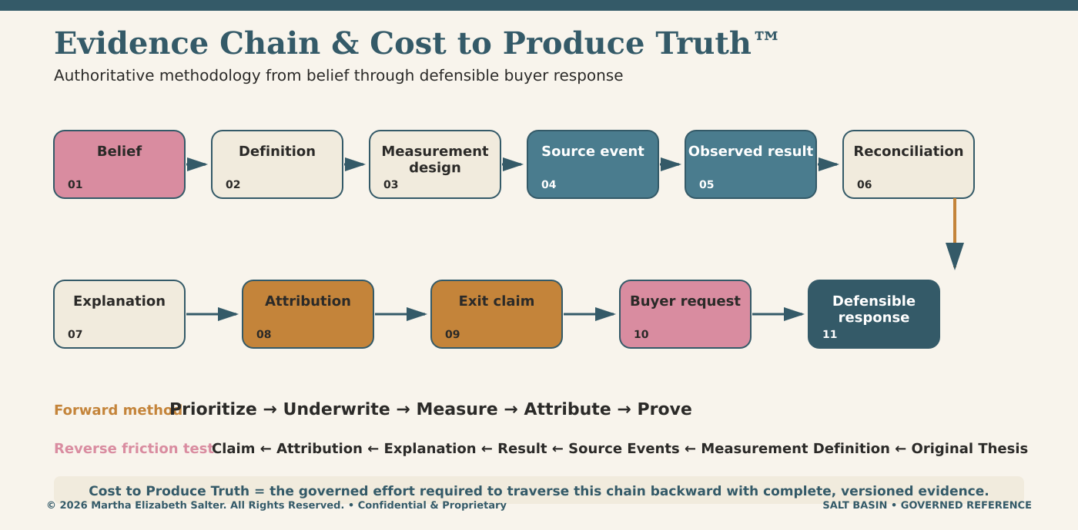
METHOD | Prioritize → Underwrite → Measure → Attribute → Prove. Salter Momentum™ describes the operating progression as Understanding → Rendering → Manifesting.
SOURCE NOTE Authoritative pasted chat context and source-derived Data Channel Rod visual. Cost to Produce Truth™ is the governed effort required to traverse a claim backward to its original thesis and evidence.
PORTFOLIO SECTION 26
Implementation Reality & Configurability
The existing Salt Basin website already provides a configurable public experience and substantial application surfaces. The operational SB-SCN registry and 001A semantic kernel remain integration work; the evidence below avoids treating client-code presence as proof of inaccessible backend records.
Surface | Observed status | Configurable now | Portfolio implication
Public experience | Verified live: 4 published pages / 23 sections | CMS draft/publish, section fields, layouts | Extend the current publishing model; do not create a second website platform.
Journey rods + calculator | Verified live interaction | Labels/defaults partly configurable; behavior coded | Reuse interaction patterns for scenario and evidence views.
Admin CMS | Deployed client code; 29 templates | Pages, sections, order, status, layout | Add scenario explorer/detail section types.
QA scenarios | Generic test-case schema | Test steps, expected results, runs, defects | Keep separate from operational SB-SCN definitions.
Scenario runtime registry | Exact SB-SCN IDs not found in deployed client | No current client configuration surface found | Import the 2,400 rows as governed runtime configuration.
Workbook 001A kernel | Rich source workbook; private backend unverified | Versioned workbook import contract supplied | Load atoms, molecules, events, stages, policies, connections, and projections.
EVIDENCE BOUNDARY | No SB-SCN-*, SB-SCEN-*, ATOM-*, or MOL-* identifiers were found in the reviewed deployed client bundle. This does not prove protected/private backend records are absent.
SOURCE NOTE Public site/API observation and deployed client-bundle review completed 2026-07-15; detailed per-scenario coverage is included in the organization import workbook.
PORTFOLIO SECTION 27
Organization Import & Semantic Kernel Data Model
The new workbook is a validate-first, idempotent import contract for extending the current Supabase build. It carries organization scope, stable identifiers, explicit source provenance, version fields, effective dates, and skip-safe templates for runtime facts that must not be fabricated.
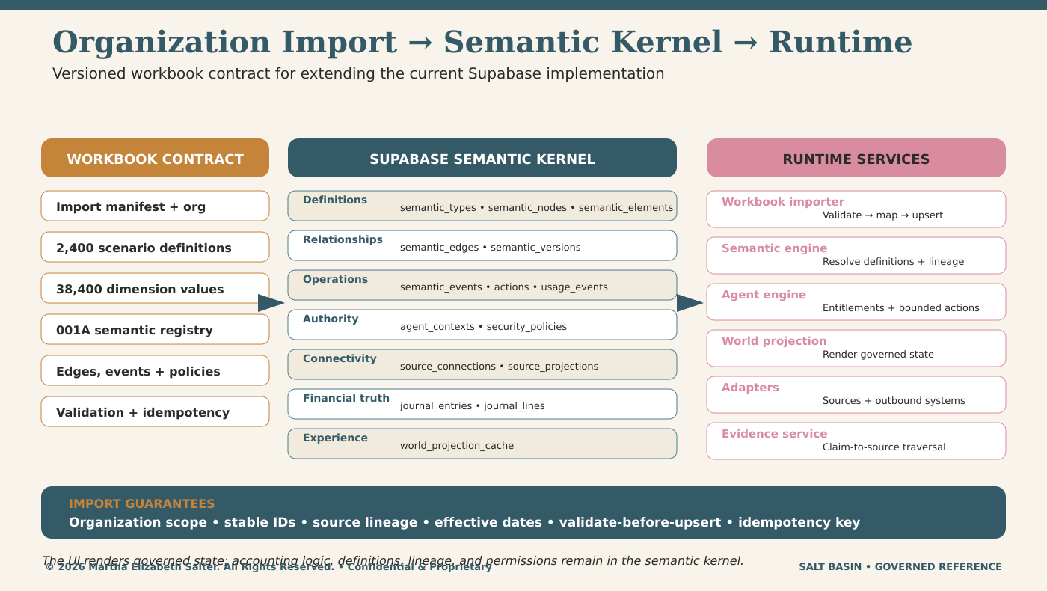
Contract area | Rows | Direct target / treatment | Import guardrail
Scenario definitions | 2,400 | scenario_definitions extension | Stable Scenario_ID; source row and fixture key retained.
Scenario dimension values | 38,400 | scenario_dimension_values extension | Exactly 16 values per scenario; canonical codes and atom paths retained.
Semantic nodes | 2,952 | semantic_nodes | 001A registry plus scenario nodes; no implied scenario crosswalk.
Semantic edges | 398 | semantic_edges | Hierarchy, tributary, atom→molecule, event→channel, stage→channel, and projection links.
Policies + sources | 10 policies / 11 sources / 5 projections | security_policies / source_connections / source_projections | Credentials excluded; authority and projection rules retained.
Runtime fact templates | 5 disabled rows | actions / cache / journals / usage | Importer must skip disabled templates; no facts synthesized.
SOURCE NOTE Salt_Basin_Org_Semantic_Kernel_Import_v1.xlsx. Target model: Supabase PostgreSQL, Auth, Storage, workbook importer, semantic engine, agent engine, adapters, and governed world projection.
PORTFOLIO SECTION 28
Product Suite & Claim-Safe Outcomes
Nine coordinated products support one evidence architecture. The products organize thesis, journey, semantic, operational, cost, agent, and experience capabilities; outcomes are governed hypotheses until production evidence validates them.
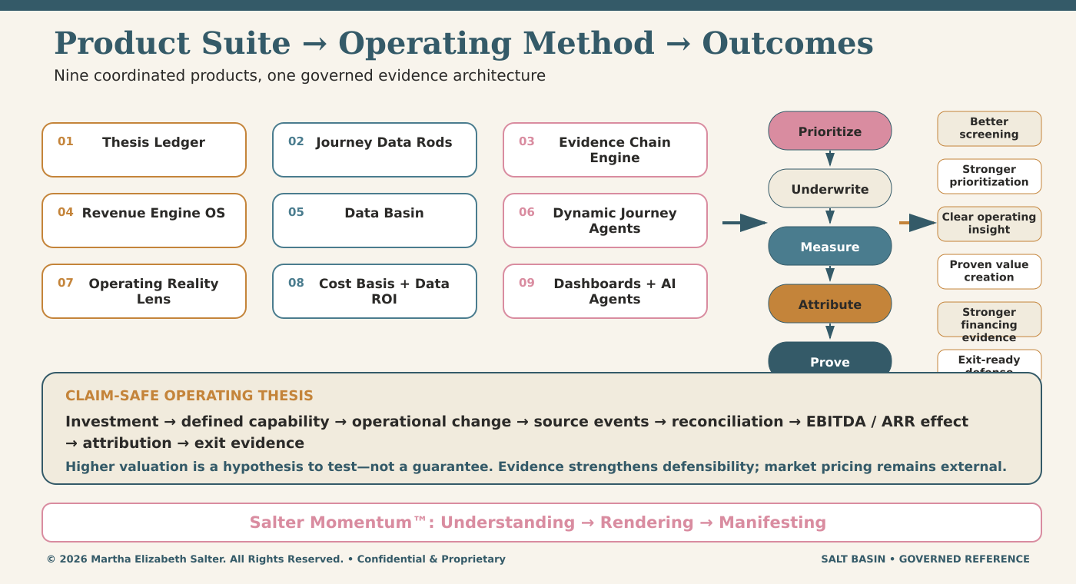
Product family | Primary responsibility | Evidence-chain contribution
Thesis Ledger System | Targets, assumptions, hypotheses, evidence requirements | Preserves belief, version, owner, counterfactual, and acceptance criteria.
Journey Data Rods + Dynamic Journey Agents | Stages, branches, merges, what-if simulation | Preserves operational context without duplicating master truth.
Evidence Chain Engine + Data Basin | Capture, normalize, validate, link, classify | Makes claim-to-source traversal inspectable and repeatable.
Revenue Engine OS + Operating Reality Lens | Patterns, metrics, anomalies, risk, leading signals | Connects governed events and reconciliations to operating results.
Cost Basis & Data ROI + Dashboards / Agents | Truth-production cost, ROI, recommendations, explanation | Makes evidence cost and decision support visible to entitled users.
CLAIM-SAFE THESIS | Investment → defined capability → operational change → source events → reconciliation → EBITDA / ARR effect → attribution → exit evidence. A stronger evidence chain can improve defensibility; it does not guarantee market pricing or a higher multiple.
SOURCE NOTE Authoritative pasted chat context and source-derived platform architecture visual.
PORTFOLIO SECTION 29
Scenario-to-001A Semantic Coverage
Workbook 001A is materially richer than the prior portfolio cover implied: 139 atoms, 45 molecules, 48 channels, 47 tributaries, 44 magnetic fields, 45 events, 28 stages, 10 security policies, 21 negative-convergence rules, and 5 zero-copy projections. Its scenario-level crosswalk remains incomplete.
Scenario family | Rows | 001A component support | Representative semantics | Next definition action
New Sale | 241 | Direct component support | CH-REV-0001; EVT-0012; revenue stages | Add explicit SB-SCN crosswalk and load configuration.
Modification | 259 | Direct component support | EVT-0033; EVT-0007; TR-0011 | Add explicit SB-SCN crosswalk and load configuration.
Renewal | 227 | Partial | STG-REV-11; STG-CUST-07; ATOM-SUB-007 | Define dedicated renewal event and crosswalk.
Expansion | 239 | Partial | Renewal/expansion stages; EVT-0033 | Define explicit expansion event and crosswalk.
Reactivation | 256 | Partial | EVT-0032; subscription + entitlement molecules | Define reactivation transition and crosswalk.
Churn | 262 | Partial | EVT-0035; at-risk/former-customer stages | Define termination/churn event and crosswalk.
Ramp Step | 222 | Partial | Pricing versions; modification; ramp atom | Define ramp-step event/schedule and crosswalk.
Contraction | 218 | Partial | Subscription/pricing modification semantics | Define contraction event and crosswalk.
Credit | 232 | Definition gap | No credit-issued / credit-memo event | Create credit event, state, accounting, and crosswalk.
Refund | 244 | Definition gap | No refund-issued / refund-settled event | Create refund event, state, accounting, and crosswalk.
STRICT RESULT | 0 of 2,400 SB-SCN rows has an explicit 001A scenario crosswalk. Component assessment: 500 direct, 1,424 partial, 476 definition gaps. The import workbook preserves all 2,400 per-scenario assessments.
SOURCE NOTE Salt_Basin_Workbook_001A_Enterprise_Foundation_v4.xlsx, Salt_Basin_2400_Scenario_Repository.xlsx, and the 2026-07-15 implementation audit.
PORTFOLIO SECTION 30
Supabase Implementation & Rollout Roadmap
The roadmap extends the current application instead of rebuilding a parallel platform. Release gates are evidence-based: a phase advances only when definitions, source lineage, deterministic fixtures, reconciliation, security, and user explanation are reproducible.
Method stage | Implementation increment | Release proof | Exit condition
Prioritize | Migrations, organization scope, import manifest, 001A registry seed | Schema contract; authority profile; idempotent validate mode | Template org values replaced; validation shows no blocking structural errors.
Underwrite | 2,400 scenario definitions + 38,400 dimension values | Scenario list/detail/filter; source/event/fixture lineage | Core 240 scenarios queryable; explicit semantic gaps visible.
Measure | Event ingestion, transactions, controls, metric definitions/observations | Golden fixtures; Revenue→GL, Invoice→AR, Payment→Cash, debt controls | Core calculations reconcile with zero unexplained variance.
Attribute | Claim, evidence requirement, attribution, versions, time semantics | Claim-to-source traversal; counterfactual and confidence treatment | Every claim resolves to definitions, events, results, explanations, and owners.
Prove | Scenario explorer, evidence views, world projection, sponsor/buyer experience | Entitlement tests; Why Changed? explanation; proof-pack export | Production slice is reproducible as-of prior versions and entitled views.
REPOSITORY LAYOUT | supabase/migrations • supabase/seed • supabase/functions • src/semantic-engine • src/workbook-importer • src/agent-engine • src/world-projection • src/adapters
SOURCE NOTE Authoritative pasted chat context; roadmap remains outcome-gated. Owners, dates, budget, dependencies, and completion evidence belong in the Thesis / Tributary Ledger.
PORTFOLIO SECTION 31
Maturity Signals & Operational Volatility
Maturity is evaluated claim by claim. Seven independent signals determine whether a claim is merely asserted, defined, reproducible, reconciled, explainable, or outcome validated; any weak signal constrains the overall maturity.
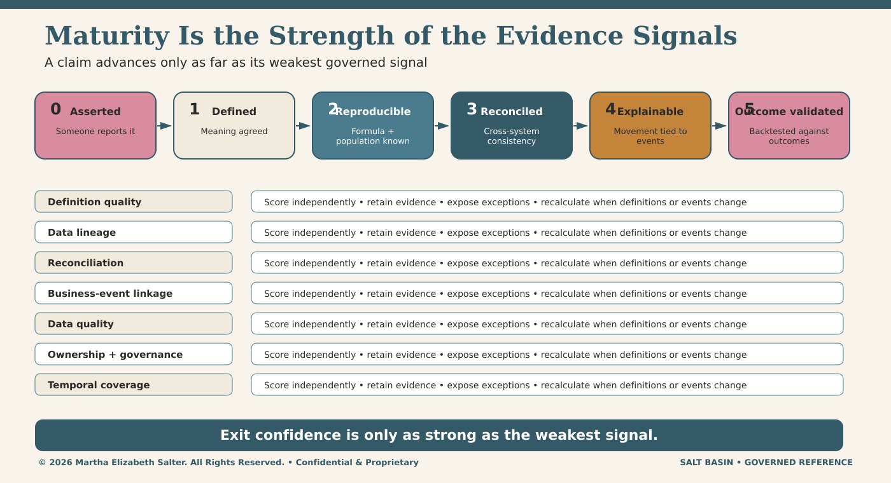
SIGNALS | Definition quality • data lineage • reconciliation • business-event linkage • data quality • ownership and governance • temporal coverage.
SOURCE NOTE The Signals That Matter in the Maturity Model visual and Salt_Basin_Thesis_Evidence_Chain_Examples workbook. Levels and example treatments are illustrative until calibrated and backtested.
PORTFOLIO SECTION 32
Hold-Period Evidence Preservation
Leadership turnover, system changes, billing redesigns, acquisitions, chart-of-accounts changes, and reporting drift can break the path from thesis to outcome. Effective dating, lineage, crosswalks, reconciliation, and continuous evidence packaging preserve it.
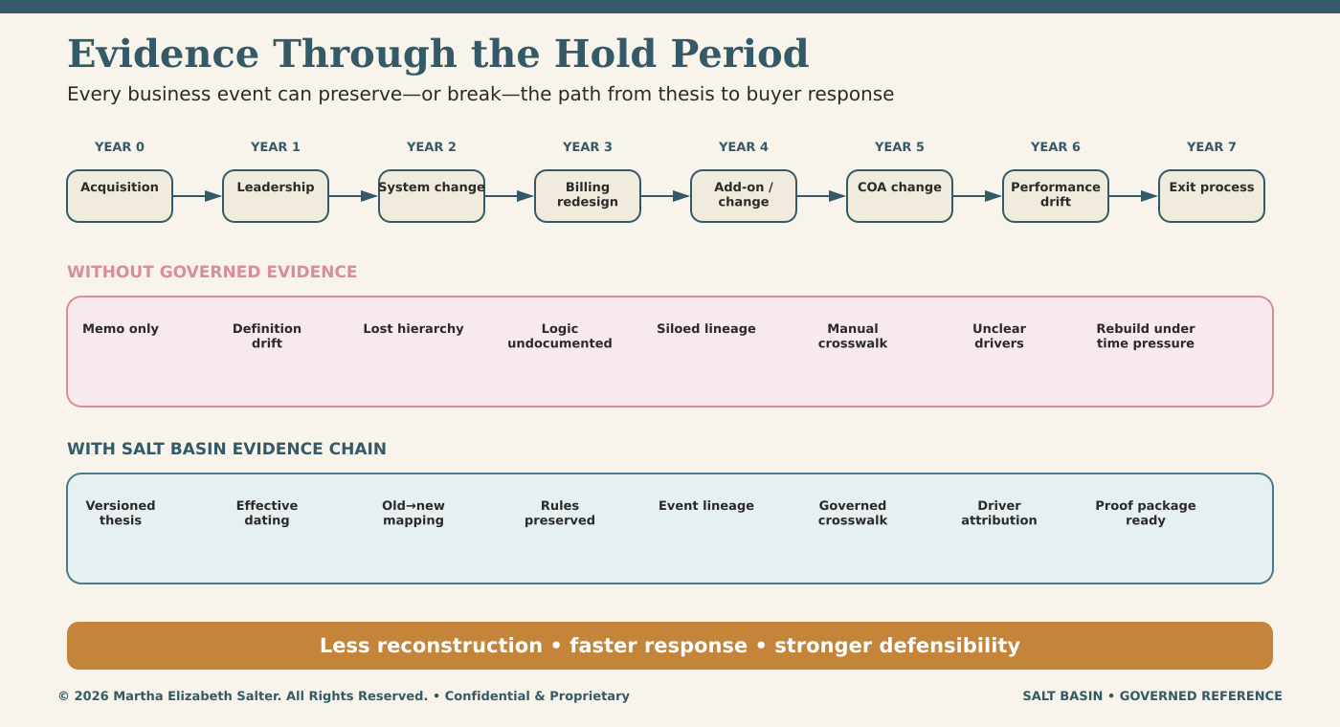
BUYER-READY PRINCIPLE | Every material event creates a potential break. Salt Basin preserves meaning and proof so the exit response is assembled from governed history instead of reconstructed under time pressure.
SOURCE NOTE How the Evidence Chain Is Impacted Through the Hold Period visual; pricing transformation and add-on examples remain illustrative.
PORTFOLIO SECTION 33
Data Cost Basis & Claim-Safe Value Thesis
Data cost basis documents the people, process, system, definition, lineage, quality, and control investment required to make data reusable and defensible. Operational and financial effects must then be measured and attributed; they are not assumed.
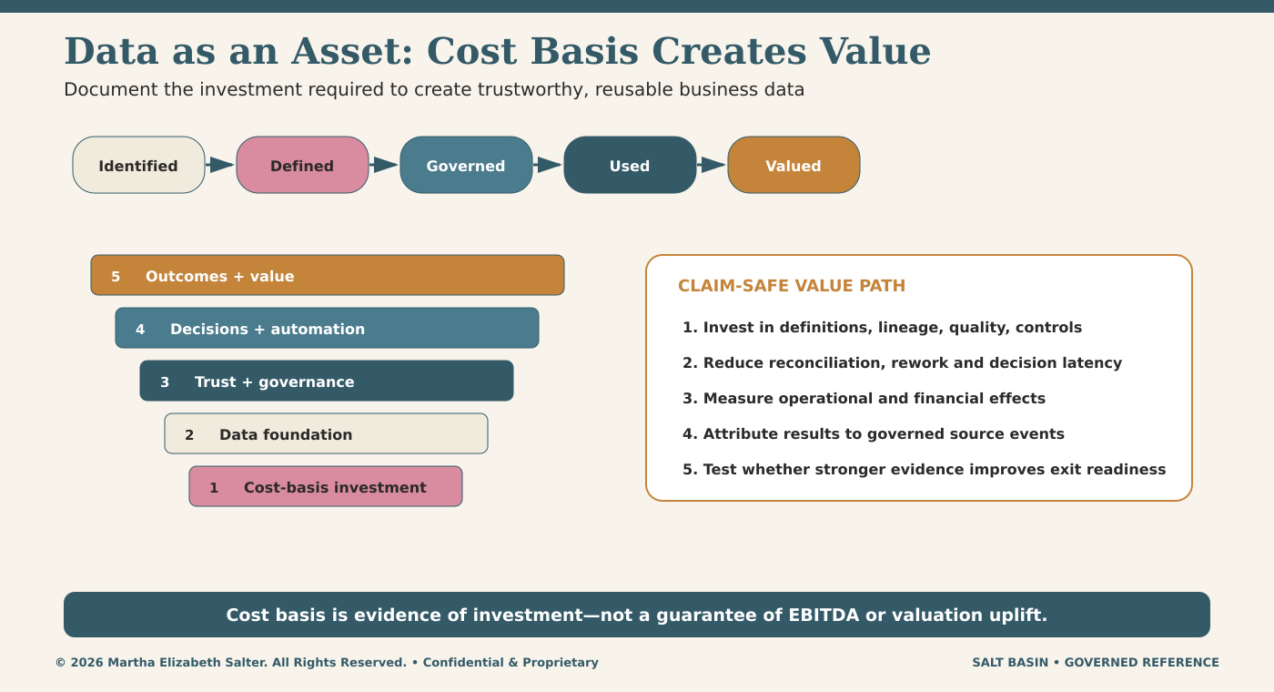
GUARDRAIL | The source visual contains illustrative investment, EBITDA, enterprise-value, and multiple ranges. They are hypotheses for pilot measurement and backtesting—not forecasts, guarantees, or production results.
SOURCE NOTE Data as an Asset / Cost Basis Creates Value visual and Salt_Basin_Thesis_Evidence_Chain_Examples workbook.
PORTFOLIO SECTION 34
TH-001 Worked Claim: Pricing Transformation
The worked example shows how a single source record becomes governed identity, contract, pricing, evidence, event, and reconciliation objects across three rods before it can support an attributable claim.
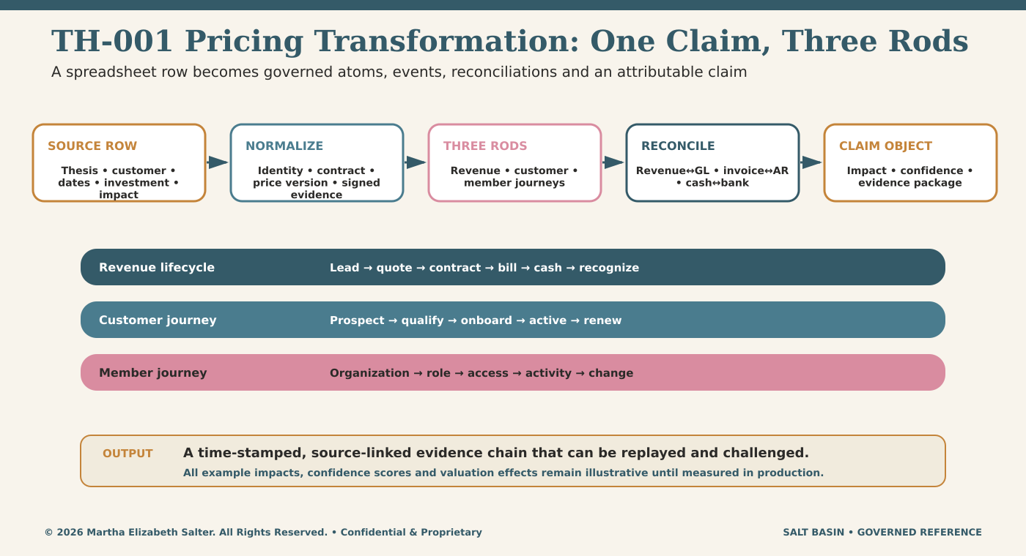
REQUIRED PROOF | Stable source identifiers • versioned terms • signed evidence • event time • Revenue-to-GL, Invoice-to-AR, and Cash-to-Bank reconciliation • competing-driver treatment • claim confidence.
SOURCE NOTE TH-001 Pricing Transformation visual, Salt_Basin_Thesis_Evidence_Chain_Examples workbook, and the extended LoneTree proposal. All example values are illustrative.
PORTFOLIO SECTION 35
Crystal Atom, Molecule, Rod & Orbit Model
A crystal atom is the smallest bounded unit of governed truth: definition, evidence, validation, temporal history, confidence, and lineage. Atoms group into molecules and clusters, operate through journey rods, and converge into an enterprise orbit.
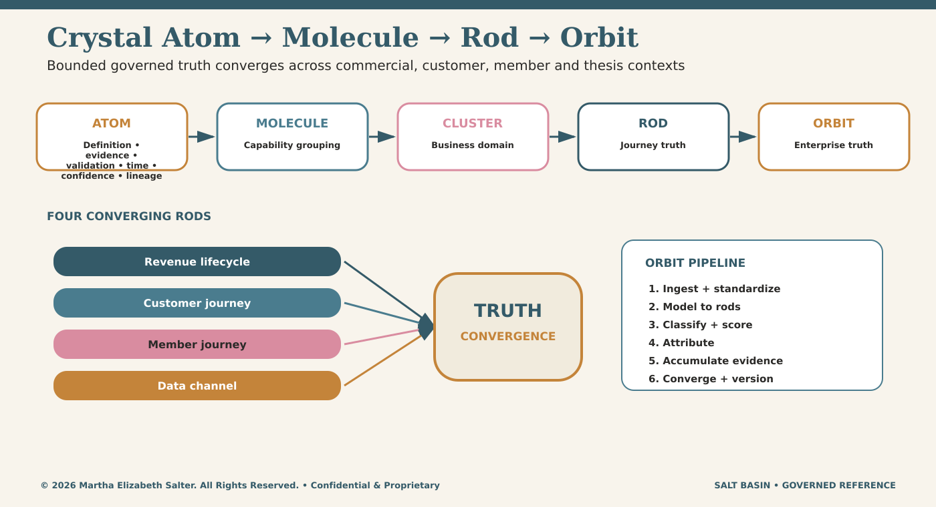
COUNT BOUNDARY | Workbook 001A contains 139 canonical atoms and 45 molecules. The separate 5,000-row Metadata Atom Catalog is explicitly a generated starter catalog and remains a review/reference layer; it does not change the canonical 001A count.
SOURCE NOTE Salt Basin Orbit Visual & Data Model, Metadata Atom Catalog v0.1, Website Data Model Build Aligned v1.0, and Workbook 001A.
PORTFOLIO SECTION 36
Data Channel Rod: Claim to Exit Proof
The Data Channel Rod carries thesis metadata and evidence across time. Its six states connect the claim object, attribution object, evidence classification, operational reporting, confidence recalculation, and exit-defense package.
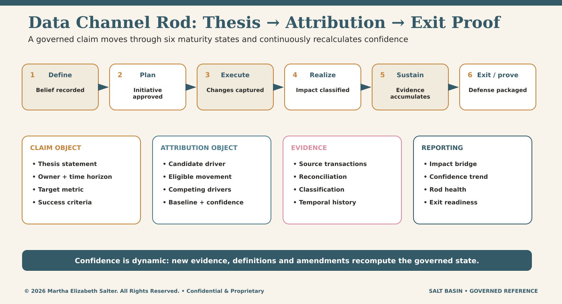
SIX STATES | Define → Plan → Execute → Realize → Sustain → Exit / Prove. State and confidence are recomputed as governed evidence, definitions, amendments, and reconciliations arrive.
SOURCE NOTE Salt Basin Data Channel Rod visual, Thesis Evidence Orbit annotated notes, and DataBasin Data Bridge methodology.
ILLUSTRATIVE VISUAL REFERENCE
Product Suite → Operating Method → Outcomes
ILLUSTRATIVE • CONCEPTUAL • NOT A PRODUCTION SCREEN
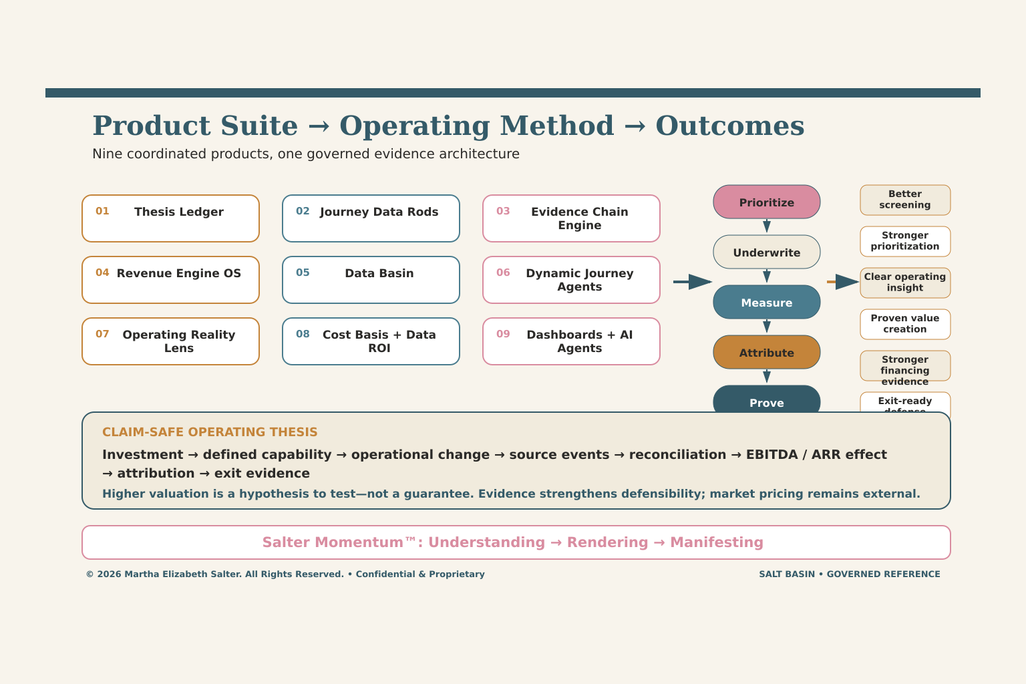
Source-derived native reference diagram connecting the nine-product suite to the operating method and claim-safe outcomes.

ILLUSTRATIVE VISUAL REFERENCE
Scenario Runtime & Metadata-Governed Rods
ILLUSTRATIVE • CONCEPTUAL • NOT A PRODUCTION SCREEN
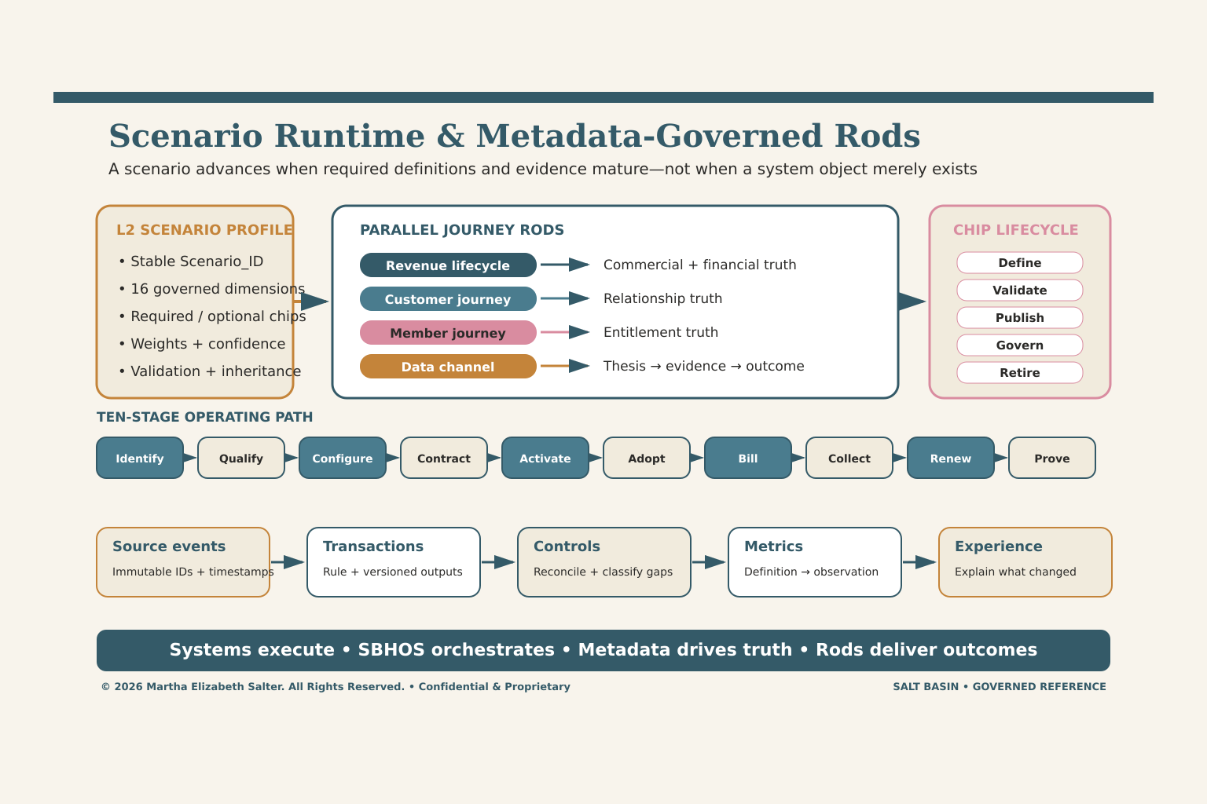
Source-derived native reference diagram showing scenario profiles, metadata-chip lifecycle, parallel rods, stage maturity, and the event-to-experience chain.

ILLUSTRATIVE VISUAL REFERENCE
Organization Import → Semantic Kernel → Runtime
ILLUSTRATIVE • CONCEPTUAL • NOT A PRODUCTION SCREEN
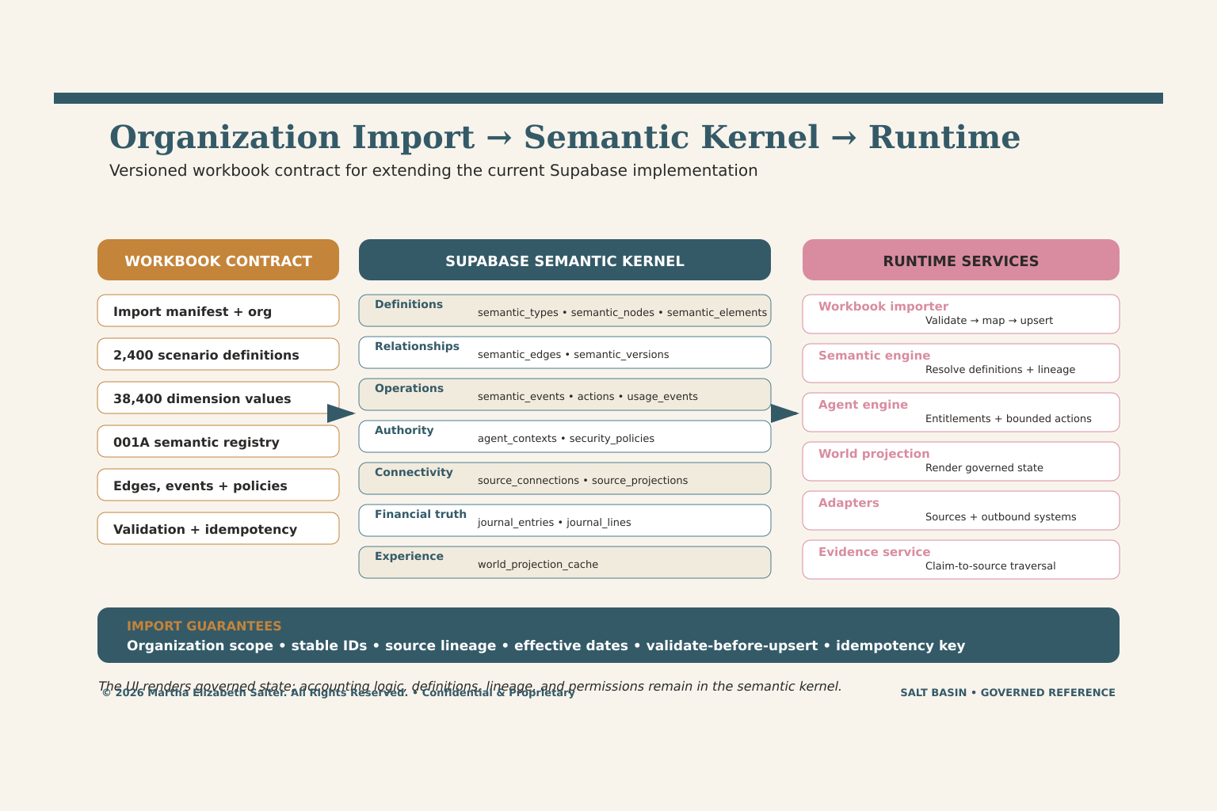
Authoritative chat-context reference for a versioned organization workbook import into the current Supabase semantic kernel and runtime services.

ILLUSTRATIVE VISUAL REFERENCE
Evidence Chain & Cost to Produce Truth™
ILLUSTRATIVE • CONCEPTUAL • NOT A PRODUCTION SCREEN
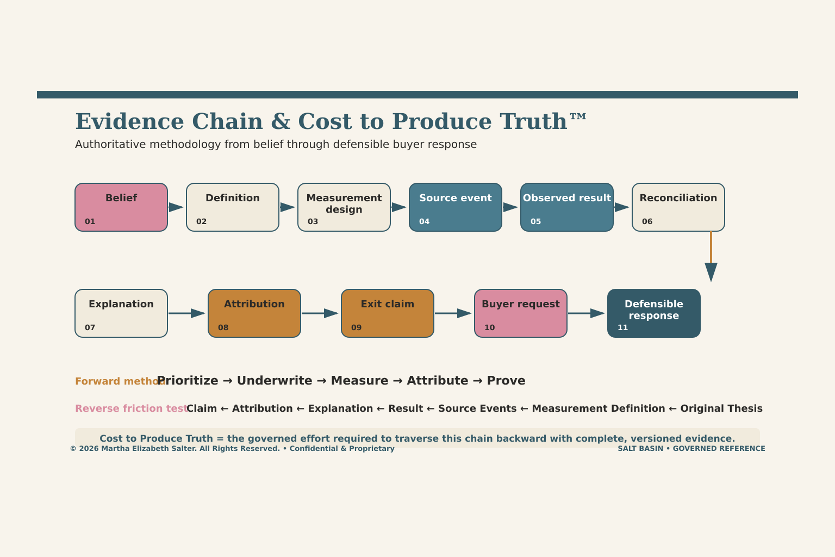
Authoritative evidence-chain reference. Valuation uplift remains a hypothesis to validate; the diagram makes claim-to-source traversal and truth-production friction explicit.

PORTFOLIO SECTION A
Appendix A — Canonical Dimension Dictionary
A compact implementation dictionary for the 16 scenario dimensions. Extend with the exact canonical value codes, definitions, evidence rules, mappings, and regression fixtures from the repository workbook.
DIMENSION | N | IMPLEMENTATION INTERPRETATION
Customer_Segment | 4 | Defines commercial scale/context; affects pricing, service, hierarchy and metrics.
Customer_State | 3 | Separates new, existing and lifecycle relationship behavior.
Product_Model | 5 | Defines product/service structure and fulfillment pattern.
Pricing_Model | 7 | Defines fixed, unit, tier, block, usage, commitment or related economics.
Contract_Term | 5 | Defines duration, evergreen, renewal and enforceability behavior.
Billing_Cadence | 5 | Defines invoice frequency and period boundaries.
Billing_Timing | 4 | Defines advance/arrears timing and related recognition/cash implications.
Payment_Method | 5 | Defines settlement source, fees, timing, reversals and controls.
Commercial_Event | 10 | Defines the lifecycle event family and primary lineage root.
Usage_State | 6 | Defines committed, consumed, overage, dormant or related usage behavior.
Revenue_Pattern | 5 | Defines point-in-time, ratable, usage-based or related recognition.
Invoice_State | 6 | Defines draft/issued/partially paid/paid/void/other lifecycle state.
Payment_State | 6 | Defines initiated/settled/failed/refunded/reversed/other settlement state.
Debt_State | 5 | Defines draw, outstanding, accrual, repayment and closing-balance behavior.
Source_System | 10 | Defines authoritative source and native lineage behavior.
Security_Slice | 7 | Defines entitled exposure/action context and policy tests.
DICTIONARY COMPLETION For each value add: stable code • display label • definition • inclusion/exclusion • atom path • molecule • evidence • validation • event compatibility • transaction impact • temporal behavior • agent/user policy • regression IDs.
SOURCE NOTE Cardinalities are exact; short interpretations are implementation guidance and remain subordinate to the source dictionary.

PORTFOLIO SECTION B
Appendix B — Implementation Checklists
These checklists convert the reference model into repeatable definition, build, test, release, and operating reviews.
DEFINITION READINESS
IDENTITY  Stable codes, owners, lifecycle states and authority hierarchy approved. | MEANING  Definitions, inclusions/exclusions, atoms, molecules and path treatment complete. | LINEAGE  Source events, native IDs, rules and time fields mapped.
TRANSACTIONS  Declared records, postings and no-generate rules explicit. | CONTROLS  Expected reconciliations, exception classes and pass thresholds defined. | METRICS  Formula, grain, time, dependencies, policy and validation versioned.
REGRESSION PROOF
GATE | PASS CONDITION
State | Expected L1/L2/L3 path, statuses, branch/merge and maturity reproduce
Financial | Transactions and balances tie under all four applicable controls
Metrics | Expected values, dependencies, invalidation and propagation reproduce
Exceptions | Timing, mapping, source, rule, entitlement and adjustment paths classify correctly
Temporal | Prior as-of state, restatement, supersession and replay reproduce
Lineage | Source → rule → record → control/metric → UI remains traversable
Security | Allow and deny paths, memory, exposure and actions follow agent policy
Experience | Trace and Why Changed? explain current/prior results without hidden assumptions
Performance | Bounded recalculation, projection freshness and recovery meet target
Release | Evidence pack, gaps, approvals, compatibility and next review recorded
SOURCE NOTE Checklist consolidates validation themes present across the repository, DataBasin, EIDOS, security, and UI/experience materials.

APPENDIX C
Source Estate Register — Broad Screen
122 candidate artifacts were identified using unrestricted Salt Basin source queries. The register is intentionally broad; authority tier and category prevent duplicates, prototypes, and precursor work from silently overriding governing sources.
ARTIFACT | FORMAT | CATEGORY | AUTHORITY | MODIFIED
Enterprise_Intelligence_and_Delivery_Operating_System_EIDOS_v1_0.docx | Document | Operating governance | T1 • Current / governing | 2026-07-05
Salt_Basin_2400_Scenario_Repository.xlsx | Workbook | Scenario & metadata | T1 • Current / governing | 2026-07-13
Salt_Basin_DataBasin_Data_Bridge_Methodology.docx | Document | Implementation | T1 • Current / governing | 2026-07-09
Salt_Basin_Holdings_Enterprise_Constitution_v1_0.docx | Document | Operating governance | T1 • Current / governing | 2026-07-05
Salt_Basin_Transaction_Grounded_Intelligence_Portfolio.docx | Document | Adjacent reference | T1 • Current / governing | 2026-07-13
Salt_Basin_Visual_Design_System_v1.docx | Document | Visual reference | T1 • Current / governing | 2026-07-08
Salt_Basin_Workbook_001A_Enterprise_Foundation_v4.xlsx | Workbook | Adjacent reference | T1 • Current / governing | 2026-07-14
SBHOS_Metadata_Definition_By_L2_Scenario_and_Data_Rod.xlsx | Workbook | Scenario & metadata | T1 • Current / governing | 2026-07-09
Thesis_Ledger_System_Framework_v1.docx | Document | Thesis & evidence | T1 • Current / governing | 2026-07-05
Salt_Basin_Last_3_Chats_Fully_Annotated_Notes_July_2026.docx | Document | Adjacent reference | T2 • Supporting | 2026-07-14
Salt_Basin_Master_Recap_and_Smart_Use_Guide.docx | Document | Experience | T2 • Supporting | 2026-07-13
Salt_Basin_PE_Exit_Evidence_Research_Memo_v3.docx | Document | Thesis & evidence | T2 • Supporting | 2026-07-14
Salt_Basin_POC_to_Data_Model_Mapping.xlsx | Workbook | Adjacent reference | T2 • Supporting | 2026-07-14
Salt_Basin_Thesis_Evidence_Chain_Examples.xlsx | Workbook | Thesis & evidence | T2 • Supporting | 2026-07-14
Salt_Basin_Thesis_Evidence_Orbit_Annotated_Notes.docx | Document | Thesis & evidence | T2 • Supporting | 2026-07-14
Salt Basin Net Works(1).pdf | PDF | Adjacent reference | T3 • Precursor / variant | 2026-06-18
Salt_Basin_EIDOS_Expanded_Proliferated_L2_Scenarios.xlsx | Workbook | Scenario & metadata | T3 • Precursor / variant | 2026-07-09
salt_basin_highway_html_artifacts(1).zip | Artifact | Adjacent reference | T3 • Precursor / variant | 2026-07-10
salt_basin_highway_interactive(1).html | Web / prototype | Adjacent reference | T3 • Precursor / variant | 2026-07-10
Salt_Basin_HOS_2400_L2_Scenarios_Workbook.xlsx | Workbook | Scenario & metadata | T3 • Precursor / variant | 2026-07-10
Salt_Basin_LoneTree_Thesis_to_Exit_Proposal_v3_Clean(1).pdf | PDF | Thesis & evidence | T3 • Precursor / variant | 2026-07-14
Salt_Basin_LoneTree_Thesis_to_Exit_Proposal_v3_Clean(1).pptx | Artifact | Thesis & evidence | T3 • Precursor / variant | 2026-07-14
Salt_Basin_Prospect_Crystal_3D_Experience(1).html | Web / prototype | Experience | T3 • Precursor / variant | 2026-07-14
Salt_Basin_Prospect_Send_Package(1).zip | Artifact | Adjacent reference | T3 • Precursor / variant | 2026-07-14
Salt_Basin_Variable_Config_and_3D_World_Spec(1).docx | Document | Implementation | T3 • Precursor / variant | 2026-07-04
Salt_Basin_Variable_Config_and_3D_World_Spec(2).docx | Document | Implementation | T3 • Precursor / variant | 2026-07-04
Salt_Basin_Variable_Config_and_3D_World_Spec(3).docx | Document | Implementation | T3 • Precursor / variant | 2026-07-04
Salt_Basin_White_Paper(1).pdf | PDF | Adjacent reference | T3 • Precursor / variant | 2026-03-31
Salt_Basin_Workbook_001A_Enterprise_Foundation(1).xlsx | Workbook | Adjacent reference | T3 • Precursor / variant | 2026-07-15
Salt_Basin_Workbook_001A_Enterprise_Foundation_v3(1).xlsx | Workbook | Adjacent reference | T3 • Precursor / variant | 2026-07-14
START_HERE_Salt_Basin_Prospect_Experience(1).pdf | PDF | Experience | T3 • Precursor / variant | 2026-07-14
Betsy_Salter_Career_Master_Database__Final.pdf | PDF | Adjacent reference | T3 • Reference | 2026-07-08
Betsy_Salter_Case_Study_Portfolio_Canva_Source_Final.pdf | PDF | Adjacent reference | T3 • Reference | 2026-07-08
Betsy_Salter_Flagship_Resume_Concept.pptx | Artifact | Adjacent reference | T3 • Reference | 2026-07-08
Consolidated_Package_Manifest.xlsx | Workbook | Adjacent reference | T3 • Reference | 2026-06-13
Corporate product impact matrix infographic.png | Image | Visual reference | T3 • Reference | 2026-07-14
Corporate strategy dashboard and priorities overview.png | Image | Visual reference | T3 • Reference | 2026-07-14
Data channel rod for thesis analysis.png | Image | Visual reference | T3 • Reference | 2026-07-14
EIDOS_Process_Definition_Repository_Starter.xlsx | Workbook | Operating governance | T3 • Reference | 2026-07-09
eidos_spatial_semantic_prototype.html | Web / prototype | Operating governance | T3 • Reference | 2026-07-11
eidos_true_3d_webgl_prototype.html | Web / prototype | Operating governance | T3 • Reference | 2026-07-11
HERQ_Master_Repository_v1.xlsx | Workbook | Adjacent reference | T3 • Reference | 2026-06-13
Home_Equity_Recovery_Fund_Executive_With_Charts.pdf | PDF | Experience | T3 • Reference | 2026-03-13
Maturity models: competition vs Salt Basin.png | Image | Visual reference | T3 • Reference | 2026-07-14
OPEN_SALT_BASIN_EXPERIENCE.html | Web / prototype | Experience | T3 • Reference | 2026-07-14
SaaS journey and metadata flow diagram.png | Image | Visual reference | T3 • Reference | 2026-07-09
Salt Basin data model overview.png | Image | Visual reference | T3 • Reference | 2026-07-14
Salt Basin highway operating system diagram.png | Image | Visual reference | T3 • Reference | 2026-07-09
Salt Basin Highway Operating System workflow.png | Image | Visual reference | T3 • Reference | 2026-07-09
Salt Basin methodology infographic.png | Image | Visual reference | T3 • Reference | 2026-07-09
Salt Basin modeling evidence chain roadmap.png | Image | Visual reference | T3 • Reference | 2026-07-14
Salt Basin modeling evidence chain visualization.png | Image | Visual reference | T3 • Reference | 2026-07-14
Salt Basin Net Works.pdf | PDF | Adjacent reference | T3 • Reference | 2026-06-18
Salt Basin platform architecture diagram.png | Image | Visual reference | T3 • Reference | 2026-07-14
Salt Basin product to outcome matrix.png | Image | Visual reference | T3 • Reference | 2026-07-14
Salt Basin proof of concept dashboard.png | Image | Visual reference | T3 • Reference | 2026-07-14
Salt_Basin_Cinematic_3D_Interactive_Experience.html | Web / prototype | Experience | T3 • Reference | 2026-07-10
Salt_Basin_Crystal_Evidence_Operating_System_Artifact.html | Web / prototype | Thesis & evidence | T3 • Reference | 2026-07-14
Salt_Basin_EIDOS_L2_Scenario_Repository_Initial_500.xlsx | Workbook | Scenario & metadata | T3 • Reference | 2026-07-09
Salt_Basin_EIDOS_Proliferated_L2_Scenarios.xlsx | Workbook | Scenario & metadata | T3 • Reference | 2026-07-09
Salt_Basin_Enterprise_Constitution_Master_Blueprint_Volume_I_Draft.docx | Document | Operating governance | T3 • Reference | 2026-07-05
Salt_Basin_Hierarchical_Prospect_Crystal_Experience.html | Web / prototype | Experience | T3 • Reference | 2026-07-14
Salt_Basin_Hierarchical_Prospect_Crystal_Experience_v2.html | Web / prototype | Experience | T3 • Reference | 2026-07-14
salt_basin_highway_html_artifacts.zip | Artifact | Adjacent reference | T3 • Reference | 2026-07-10
salt_basin_highway_interactive.html | Web / prototype | Adjacent reference | T3 • Reference | 2026-07-10
Salt_Basin_Holdings_Enterprise_Constitution_v0_1.docx | Document | Operating governance | T3 • Reference | 2026-07-05
Salt_Basin_Holdings_White_Paper_Full.pdf | PDF | Adjacent reference | T3 • Reference | 2026-03-31
Salt_Basin_HOS_Commercial_Scenario_Intelligence.html | Web / prototype | Scenario & metadata | T3 • Reference | 2026-07-10
Salt_Basin_HOS_Plaid_Integration_Starter.zip | Artifact | Adjacent reference | T3 • Reference | 2026-07-10
Salt_Basin_HOS_Product_Experience_Readability_Fix.html | Web / prototype | Experience | T3 • Reference | 2026-07-10
Salt_Basin_HOS_Product_Experience_Updated.html | Web / prototype | Experience | T3 • Reference | 2026-07-10
Salt_Basin_HOS_Product_Experience_With_Plaid.html | Web / prototype | Experience | T3 • Reference | 2026-07-10
Salt_Basin_HOS_Refined_Polished_Interactive.html | Web / prototype | Adjacent reference | T3 • Reference | 2026-07-10
Salt_Basin_Interactive_End_Result_Deliverables.html | Web / prototype | Adjacent reference | T3 • Reference | 2026-07-10
Salt_Basin_Interactive_Methodology_Document.html | Web / prototype | Adjacent reference | T3 • Reference | 2026-07-09
Salt_Basin_Interactive_Methodology_Document_ANCHOR_FIXED.html | Web / prototype | Adjacent reference | T3 • Reference | 2026-07-09
Salt_Basin_Interactive_Methodology_Document_FIXED.html | Web / prototype | Adjacent reference | T3 • Reference | 2026-07-09
Salt_Basin_Interactive_Prospect_Experience.html | Web / prototype | Experience | T3 • Reference | 2026-07-14
Salt_Basin_Large_L2_Scenario_Explorer.html | Web / prototype | Scenario & metadata | T3 • Reference | 2026-07-09
Salt_Basin_Lead_to_Cash_Workshop_Intake_Expanded.html | Web / prototype | Adjacent reference | T3 • Reference | 2026-07-09
Salt_Basin_LoneTree_Capital_Proposal.pdf | PDF | Adjacent reference | T3 • Reference | 2026-07-14
Salt_Basin_LoneTree_Capital_Proposal.pptx | Artifact | Adjacent reference | T3 • Reference | 2026-07-13
Salt_Basin_LoneTree_End_to_End_Thesis_Salt_Basin_Branded_2026.pdf | PDF | Thesis & evidence | T3 • Reference | 2026-07-14
Salt_Basin_LoneTree_End_to_End_Thesis_Salt_Basin_Branded_2026.pptx | Artifact | Thesis & evidence | T3 • Reference | 2026-07-14
Salt_Basin_LoneTree_Executive_Preview.html | Web / prototype | Adjacent reference | T3 • Reference | 2026-07-14
Salt_Basin_LoneTree_Executive_Preview_Package.zip | Artifact | Adjacent reference | T3 • Reference | 2026-07-14
Salt_Basin_LoneTree_Operating_Diagnostic_Companion_Pared_Down.pdf | PDF | Adjacent reference | T3 • Reference | 2026-07-14
Salt_Basin_LoneTree_Operating_Diagnostic_Companion_Pared_Down.pptx | Artifact | Adjacent reference | T3 • Reference | 2026-07-14
Salt_Basin_LoneTree_Thesis_to_Exit_Proposal_v2.pdf | PDF | Thesis & evidence | T3 • Reference | 2026-07-14
Salt_Basin_LoneTree_Thesis_to_Exit_Proposal_v2.pptx | Artifact | Thesis & evidence | T3 • Reference | 2026-07-14
Salt_Basin_LoneTree_Thesis_to_Exit_Proposal_v3_Clean.pdf | PDF | Thesis & evidence | T3 • Reference | 2026-07-14
Salt_Basin_LoneTree_Thesis_to_Exit_Proposal_v3_Clean.pptx | Artifact | Thesis & evidence | T3 • Reference | 2026-07-14
Salt_Basin_NoJS_Scenario_Simulator.html | Web / prototype | Scenario & metadata | T3 • Reference | 2026-07-09
Salt_Basin_PE_Exit_Evidence_200_Query_Research_Memo.docx | Document | Thesis & evidence | T3 • Reference | 2026-07-14
Salt_Basin_Platform_Interactive_Experience.html | Web / prototype | Experience | T3 • Reference | 2026-07-10
Salt_Basin_Preloaded_L2_Scenario_Library_Translator.html | Web / prototype | Scenario & metadata | T3 • Reference | 2026-07-09
Salt_Basin_Product_Demo_Full_Experience.html | Web / prototype | Experience | T3 • Reference | 2026-07-10
Salt_Basin_Prospect_Crystal_3D_Experience.html | Web / prototype | Experience | T3 • Reference | 2026-07-14
Salt_Basin_Prospect_Experience_Accurate_Visual_Rebuilds.html | Web / prototype | Visual reference | T3 • Reference | 2026-07-14
Salt_Basin_Prospect_Experience_NoJS_Clickable.html | Web / prototype | Experience | T3 • Reference | 2026-07-14
Salt_Basin_Prospect_Experience_NoJS_Clickable_v2.html | Web / prototype | Experience | T3 • Reference | 2026-07-14
Salt_Basin_Prospect_Immersive_Crystal_Operating_Thesis.html | Web / prototype | Thesis & evidence | T3 • Reference | 2026-07-14
Salt_Basin_Prospect_Immersive_Crystal_Operating_Thesis_Built_Out.html | Web / prototype | Thesis & evidence | T3 • Reference | 2026-07-14
Salt_Basin_Prospect_Operating_Thesis_Experience_Mobile.html | Web / prototype | Thesis & evidence | T3 • Reference | 2026-07-14
Salt_Basin_Prospect_Operating_Thesis_Experience_Mobile_v2.html | Web / prototype | Thesis & evidence | T3 • Reference | 2026-07-14
Salt_Basin_Prospect_Send_Package.zip | Artifact | Adjacent reference | T3 • Reference | 2026-07-14
Salt_Basin_Robust_Build.html | Web / prototype | Experience | T3 • Reference | 2026-07-10
Salt_Basin_Scenario_Repository_Portfolio_v1.docx | Document | Scenario & metadata | T3 • Reference | 2026-07-15
Salt_Basin_Variable_Config_and_3D_World_Spec.docx | Document | Implementation | T3 • Reference | 2026-07-04
Salt_Basin_Variable_Config_and_3D_World_Spec.pdf | PDF | Implementation | T3 • Reference | 2026-07-04
Salt_Basin_Visual_Design_System_v1.pdf | PDF | Visual reference | T3 • Reference | 2026-07-08
Salt_Basin_White_Paper.pdf | PDF | Adjacent reference | T3 • Reference | 2026-03-31
Salt_Basin_Workbook_001A_Enterprise_Foundation.xlsx | Workbook | Adjacent reference | T3 • Reference | 2026-07-14
Salt_Basin_Workbook_001A_Enterprise_Foundation_v2.xlsx | Workbook | Adjacent reference | T3 • Reference | 2026-07-14
Salt_Basin_Workbook_001A_Enterprise_Foundation_v3.xlsx | Workbook | Adjacent reference | T3 • Reference | 2026-07-14
Salt_Basin_Workshop_Capture_Interactive_Prototype.html | Web / prototype | Experience | T3 • Reference | 2026-07-09
Salt_Basin_x_LoneTree_End_to_End_Thesis_Proposal_Extended.pdf | PDF | Thesis & evidence | T3 • Reference | 2026-07-14
Salt_Basin_x_LoneTree_End_to_End_Thesis_Proposal_Extended.pptx | Artifact | Thesis & evidence | T3 • Reference | 2026-07-14
SBHOS_Interactive_Smart_Art.html | Web / prototype | Adjacent reference | T3 • Reference | 2026-07-09
START_HERE_Salt_Basin_Prospect_Experience.pdf | PDF | Experience | T3 • Reference | 2026-07-14
The Salt Basin Methodology blueprint.png | Image | Visual reference | T3 • Reference | 2026-07-09
The Salt Basin Methodology overview.png | Image | Visual reference | T3 • Reference | 2026-07-09

SCREEN SUMMARY
Adjacent reference: 39 • Experience: 20 • Implementation: 6 • Operating governance: 7 • Scenario & metadata: 11 • Thesis & evidence: 20 • Visual reference: 19
T1 • Current / governing: 9 • T2 • Supporting: 6 • T3 • Precursor / variant: 16 • T3 • Reference: 91
SOURCE NOTE The source register is a screened estate index, not a representation that every artifact was equally authoritative or exhaustively quoted.

PORTFOLIO SECTION D
Appendix D — Reference Stewardship
Keep this document cohesive by treating it as the narrative index to governed repository releases. Add evidence and decisions; do not allow the portfolio to become a parallel source of truth.
ROLE | STEWARDSHIP
Repository owner | Owns Scenario_IDs, dimensions, value codes, coverage tiers and release compatibility
Metadata/token owners | Own definitions, atom/molecule placement, evidence, validation, path treatment and review
Product/engineering | Own fixtures, generation rules, dependency graph, UI trace and performance
Finance/control | Own transaction rules, reconciliations, metric contracts, exceptions and close evidence
Security/privacy | Own agent envelopes, entitlements, retention, consent and action policies
Thesis/value owner | Own claims, drivers, counterfactuals, attribution, confidence and measured value
Release steward | Own proof pack, open gaps, approvals, version notes and next review
DOCUMENT UPDATE RHYTHM
PER RELEASE | Coverage, code/rule changes, proof summary, gaps, approvals | PER QUARTER | Metric/claim maturity, evidence freshness, roadmap and source authority
ON INCIDENT | Exception, correction, restatement, security or lineage learning | ON EXPANSION | New family brief, value definitions, fixtures, compatibility and rollout gate
PRESERVE | Prior editions and reproducible source references | PUBLISH | One current reference edition with explicit as-of date
COPYRIGHT AND USE CONFIDENTIAL • PROPRIETARY • ILLUSTRATIVE. © 2026 Salt Basin Holdings / Martha Elizabeth Salter. All Rights Reserved. Worked scenarios, diagrams, values, valuation impacts, and operating examples are conceptual unless separately validated against governed production evidence.
SOURCE NOTE Expanded portfolio prepared July 2026 as a cohesive, extensible reference to the Salt Basin scenario repository and surrounding source estate.

