# Results survey

## Workflow description

Information about the profile in general (peak heights, TAC, MAC, check with NOC tool); checking the locus with the MAC to see if all peaks can be explained with the expected number of donors; checking for stutter peaks / extra peaks from another donor. Missing steps in workflow:

* Checking the number of peaks below the detection threshold (6x). This gives an indication of the DNA quality (1x) / the amount of dropout (3x).
* Experts can often not make a reliable choice between 4 or 5 donors based on the information (1x).
* None (3x).
* Locus SE33 (1x)

## Counterfactual vs feature importance

Which explanation type is more valuable to help make a decision between 4 or 5 donors?

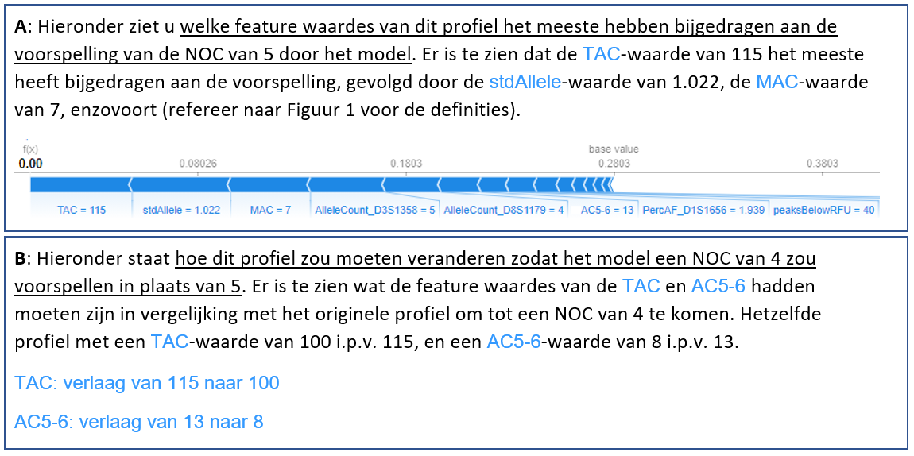

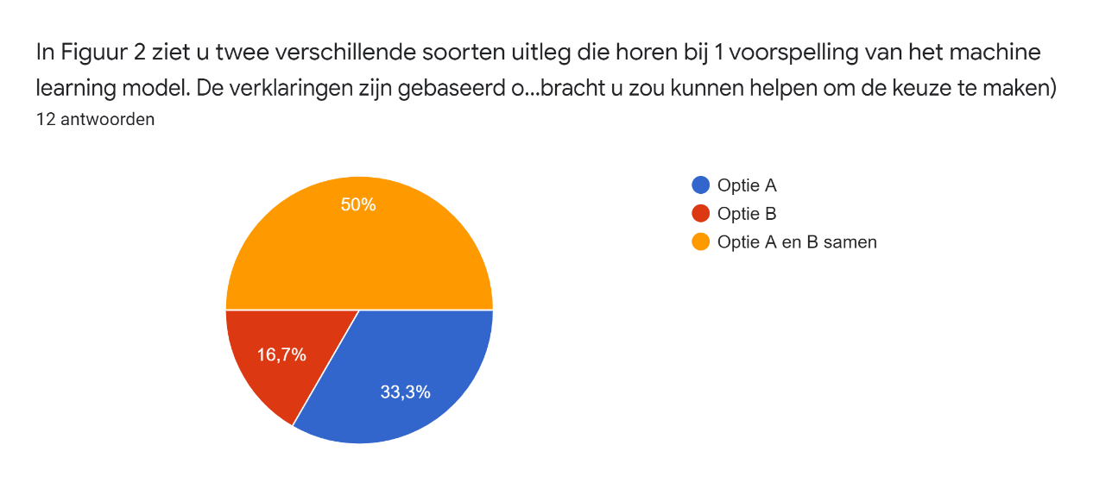

Explanations for choosing A:

* You want to know why the model predicted its result (2x)
* Easier to understand (1x)
* Option B is also good, but a visual explanation is better (1x)
* Option B is also good, but can the model know if the expert is interested in 4 or 6? (2x)

Explanations for choosing B:

* Is more specific for comparing one to another (2x), which is relevant for criminal case investigations (1x), option A is more background information.
* Option A and B together is also a good option.

Explanations for choosing A and B:

* Option B can provide very specific information (1x) (e.g. if the allele count on one locus were lower to get a different NOC, and it could be explained by stutter).
* Option B is relevant when you came to a different NOC than the tool outputs (2x)
* Option A tells you why it came to its result in the first place (4x).
* Option B tells you where the threshold values lie (1x).
* Option B tells you if the predictions were close together (1x).
* More convincing (1x)
* Combination of information makes the decision complete (1x)

## Features vs individual peak data

Which explanation type is more valuable to help make a decision between 4 or 5 donors?

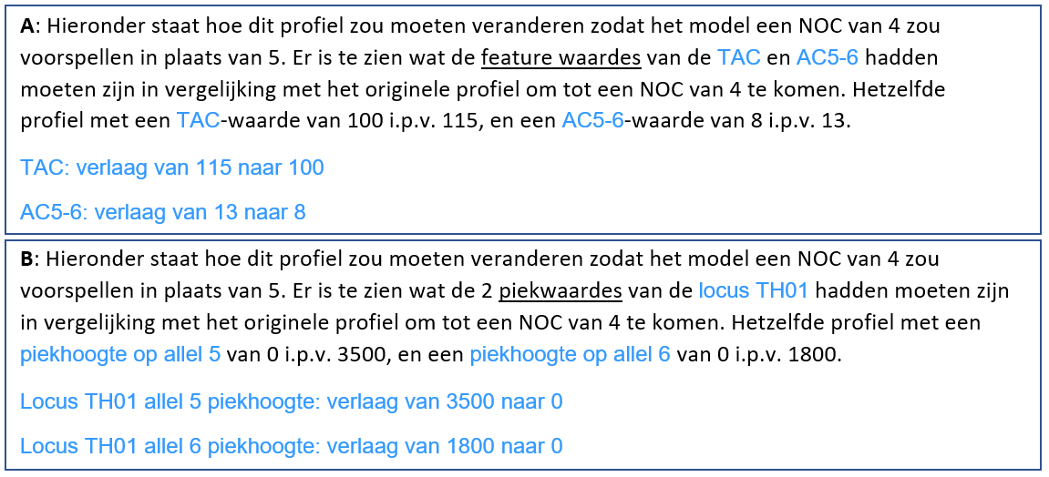

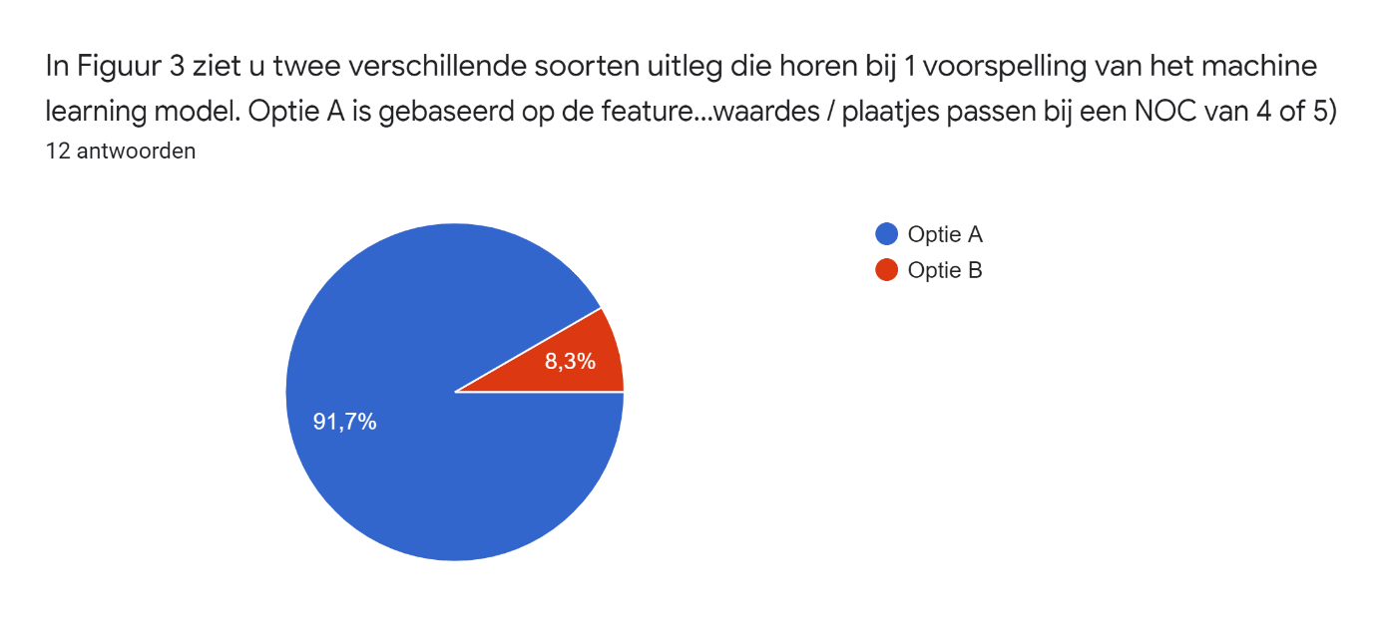

* The only person that picked Option B mentions heterozygote imbalance for which peak heights would be more informative, yet also mentions heightened levels of stutters, artefacts, drop-ins, which influence the TAC and MAC. A combination would be ideal.

Explanations for option A:

* When you change the peak heights, you essentially change the TAC/MAC/other features (1x).
* Changing peak heights / removing peaks at certain loci does not make sense to me (2x).
* Option B seems too trivial, it sounds like the prediction is based on only one locus (2x).
* I look at TAC/MAC, not the peak heights at one locus (1x).
* I prefer looking at the profile-level, not an individual locus. Even though it can influence a decision, it is not decisive.
* Option B would require a lot of research into individual loci, option A is enough (1x).
* Option A gives more information than the expert can see, whereas option B the expert probably already noticed (2x).
* Peak heights are not stable for the PPF6C kit! (1x), therefore I’d prefer seeing the influence of features (1x).