

Technical Safety Concept Lane Assistance

**Document Version: 1.0**

**Released on 2017-10-22**



# Document history

|  |  |  |  |
| --- | --- | --- | --- |
| Date | Version | Editor | Description |
| 2017-10-22 | 1.0 | Martin Hintz | Initial Version |
|  |  |  |  |
|  |  |  |  |
|  |  |  |  |
|  |  |  |  |

# 

# Table of Contents

Document history

Table of Contents

Purpose of the Technical Safety Concept

Inputs to the Technical Safety Concept

Functional Safety Requirements

Refined System Architecture from Functional Safety Concept

Functional overview of architecture elements

Technical Safety Concept

Technical Safety Requirements

Refinement of the System Architecture

Allocation of Technical Safety Requirements to Architecture Elements

Warning and Degradation Concept

# Purpose of the Technical Safety Concept

This document provides a detailed overview of the technologies present in the Lane Assistance item as of the product development phase of its life cycle, presented at the system level.

# Inputs to the Technical Safety Concept

## Functional Safety Requirements

|  |  |  |  |  |
| --- | --- | --- | --- | --- |
| **ID** | **Functional Safety Requirement** | **ASIL** | **Fault Tolerant Time Interval** | **Safe State** |
| Functional  Safety  Requirement  01-01 | The Electronic Power Steering ECU shall ensure that the lane departure warning oscillating torque amplitude is below  Max_Torque_Amplitude | C | 50 ms | Turn Off System |
| Functional  Safety  Requirement  01-02 | The Electronic Power Steering ECU shall ensure that the lane departure warning oscillating torque amplitude is below  Max_Torque_ Frequency | C | 50 ms | Turn Off System |
| Functional  Safety  Requirement  02-01 | The electronic power steering ECU  shall ensure that the lane keeping  assistance torque is applied for only  Max_Duration. | C | 500 ms | Turn Off System |

## Refined System Architecture from Functional Safety Concept

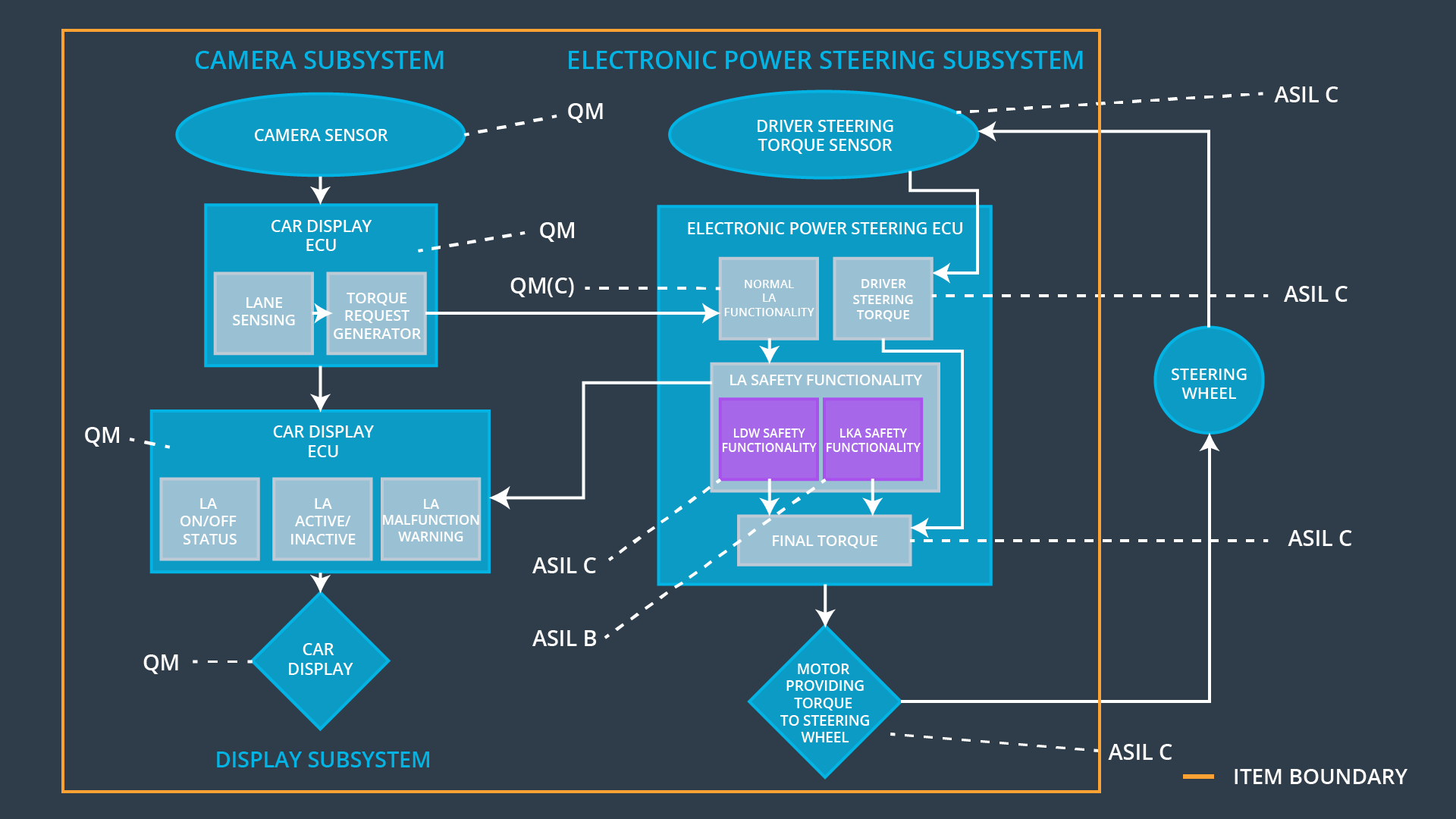

Figure : Refined Architecture of the Lane Assistance System

### 

### Functional overview of architecture elements

|  |  |
| --- | --- |
| **Element** | **Description** |
| Camera Sensor | One or more sensor(s) located at the front of the vehicle that collect(s) visual data (image, video). |
| Camera Sensor ECU - Lane Sensing | A computer (electronic control unit) that interprets data collected by the camera sensor(s) and that detects lane lines and triggers audio-visual warnings on the car display ECU. |
| Camera Sensor ECU - Torque request generator | A computer that interprets detected lane lines to identify and calculate steering corrections that trigger the power steering ECU. |
| Car Display | A physical display in front of the vehicle’s driver to provide audio-visual feedback. |
| Car Display ECU - Lane Assistance On/Off Status | A section in the car display to visualize the engagement status of the lane assistance item. |
| Car Display ECU - Lane Assistant Active/Inactive | A section in the car display to visualize the activation status of the lane assistance item. |
| Car Display ECU - Lane Assistance malfunction warning | A section in the car display to visualize the malfunction status of the Lane Assistance item. |
| Driver Steering Torque Sensor | A sensor that measures the torque applied to the  steering wheel by the driver. |
| Electronic Power Steering (EPS) ECU - Driver Steering Torque | A computer attached to the power steering that  converts torque applied by the driver to appropriate  steering actions for the vehicle |
| EPS ECU - Normal Lane Assistance Functionality | A computer attached to the power steering that controls the torque applied to the steering wheel when the Lane Assistance is operating normally. |
| EPS ECU - Lane Departure Warning Safety Functionality | A computer attached to the power steering that triggers warnings on the car display ECU if the vehicle is leaving its ego lane. |
| EPS ECU - Lane Keeping Assistant Safety Functionality | A computer attached to the power steering that triggers warnings on the car display ECU if the LKA is exceeding limits. |
| EPS ECU - Final Torque | A computer attached to the power steering that ensures torque frequency and amplitude applied to the steering wheel are within limits. |
| Motor | An actuator responsible for applying torque to the steering wheel. |

# Technical Safety Concept

## Technical Safety Requirements

**Lane Departure Warning (LDW) Requirements:**

Functional Safety Requirement 01-01 with its associated system elements

(derived in the functional safety concept)

|  |  |  |  |  |
| --- | --- | --- | --- | --- |
| **ID** | **Functional Safety Requirement** | **Electronic Power Steering ECU** | **Camera ECU** | **Car Display ECU** |
| Functional  Safety  Requirement  01-01 | The lane keeping item shall ensure that the lane departure oscillating torque amplitude is below Max_Torque_Amplitude | X |  |  |

Technical Safety Requirements related to Functional Safety Requirement 01-01 are:

|  |  |  |  |  |  |
| --- | --- | --- | --- | --- | --- |
| **ID** | **Technical Safety Requirement** | **ASIL** | **Fault Tolerant Time Interval** | **Architecture Allocation** | **Safe State** |
| Technical  Safety  Requirement  01 | The LDW safety component shall ensure that the amplitude of the 'LDW_Torque_Request' sent to the 'Final electronic power steering Torque’ component is below 'Max_Torque_Amplitude. | C | 50 ms | EPS ECU LDW Safety Functionality | Turn off system |
| Technical  Safety  Requirement  02 | As soon as the LDW function deactivates the LDW feature, the 'LDW Safety' software block shall send a signal to the car display ECU to turn on a warning light. | C | 50 ms | EPS ECU LDW Safety Functionality | Turn off system |
| Technical  Safety  Requirement  03 | As soon as a failure is detected by the LDW function, it shall deactivate the LDW feature and the 'LDW_Torque_Request' shall be set to zero. | C | 50 ms | EPS ECU LDW Safety Functionality | Turn off system |
| Technical  Safety  Requirement  04 | The validity and integrity of the data transmission for 'LDW_Torque_Request' signal shall be ensured. | C | 50 ms | EPS ECU LDW Data Integrity Check | Turn off system |
| Technical  Safety  Requirement  05 | Memory test shall be conducted at startup of the EPS ECU to check for any faults in memory. | A | Time of ignition Cycle | EPS ECU Memory Test | Turn off system |

Functional Safety Requirement 01-2 with its associated system elements

(derived in the functional safety concept)

|  |  |  |  |  |
| --- | --- | --- | --- | --- |
| **ID** | **Functional Safety Requirement** | **Electronic Power Steering ECU** | **Camera ECU** | **Car Display ECU** |
| Functional  Safety  Requirement  01-02 | The lane keeping item shall ensure that the lane departure oscillating torque frequency is below Max_Torque_Frequency | X |  |  |

Technical Safety Requirements related to Functional Safety Requirement 01-02 are:

|  |  |  |  |  |  |
| --- | --- | --- | --- | --- | --- |
| **ID** | **Technical Safety Requirement** | **ASIL** | **Fault Tolerant Time Interval** | **Architecture Allocation** | **Safe State** |
| Technical  Safety  Requirement  01 | The LDW safety component shall ensure that the amplitude of the 'LDW_Torque_Request' sent to the 'Final electronic power steering Torque’ component is below 'Max_Torque_Amplitude. |  | 50 ms | EPS ECU LDW Safety Functionality | Turn off system |
| Technical  Safety  Requirement  02 | As soon as the LDW function deactivates the LDW feature, the 'LDW Safety' software block shall send a signal to the car display ECU to turn on a warning light. |  | 50 ms | EPS ECU LDW Safety Functionality | Turn off system |
| Technical  Safety  Requirement  03 | As soon as a failure is detected by the LDW function, it shall deactivate the LDW feature and the 'LDW_Torque_Request' shall be set to zero. |  | 50 ms | EPS ECU LDW Safety Functionality | Turn off system |
| Technical  Safety  Requirement  04 | The validity and integrity of the data transmission for 'LDW_Torque_Request' signal shall be ensured. |  | 50 ms | EPS ECU LDW Data Integrity Check | Turn off system |
| Technical  Safety  Requirement  05 | Memory test shall be conducted at startup of the EPS ECU to check for any faults in memory. |  | Time of ignition  Cycle | EPS ECU Memory Test | Turn off system |

**Lane Departure Warning (LDW) Verification and Validation Acceptance Criteria:**

|  |  |  |
| --- | --- | --- |
| **ID** | **Validation Acceptance Criteria**  **and Method** | **Verification Acceptance Criteria and**  **Method** |
| Technical  Safety  Requirement  01 | Measure various LDW_Torque_Request values sent to the EPS Final Torque component to ensure all values are within limits. | All measured LDW_Torque_Request values sent to the Final EPS Torque component are within limits. |
| Technical  Safety  Requirement  02 | Test audio-visual warning display by artificially inducing a deactivation of the LDW | An audio-visual warning is displayed when the LDW function deactivates the LDW feature. |
| Technical  Safety  Requirement  03 | Test zero torque is applied by artificially inducing a deactivation of the LDW | The applied torque is set to zero as soon as the LDW function deactivates the LDW feature. |
| Technical  Safety  Requirement  04 | Test reliability and throughput of data connection. | Data is transmitted to the ECU within a specified data rate |
| Technical  Safety  Requirement  05 | Test for memory faults. | No memory faults are present during operation. |

**Lane Keeping Assistance (LKA) Requirements:**

Functional Safety Requirement 02-1 with its associated system elements

(derived in the functional safety concept)

|  |  |  |  |  |
| --- | --- | --- | --- | --- |
| **ID** | **Functional Safety Requirement** | **Electronic Power Steering ECU** | **Camera ECU** | **Car Display ECU** |
| Functional  Safety  Requirement  02-01 | The lane keeping item shall ensure that the lane keeping assistance torque is applied for only Max_Duration | X |  |  |

Technical Safety Requirements related to Functional Safety Requirement 02-01 are:

|  |  |  |  |  |  |
| --- | --- | --- | --- | --- | --- |
| **ID** | **Technical Safety Requirement** | **ASIL** | **Fault Tolerant Time Interval** | **Allocation to Architecture** | **Safe State** |
| Technical  Safety  Requirement  01 | The LKA safety component shall ensure that lane keeping assistance torque is applied only for Max_Duration |  | 500 ms | EPS ECU LDW Safety Functionality | Turn off system |
| Technical  Safety  Requirement  02 | As soon as a failure is detected by the LKA function, it shall deactivate the LKA feature and the LKA_Error_Status shall update the car display to display a malfunction warning light. |  | 500 ms | EPS ECU LDW Safety Functionality | Turn off system |
| Technical  Safety  Requirement  03 | As soon as the LKA function deactivates the LKA feature, the LKA Safety software block shall send an LKA_Activation_Status to the car display ECU to set the item to inactive status. |  | 500 ms | EPS ECU LDW Safety Functionality | Turn off system |
| Technical  Safety  Requirement  04 | The validity and integrity of the data transmission for the LKA Safety software block shall be ensured. |  | 500 ms | EPS ECU LDW Data Integrity Check | Turn off system |
| Technical  Safety  Requirement  05 | Memory test shall be conducted at startup of the EPS ECU to check for any faults in memory. |  | Time of ignition cycle | EPS ECU Memory Test | Turn off system |

**Lane Keeping Assistance (LKA) Verification and Validation Acceptance Criteria:**

|  |  |  |
| --- | --- | --- |
| **ID** | **Validation Acceptance Criteria**  **and Method** | **Verification Acceptance Criteria and**  **Method** |
| Technical  Safety  Requirement  01 | Measure various LKA_Torque_Request values sent to the EPS Final Torque component to ensure all values are within limits. | All measured LKA_Torque_Request values sent to the Final EPS Torque component are within limits. |
| Technical  Safety  Requirement  02 | Test audio-visual warning display by artificially inducing a deactivation of the LKA | An audio-visual warning is displayed when the LKA function deactivates the LKA feature. |
| Technical  Safety  Requirement  03 | Test zero torque is applied by artificially inducing a deactivation of the LKA | The applied torque is set to zero as soon as the LKA function deactivates the LKA feature. |
| Technical  Safety  Requirement  04 | Test reliability and throughput of data connection. | Data is transmitted to the ECU within a specified data rate |
| Technical  Safety  Requirement  05 | Test for memory faults. | No memory faults are present during operation. |

## Refinement of the System Architecture

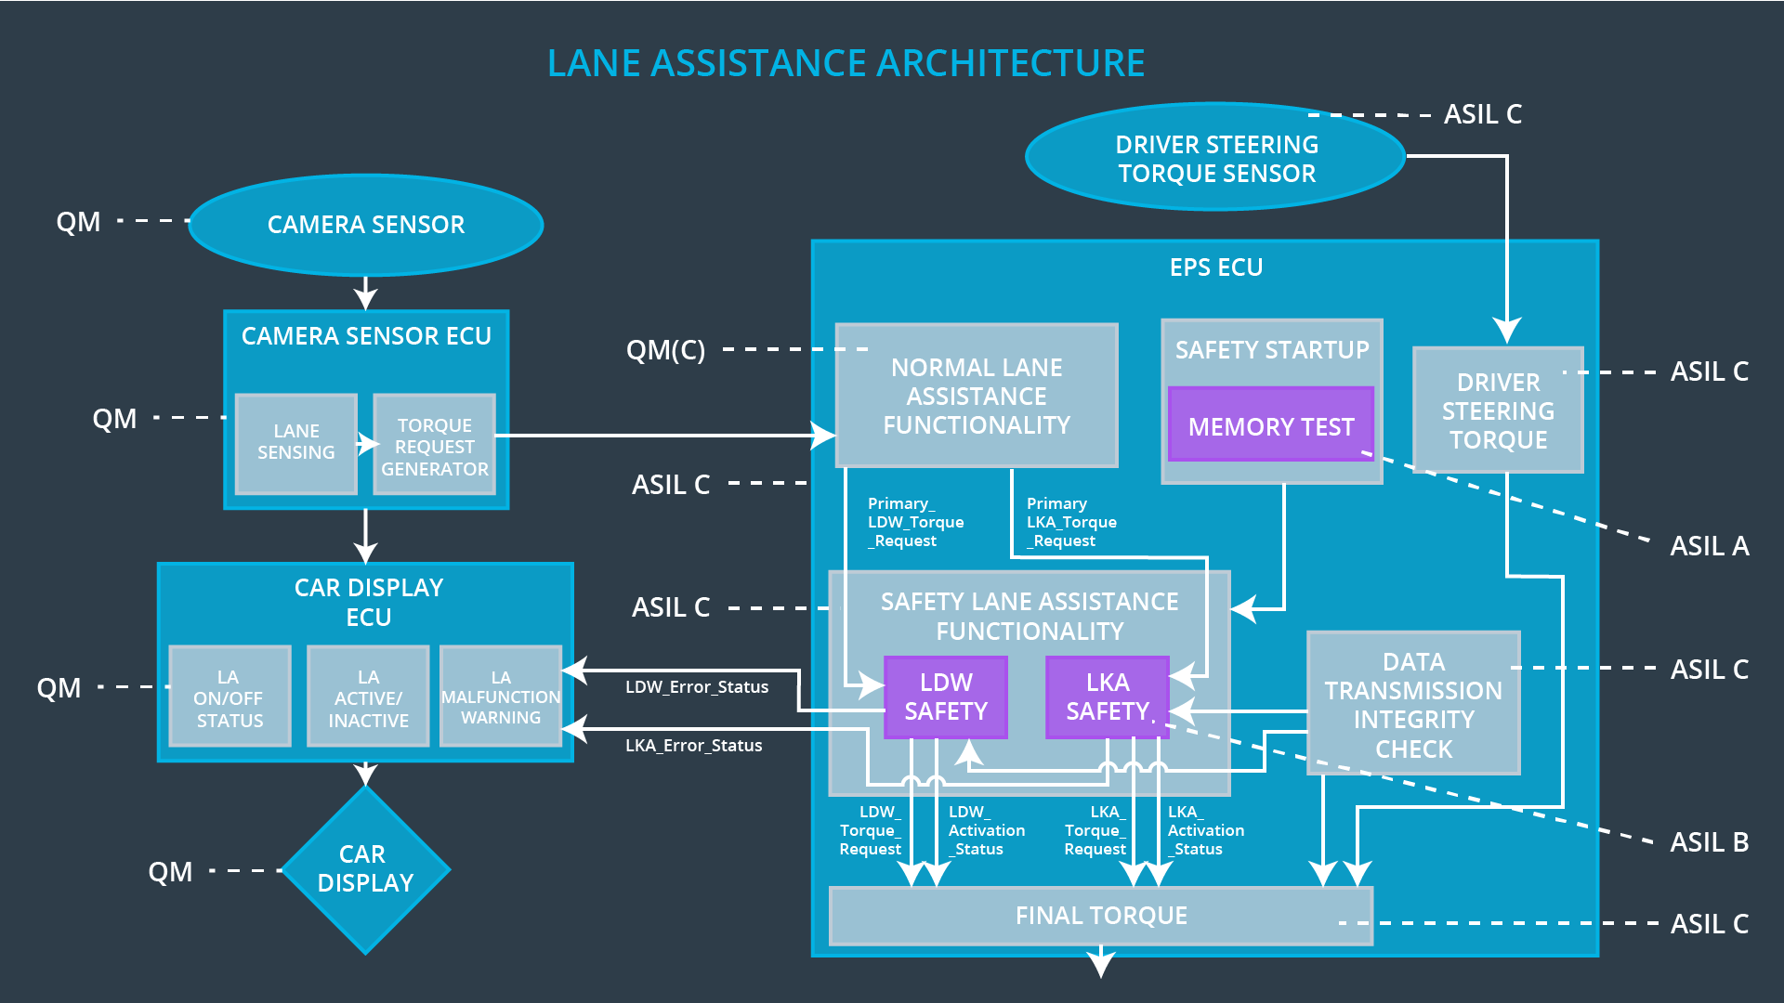

Figure : Refinement of the System Architecture of the Lane Assistance Functionality

## Allocation of Technical Safety Requirements to Architecture Elements

All technical safety requirements are allocated to the Electronic Power Steering ECU.

## Warning and Degradation Concept

|  |  |  |  |  |
| --- | --- | --- | --- | --- |
| **ID** | **Degradation**  **Mode** | **Trigger for**  **Degradation Mode** | **Safe State**  **Invoked?** | **Driver Warning** |
| WDC-01 | Turn off functionality | Malfunction_01  Malfunction_02 | Yes | Audio-visual warning in car display |
| WDC-02 | Turn off functionality | Malfunction_03 | Yes | Audio-visual warning in car display |