Curtin College

Bentley Campus

**Report**

**Assignment 2:**

**Vampirism Epidemic Simulation**

Mamert Vonn G. Santelices

Student ID: 90026174

# Abstract

This report aims to inform the World Health Organization to predict epidemic of a rare bat virus transmitted to a group of people in the deep jungles of Africa. An analysis will be performed based on the emulated data of the simulation to interpret and deduce actions to be taken by the World Health Organization to minimize the casualties of the epidemic. This study aims to limit the spread of the infection by deriving measures from the simulated data. It is recommended by the study to accommodate people in smaller groups and avoid in accommodating them within confined spaces. When the population of infect within a group exceed more than 3 it is very likely for that group to be eliminated, especially at densely populated area. Hence, people should be accommodated to large areas with a minimal amount of people occupying a square area.

# Background

The rare bat virus in the deep jungles of Africa causing them to live forever without the need of food or water. The infected people live with a continual desire to bite humans and drink their blood, hence spreading the infection through contact. As a result, the victims bitten by the vampire mutates to vampires themselves. The epidemic could potentially eliminate the human species if spread to densely populated cities, thus crumbling the current institutions and system.

# Methodology

An analysis is performed on the data provided by the simulated environment of the program used for the project. The program was designed with several assumption that may not be true to the greater population of the inflicted contagions. Therefore, data may not provide an accurate depiction of a realistic expectations. The program uses the Von Neumann neighbourhood algorithm when interacting with the simulation’s agents. The Von Neumann neighbourhood is classically defined in a two-dimensional square lattice composed of a central cell with 4 adjacent. Hence, it is often result in a diamond-shaped region. This neighbourhood can be used to define the notion of 4-connected pixels in computer graphics.

# Results

The figures above show that any time a spike in infection occur, thus wiping the human population, would then later slowly decline the vampire population. In the absence of humans, in-conflict between the vampires wipes out their population. Also, accommodating many citizens within an area could cause the initial spike of vampires and sharp downtrend of humans. Hence, areas need to only be occupied by a limited number of humans at a time since whenever vampire population is higher than 10%, then a likely wipe of human life is to occur.

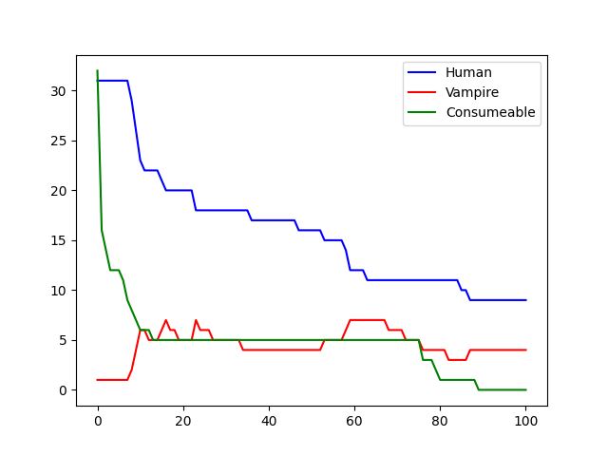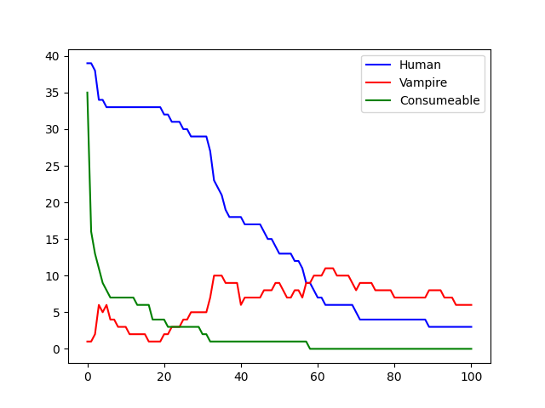The ideal scenario is to isolate the infected from the humans causing in-fighting that diminishes the vampire population.

# Conclusions

Based on the simulated data, people should be grouped in a wide living area that exceeds no more than 10-20 people. This prevents the vampires from exponentially spreading and the humans from sharply being wiped out. Scenario’s where the vampires are wiped out happened in instances where the human refugees is successful at hiding long enough for the vampire infighting to eliminate their population.