CHAPTER 34
Reason the Constitutional Argument Yourself:
The Open-Book Examination
A reader who has come this far is entitled to a fair question: how do I know the argument in these pages is sound, and not merely well built? The chapters have laid out the holdings, the statutes, and the asymmetry between the two halves of the patent term. Lawyers are reviewing the manuscript. But the reader need not wait for the lawyers, and need not take the author's word. The reader can test the argument directly.
The instrument for that test is now widely available, and it is worth being plain about what it is. A modern artificial-intelligence language model is, for practical purposes, something like a gifted graduate assistant — a fast study with a wide command of material and a strong instinct for logical consequence, though no judgment a court would defer to. The exercise in this chapter does to such a model what a professor does to a graduate student on the first day. It sends it back to school. It hands the model the syllabus — the Supreme Court holdings, the relevant constitutional text, and the governing federal statutes and regulations — together with plain diagrams showing what this book sees in that material. Then it asks the model to reason.
The point is not that a machine's agreement proves anything. A model is not a court. Its answers vary between systems, between versions, and between runs, and they can be wrong. The point is narrower and more interesting. If a range of these systems — built by different companies, trained on different data, carrying different dispositions — are handed the same neutral materials and asked to reason from them, do they converge? Or do they diverge? A leading question put to a single agreeable model proves nothing. The same neutral question, put to many independent ones, is a different kind of evidence: not proof, but a test of whether the conclusion follows from the authorities, or only from the way the author tells the story.

How the Examination Is Built
The examination is built like a trial, in three parts. First comes the law — the relevant Supreme Court holdings, the constitutional text, and the governing federal statutes and regulations, given whole, the cases that cut against this argument set beside the cases that favor it. Then come the two advocates — a case for restoring the public's right and a defense of the present system, each given equal space. Last comes the verdict — the reasoning of the artificial intelligence, after it holds the full law and has heard both sides.
One question this examination does not ask is who may bring such a case to court. That is the separate matter of standing and timing, taken up in Sovereign and Public-Fiduciary Plaintiffs, Direct and Associational Plaintiff Categories, and The Filable Case: Why 2026 and Not Before. This chapter tests the merits — whether the law permits the regulatory bar — not the procedure for raising the question. A juror weighing the merits need not know who the plaintiff is.
What follows is in two parts. Part One is the examination itself — the law, the two advocates, and the diagrams — written to be read by the AI, and available free of charge online at marti124.github.io/Patent_Exam. Part Two is for you: how to run the examination, the prompts to give the AI, and the sheet on which to score what it answers.

A note before the materials. Little in Part One is new to a reader who has come this far. The holdings below are the same cases walked in The Patent Clause Prong and The Takings Clause Prong — Graham’s grant-and-limitation, Singer’s public property, Scott Paper’s dedication to public use — stripped here to their operative language, the way a court would receive them, with the cases that cut against this book set beside the ones that favor it. You may read Part One as a review, skim it as a checklist, or skip directly to Part Two and let the machines do the reading. The materials are for them.

PART ONE — The Examination Materials (for the AI to read)
Everything in this part is the material the AI reads. It is published free of charge online at marti124.github.io/Patent_Exam, where it downloads under the filename The_Forgotten_Half_of_the_Patent_Clause_Exam.pdf. To run the examination, give the AI that PDF and then one of the prompts from Part Two. Nothing in this part tells the AI what to conclude.
Reasoning instruction: “You are given a set of legal materials and the arguments of two advocates. Reason from the materials provided. You may reason by analogy, extending the principles underlying these holdings to the facts presented; when you do, distinguish clearly between what a case holds and what you infer by extension. Be rigorous and concise.”
The Supreme Court holdings
1. Patterson v. Kentucky, 97 U.S. 501 (1878) — A patent does not exempt the patented article from generally applicable state safety regulation. Source: https://supreme.justia.com/cases/federal/us/97/501/
Operative language: The patent right “is not granted or secured without reference to the general powers which the several states of the Union unquestionably possess over their purely domestic affairs, whether of internal commerce or of police.”
2. Webber v. Virginia, 103 U.S. 344 (1880) — A patent confers the right to make and sell the invention, but does not place the article beyond the reach of general police-power regulation. Source: https://supreme.justia.com/cases/federal/us/103/344/
Operative language: “Letters patent granted by the United States do not exclude … the tangible property in which the invention or discovery is embodied” from a State’s tax or license law.
3. James v. Campbell, 104 U.S. 356 (1882) — A patent is private property; the federal government's use of a patented invention is a taking for which the owner must be compensated. Source: https://supreme.justia.com/cases/federal/us/104/356/
Operative language: A patent “confers upon the patentee an exclusive property in the patented invention which cannot be appropriated or used by the government itself, without just compensation, any more than it can appropriate or use without compensation land which has been patented to a private purchaser.”
4. Singer Manufacturing Co. v. June Manufacturing Co., 163 U.S. 169 (1896) — When the patents on a machine expire, its form becomes public property, free for anyone to make. Source: https://supreme.justia.com/cases/federal/us/163/169/
Operative language: “[T]he right to make the thing formerly covered by the patent becomes public property”; “there passes to the public the right to make the machine in the form in which it was constructed during the patent.” Along with the device, the generic name also “pass[es] to the public,” subject only to the maker’s duty to identify its own source. (163 U.S. at 185.)
5. McCormick Harvesting Machine Co. v. Aultman, 169 U.S. 606 (1898) — Once a patent issues it is the property of the patentee; only a court, not the granting agency, may set it aside. Source: https://supreme.justia.com/cases/federal/us/169/606/
Operative language: A patent, once issued, “is not subject to be revoked or canceled by the president, or any other officer of the government. … It has become the property of the patentee, and as such is entitled to the same legal protection as other property.”
6. Pennsylvania Coal Co. v. Mahon, 260 U.S. 393 (1922) — A regulation that diminishes property value too far may constitute a taking. Source: https://supreme.justia.com/cases/federal/us/260/393/
Operative language: “The general rule at least is that while property may be regulated to a certain extent, if regulation goes too far it will be recognized as a taking.”
7. Scott Paper Co. v. Marcalus Manufacturing Co., 326 U.S. 249 (1945) — The patent laws dedicate to public use the invention of an expired patent; no one may withhold that invention from public use. Source: https://supreme.justia.com/cases/federal/us/326/249/
Operative language: The patent laws “dedicate to public use the invention of an expired patent,” and do not contemplate that anyone may “withhold from the public the use of the invention of an expired patent.”
8. Bolling v. Sharpe, 347 U.S. 497 (1954) — The Fifth Amendment’s Due Process Clause imposes on the federal government an equal-protection obligation comparable to that the Fourteenth Amendment imposes on the states; federal action that draws unjustified distinctions between similarly situated persons is unconstitutional. Source: https://supreme.justia.com/cases/federal/us/347/497/
Operative language: “The concepts of equal protection and due process … are not mutually exclusive. … [D]iscrimination may be so unjustifiable as to be violative of due process.” It would be “unthinkable that the same Constitution would impose a lesser duty on the Federal Government.”
9. Williamson v. Lee Optical of Oklahoma, Inc., 348 U.S. 483 (1955) — Economic regulation is upheld under rational-basis review if it is rationally related to a legitimate government interest. Source: https://supreme.justia.com/cases/federal/us/348/483/
Operative language: “[T]he law need not be in every respect logically consistent with its aims to be constitutional. It is enough that there is an evil at hand for correction, and that it might be thought that the particular legislative measure was a rational way to correct it.”
10. Sears, Roebuck & Co. v. Stiffel Co., 376 U.S. 225 (1964) — An article whose patent has expired is in the public domain and may be made and sold by anyone. Source: https://supreme.justia.com/cases/federal/us/376/225/
Operative language: An article on which the patent has expired “may be made and sold by whoever chooses to do so.”
11. Graham v. John Deere Co., 383 U.S. 1 (1966) — The Patent Clause is both a grant of power and a limitation on it; Congress, in exercising the patent power, may not overreach the restraints imposed by the clause's stated purpose. Source: https://supreme.justia.com/cases/federal/us/383/1/
Operative language: The Patent Clause “is both a grant of power and a limitation,” and “Congress in the exercise of the patent power may not overreach the restraints imposed by the stated constitutional purpose.”
12. United States Department of Agriculture v. Moreno, 413 U.S. 528 (1973) — A classification fails rational-basis review where the only rationale for it is a bare desire to harm a disfavored group. Source: https://supreme.justia.com/cases/federal/us/413/528/
Operative language: “[I]f the constitutional conception of ‘equal protection of the laws’ means anything, it must at the very least mean that a bare congressional desire to harm a politically unpopular group cannot constitute a legitimate governmental interest.”
13. Penn Central Transportation Co. v. New York City, 438 U.S. 104 (1978) — Whether a regulation is a taking is judged by weighing its economic impact, its interference with investment-backed expectations, and the character of the government action. Source: https://supreme.justia.com/cases/federal/us/438/104/
Operative language: Relevant factors are “[t]he economic impact of the regulation on the claimant and, particularly, the extent to which the regulation has interfered with distinct investment-backed expectations … So, too, is the character of the governmental action.”
14. Andrus v. Allard, 444 U.S. 51 (1979) — A federal ban on the commercial sale of lawfully held property is not necessarily a taking where other uses of the property remain. Source: https://supreme.justia.com/cases/federal/us/444/51/
Operative language: “[W]here an owner possesses a full ‘bundle’ of property rights, the destruction of one ‘strand’ of the bundle is not a taking, because the aggregate must be viewed in its entirety.”
15. Aronson v. Quick Point Pencil Co., 440 U.S. 257 (1979) — Federal patent law does not displace ordinary state law governing a product; a contract or other general legal obligation tied to an invention remains enforceable whether or not the invention is patented. Source: https://supreme.justia.com/cases/federal/us/440/257/
Operative language: “Commercial agreements traditionally are the domain of state law. State law is not displaced merely because the contract relates to intellectual property which may or may not be patentable.”
16. Loretto v. Teleprompter Manhattan CATV Corp., 458 U.S. 419 (1982) — A permanent physical occupation of property is a per se taking. Source: https://supreme.justia.com/cases/federal/us/458/419/
Operative language: “[A] permanent physical occupation of property is a taking.”
17. Ruckelshaus v. Monsanto Co., 467 U.S. 986 (1984) — Intangible property, such as a trade secret, is protected property under the Takings Clause. Source: https://supreme.justia.com/cases/federal/us/467/986/
Operative language: “[T]o the extent that Monsanto has an interest in its health, safety, and environmental data cognizable as a trade-secret property right under … law, that property right is protected by the Taking Clause of the Fifth Amendment.”
18. City of Cleburne v. Cleburne Living Center, 473 U.S. 432 (1985) — A classification fails rational-basis review where it rests only on irrational prejudice against a disfavored group. Source: https://supreme.justia.com/cases/federal/us/473/432/
Operative language: “[M]ere negative attitudes, or fear … are not permissible bases” for unequal treatment; the permit denial rested on “an irrational prejudice.”
19. First English Evangelical Lutheran Church v. County of Los Angeles, 482 U.S. 304 (1987) — The Takings Clause does not forbid the government from taking property; it requires compensation when a taking occurs. Source: https://supreme.justia.com/cases/federal/us/482/304/
Operative language: The Takings Clause “does not prohibit the taking of private property, but instead places a condition on the exercise of that power” — the payment of just compensation.
20. Bonito Boats, Inc. v. Thunder Craft Boats, Inc., 489 U.S. 141 (1989) — Federal patent law leaves unpatented and patent-expired designs free for the public to copy; a government may not pull them back out of the public domain. Source: https://supreme.justia.com/cases/federal/us/489/141/
Operative language: “[F]ree exploitation of ideas will be the rule, to which the protection of a federal patent is the exception.” Federal law leaves patent-expired designs free for the public to copy.
21. Lucas v. South Carolina Coastal Council, 505 U.S. 1003 (1992) — A regulation that denies an owner all economically beneficial use of property is a per se taking. Source: https://supreme.justia.com/cases/federal/us/505/1003/
Operative language: When an owner is “called upon to sacrifice all economically beneficial uses in the name of the common good, that is, to leave his property economically idle, he has suffered a taking.”
22. Adarand Constructors, Inc. v. Peña, 515 U.S. 200 (1995) — The Fifth Amendment imposes on the federal government an equal-protection requirement equivalent to the one the Fourteenth Amendment imposes on the states. Source: https://supreme.justia.com/cases/federal/us/515/200/
Operative language: “[T]he equal protection obligations imposed by the Fifth and the Fourteenth Amendments [are] indistinguishable,” so that “the standards for federal and state racial classifications [are] the same.”
23. Romer v. Evans, 517 U.S. 620 (1996) — A classification fails even rational-basis review where it is explained only by animus toward those it disadvantages. Source: https://supreme.justia.com/cases/federal/us/517/620/
Operative language: “[Amendment 2] classifies homosexuals not to further a proper legislative end but to make them unequal to everyone else”; the law is “inexplicable by anything but animus toward the class it affects.”
24. Florida Prepaid Postsecondary Education Expense Board v. College Savings Bank, 527 U.S. 627 (1999) — A patent is a form of property, protected as other property is. Source: https://supreme.justia.com/cases/federal/us/527/627/
Operative language: “Patents … have long been considered a species of property.”
25. Eldred v. Ashcroft, 537 U.S. 186 (2003) — A copyright-term extension did not violate the “limited Times” prescription; Congress receives substantial deference in setting the duration of intellectual-property rights. Source: https://supreme.justia.com/cases/federal/us/537/186/
Operative language: A “limited” timespan means “confined within certain bounds, restrained, or circumscribed,” and “a timespan appropriately ‘limited’ as applied to future copyrights does not automatically cease to be ‘limited’ when applied to existing copyrights.”
26. Arkansas Game & Fish Commission v. United States, 568 U.S. 23 (2012) — Even temporary government-induced invasions of property may constitute takings. Source: https://supreme.justia.com/cases/federal/us/568/23/
Operative language: “[G]overnment-induced flooding temporary in duration gains no automatic exemption from Takings Clause inspection.”
27. Horne v. Department of Agriculture, 576 U.S. 350 (2015) — The per se takings rule applies with full force to the appropriation of personal property. Source: https://supreme.justia.com/cases/federal/us/576/350/
Operative language: “The Fifth Amendment requires that the Government pay just compensation when it takes personal property, just as when it takes real property.”
28. Kimble v. Marvel Entertainment, LLC, 576 U.S. 446 (2015) — When a patent expires, the right to make or use the article, free from all restriction, passes to the public. Source: https://supreme.justia.com/cases/federal/us/576/446/
Operative language: When a patent expires, “the right to make or use the article, free from all restriction, passes to the public.”
29. Cedar Point Nursery v. Hassid, 594 U.S. 139 (2021) — A regulation granting third parties a right of physical access to property, even for limited hours, is a per se physical taking. Source: https://supreme.justia.com/cases/federal/us/594/20-107/
Operative language: The access regulation “appropriates a right to invade the growers’ property and therefore constitutes a per se physical taking.”
30. Tyler v. Hennepin County, 598 U.S. 631 (2023) — The government cannot declare away a property interest that the law has historically recognized. Source: https://supreme.justia.com/cases/federal/us/598/22-166/
Operative language: A government “may not sidestep the Takings Clause by disavowing traditional property interests.”
31. Sheetz v. County of El Dorado, 601 U.S. 267 (2024) — A permit condition imposed by general legislation is still subject to takings scrutiny. Source: https://supreme.justia.com/cases/federal/us/601/22-1074/
Operative language: “The Takings Clause does not distinguish between legislative and administrative permit conditions.”
The regulatory facts
1. Federal energy and safety standards (administered by agencies including the EPA, NHTSA, and DOE) apply to a product according to the date it was manufactured. A product lawfully built to the standards in force in its year of manufacture remains lawful to own, use, sell, and register for the remainder of its service life, even after later standards take effect. This is commonly called grandfathering. Source: https://www.ecfr.gov/current/title-49/subtitle-B/chapter-V/part-571
Operative language: 49 C.F.R. §571.5(a): “[E]ach standard set forth in subpart B of this part applies according to its terms to all motor vehicles or items of motor vehicle equipment the manufacture of which is completed on or after the effective date of the standard.” 49 C.F.R. §567.4 (certification label): “This vehicle conforms to all applicable Federal motor vehicle safety standards in effect on the date of manufacture shown above.”
2. These standards tighten over time and are not, in practice, relaxed; a standard once in force sets a floor that subsequent standards meet or exceed. (One such floor is codified at 42 U.S.C. 6295(o)(1).) Source: https://www.law.cornell.edu/uscode/text/42/6295
Operative language: 42 U.S.C. §6295(o)(1): “The Secretary may not prescribe any amended standard which increases the maximum allowable energy use … or decreases the minimum required energy efficiency, of a covered product.”
3. A newly manufactured product must meet the standards in force in its year of manufacture, not the standards of any earlier year. Source: https://www.law.cornell.edu/uscode/text/42/7521
Operative language: 42 U.S.C. §7521(a)(1): “Such standards shall be applicable to such vehicles and engines for their useful life … whether such vehicles and engines are designed as complete systems or incorporate devices to prevent or control such pollution.”
4. As a result, a product that reproduces a design whose patents have all expired — built new today from that expired design — must meet today's standards. Because the design was certified to the standards of an earlier year, the newly built reproduction does not meet today's standards and may not be manufactured for sale, even though an identical unit built when the design was current remains lawful to own and operate indefinitely under grandfathering.
5. Patent terms are fixed by statute and expire on schedule. The regulatory standards described above have no expiration date. Source: https://www.law.cornell.edu/uscode/text/35/154
Operative language: 35 U.S.C. §154(a)(2): “[S]uch grant shall be for a term beginning on the date on which the patent issues and ending 20 years from the date on which the application for the patent was filed in the United States.”
The statutory and regulatory authority
A. Authority for the standards.
1. Clean Air Act, Pub. L. No. 91-604 (1970), as amended 1977 and 1990; codified at 42 U.S.C. 7401 et seq. Authorizes the EPA to set and enforce air-quality and motor-vehicle emissions standards. Source: https://www.law.cornell.edu/uscode/text/42/chapter-85
Operative language: 42 U.S.C. §7521(a)(1): “The Administrator shall by regulation prescribe (and from time to time revise) … standards applicable to the emission of any air pollutant from any class or classes of new motor vehicles or new motor vehicle engines … Such standards shall be applicable to such vehicles and engines for their useful life.”
2. Energy Policy and Conservation Act of 1975, Pub. L. No. 94-163; codified at scattered sections of 42 U.S.C. and 49 U.S.C., including the Corporate Average Fuel Economy program at 49 U.S.C. 32902. Source: https://www.ecfr.gov/current/title-10/chapter-II/subchapter-D
3. National Appliance Energy Conservation Act of 1987, Pub. L. No. 100-12, amending the Energy Policy and Conservation Act. Added the anti-backsliding provision at 42 U.S.C. 6295(o)(1), which provides that a federal energy-efficiency standard may be made more stringent over time but may not be made less stringent than the standard already in force. Source: https://www.govinfo.gov/app/details/GPO-CRECB-1987-pt3
4. Federal motor-vehicle safety authority: the Federal Motor Vehicle Safety Standards, administered by NHTSA and codified at 49 C.F.R. Part 571. A vehicle offered for sale new must comply with the standards in force for its model year. Source: https://www.federalregister.gov/documents/2024/05/09/2024-09462/federal-motor-vehicle-safety-standards-automatic-emergency-braking-systems-for-light-vehicles
5. The standards in (1)-(4) bind a product by its date or year of manufacture. A unit lawfully built to the standards in force when it was made remains lawful to own, use, and sell thereafter; a unit manufactured later must meet the standards in force at the later date.
6. The tightening is concrete. Under the Tier 1 standards (40 C.F.R. § 86.708-94, Table H94-4, full useful life; promulgated at 56 Fed. Reg. 25781, June 5, 1991), a gasoline passenger car met a full-useful-life NOx limit of 0.60 g/mi; light trucks were regulated on separate, weight-tiered limits set looser than the passenger-car standard. Under Tier 2 (40 C.F.R. § 86.1811-04; definitions at § 86.1803-01), cars and light trucks alike were brought to a single fleet-average NOx standard of 0.07 g/mi — for passenger cars, nearly a ninefold reduction — phased in from model year 2004 for cars and lighter trucks and from 2008 for the heaviest. Under Tier 3 (40 C.F.R. § 86.1811-17), both must meet a combined NMOG+NOx fleet average of 0.030 g/mi at full useful life — less than half the Tier 2 NOx figure, and now folding in the organic gases earlier tiers measured separately.
B. Doctrine bearing on the validity of such regulation.
6. Chevron U.S.A., Inc. v. Natural Resources Defense Council, Inc., 467 U.S. 837 (1984), as limited by Loper Bright Enterprises v. Raimondo, 603 U.S. 369 (2024) — Courts formerly deferred to an agency's reasonable reading of an ambiguous statute it administers; Loper Bright ended that deference, requiring courts to determine the best reading of the statute themselves. Source: https://supreme.justia.com/cases/federal/us/467/837/
Operative language: Chevron (Stevens, J.): “[I]f the statute is silent or ambiguous with respect to the specific issue, the question for the court is whether the agency’s answer is based on a permissible construction of the statute.” Loper Bright (Roberts, C.J.): “Chevron is overruled. Courts must exercise their independent judgment in deciding whether an agency has acted within its statutory authority … courts … may not defer to an agency interpretation of the law simply because a statute is ambiguous.”
7. West Virginia v. Environmental Protection Agency, 597 U.S. 697 (2022) — Under the major-questions doctrine, an agency asserting authority over a matter of vast economic and political significance must point to clear congressional authorization. Source: https://supreme.justia.com/cases/federal/us/597/20-1530/
Operative language: Under the major-questions doctrine, given “the history and the breadth of the authority that the agency has asserted and the economic and political significance of that assertion,” the agency must point to “clear congressional authorization.”
The case for restoring the public's right
• The Constitution grants exclusive rights only for limited Times. When that time ends, the design enters the public domain — free for all to make, use, and improve. The Supreme Court has said so for over a century, from Singer and Scott Paper to Sears, Bonito Boats, and Kimble.
• The patent bargain has two halves. The inventor receives a temporary monopoly. In exchange, the public receives the invention when the term ends. The patent term does end on schedule. But the regulatory regime applies by manufacture date. The original article stays lawful under its platform-year standards. A faithful public-domain remake is treated as a current-year manufacture and held to standards the original never had to meet. The problem is not that regulation continues. The problem is that the public receives the invention on a different regulatory timeline than the patent holder enjoyed.
• A faithful remake of a patent-expired design is treated as a new current-year product. So it must meet today’s standards, not the platform-year standards the original lawfully met and still carries through grandfathering. The remake is barred — not because the design was unlawful when certified, and not because the public seeks freedom from regulation, but because the compliance year has been shifted forward after the public’s right finally vests. The effect is to preserve the original manufacturer’s protection from low-cost remake competition with no terminus, defeating the public’s half of the bargain.
• The bar operates through regulation, but its source of power cannot save it. An agency holds no power its creating Congress did not have. And Congress could not grant perpetual exclusivity over an expired design under any of its powers, because “limited Times” limits the result, not the route. When a specific constitutional provision and a general one bear on the same act, the specific governs: the commerce and spending powers are general, but “limited Times” speaks directly to exclusive rights in inventions, and a general power may not accomplish what a specific provision forbids. The label on the statute does not control; the effect does. A safety or energy rule that, in operation, extends an inventor’s exclusivity past the term the Patent Clause fixed is doing the patent power’s forbidden work under another name. This conclusion is the argument’s own inference from the structure of the enumerated powers; no single case holds it.
• The same federal architecture treats the same design differently by who occupies the timeline. The original article, built during the patent holder’s period of exploitation, stays lawful indefinitely under its platform-year certification. The public’s faithful remake — built only after expiration, because the public was forbidden to build earlier — is barred by current-year standards. That is the relevant inequality. It is not merely a date distinction of ordinary safety law. In the patent setting, the date distinction decides whether the public ever receives the invention the Constitution required to pass to it at expiration. Bolling v. Sharpe (1954) and Adarand Constructors v. Peña (1995) confirm the federal government is not exempt from equality principles. But the more specific equality here comes from the Patent Clause itself: the patentee’s exclusive period and the public’s post-expiration period must be treated on parity.
• The remedy is narrow. A faithful remake of a fully patent-expired design is held to the federal safety, emissions, and energy standards of its certified platform year — the same standards the original met, and under which the original remains lawful — while newly designed products remain fully subject to current standards. The standard is time-shifted, not removed. The remake must independently certify that it contains nothing still under patent, avoids protected marks and trade dress, and satisfies the platform-year rules. The patent ends on schedule. Only the public’s long-promised right to build the expired design, on parity with the original timeline, is restored.
• The post-expiration commons is not theoretical. Remanufacturers abroad build new vehicles on patent-expired platforms today. The Mahindra Thar, built on the long-expired Jeep CJ platform, earned a five-star current-year crash rating from Bharat NCAP in 2024 and sells new for a fraction of its walled American counterpart. The lesson is not that remakes should be unregulated. It is that lawful remake markets can exist under certification regimes calibrated to the platform built, rather than treating every faithful remake as a newly invented current-year design. The American bar is a policy choice about regulatory timing, not an unavoidable safety necessity.
• Opening the commons does not destroy the original maker. The pre-1970 record shows the opposite: when a design’s protection lapsed, the original manufacturer routinely led the market that followed. Ford ran a dealer engine-exchange program; Detroit Diesel built its remanufacturing program in 1966; Singer continued to dominate sewing machines after its patents expired in 1877. The maker loses the unequal regulatory wall, not the business.
• The bar is not a minor regulatory detail; its economic scale is vast. A new full-size pickup consumed about 34 percent of a year’s median earnings in 1970 and about 54 percent in 2025 — the platform’s core patents long since expired, yet its price climbing as a share of income. Across the durable-goods categories where the bar bites — vehicles, farm and earth-moving equipment, trucking, HVAC and appliances, often compounding through several tiers of a product’s bill of materials — lawful platform-year remanufacture would, on the international and historical evidence, reduce prices substantially. A sustained wealth transfer of that magnitude is the vast economic and political significance that under West Virginia v. EPA demands clear congressional authorization, and the economic impact that Penn Central weighs in the takings analysis. The effect of the current rule is to deny the public the same regulatory timeline the original article received, thereby preserving the original makers’ commercial advantage against competition long after the patent term that alone was meant to grant it. The magnitude is not itself the constitutional argument; it is what makes the constitutional question consequential rather than academic.
The defense of the present system
• The federal energy and safety standards at issue are ordinary economic and public-welfare regulation, enacted under Congress's commerce and spending powers and administered by agencies Congress authorized. Under Williamson v. Lee Optical, such regulation is valid if rationally related to a legitimate interest, and reducing emissions, fuel use, and crash risk is plainly legitimate.
• The standards do not mention patents and do not turn on patent status. They bind every new manufacture alike, by date of manufacture — a neutral, administrable line long accepted in safety law. That a patent has expired changes nothing: Patterson v. Kentucky, Webber v. Virginia, and Aronson v. Quick Point establish that a patent never exempted its article from general regulation, so the expiry of a patent cannot create an exemption that never existed.
• The limited Times clause constrains the patent power; it says nothing about the commerce or spending powers under which these standards are enacted. Eldred v. Ashcroft shows the Court will not read limited Times expansively to override Congress's considered judgments about the scope of intellectual-property and related regulation.
• No taking occurs. Under Penn Central, a manufacturer has no investment-backed expectation in building to superseded standards; and under Andrus v. Allard, a restriction on one commercial use — selling newly built copies — is not a taking where the design may still be studied, improved, and built into new compliant products.
• The asymmetry the challengers decry is the asymmetry every safety regime produces: an old building need not be torn down, but a new one must meet the current code. Finally, the relief sought would require courts to manage a sprawling certification regime and to second-guess technical standards across the durable-goods economy — a task West Virginia v. EPA and separation-of-powers principles commit to Congress and the agencies. If the line is to change, Congress can change it.
• As for foreign practice: vehicles certified to foreign standards are not certified to current U.S. safety and emissions requirements. That much of the world permits patent-expired manufacture shows the American bar is a policy choice, but not that removing it would be safe or that foreign outcomes would transfer. And whatever the original maker’s commercial prospects, the constitutional question is the validity of the regulation, not the fortunes of any firm.
• The scale of potential savings, however large, is a matter for Congress, not a constitutional defect. Rational-basis review does not ask whether a regulation is costly; the major-questions doctrine asks whether the agency had authority over the subject, not the dollar value of relief foregone; and that incumbents benefit from a regulation does not make it invalid — most regulation advantages someone. A price-to-income ratio is a policy grievance, not a constitutional injury.

The Diagrams
Four diagrams accompany the examination. The first three carry the geometry of the problem and of the proposed remedy over time. The fourth states the limiting principle: the gates a build must pass to enter the narrow class the remedy reaches. They are part of this material; an AI reading this file reads them along with the rest.
Diagram T1. Patent term and regulatory standard over time.
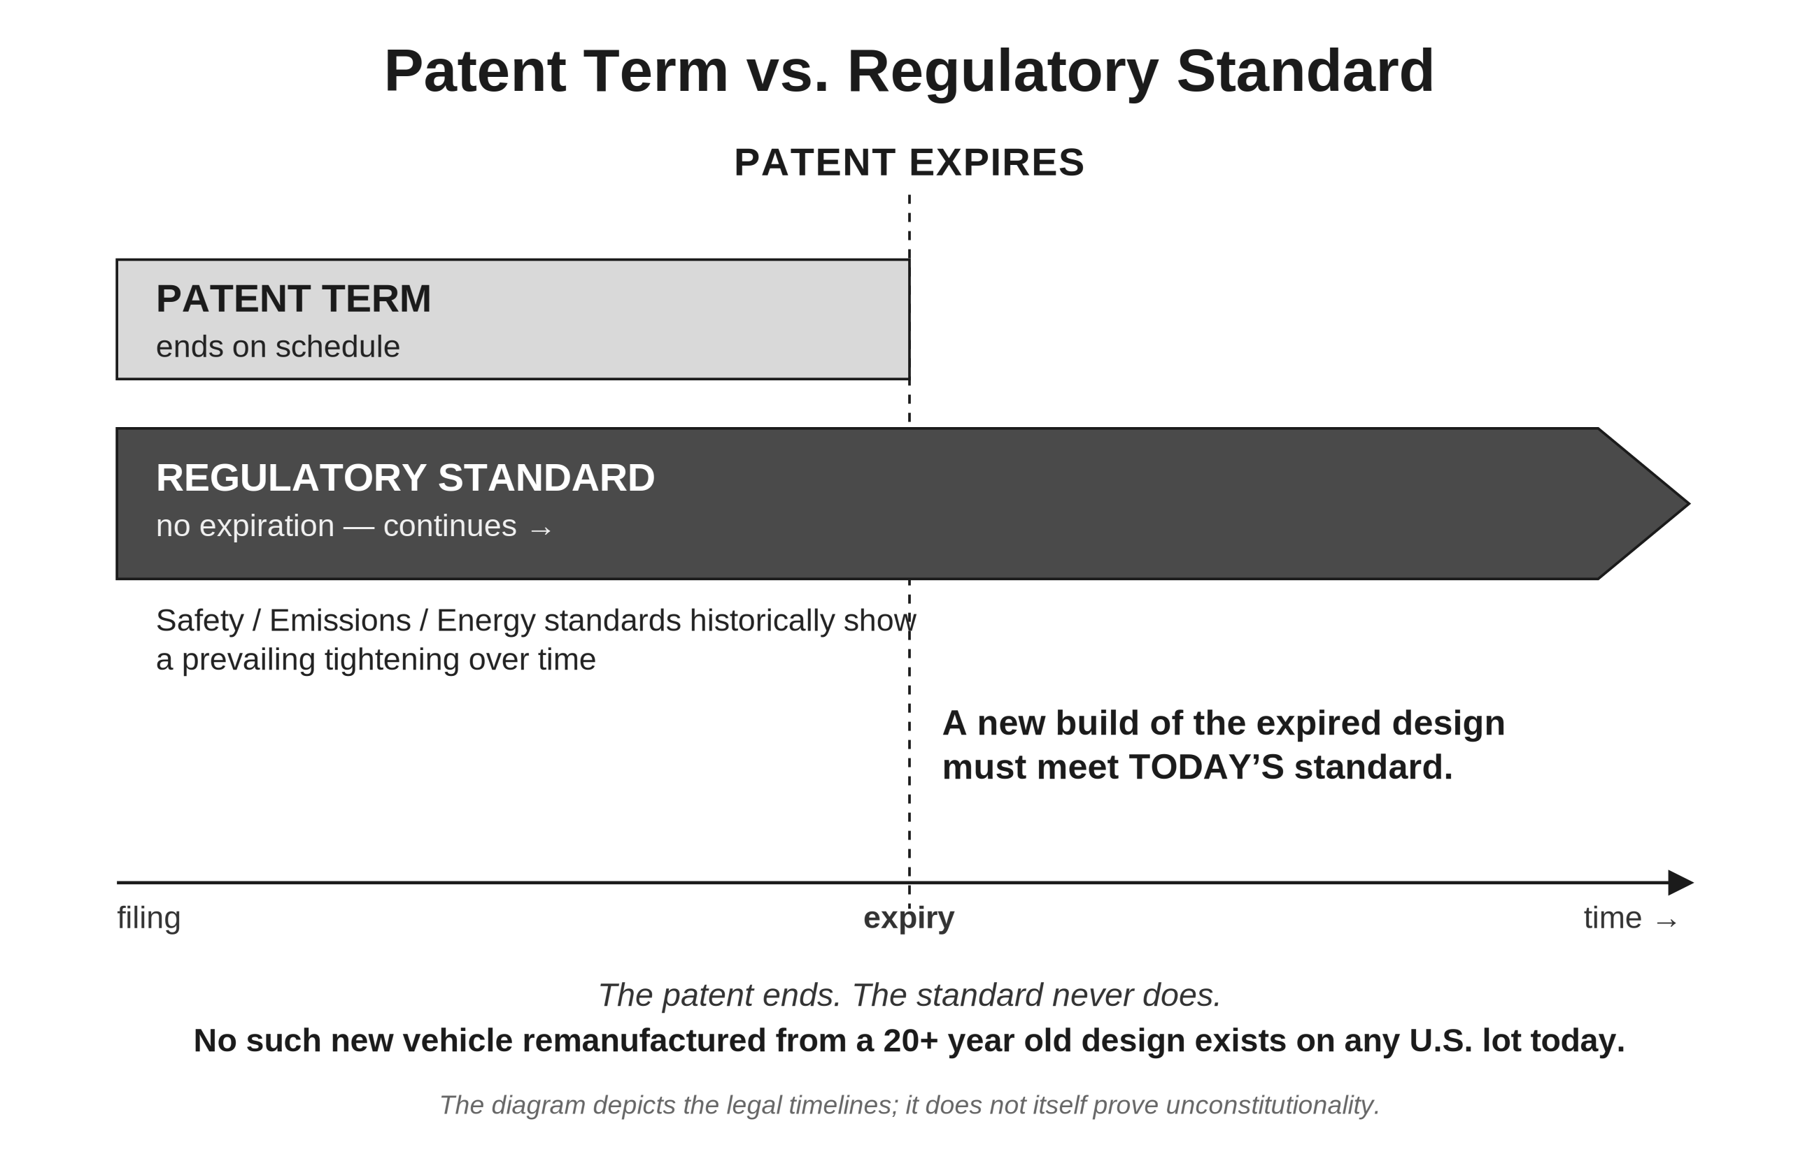

Diagram T2. The same design; one build exists, one cannot.
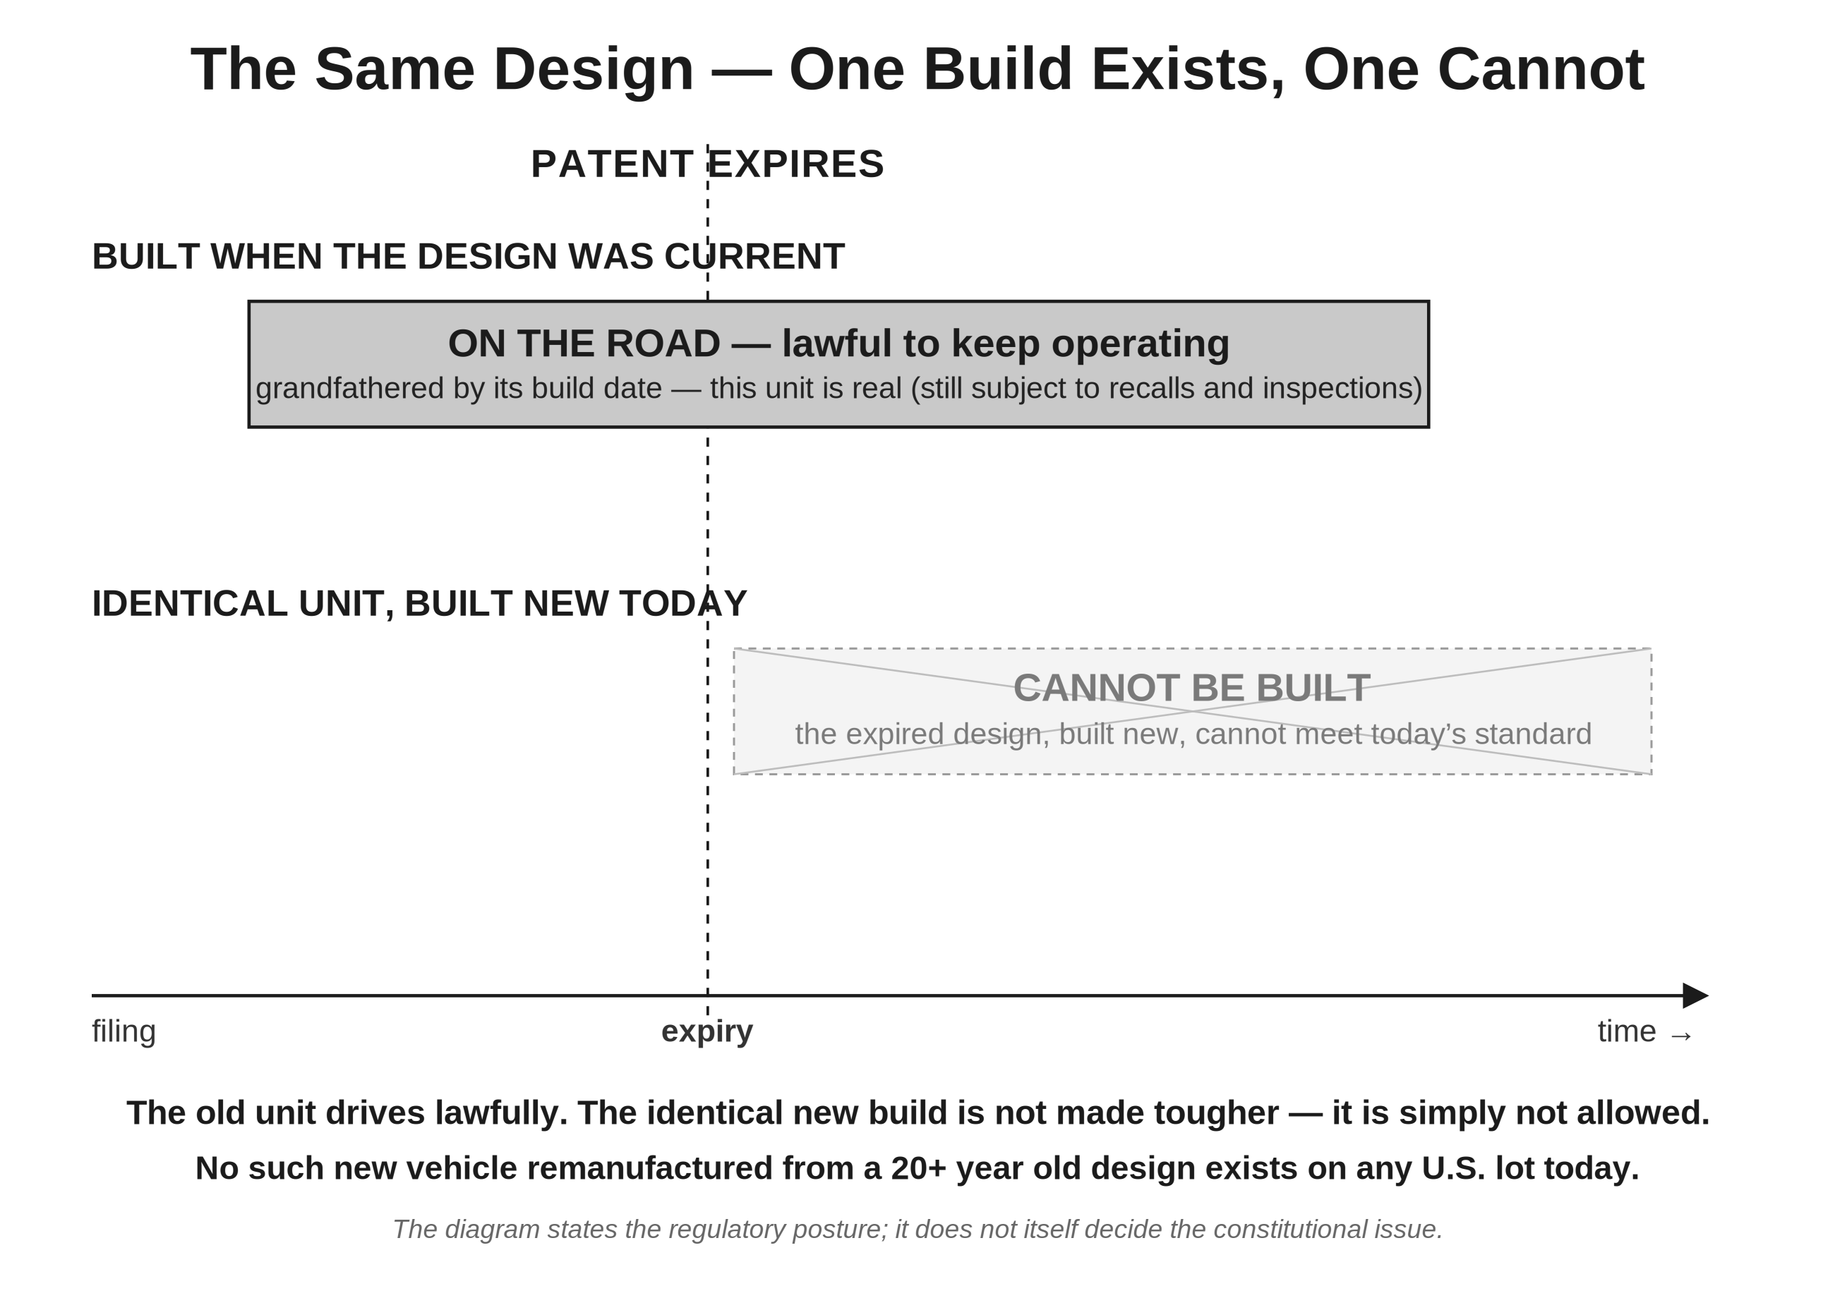

Diagram T3. Platform-year parity: the three-lane remedy.
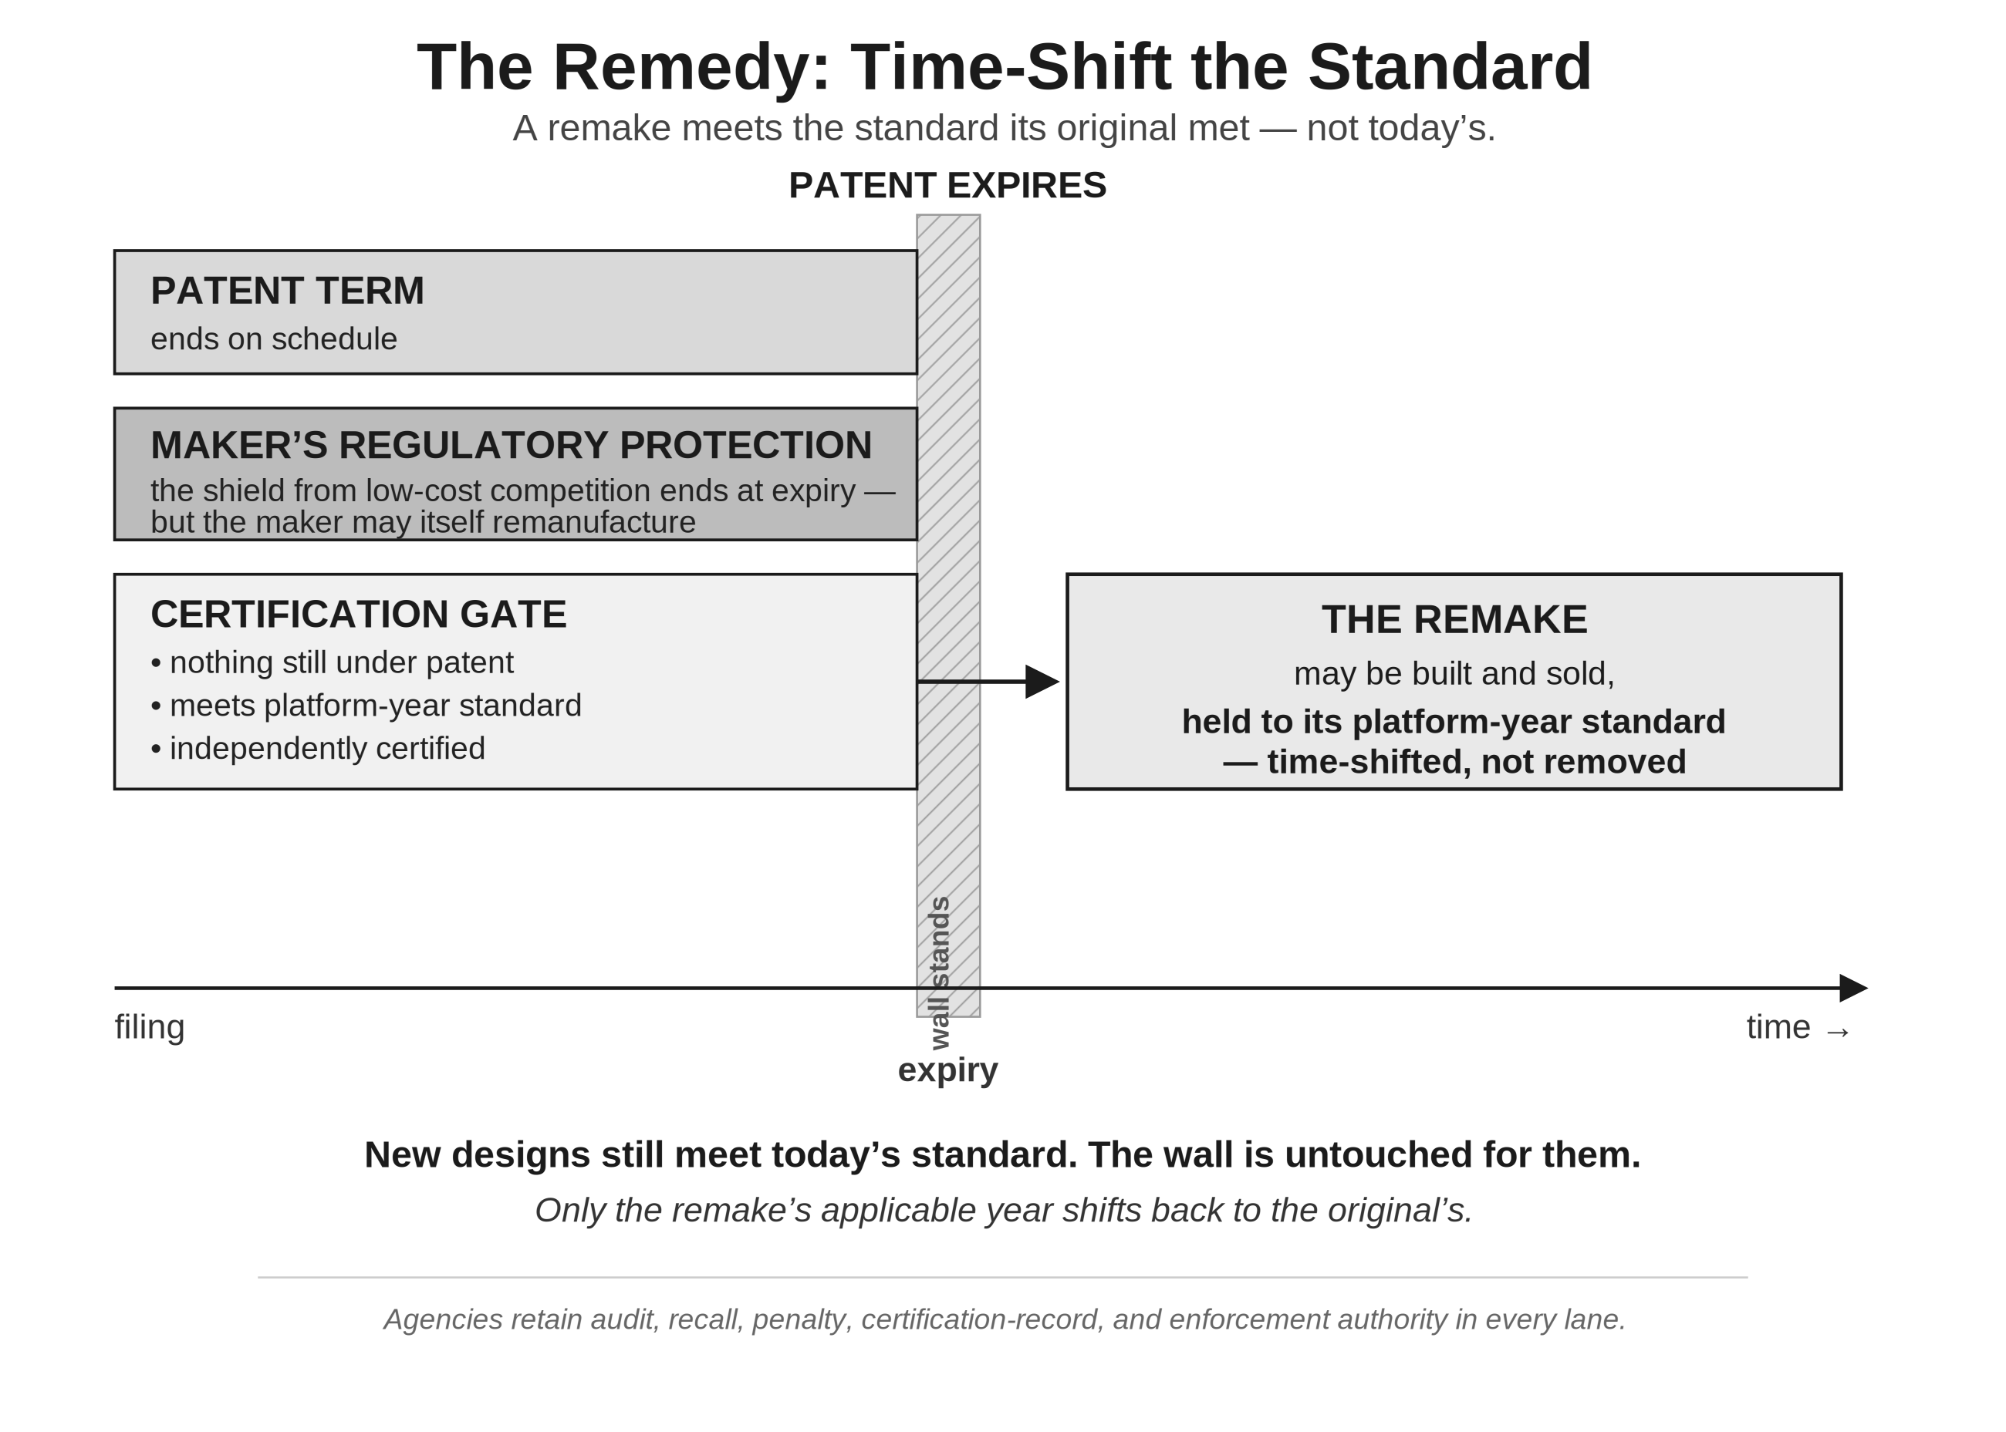

Diagram T4. The narrow constitutional class: the gates a build must pass.
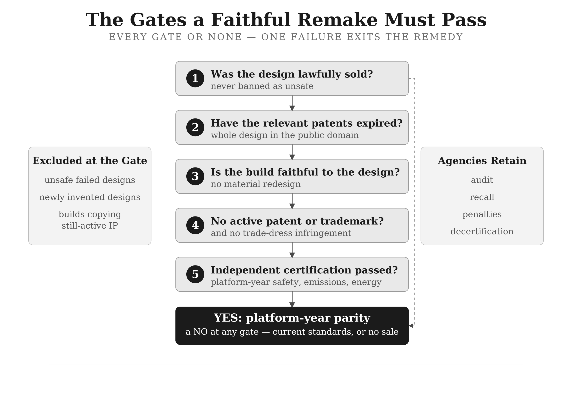

The Standards Tables
Two tables accompany the diagrams. Each compares a platform as it was lawfully built against what a faithful new copy of that same platform would have to satisfy in the year its patents expire, twenty years later. One table covers passenger cars; the other covers light trucks and pickups, whose standards differ in places.
Built-to emissions is the EPA light-duty tier in force when the platform was certified — Tier 1 (the standard codified from 1991) or Tier 2 (phased in from model year 2004). Must meet at expiry is the tier a new build must satisfy in the expiry year. Every expiry year shown is 2020 or later, so every copy must meet Tier 3, the standard in force since model year 2017, which no Tier 1 or Tier 2 platform was engineered to meet.
The three safety columns each name a federal requirement set by date of manufacture. An entry such as “→ req. MY08,” “→ req. MY12,” “→ req. MY13,” or “→ req. MY14” means the standard was not required when the platform was built but was required by the model year shown — tire-pressure monitoring (FMVSS 138) for model year 2008, electronic stability control (FMVSS 126) for 2012, and the side-impact pole test (FMVSS 214) for 2013 for passenger cars and 2014 for the heavier light trucks. A dash (“—”) means the standard was already required when that platform was built, so it is not a new requirement at expiry and is shown as a dash. A row appears only where at least one requirement differs between the build year and the expiry year; where every tracked requirement was identical at both points, the row is omitted.
The requirements tracked here are not exhaustive. A further federal standard — automatic emergency braking (FMVSS 127), finalized in 2024 and codified for model year 2030 — follows the same date-of-manufacture pattern and would apply to platforms built as late as 2029, but it is omitted from these tables because, as of 2026, it remains under petition for reconsideration and its compliance date may change.
Table T5. Passenger cars: standards in force at build, and standards a faithful remake must meet at patent expiry.
Filed | Patents expire | Built-to emissions | Must meet at expiry | TPMS (FMVSS 138) | ESC (FMVSS 126) | Side-impact (FMVSS 214)
2000–2003 | 2020–2023 | Tier 1 | Tier 3 | → req. MY08 | → req. MY12 | → req. MY13
2004–2007 | 2024–2027 | Tier 2 | Tier 3 | → req. MY08 | → req. MY12 | → req. MY13
2008–2011 | 2028–2031 | Tier 2 | Tier 3 | — | → req. MY12 | → req. MY13
2012 | 2032 | Tier 2 | Tier 3 | — | — | → req. MY13

Table T6. Light trucks and pickups: standards in force at build, and standards a faithful remake must meet at patent expiry.
Filed | Patents expire | Built-to emissions | Must meet at expiry | TPMS (FMVSS 138) | ESC (FMVSS 126) | Side-impact (FMVSS 214)
2000–2003 | 2020–2023 | Tier 1 | Tier 3 | → req. MY08 | → req. MY12 | → req. MY14
2004–2007 | 2024–2027 | Tier 2 | Tier 3 | → req. MY08 | → req. MY12 | → req. MY14
2008–2012 | 2028–2032 | Tier 2 | Tier 3 | — | → req. MY12 | → req. MY14
2013 | 2033 | Tier 2 | Tier 3 | — | — | → req. MY14

