1. Assumed initial conditions and analytic model
The halo is assumed to follow a truncated NFW profile with characteristic density ρs, scale radius rs, and outer truncation radius Rvir. The density profile is ρ(r) = ρs / [(r/rs)(1 + r/rs)^2]. The enclosed mass follows the standard NFW expression M(<r) = 4πρsrs^3 [ln(1+x) - x/(1+x)], where x = r/rs. The truncated potential is written so that Φ(Rvir) = 0.
The analysis script discretizes the halo into logarithmically spaced shells, which is a convenient choice because an NFW profile spans many orders of magnitude in radius and the inner halo is much more strongly resolved on a log grid. For each shell, the code computes the shell mass, the contribution of that shell to the central potential, the outer-potential fraction as a function of cutoff radius, and the force contribution at a finite probe radius.

2. Interpretation of the results

2.1 Enclosed mass and shell mass fraction
The enclosed-mass plot shows the expected monotonic NFW growth with radius, while the shell-mass fraction increases toward larger radii. This means that the outer halo contains a substantial part of the total mass budget. The result is qualitatively consistent with the idea that replacing the outer region by a smooth analytic potential can capture an important part of the halo structure without retaining every outer particle.
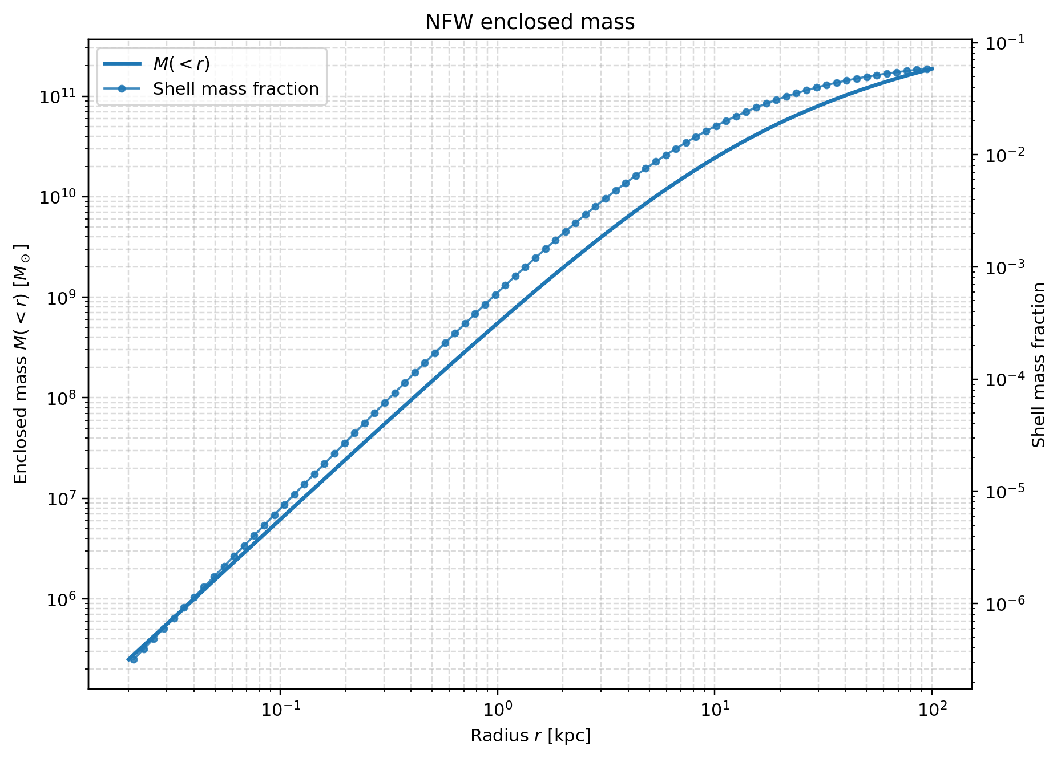

2.2 Central potential contribution
The central-potential plot is the most direct evidence in favor of the hybrid model. It shows that shells at radii well outside the centre still make a sizeable contribution to the potential depth at r = 0. This is exactly what is expected for a spherical halo: outer matter does not change the force at the centre, but it does deepen the potential well and therefore changes the escape-speed scale. The result supports the statement that the inner halo is influenced by the outer halo through the potential background.
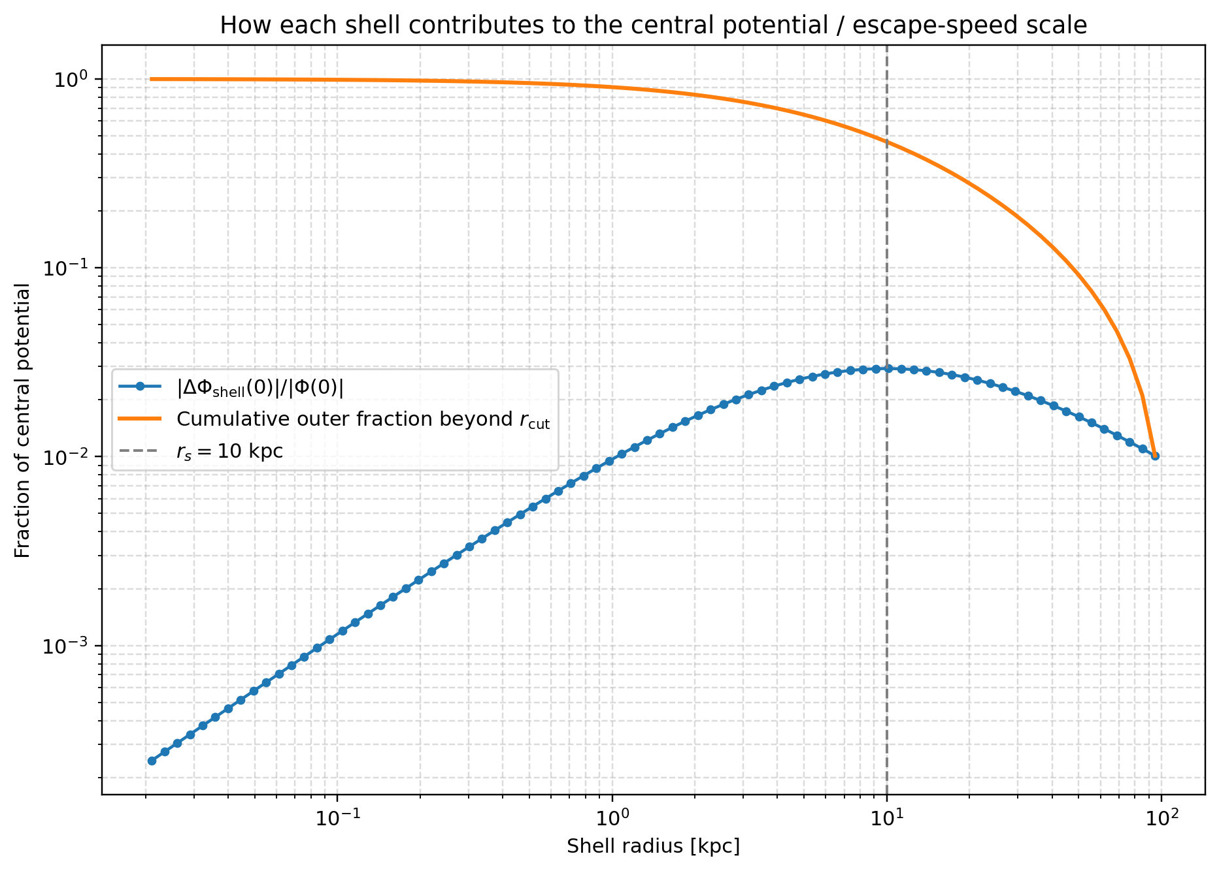

2.3 Outer-potential fraction versus cutoff radius
The cutoff-radius plot shows that the fraction of the potential coming from material outside rcut decreases as the cutoff is moved outward. This is the key diagnostic for selecting a truncation radius. If the outer-potential fraction remains large for the inner radii of interest, then the outer halo cannot be ignored or replaced by a crude boundary. Instead, it should be represented by a smooth analytic component.
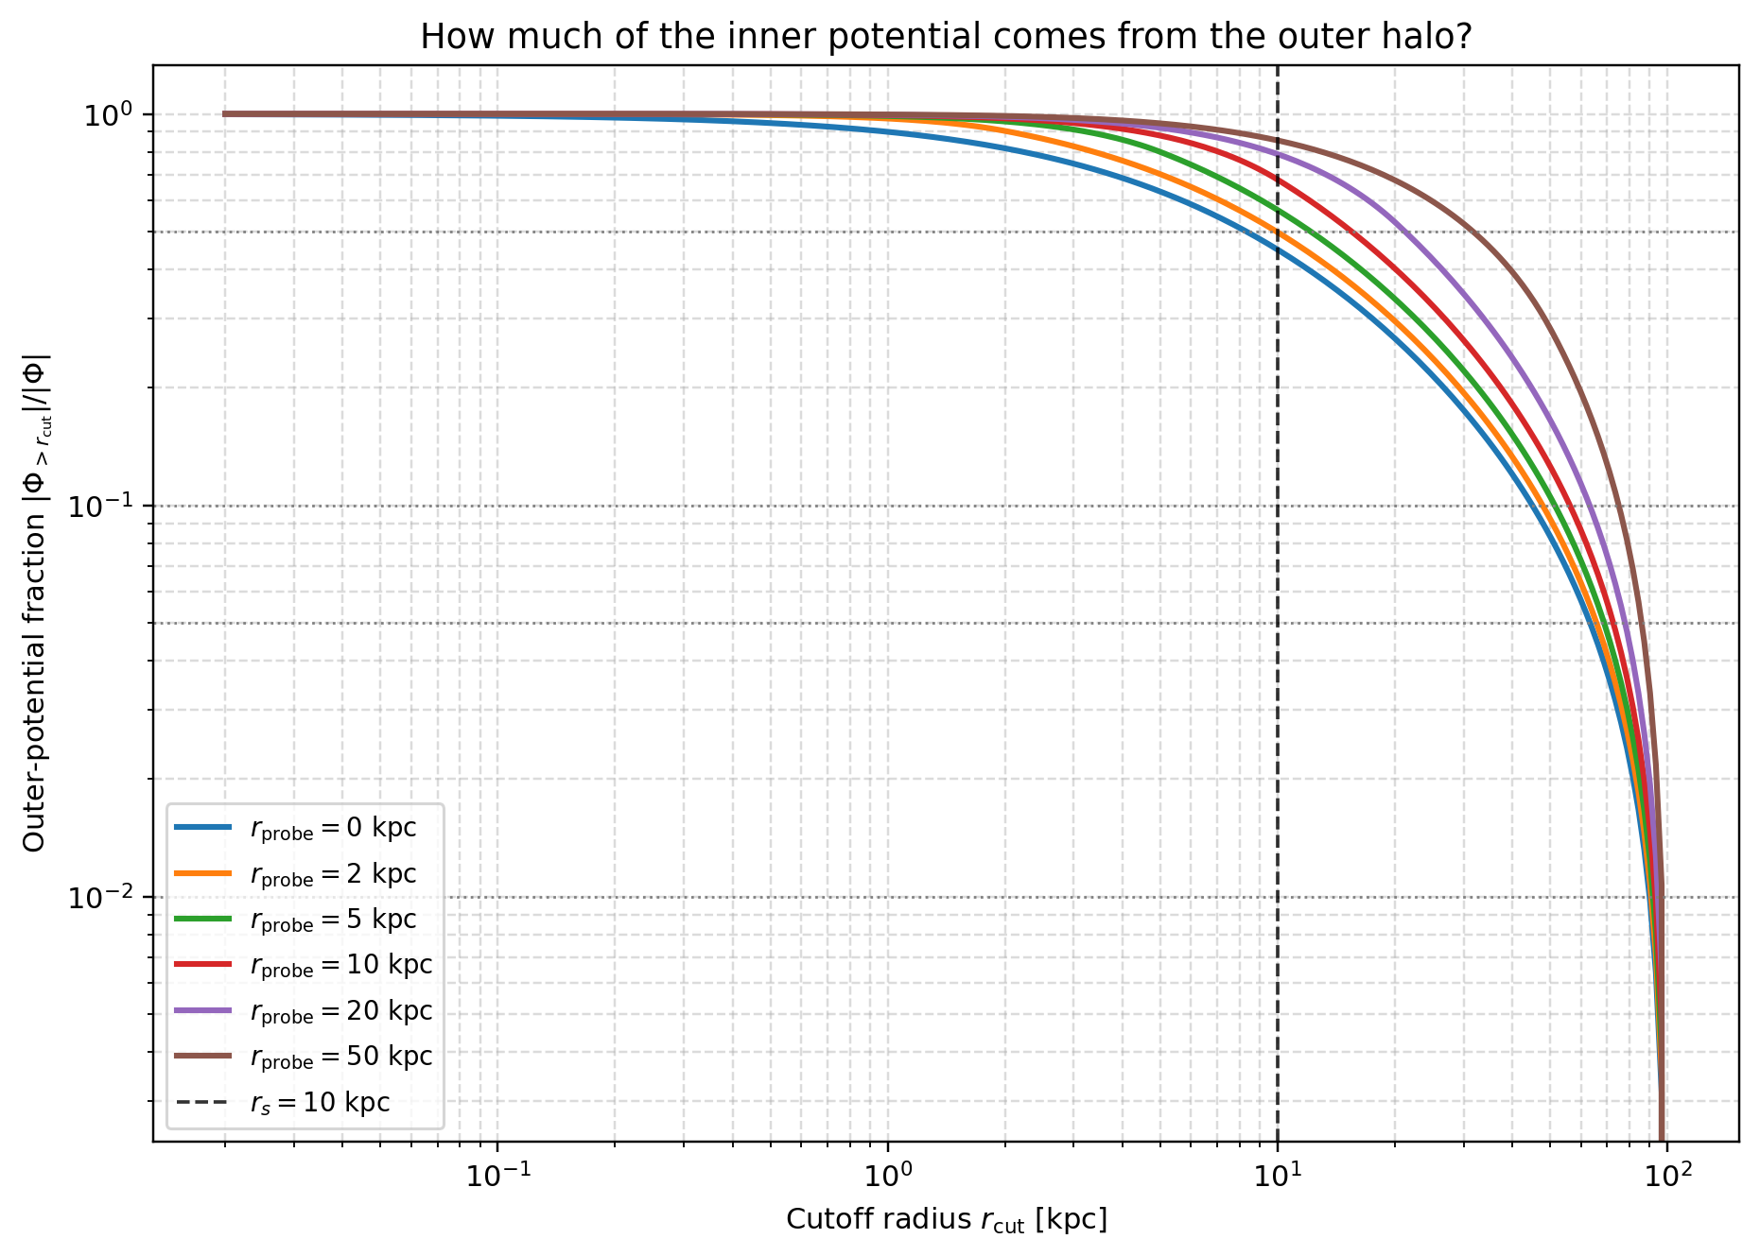

2.4 Two-dimensional outer-fraction map
The 2D map summarizes the same physics in a more compact form. It shows that the outer-halo contribution is large over most of the inner region when the cutoff is small, and it only becomes negligible when the cutoff approaches the outer halo edge. This figure is useful for choosing a practical rcut.
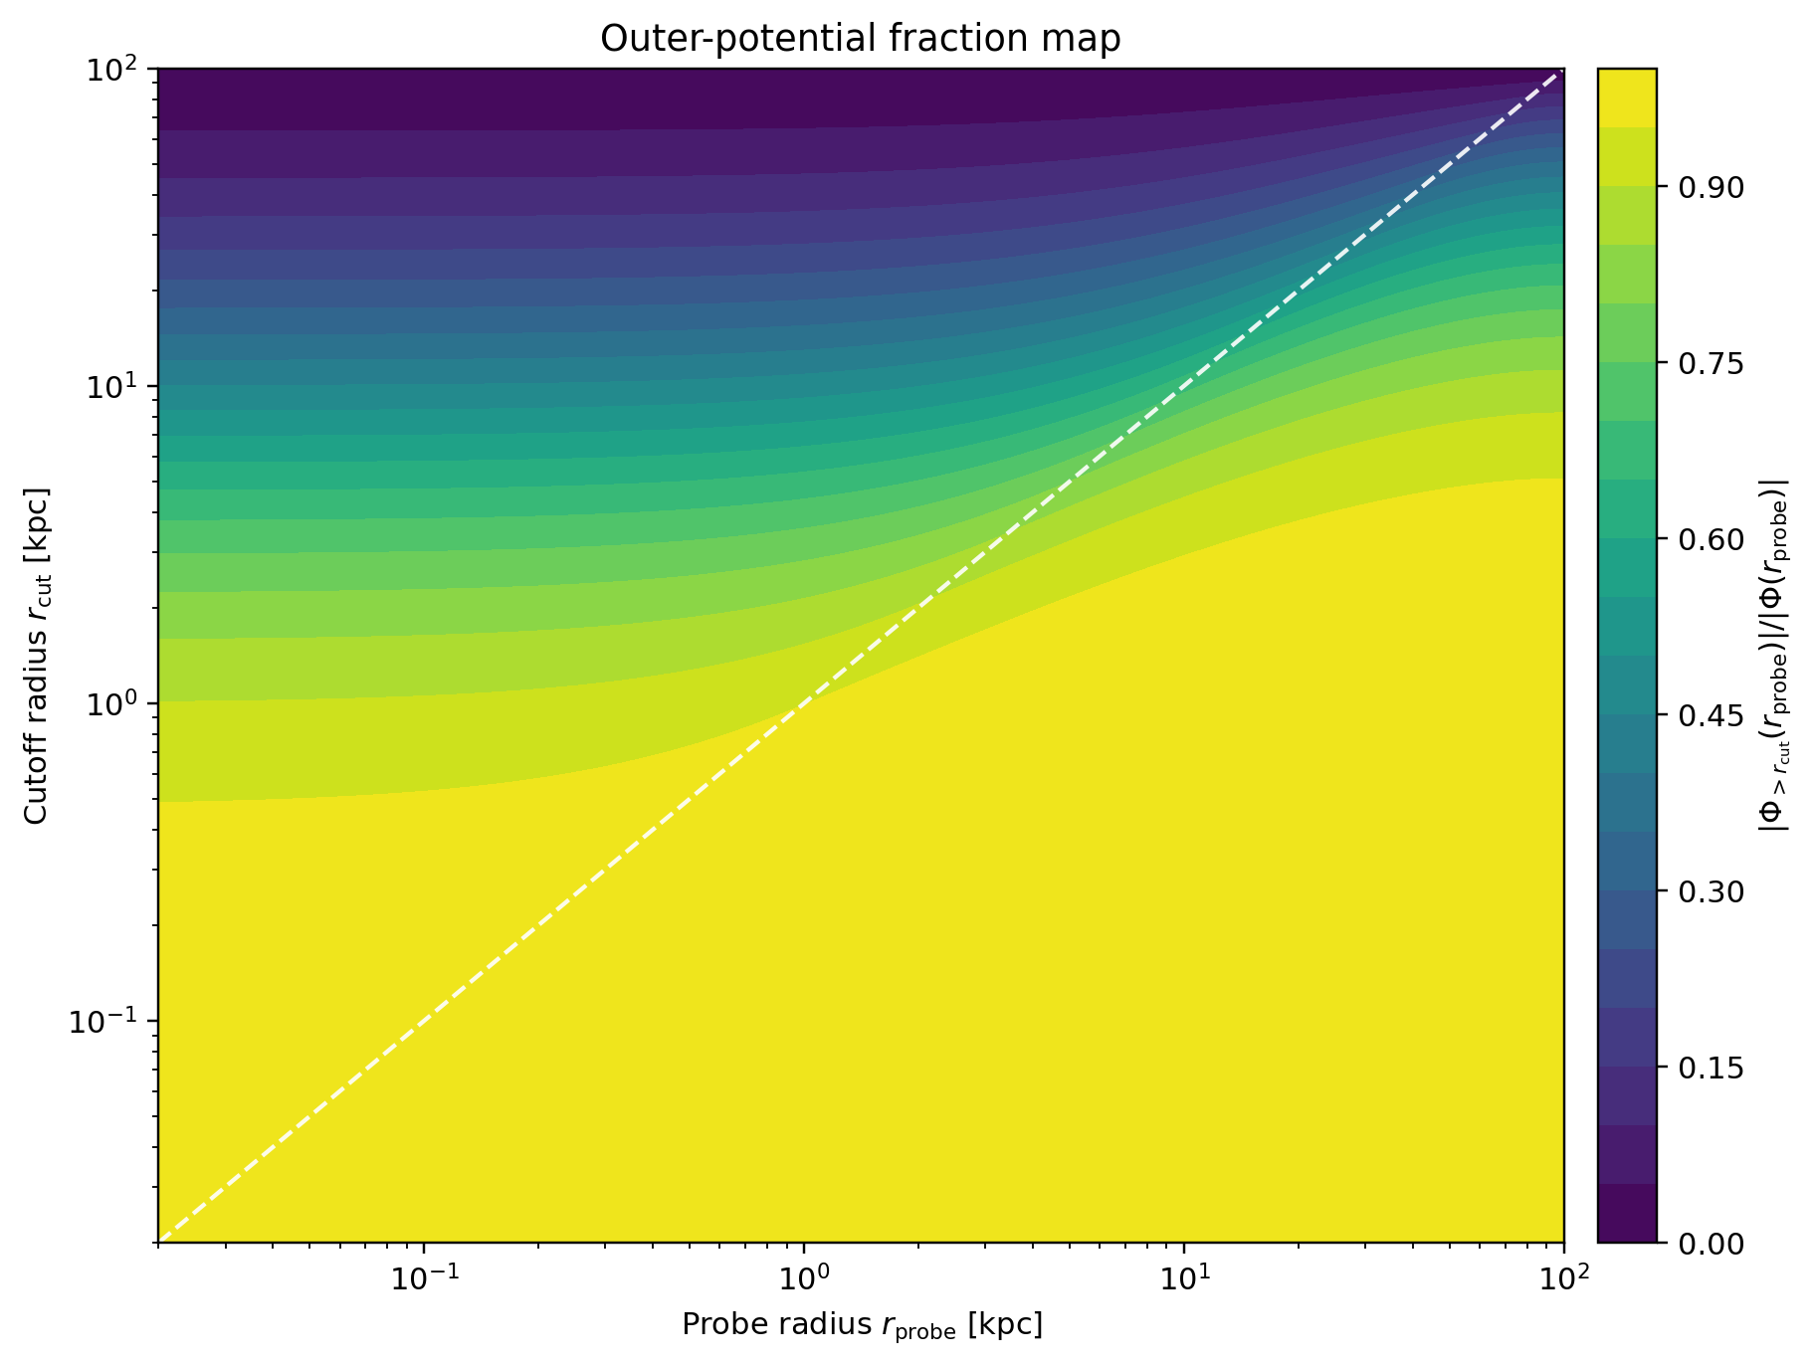

6. Recommended next steps
- Compare the analytic shell diagnostics with the actual SWIFT halo.
- Measure force or acceleration errors inside the retained region for several candidate cutoff radii.
- Check whether the outer halo is numerically noisy or poorly sampled in the particle realization.
- Choose rcut from a quantitative tolerance, for example the smallest radius for which the force error inside the inner region stays below 1% or 5%.
- Add one final convergence plot comparing the full particle halo with the hybrid model.
Practical thesis phrasing: the hybrid model is not justified because outer shells pull on the centre; it is justified because they contribute significantly to the inner potential and because a smooth analytic outer halo can reproduce that background more efficiently and robustly than a noisy particle representation.

