USER MANUAL

*Hospital Management for rare diseases.*

Made by: Martina Galán, Celia Pérez, Blanca Pueche, Elena Marco.

**USER MANUAL**

# TABLE OF CONTENTS

1.0 GENERAL INFORMATION 1

1.1 System Overview 1-1

1.2 Authorized Use Permission 1-1

2.0 SYSTEM FEATURES 2-1

2.1 Login 2-1

2.1.1 Successful Login 2-2

2.1.2 Invalid Username / Password 2-2

2.2 Register a new patient 2-3

2.2.1 Select option “Register a new patient” 2-3

2.2.2 Insert all the information needed 2-3

2,2.3 No illness found………………………………………………………………………………...2-3

2.3 Select a patient data 2-4

2.3.1 Select option “Select patient data” 2-4

2.3.2 Input the name and id of the patient 2-4

2.3.3 Successful selection 2-4

2.3.4 Invalid name 2-4

2.3.5 Invalid ID 2-4

2.4 Select a doctor data 2-5

2.4.1 Select option “Select doctor data” 2-5

2.4.2 Input the name and surname of the doctor 2-5

2.4.3 Successful selection 2-5

2.4.4 Invalid name or surname 2-6

2.5 Show hospitals 2-6

2.5.1 Select option “Show hospitals” 2-6

2.6 Create XML’s 2-6

2.6.1 Select option “Create XML’s” 2-6

2.6.2 What to turn into XML 2-7

2.6.3 Create an HTML 2-8

2.7 Update data of the doctor 2-8

2.7.1 Select option “Update data” 2-8

2.7.2 Input new data 2-8

2.8 Show data of the doctor 2-8

2.8.1 Select option “Show data” 2-8

2.8.2 Display information 2-9

2.9 Delete doctor 2-9

2.9.1 Select option “Delete doctor” 2-9

2.9.2 Successful delete 2-9

2.10 Create doctor XML 2-10

2.10.1 Select option “Create doctor XML” 2-10

2.10.2 Create HTML 2-10

2.11 Update data of the patient 2-10

2.11.1 Select option “Update data” 2-10

2.11.2 Input new data 2-111

2.11.3 Update illness severity 2-11

2.12 Show data of the patient 2-11

2.12.1 Select option “Show data” 2-12

2.12.2 Display information 2-12

2.13 Search hospital 2-12

2.13.1 Select option “Search hospital” 2-12

2.13.2 Select illness to treat 2-12

2.13.3 Successful assignation 2-12

2.14 Assign illness 2-13

2.14.1 Select option “Assign illness” 2-13

2.14.2 Display information 2-13

2.15 Update state of an illness 2-13

2.15.1 Select option “Update state of an illness” 2-13

2.15.2 Select illness 2-13

2.15.3 Input the new severity 2-13

2.15.4 Error no illness available 2-13

2.16 Create patient XML 2-14

2.16.1 Select option “Create patient XML” 2-14

2.16.2 Create HTML 2-15

# GENERAL INFORMATION.

# System Overview.

The Hospital Management for rare diseases app is an application that allows you to assign a hospital for a patient who needs a treatment not accessible in most hospitals. The information available includes a list of hospitals and their respective machines and doctors, as well as information on the sorting medics, all already inside the database.

The goal is to provide people with uncommon diseases a fast and secure way to find a hospital that can provide the treatment that they need.

# Authorized Use Permission.

The app is available only to sorting medics. You need a username and password to view or modify the data. That way only sorting medics can login to add or update the necessary information.

# SYSTEM FEATURES.

# Login.

By logging in you will be allowed to access the main menu where a list of options will show up to do various tasks.

* + 1. Click on Run Menu.

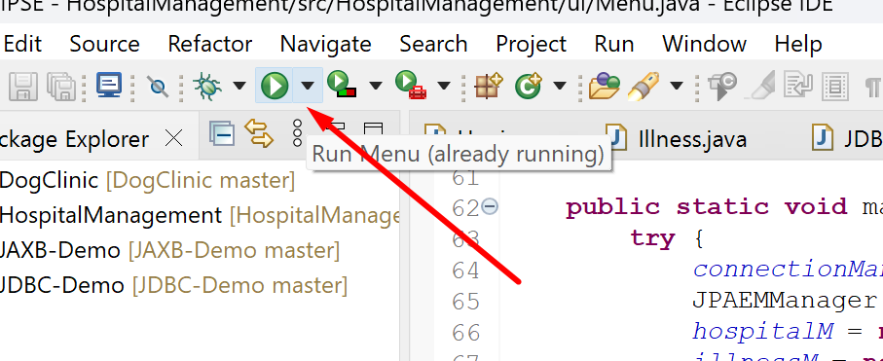

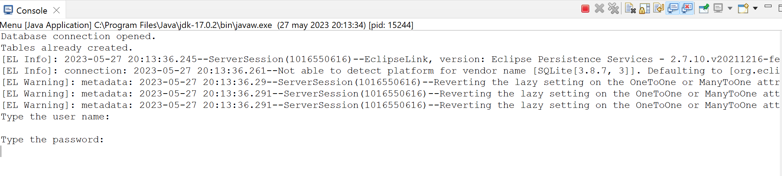 The login screen displays as shown below.

* + 1. Type the **Username** and **Password**. (This is an example, there’s 3 options by default)

Options: johnny / hobbit73; ade / spiderman32; agnessy / theLordofRings47.

## Successful Login.

The main menu is displayed.

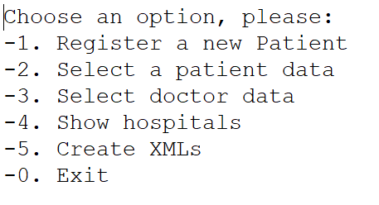

## Invalid Username / Password.

If user enters invalid username or password, then the following error message will display: “Incorrect username / password.”

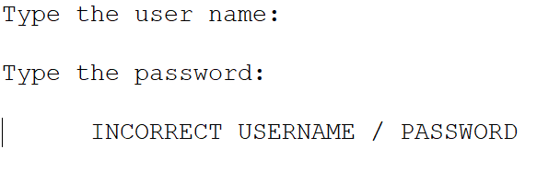

After that it will ask you again for a username and password.

# Register a new patient.

## 2.2.1 Select option “Register a new patient.”

To select the first option, type a 1.

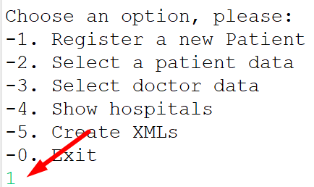

## Insert all the information needed.

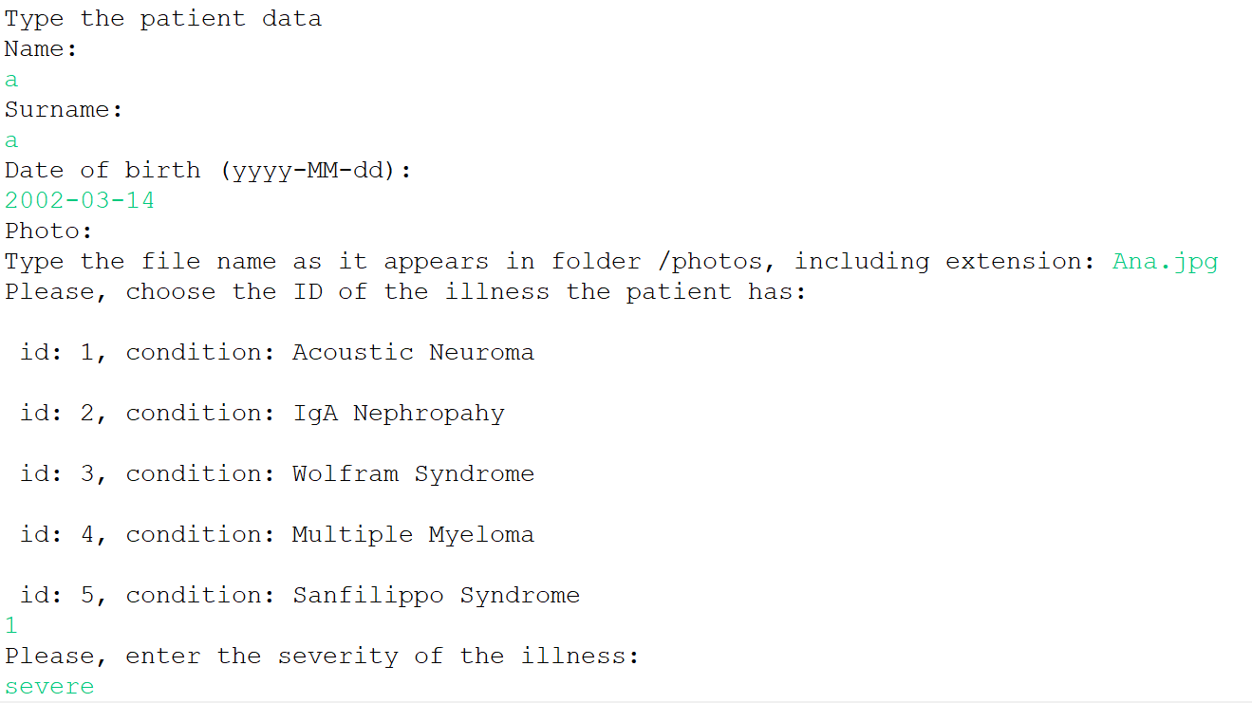Fill all the fields with the data of the new patient.

## No illness found.

If you put a number of an id that doesn’t exit, then an error will pop up “No illness found with that id”.

# Select a patient data.

## 2.3.1 Select option “Select patient data.”

To select the option, type a 2.

## Input the name and id of the patient.

## 2.3.3 Successful selection.

A menu of the patient will appear to show all the available choices you can do with a patient.

## Invalid name.

If the name isn’t right a warning will appear: “There is no one with that name.”

## Invalid ID.

If the ID isn’t right a warning will appear: “No patient with that id.”

# Select a doctor data.

## 2.4.1 Select option “Select doctor data.”

To select the option, type a 3.

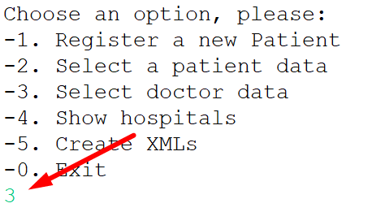

## Input the name and surname of the doctor.

To select a doctor, it is necessary to input their name and surname, after that a list of doctors who have the same name will show up, select the id of the one you want to select.

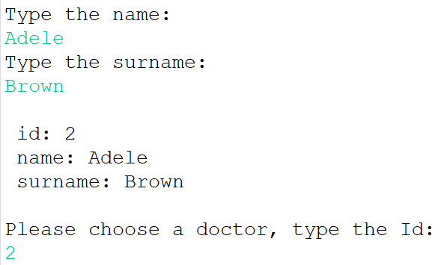

## 2.4.3 Successful selection.

A menu of the doctor will appear to show all the available choices you can do with the specific doctor that has been chosen.

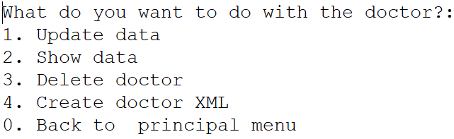

## Invalid name or surname.

If the name or surname isn’t right a warning will appear: “There is no one with that name”.

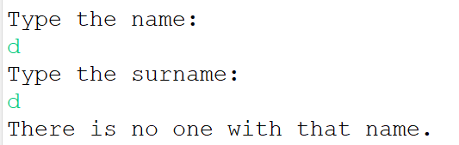

# Show hospitals.

## 2.5.1 Select option “Show hospitals.”

To select the option, type a 4.

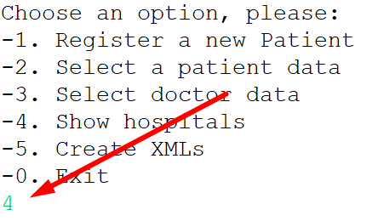

After that a list of hospitals available will show up.

# Create XML’s.

## 2.6.1 Select option “Create XML’s.”

To select the option, type a 5.

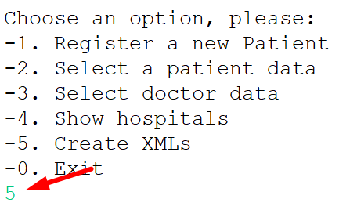

## What to turn into XML.

Select what do you want to turn into an XML.

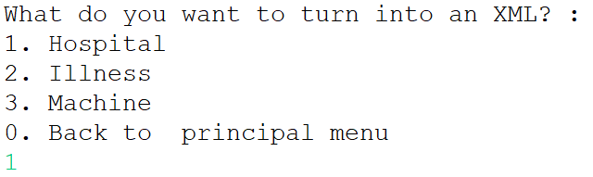

*Note: In this case we will be creating a Hospital XML.*

After that a list of hospitals will show up, select the one you want to turn into an XML by choosing their id.

This same process will happen when choosing to create an XML of Machine and Illness. After choosing the id, the XML will be saved in the xml folder of the project.

## Create an HTML.

An option will show up after having selected the hospital in this case. If you also want to create an HTML after creating the XML type “Y” for yes, if not type a “N” for no.

When choosing “Y”, the HTML link will be created in the xml folder of the project. To open the HTML, you’ll only have to click on it and the page will be opened in your browser.

# Update data of the doctor.

To update the data of the doctor you must have selected a doctor first.

## Select option “Update data.”

To select, type option 1.

## Input new data.

When asked for that field you can either leave it as it was by pressing enter or input the new information.

# Show data of the doctor.

To update the data of the doctor you must have selected a doctor first.

## Select option “Show data.”

To select, type option 2.

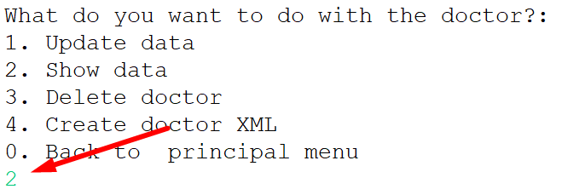

## Display information.

The information will be displayed automatically after selecting the option 2.

# Delete doctor.

To delete the data of the doctor you must have selected a doctor first.

## Select option “Delete doctor.”

To select, type option 3.

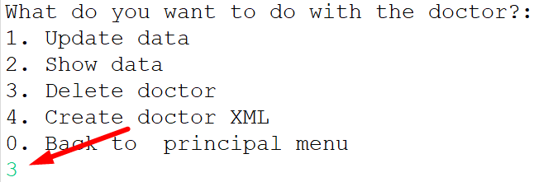

## Successful delete.

Once the doctor selected is deleted a message will be displayed and you will be back in the main menu.

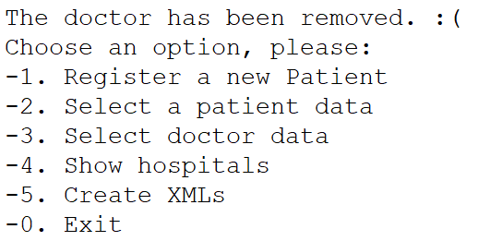

# Create doctor XML.

To create a doctor XML, you must have selected a doctor first.

## Select option “Create doctor XML.”

To select, type option 3.

## Create HTML.

Once the XML is created it will ask you if you want to create an HTML. If you want to then input a “Y” for yes and a “N” for no.

When “Y” is chosen, the HTML link will appear in the xml folder of the program.

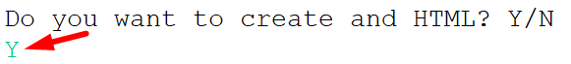

# Update data of the patient.

To update the data of the patient you must have selected a patient first.

## Select option “Update data.”

To select, type option 1.

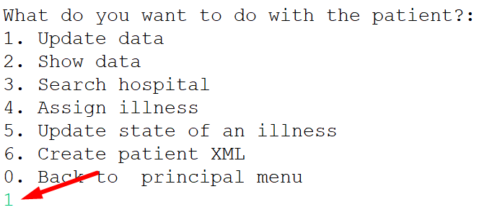

## Input new data.

When asked for that field you can either leave it as it is by pressing enter or input the new information.

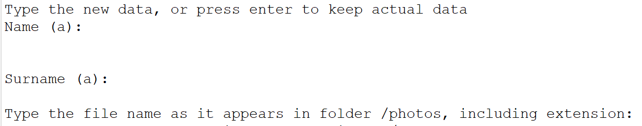

## Update illness severity.

After updating the name / surname / photo you can update the illness severity. If you want to then input a “Y” for yes and a “N” for no.

1. YES

A list of illnesses will show up, you must select the illness you want to update.

After selecting the illness input the new severity.

1. NO

# Show data of the patient.

To display the data of the patient you must have selected a patient first.

## Select option “Show data.”

To select, type option 2.

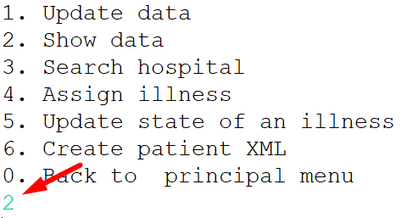

## Display information.

The information will be displayed automatically after selecting the option 2.

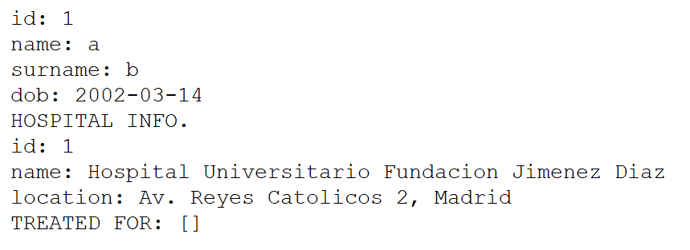

# Search hospital.

To display the data of the patient you must have selected a patient first.

## Select option “Search hospital.”

To select, type option 3.

## Select illness to treat.

A list with all the illnesses of the patient will show up. Input the id of the illness you want to treat.

## Successful assignation.

If there is a hospital that has a machine and a doctor that can treat that illness and is available, then it will be assigned to the patient.

# Assign illness.

To display the data of the patient you must have selected a patient first.

## Select option “Assign illness.”

To select, type option 4.

## Display information.

The information will be displayed automatically after selecting the option 2.

# Update state of an illness.

To display the data of the patient you must have selected a patient first.

## Select option “Update state of an illness”.

To select, type option 5.

## Select illness.

A list of illnesses will show up, you must select the illness you want to update.

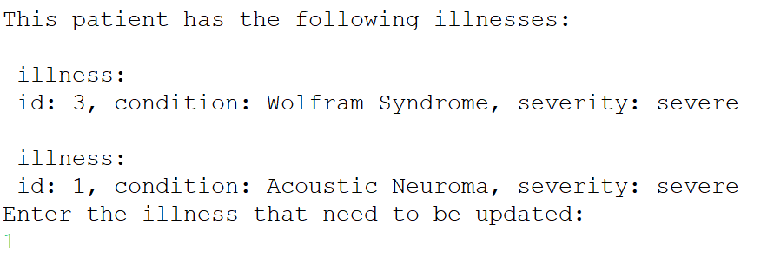

## Input the new severity.

After selecting the illness, input the new severity.

## Error no illness available.

If a patient doesn’t have an illness, then “The patient has no illness” will show up.

# Create patient XML.

To create a patient XML, you must have selected a patient first.

## Select option “Create patient XML.”

To select, type option 6.

## Create HTML.

Once the XML is created it will ask you if you want to create an HTML. If you want to then input a “Y” for yes and a “N” for no.

When choosing “Y”, the HTML link will be saved in the XML folder.

