Martijn van der Eijk  Full Stack Developer · apps & websites  ABOUT  Based in northern Tuscany since 2021. I build apps and websites end-to-end — native mobile, React/Next.js, and cloud backends — with a strong eye for polish and usable detail.  EXPERIENCE  Freelance Full Stack Developer  2017 – Present  • Sonid — music education platform (Swift, Kotlin, Next.js, Firebase, Postgres)  • Toka & Capo — native practice apps (Swift, Kotlin)  • Sonid Classroom — school management (Next.js, Firebase, Postgres)  • Directus Mobile — React Native / Expo  • Kurbo.dev & client sites — Next.js, WordPress  Medior Full Stack Developer — EcBase  Remote · 2021 – 2026  • WMS product features — TanStack, Vite, Chart.js  • Starter templates & sites — Next.js, Tailwind, Radix  • Transport app — Expo, Tamagui, Redux  • Shared UI library — Rollup, Storybook  EDUCATION  Bachelor Jazz & Pop Guitar  Conservatory Utrecht · 2007 – 2012  Information & Communication Technology  Nova College Haarlem · 2002 – 2006 | 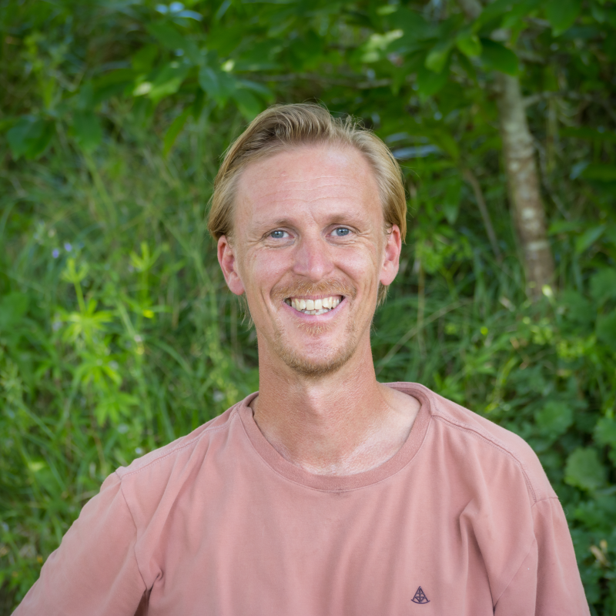  CONTACT  Villafranca in Lunigiana, Italy  +31 624 852 964  +39 338 2517 381  martijn.michel@gmail.com  martijnvde.nl  LinkedIn  LANGUAGES  Dutch · Native  English · Fluent  Italian · Fluent  FOCUS  Native mobile (iOS / Android)  React & Next.js products  Firebase & Postgres backends

