Proxmox Lab
Creating a Windows Server 2022 VM
Complete Wizard Guide with Screenshots
Version 1.0 | March 2026 | Proxmox VE 9.1.6 | macpro2013.local

1. Overview
This guide documents the exact process of creating a Windows Server 2022 virtual machine in Proxmox VE 9.1.6. It is based on actual lab setup experience and includes all corrections and lessons learned during the build.
The lab runs on a Mac Pro 2013 (macpro2013.local) with 128GB RAM, 3.6TB NVMe storage, and Proxmox VE 9.1.6. All VMs use the local-lvm storage pool backed by NVMe.

1.1 Lab Environment
Component | Details
Proxmox Host | macpro2013.local — Mac Pro 2013 Trashcan
Proxmox Version | 9.1.6
RAM | 128 GB
Storage | 3.6 TB NVMe (local-lvm pool)
Network Bridge | vmbr0 — internal lab network (192.168.178.x)
Proxmox WebUI | https://192.168.178.205:8006

1.2 SSL Certificate Warning
When accessing the Proxmox WebUI at macpro2013.local, Safari shows a certificate warning because Proxmox uses a self-signed certificate by default. This is the motivation for setting up an internal Certificate Authority (CA) later — once the CA is in place, a proper trusted certificate can be issued for Proxmox.

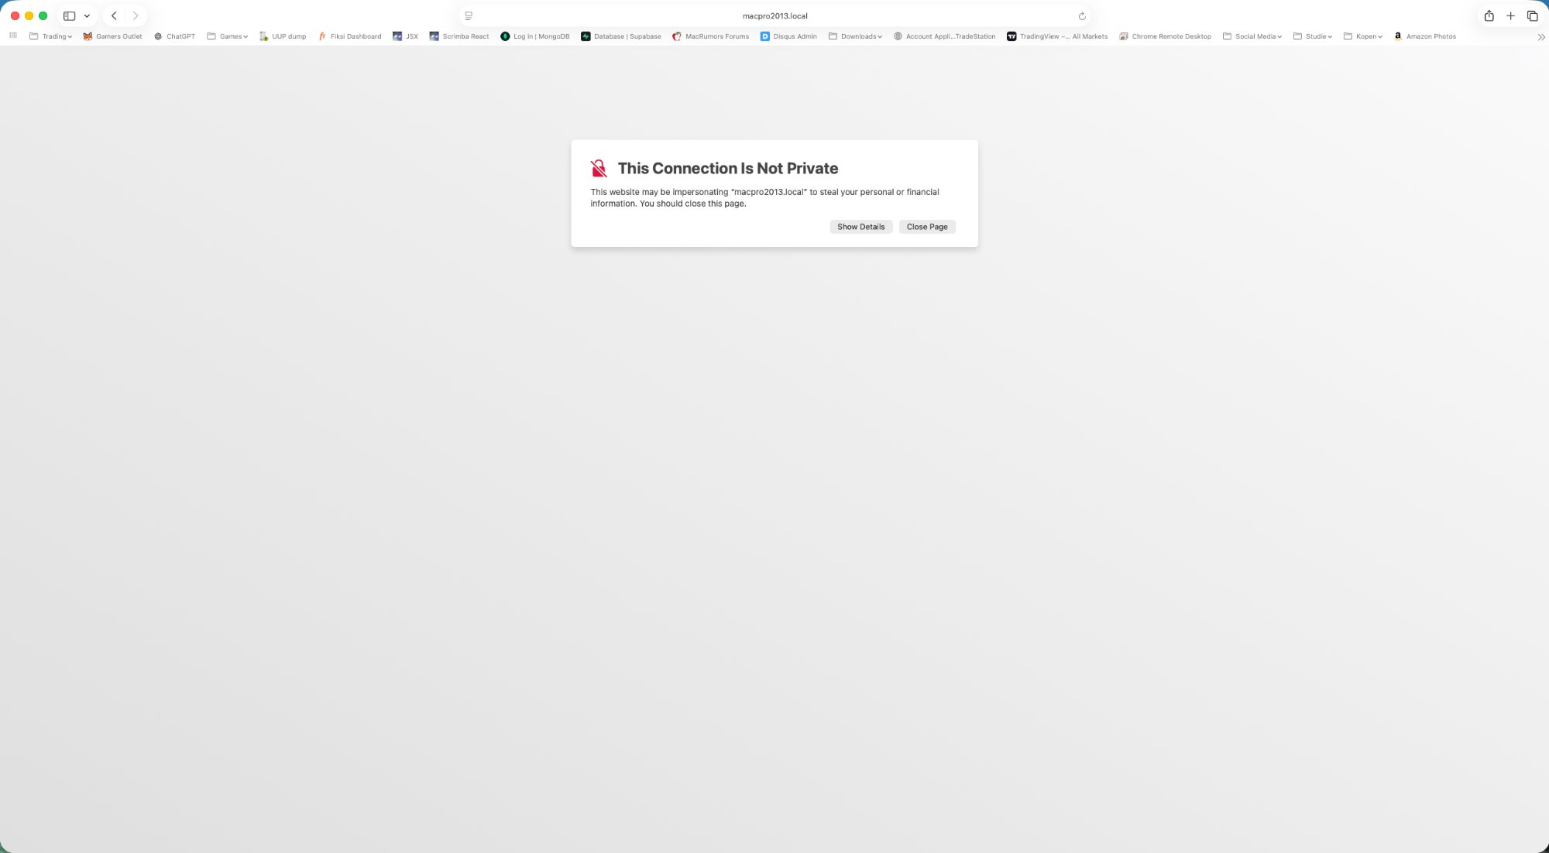
Figure: Safari showing SSL warning for macpro2013.local — resolved after CA setup

2. Prerequisites
Before creating a VM, ensure the following ISO images are uploaded to Proxmox local storage (Proxmox WebUI → local → ISO Images):
- Windows Server 2022 Evaluation: Windows_2022_SERVER_EVAL_x64FRE_en-us.iso
- VirtIO Drivers: virtio-win-0.1.285.iso (or newer)

⚠ Both ISOs are required. Without the VirtIO ISO, Windows Setup cannot detect the disk and network adapter.

3. VM Naming Convention
Use consistent naming for all lab VMs. Include the OS version and all roles in the name for clarity at a glance in the Proxmox panel.

Pattern | Example | Description
WS2022-LAB{nn}-{ROLES} | WS2022-LAB01-AD-DNS | Lab VM — number + all active roles
WS2022-LAB{nn}-CA | WS2022-LAB02-CA | Certificate Authority VM
WS2022-TEMPLATE-{NAME} | WS2022-TEMPLATE-BASE | Template VM — use VM ID 900+

To rename a VM via the Proxmox host shell (the Proxmox GUI does not have a rename option):

ssh root@macpro2013.local
qm set <VMID> --name <NEW-NAME>

# Example — rename VM 100:
qm set 100 --name WS2022-LAB01-AD-DNS

4. Creating the VM — Proxmox Wizard
In the Proxmox WebUI, click Create VM (top right blue button). Work through each tab in order as described below.

4.1 General Tab
Setting | Value | Notes
Name | WS2022-TEMPLATE-BASE | Descriptive name including OS + role
VM ID | 900 | Use 900+ for templates, 100+ for lab VMs
Node | macpro2013 | Your Proxmox host node

4.2 OS Tab
Setting | Value | Notes
ISO Image | Windows_2022_SERVER_EVAL_x64FRE_en-us.iso | Select from local storage
Type | Microsoft Windows | Must be set explicitly — do not leave at default
Version | 11/2022/2025 | Must be set explicitly — do not leave at default
Add VirtIO drivers ISO | Enabled (checkbox) | Adds a second CD drive for VirtIO ISO
VirtIO ISO | virtio-win-0.1.285.iso | Select from local storage

⚠ The OS Type and Version must both be set manually. The additional VirtIO ISO checkbox adds a second CD drive — this is essential for loading storage and network drivers during Windows Setup.

4.3 System Tab
Setting | Value | Notes
BIOS | OVMF (UEFI) | Required for Windows Server 2022
Machine | pc-q35 | Modern chipset required for TPM 2.0
SCSI Controller | VirtIO SCSI single | Best storage performance
EFI Storage | local-lvm | Must be explicitly selected — no default
TPM Storage | local-lvm | Must be explicitly selected — no default
TPM Version | v2.0 | Required for Windows Server 2022

⚠ EFI Storage and TPM Storage have no default — both must be explicitly selected. Without them the VM will not boot correctly.

4.4 Disks Tab
Setting | Value | Notes
Bus/Device | SCSI | Use with VirtIO SCSI controller
Storage | local-lvm | NVMe-backed pool
Disk Size | 60 GB | Sufficient for OS, roles and tools
Cache | Write back | Best performance on NVMe
Discard | Enabled | Enables TRIM for SSD/NVMe storage
IO Thread | Enabled | Improves disk throughput

4.5 CPU Tab
Setting | Value | Notes
Sockets | 1 | Single socket
Cores | 2 | Sufficient for all lab VM roles
Type | host | Passes through actual host CPU — better performance and compatibility than kvm64

⚠ CPU Type must be set to host. The default kvm64 limits available CPU instruction sets and reduces performance.

4.6 Memory Tab
Setting | Value | Notes
Memory | 4096 MB | 4GB per VM
Minimum Memory | 4096 MB | Set identical to Memory to disable ballooning
Ballooning Device | Disabled | Not well supported on Windows — must be disabled

⚠ Ballooning must be disabled for Windows VMs. Set Minimum Memory equal to Memory to enforce this.

4.7 Network Tab
Setting | Value | Notes
Bridge | vmbr0 | Internal lab network
Model | VirtIO (paravirtualized) | Best performance — requires VirtIO drivers
Firewall | Enabled (leave default) | Keep enabled — mirrors production and builds troubleshooting skills

⚠ Leave the Proxmox firewall enabled on the network adapter. Disabling it may seem convenient but removes an important layer that mirrors real production environments. Troubleshooting through the firewall is a valuable skill.

4.8 Verifying Hardware Before Boot
After clicking Finish, do NOT start the VM immediately. First verify the hardware config by clicking the VM in the left panel and selecting Hardware. The screenshot below shows the correctly configured template VM (VM 900):

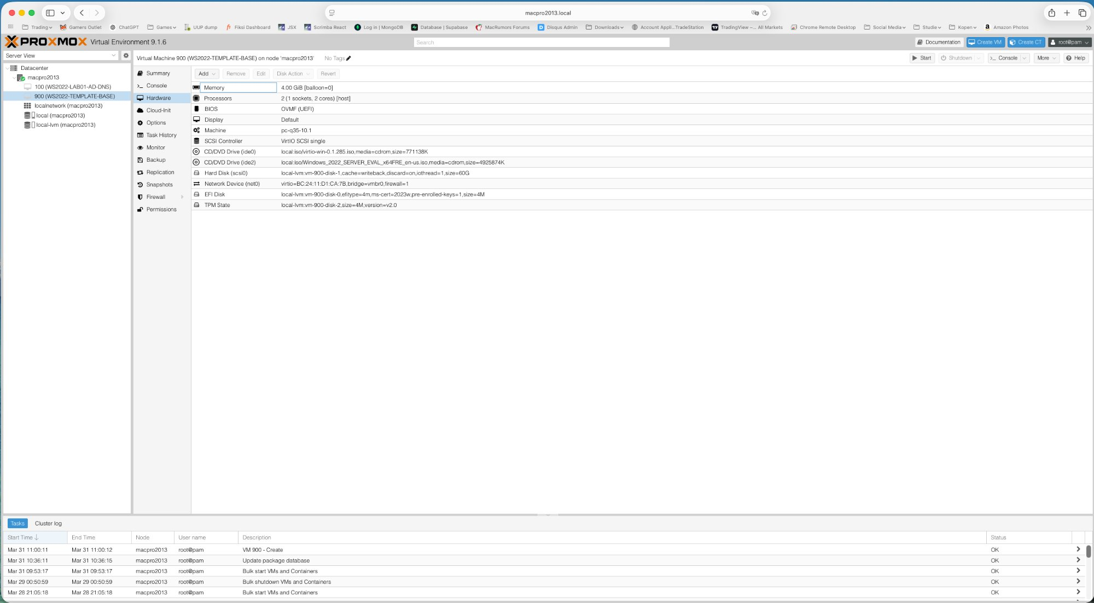
Figure: VM 900 (WS2022-TEMPLATE-BASE) — Hardware tab showing correct configuration

Verify all of the following in the Hardware tab:
- Memory: 4.00 GiB [balloon=0] — balloon=0 confirms ballooning is disabled
- Processors: 2 (1 socket, 2 cores) [host] — confirms host CPU type
- BIOS: OVMF (UEFI)
- Machine: pc-q35-10.1
- SCSI Controller: VirtIO SCSI single
- CD/DVD ide0: virtio-win ISO
- CD/DVD ide2: Windows 2022 ISO
- Hard Disk: 60G, cache=writeback, discard=on, iothread=1
- Network: vmbr0, firewall=1
- EFI Disk and TPM State present on local-lvm

5. Starting the VM and Windows Boot
Click Start and immediately open Console. When you see the following message, click inside the console window first (to capture keyboard focus) and press any key:

Press any key to boot from CD or DVD......

⚠ If you miss this prompt, the VM will fall through to PXE boot as shown below. Simply reset the VM and try again — be ready at the console before clicking Start.

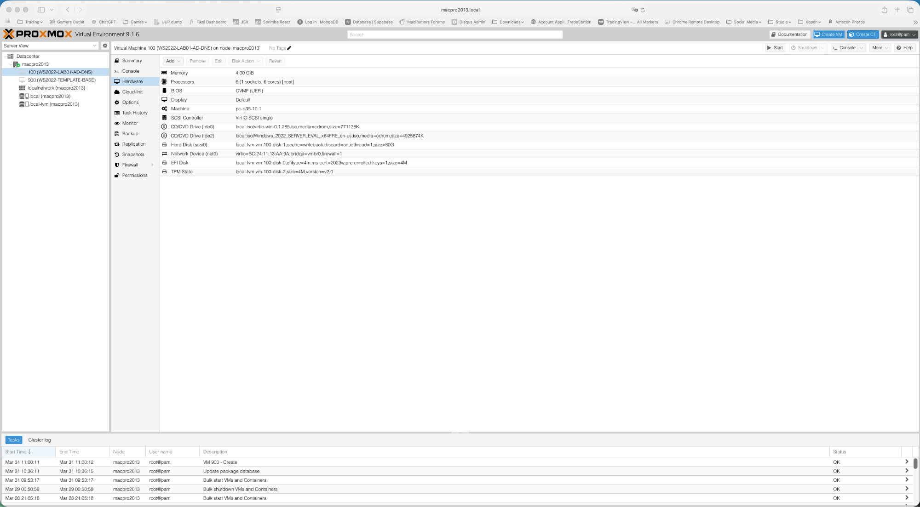
Figure: PXE boot fallback when the CD boot prompt was missed — reset and try again

When you catch the prompt in time, the Windows Boot Manager appears:

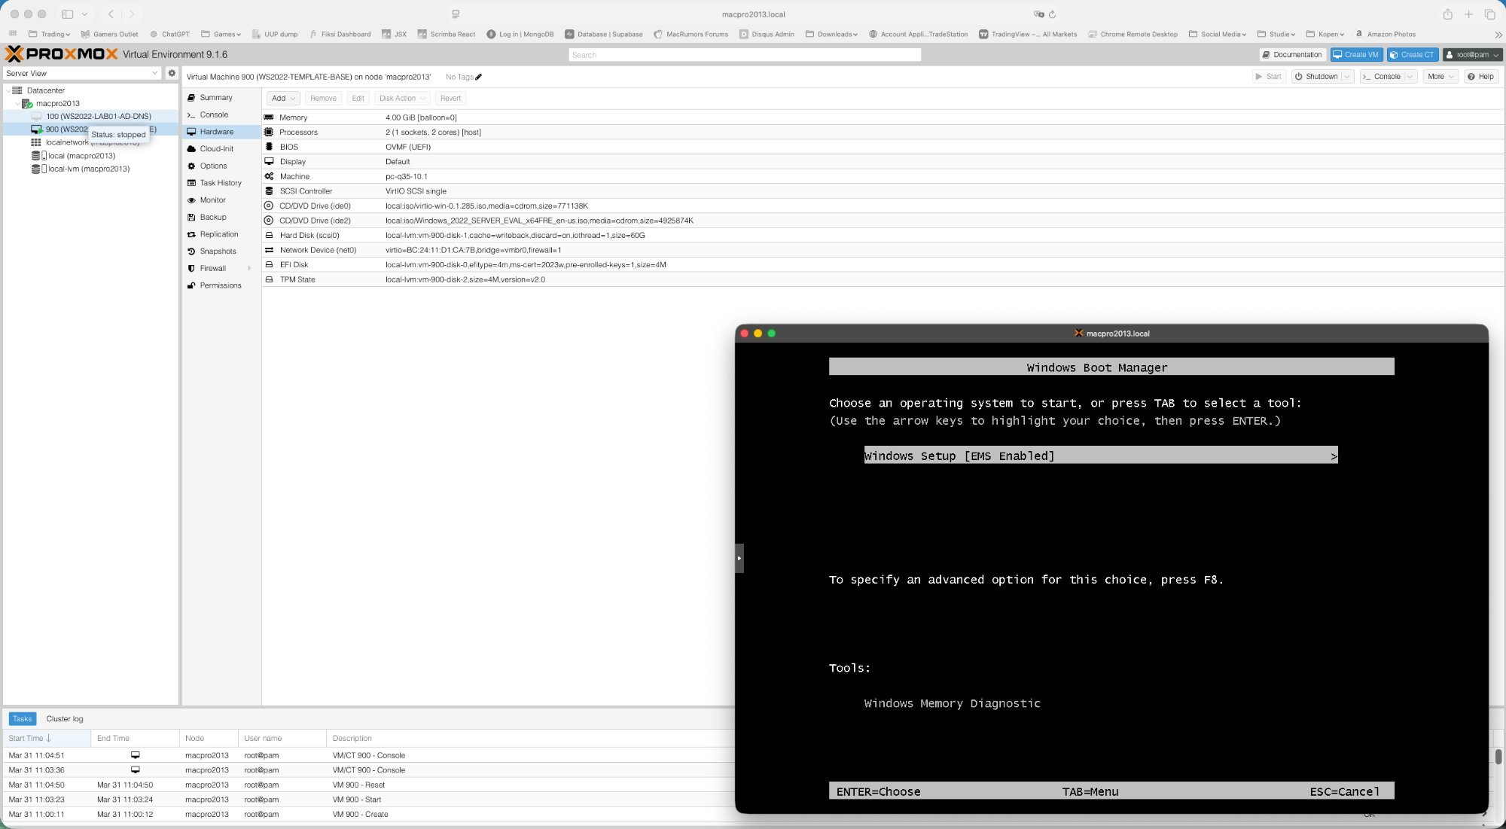
Figure: Windows Boot Manager — select Windows Setup [EMS Enabled] and press Enter

Select Windows Setup [EMS Enabled] (already highlighted) and press Enter to continue.

6. Windows Setup — Edition Selection
When prompted to select an edition, choose:

Windows Server 2022 Datacenter (Desktop Experience)

⚠ Make sure to select Datacenter — not Standard. And Desktop Experience — not Core. Core has no GUI which makes it unsuitable for this lab template.

7. Loading the VirtIO Storage Driver
On the 'Where do you want to install the operating system?' screen, the disk list will be empty. This is expected — Windows cannot see the VirtIO SCSI disk without the driver.

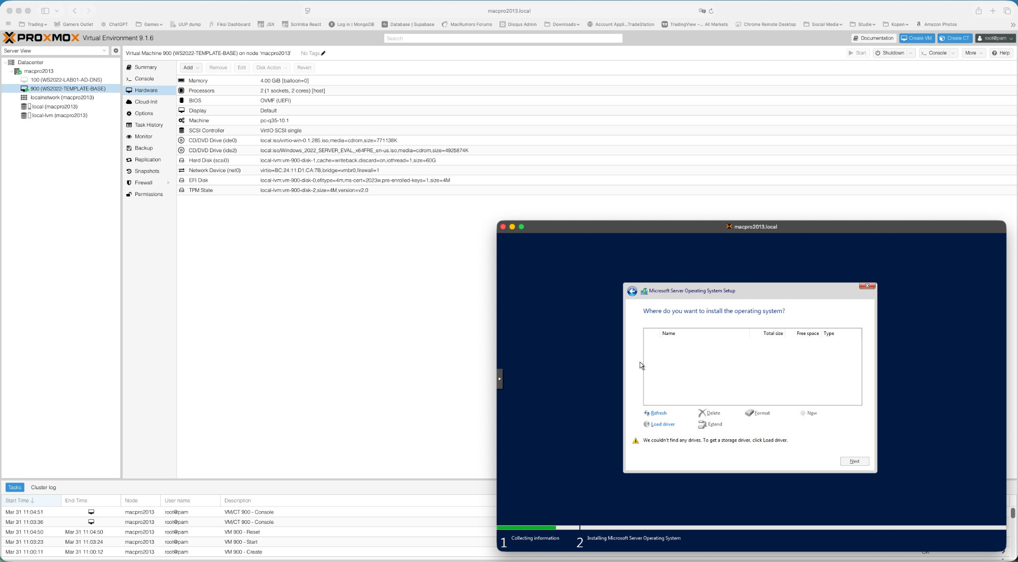
Figure: Windows Setup showing no disk — VirtIO SCSI driver must be loaded first

Follow these steps to load the driver:
- Click Load driver
- Click Browse
- Navigate to the VirtIO CD drive (D: or E:)
- Open folder: vioscsi \ w2k22 \ amd64
- Click OK
- Select Red Hat VirtIO SCSI pass-through controller
- Click Next

The 60GB disk will now appear in the list. Select it and continue. Windows installation will begin:

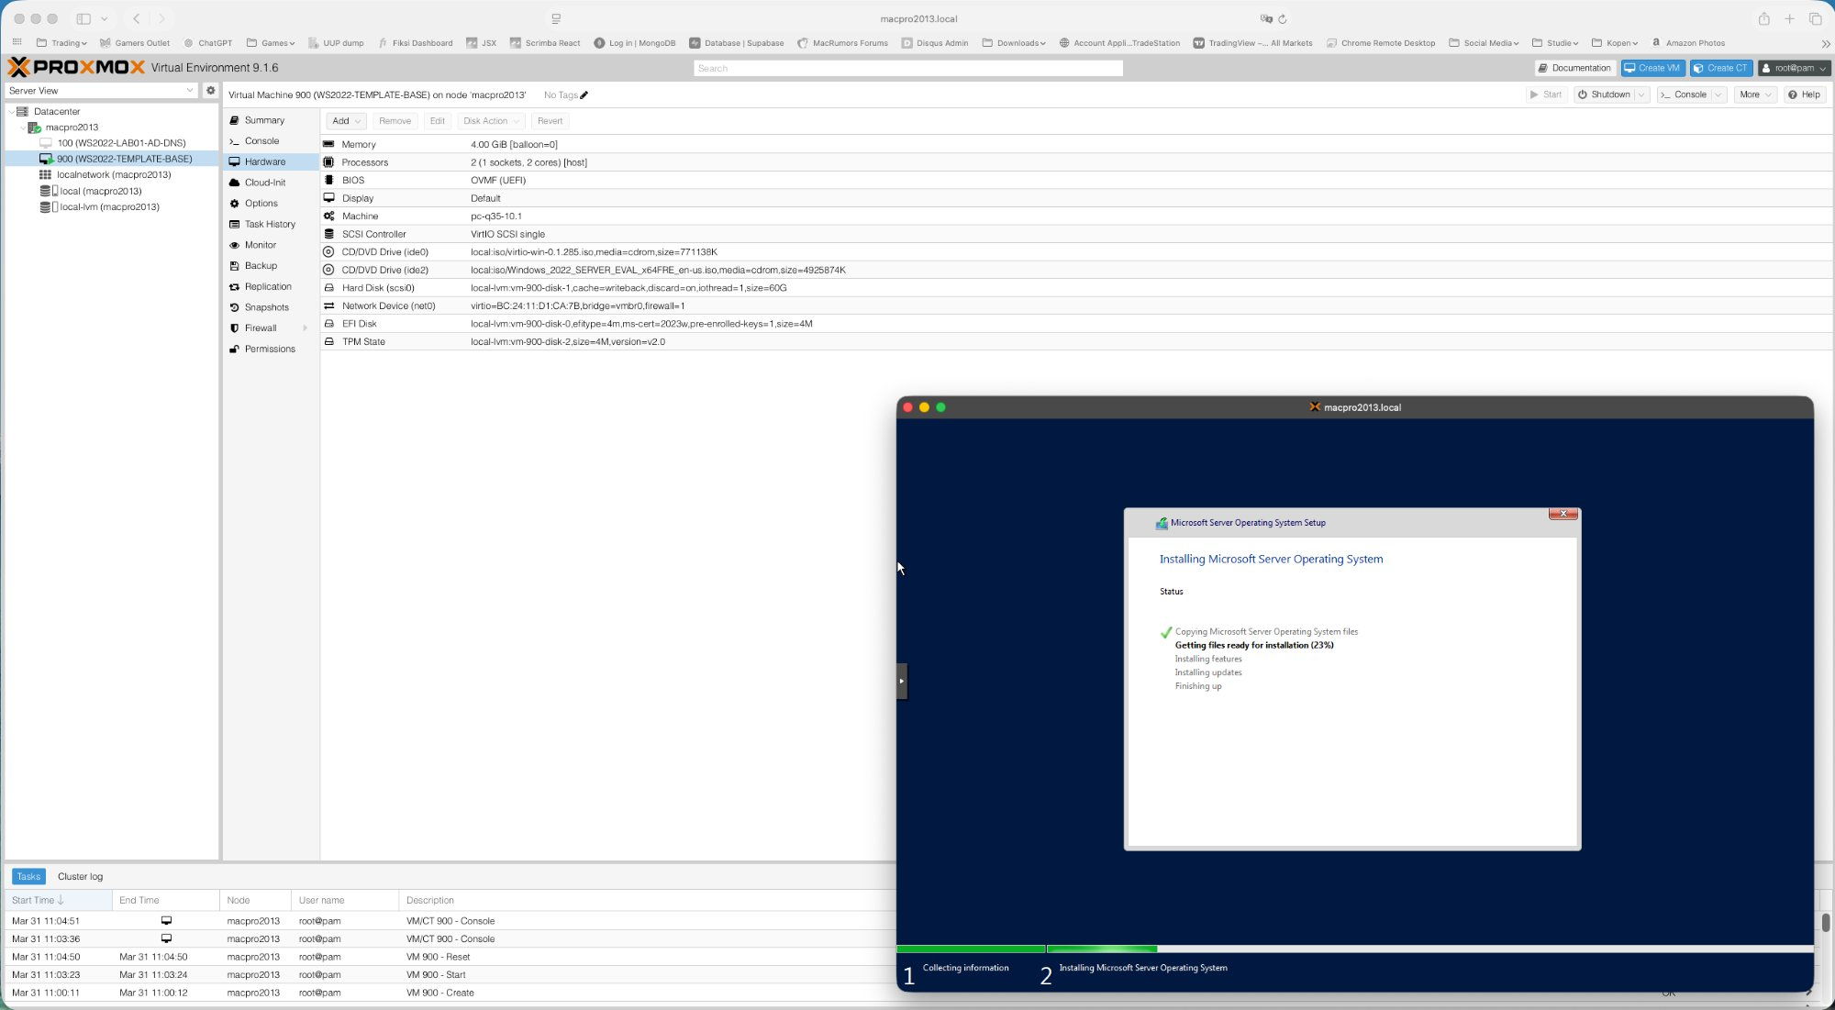
Figure: Windows Server 2022 installation in progress

8. After Installation — Server Manager
After Windows installs and reboots, you will land at the Server Manager Dashboard. Close the Windows Admin Center popup (tick Don't show this message again):

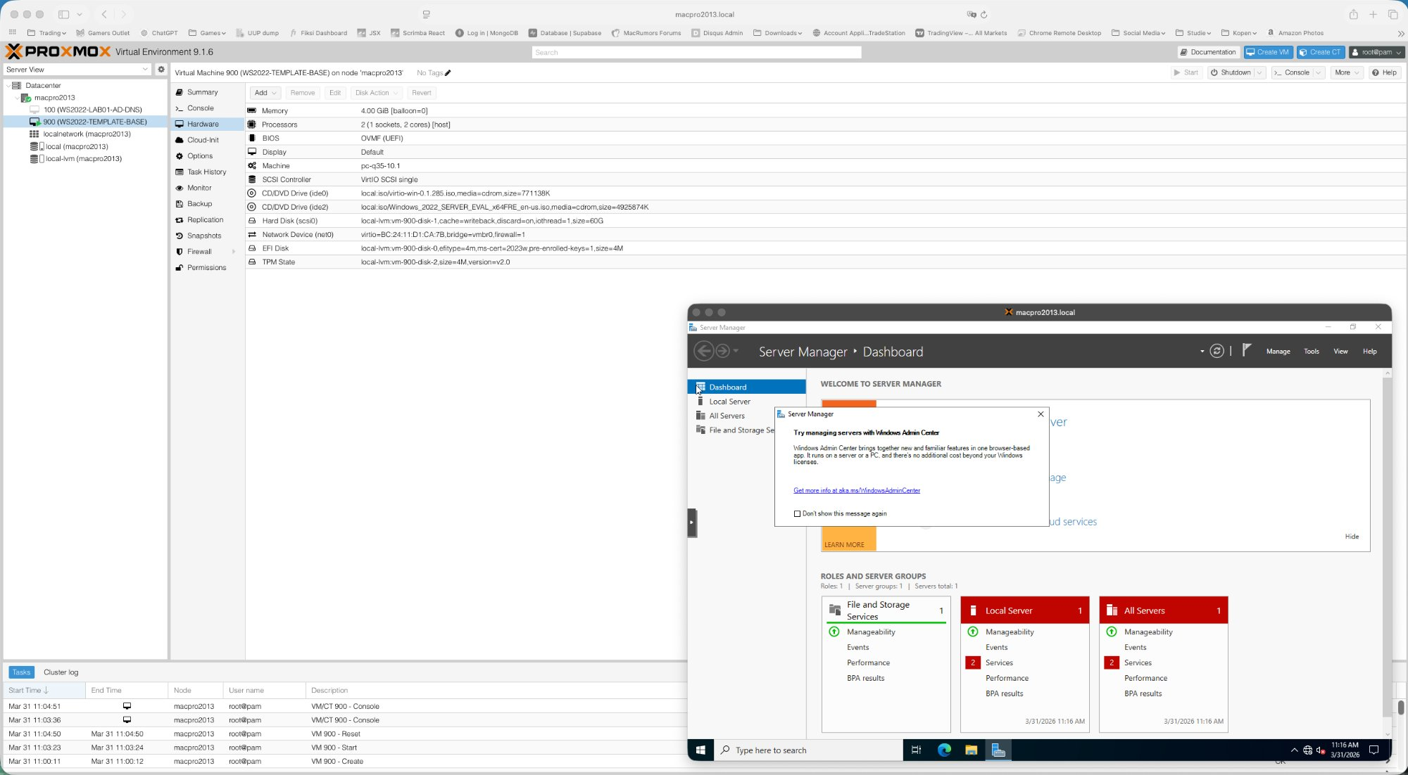
Figure: Server Manager Dashboard — Windows Server 2022 Datacenter successfully installed

The VM is now ready for the template preparation steps described in the companion manual: Proxmox Lab — Windows Server 2022 Template Preparation.

9. Summary Checklist
# | Task | Done
1 | Upload Windows Server 2022 ISO to Proxmox local storage | ☐
2 | Upload VirtIO drivers ISO to Proxmox local storage | ☐
3 | Create VM with correct settings across all wizard tabs | ☐
4 | Verify hardware config in Proxmox Hardware tab before booting | ☐
5 | Boot VM — catch CD boot prompt immediately in Console | ☐
6 | Select Windows Server 2022 Datacenter (Desktop Experience) | ☐
7 | Load VirtIO SCSI driver (vioscsi/w2k22/amd64) before disk selection | ☐
8 | Complete Windows installation | ☐
9 | Proceed to Template Preparation manual | ☐

