

Índex
Canon Notes 3
Chapter 1: Prologue 4
Chapter 2: A Turbulent Journey 5
Help Sophia 7
Don’t Help Sophia 8
Outside the Train 9

Canon Notes
This section serves as the Writer’s Notes and context between the Game and this book-like approach to the story.
Lucas is the Canon name of the protagonist of the Story, the main character of the game. When playing the game, the player can choose to be a boy or a girl and choose his/her name.
The Story is dependent on the player’s choices so in this version when a path deciding choice appears you will have a Hyperlink to skip to the path.

Chapter 1: Prologue

It’s a bright morning in the Tearoma Region. Everyone in Pinewood Town is still sleeping. The birds sing as the sun rises, just like any other day. Except it isn’t just another day, at least not for Lucas, who is starting the Academy today.
Lucas doesn’t know it yet, but he is about to take the first step into an entirely new world!
Lucas gets up and gets ready calmly as the Welcome Ceremony starts at 9:30 but he couldn’t sleep with the excitement.
???: Hey Lucas, come down for breakfast!!!
Lucas: I’m going! – I am finally starting training in the Academy; I’m going to be the best Knight of all time and then I can serve as one of the 10 Golden Swords with my Dad!
Thomas Orizon, the first person from The Wilds to be honored by the King with the highest honor a Knight can receive, becoming one of the ten protectors of the King himself as well as his elite team.
Mom: What are you thinking about? You seem apprehensive.
Lucas: Oh, nothing, just really excited to get started on the Academy; The pancakes are great Mom, thanks!
Mom: Of course! Now finish getting ready so you won’t be late!
Lucas: Isn’t Dad coming to the Welcome Ceremony?
Mom: Sorry sweetie there was an important mission, so he won’t be able to come.
Lucas: Really? And they couldn’t send someone else?
Mom: I know. Come on let’s go, if you don’t catch the train, you won’t be admitted. Oh, and here is my book. Take it!
Lucas: Are you sure? I know how much this book means to you.
Mom: Yes, I’m sure. I didn’t cross half the world making that book for it to gather dust on a shelf.
Lucas: Thanks Mom! I’ll take good care of it! Now Let’s GO!!

Chapter 2: A Turbulent Journey

Lucas promptly gets on the train. It’s really crowded; the scent of new upholstery is quickly supplanted by the volcanic smell of the burning coal as the train’s gears grind into motion. Some people are talking obnoxiously loudly, some are clearly nervous and some are sleeping soundly looking unbothered and almost unaware of all the commotion.
Pinewood Town is a small town, so everyone knew each other and it was clear to see that most of the people on the train were going to the Academy.
Lady: Excuse me, would you be so kind as to give me the priority seat please?
???: Sit somewhere else and don’t bother me you dinosaur!
People start to stare.
Lucas’s fists tighten.
Lucas: I can’t just do nothing. I have to help that lady
As he’s getting up, a sound resonates through the unstable carriage.
Lucas: Wha-
The rude man is on the floor. A girl is standing over him with a disgusted yet determined look on her face.
???: This loser… Who does he think he is?
The attention is on this girl; no one had even noticed her presence until this moment.
Everyone is awake, looking and whispering at each other, the nearest passengers moved away with a terrified “I have nothing to do with this” face.
Lucas: It’s clear that some of these people are ready for a fight and that guy is calling security. Security will have to wait for the next stop, so I don’t think they’ll be any help.
Lady: Thank you dear, you really didn’t have to. What’s your name?
Sophia: My name is Sophia and it was no problem; I hate people who think they’re better than others.
Two men approach Sophia, who looks dead-calm.
Grunt 1: You’re getting it now! You just hit a Wild Crow member.
Sophia: Don’t make me laugh.
Grunt 2: Oh, you won’t be laughing.
Sophia got really serious, the carriage turned ghost-silent.
Lucas: If security enters the carriage on the next stop, everyone involved in a fight will be thrown out and I won’t make it in time to enroll into the Wilds Academy! But I can’t just watch a girl and an old lady being attacked by two lowlifes.
Lucas ponders helping Sophia fight the two Wild Crow grunts. (Help / Don’t Help)

Help Sophia

Lucas: I have to help!
Lucas jumps in and decides to take on one of the grunts while Sophia took care of the other.
After a brief trade of blows Lucas gets a cut on his lip and several bruises on his body.
The grunt fares worse. Lucas drives a blow into his liver, then his jaw, and the man crumples to the floor in pain.
Lucas wipes some blood from his lip.
Lucas: The bruises don’t hurt that bad.
Sophia: They will; that’s just the adrenaline.
Lucas: How is that possible? Did she really beat someone twice her size up with her bare hands? How is that even possible? She is kind of ama-
The grunt’s movement snaps Lucas back to reality. Lucas knocks him out and Sophia does the same.
The train stops and the old lady left the train terrified in the middle of the confrontation and so did a number of people. As the crowd rushes off the train some fall over each other.
The security guards try to get past them to enter the carriage, but the whole incident keeps them out helping the injured and leaving Lucas and Sophia alone with the two unconscious men as the train leaves the station.
Lucas: Hey…
Sophia: I didn’t ask for your help.
Lucas: Really? What a cold stare. You’re welcome! Next time I will let them attack you all they want!
Sophia: Hmm! I could take them both on easily anyway.
Lucas: There’s something wrong with this girl. I just saved her and she just left me here.
The train arrives at the closest stop to the Academy so it’s time for Lucas to get off. A security guard enters the carriage before Lucas or Sophia could move.
Security: Ok, who here beat up these two gentlemen?
Sophia mutters: Gentleman? Yeah right.
No one dared to utter a word because everyone saw how strong and short-fused Sophia was, so both teenagers got off the train and went on their way to the academy.
Outside the Train

Don’t Help Sophia

Lucas: I can’t risk everything! She seems strong anyway… She’ll be OK; I hope.
Both grunts lunge forward to attack Sophia at the same time. She manages to hold her own against both of them but is losing ground rapidly. A man tries to help but he’s quickly hit on the head with a wooden club by one of the grunts.
Sophia uses this opportunity to try to separate the grunts but ends up in the middle of them, surrounded with no escape.
Lucas is fighting everything in his body to remain on his seat as they start landing repeated hits on Sophia as she grunts in pain.
Lucas: I can’t just stand here!
Lucas and Sophia lock eyes.
Sophia: Who is this guy? I didn’t want to use this because it could hurt someone in such a closed space, but I’ll have to! I can’t rely on anyone, as always!
Sophia: “Breath of Cinder, Heart of Flame. Fire Breath”.
With a swift movement Sophia exhales a burst of fire forcing both the grunts to back off.
Grunt1: Ahhhh! It burns! F***. You b****!
Grunt2 falls backwards dropping the club and both grunts run to the other side of the carriage. As soon as the train arrives at the next stop both grunts leave with serious burns on their arms. Security guards that were waiting for them follow.
Lucas: She can use fire abilities? Who is this girl?
Lady groans: Ahh.
Sophia looks back at the old lady to see her arm slightly burnt.
Sophia: I’m so sorry! I was just trying to help.
Lady: Yeah, big help someone was rude, so your help is burning me to better the situation with violence. GREAT!
Sophia: Wow that’s a big change in attitude! Well, I guess I deserve it. My stop it’s the next one so I’ll just wait by the door… Everyone is looking at me; no one helped… I failed; AGAIN! That boy is coming up to me?
Lucas: I’m sorry I didn’t help.
Sophia: No, you’re not. You didn’t want to be involved so you could enter the Academy, right? It’s all over your face.
Lucas: At first yes…
Sophia: Don’t talk to me then.
Lucas: Damn…
As the doors open both of them leave maintaining distance.

Outside the Train
Lucas: There must be 50 people all heading toward the Academy and of course she is going as well.
Lucas: Wow, what’s that?! A flock of Talonflame!! Summer is near so seeing them here makes sense. Let me find them in my Mom’s Book.
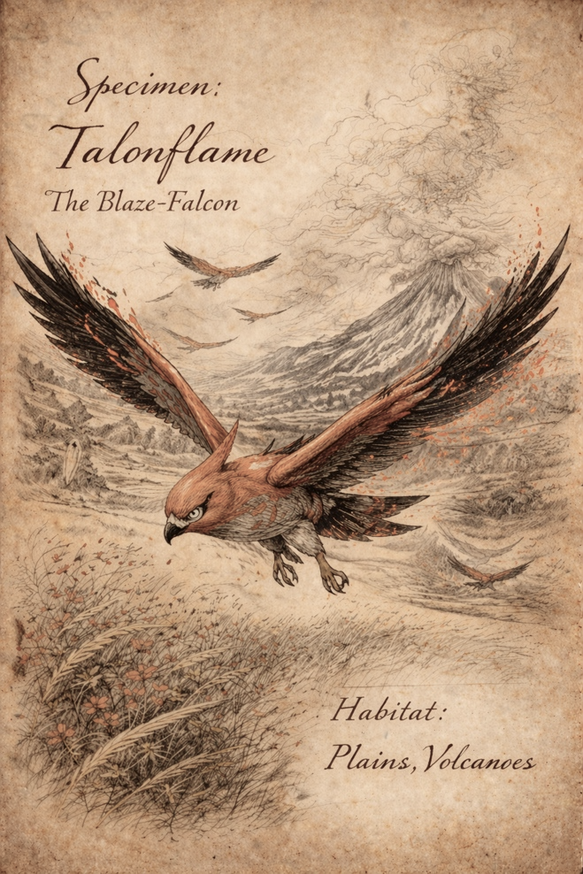
Talonflame
The Talonflame, known as the Blaze-Falcon, is a swift aerial predator with fiery red-orange plumage, dark-tipped wings, and powerful yellow talons. Its arrow-shaped tail grants exceptional control in flight.
Embers drift from its feathers as it flies, and its heat-resistant wings allow it to soar above plains and volcanic regions with ease.
During the cold seasons, Talonflames leave the plains to heat up near volcanoes.
Lucas: I knew my Mom spent a lot of time wandering the world to make this book but wow, these drawings are great and so much information about each species! Let me hurry back to the group so I don’t get lost!
WA staff: Hello everyone! Welcome to the “Crossroads of Destiny”. One of the paths leads to the Academy in 10 minutes and the other one leads to a fake long path. This means those who get my question wrong, won’t get to the Academy in time to register and that will seal your destiny! My question is…

Chapter 3: Crossroads of Destiny
WA staff: “The objective of the Academy is to create knights to serve the King as well as they possibly can and the epiphany of this are the 10 Golden Swords!”
Lucas: Hm… Well, it is why we’re here right so it mak-
WA staff: If you think the answer is True, head down the path to my right. If you think it’s False, head down the path to my left.
Lucas: We have 10 minutes to choose the correct path because the registration ends in 25 minutes and I need around 5 to register myself. If I choose the wrong one, it’s over. At its core the Academy does what the King wants. But does he really want people to just serve him?
???: This is easy! Of course that’s the objective! Why do you think we’re here?! Don’t joke around. I’m going right!
WA staff: Verry well, Wallace Ferrari chooses Truth. Please advance and follow the path to the right.
Wallace: Even if I’m wrong, I’ll just run back! I can run 5 times faster than you all! “Light as a Feather, Fast as Thunder. Speed Boost”
Lucas: He can use an ability; and it’s a really useful one in this scenario too. If his description of his ability is accurate, it should take him 4 minutes to go and come back so if he isn’t here in 9, I’ll choose the right path. It’s simple!
Most candidates thought the same. This was not the case when it came to Sophia.
Sophia: There has to be something they’re not telling us otherwise everyone will pass the test not having to think about the test… That’s it! Excuse me, I have my answer. I want to go left!
WA staff: Are you sure miss… Sophia Raven? Any moment you should have the answer everyone is clearly waiting for.
Sophia: Yes, I’m sure. Especially after what you just said! So, tell me Mr. STAFF, are you using spirit energy blocking or psychic abilities? Or did you just knock him out? See you in the Academy!

