

*Artificial Intelligence and Data Engineering*

*Industrial* *Applications*

***CarVibes***

________________________________________________________________________

Project architecture

Luca Caprioli

Martina Marino

Roberta Matrella

Academic Year 2021/2022

When the user enters the car and sits in the driver’s seat, the camera scans the face and recognizes the user to load the personal profile. The simulation starts basing on the user information included into the profile. If no information is present, the user can provide them compiling a form or can use vocal commands to request a specific simulation. During the simulations, the emotions of the user are registered and used to suggest the most liked car.

Basing on the requirements previously described, it is possible to draw an architecture of the platform, as shown in the image below.

In particular, the following elements have been identified:

* **Emotion recognition system**:
* **User interaction module**: this system handles the interaction between the user and the car.
* **User profile system**: it stores all the profile information, including the simulations score of the users for each car.
* **Car suggestion module**: it analyzes all the information regarding the mood detected during the simulations stored in the user profile and suggest a car.
* **Virtual road module**: it provides the simulation basing on the information available in the user profile; core of the platform, this system analyzes the landmarks of the face and extrapolates the mood of the person.

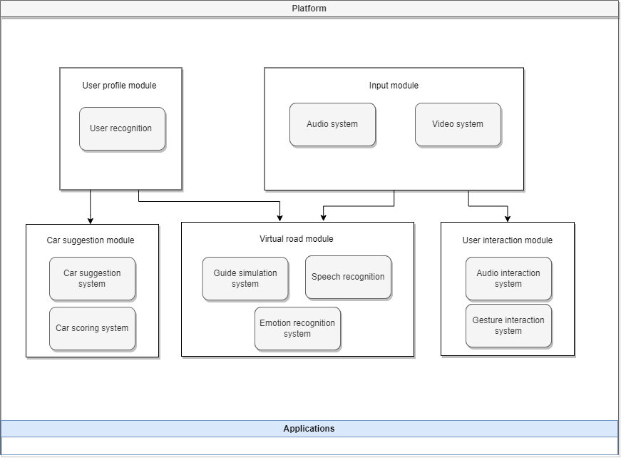

The application in the layer below, can be deployed over this platform without any knowledge of the implementation details.

Whenever a user enters the car, all the user profile information are retrieved from the cloud and, meanwhile, some information are acquired by the platform thanks to the input system.

The different sensors collect information for the emotion recognition module. This module helps the platform to identify the emotion of the user during the simulation. This information is used to update the user profile and suggest the best car.

The information regarding the user profile, including also the emotion score for each simulation and guide experience, are stored in a remote server hosted in a cloud.

Different cloud services have been compared to find the one that suits the best the application needs. First of all, the main cloud services have been identified. As it is possible to see in the following figure, the three main cloud services are AWS, Microsoft Azure and Google Cloud Platform. AWS and Azure together covers the 50% of the market.

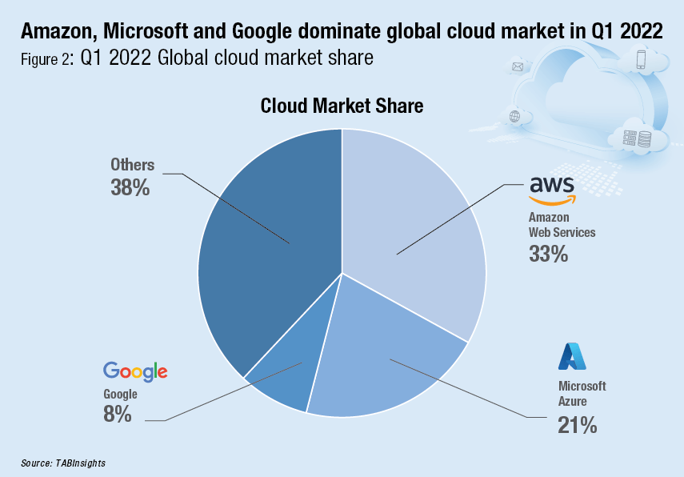

One of the main differences between these three cloud services is the availability zone.

* AWS covers 66 zones.
* Microsoft Azure covers 24 regions of the world in 140 countries.
* GCP is available in 24 regions with 73 zones.

The one with the higher coverage is AWS, followed by Azure. GCP have been born few years ago and doesn’t already have the coverage offered by the other two.

Another important aspect is the price.

* For a small instance of Amazon Web Services, it is necessary to pay around $69 USD per month. The price of a large instance however increases to about $3.97 USD per hour.
* A small Azure instance costs almost the same price as the AWS option, arriving at a $70 USD per month fee. However, the largest instance of Azure costs almost double, $6.79 USD an hour.
* Google Cloud only provides a basic $52 USD per month instance. A large GCP instance costs $5.32 an hour, standing right in the middle.

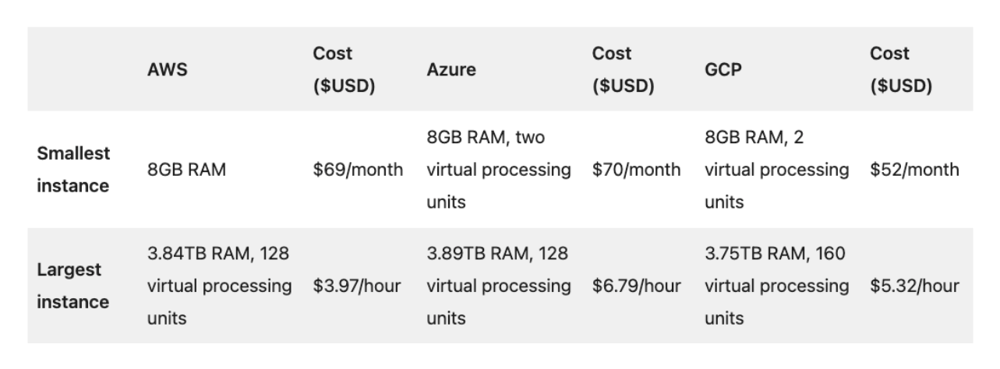

The price of AWS and Azure is almost the same. GCP is the cheapest but offers the lowest number of services. All the three cloud services offer different storage solutions and different databases, both relational and non-relational databases.

Moreover, the advantage of Microsoft Azure is the strong compatibility with all the Microsoft products and the high number of tools and APIs that are useful building an application.

GCP, instead, has been focusing on years on AI and ML and offers a high number of advanced models.

AWS, moreover, offers a high number of services and it is the more stable of the three.

Basing on the requirements of the project, the most suitable is Microsoft Azure. In fact, it provides services essential to the project and has a good coverage with respect to the price.