

*Artificial Intelligence and Data Engineering*

*Industrial* *Applications*

***CarVibes***

________________________________________________________________________

Project report

Luca Caprioli

Martina Marino

Roberta Matrella

Academic Year 2021/2022

Sommario

Introduction 1

Levels of Automation 2

Goal of the project 2

State of the Art 3

Car Buying Apps 3

User Needs 4

Market Analysis 6

Functional and Non-functional requirements 8

Platform Architecture 9

Working Staff 10

Work Package 11

GANTT 12

Risk analysis 13

# Introduction

Since the first vehicles was invented, some futurists have been dreaming about realizing cars without humans on the driver seat. One of the first demonstrations was a radio-controlled driver-less car built in the 1920's. In the following years also many movies put the attention on the topic, like *The Love Bug* (*Il Maggiolino Tutto Matto*) following the adventures of the anthropomorphic Volkswagen Beetle named Herbie (1968) or *Supercar,* a TV series in which the protagonist fights the forces of evil together with KITT, an indestructible and fully automated car controlled by an artificial intelligence. In the 1980's, Ernst Dickmanns and his team of Bundeswehr University Munich in Germany managed to alter a Mercedes Benz van to drive autonomously over more than 20 km with top speeds of 96 km/h on an empty highway; by 1989 it was able to recognize obstacles and in the 1990’s it could perform lane changes autonomously. From this demonstration many projects arose with the aim of reproducing this experiment. Since the early 2000’s many universities and car companies have been working on improving vehicle autonomy but it was always necessary the presence of a human driver to intervene in case of difficult situations.

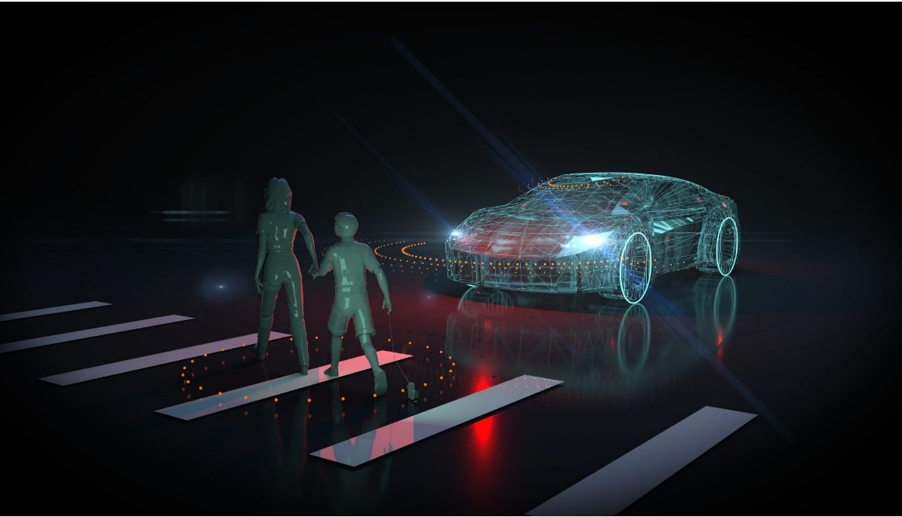Nowadays there is strong competition between newer technology companies (such as Google, Uber and Tesla) and established car companies (such as Mercedes Benz, General Motors, Nissan and many others). Some have been working on autonomous vehicles for years, and there are many working prototypes and trial programs. Some aspects of the driver-less car still need to be refined, and there are many legal, liability, technical and social problems that must be overcome. However, in terms of transport planning into the future, autonomous vehicles should be considered, as they are likely to have significant impacts on travel behaviour and road network operations.

# Levels of Automation

There are six autonomous driving levels, classified based on their degree of automation. Categorized by the Society of Automotive Engineers (SAE), the spectrum ranges from level 0 to level 5–from no automation to fully autonomous vehicles.

At a high level, you can think of the levels of automation as:

* Level 0: No automation at all
* Level 1: Very light automation (cruise control, etc.)
* Level 2: Some automation but requires human attention at all times
* Level 3: Can self-drive but require intervention in severe conditions
* Level 4: Highly autonomous
* Level 5: Completely autonomous

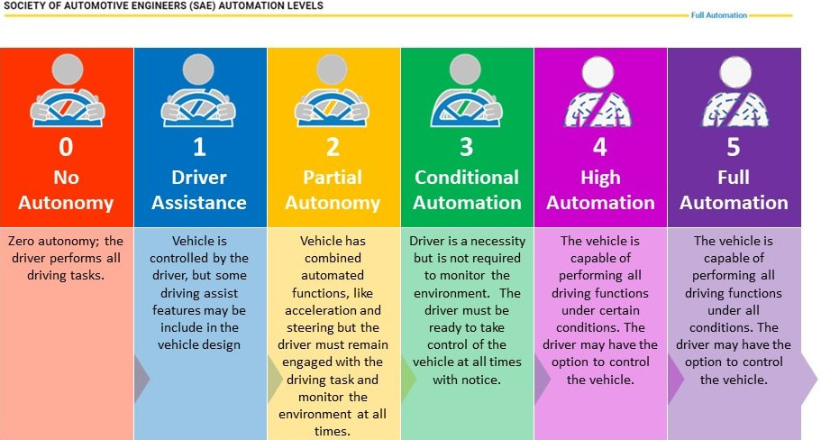

# Goal of the project

The aim of this project is to introduce a product innovation for the vehicles with a level of automation 3 or more with the objective of understanding the “feeling” between driver and car. This is achievable thanks the use of a software for the recognition of the emotions felt by the driver while using the car. Such innovation can be exploited for different purposes, in particular for a car buyer undecided about what car may be the right choice for him/her.

# State of the Art

### Car Buying Apps

Buying a car can be complicated, so over the years many applications have been created in order to offer features and helpful tools that can simplify the process. The first step is to see what has been done in this field of interest up to now in order to highlight what has to be maintained and what is matter of innovation.

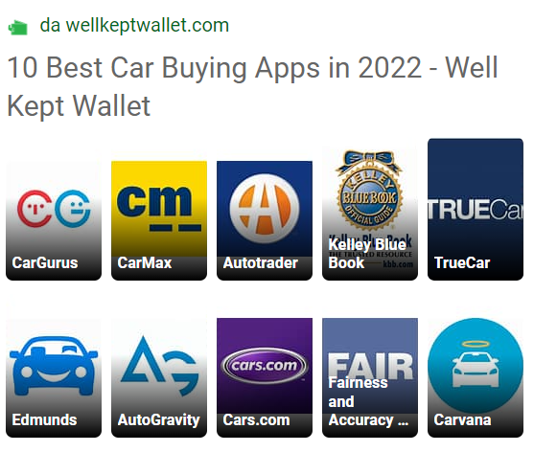With a quick online search of the best car buying apps of 2022, the results are almost always the ones reported below.

Without analysing them one by one we can underline what they have in common. The functionalities offered are more or less the same:

* Used and new cars handled
* Search filters
* Car comparison
* Drivers and experts reviews
* Rating
* Information about dealers
* Search saving
* Leasing

Focusing on the 3 most used of them, they have some more features:

* *CarGurus*: offering details on car history
* *Carmax*: with free reports and a maintenance service
* *Edmunds*: exploiting augmented reality and giving a service of market value evaluation

### User Needs

Buying a car is generally a long-term purchase and also one of the most important ones in the life and for this reason there are a lot of factors to consider in choosing the right one. In US, according to data from Statista's Global Consumer Survey, at the top of the checklist are fuel efficiency and safety with 56 and 55 percent, respectively. The design is not so taken in consideration and only 32 percent seem to be primarily concerned with the appearance of their new car.

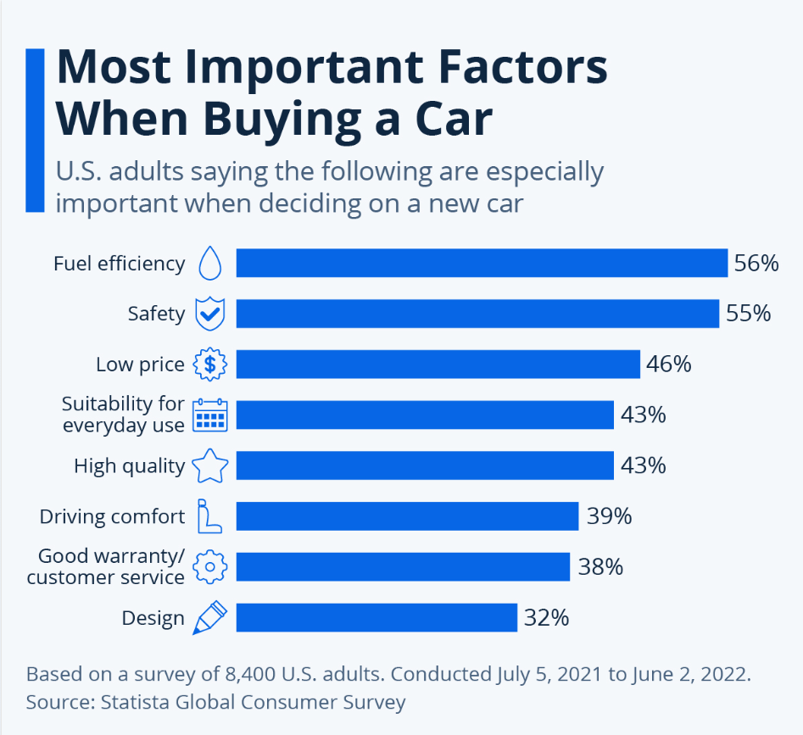

Nowadays these are the main factors that people take in consideration for the actual level of automation in which the driver still has a very important role during the trip, but considering a level of automation of 3 or more, the attention is shifted on the interior environment and the passenger experience, because driving is not the primary necessity when using a car. Furthermore

What is missing among the features offered by the apps previously named are the following factors:

* Consideration of emotions: although the main important things to consider when buying a car are technical.
* Real-time suggestions:
* Customer history regard:
* Interactive experience:

Explanation of factors and companies that exploit them.

Practical examples

# Market Analysis

The automotive sector is one of Italy’s major industries and employs 278,000. Last available data (February 2021) showed that in 2020, the automotive sector’s turnover was €106.1 billion, which was 11% of Italy’s manufacturing turnover and 6.2% of Italy’s GDP. The conversion from thermal engines to electromobility (hybrid and electric) is reshaping the sector and may offer opportunities for U.S. vehicle component, charging infrastructure, and diagnostic equipment manufacturers. Major changes in the circulating stock may also drive the development of the aftermarket sector in Italy.

In 2021, 797,243 vehicles (443,819 cars, 290,021 light commercial vehicles, and 63,403 trucks and buses) were produced in Italy, a 2.6% increase over 2020. 1,457,952 new cars, 5.5% more than in the prior year, were registered in 2021. The leading brands were the Stellantis Group (37.82% of the market), followed by the Volkswagen Group (16.52%), and the Renault Group (11.48%). In January 2021, FCA and PSA merged and became Stellantis, the world’s fourth largest automotive group, with 551,421 units registered in Italy in 2021 compared to 537,071 units for FCA and PSA in 2020 (or 38.88% of the market). 80,989 units by Ford Motor Company were registered in 2021 (5.55% of the market), and 89,573 in 2020 (6.48% of the market). 6,045 Tesla cars were registered in 2021 (0.41% of the market) and 3,805 cars in 2020 (0.28% of the market).

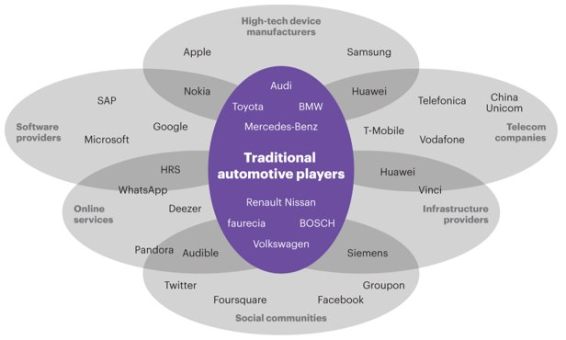

# Functional and Non-functional requirements

## Functional requirements

* The system recognizes the user from the face autonomously.
* The system profiles the user and uses it to provide a personalized virtual guide experience.
* The system must provide basic commands to interact with the user.
* The system must extract and collect into the user profile information about user’s emotions from the face.
* The system must provide a rank of the car basing on the average score of their different simulations.

## Non-functional requirements

* Reliability: the application guarantees and accuracy of at least 90% on emotion recognition (high accuracy in recognize positive emotions).
* Accessibility: the application must always be accessible by all the users.
* Privacy: the application must guarantee the privacy of all the users.
* Performance: the application must guarantee a fast detection of the user mood and ability to detect changes of the mood.
* Capacity: high storage capacity, platform provides high resources.

# Platform Architecture

In the figure below is defined a possible architecture for our platform considering the modules that offer the different functionalities. Have also been highlighted the relations between the modules. The application can use the services provided by the platform in a transparent manner, without any knowledge of the implementation details.

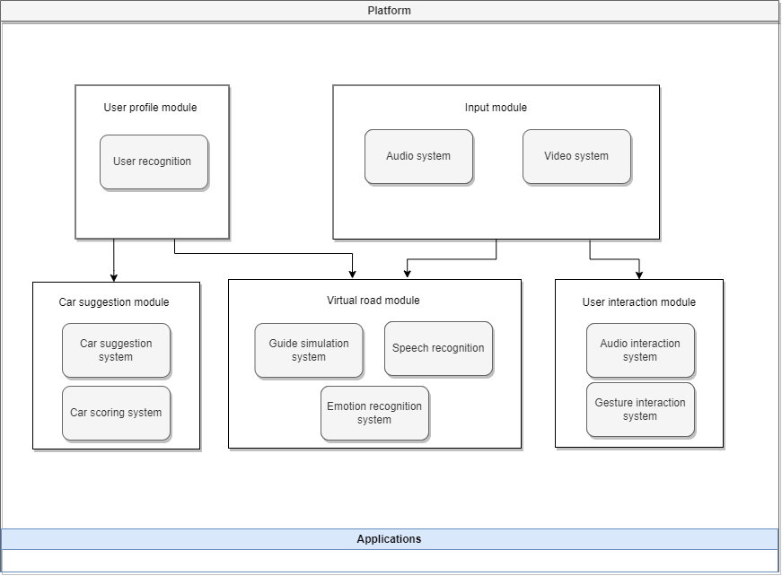

# Working Staff

We have individuated the following profiles that will be involved in the development of the whole project based on their skills.

* **Front-End Developer:** the main characteristic of this expert is the knowledge of the graphic libraries that will be used to realize the graphic user interface of our application and the knowledge of the management of the signal that will be used in our application in order to update such an interface.
* **Back-End Developer:** this expert is responsible for the development of the all the software needed to the implementation of the virtual environment. He is also in charge of providing the APIs to the higher levels and to the external applications that will exploit the platform for their services.
* **Embedded System Engineer:** the figure in this case is a proficient developer with the ability to design appropriate embedded system solutions with a high experience on the communication with signals from hardware components (possibly related to the automotive environment), the acquisition of real time data. These figures will be responsible also for the testing of the algorithm implemented.
* **Natural Language Processing Expert:** this figure oversees identifying which are the most used and advanced NLP cloud systems available on the market, also considering their costs and the system’s requirements. The expert must have a deep knowledge of the cloud APIs market and should be as much neutral as possible to get the objective best solution without preponderance towards a system.
* **Machine Learning Engineer:** this expert is a person in IT who focuses on researching, building, and designing self-running artificial intelligence (AI) systems to automate predictive models. In particular, he must have a deep knowledge on all the ML pipeline related to the definition of the best possible classifier to perform the detection of the mood by exploiting all the data coming in input.
* **Data Analyst:** this figure oversees all the aspects related to the analysis of the data by taking particular attention in the data preparation, collection, and aggregation phase in order to define an ad-hoc dataset for the development of the ML model. He must have a strong knowledge of the data coming as output from the main modules of the platform to define a matching strategy as good as possible for the virtual room system.
* **Project Manager:** he oversees the project from initiation to close, making sure the work gets done efficiently and satisfactorily. He must have high experience in the automotive sector and strong capability to coordinate a team.
* **Marketing Manager:** this expert must have strong competences in defining the right marketing campaign and the budget for the project. He must also negotiate with external companies in the cloud and cybersecurity sector to get the best solution.

# Work Packages



## Summary Table

|  |  |  |
| --- | --- | --- |
| WP | Description | Tasks |
| Coordination & Management |  | 1. Project coordination. |
| Feasibility Analysis | In this first package the market research analysis of the competitors is carried out, the functional and non-functional requirements of our product are analyzed up to define the structure of the platform. | 1. Objective & Goals Definition. 2. Platform Specification. 3. Functional Requirements. 4. Non-Functional Requirements. |
| GUI/VUI Module | Creation of a modern, user friendly, easy to use interface that makes the experience inside the car better. | 1. HM Interaction Guidelines. 2. Software Development. 3. GUI Test. 4. VUI Test. |
| Mood Recognition | In this WP we study the different mood recognition services already available on the market and evaluate the best options to integrate with our product. | 1. SotA Analysis. 2. Data Collection & Preparation. 3. Training, Validation & Testing 4. Product Suggestion. |
| Virtual Road | In this WP all the tasks related to the implementation of the virtual room service are grouped. | 1. Profiling Strategy Definition. 2. Framework Integration. 3. Simulation Environment Implementation. 4. Simulated Road Test. |
| Test & Deployment | Final WP in which all the task dedicated to the assessment of our product and its distribution are carried out. | 1. Testing Plan Definition. 2. Platform Specs & Requirements Check. 3. Deployment. 4. Monitoring. |

## Work Packages Description

### WP 1

|  |
| --- |
| **Title***: Project coordination and Management* |
| ***Weeks****: T0 + 36* |
| **Objectives***: Project coordination* |
| **General description of the WP:** *This step is related to all those activities that regard the coordination of different professional to produce a step-by-step solution. Monitoring all the different phases of the project is the main aims of this task that must detect possible mistake and solve them. Help to get out the documentation.* |
| **Activity***: Project coordination* |
| **Deliverables***: Monitoring, documentation* |
| **Personnel***: Project Manager, Market Manager, Embedded System Engineer* |

### WP 2

|  |
| --- |
| **Title***: Feasibility Analysis* |
| ***Weeks****: T0 + 14* |
| **Objectives***: Competitor Marketing Analysis, Platform specification* |
| **General description of the WP***: in this first package the market research analysis of the competitors is carried out, the functional and non-functional requirements of our product are analyzed up to define the structure of the platform.* |
| **Activity***: Objectives & Goals Definition, Platform Specifications, Functional Requirements, Non-Functional Requirements* |
| **Deliverables***: Project documentation, SWOT Analysis, Perceptual Map* |
| **Personnel***: Project Manager, Marketing Manager, Embedded System Engineer* |

|  |  |  |  |
| --- | --- | --- | --- |
| Name | Description | Personnel | Weeks |
| Objectives & Goals Definition | The aim of this task is to study the field to which we are interested in. It is essential to define the challenges to cope with, to study the market by identifying competitors and customers, the objectives to be achieved with the project and the strategies that will be adopted to accomplish to them. | Project Manager, Marketing Manager | 4 |
| Platform Specifications | In this step all the functionalities and features of the platform are defined with all the modules required for the implementation. all the actors that could be involved are identified and categorized in order to better segment the market and provide a more specific product for different classes of users (use case). | Embedded system Engineer | 3 |
| Functional Requirements | Requirements analysis is very critical process that enables the success of our system to be assessed. the functional requirements are defined through the use cases and represent all these functionalities need to be necessarily incorporated into the system as a part of a contract. | Embedded system Engineer | 5 |
| Non-Functional Requirements | Subsequently the non-functional requirements are described to identify the quality constraints that the system must satisfy according to the project contract. | Embedded system Engineer | 5 |

### WP 3

|  |
| --- |
| **Title***: UI Module* |
| ***Weeks****: T8 + 18* |
| **Objectives***: Definition and Implementation of HM interface with subsequent testing* |
| **General description of the WP***: Creation of a modern, user friendly, easy to use interface that makes the experience inside the car better.* |
| **Activity***: HM Interaction Guidelines, Software Development, GUI Test, VUI Test* |
| **Deliverables***: GUI guidelines and user interface prototype* |
| **Personnel***: Front-end Developer, Back-end Developer, NLP Engineer* |

|  |  |  |  |
| --- | --- | --- | --- |
| Name | Description | Personnel | Weeks |
| HM Interaction Guidelines | Making extensive research to discover user needs, carrying out numerous iterations, and gather feedback to achieve adequate performance of the product and its design. it is essential to define a series of guidelines that provide readability, usability and safety. | Front-end developer, NLP Engineer | 4 |
| Software Development | The user interface must be designed as an easy-to-use one, possibly textless and graphically attractive. These are key points for a successful product since users want their usage experience to be as much satisfying as possible. We have then to design a two-way user interface, one graphic and one vocal, to increase the flexibility with which users can interact with the system to insert new tasks or to monitor the progress in the execution of the previously inserted tasks. | Front-end developer, Back-end developer, NLP Engineer | 6 |
| GUI Test | Check Graphic User Interface, it must be simple and intuitive to simplify the usage of the platform. In this part also the proper functioning of the GUI is checked  through the use cases and represent all these functionalities need to be necessarily incorporated into the system as a part of a contract. | Front-end developer | 4 |
| VUI Test | Check Voice User Interface, it must be simple and easy to use to encounter the needs of the users. In this part also the correct recognition of the command given by user is checked. | NLP Engineer | 4 |

### WP 3

|  |
| --- |
| **Title***: Mood Recognition* |
| ***Weeks****: T8 + 21* |
| **Objectives***: Searching for the best network for mood recognition* |
| **General description of the WP:** T*his package contains all the steps necessary for the creation and choice of the best neural network dedicated to mood recognition* |
| **Activity***: SotA Analysis, Data Collection & Preparation, Training, Validation & Testing, Product Suggestion* |
| **Deliverables***: Best network for mood recognition* |
| **Personnel***: Data Analyst, ML Engineer, NLP Expert* |

|  |  |  |  |
| --- | --- | --- | --- |
| Name | Description | Personnel | Weeks |
| SotA Analysis | Initial phase in which the most recent discoveries from a technological point of view are analyzed regarding the recognition of the mood from expressions, gestures, tone of voice, heart rate. We go in search of possible approaches to be taken in consideration published in the scientific world. | ML Engineer, NLP Engineer | 4 |
| Data Collection & Preparation | In this phase data are collected from different sources which can also be different. This data is aggregated and normalized. At this point the collected data is analyzed, the respective classes are assigned and to make a more in-depth study: the classes must be balanced (oversampling or under-sampling techniques), and the study of input coverage is also essential. Once the pre-processing is finished, the data is ready to be transformed to extract the features. At this point it is essential to divide the data into three different sets by choosing the splitting percentages. | Data Analyst | 6 |
| Training, Validation & Testing | Several neural networks are examined which are trained by setting the hyperparameters.  Once the training is completed the validation phase is carried out in which the best hyperparameters for the networks under examination are chosen, but before going on, it is necessary to check that the networks are not overtrained.  In the last phase the best network is tested on the test set. Also in this case it is necessary to make sure that the error on the test set and training set is not beyond a certain threshold, otherwise it is necessary to collect new samples. | ML Engineer | 7 |
| Product Suggestion | Phase were the data collected by the various sensors to exert mood recognition are used to compute the various car suggestions to generate a detailed ranking and help the user in its choice. The vary rules on how to create this ranking are defined in this stage. | ML Engineer, Data Analyst | 4 |

### WP 4

|  |
| --- |
| **Title***: Virtual Road* |
| ***Weeks****: T8 + 23* |
| **Objectives***: Virtual Road system concept and integration* |
| **General description of the WP***: in this WP all the tasks related to the implementation of the virtual road service are grouped* |
| **Activity***: Profiling Strategy Definition, Framework Integration, Simulation Environment Implementation, Simulated Road Test* |
| **Deliverables***: Virtual Road System* |
| **Personnel***: Data Analyst, Embedded System Engineer, Front-End Developer, Back-End Developer* |

|  |  |  |  |
| --- | --- | --- | --- |
| Name | Description | Personnel | Weeks |
| Profiling Strategy Definition | The aim of this task is to provide clear ways of matching strategy. this means that we focus the attention on the possible interests that a user may have and how these interests can be matched. we define macro-topics, that express more general information and collect more specific sub-topic. | Data Analyst | 4 |
| Framework Integration | Integration of the main modules of the platform and how they must communicate among them. | Embedded System Engineer | 5 |
| Simulation Environment Implementation | The platform must provide easy solution to be exploited from third party’s companies. A set of functions (API) will be exposed to allows application to use SPI functionalities. A virtual experience must be implemented by combining all the sensors and devices provided but that can be also modulable and applied to systems with different configurations. | Front-End Developer, Back-End Developer | 8 |
| Simulated Road Test | Phase where the all the implemented virtual experiences are tested by combining the feedback of the various sensors and multimedia devices (primarily the displays) to detect delays and desynchronizations guaranteeing a simulation as defined as possible. | Embedded System Engineer | 6 |

### WP 5

|  |
| --- |
| **Title***: Test & Deployment* |
| ***Weeks****: T13 + 20* |
| **Objectives***: Service deployment and testing* |
| **General description of the WP***: Final WP in which all the task dedicated to the assessment of our product and its distribution are carried out* |
| **Activity***: Testing Plan Definition, Platform Specs & Requirements Check, Deployment, Monitoring* |
| **Deliverables***: Platform infrastructure development* |
| **Personnel***: Embedded System Engineer, Data Analyst* |

|  |  |  |  |
| --- | --- | --- | --- |
| Name | Description | Personnel | Weeks |
| Testing Plan Definition | Some standard tests to measure the requirements are defined. Once each requirement is passed through these tests they are evaluated and freeze. Analysis of the results of the project from a business perspective, and identification of business cases for the exploitation of the results. | Embedded System Engineer | 4 |
| Platform Specs & Requirements Check | The main objective of this work package is to ensure the achievement of the project objectives and meet the contractual commitments through administrative coordination as well as providing the measures that will help to achieve the expected project impacts. | Embedded System Engineer | 6 |
| Deployment | the result will be a fully working system that can be deployed and sold. The system will be able to recognize the mood and understand the topic from a conversation (associate to each user) to discover the best matches. integration and deployment of the technologies and infrastructure required to set up. | Embedded System Engineer | 6 |
| Monitoring | A performance monitoring system is defined and assembled within the project to keep the accuracy and reliability of our product under control. | Embedded System Engineer, Data Analyst | 4 |

# GANTT

In the picture below we designed the GANTT chart for the development of our platform.



# Risk analysis

An autonomous vehicle involves multiple subjects, including computing systems, machine learning, communication, robotics, mechanical engineering, and systems engineering, to integrate different technologies and innovations.

Now we must identify the main business risks for our project. We listed all the critical components of our project that expose some risks, namely all the aspects that may lead to a project failure or reduction of profits. After a deep analysis of our project and all its components, we have extracted the main possible risks that can cause an economical damage to the company.

## Cloud Risks

For each cloud component in our system (NLP, Road Selection) after having chosen one implementation for each of them, we may find a better one in the market, both in terms of performance and cost. Moreover, after having implemented the system with a specific cloud service in mind, the selling company may change its license agreement.

For these reasons, it is very important to focus on a deep market analysis to choose the best cloud service, taking in consideration its possible evolution in the future, both in terms of technical support, software updates (usually not a problem when considering cloud solutions) and stipulated license agreements.

Hardware Risks  
  
The target hardware may become obsolete in a short time, due to the fact that hardware’s evolution rate is quite high. We can overcome this problem by developing our application while limiting the part of hardware dependent code (e.g., writing the code in a high-level programming language, running the code on a general-purpose OS).

As example we can face a microcontroller obsolescence, meaning that could be found on the market better HW systems at lower prices.

A possible solution we propose to face that risk is implementing our application using not hardware related programming languages or at least reducing to 5/10% the quantity of code HW dependent.

Software Risks  
  
For each component in our system, after having chosen one implementation for each of them, we may find a better one in the market, both in terms of performance and cost. Moreover, after having implemented the system and stipulated contracts with partners they may change its license agreement.

For these reasons, it is very important to focus on a deep market analysis in order to choose the best SDK service, taking in consideration its possible evolution in the future, both in terms of technical support, software updates and stipulated license agreements.

A possible solution could be to choose the most integrable and composable SDK in order to make and eventual porting as easy and modulable as possible.

Artificial Intelligence Risks  
  
The last component that could be subject of business risks is related to the Neural Network. Like the previous case, the risk is the Neural Network obsolescence, meaning that more accurate and reliable models could be found on the market.

The solution we propose is abstracting the class implementation methods to be called independently from the below Neural Network. In this way if we find a new and more accurate system, we may replace it without any change in the application code.

Another aspect to consider is the concept drift because data may change over time. When concept drift occurs, the model used can make more and more mistakes in detecting the mood, if not updated. We can define some thresholds to detect errors (on misclassified instances) and to decide the right time to retrain the model.

## Privacy Risks

As the vehicle captures a massive amount of sensor data from the environment, vehicle data privacy becomes a big issue. For example, all the aspects related to the profile of the users and all its experiences need to be treated very carefully. Furthermore, who owns this data is also an important issue, which requires the system’s support for data access, storage, and communication.

A possible solution is to rely on expert cybersecurity companies for the management of data and to keep them safe.

|  |  |  |
| --- | --- | --- |
| Risk | Problem | Solution |
| Cloud | License agreements, performance, costs. | Deep market analysis to identify best technical support, SW updates and license agreements. |
| Hardware | Better HW system at lower price. | Exploit programming languages not HW related. |
| Software | Better SW system at lower price. | Exploit highly compatible and modulable SDK. |
| Artificial Intelligence | More accurate models available. | Abstract the implementation of the class methods to make the model independent from them. |
| Privacy | Management of personal data. | Rely on external cybersecurity companies. |