

*Artificial Intelligence and Data Engineering*

*Industrial* *Applications*

***CarVibes***

________________________________________________________________________

Project Technologies

Luca Caprioli

Martina Marino

Roberta Matrella

Academic Year 2021/2022

# Technologies

The application must recognize the vocal commands of the users and recognize their emotions. The main objective is to perform these operations in an autonomous guide car under two conditions:

* + Different users in different seats
  + The noise in the auto

It is possible thanks to a model for emotion recognition and speech detection and high-quality devices to collect the data.

# Emotion recognition model

The model that best fits the application needs is the one shown below [1]. This convolutional neural network archives an accuracy of 93% in the recognition of the positive emotions, as the application requires.

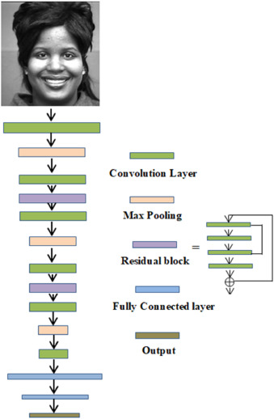

The model has been built starting from two datasets:

* + Cohn–Kanade (CK+)
  + Japanese Female Facial Expression (JAFFE)

These two datasets contain images regarding:

* + Male and female of different countries
  + Six different emotions such as sadness, happiness, surprise, angriness, fear and disgust.

Images resolution:

* + 640 x 480 pixels, 30 fps

# Emotion recognition usage

The emotion is recognized during the guide simulation.

Each time a positive emotion is recognized, a counter associate to the guide session and the user is updated locally and at the end the score is sent to the server that saves the score into the user profile.

At the end of all the simulations, the most appreciated car is suggested basing on the average values of the different simulations of each car (weighted according to the duration of the simulation). The cars are ordered by descendent score and the one with the highest score is suggested. The rank provided is based on all the guide simulations experienced by the user.

The positive emotions considered are:

* + Happiness
  + Surprise

The score is performed in this way:

1. Loading of the user profile
2. Proposal of guide simulation basing on the preferences present into the profile
   1. If no preference is expressed into the user profile or the user wants a specific simulation, he can use vocal command and ask for a specific guide simulation
3. The guide simulation experience is provided, and the emotions are recognized
4. At the end of the simulations, the car with the highest average score between the tried cars is shown

Face recognition

In order to get the user profile, a face recognition method is used. It automatically recognizes the user seated in the driver’s side and retrieves his profile. This method allows the user to access his personal profile from any car without having to insert his credentials. In this way, the access is fast and secure. Modern-day face extraction techniques have made use of Deep Convolution Networks. The one that gives the best results is FaceNet, provided by Google, that achieves an accuracy of about 98%[2].

# Screen display

Specifics **(55EW5G-V 55” FHD Transparent OLED)**:

* **Native resolution:** 1920×1080 (FHD)
* **Vision** **angle (O x V):** 178 × 178
* **Colour depth:** 1,07 billion of colours
* **Usage time (hours/days):** 18/7
* **Protective screen:** 3.0 mm, tempered, no-reverb
* **Functional temperature interval:** -10°C to 50°C
* **Functional humidity interval:** 10% to 90%

# Video acquisition system

Specifics **(Sony IMX686 + Sony IMX363)**:

* Primary: Sony IMX686 1/1.73” 64 MP Quad-Bayer sensors with 0.8 µm pixels, 26.6 mm-equivalent f/1.8-[aperture](https://www.dxomark.com/glossary/aperture/) lens, [PDAF](https://www.dxomark.com/glossary/pdaf/), [OIS](https://www.dxomark.com/glossary/ois/)
* Ultra-wide: Sony IMX363 1/2.55″ 12 MP sensor with 1.4 µm pixels, 14.3 mm-equivalent f/2.2-aperture lens, PDAF
* LED flash
* 8K at 24fps, 4K at 30/60 fps, 1080p at 30/60 fps (4K at 30 fps tested)

# Audio acquisition system

Basing on the speech recognition recommendations provided by Microsoft Azure, the microphone must have at least a frequency response of 16khz and bit rate of 24 bit.

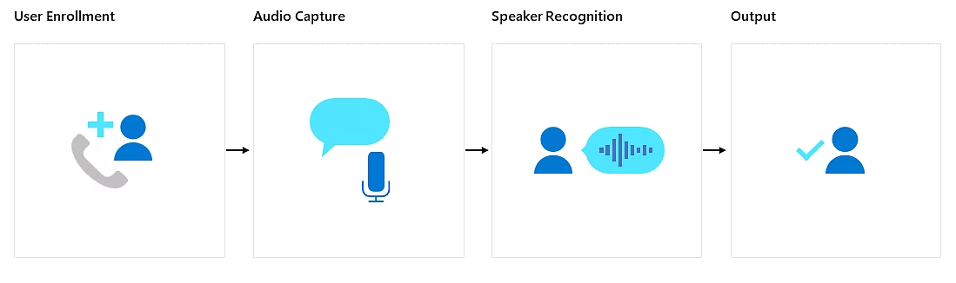

CodeWorld [3] provides different possible microphones place solutions to achieve a good noise and echo attenuation. To reduce also the noise coming from the outside a SNR higher than 65 dbA is necessary. Even if the simulation can be done inside the dealership, there could be noise outside.

The best disposal of microphones is the one provided by Bose that offers a good noise-cancelling system, as it is shown in the following image. It also guarantees a good coverage of the entire car.

# Specifics **(Audio-Technica ATR4697-USB)**:

* **Polar Pattern:** Omnidirectional in hemisphere above mounting surface
* **Frequency Response:** at least 50-16000 Hz
* **Maximum Input Sound Level:** 130 dB
* **Signal-to-Noise Ratio:** at least 46 dB (65 dB to avoid external noise)

Indeed, the omnidirectional microphones achive the best audio coverage w.r.t. the other type of microphone:

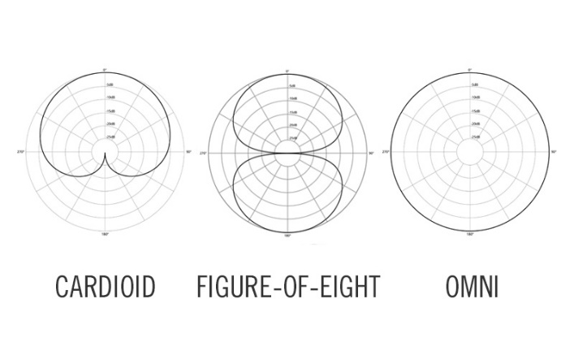

Using omnidirectional microphones it is possible to reduce the number of microphones, evaluating it basing on the dimension of the car and the number of passengers.

Fragrance system

Car diffuser [4] allows to spread the fragrance in all the car. There are different fragrance that can be used. The limit of them is that to change the fragrance the diffuser has to be change. The most used fragrance are:

* [The White Company’s car diffusers](https://www.thewhitecompany.com/uk/Car-Scent-Diffuser/p/CSDST?swatch=No+Colour) (£15) come as a plug-in stick; just add a few drops of essential oil into the aluminium casing.
* [Jo Malone](https://www.jomalone.co.uk/home/diffusers/car-diffuser-scented) now offers car diffuser sets (£73) featuring signature scents like Lime, Basil & Mandarin
* [Diptyque](https://www.diptyqueparis.com/en_uk/p/diffuseur-pour-la-voiture-et-sa-cartouche-parfumee-baies.html)’s intoxicating Baies (£79) scented cartridge slots into a metal, grille-like diffuser you plug into the air vent.
* [Acqua di Parma’s diffuser](https://www.acquadiparma.com/en/gb/car-diffuser/ADPCARDIFFUSERBUNDLE001.html?) (£95) is made with Poltrona Frau leather; it’s a car diffuser and a design object in its own right.
* [L’Original London](https://loriginal.co.uk/)’s orb-shaped diffusers (£39.90), in an array of metallic finishes like rose gold and galaxy silver, double up as fiddle objects you can throw in a handbag and sniff when you’re out and about.

Light system

The upcoming next big trend in automotive interior lighting are 1,000 of RGB light-emitting diodes (LEDs).

Large area “pixelated” lighting [5] with daylight performance requires an optimized combination of optic technologies as well as dedicated electronics, hardware and software:

* High power RGB LEDs (daylight readable)
* Light guides for direct-lit backlight
* Efficient current drivers with high-speed digital interfaces (in the range of Mbit/s)
* Dedicated control units capable of addressing hundreds of RGB LEDs in real time with high frame rates (>400 Hz)
* Software for designers to create efficiently the content to be displayed

Il concetto ISELED offre una soluzione elegante per questi problemi. Si basa su un chip controller sviluppato da Inova Semiconductors, che è integrato insieme ai LED RGB in un sistema in pacchetto (SIP), vedi Figura 3. Questi pacchetti possono essere facilmente collegati ad una lunga catena a margherita (due maglie), che è controllato tramite il personalizzato e proprietario Protocollo ISELED.

Circa 200 ISLED possono essere serializzati con un frame rate di circa 80 Hz e tutti i dati del livello di grigio RGB vengono aggiornati ogni frame per le animazioni dinamiche.

Until now:

* to **individually control each individual RGB LED**
* necessity to use a microcontroller containing the specific data of the respective LEDs.

Now:

A **single microcontroller** can handle a LED strip containing up to **4,096 LEDs**.

The advantages are:

* Lower costs
* Simplified control
* Expanded functionalities

References

[1]https://www.sciencedirect.com/science/article/pii/S016786551930008X?casa_token=KOzFGH7sea4AAAAA:1AxQhQUNolggJwaXiy1CxWbm_2_059BfKfrHuF-Z6Ij0OoM1vtEdriot7LtrD_I9JRNYbO-RUg

[2]<https://www.analyticsvidhya.com/blog/2021/06/face-detection-and-recognition-capable-of-beating-humans-using-facenet/>

[3] <https://www.codetd.com/en/article/7713766>

[4] *www.readersdigest.co.uk*

[5] [researchgate.net](https://www.researchgate.net/publication/340877662_Advances_in_automotive_interior_lighting_concerning_new_LED_approach_and_optical_performance/fulltext/5ea2aa84458515ec3a02f639/Advances-in-automotive-interior-lighting-concerning-new-LED-approach-and-optical-performance.pdf)