TEMPLATE INSTRUCTIONS
This template document contains guidance notes, such as this one. These instructions should therefore be deleted before the release of the document. This also applies to this chapter "Template instructions". Information highlighted in yellow should also be evaluated and completed.
Sections that are indicated as optional can be deleted. Also, required content can be added.
The version history below applies to the template and not to the resulting document. Clean up the table as needed and use it for your document control purposes.
Template Version History
Version | Date of validity | Author | Description of change
1 | 2022-06-01 | Célia Cruz | First version

Version History
Version | Date of validity | Created by | Approved by | Description of change
1 | YYYY-MM-DD | [Name, including digital signature] | [Name, including digital signature] | First version

Purpose and Scope
The purpose of this procedure is to describe methods for the processing and reporting of incidents and field safety corrective actions.
This procedure applies to all medical devices as well as incidents and required field safety corrective actions which occurred / performed in the European Economic Area (EEA).

Responsibilities
Please adapt the responsibilities accordingly to your company.
The Person Responsible for Regulatory Compliance (PRRC) is responsible for following, applying and updating this procedure.

Procedure
Please adapt accordingly to your company.

Terms
The following terms are consistent with the definitions in the MDR and MEDDEV 2.12/1 Rev.8 in combination with the document "Additional Guidance Regarding the Vigilance System as outlined in MEDDEV 2.12-1 rev. 8".

Incident
An incident means a malfunction or deterioration in the characteristics or performance of a product already on the market, including application errors due to ergonomic features, as well as an inadequacy in the information provided by the manufacturer or an undesirable side effect.
A serious incident describes an adverse event which directly or indirectly has had or could have had one of the following consequences:
a) the death of a patient, user or other person,
b) the temporary or permanent serious deterioration in the state of health of a patient, user or other person,
c) a serious risk to public health.
A serious threat to public health means an event which could result in an immediate risk of death, serious deterioration in the health status of a person, or a serious illness requiring immediate remedial action, and which may cause significant morbidity or mortality in human beings, or which is unusual or unexpected for a specific place and time.

Reportable Incident
The term "reportable incident" is not described in the Medical Device Regulation. Any serious incident that becomes known is considered reportable if one of our products is suspected of having caused or been involved in the serious incident. For other reportable events, please also refer to the chapters Field Safety Corrective Actions and Reportable Trends.
If the PRRC or its representative is uncertain whether a serious incident has occurred, should report it within the time limits specified in section Reporting Deadlines.

Field Safety Corrective Action (FSCA)
Field Safety Corrective Action (FSCA) refers to a corrective action taken by a manufacturer for technical or medical reasons to prevent or reduce the risk of a serious incident in relation to a device made available on the market. FSCAs include:
- Return (take-back (e.g. from distributor) and / or recall from end user))
- Exchange
- Conversion or retrofitting / modification
- Discarding
- Destruction
- Recommendation of measures for the use of the product for further use or for patient management (e.g. for control examinations of implants)
A product modification may include, for example:
- Permanent or temporary change in labeling or instructions for use.
- Software updates / upgrades
Any FSCA related to a product made available on the EEA market is subject to reporting. In addition, FSCAs in third countries are also reportable if the FSCA relates to a product that is also made available in the EEA market, and provided that the reason for the FSCA does not relate only to the third country (example for a non-reportable FSCA: an error in the Japanese version of the instructions for use, provided that the error only occurs in the Japanese translation).

Recall
A recall is any measure aimed at achieving the return of a device that has already been made available to the end user.

Withdrawal
A withdrawal refers to any measure aimed at preventing a device in the supply chain from being further made available on the market.

Field Safety Notice (FSN)
A Field Safety Notice (FSN) refers to a communication sent by a manufacturer to users or customers in relation to a field safety corrective action (and, if possible, made available to the public via the EUDAMED).
Therefore, it is the notification with which users are informed of required FSCA activities.
The FSNs must be written in an official language or official languages of the EU. The states in which the FSCA is taken make the corresponding specifications.
The FSN includes the following information:
- Information to correctly identify the product (by including the relevant UDI, if applicable);
- Information to correctly identify the manufacturer (by including the Single Registration Number (SRN), if applicable) undertaking the FSCA;
- Reasons for the FSCA with reference to the malfunction of the product and associated risks to patients, users and third parties;
- Any action to be taken by the user (Professional users and operators will be informed, if necessary, that products and sample materials suspected of being involved in a serious incident should not be discarded immediately but may need to be provided to the manufacturer as evidence).
A template of the FSN can be found in FRM-VI-02 Field Safety Notice.

Reportable Trends
For reporting trends purposes (MDR Article 88), trend is any statistically significant increase in frequency or severity of non-serious events or anticipated adverse reactions that could have a significant impact on the risk-benefit analysis and that results or could result in putting the health or safety of patients, users, or others at a higher risk, which is unacceptable considering the intended benefits.
Reportable trends are defined in SOP-PMS-01 Procedure Post Market Surveillance.

Involved Authorities
As soon as the functionality of the EUDAMED is guaranteed, the reporting is to be made via the electronic system. Please note that at the national level, EU countries may have their own regulations on how to proceed until the EUDAMED is functional.
Reportable incidents are reported to the authorities of the country in which the reportable event has occurred.
The PRRC reports Field Safety Corrective Action (FSCA) reports to the authorities in the countries where the FSCA is to be implemented.
FSCAs that we conduct outside the EEA but which are or may be related to a product on the EEA market are reported by the PRRC to the National Competent Authority where the manufacturer is based.

Trends are reported to the National Competent Authority where the manufacturer is based.
Contacts of the National Competent Authorities can be found in LST-VI-01 Regulatory Entities Contacts.
Until the EUDAMED is fully functional and / or the reporting form is renewed, use the following templates:
- Manufacturer incident report
- Forms available from the applicable National Competent Authority.

Reporting Deadlines
The timescale for reporting a serious incident is:
- In the event of imminent danger:
  - Immediately (without any delay that could not be justified)
- In the event of a serious public health threat:
  - Immediately after a link was established between the device and the event, but no later than 2 elapsed calendar days following the date of awareness of the event.
- Death or serious deterioration in state of health:
  - immediately after a link was established between the device and the event, but no later than 10 elapsed calendar days following the date of awareness of the event.
- Other reportable incidents:
  - Immediately after a link was established between the device and the event, but not later than 15 elapsed calendar days following the date of awareness of the event.
- Field Safety Corrective Action (FSCA):
  - Immediately, at latest with the beginning of the implementation of actions.
All report times refer to when the National Competent Authority must first be notified. In case of uncertainty whether the incident has to be reported or not, it is reported within the above deadlines.

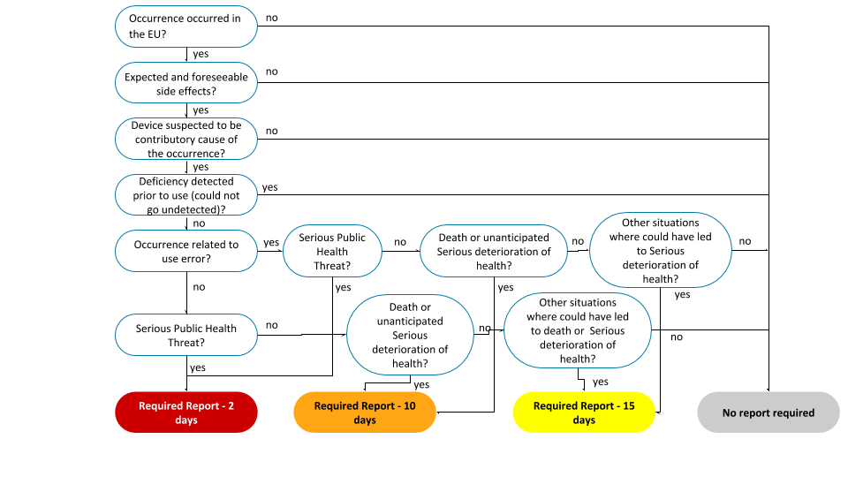

Storage of Reports and Records
The PRRC shall record the analysis of potential reportable incidents in the FRM-VI-01 Incident Evaluation, listing the location of all reports, forms and other records.

Reporting of Serious Incidents

Becoming aware
Any employee of the company once becoming aware of an event, such as coming either from feedback, complaint, notification/information from authorities or internal results (SOP-CM-01 Procedure Feedback and Complaint Management), informs the PRRC.
The PRRC evaluates whether a serious incident has occurred. It should be assessed whether the incident is reportable, as described in the section Reporting Deadlines. The evaluation is documented in FRM-VI-01 Incident Evaluation.
If authorities become aware of a potential incident and inform us, the event is assessed in the same way. If we do not classify it as a reportable incident, a justification must be provided within 15 days. However, if the National Competent Authority does not agree with the conclusion, we still report within the deadlines and take action, if necessary.

Investigation
The PRRC investigates the root cause analysis of the event to determine if there is a causal relationship between the use of the medical device and the event. The investigation follows the SOP-CP-01 Procedure Corrective and Preventive Actions.
If there is no causal relationship, the event is not considered a reportable incident.
In the case of uncertainty, the event is reported as a reportable incident.
If there is a relationship, the PRRC secondly evaluates if the event qualifies as a reportable incident by filling out the FRM-VI-01 Incident Evaluation.
It is also simultaneously checked whether and which safety corrective actions are necessary. This is assessed on the risk analysis if immediate action is required, such as:
- a device recall;
- a FSN to customers / distributors regarding FSCA and the action to be taken (e.g. workaround);
- no action, e.g. if the investigation shows that our device was not involved in the incident.
No action will be taken during the investigation that results in a change to the product or a sample of the affected batch that could have an impact on a subsequent evaluation of the causes of the incident, prior to notifying the National Competent Authorities of such action.
In case of doubts regarding the reporting requirement or if it was not possible to terminate the investigation / risk analysis within the reporting deadlines due to the lack of information, the PRRC reports the incident, if necessary, in an incomplete state (initial report).
If the incident is considered not reportable, the PPRC it will be further evaluated within the section Trend Reporting. No further action from this procedure is required.

Reporting Incidents

Initial Reporting
Within the applicable reporting timescale as described in section Reporting Deadlines, the PRRC informs the responsible National Competent Authority about the event using respective reporting forms.
If applicable, a copy of the report is sent to the Notified Body involved in the conformity assessment procedure of the device.
The PRRC fills out the Manufacturer Incident Report (indicated in the section Involved Authorities) as far as reasonable and possible.
If at this time it is already known that a FSCA is required, a draft of the FSN is also forwarded to the National Competent Authority for comments along with the incident report. In urgent cases, the preliminary commenting by the National Competent Authority can be waived. If not ready yet, once available it should be forwarded to the National Competent Authorities. The section Implementing and Reporting of FSCA is triggered in this case, and upon notification, the safety corrective action is implemented.

Proceeding the investigation and determining actions
If the investigation has not yet been closed, the PRRC proceeds with the investigation according to SOP-CP-01 Procedure Corrective and Preventive Actions.
There should be cooperation with the authorities (possibly also other involved member states) and, if necessary, the Notified Body in the investigation and definition of the actions, considering the findings of the National Competent Authorities and Notified Body and if requested/needed provide them with information, documents or other materials.

Completing the report
If an incomplete report had to be made initially to meet the required deadlines, a corresponding completed follow-up report will be created using the same form and sent to the National Competent Authority.
If the investigation cannot be completed within the reporting deadline, the PRRC sends a follow-up report with the same form to the authorities involved, thus notifying the National Competent Authority of any delays that may have occurred.

Field Safety Corrective Actions

Implementing FSCA
Based on a risk and root cause analysis of the event, the PRRC decides if FSCAs are required to reduce existing risks.
Before actions are taken, users / customers are informed about such as part of a field safety notice (FSN).
The FSN is written in the language of the respective country and must at minimum include:
- Subject: Safety Alert or Urgent Safety Notice (a clear title on the notice itself)
- Manufacturer information (e.g., contact details)
- A clear statement on the intended audience
- Information to identify the affected devices (e.g., device name and software version)
- Description of the incident problem including resulting risks and the reasons for FSCA and, where appropriate, the likelihood of occurrence, being mindful of the intended audience
- If applicable, actions recommended to the user / customer. For example, this could include actions to restore the safety or recommended clinical investigations.
- Where appropriate, include time frames by which the action(s) should be taken by the manufacturer and user.
- Designated contact point for the recipient of the Field Safety Notice to use to obtain further information.
When applicable, the notice will contain a request to inform customers/ or patients who received the product.

The PRRC with the help of Sales department identifies the affected customers based on our traceability data. We inform all of the affected customers by means of a safety alert/recommendation for action in the respective language of the country. Customers confirm the receipt of FSNs as well as the implementation of recommended actions. If a customer does not respond, at least three attempts for delivery (ideally via different means) should be made and documented. The PRRC documents if there are still customers who have not responded or if they refuse the implementation of the action. The PRRC documents a summary of the phone calls or meetings, if a customer does not respond in writing.
The PRRC is responsible for coordinating and monitoring the implementation of the actions planned in the process in collaboration with Sales and Support team.
If the direct contact with the user is not possible, indirect communication channels (e.g. via medical specialists) or publication of the FSN via other suitable channels.
All FSCA are documented and a copy of the FSN shall be archived.

Monitoring the implementation and checking the effectiveness
Following the implementation of the actions, the PRRC verifies if they have effectively been implemented at the customer.

Preparing final / follow-up report, submitting and closing FSCA
Following the implementation of all FSCAs, the PRRC sends a final report to the involved authorities (if not already done) and to the Notified Body.
The PRRC responds to all questions of the authorities and the Notified Body in a timely manner. We document the reports and the correspondence in the incident/FSCA file.

Checking the effectiveness and closing the case
Following the implementation of the actions, the PRRC verifies within the SOP-CP-01 Procedure Corrective and Preventive Actions if they have been effective. This can be for example by means of feedback of the affected customers or verification of bug fixes.
The PRRC further defines actions, if the actions taken to date have not been effective. Otherwise, the PRRC documents the effectiveness check and closes the case.
If the implemented actions have been verified and documented as effective, no further actions are necessary and the form has been completed (as far as reasonable and possible), the case can be closed and the final report can be submitted.

Preparing and submitting final / follow-up report
Following the implementation of all FSCAs, the PRRC sends a final report to the involved authorities (if not already done) and to the Notified Body.
The PRRC responds to all questions of the authorities and the Notified Body in a timely manner. The PRRC documents the reports and the correspondence in the incident/FSCA file.
If it has been agreed with the authorities, the PRRC reports several reportable incidents with the same device (product type) periodically. If all required information is already available, the PRRC sends a final report to the authority / authorities.

Trend Reporting

Preparing and submitting the trend report
The reporting of trends will be done via the EUDAMED, once it is functional.
If a reportable trend is identified in the SOP-PM-01 Procedure Post Market Surveillance, the PRRC informs the relevant authorities. For this purpose, we send a (possibly incomplete) trend report using the form specified in section Involved Authorities.
Upon identification, a root cause analysis and action planning should be performed by following SOP-CP-01 Procedure Corrective and Preventive Actions.

Coordinating actions, finalizing report
Actions are coordinated with the responsible authority and supplement the trend report with our final action plan and additional information, if necessary.
The PRRC submits the final report and monitors the implementation of the measures. This includes checking that the information in our reports from SOP-PM-01 Procedure Post Market Surveillance is updated.

Annex

Applicable and relevant documents
Document Identification | Document Title
SOP-CM-01 | Procedure Feedback and Complaint Management
SOP-PM-01 | Procedure Post-Market Surveillance
SOP-CP-01 | Procedure Corrective and Preventive Actions
LST-VI-01 | Regulatory Entities Contacts
FRM-VI-01 | Incident Evaluation
FRM-VI-02 | Field Safety Notice

