Tokeneer ID Station
INFORMED Design
S.P1229.50.2
Issue: 1.2
Status: Definitive
19th August 2008

DOCTYPE:Praxis title:varchar=title reference:varchar=reference status:varchar=status issue:varchar=issue date:varchar=date projectname:varchar=DocumentSet
Issue 1.2, Definitive, 19th August 2008
050_002 INFORMED Design

 |  | Originator
 |  | Janet Barnes (Project Manager)
 |  | Approver
 |  | David Cooper (Technical Authority)
 |  | Copies to:
 |  | NSA | Praxis High Integrity Systems
 |  |  | Project File
 |  | SPRE Inc

Contents
1 Introduction 3
1.1 Background 3
1.2 Purpose 3
1.3 Scope 3
1.4 Notation 4
2 INFORMED Design 6
2.1 Identification of System Boundary 6
2.2 Identification of the SPARK boundary 7
2.3 Identification and Localisation of state 9
2.4 Initialisation of State 18
2.5 Other design issues 20
2.6 The Second SPARK Subsystem 28
3 Package Summary 29
3.1 Types Packages 29
3.2 Variable Packages 42
3.3 Utility Layers 63
Document Control and References 68
Changes history 68
Changes forecast 68
Document references 68

- Introduction
  - Background
In order to demonstrate that developing highly secure systems to the level of rigour required by the higher assurance levels of the Common Criteria is possible, the NSA has asked Praxis High Integrity Systems to undertake a research project to develop a high integrity variant of an existing secure system (the Tokeneer System) in accordance with their own high-integrity development process. The component of the Tokeneer System that is to be redeveloped is the core functionality of the Token ID Station (TIS). This development work will then be used to show the security community that it is possible to develop secure systems rigorously in a cost-effective manner.
  - Purpose
The purpose of this design document is to present aspects of the design process that are not covered by the Formal Design. These are non-functional issues concerned with the mechanism by which the system should be implemented. This document does not present a functional description of the core TIS software; the reader is referred to the Formal Design [2] for functional information.
  - Scope
This document presents the INFORMED design for the high integrity TIS core development. This document also details the architectural design issues not covered by the Formal Design.
In particular it derives the software architecture in terms of the Ada packages that make up the system, the public operations offered by each of these packages, and their relationship to the Formal Design.
This document also addresses other technical design issues not covered in the formal model, including managing persistent data, file formats and file locations.
  - Abbreviations
CA | Certification Authority
CR | Carriage Return character
I&A | Identification and Authentication
LF | Line Feed character
SPARK | SPADE Ada Kernel (Analysable Ada subset from Praxis High Integrity Systems)
TIS | Token ID Station

  - Notation
Within the informed design there are several diagrams showing the structure of the system. Within these diagrams the following notation is used.
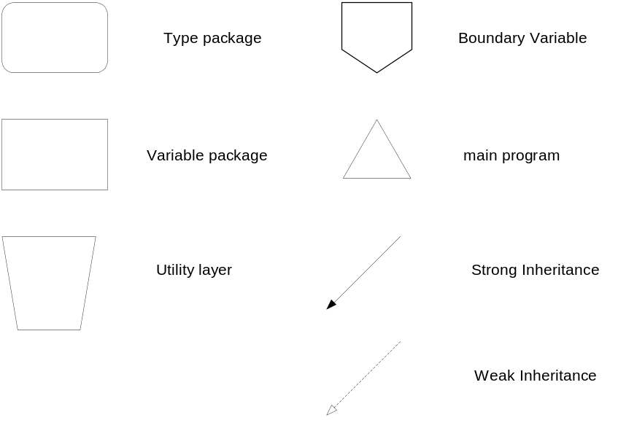
Figure 1 : Key to INFORMED Notation
A Type package is a package that introduces types and possibly operations on those types but does not introduce persistent state to the system.
A variable package is a package that introduces global variables (persistent state) to the system along with operations that manipulate that state.
A utility layer is a package that introduces operations to the system but does not introduce state or types.
A boundary variable marks the point of introduction into the SPARK environment of an external variable to the system; this represents either an import into the SPARK system or an export from the SPARK system. Boundary variables are used to represent real world entities.
The main program is the point of control of the SPARK system.
Strong Inheritance represents use, either directly or indirectly of the global variables of a package.
Weak Inheritance represents use of types and utilities provided by a package without using or affecting the state of the package.
- INFORMED Design
The INFORMED design process, as described in [1], progresses through a number of stages, the emphasis being on the location of state in the system. The key stages can be summarised as follows:
- Identification of System Boundary; inputs and outputs.
- Identification of the SPARK Boundary.
- Identification and localisation of system state.
- Handling of initialisation of state.
- Handling of secondary requirements.
In order to demonstrate the techniques employed in obtaining the final system architecture these stages are elaborated in this document.
  - Identification of System Boundary
This involves determining the entities in the physical real world which influence or are influenced by the behaviour of the core TIS.
These have already been elaborated in the Formal Design [2] and can be summarised as:
Entity | Input / Output | Comment
door | input | The core TIS monitors the status of the door via API calls.
latch | output | The core TIS controls the state of the latch via API calls.
alarm | output | The core TIS controls the state of an (audible) alarm via API calls.
time | input | The core TIS makes use of the current time in its decision making process. Time will be supplied by system calls.
display | output | The core TIS controls the text presented on the display at the portal, this is via API calls.
finger | input | The core TIS makes use of fingerprint data in determining user authentication, this is via API calls to the Biometric Library.
userToken | input /output | Data from the userToken is used by TIS in the authentication process.  The userToken may be updated as part of the user authentication process.  Access to the userToken is via the CardReader API.
adminToken | input | Data from the adminToken is used by TIS in the administrator logon process.
keyboard | input | The core TIS is controlled by commands entered by the administrator at the console keyboard. Data will be obtained via system calls.
screen | output | The core TIS displays information to the administrator at the console. Screen updates will be performed using system calls
floppy | input/ output | Large volume data is supplied to the core TIS and exported from core TIS via the floppy drive.
Table 1 System boundary, Inputs and Outputs
  - Identification of the SPARK boundary
The formal design of TIS shows the TIS system to be a purely sequential system. Although User Entry and Administrative functions could be performed in parallel and be viewed as being performed by separate SPARK systems this will not be done since there are constraints in the specification and design that ensure that user and administrative operations do not occur concurrently.
Considering the Interfaces, the Card Reader does not map well onto the entities that we want to reason about within the main program. The Card Reader does not appear explicitly in the Formal Design and it would be desirable if the annotations in the SPARK system relate closely to the entities in the formal design, this will not be possible if the Card Reader is included in the SPARK system. However the Card Reader itself will be fairly complex and we would benefit from performing static analysis on the processing within the Card Reader.
This suggests introducing a SPARK system to manage the CardReader interface with the tokens, which will process information from and to the tokens via the token reader. This layer will provide operations that answer questions in terms of system entities, such as “is User Token Present”. The implementation of which will require complex interactions with the Card Reader API.
Hence the core TIS will be two SPARK systems:
- one to provide an abstraction of the Card Reader interface which manages token data; and
- one to use token data and all the other inputs to control the TIS system outputs.
This is realised in Figure 2.
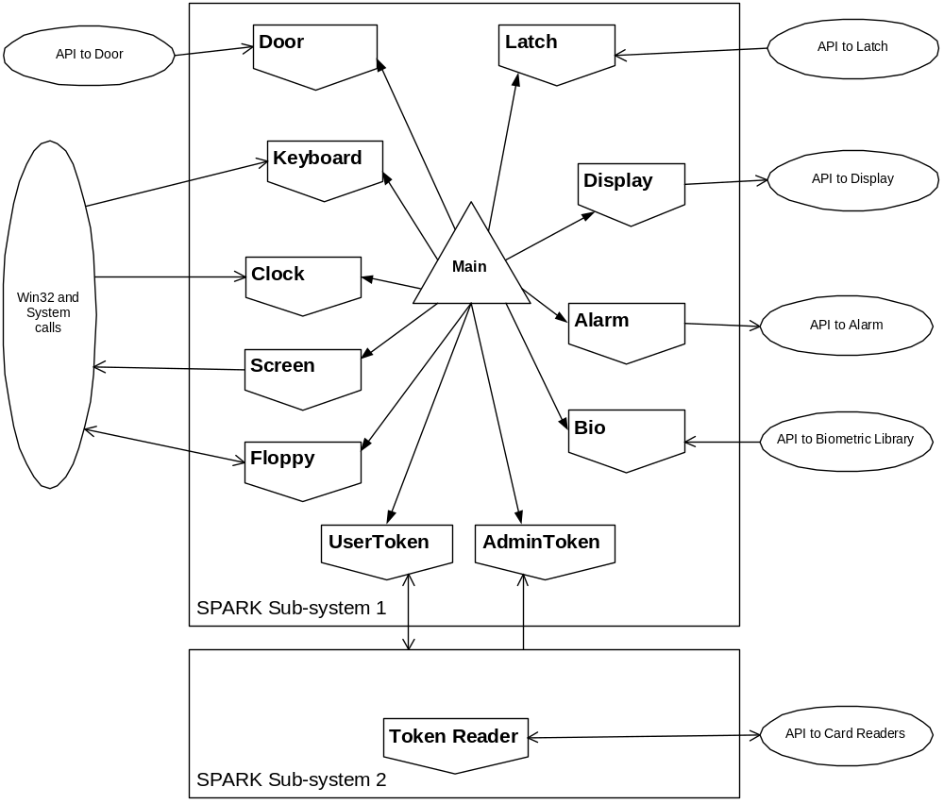
Figure 2 : SPARK System boundary
The core TIS is only a component of the TIS system. The TIS system itself comprises the Crypto Library, Certificate Processing Library, and several drivers that are not included in the core TIS. These will not form part of the SPARK system. The majority of these provide access to the environment. Those that do not provide interfaces to the environment are the Certificate Processing Library and the Crypto Library.
Both of these libraries will be encapsulated within SPARK packages that provide a thin layer access to the routines provided within the library. These SPARK packages will include annotations in their specifications which reflect the flow of information resulting from use of the libraries. The Certificate Processing Library has no persistent state so can be encapsulated within a utility package, CertProcessing. The Crypto Library contains state corresponding to the keys held within the library so this must be encapsulated within a variable package, KeyStore.
  - Identification and Localisation of state
Within this stage we need to identify the state that needs to be stored. Again the formal design has identified the system state, so the activity within the INFORMED process is reduced to localisation of state in order to present meaningful system level information flow and ensure that state is not made un-necessarily global. Subsystem 1 captures the core TIS as specified in the formal design.
From the formal design (IDStationC) we identify the following state:

State | Constituents | Comments
UserToken | userTokenPresence | Determined through polling the user token via the Card Reader. Associated with the UserToken boundary.
UserToken | currentUserToken | A local copy of the data on the current user token. Must be held for efficiency reasons. Associated with the UserToken boundary. There are four types of certificate that may be utilised from the user token.
AdminToken | adminTokenPresence | Determined though polling the admin token via the Card Reader. Associated with the AdminToken boundary.
AdminToken | currentAdminToken | A local copy of the data on the current admin token. Must be held for efficiency reasons. Associated with the AdminToken boundary. Only the authorisation certificate is used from the admin token.
Finger | fingerPresence | Determined through polling the finger via the Bio Interface. This only need be checked when the system is waiting for a finger to authenticate, local state is unnecessary.
DoorLatchAlarm | currentDoor | A local copy of the current state of the door, must be held to determine when the door state changes. Associated with the Door boundary
DoorLatchAlarm | currentLatch | A local copy of the current state of the latch, must be held to determine when the latch state needs to change. Associated with the Latch boundary.
DoorLatchAlarm | latchTimeout | Indicates when the latch must be locked, associated with the Latch boundary.
DoorLatchAlarm | doorAlarm | Indicates when the door is in an insecure state. Associated with the Door boundary, but depends on the current state of the Latch.
DoorLatchAlarm | alarmTimeout | Indicates when the door must be closed before the door is considered in an insecure state. Associated with the Door boundary
DoorLatchAlarm | currentTime | A local copy of the current time. This is associated with the Clock boundary.
Floppy | floppyPresence | Indicates whether the floppy is present or not. Associated with the Floppy boundary.
Floppy | currentFloppy | Indicates the latest value read from the floppy. Associated with the Floppy boundary.
Floppy | writtenFloppy | Indicates the latest value written to the floppy. Required to enable checks to ensure the audit log is written successfully. Associated with the Floppy boundary.
Keyboard | keyedDataPresence | Indicates whether there is data at the keyboard or not. Associated with the Keyboard boundary.
Config |  | Configuration Data used to determine entry permissions and authorisation certificate validity along with a number of durations and thresholds. This configuration data is security critical essential state.  The configuration data is persistent through power down.
Stats |  | This is an internal record of operating statistics. It is not essential to the function of the system.
KeyStore |  | The state associated with the KeyStore is entirely maintained by the Crypto Library. Following enrolment this state is constant and is preserved through power down.
CertificateStore |  | This contains the next Serial number used for issuing Authorisation certificates. This is persistent through power down. The value of this state impacts the output Authorisation certificate so it should be considered essential.
Admin |  | This is TIS internal state that records whether an administrator is logged on or not and the currently performed operation if any.
AuditLog |  | This represents the record of auditable events held by the system. Its presence is required to ensure the system is demonstrably secure and the state is essential. This state is preserved through power down.
Internal | status | Internal state associated with the User Entry operation. At the system level this need not be visible.
Internal | fingerTimeout | Internal state associated with the User Entry operation. At the system level this need not be visible.
Internal | tokenRemovalTimeout | Internal state associated with the User Entry operation. At the system level this need not be visible.
Internal | enclaveStatus | Internal state associated with all enclave functions of the TIS, ie all functions excluding user entry. At the system level this need not be visible.
currentDisplay |  | Indicates the latest message on the display, required to enable logging of changes to the display. Associated with Display boundary.
currentScreen |  | Indicates the latest message on the display, screenMsg is required to enable logging of changes to the display. For efficiency reasons it may be useful to retain a record of the other screen components, however it is not necessary. Associated with Screen boundary.
Table 2 State Identification
Although the Internal state is internal to the way in which the system operates we choose to encapsulate this within two variable packages Enclave and Entry. Where additional local state is associated with a boundary variable the boundary variable is encapsulated by a variable package containing the additional state. The overall localisation of state is given by Figure 3.
We make the following observations about this design.
- All boundary variables are encapsulated within a variable package. In many cases this is because there is additional state associated with this boundary. However for Alarm and Bio this is not the case. The reason for encapsulating these is that the boundary variable packages should have very simple implementations, simply providing calls through to the API. The encapsulating variable packages will also handle other activities such as auditing any system errors.
- By making Stats and Admin abstract data types these will not appear in the main program information flow annotations.
- All the interfaces may use the AuditLog for reporting system faults – these dependencies are not shown explicitly to avoid cluttering the diagrams.
- Some uses of ConfigData have been omitted for clarity. These are noted under each figure.
- There are a number of simple types packages these will be used throughout the system. Again usage is not shown on the diagrams.
- The File utility later provides types and operations for accessing system files.
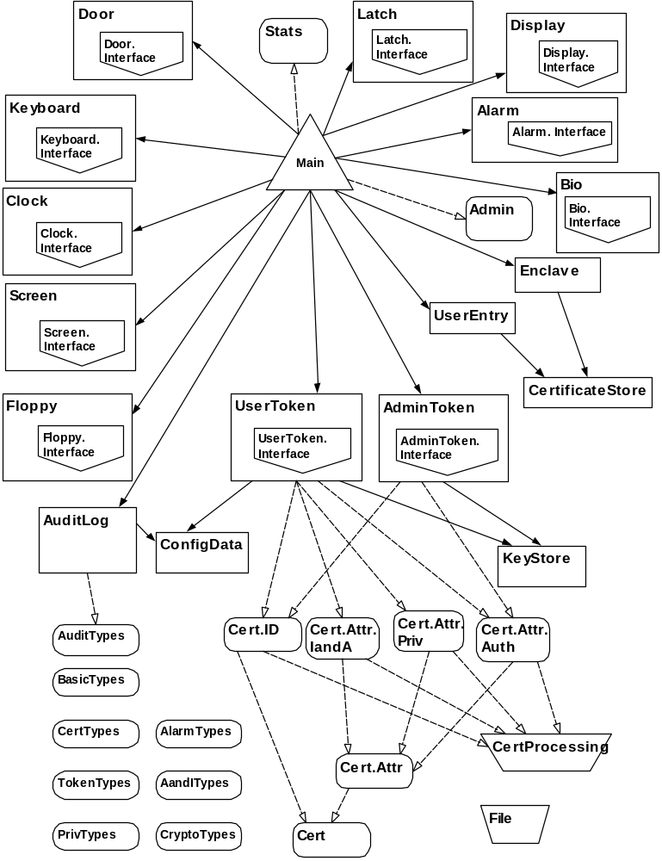
Figure 3 : Localisation of State
The TIS function can be decomposed into a number of key components, which are already apparent in the structure of the formal design. The system structure is shown separately for each of these key components.
- Polling: this covers the process of obtaining regular updates of system inputs.
- Updating: this covers the process of performing regular updates of system outputs.
- Processing user entry: this covers the multi-phase user entry operation.
- Performing enclave activities: this covers the activities performed at the console, all administrator operations and enrolment.
In the following diagrams the boundary variable is shown only where it is used. So for instance polling makes use of the latch state but not the boundary variable associated with the interface to the latch.
    - Polling
We introduce a utility layer to control the polling activity. Notice that during polling the internal Door state is updated based on the current state of the latch.
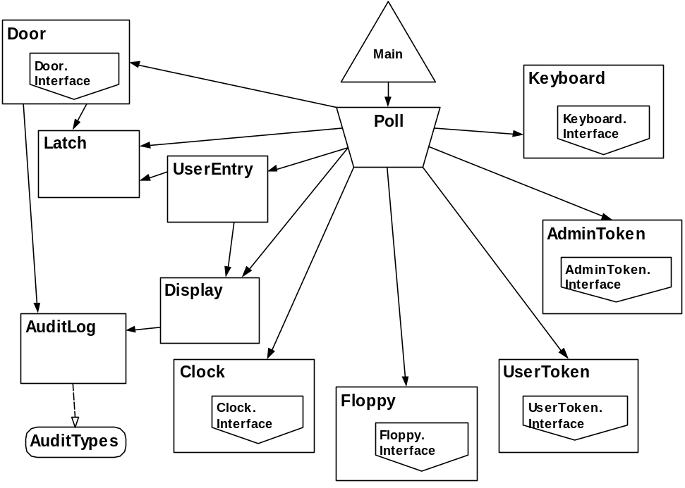
Figure 4 : Poll Context
The AuditLog may be used by the Door, Display, AdminToken and UserToken during polling. The AdminToken and UserToken may raise SystemErrors.
The AuditLog uses ConfigData.
    - Updating
We introduce a utility layer to manage the update of environmental data controlled by TIS. The screen updates will depend on who is currently logged on and the system statistics, provided as parameters and the configuration data.
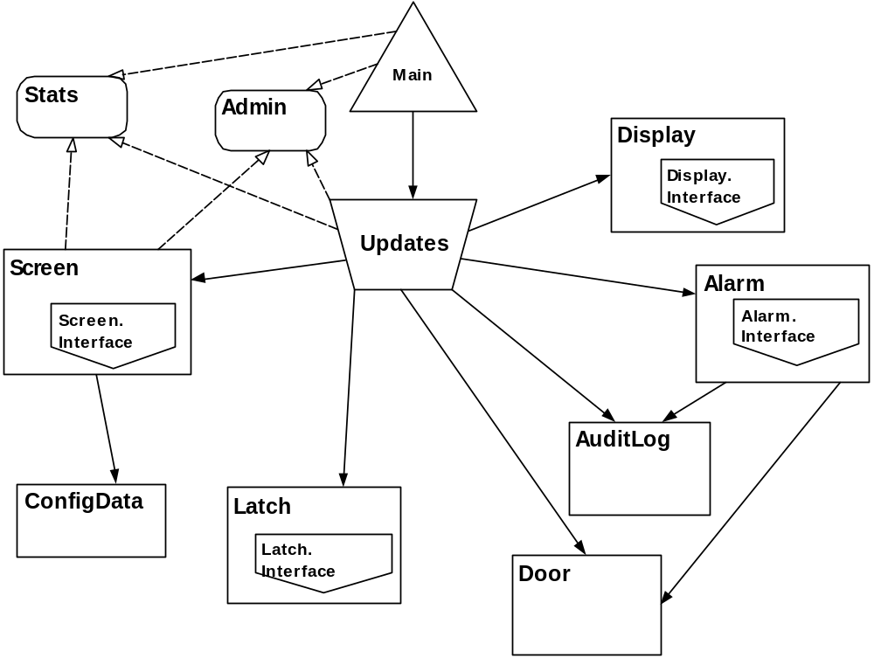
Figure 5: Update Context
The AuditLog may be used by Alarm, Display, Screen, Latch.
The AuditLog also uses ConfigData.
    - Processing User Entry
The user entry operation is controlled by a state-machine. This state-machine is the state of the Entry package. The Entry package will also provide the top level operations required to support User Entry. The processing of the certificates in the UserToken will make use of the CertificateProcessing utility layer. This CertificateProcessing utility layer is implemented using the Certificate Processing Library API.
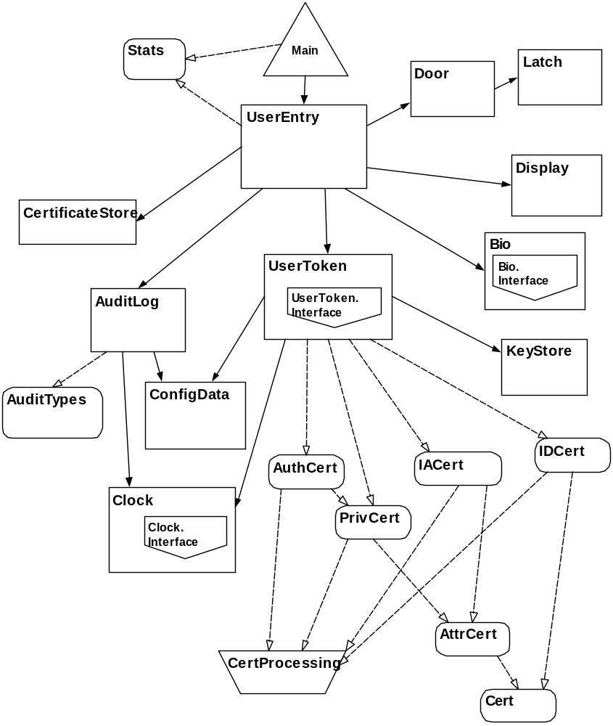
Figure 6 : User Entry Context
The AuditLog may be used by UserEntry, Latch, Display, KeyStore and Bio. Bio and KeyStore may log SystemFaults.
ConfigData is used by AuditLog, Door, UserEntry and UserToken.
    - Performing Enclave Activities
The activities performed in the enclave are controlled by a state-machine. This state-machine is the state of the Enclave package. The Enclave package must also make use of the Admin state to determine what can be performed. The Enclave package will also provide the top level operations required to support operations performed within the enclave. Utility layers are introduced to perform the configuration data checks and updates and the enrolment checks and updates.
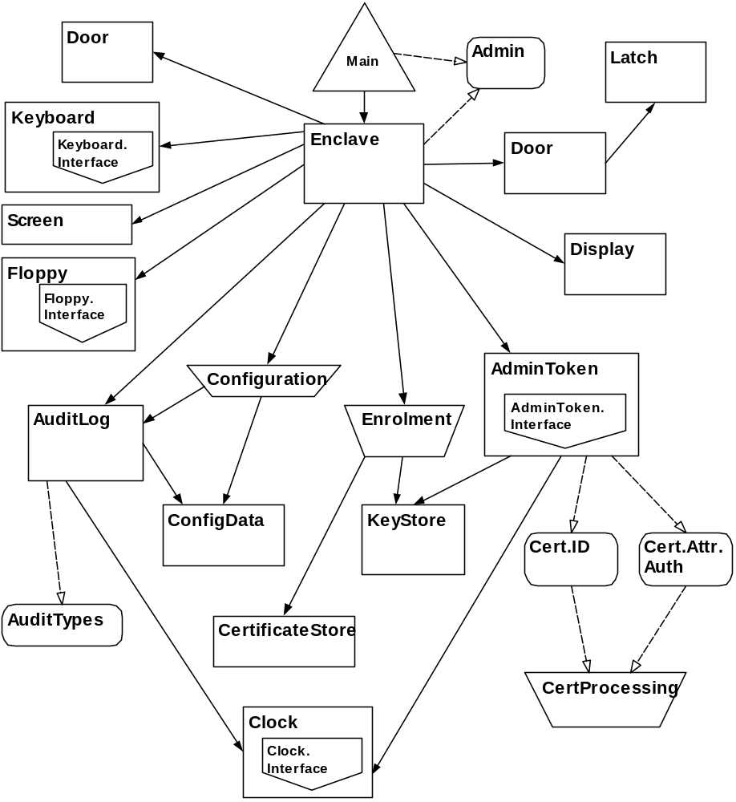
Figure 7 : Enclave Context
AuditLog may be used by Configuration, Display, Enclave, Enrolment, Latch and KeyStore. KeyStore may raise SystemFaults.
ConfigData is used by AuditLog and Configuration.
  - Initialisation of State
All boundary variables are assumed to be initialised by the environment.
The remaining state must either be initialised during elaboration, or operations must be made available to initialise the state prior to its use.
Within INFORMED it is considered bad practice to initialise state to “in range” values that are not necessarily consistent since this will prevent the use of static analysis to ensure that the system state is all initialised and consistent. With this in mind we take the following approach to initialisation.
Where all components of a package state variable can be initialised at elaboration to appropriate valid values, these will be initialised at elaboration. However the initialisation of much of the state depends on the value of entities persistent across power-down or is dependant on whether the IDStation is already enrolled or not. Where this is the case the state must be set by a procedure call to allow adequate static analysis.
State that is persistent across power-down will be stored in persistent memory and will need to be initialised by a procedure call since the data will need to be extracted from the memory. This applies to the state associated with KeyStore, CertificateStore, ConfigData and AuditLog. The persistent components of the state associated with these packages should be maintained separately from those aspects that are set at power-up. As CertificateStore, ConfigData and AuditLog maintain local state as well as using files to store persistent data, the data held on file will be recorded by FileState.
The initial value of some state depends on whether the IDStation is already enrolled or not. Where this is the case the state should be set by a procedure call. This applies to state associated with Screen, Display, Enclave.
A summary of the state and the initialisation mechanisms is presented in the Table 3.
Ada Package state variable | mode | initialisation mechanism | Z State
AdminToken.Input | in | assumed | adminToken
AdminToken.Status | - | assumed | -
AdminToken.State | - | elaboration | adminTokenPresence  currentAdminToken
Alarm.Output | out | assumed | alarm
AuditLog.State | - | procedure call | AuditLog (excluding logFiles)
AuditLog.FileState | - | elaboration | AuditLog.logFiles
CertificateStore.State | - | procedure call | CertificateStore
CertificateStore.FileState | - | elaboration | -
Clock.CurrentTime | - | procedure call | currentTime
Clock.Now | in | assumed | now
ConfigData.State | - | procedure call | ConfigData
ConfigData.FileState | - | elaboration | -
Display.Output | out | assumed | display
Display.State | - | procedure call | currentDisplay
Door.Input | in | assumed | door
Door.State | - | elaboration | currentDoor  alarmTimeout  doorAlarm
Enclave.State | - | procedure call | enclaveStatus
Floppy.Input | in | assumed | floppy (for reads)
Floppy.Output | out | assumed | floppy (for writes)
Floppy.State | - | elaboration | currentFloppy  floppyPresence
Floppy.WrittenState | - | elaboration | writtenFloppy
Keyboard.Input | in | assumed | keyboard
Keyboard.State | - | elaboration | keyDataPresence
KeyStore.State | - | procedure call | privateKey
KeyStore.Store | - | assumed | keys
Latch.Output | out | assumed | latch
Latch.State | - | elaboration | currentLatch  latchTimeout
Main.TheAdmin | - | elaboration | Admin
Main.TheStats | - | elaboration | Stats
Screen.Output | out | assumed | screen
Screen.State | - | procedure call | currentScreen.screenMsg
UserEntry.State | - | elaboration | status  fingerTimeout  tokenRemovalTimeout
UserToken.Input | in | assumed | userToken (reads)
UserToken.Output | out | assumed | userToken (writes)
UserToken.Status | - | assumed | -
UserToken.State | - | elaboration | currentUserToken  userTokenPresence
Table 3 : State Summary
  - Other design issues
    - Managing Persistent data
TIS retains some data that must be preserved over a power cycle. The majority of this data will be stored in TIS System files as described in the following table. The remaining data (KeyStore.Store) is data held within the Crypto library; the preservation of this data is managed by the Library.
Data | FileName | Location
ConfigData | config.dat | ./System
CertificateStore | keystore | ./System
AuditLog | file01.log  …  filenn.log | ./Log
ConfigData from Floppy | config.dat | ./Temp
Enrolment Data from Floppy | enrol.dat | ./Temp
Archive for Floppy | archive.log | ./Temp
All file locations are relative to the location at which the TIS application is installed.
    - File Formats
The data received and supplied via the floppy has the following naming convensions:
- Configuration data is supplied in a file named config.dat.
- Enrolment data is supplied in a file named enrol.dat.
- Archives of the audit log are always written to a file named archive.log.
File formats are defined here for all files that are exported or imported from the system.
      - AuditLog
Audit log data is exported during an archive.
The audit file contains a number of audit entries with the following properties.
- each audit entry is terminated by a LF (Line feed) and CR (Carriage return). The entry itself does not contain any LF or CR.
- each field of an audit entry is comma separated. Individual fields do not contain commas.
The fields of an audit entry are presented it the order and format given in the table below:
field | format | comments
time | yyyy-mm-dd hh:mm:ss.s | Time is displayed to 1/10th second accuracy.
severity | n | Allowed values “1” – info; “2” – warning, “3” – critical
id | nn | Numeric representation of the audit element type. This is the offset of the element type in AUDIT_ELEMENT from the first element.  For example startUnenrolledTISElement has value 0.
type | ASCII text | Text name for the given audit element type see Formal Design [2], values are given in AUDIT_ELEMENT.  This field does not exceed 20 characters.
user | ASCII text | Text description identifying user in the form  “Issuer: xxx SerialNo: yyy” or “NoUser”.  This field does not exceed 50 characters.
description | ASCII text | free text description containing additional information  This field does not exceed 150 characters.
Where “n” represents a single ASCII digit.
      - ConfigData
The format of a configuration data file is presented in the next table. Each field is presented on a new line and takes the form of a field identifier followed by at least one space and the value of the field. Each line is terminated by a CR and LF.
The file formats have been selected to provide a user-friendly interface for entering values. This includes restricting the granularity of short timeout durations to 1 second, the granularity of longer times to minutes and the granularity of file sizes to kBytes.
File format | comments
ALARMSILENTDURATION nnn | value is in seconds range 00..200
LATCHUNLOCKDURATION nnn | value is in seconds range 00..200
TOKENREMOVALDURATION nnn | value is in seconds range 00..200
FINGERWAITDURATION nnn | value is in seconds range 00..200
ENCLAVECLEARANCE tttttt | values of “ttttt” are unmarked, unclassified, restricted, confidential, secret, topsecret
WORKINGHOURSSTART hh:mm | 00:00 represents midnight, max value is 23:59
WORKINGHOURSEND hh:mm | 00:00 represents midnight, max value is 23:59
MAXAUTHDURATION hh:mm | max value is 10:00
ACCESSPOLICY tttttt | values of “tttttt” are allhours and workinghours
MINENTRYCLASS ttttt | values of “ttttt” are unmarked, unclassified, restricted, confidential, secret, topsecret  This field must have no higher classification than the value given for ENCLAVECLEARANCE.
MINPRESERVEDLOGSIZE nnnn | value is in kBytes range 0 .. 4096
ALARMTHRESHOLDSIZE nnnn | value is in kBytes range 0 .. 4096  This field must be no greater than the value given for MINPRESERVEDLOGSIZE.
SYSTEMMAXFAR nnnnnnnnnn | INTEGER32 value nnnnnnnnnn/(2³¹ – 1 ) is the required probability of false acceptance.
      - Enrolment Data
Enrolment data is supplied as a number of ID certificates within a single file. Each ID Certificate takes the same format as a certificate transmitted across the TCP/IP interface to the device drivers (although the outermost braces enclosing the certificate “dictionary” are omitted). Each certificate will appear as a string on a single line within the enrolment data file.
The first ID certificate in the file must be that of the CA that issued the TIS ID Certificate, the second ID certificate in the file must be the ID certificate of the TIS being enrolled. The remaining certificates may be in any order as long as the ID certificate of a CA precedes any ID certificates issued by that CA.
The format of the certificate is as presented in Table 4, non-bold text appears in the file as presented here, bold text is defined in the subsequent table. Return characters should not appear in the string, they are used here to improve layout, similarly space characters are optional and will be ignored within the processing.
ID Certificate format within Enrolment file
'CertLength': 'CertificateLength',
'CertDataT':
{'CertType': '0',
'SerialNumber': 'SerialNumber',
'SigAlgID': 'Algorithm',
'Issuer': {'Text': 'IssuerText',
'ID': 'IssuerID',
'TextLength': 'IssuerTextLength'},
'Validity': {'NotAfter': {'Minute': 'Minute',
'Month': 'Month',
'Day': 'Day',
'Hour': 'Hour',
'Year': 'Year'},
'NotBefore': {'Minute': 'Minute',
'Month': 'Month',
'Day': 'Day',
'Hour': 'Hour',
'Year': 'Year'}},
'Subject': {'Text': 'UserText',
'ID': 'UserID',
'TextLength': 'UserTextLength'},
'SubjectPublicKeyInfo': {'KeyLength': 'KeyLength',
'AlgoRithmID': 'Algorithm',
'KeyID': 'KeyID'},
'CryptoControlData': {'DigestFinalReturn': 'ReturnValue',
'DigestLength': 'DigestLength',
'DigestUpdateReturn': 'ReturnValue',
'Digest': {'VerifyReturn': 'ReturnValue',
'SignReturn': 'ReturnValue',
'DigestID': 'DigestID'}},
'SignatureData': {'AlgoRithmID': 'Algorithm',
'SigLength' : 'SigLength',
'Signature': {'KeyID': 'KeyID',
'DigestID': 'DigestID'}}}
Table 4 ID certificate structure within enrolment file
Values taken by entities in bold are presented in Table 5. Constraints on valid ID certificates are detailed in Table 6.

Certificate Entity | valid values
Algorithm | string with the following values:  RSA MD2 MD5  SHA_1 RIPEMD128 RIPEMD160  MD2_RSA MD5_RSA SHA1_RSA  RIPEMD128_RSA RIPEMD160_RSA
CertificateLength | numeric string range 0 .. 4050
Day | numeric string range 01 .. 31
DigestID | numeric string range 0 .. 2³² -1
DigestLength | numeric string range 0 .. 32
Hour | numeric string range 00 .. 23
IssuerTextLength | numeric string range 0 .. 40
IssuerId | numeric string range 0 .. 2³² –1
IssuerText | ASCII string with maximum length of 40 characters (no CR or LF characters).
KeyID | numeric string range 0 .. 2³² -1
KeyLength | numeric string range 0 .. 128
Minute | numeric string range 00 .. 59
Month | numeric string range 01 .. 12
ReturnValue | string with one of the following values  OK HostMemory  GeneralError FunctionFailed  ArgumentsBad AttributeReadOnly  AttributeTypeInvalid AttributeValueInvalid  DataInvalid DataLenRange  DeviceError DeviceMemory  FunctionCanceled KeyHandleInvalid  KeySizeRange KeyTypeInconsistent  KeyFunctionNotPermitted MechanismInvalid  MechanismParamInvalid ObjectHandleInvalid  OperationActive OperationNotInitialized  SignatureInvalid SignatureLenRange  TemplateIncomplete TemplateInconsistent  BufferTooSmall CryptokiNotInitialized  CryptokiAlreadyInitialized
SerialNumber | numeric string range 0 .. 2³² -1
SigLength | numeric string range 0 .. 128
UserId | numeric string range 0 .. 2³² –1
UserText | ASCII string with maximum length of 40 characters
UserTextLength | numeric string range 0 .. 40
Year | numeric string range 1901 .. 2099
Table 5 Valid values of fields

Constraint | Description
Date exists | Both the NotBefore and NotAfter dates must be real dates. Setting Month to 2 and Day to 30 would always be invalid
Certificate length correct | The certificate length is the number of characters in the string starting from the ‘{‘ following CertDataT field to the final ‘}’.
Algorithm consistent | The SignatureData.AlgorithmID and SigAlgID must match, this algorithm must also be combined algorithm including an encryption mechanism and a digest mechanism.
Signature not too long | The SigLength field must be no larger than the length of the key used to sign the certificate.
Returns OK | The crypto control data detailing the return values crypto operations DigestUpdateReturn, DigestFinalReturn and VerifyReturn must be set to OK. This indicates that these functions will succeed.
Digest matches signed digest | The SignatureData.Signature.DigestID must match CryptoControlData.Digest.DigestID. This represents the digest used to create the signature being the same as the digest calculated from the raw certificate data.
signing key matches issuer | The SignatureData.Signature.KeyID must match the key id associated with the Issuer.ID. This will be the KeyID supplied within the SubjectPublicKeyInfo of the Issuer’s ID certificate.
Table 6 Constraints on valid certificates
    - System Faults
The formal design indicates that system faults may be raised. These should be handled as follows:
System faults are warnings except in the following critical cases:
- Failure to control the Latch
- Failure to monitor the Door
- Failure to write to the Audit Log
The system shall continue to function following a system fault categorised as a warning.
The system shall raise an alarm following a critical fault.
    - Implementation constraints on types
A number of the numeric entities in the Formal Design are permitted to take any value. The following constraints are applied to the values of these entities within the implementation.
Z Entity | State / Type | Implementation range | Units
CertificateId.serialNumber | State | 0 .. 2³² – 1
TOKENID | Type | 0 .. 2³² – 1
TIME | Type | 1901-01-01 00:00:00.0 to 2099-12-31 23:59:59.9
ConfigData.alarmSilentDuration | State | 0 .. 2000 | 1/10th sec
ConfigData.latchUnlockDuration | State | 0 .. 2000 | 1/10th sec
ConfigData.tokenRemovalDuration | State | 0 .. 2000 | 1/10th sec
ConfigData.fingerWaitDuration | State | 0 .. 2000 | 1/10th sec
ConfigData.maxAuthDuration | State | 0 .. 864000 | 1/10th sec
ConfigData.minPreservedLogSize | State | 0 .. 2²² | Bytes
ConfigData.alarmThresholdSize | State | 0 .. 2²² | Bytes
CertificateStore.nextSerialNumber | State | 0 .. 2³² – 1
AuditLog.numberLogEntries | State | 0 .. 2¹⁴
Stats.successEntry | State | 0 .. 2³¹ -1
Stats.failEntry | State | 0 .. 2³¹ -1
Stats.successBio | State | 0 .. 2³¹ -1
Stats.failBio | State | 0 .. 2³¹ -1
The size of an Audit Log entry is 2⁸ bytes, this determines the ratio between AuditLog.numberLogEntries and ConfigData.minPreservedLogSize. The maximum value for ConfigData.minPreservedLogSize was selected bearing in mind that
- each log file must fit on the Floppy Drive if it is archivable;
- to archive data we need to have at least a complete log file.
The figure for ConfigData.minPreservedLogSize corresponds to 17 log files each with a capacity of 1024 elements. This gives an audit capacity of over 4Mbytes (> 16,000 log elements) and should result in a system where each of the functions is testable.
Certificate serial numbers and token Ids will be represented by Unsigned 32bit words. Other values will be represented by Signed 32bit words.
It should be noted that in the implementation we distinguish between durations and time stamps. All of these appear as type TIME in the formal design.
This has the following impact on the implementation:
- Statistics will only report the number of failures/successes up to the implementation maximum, after this point the statistic will not be incremented.
- TIS will not issue authorisation certificates once the maximum certificate serial number has been reached. This will result in TIS raising a system fault.
  - The Second SPARK Subsystem
The second spark subsystem is very simple. It consists of a single variable package, which encapsulates a boundary variable representing the interface to the Card Reader API. This subsystem may make use of the audit log facilities of the primary SPARK subsystem. However there is a contextual change made at the interface of the Primary SPARK subsystem at the point at which it uses the TokenReader. This context change ensures that the primary SPARK subsystem distinguishes the interfaces to the User and Admin Token Readers.
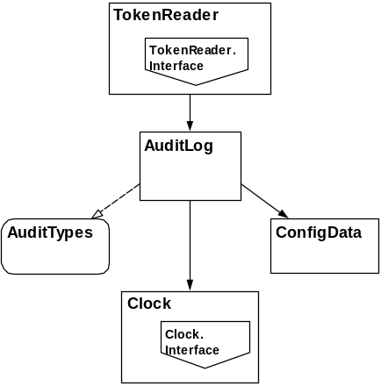
Figure 8 : The Second SPARK Subsystem
The state associated with the TokenReader package is identified as follows. As this SPARK subsystem provides a conversion between the available APIs and the system model there is a less strong correspondence between the Z state and the state encapsulated by this package. Where there is a correspondence it is tabulated below, although in all cases the Z state components are also modelled within the Primary SPARK subsystem.
Ada Package state | mode | initialisation mechanism | represents
TokenReader.Input | in | assumed | data read from tokens (adminToken and userToken)
TokenReader.Output | out | assumed | data written to tokens (userToken)
TokenReader.Status | - | assumed | status information obtained from tokens
TokenReader.State | - | procedure call | persistent state maintained by the SPARK subsystem relating to the token reader (includes userTokenPresence and adminTokenPresence)
- Package Summary
The following section summarises the facilities provided by each of the library level packages in the system and references the formal design where the types, state or operations are derived from the formal design.
This does not provide further details of the boundary variables as these have all been made private to a variable package. The state associated with these boundary variables is virtual and will be form part of the appropriate variable package state.
  - Types Packages
In the Z there are a number of entities that have optional types. This means that the value may not be defined. Hence, where the underlying type is a free type (implemented by an enumeration type) the implementation will declare a parent type of the enumeration type, which is extended by a value representing the undefined value. Where the underlying type is not implemented by an enumerated type, a Boolean flag will be used to indicate the validity of the optional type.
    - Admin
Abstract Data Type containing administrator control information.
      - Types
Ada Type | type classification | Z type
Admin.OpT | enumeration | ADMINOP
Admin.OpAndNullT | enumeration | optional ADMINOP
Admin.T | private | Admin
      - Operations
Ada Operation | operation type | Z Operation
Admin.Init | procedure | InitAdmin
Admin.Logon | procedure | AdminLogon
Admin.Logout | procedure | AdminLogout
Admin.StartOp | procedure | AdminStartOp
Admin.FinishOp | procedure | AdminFinishOp
Admin.IsPresent | Boolean function | AdminIsPresent
Admin.OpIsAvailable | function returning OpAndNullT | AdminOpIsAvailable
Admin.IsDoingOp | Boolean function | AdminIsDoingOp
Admin.TheCurrentOp | retrieval function | The currentAdminOp value
Admin.SecurityOfficerIsPresent | Boolean function | the rolePresent = securityOfficer
    - AlarmTypes
Types that appear within the context of alarms.
      - Types
Ada Type | type classification | Z type
AlarmTypes.StatusT | enumeration | ALARM
    - AuditTypes
Types that appear within the context of the audit log.
      - Types
Ada Type | type classification | Z type
AuditTypes.ElementT | enumeration | AUDIT_ELEMENT
AuditTypes.SeverityT | enumeration | AUDIT_SEVERITY
AuditTypes.DescriptionT | string | TEXT
AuditTypes.UserTextT | string | USERTEXT
AuditTypes.FileSizeT | integer | N
AuditTypes.AuditEntryCountT | integer | N
    - BasicTypes
These are types that appear across the TIS implementation
      - Types
Ada Type | type classification | Z type
BasicTypes.Integer32T | numeric | INTEGER32
BasicTypes.ByteT | numeric | BYTE
BasicTypes.PresenceT | enumeration | PRESENCE
    - Cert
Abstract data type representing the common aspects of certificates.
      - Types
Ada Type | type classification | Z type
Cert.ContentsT | private | CertificateContents
      - Operations
Ada Operation |  | operation type | Z Operation
Cert.TheIssuer |  | retrieval function | value of id.issuer
Cert.TheId |  | retrieval function | value of id
Cert.ExtractUser |  | function | thisUser
Cert.TheMechanism |  | retrieval function | value of mechanism
Cert.IsCurrent |  | Boolean function | CertIsCurrent
Cert.GetData |  | retrieval function | value of data
Cert.GetSignature |  | retrieval function | value of signature
Cert.IssuerKnown |  | procedure | CertIssuerKnown
Cert.IsOK |  | procedure | CertOK
    - Cert.Attr
Abstract data type representing the common aspects of all attribute certificates.
      - Types
Ada Type | type classification | Z type
Cert.Attr.ContentsT | private | AttCertContents
      - Operations
Operations inherited from Cert with the addition of the following.
Ada Operation |  | operation type | Z Operation
Cert.Attr.TheBaseCert |  | retrieval function | value of baseCertId
Cert.Attr.ExtractUser |  | function | thisUser
Note that ExtractUser overrides the operation inherited from Cert. The user of an attribute certificate is deduced from the baseCertId and not the CertId.
    - Cert.Attr.Auth
Abstract data type representing authorisation certificates.
      - Types
Ada Type | type classification | Z type
Cert.Attr.Auth.ContentsT | private | AuthCertContents
      - Operations
Operations inherited from Cert.Attr with the addition of the following:
Ada Operation |  | operation type | Z Operation
Cert.Attr.Auth.Contstruct |  | procedure | constructAuthCert
Cert.Attr.Auth.IsOK |  | procedure | AuthCertOK
Cert.Attr.Auth.TheRole |  | retrieval function | value of role
Cert.Attr.Auth.TheClearance |  | retrieval.function | value of clearance
Cert.Attr.Auth.Extract |  | procedure | extractAuthCert
Cert.Attr.Auth.SetContents |  | procedure | -
Cert.Attr.Auth.Clear |  | procedure | -
    - Cert.Attr.IandA
Abstract data type representing the identification and authentication certificates.
      - Types
Ada Type | type classification | Z type
Cert.Attr.IandA.ContentsT | private | IandACertContents
      - Operations
Operations inherited from Cert.AttrCert with the addition of the following
Ada Operation |  | operation type | Z Operation
Cert.Attr.IandA.TheTemplate |  | retrieval function | value of template
Cert.Attr.IandA.Extract |  | procedure | extractIandACert
Cert.AttrIandA.Clear |  | procedure | -
    - Cert.Attr.Priv
Abstract data type representing privilege certificates.
      - Types
Ada Type | type classification | Z type
Cert.Attr.Priv.ContentsT | private | PrivCertContents
      - Operations
Operations inherited from Cert.Attr with the addition of the following
Ada Operation |  | operation type | Z Operation
Cert.Attr.Priv.TheRole |  | retrieval function | value of role
Cert.Attr.Priv.TheClearance |  | retrieval.function | value of clearance
Cert.Attr.Priv.Extract |  | procedure | extractPrivCert
Cert.Attr.Priv.Clear |  | procedure | -
    - Cert.ID
Abstract data type representing ID Certificates.
      - Types
Ada Type | type classification | Z type
Cert.ID.ContentsT | private | IDCertContents
      - Operations
Operations inherited from Cert with the addition of the following
Ada Operation |  | operation type | Z Operation
Cert.ID.ThePublicKey |  | retrieval function | value of subjectPubK
Cert.ID.TheSubject |  | retrieval function | value of subject
Cert.ID.Extract |  | procedure | extractIDCert
Cert.ID.Clear |  | procedure | -
    - CertTypes
Types that appear within the context of certificates.
      - Types
Ada Type | type classification | Z type
CertTypes.RawCertificateT | String | RawCertificate
CertTypes.SignatureT | String | SIGDATA
CertTypes.RawDataT | String | RAWDATA
CertTypes. IDT | record | CertificateId
CertTypes.SerialNumberT | integer | N
    - CryptoTypes
Types that appear within the context of encryption.
      - Types
Ada Type | type classification | Z type
CryptoTypes.KeyTypeT | enumeration | KEYTYPE
CryptoTypes.KeyPartT | record | KeyPart
CryptoTypes.IssuerT | record | Issuer
CryptoTypes.AlgorithmT | enumeration | ALGORITHM
    - IandATypes
Types that appear within the context of the Biometric checks.
      - Types
Ada Type | type classification | Z type
IandATypes.FarT | numeric | INTEGER32
IandTypes.MatchResultT | enumeration | MATCHRESULT
IandATypes.TemplateT | record | FingerprintTemplate
    - PrivTypes
Types that appear within the context of privileges.
      - Types
Ada Type | type classification | Z type
PrivTypes.ClassT | enumeration | CLASS
PrivTypes.ClearanceT | record | Clearance
PrivTypes.PrivilegeT | enumeration | PRIVILEGE
PrivTypes.AdminPrivilegeT | array | ADMINPRIVILEGE
    - Stats
Abstract Data Type for maintaining system statistics.
      - Types
Ada Type | type classification | Z type
Stats.T | private | Stats
      - Operations
Ada Operation | operation type | Z Operation
Stats.Init | procedure | InitStats
Stats.AddSuccessfulEntry | procedure | AddSuccessfulEntryToStats
Stats.AddFailedEntry | procedure | AddFailedEntryToStats
Stats.AddSuccessfulBio | procedure | AddSuccessfulBioToStats
Stats.AddFailedBio | procedure | AddFailedBioToStats
Stats.DisplayStats | procedure | displayStats
    - TokenTypes
Types that appear within the context of tokens.
      - Types
Ada Type | type classification | Z type
TokenTypes.TokenId | INTEGER32 | N
TokenTypes.TryT | enumeration | TOKENTRY
  - Variable Packages
    - Alarm
Variable package providing the interface to the Alarm API.
      - State
The state of this package is solely the boundary variable representing the real world alarm.
      - Operations
Ada Operation |  | operation type | Z Operation
Alarm.UpdateDevice |  | procedure | UpdateAlarm
    - AuditLog
The Variable package holding and controlling the audit log.
      - State
Ada Package state | mode | Z State
AuditLog.State | - | AuditLog (excluding logFiles)
AuditLog.FileState | - | AuditLog.logFiles
The audit log state comprises files holding the audit entries, control state and audit alarm, this is not elaborated here.
      - Operations
Ada Operation | operation type | Z Operation
AuditLog.Init | procedure | TISStartup (partial)  InitAuditLog
AuditLog.AddElementToLog | procedure | AddElementToLog
AuditLog.ArchiveLog | procedure | ArchiveLog
AuditLog.ClearLogEntries | procedure | ClearLogEntries
AuditLog.CancelArchive | procedure | CancelArchive
AuditLog.TheAuditAlarm | retrieval function | auditAlarm value
AuditLog.SystemFaultOccurred | function
The operation Init updates the internal state from data preserved on file. In addition to the initialisation detailed in the Formal Design the Init procedure will ensure that the Log directory used by the AuditLog package is present.
The operation AddElementToLog will also construct the element from the parameters.
The operation SystemFaultOccurred indicates whether or not a critical system fault has occurred whilst writing to the log.
    - AdminToken
Variable package holding and managing the admin token state.
      - State
Ada Package state | type | Z State
AdminToken.State | private | adminTokenPresence  currentAdminToken
      - Operations
Ada Operation |  | operation type | Z Operation
AdminToken.Poll |  | procedure | PollAdminToken
AdminToken.ReadAndCheck |  | procedure | ReadAdminToken  AdminTokenOK  AdminTokenNotOK
AdminToken.IsPresent |  | Boolean function | adminTokenPresence = present
AdminToken.IsCurrent |  | Boolean function | AdminTokenCurrent
AdminToken.ExtractUser |  | function | extractUser
AdminToken.GetRole |  | retrieval function | value of AuthCertContents.role
AdminToken.Clear |  | procedure | ClearAdminToken
The operation ExtractUser makes use of Cert.ID.ExtractUser.
    - Bio
The variable package holding state representing the biometric device and providing interfaces to the biometric device.
      - State
The state associated with this package is solely state representing the input from and status of the biometric device.
      - Operations
Ada Operation |  | operation type | Z Operation
Bio.Poll |  | procedure | PolFinger
Bio.Verify |  | procedure | verifyBio
Bio.Flush |  | procedure | FlushFingerData
    - CertificateStore
The variable package holding and maintaining the certificate store state.
      - State
Ada Package state | type | Z State
CertificateStore.State | private | CertificateStore
CertificateStore.FileState | private | -
      - Operations
Ada Operation |  | operation type | Z Operation
CertificateStore.Init |  | procedure | TISStartup (partial)  InitCertificateStore
CertificateStore.UpdateStore |  | procedure | UpdateCertificateStore
CertificateStore.SerialNumber |  | function | nextSerialNumber value
CertificateStore. SerialNumberHasOverflowed |  | function | -
    - Clock
Variable package maintaining the local time and providing access to the system clock.
      - Types
Ada Type | type classification | Z type
Clock.TimeT | private | TIME
Clock.DurationT | integer | TIME
Clock.TimeTextT | string | -
Clock.DurationTextT | string | -
      - State
Ada Package state | type | Z State
Clock.CurrentTime | Clock.Time | currentTime
      - Operations
Ada Operation |  | operation type | Z Operation
Clock.Poll |  | procedure | PollTime
Clock.TheCurrentTime |  | retrieval function | currentTime value
Clock.GetNow |  | procedure, direct read of real world time. | now value
Clock.GreaterThan |  | Boolean function | >
Clock.LessThan |  | Boolean function | <
Clock.GreaterThanOrEqual |  | Boolean function | ≥
Clock.LessThanOrEqual |  | Boolean function | ≤
Clock.ConstructTime |  | constructor function
Clock.SplitTime |  | procedure
Clock.PrintTime |  | function
Clock.PrintDuration |  | function
Clock.AddDuration |  | function | +
Clock.StartOfDay |  | function
    - ConfigData
Package maintaining the configuration data.
      - Types
Ada Type | type classification | Z type
ConfigData.DurationT | subtype of Clock.Duration | N
ConfigData.AccessPolicyT | enumeration | ACCESS_POLICY
      - State
Ada Package state | type | Z State
ConfigData.State | private | ConfigData
ConfigData.FileState | private | -
      - Operations
Ada Operation |  | operation type |  | Z Operation
ConfigData.Init |  | procedure |  | InitConfig  TISStartup (partial)
ConfigData.UpdateData |  | procedure |  | -
ConfigData.TheDisplayFields |  | procedure |  | displayConfigData
ConfigData.ValidateFile |  | procedure |  | constraints on ConfigData
ConfigData.WriteFile |  | procedure
ConfigData.AuthPeriodIsEmpty |  | function |  | authPeriodIsEmpty
ConfigData.GetAuthPeriod |  | function |  | getAuthPeriod
ConfigData.IsInEntryPeriod |  | Boolean function |  | in entryPeriod
ConfigData.TheAlarmThresholdEntries |  | retrieval function |  | value of alarmThresholdEntries
ConfigData.TheAlarmSilentDuration |  | retrieval function |  | value of alarmSilentDuration
ConfigData.TheLatchUnlockDuration |  | retrieval function |  | value of latchUnlockDuration
ConfigData.TheFingerWaitDuration |  | retrieval function |  | value of fingerWaitDuration
ConfigData.TheTokenRemovalDuration |  | retrieval function |  | value of tokenRemovalDuration
ConfigData.TheEnclaveClearance |  | retrieval function |  | value of enclaveClearance
ConfigData.TheSystemMaxFar |  | retrieval function |  | value of systemMaxFar
In addition to the initialisation detailed in the Formal Design the Config.Init procedure will ensure that the System directory used by the ConfigData package is present.
    - Display
This variable package maintains a local record of the display state and provides an interface to the Display API.
      - Types
Ada Type | type classification | Z type
Display.MsgT | enumeration | DISPLAYMESSAGE
      - State
Ada Package state | type | Z State
Display.State | Display.MsgT | currentDisplay
      - Operations
Ada Operation |  | operation type | Z Operation
Display.UpdateDevice |  | procedure | UpdateDisplay
Display.SetValue |  | procedure | set currentDisplay
Display.ChangeDoorUnlockMsg |  | procedure | DisplayPollUpdate (partial)
Display.Init |  | procedure | TISStartup (partial)
    - Door
Variable package maintaining the local state of the door and interfacing to the Door API.
      - Types
Ada Type | type classification | Z type
Door.T | enumeration | DOOR
      - State
Ada Package state | type | Z State
Door.State | private | currentDoor  alarmTimeout  doorAlarm
      - Operations
Ada Operation |  | operation type | Z Operation
Door.Poll |  | procedure | PollTimeAndDoor (partial)
Door.UnlockDoor |  | procedure | UnlockDoor
Door.LockDoor |  | procedure | LockDoor
Door.Init |  | procedure | InitDoorLatchAlarm (partial)
Door.TheDoorAlarm |  | retrieval function | doorAlarm value
Door.TheCurrentDoor |  | retrieval function | currentDoor value
Door.Failure |  | procedure | DoorLatchFailure (partial)
    - Enclave
Variable package maintaining the enclave status and controlling enclave activities.
      - Types
Ada Type | type classification | Z type
Enclave.Status | enumeration | ENCLAVESTATUS
      - State
Ada Package state | type | Z State
Enclave | private | enclaveStatus
      - Operations
Ada Operation |  | operation type | Z Operation
Enclave.EnrolmentIsInProgress |  | Boolean function | EnrolmentIsInProgress
Enclave.AdminMustLogout |  | Boolean function | AdminMustLogout
Enclave.CurrentAdminActivityPossible |  | Boolean function | CurrentAdminActivityPossible
Enclave.EnrolOp |  | procedure | TISEnrolOp
Enclave.AdminLogout |  | procedure | TISAdminLogout
Enclave.ProgressAdminActivity |  | procedure | TISProgressAdminLogon  TISAdminOp
Enclave.StartAdminActivity |  | procedure | TISStartAdminLogon  TISStartAdminOp
Enclave.ResetScreenMessage |  | procedure | ResetScreenMessage (partial)
Enclave.Init |  | procedure | TISStartup (partial)
    - Floppy
This variable package maintains local state relating to the contents of the floppy and provides access to the floppy drive via system calls.
      - State
Ada Package state | type | Z State
Floppy.State | File.T | currentFloppy  floppyPresence
Floppy.WrittenState | File.T | writtenFloppy
      - Operations
Ada Operation |  | operation type | Z Operation
Floppy.IsPresent |  | Boolean function | PollFloppy  floppyPresence = present
Floppy.Write |  | procedure | UpdateFloppy
Floppy.Read |  | procedure | ReadFloppy
Floppy.CheckWrite |  | procedure | currentFloppy = writtenFloppy
Floppy.CurrentFloppy |  | retrieval function | value of currentFloppy
Floppy.Init |  | procedure | TISStartup (partial)
In addition to the initialisation detailed in the Formal Design the Floppy.Init procedure will determine the drive letter for the floppy drive and ensure that the Temp directory used by the Floppy package is present.
    - Keyboard
This variable package maintains local state associated with the keyboard and accesses the keyboard via system calls.
      - Types
Ada Type | type classification | Z type
Keyboard.DataT | string | KEYBOARD
      - State
Ada Package state | type | Z State
Keyboard.State | private | keyedDataPresence
      - Operations
Ada Operation |  | operation type | Z Operation
Keyboard.Poll |  | procedure | PollKeyboard
Keyboard.DataIsPresent |  | function | keyedDataPresence = present
Keyboard.Read |  | procedure | read keyboard
    - KeyStore
This package provides the TIS core interface to the Crypto Library.
      - State
Ada Package state | type | Z State
KeyStore.State | private | privateKey
There is no explicit state, this state models state associated with Cypto Library.
      - Operations
Ada Operation |  | operation type | Z Operation
KeyStore.Init |  | procedure | InitKeyStore  TISStartup (partial)
KeyStore.KeyMatchingIssuerPresent |  | procedure | keyMatchingIssuer ≠ nil
KeyStore.PrivateKeyPresent |  | function | privateKey ≠ nil
KeyStore.IssuerIsThisTIS |  | function | CertIssuerIsThisTIS
KeyStore.ThisTIS |  | function | (the privateKey).keyOwner
KeyStore.isVerifiedBy |  | procedure | isVerifiedBy
KeyStore.Sign |  | procedure | sign
KeyStore.AddKey |  | procedure | UpdateKeyStore
KeyStore.Delete |  | procedure | -
The initialise operation will initialise the underlying crypto library.
    - Latch
Variable Package maintaining local representation of the state of the Latch and interfacing to the Latch API.
      - Types
Ada Type | type classification | Z type
Latch.T | enumeration | LATCH
      - State
Ada Package state | type | Z State
Latch.State | - | currentLatch  latchTimeout
      - Operations
Ada Operation |  | operation type | Z Operation
Latch.UpdateDevice |  | procedure | UpdateLatch
Latch.UpdateInternalLatch |  | procedure | UpdateInternalLatch
Latch.Init |  | procedure | InitDoorLatchAlarm (partial)
Latch.SetTimeout |  | procedure | SetUnlockDoorTimeouts (partial)  SetLockDoorTimeouts  (partial)
Latch.IsLocked |  | function | currentLatch = locked
Latch.Failure |  | procedure | DoorLatchFailure  (partial)
    - Screen
This variable package maintains the local screen state and interfaces to the screen via system calls.
      - Types
Ada Type | type classification | Z type
Screen.MsgText | enumeration | SCREENTEXT
      - State
Ada Package state | type | Z State
Screen.State | Screen.MsgText | currentScreen.screenMsg
      - Operations
Ada Operation |  | operation type | Z Operation
Screen.UpdateScreen |  | procedure | UpdateScreen
Screen.SetMessage |  | procedure | set currentScreen.screenMsg
Screen.Init |  | procedure | InitIDStation (partial)
    - TokenReader
Variable package managing the interface to the token readers.
      - State
Ada Package state | type | represents
TokenReader.State | private | persistent state maintained by the SPARK subsystem relating to the token reader (includes userTokenPresence and adminTokenPresence)
      - Operations
This is the package within the secondary SPARK system. As such there is no correspondence between Z operations and implemented operations. Here we state the purpose of each operation rather than map it to the Z.
Ada Operation |  | operation type |  | Purpose
TokenReader.Poll |  | procedure |  | Polls the specified reader for the status of the token within that reader. Records status information within the TokenReader.State.
TokenReader.TheTokenPresence |  | function |  | Retrieves the current presence of a token in the specified reader.
TokenReader.TheTokenID |  | function |  | Retrieves the current token Id of a token in a specified reader.
TokenReader.TheTokenTry |  | function |  | Retrieves the current status of the token in the specified reader, in terms of noToken, badToken or goodToken.
TokenReader.GetCertificate |  | procedure |  | Reads the required token from the specified reader.
TokenReader.WriteAuthCert |  | procedure |  | Writes the supplied auth certificate to the User Token.
TokenReader.Init |  | procedure |  | Initialises the token readers, obtaining a list of all the connected readers.
    - UserEntry
This variable package maintains the state and controls the state-machine managing the User Entry activity.
      - Types
Ada Type | type classification | Z type
UserEntry.Status | enumeration | STATUS
      - State
Ada Package state | type | Z State
UserEntry.State | private | status  fingerTimeout  tokenRemovalTimeout
      - Operations
Ada Operation |  | operation type |  | Z Operation
UserEntry.CurrentActivityPossible |  | Boolean function |  | CurrentUserEntryActivityPossible
UserEntry.CanStart |  | Boolean function |  | UserEntryCanStart
UserEntry.InProgress |  | Boolean function |  | UserEntryInProgress
UserEntry.Progress |  | procedure |  | TISProgressUserEntry
UserEntry.StartEntry |  | procedure |  | TISStartUserEntry
UserEntry.DisplayPollUpdate |  | procedure |  | DisplayPollUpdate
    - UserToken
Variable package holding and managing the user token state.
      - State
Ada Package state | type | Z State
UserToken.State | private | currentUserToken  userTokenPresence
      - Operations
Ada Operation |  | operation type |  | Z Operation
UserToken.Poll |  | procedure |  | PollUserToken
UserToken.UpdateAuthCert |  | procedure |  | UpdateUserToken
UserToken.ExtractUser |  | function |  | extractUser
UserToken.IsPresent |  | Boolean function |  | userTokenPresence = present
UserToken.ReadAndCheckAuthCert |  | procedure |  | ReadUserToken  UserTokenWithOKAuthCert
UserToken.ReadAndCheck |  | procedure |  | ReadUserToken  UserTokenOK  UserTokenNotOK
UserToken.AddAuthCert |  | procedure |  | AddAuthCertToUserToken
UserToken.GetIandATemplate |  | retrieval function |  | value of iandACertContents.templateC
UserToken.GetClass |  | retrieval function |  | value of authCertContents.clearance.Class
UserToken.Init |  | procedure |  | -
UserToken.Clear |  | procedure |  | ClearUserToken
The operation ExtractUser makes use of Cert.ID.ExtractUser and Cert.Attr.ExtractUser.
  - Utility Layers
    - CertProcessing
This utility layer provides operations associated with certificate processing.
      - Operations
Ada Operation |  | operation type | Z Operation
CertProcessing.ExtractIDCertData |  | procedure | extractIDCert
CertProcessing.ExtractPrivCertData |  | procedure | extractPrivCert
CertProcessing.ExtractIACertData |  | procedure | extractIandACert
CertProcessing.ExtractAuthCertData |  | procedure | extractAuthCert
CertProcessing.ConstructAuthCert |  | procedure | constructAuthCert
CertProcessing.ObtainSignatureData |  | procedure | retrieve signature
CertProcessing.AddAuthSignature |  | procedure | sets signature
    - Configuration
This utility layer provides operations associated with managing configuration data.
      - Operations
Ada Operation |  | operation type | Z Operation
Configuration.UpdateData |  | procedure | FinishUpdateConfigData
Configuration.Initialise |  | procedure | TISStartUp (partial)  InitConfig
The initialise operation reads the configuration data from file, if one is available otherwise it sets configuration data to the default value.
    - Enrolment
This utility layer provides operations associated with the enrolment of the TIS. This will validate file data and insert it into the KeyStore.
      - Operations
Ada Operation |  | operation type | Z Operation
Enrolment.Validate |  | procedure | ValidateEnrolmentData
    - File
This utility layer provides types and operations for basic file manipulation.
      - Types
Ada Type | type classification | Z type
File.T | private | FLOPPY
      - Operations
Ada Operation | operation type | Z Operation
File.OpenRead | procedure | -
File.OpenWrite | procedure | -
File.OpenAppend | procedure | -
File.Close | procedure | -
File.SetName | procedure | -
File.GetName | procedure | -
File.Create | procedure | -
File.Exists | function | -
File.Construct | function | -
File.EndOfFile | function | -
File.EndOfLine | function | -
File.GetChar | procedure | -
File.GetString | procedure | -
File.GetInteger | procedure | -
File.PutInteger | procedure | -
File.PutString | procedure | -
File.SkipLine | procedure | -
File.NewLine | procedure | -
File.Compare | procedure | -
File.Copy | procedure | -
File.CreateDirectory | procedure | -
    - Poll
This utility layer provides operations to manage the polling of external data.
      - Operations
Ada Operation |  | operation type | Z Operation
Poll.Activity |  | procedure | TISPoll
    - Updates
This utility layer provides operations for updating the environment.
      - Operations
Ada Operation |  | operation type | Z Operation
Updates.Activity |  | procedure | TISUpdate
Updates.EarlyActivity |  | procedure | TISEarlyUpdate

Document Control and References
Praxis High Integrity Systems Limited, 20 Manvers Street, Bath BA1 1PX, UK.
Copyright © (2003) United States Government, as represented by the Director, National Security Agency. All rights reserved.

This material was originally developed by Praxis High Integrity Systems Ltd. under contract to the National Security Agency.
Changes history
Issue 0.1 (23 May 2003): Initial issue for internal review.
Issue 0.2 (30 June 2003): Included second SPARK subsystem.
Issue 1.0 (4 July 2003): Updates following internal review, S.P1229.7.9.
Issue 1.1 (22 August 2003): Updates due to fault reports S.P1229.6.11-12, 17, 20, 25-27, 29, 34, 36, 37, 39-40, 45.
Issue 1.2 (19 August 2008): Updated for public release.
Changes forecast
None. This document is now under change control.
Document references
- INFORMED Design Method for SPARK, S.P0468.42.2, Issue 2.0, October 2001
- TIS Formal Design, S.P1229.50.1.

