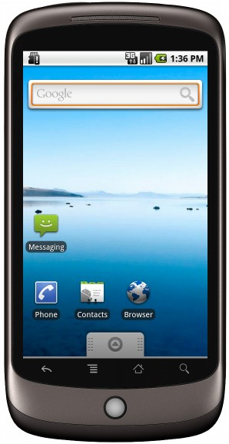

IMAGE

Splash Screen



Created by Martin Friedberg

This application will show some information on a selected number of cars.

Please Press the Start button to begin

Start Button

Start Screen



Menu Icon

Submit Button

Date Picker

Please select any date from the Date Picker

Date Picker Screen



View Saved Data Button

Pick Date Button

Text View displaying car description

Text View displaying car model

Menu Icon

Date Picker Output Screen



Back Button

Display Car Description

Display Car Name

Display Month

Display Day of Week

Saved Data Screen

Menu Icon