**QUADCOPTER**

**DOCUMENTATION**

by Martin Garaj

<garaj.martin@gmail.com>

Table of Contents

Radio Communication 3

Quartus II project - GHRD_quad_v2 3

nios2_gen2 configuration 4

nios2_ram configuration 7

shared_mem configuration 8

pin definition in ghrd 9

NIOS II Project 10

uart internal registers 10

Avalon Memory Mapped - bus width and its consequences 10

Eclipse Project 11

Avalon Memory Mapped - bus width and its consequences 11

Debugging 12

auto_signaltap_0 12

Nios II Eclipse 12

Radio Communication 14

# Radio Communication projects

## Quartus II project - GHRD_quad_v2

The figure presents the components inside the FPGA fabric

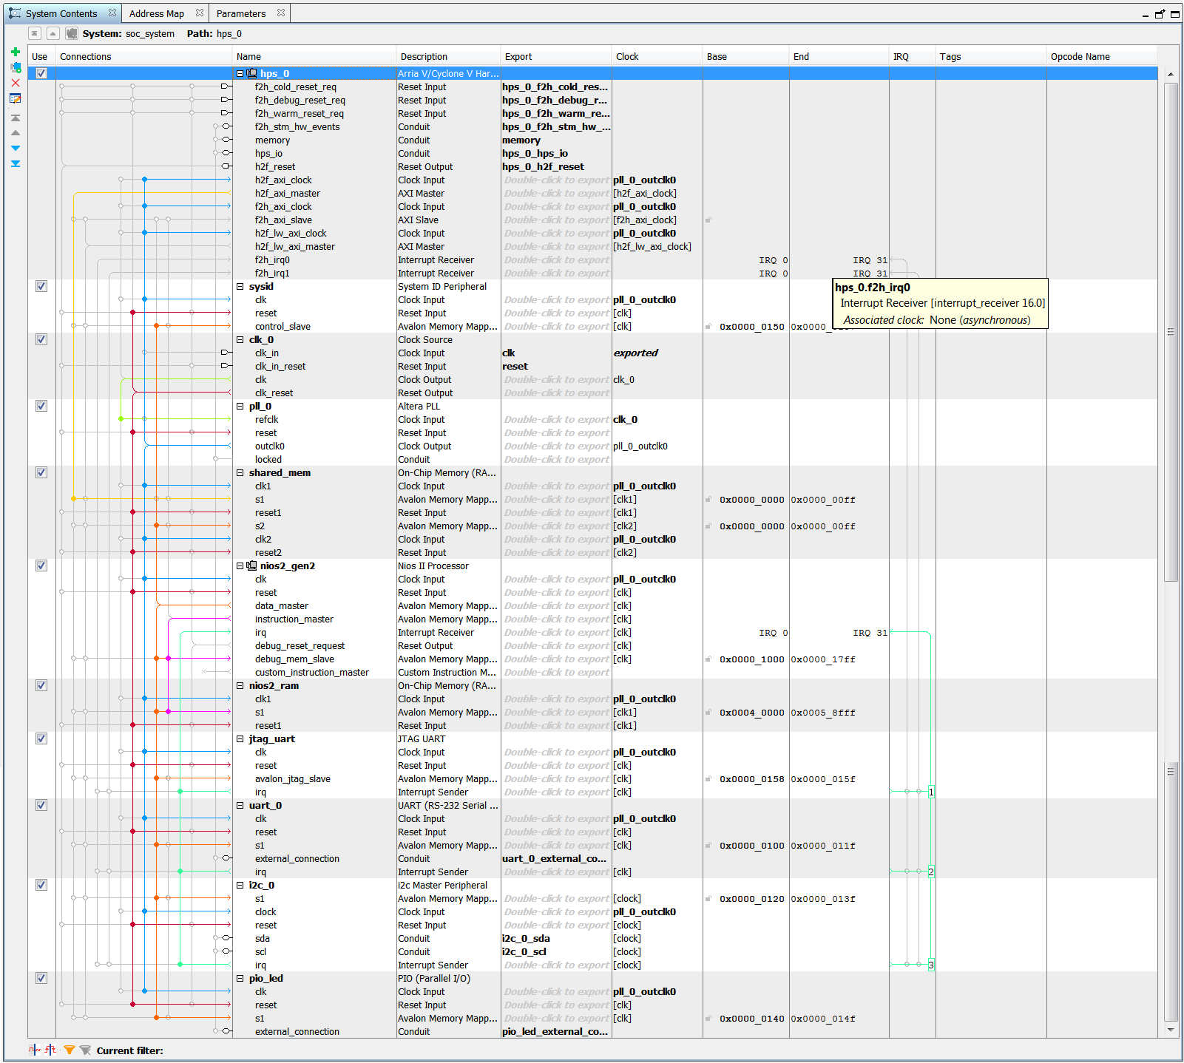

### nios2_gen2 configuration

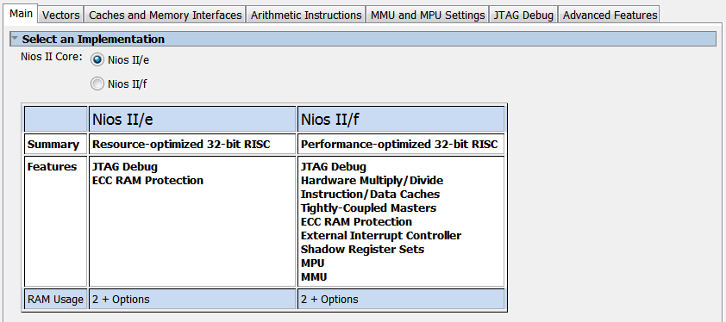

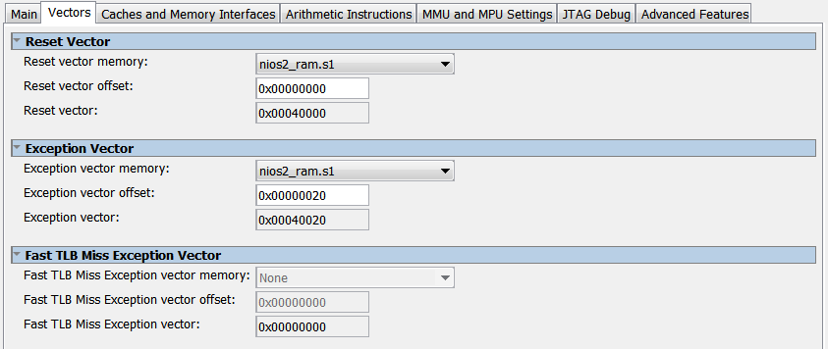

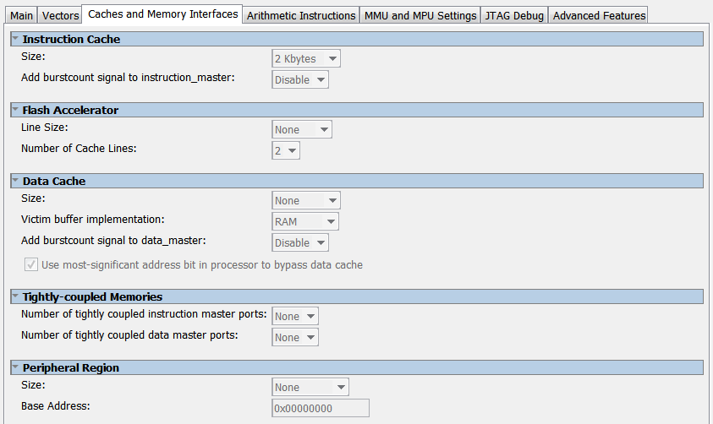

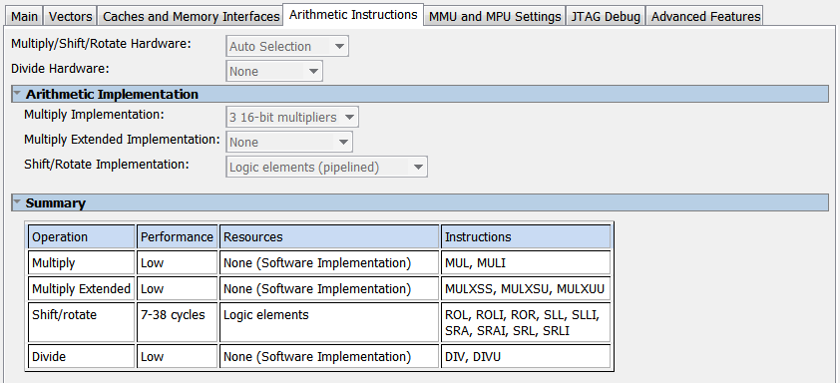

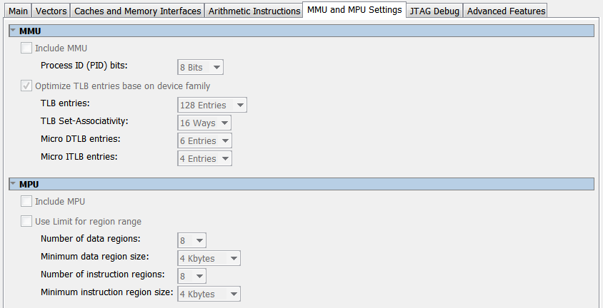

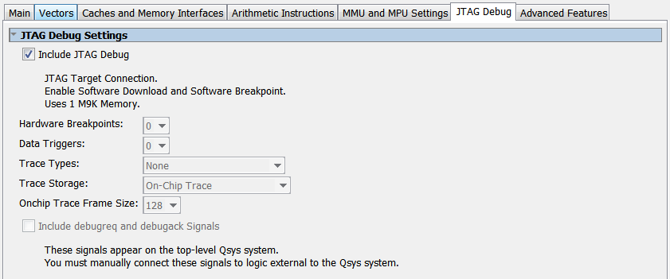

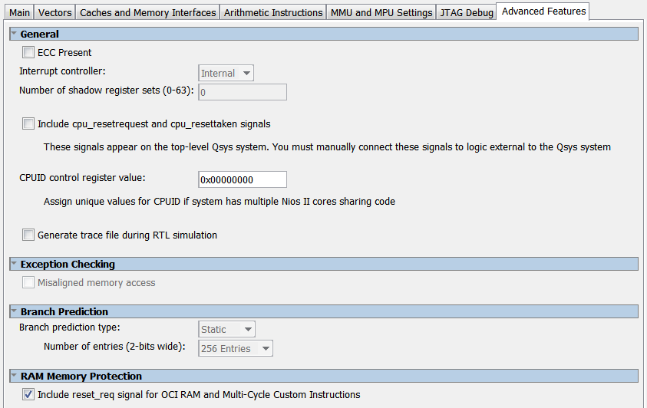

### nios2_ram configuration

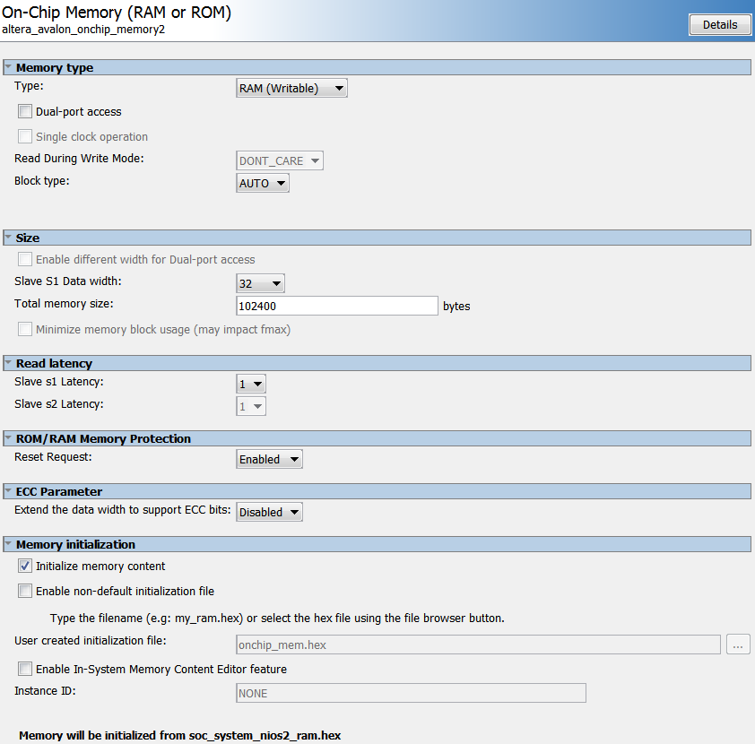

### shared_mem configuration

## 

### pin definition in ghrd

.uart_0_external_connection_rxd (GPIO_0[1]), // uart_0_external_connection.rxd

.uart_0_external_connection_txd (GPIO_0[0]), // .txd

.uart_0_external_connection_cts_n (GPIO_0[3]), // .cts_n

.uart_0_external_connection_rts_n (GPIO_0[2]), // .rts_n

.i2c_0_sda_export (GPIO_0[5]), // i2c_0_sda.export

.i2c_0_scl_export (GPIO_0[4]), // i2c_0_scl.export

// GPIO pins on De0_nano_SoC are as follows :

// ---------------------------------------------

// UART 0 TX | JP1 pin 1 |

// UART 0 RX | JP1 pin 2 |

// UART 0 RTS | JP1 pin 3 |

// UART 0 CTS | JP1 pin 4 |

// i2c 0 SCL | JP1 pin 5 |

// i2c 0 SDA | JP1 pin 6 |

## NIOS II Project - quad_nios_II_v1

### uart internal registers

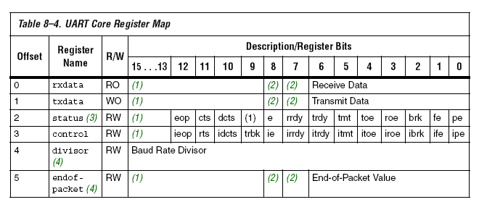

### Avalon Memory Mapped - bus width and its consequences

Nios II can use different macros to access data through Avalon MM bus. There are 2 variables, when designing communication :

1) Avalon MM bus width

2) Nios II macro

The alignment of the memory being accessed (such as in this case, the onchip_mem) DEPENDS ON the Nios II macro used. Different type of macros :

general macros :

IORD(base, offset) WORD (4 byte) aligned   
 IOWR(base, offset, data) WORD (4 byte) aligned

size oriented macors

IORD_8DIRECT(base, offset) BYTE alligned

IOWR_8DIRECT(base, offset, data) BYTE alligned  
 IORD_16DIRECT(base, offset) 2 BYTES alligned

IOWR_16DIRECT(base, offset, data) 2 BYTES alligned  
 IORD_32DIRECT(base, offset) WORD (4 byte) aligned  
 IOWR_32DIRECT(base, offset, data) WORD (4 byte) aligned

NIOS can access any byte in On-Chip Memory, regardless of the Avalon MM bus width. The addressing is byte-by-byte, see the table below :

|  |  |
| --- | --- |
| BASE_ADDRESS + 0 | 1st byte in On-Chip Memory |
| BASE_ADDRESS + 1 | 2nd byte in On-Chip Memory |
| BASE_ADDRESS + 2 | 3rd byte in On-Chip Memory |

This has been tested using 8bit and 32bit Avalon MM bus NIOS<->On-Chip Memory, using the macro IOWR_8DIRECT.

## Eclipse Project - quad_radio_v2

### Avalon Memory Mapped - bus width and its consequences

HPS can access the On-Chip Memory through h2f_axi_master. Regardless of the On-Chip Memory port width (in other words connecting Avalon MM bus width between On-Chip Memory and HPS), the addressing is 1 word (4 bytes) aligned. The following table illustrates the addressing :

|  |  |
| --- | --- |
| HPS(BASE_ADDRESS)+ 0 | 1st word (4 bytes) in On-Chip Memory |
| HPS(BASE_ADDRESS)+ 1 | 2nd word (4 bytes) in On-Chip Memory |
| HPS(BASE_ADDRESS)+ 2 | 3rd word (4 bytes) in On-Chip Memory |

When trying to access only the lower 2 bytes, using function such as follows :

**void** **set_reg**(int16_t reg_value){

shared_mem_addr[0] = reg_value;

}

and calling :

**set_reg**(0x1234);

The On-Chip Memory contain the value 0xFFFF1234, the upper 2 bytes will be overwritten by 0xFFFF value. The correct way to access the word aligned memory is by the following function :

**void** **set_reg**(int32_t reg_value){

shared_mem_addr[0] = reg_value;

}

The above behavior has been tested using 16bit and 32bit Avalon MM bus HPS<->On-Chip Memory

## Debugging

The FPGA design includes signal tap, tapping the UART module, this is regarding the IRQ and Avalon bus control, as well as Avalon bus data and address.

### auto_signaltap_0

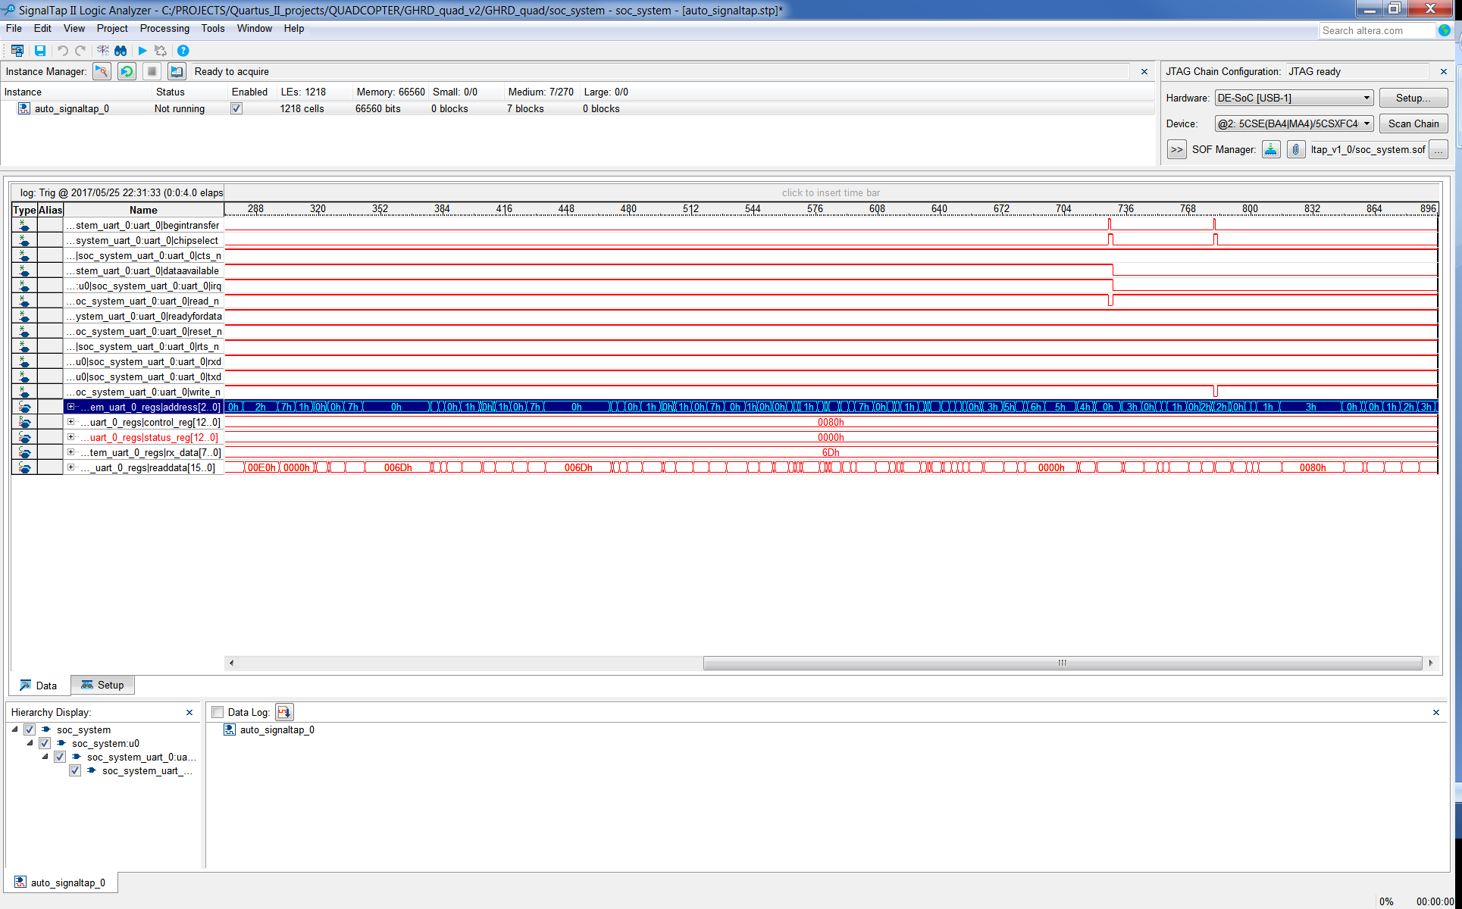

The IRQ of UART receiving a byte is recognized correctly. The above graph shows the Avalon bus communication during servicing the received IRQ. Both the RX (reading) and STATUS (writing) registers are accessed.

### Nios II Eclipse

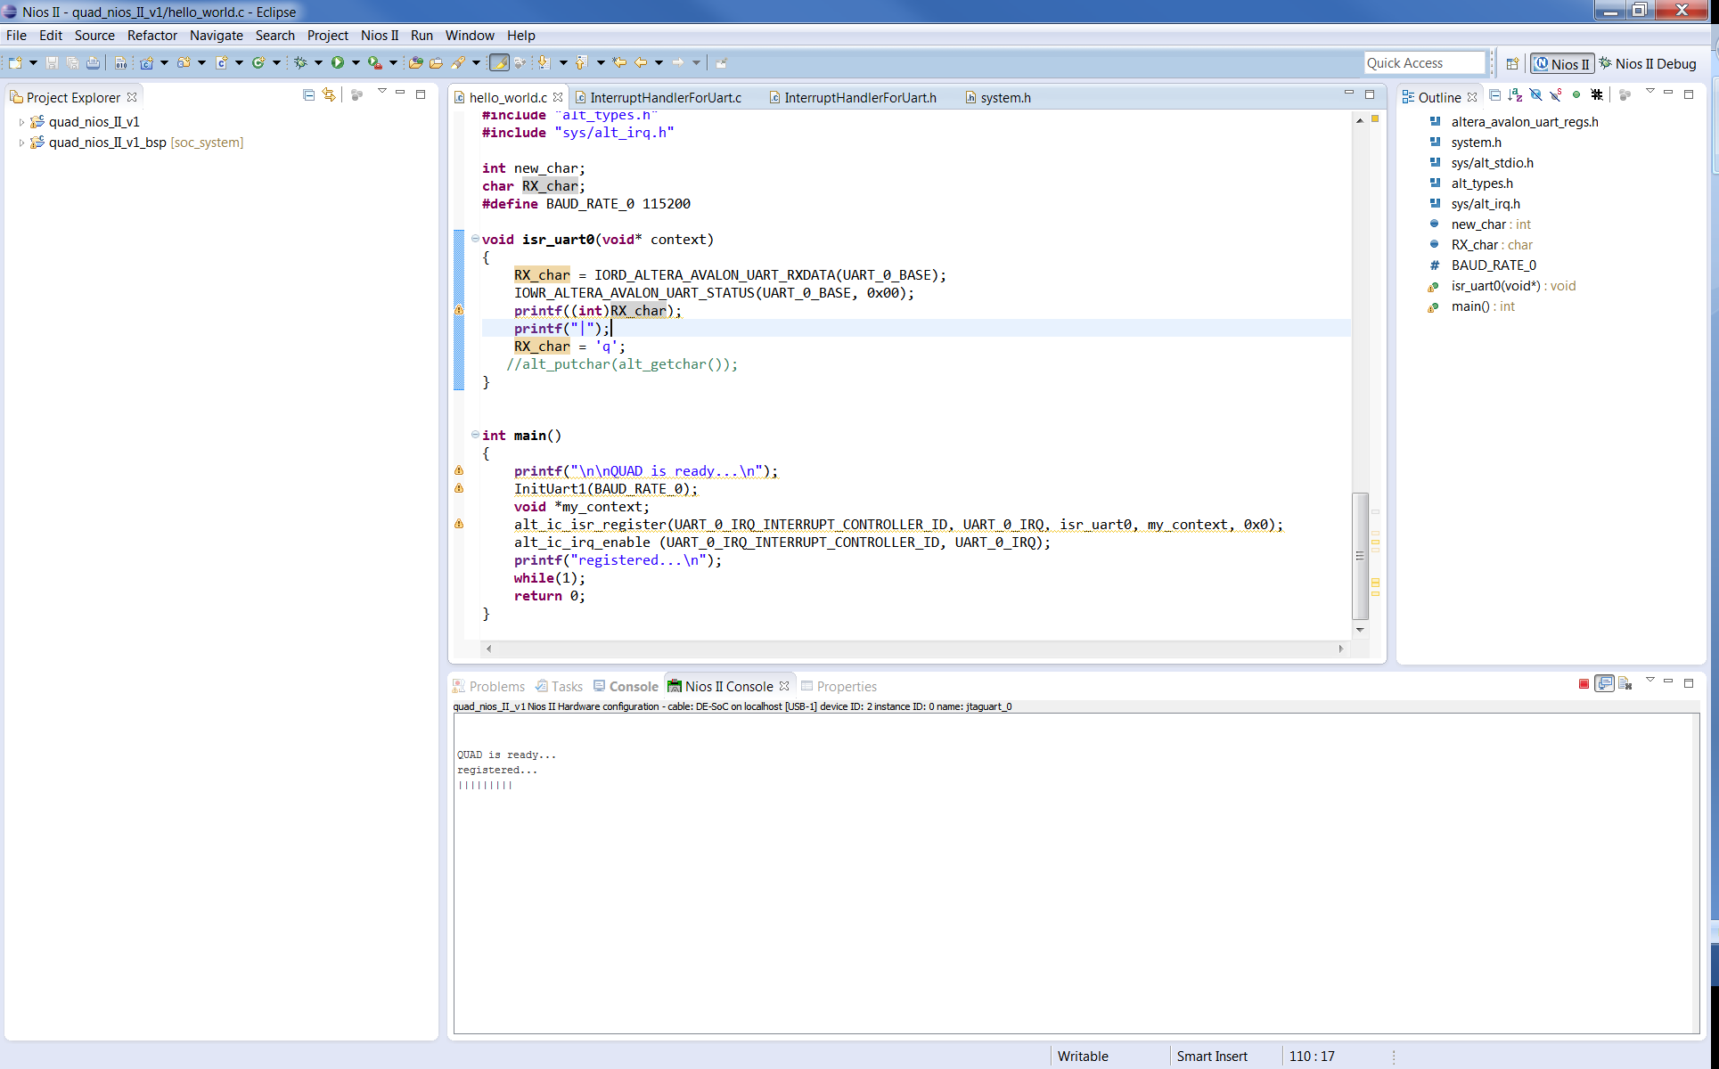

The received byte is not printed.

WORKING NOW

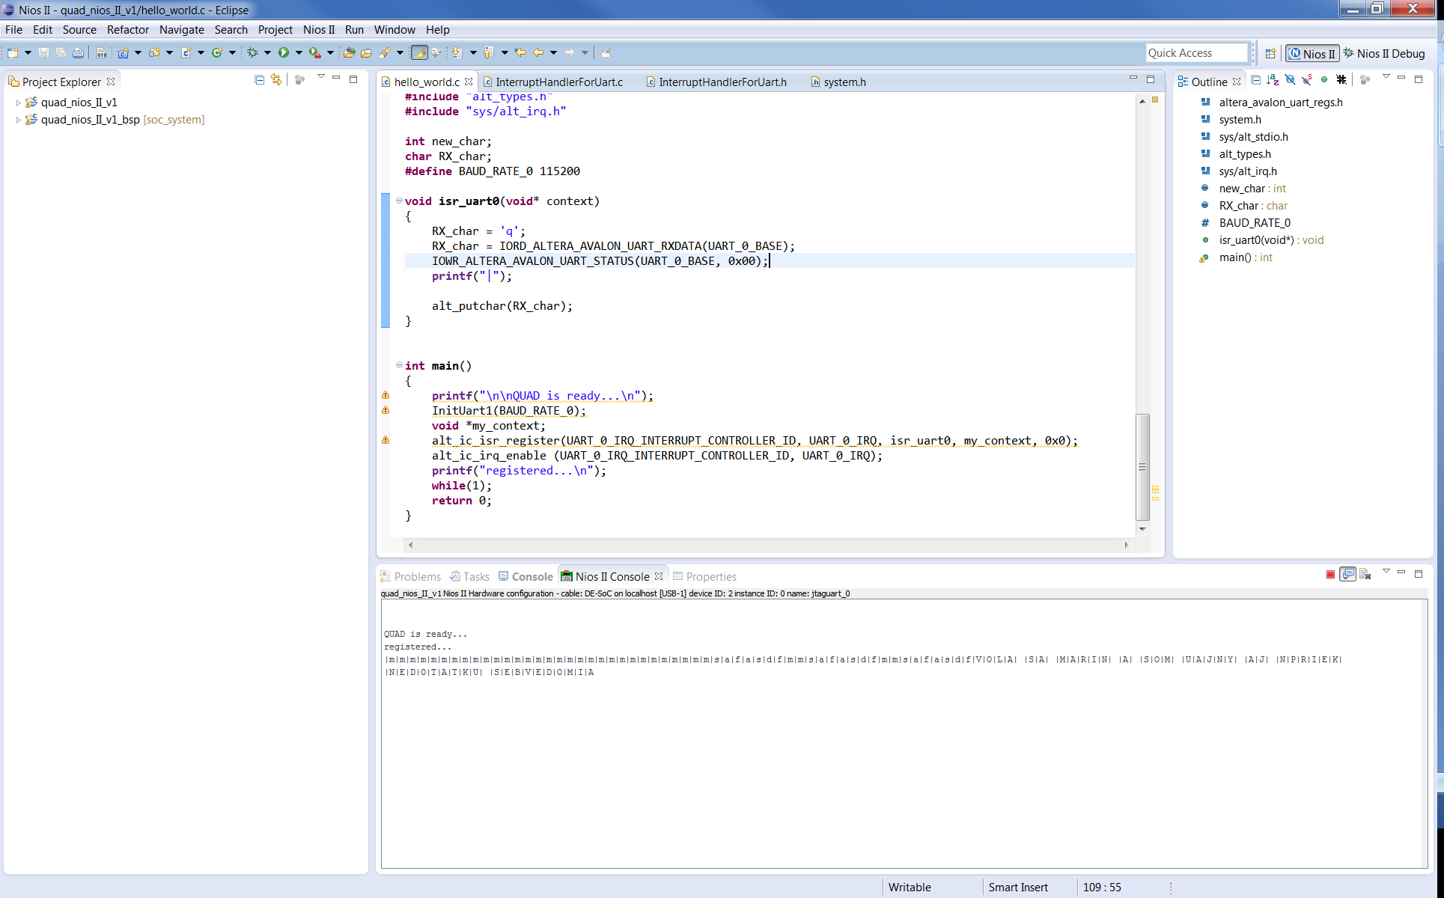

DONT USE printf !!!

## Radio Communication

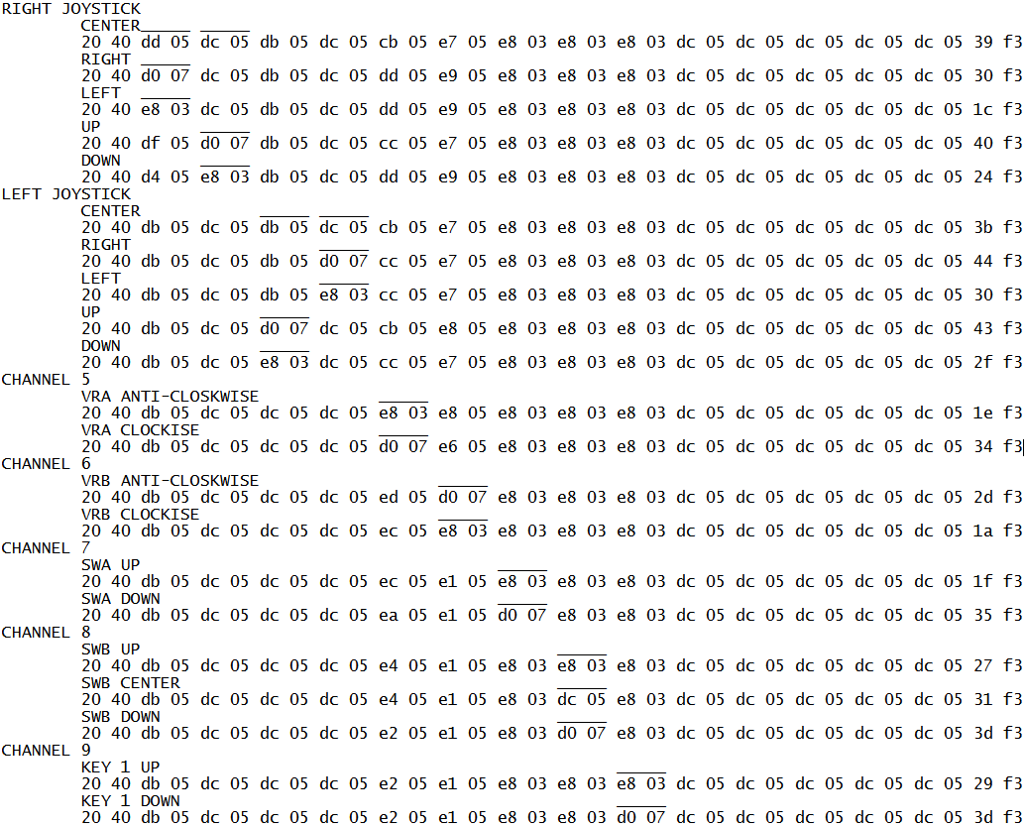

data sent by FS-iA10B according to radio transmitted signal (the channel 10 used for fly-mode change)

# Sensor communication

## Quartus II project - GHRD_quad_v1

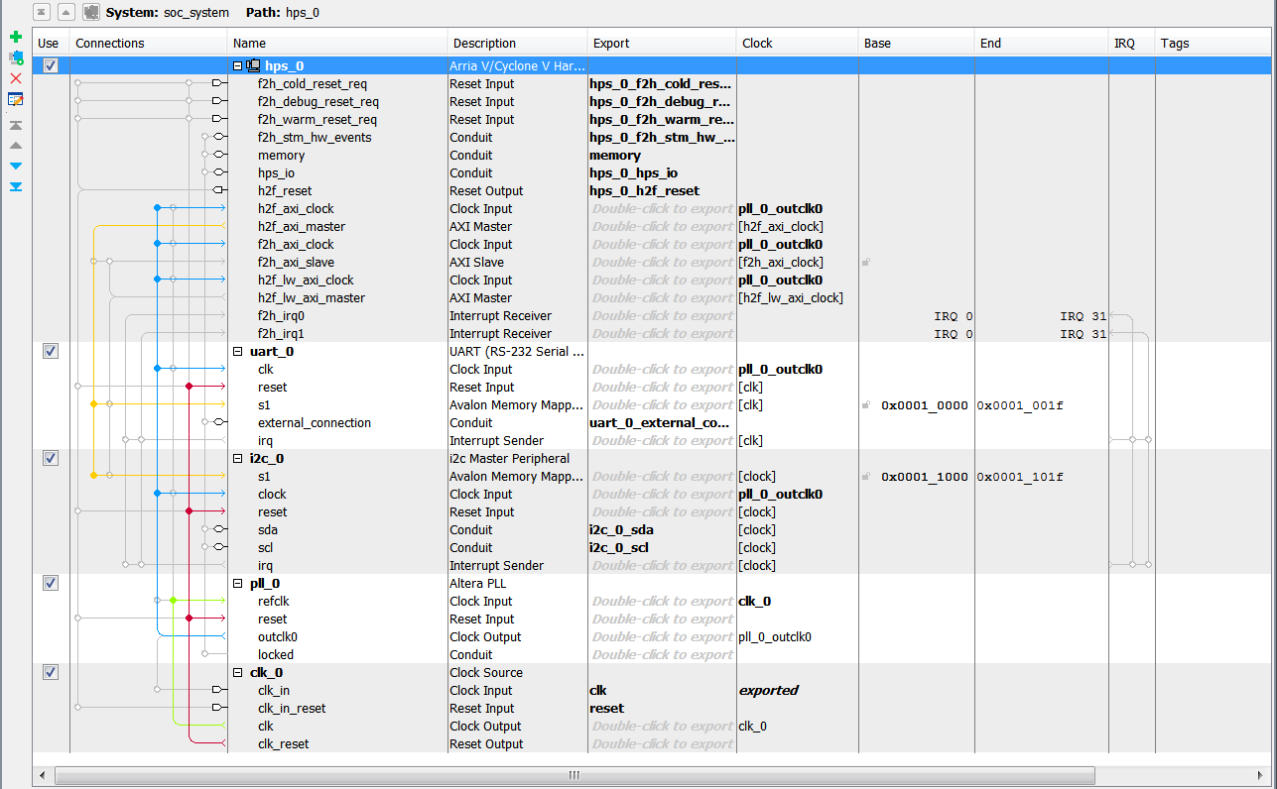

### pin definition in ghrd

.uart_0_external_connection_rxd (GPIO_0[1]), // uart_0_external_connection.rxd

.uart_0_external_connection_txd (GPIO_0[0]), // .txd

.uart_0_external_connection_cts_n (GPIO_0[3]), // .cts_n

.uart_0_external_connection_rts_n (GPIO_0[2]), // .rts_n

.i2c_0_sda_export (GPIO_0[5]), // i2c_0_sda.export

.i2c_0_scl_export (GPIO_0[4]) // i2c_0_scl.export

// GPIO pins on De0_nano_SoC are as follows :

// ---------------------------------------------

// UART 0 TX | JP1 pin 1 |

// UART 0 RX | JP1 pin 2 |

// UART 0 RTS | JP1 pin 3 |

// UART 0 CTS | JP1 pin 4 |

// i2c 0 SCL | JP1 pin 5 |

// i2c 0 SDA | JP1 pin 6 |

Eclipse project - quad_MPU6050_DMP_v3