R4DS_2E_quarto

## Exercises

Best to check the book to see the exercises: <https://r4ds.hadley.nz/quarto#exercises>

## Quarto

Quarto enables you to weave together content and executable code into a finished document. To learn more about Quarto see <https://quarto.org>.

## Running Code

When you click the **Render** button a document will be generated that includes both content and the output of embedded code. You can embed code like this:

1 + 5

[1] 6

You can add options to executable code like this

[1] 12

The echo: false option disables the printing of code (only output is displayed).

## Quarto - Visual Editor Exercises

1. Re-create the below document using the visual editor.

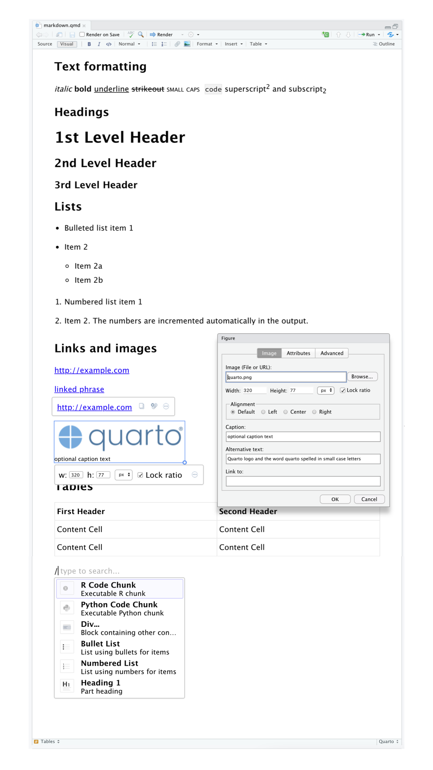

**Text formatting**