KINOTI MARTIN MWENDA
BSCCS/2024/32193
COMPUTER SCIENCE
BIT3208

ADVANCED WEB DESIGN AND DEVELOPMENT
MICHAEL NYORO
YEAR IV, SEMESTER II

PROJECT: MATERIALSVERIFY

TECHNOLOGIES USED:
MEVN STACK
POSTMAN

GITHUB REPO LINK
https://github.com/martin-m-kinoti/MaterialsVerify
Table of Content
WEEK 1: INSTALLATION AND TESTING OF LOCAL DEVELOPMENT ENVIRONMENT 1
1.1 Installation of Node.js 1
1.2 Express.js Server Running 1
1.3 Localhost Test Page 2
1.4 Hello World Test 3
1.5 Database Connection Test 3
WEEK 2: USER INTERFACE PLANNING AND SYSTEM DESIGN 4
2.1 Hand-drawn Wireframe of the Login Page 4
2.2 Dashboard Layout Design 5
2.3 Mobile View Mockup 8
2.4 Color Theme and Navigation Structure 10
2.4.1 Color Theme 10
2.4.2 Navigation Structure 12
2.5 GUI Prototype 13
WEEK 3: FRONTEND INTERACTION AND BACKEND FOUNDATIONS 14
3.1 JavaScript Form Validation 14
3.1.1 Basic Component Validation 14
3.1.2 Password Validation 15
3.2 Password Strength Checker 16
3.3 Node.js Syntax 17
3.4 Database Connection Script 18
3.4.1 Database Schema Script 18
3.4.2 Database Connection 19
3.5 Dynamic User Input Handling 19
WEEK 4: NODE.JS CONCEPTS 21
4.1 Node.js Forms Handling 21
4.2 Receiving Form Data 22
4.3 Conditional Statement 22
4.4 User Sessions 23
WEEK 5: DATABASES 24
5.1 Connecting Server to the Database & Database Creation 24
5.2 Creating Documents 24
5.3 Fetching Database Records 25
5.4 Updating Database Records (Password) 26

List of Figures
Fig 1. 1 Installation of the Node.js Environment 1
Fig 1. 2 Instance of Express.js Server Running 1
Fig 1. 3 Testing the Localhost Access Point 2
Fig 1. 4 Hello World Vue Script 3
Fig 1. 5 Week1db MongoDB Connection Test 3

Fig 2. 1 Hand-Drawn Login Page Wireframe 4
Fig 2. 2 Dashboard Layout Design 7
Fig 2. 3 Dashboard Mobile View Mockup 9
Fig 2. 4 MaterialsVerify Color Themes 12
Fig 2. 5 MaterialsVerify Navigation Structure 12
Fig 2. 6 Navigation Prototype 13

Fig 3. 1 User Details Validation 14
Fig 3. 2 Password Validation 15
Fig 3. 3 Password Strength Checker 16
Fig 3. 4 Node.js Syntax on the Server 17
Fig 3. 5 User MongoDB Database Schema 18
Fig 3. 6 Week3db Database Connection for Users 19
Fig 3. 7 Dynamic User Input Handling on the Sign Up Page 19

Fig 4. 1 Node.js form handling 21
Fig 4. 2 Receiving form data on the server 22
Fig 4. 3 Sample Node.js conditional statements 22
Fig 4. 4 Setting up user sessions 23

Fig 5. 1 Database creation and connecting it to the server 24
Fig 5. 2 Creating user documents 24
Fig 5. 3 Fetching database records on users 25

WEEK 1: INSTALLATION AND TESTING OF LOCAL DEVELOPMENT ENVIRONMENT

1.1 Installation of Node.js
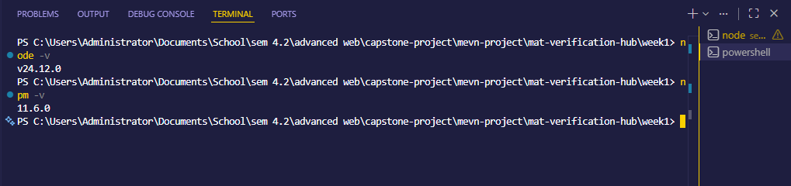
Fig 1. 1 Installation of the Node.js Environment
Fig 1.1 shows the version of Node.js that has been installed in the environment. For this case, the version (v24.12.0) has been successfully installed.

1.2 Express.js Server Running
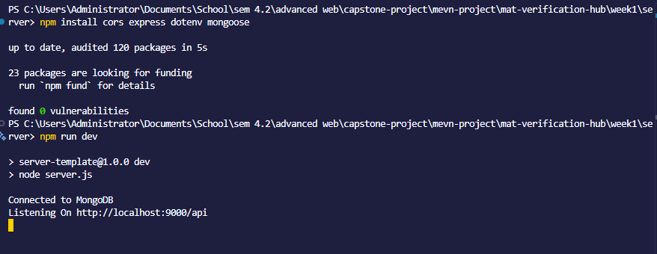
Fig 1. 2 Instance of Express.js Server Running
Fig 1.2 above shows the Express.js server running. This is done in the server directory of the project. The server successfully connects to the MongoDB database and can be accessed on the port provided.

1.3 Localhost Test Page
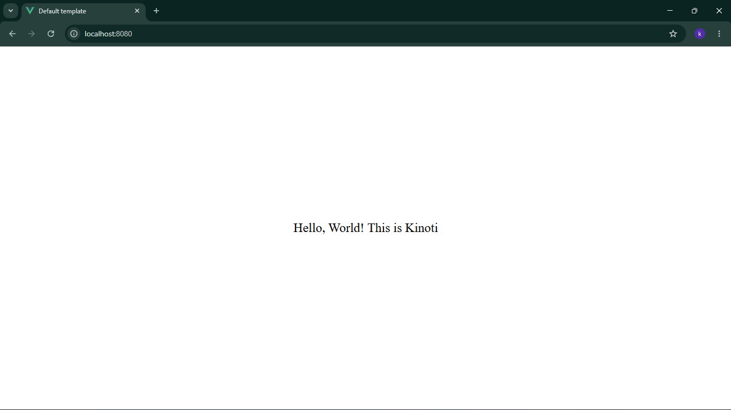
Fig 1. 3 Testing the Localhost Access Point
Fig 1.3 shows the connection to the localhost port 8080, which displays the client content on the browser. The HelloWorld Vue script is displayed above via that port.

1.4 Hello World Test
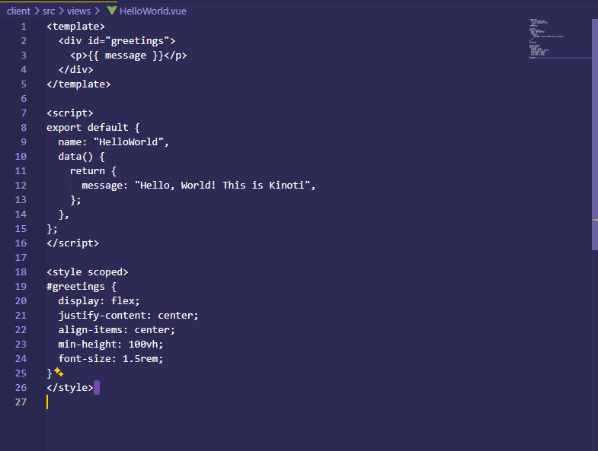
Fig 1. 4 Hello World Vue Script
Fig. 1 .4 above shows the HelloWorld script used in the display of the web page represented by Fig. 1 .3.

1.5 Database Connection Test
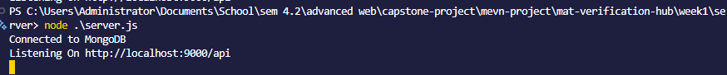
Fig 1. 5 Week1db MongoDB Connection Test
Fig 1.5 shows a successful test for connecting to the MongoDB database named week1db from the server.

WEEK 2: USER INTERFACE PLANNING AND SYSTEM DESIGN

2.1 Hand-drawn Wireframe of the Login Page
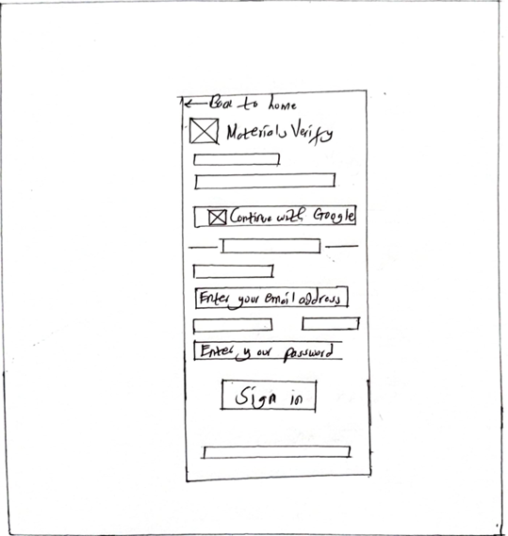
Fig 2. 1 Hand-Drawn Login Page Wireframe
Fig 2.1 shows the layout of the Sign in pages for the MaterialsVerify platform. The figure shows the sketched components of the page as they will appear on the site.

2.2 Dashboard Layout Design
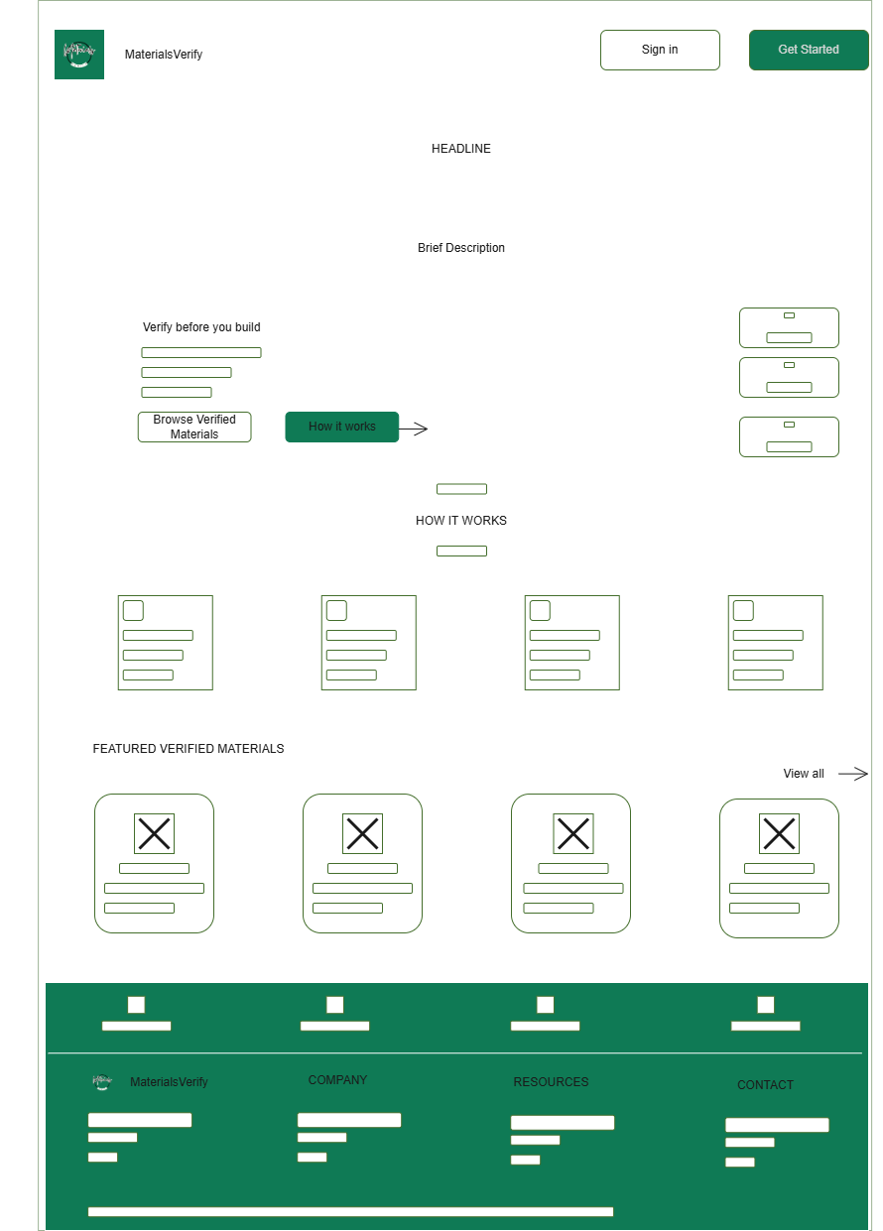
Fig 2. 2 Dashboard Layout Design
Fig. 2 .2 above shows the landing page wireframe. The wireframe shows how the various components will be organized, including the information to be displayed.

2.3 Mobile View Mockup
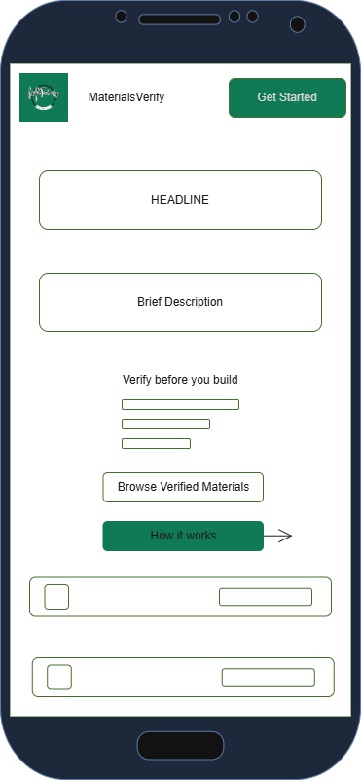
Fig 2. 3 Dashboard Mobile View Mockup
Fig. 2.3 shows how the landing page of the site will appear when accessed on a mobile phone by the user. This design shows how users would get the best experience on their phones.

2.4 Color Theme and Navigation Structure

2.4.1 Color Theme
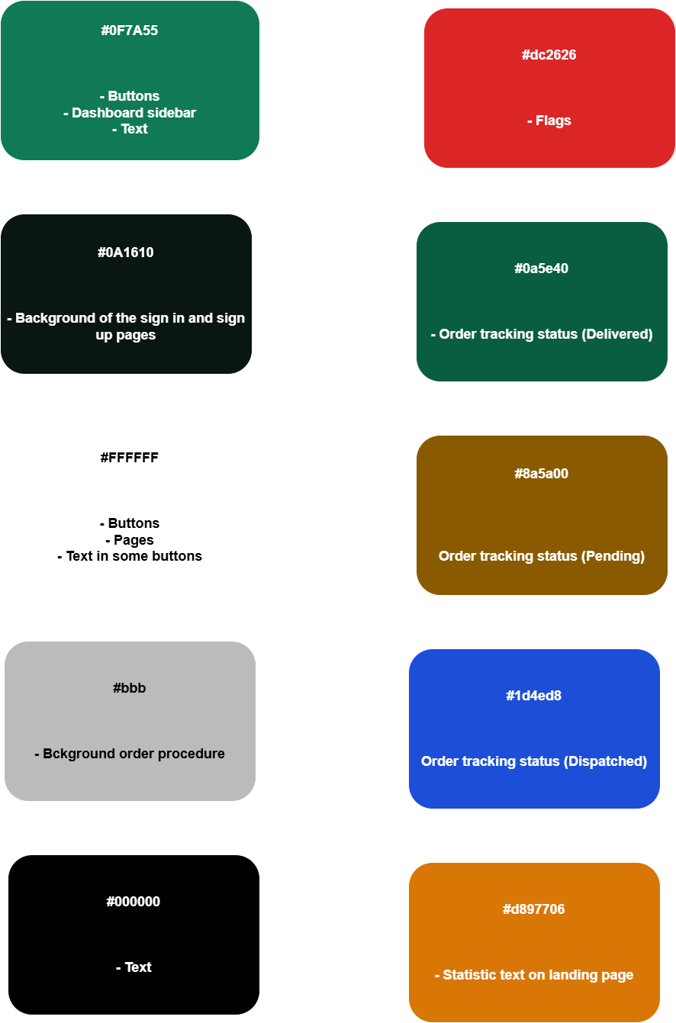
Fig 2. 4 MaterialsVerify Color Themes
Fig. 2.4 above shows the various color themes that will be used in the platform for each component.

2.4.2 Navigation Structure
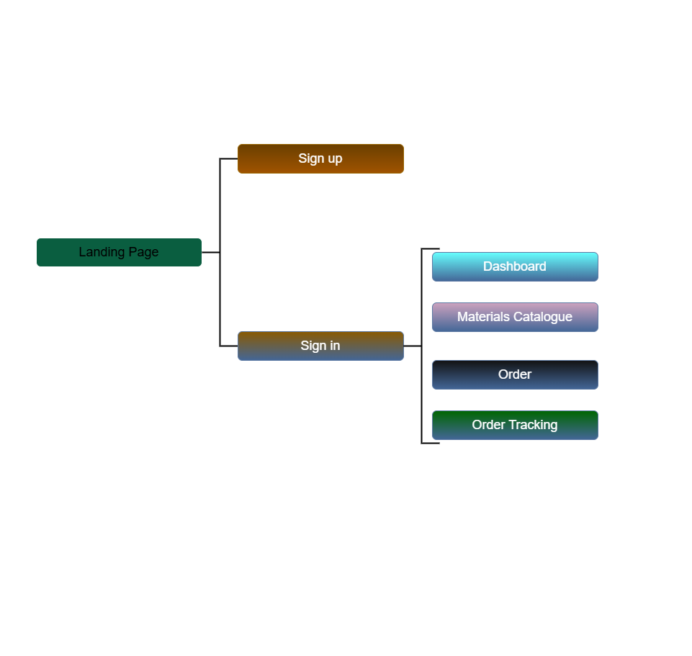
Fig 2. 5 MaterialsVerify Navigation Structure
Fig. 2.5 shows the user navigation structure, from sign-up to resource utilization.

2.5 GUI Prototype
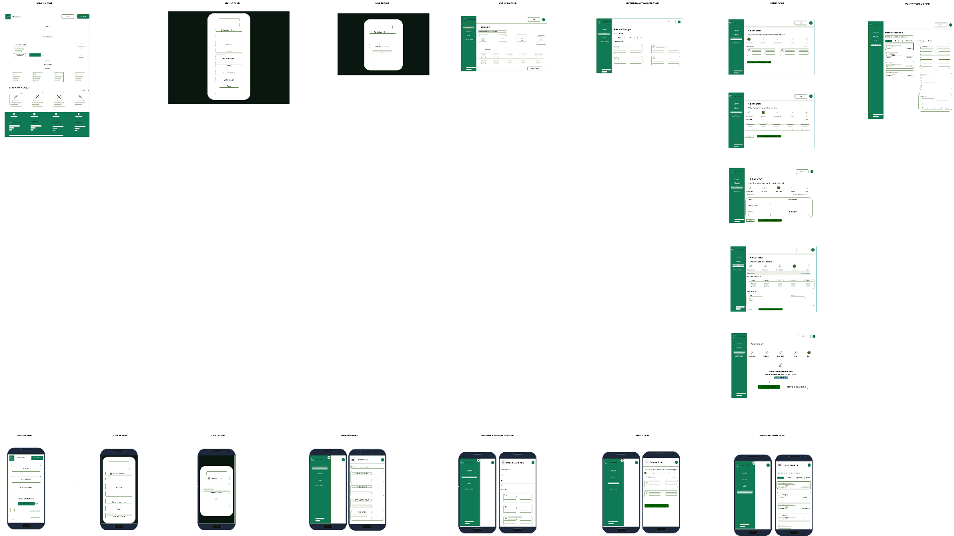
Fig 2. 6 Navigation Prototype
Fig. 2.6 shows the MaterialsVerify prototype. The prototype shows the user journey through the platform, from the landing page to other pages, including mobile view mockups.

WEEK 3: FRONTEND INTERACTION AND BACKEND FOUNDATIONS

3.1 JavaScript Form Validation

3.1.1 Basic Component Validation
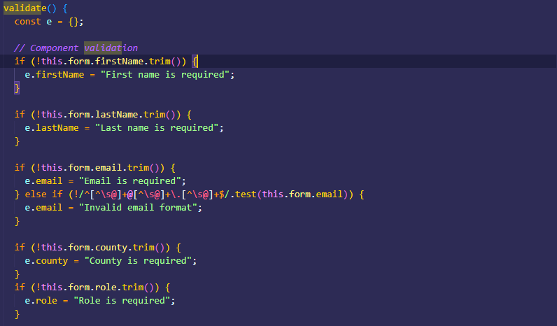
Fig 3. 1 User Details Validation
Fig. 3.1 shows the validation of the sign-up form for basic user information. The user’s name, email, county, and roles are validated to ensure accuracy.

3.1.2 Password Validation
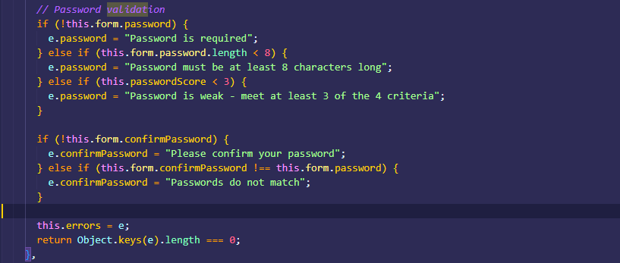
Fig 3. 2 Password Validation
Fig. 3.2 above shows user password verification to ensure that it is of the required minimum length. The password needs to be strong to pass validation. Furthermore, the user needs to confirm their password, which is also validated to ensure they are the same.

3.2 Password Strength Checker
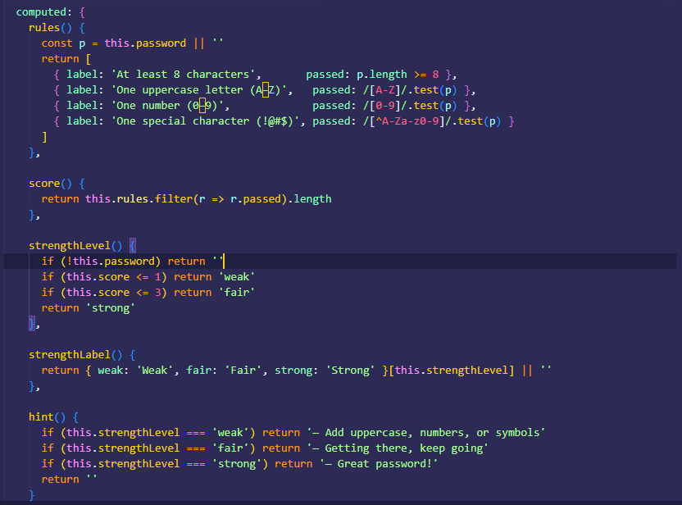
Fig 3. 3 Password Strength Checker
Fig. 3.3 shows the script for checking the strength of the password set by the user. The password is scored on four counts: length, uppercase letters used, numbers used, and special characters included in the password. Only passwords that meet this criteria are successfully validated.

3.3 Node.js Syntax
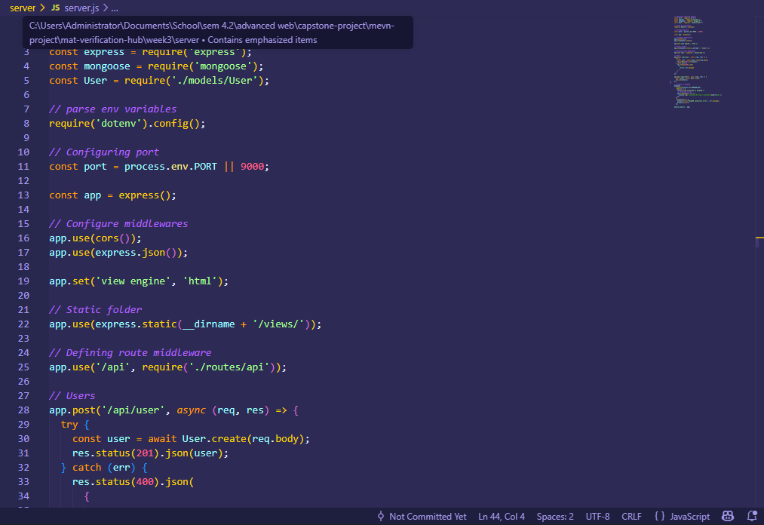
Fig 3. 4 Node.js Syntax on the Server
Fig. 3.4 shows Node.js syntax, that is written on the server.js file on the MEVN server directory. The script creates the “/api/user” endpoint for adding a user to the database, and a “/api/users” endpoint for accessing all the users successfully registered in the database.

3.4 Database Connection Script

3.4.1 Database Schema Script
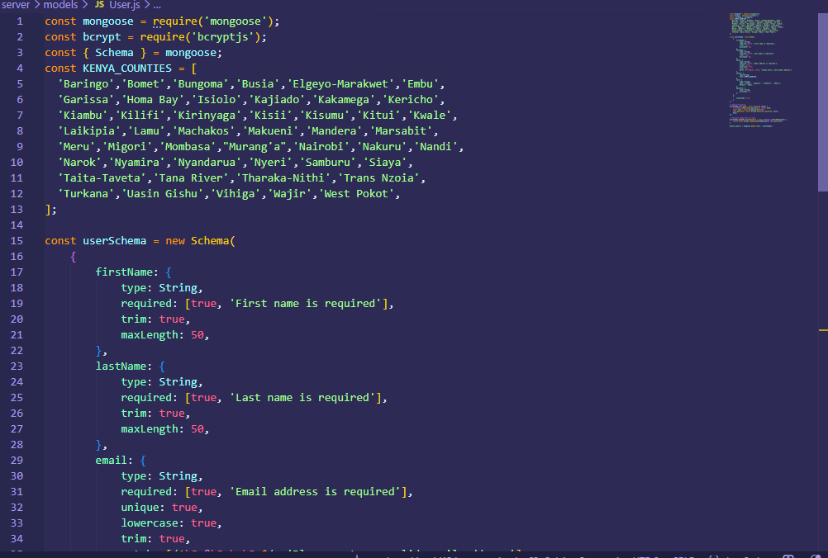
Fig 3. 5 User MongoDB Database Schema
Fig. 3.5 shows how the user schema is defined, including the fields entered and their respective types, and validation measures. This schema is referred to every time a user signs up on the platform.

3.4.2 Database Connection
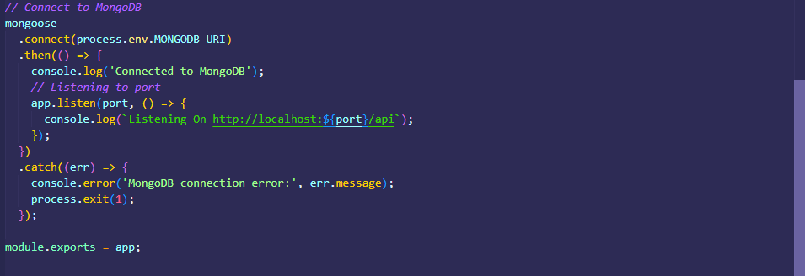
Fig 3. 6 Week3db Database Connection for Users
The figure above, Fig.3.6, shows the script for connecting to the week3db database, where the user information is being stored upon signing up. In case an error occurs, it is flagged immediately during sign up.

3.5 Dynamic User Input Handling
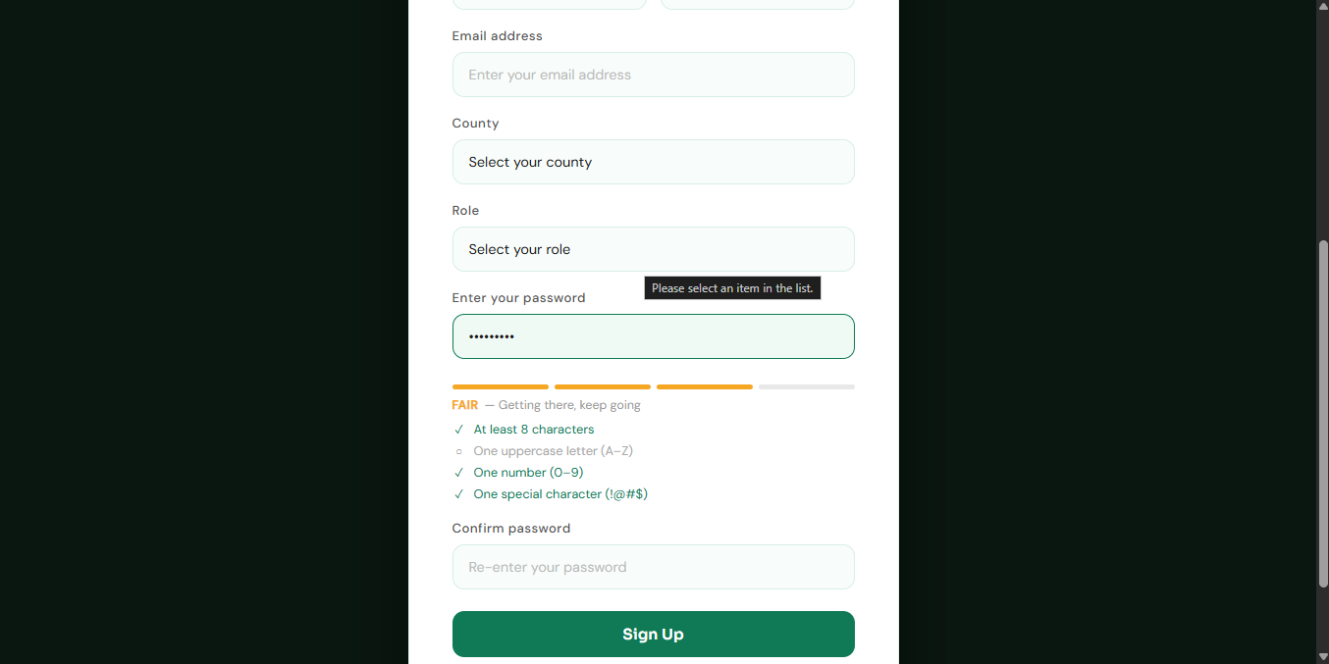
Fig 3. 7 Dynamic User Input Handling on the Sign Up Page

Fig. 3.7 shows the dynamic handling of the user inputs as they key in their details. The user inputs are validated in real time, providing them with live feedback for immediate updates. The video file above shows this dynamic handling of user inputs as they sign up.

WEEK 4: NODE.JS CONCEPTS

4.1 Node.js Forms Handling
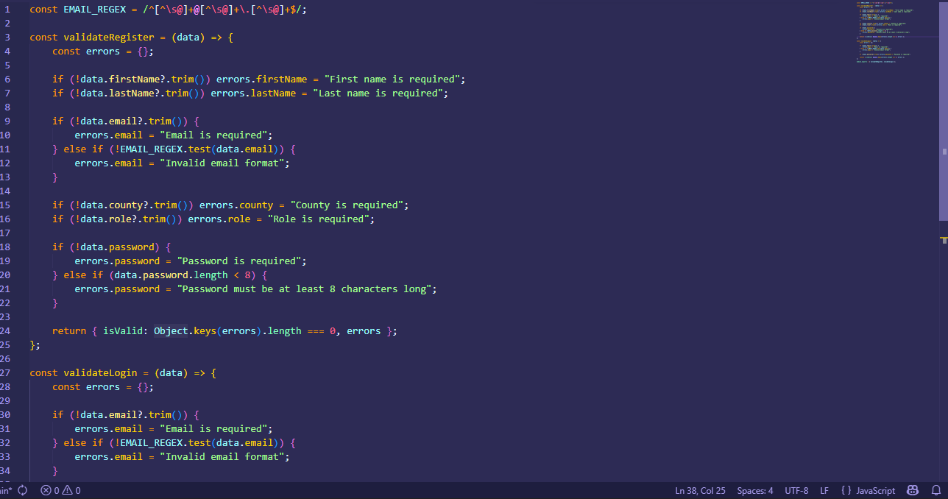
Fig 4. 1 Node.js form handling
Fig. 4.1 above shows how the client form data is retrieved and validated. In addition to client-side data validation, further form handling is done on the server to ensure that the data being written to the database is accurate and in the desired format. Form handling is done for both the data from the sign-up and sign-in pages.

4.2 Receiving Form Data
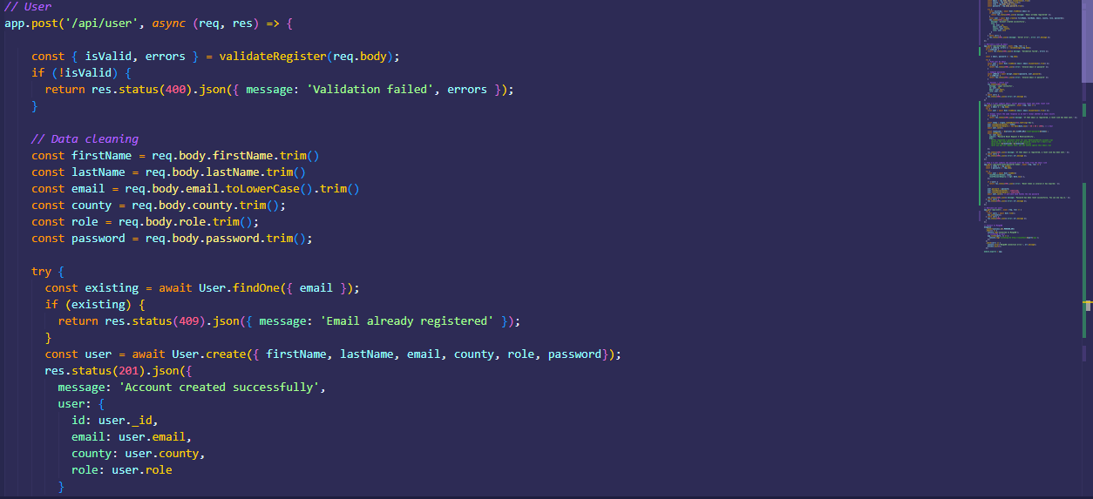
Fig 4. 2 Receiving form data on the server
Fig. 4.2 shows how data is received from the client. The data is sent in JSON format in an HTTP request. The data is received through the “/api/user” API endpoint, where each data item is unpacked and validated. If successfully validated, the user is added to the MongoDB database, with a success status sent as a response to the client.

4.3 Conditional Statement
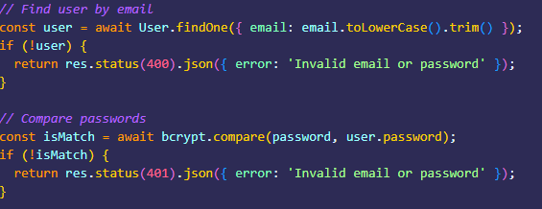
Fig 4. 3 Sample Node.js conditional statements
Fig. 4.3 above shows how conditional statements are used in the server. In the figure, the first conditional statement checks whether the user is registered in the database, and if not, an error message is sent to the client informing them of the issue. The second conditional statement checks whether the password keyed in by the user is the same as the one in the database, and if it is not, an error message is sent to the client.

4.4 User Sessions
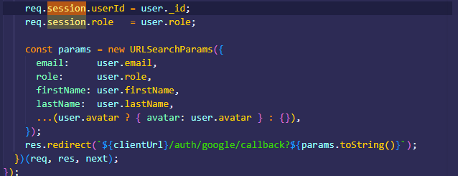
Fig 4. 4 Setting up user sessions
Fig.4.4 above shows how user sessions are setup on the server, and linked to the client. Sessions allow the server to retain the user state between requests, since HTTP is stateless and each request is treated as new. The user details are used in initializing and maintaining the user state, based on whether they have logged in using their credentials, or Google authentication.

WEEK 5: DATABASES

5.1 Connecting Server to the Database & Database Creation
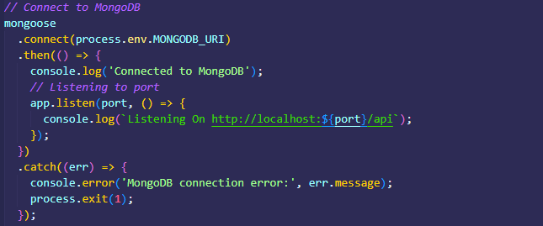
Fig 5. 1 Database creation and connecting it to the server
Fig. 5.1 above shows the connection between the server and the MongoDB database. Once the server starts running, the specified database is automatically initialized in the MongoDB cloud. Successful connection to the database is indicated by the response “connected to MongoDB”. The listening port (link port for the client) is also specified, and handling of errors if they occur.

5.2 Creating Documents
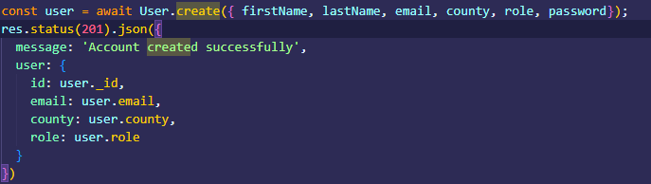
Fig 5. 2 Creating user documents
Fig. 5.2 shows how user documents are created and added to the database. Using the information received from the client form, the database schema “User” is used to add the user information based on the defined model. In the figure, the fields “firstName”, “lastName”, “email”, “county”, “role”, and “password” are added to the database. In addition, successful document storage is indicated by a response message.

5.3 Fetching Database Records
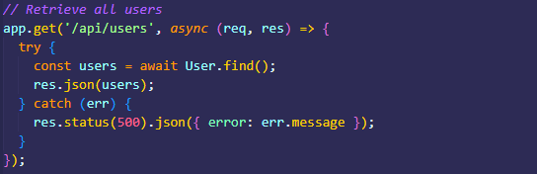
Fig 5. 3 Fetching database records on users
Fig. 5.3 shows how user data is fetched from the database. To retrieve all the users, the “User” schema uses the function “find()” and returns all the user details. In case of an error, a message is returned indicating the issue for debugging.

5.4 Updating Database Records (Password)
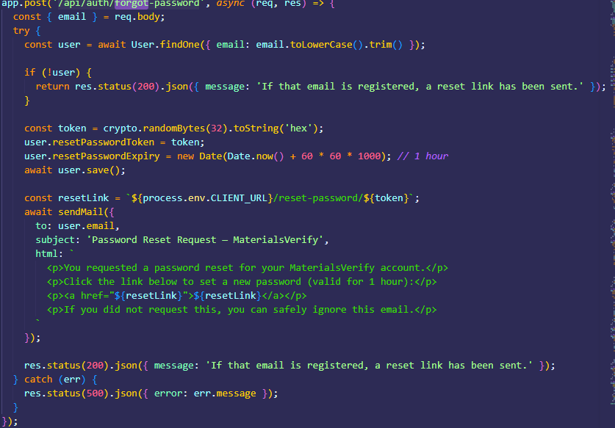
Fig 5. 4 Updating user password
Fig. 5.4 above shows how a user can be able to update their password if they forget it. The user is first verified to have an account based on their email address, and a token is generated for resetting the password. An email is sent to their account where there is a link redirecting them to the password reset page. Users are only able to access this functionality if they are already registered users and their information is in the database.

