Hong Kong University of Science and Technology
COMP4441: Computer Music

Fall 2014
Midterm Examination

Student Name: Key

Student ID:

Instructions:
- This is a closed-book, closed-notes examination.
- Answer all questions in the space provided.
- Write down your name and student ID on this page.

Question | Score
1 | /10
2 | /10
3 | /8
4 | /6
5 | /5
6 | /6
7 | /18
8 | /14
9 | /6
10 | /11
11 | /6
Total | /100

1. Acoustics and Waveforms [10 marks]

- Please read the figure and select all CORRECT statement(s). (5 marks)

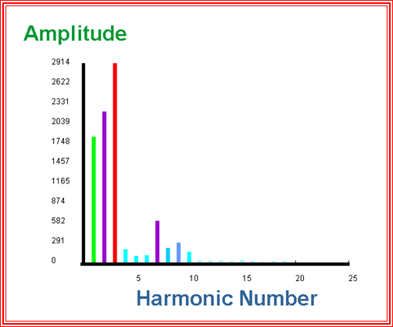
1 2 3 4 5 6 7 8 9 10
Fig. (1)
- The above spectrum is not from a real acoustic musical instrument because the amplitude of the fundamental frequency should be always the largest.
- The amplitude of the eighth harmonic is always 1/8 of the first harmonic.
- The sound’s pitch will become higher if we increase the amplitude of harmonics 7, 8, and 9.
- This spectrum must be from the clarinet because it has strong 3rd and 7th harmonics (which are odd harmonics).
- None of above.

Answer: ____ v _____

- Based on the figure, select all CORRECT statement(s): (5 marks)

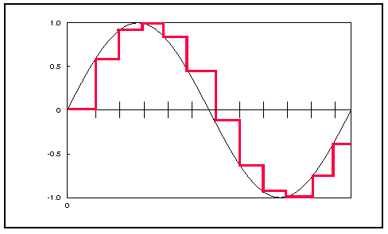

- The above figure shows a digitized version of a sine wave.
- Digitization causes aliasing in this example.
- Digitization reduces the noise in the signal.
- We can store an analogue waveform in the PC’s memory without digitization if we want to maintain its high sound quality.

Answer: _________i______

2. Spectrum Analysis and PVan [10 marks]

- Below is the procedure of spectrum analysis. Fill the blanks. (5 marks)
Recoded sound

Analog to digital converter

Samples

Time-varying Fourier Analysis

Amplitudes and Phases

Additive Synthesis

Amplitudes and Phases

- Choose all CORRECT statements: (5 marks)
  - Natural sounds are always periodic, and that is why we can find the spectrum of the sounds.
  - For Time-varying Fourier Analysis, except for the Rectangular window, most window functions look like half a period of a sine wave.
  - Automatically finding the fundamental frequency is a straightforward procedure.
  - Additive synthesis can reconstruct the original sound exactly.
  - All above are incorrect.

Answer:_____ii, iv_______
3. Additive Synthesis [8 marks]

You are going to additive synthesize a short version of the Nokia tone, the score of which has been shown below. The amplitudes of the first two harmonics are: 853 and 278 respectively.
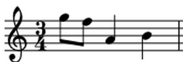

The “.orc” and “.sco” files below synthesize the melody. Fill in the blanks. Note that the blanks are more than enough. You do not need to fill them all. You are also NOT allowed to modify the “.orc” files
; nokia.sco
;waveform for oscillator - a sine wave
f1 0 16385 10 1
; start end amp pitch attack decay
i1 0 0.5 853 9.07 .02 .05

____________________________________ .02 .05

____________________________________ .02 .05

____________________________________ .02 .05

____________________________________ .02 .05

____________________________________ .02 .05

____________________________________ .02 .05

____________________________________ .02 .05

____________________________________ .02 .05

____________________________________ .02 .05

____________________________________ .02 .05

____________________________________ .02 .05

____________________________________ .02 .05

____________________________________ .02 .05

end
; nokia.orc
sr = 22050
kr = 2205
ksmps = 10
nchnls = 1

;--------------------------------------------------------------------
instr 1 ; sine wave

idur = p3
iamp = p4 ; p4 controls the amplitude
ifreq = cpspch(p5) ; set tuning ratio in Hertz
iattack = p6 ; attack time
idecay = p7 ; decay time
iwave = 1

isus = idur - iattack - idecay ; sustain is remaining duration

aenv linseg 0,iattack,iamp,isus,iamp,idecay,0 ; amp. env.
asig oscili aenv,ifreq,iwave ; signal
out asig ; output
endin
;--------------------------------------------------------------------

Answer:
i1 0 0.5 853 9.07 0.02 0.05 (1 MARK)
i1 0 0.5 278 10.07 0.02 0.05 (1 MARK)
i1 0.5 0.5 853 9.05 0.02 0.05 (1 MARK)
i1 0.5 0.5 278 10.05 0.02 0.05 (1 MARK)
i1 1.0 1 853 8.09 0.02 0.05 (1 MARK)
i1 1.0 1 278 9.09 0.02 0.05 (1 MARK)
i1 2.0 1 853 8.11 0.02 0.05 (1 MARK)
i1 2.0 1 278 9.11 0.02 0.05 (1 MARK)

ALL CORRECT: 1 MARK
4. Wavetable Synthesis [6 marks]

Synthesize the melody in Q3 using wavetable synthesis with the same .orc file.

; sinewave.sco
;waveform for oscillator - a sine wave
f1 0 16385 10 _________________________
; start end amp pitch attack decay

____________________________________ .02 .05

____________________________________ .02 .05

____________________________________ .02 .05

____________________________________ .02 .05

____________________________________ .02 .05

____________________________________ .02 .05

____________________________________ .02 .05

end

Answer:
853 278 (2 MARKS)
i1 0 0.5 853 9.07 .02 .05 (1 MARK)
i1 0.5 0.5 853 9.05 .02 .05 (1 MARK)
i1 1 1 853 8.09 .02 .05 (1 MARK)
i1 2 1 853 8.11 .02 .05 (1 MARK)

5. Amplitude, Meter and Pitch [5 marks]

Consider the piano. You are now trying to use the computer music knowledge you have learned to figure out how it makes sound. Choose all CORRECT statements.

- The harder you hit the key, the higher the pitch.
- You can control the amplitude of the sound you play.
- You can control the attack time of the sound you play.
- The white keys have a brighter sound than the black keys.
- Low notes decay faster than high notes.
- The sound will continue to be heard until you release the key.
- All above are incorrect.

Answer: _______ii__________
6. Music Emotion [6 marks]

Choose all CORRECT statements.
- In Russel’s emotion model, valence means how strong an emotion is.
- Music emotion can be perceived differently by different people or in different contexts.
- Stronger amplitude usually expresses more positive emotion.
- Valence is part of Categorical Music Emotion models.
- “Happy” has a positive valence.

Answer:____ii, v___________

7. FM Synthesis [18 marks]

a. Will vibrato modify the frequency of a tone? Justify your answer. (4 marks)

Ans: Yes. Vibrato is a type of frequency modulation.

b. What does the modulation index affect in FM synthesis? (2 marks)

Ans: It controls the amount of frequency / modulation.

c. Given than the modular frequency ratio is 3, finish the following CSound files for Quasi-Formant FM synthesis. (8 marks)

; qformant.sco
f1 0 16385 10 1
; start dur amp freq
i1 1 5 5000 311
;qformant.orc
instr 1
idur = p3
iamp = p4
ifreq = p5
index = 4 ; modulation index
iwave = 1 ; wavetable 1 (sine wave)

kcarfr = __________p5_________
kmodfr = ____kcarfr * 3_______

amod oscili index*kmodfr, kmodfr, iwave
acar oscili iamp, kcarfr+amod, iwave
out acar
endin

d. For formant FM, what is the equation for the amplitude of the 3rd harmonic for modulation index I, and n_{c} = 5? (2 marks) Also, put the equation into its simplest form. (2 marks)

Answer: A₃ = J₃₋₅ (I) – J₋₍₃₊₅₎(I) (2 marks)
= J₋₂ (I) – J₋₈(I)
OR = J₂ (I) – J₈(I) (2 marks)

8. Effects & Filters [14 marks]

a. What is a “formant”? Which type of filter should we use to achieve it? (5 marks)

Answer: Formant means resonance. We use band-pass filter (or high-pass + low-pass filters) to achieve it.

b. Can we create a band-pass filter by a pair of low-pass and high-pass filters only? Justify your answer by specifying how to set the corresponding cutoff frequencies. No marks will be given to an answer without justification. (7 marks)

Answer: Yes.
- Apply a low pass filter to a tone with cutoff frequency equals to center frequency + bandwidth / 2
- Apply a high pass filter to a tone with cutoff frequency equals to center frequency - bandwidth / 2

c. Apart from removing hum, give one more use of band-stop filter. (2 marks)

Answer: It can trim out the frequency range for a microphone which causes feedback in live performance situation. (Or any other reasonable answer)

9. Comb Filters & All-pass Filters [6 marks]

a. How does a comb filter produce echoes? (3 marks)

Answer: Using a delay feedback.

b. Give one difference between a comb filter and an all-pass filter. (3 marks)

Answer: All-pass filters give faster exponentially-decaying echoes than comb filters. (Or any other reasonable answer)

10. Reverb [11 marks]

a. Why shouldn’t you set the comb delay times to integer multiples of one another in a Schroeder Reverberator? (3 marks)

Answer: Because the echoes will coincide (and make a metallic ring).

b. Finish the below Schroeder Reverberator implementation. (8 marks)

;reverb.orc
garev init 0 ; initialize garev
;--------------------------------------------------
instr 2 ; regular instrument
...
endin
;--------------------------------------------------
instr 99 ; Csound global reverb instrument
idur = p3
igain = p4 ; gain to control amplitude
irevtime = p5 ; reverb time
ireverb = p6 ; percent reverberated signal
iacoustic = 1 - ireverb ; pct unreverberated
p3 = p3+irevtime +.1 ; lengthen p3
inorm = .91999 ; normalize the tone
; make sure gain is between 0 and 1 (1 = 100%)
...
; make sure % reverb between 0 and 1 (0 ok, 1=100%)
...
; reverberate the global signal with
; Schroeder reverberator
af1 comb garev, irevtime, .0297 [1 mark for each column]
af2 comb garev, irevtime, .0371
af3 comb garev, irevtime, .0411
af4 comb garev, irevtime, .0437
afilt = af1 + af2 + af3 + af4 (1 MARK)
af5 alpass(1 MARK) afilt(1 MARK), .09683, .005
af6 alpass(1 MARK) af5, .03292, .0017

; output section
...
endin
11. Voices & Sampling [6 marks]

a. What is the main spectral characteristic of vowels? (2 marks)

Answer: Formants.

b. Name two disadvantages of sampling. (4 marks)

Answer:
- It’s difficult to pick good loop points
- It’s easy to generate artifacts
- It will sound unrealistic if the sample is too short
- It can sound unnatural if the synthesized sound is pitch-shifted too much compared
to the original.
- It can sound unnatural if the synthesized sound is too much longer/shorter than the
original.
- Limited to same articulation as original.
- Other reasonable answers

