Hong Kong University of Science and Technology
COMP4441: Computer Music

Spring 2014
Midterm Examination

Student Name: Key

Student ID:

Instructions:
- This is a closed-book, closed-notes examination.
- Answer all questions in the space provided.
- Write down your name and student ID on this page.

Question | Score
1 | /9
2 | /8
3 | /9
4 | /10
5 | /4
6 | /5
7 | /24
8 | /12
9 | /4
10 | /9
11 | /6
Total | /100

1. Acoustics and Waveforms [9 marks]

- Please look at the figure and select all CORRECT statement(s). (5 marks)

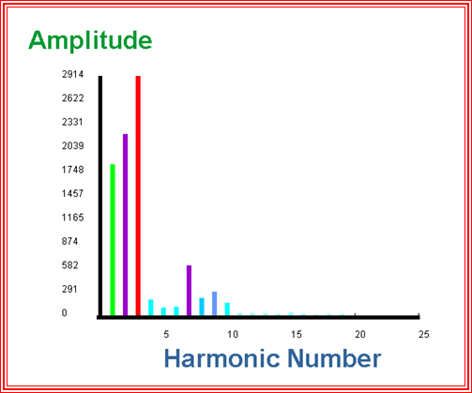
1 2 3 4 5 6 7 8 9 10
Fig. (1)
- All sounds in nature contain exactly ten harmonics.
- In Fig. (1), the third harmonic is the fundamental frequency of this sound.
- The higher the fundamental frequency, the higher the pitch of the sound.
- In Fig. (1), the sound’s pitch will become higher if harmonic 7 has the highest amplitude.
- All natural sounds are made of special combinations of harmonics.

Answer: __________ Answer: iii

- Below are sampled waveforms with different sampling rates. Read the figures and select all CORRECT statement(s): (4 marks)

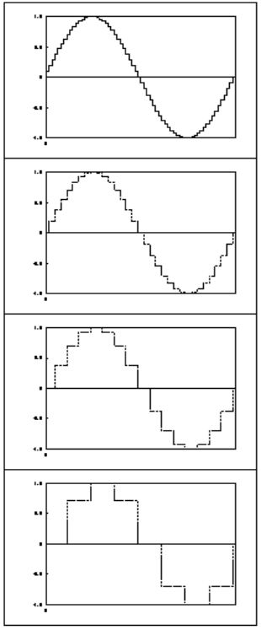

- The top sample has the highest quality.
- The third sample has twice the sample rate of the fourth sample.
- Frequencies above the Nyquist frequency "fold over" to sound like higher frequencies.
- We can digitally represent only frequencies more than half the sampling rate.
Answer: i, ii.

2. Spectrum Analysis and PVan [8 marks]

- Choose all CORRECT statements: (4 marks)
- Spectrum analysis can capture the noise of a sound for resynthesis.
- The spectrum of a sound is steady from start to end.
- Automatically finding the fundamental frequency is trivial.
- All the above are correct.
- All the above are incorrect.

Answer______________
Answer: v

- For the CSound header statement, choose all CORRECT statements: (4 marks)
sr = 22050
kr = 2205
ksmps = 10
nchnls = 1

- “sr” stands for sampling rate.
- The second header line sets the control rate for very quickly varying functions.
- The third header line sets the number of samples in one control period.
- “.sco” file stands for “orchestra”, where one or more instruments are specified.
- All the above are correct.
Answer___________
Answer: i,iii

3. Additive Synthesis [9 marks]

The “.orc” and “.sco” files below are two independent ways to additive synthesize the same sound. Fill in the blanks appropriately.
;waveform for oscillator - a sine wave
f1 ___ 16385 10 1
; start dur amp freq att decay
i1 1 2 5311 311 .02 .05
i1 1 2 223 622 .02 .05
i1 1 2 3886 933 .02 .05
i1 1 2 961 1244 .02 .05
i1 1 2 6972 1555 .02 .05
end
; 1st instrument sine wave
Answer:
0 (1)
17353 (1)
instr (1)
p5 (1)
1 (1)
0 (1)
asig1 + … + asig5 (1)
asig * aenv (1)
endin (1)

sr = ____________
kr = 2205
ksmps = 10
nchnls = 1

;--------------------------------------------------------------------
________ 1 ; sine wave

idur = p3
iamp = p4
ifreq = ______
iattack = p6
idecay = p7
isus = idur - iattack - idecay
iwave = ___________

aenv linseg 0,iattack,1,isus,1,idecay,________

itotal = 17353

asig1 oscili iamp * (5311 / itotal), ifreq, iwave ; signal
asig2 oscili iamp * (223 / itotal), ifreq * 2, iwave ; signal
asig3 oscili iamp * (3886 / itotal), ifreq * 3, iwave ; signal
asig4 oscili iamp * (961 / itotal), ifreq * 4, iwave ; signal
asig5 oscili iamp * (6972 / itotal), ifreq * 5, iwave ; signal

asig = (____________________________)

out ____________________ ; output
________________
4. Wavetable Synthesis [10 marks]

Read the wavetable synthesis equation. Answer the following questions.
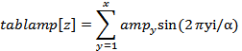

- Fill the below blanks. (6 marks)
x represents _____________________________________; (fill in text description)
y represents _____________________________________; (fill in text description)
represents _________________________________; (fill in text description)
Answer: Number of harmonics; harmonic number; amplitude envelope for harmonicy

- Suppose further that the wavetable is as follows.
f1 0 64 10 1 .5 .25
Fill in the below blanks. (4 marks)

x = ____________________; (fill in a number)
= ____________________; (fill in a number)

Answer: 3; 64

5. Amplitude, Meter and Pitch [4 marks]

Imagine there is a wind instrument A. You are now trying to use your computer music knowledge to figure out how it makes sound. Choose all CORRECT statements.
- The more air you blow into A, the higher pitch it will make.
- If you play several repeating notes (notes with the same pitch and duration) using A, the spectra of these notes are exactly the same.
- You can play vibrato by changing the speed of the input air frequently.
- All the above are incorrect.

Answer_________________
Answer: iv

6. Music Emotion [5 marks]

Choose all CORRECT statements.
- In Russel’s emotion model, valence means the positiveness of an emotion.
- There is only one emotion expressed by a song.
- Stronger amplitude usually expresses more intense emotion.
- Usually, the brighter a tone is, the more positive the tone sounds.
- Music emotion means what emotion listeners will feel after listening to the music.

Answer_________________
Answer: i,iii

7. FM Synthesis [24 marks]

- What will result if we add the following signal

aosc oscili 0.05 * ifreq, 18, 1

to the frequency of a simple sinewave? What will happen if we double the speed of the above additional signal? You may assume that ifreq is the fundamental frequency of the sinewave. (5 marks)

Answer:
A sinewave with vibrato is generated. (2) The sinewave with vibrato will become a full spectrum if the speed of the additional signal is doubled. (3)

- In FM synthesis, what is the relationship between the fundamental frequency and the modulation frequency if the Carrier-Modulator Ratio equals 1? (3 marks)

Answer:
The fundamental frequency is equal to the modulation frequency (3)

- Given the following CSound score file

; midterm.sco
f1 0 16385 10 1

; start dur amp freq
i1 0 1 4000 440

Finish the following CSound orchestra file to synthesize a FM tone with the following settings:

- Carrier-Modulator Ratio = 10/7
- Modulation index increases from 0 to 10 over time

(11 marks)

Answer:
; midterm.orc
instr 1

idur = p3
iamp = p4
ifreq = p5
icar = ifreq ; carrier frequency
imod = icar *0.7 (2) ; modulator frequency

index = 3 ; modulation index
iwave = 1

aindex linseg 0, idur, 10 (3)
amod oscili aindex * imod (2), imod, iwave
acar oscili iamp, icar + amod (2), iwave
out acar (2)
endin

- For formant FM, what is the equation for the amplitude of the 2nd harmonic for modulation index I and n_{c} = 4? (5 marks)

Answer:
(2 marks)
(1 mark)
(2 marks)

8. Effects & Filters [12 marks]

- Is FM synthesis a type of effect? Why or why not? (3 marks)
Answer: No. (1) It generates a sound rather than modifying a sound (2)

- What is the amplitude at the cut-off frequency after applying a high-pass filter to a signal with amplitude 4000? Show your calculation clearly. (3 marks)

Answer:
4000 * 0.707 = 2828

- How can you reduce 50Hz electric hum (assigning a bandwidth of 10) in a signal? Specify the center frequency as well. (2 marks)

Answer:
Use a band-stop / notch filter. 50 Hz

- Write a CSound statement to reduce electric hum for part c. You may assume that the signal is named asig and the wavetable number is 1. (4 marks)

afilter
Answer:
areson asig, 50, 10, 1

9. Comb Filters & All-pass Filters [4 marks]

- How does a comb filter affect a sinewave if they both have the same frequency? (2 marks)

Answer:
It slows the fade-in and fade-out (i.e. a sharper rolloff, but doesn’t change the fundamental) of the sine wave (P.4 of Comb filter)

- Suppose we have a signal named asig, write CSound statements to add an all-pass filter to asig. The ring time and loop time are 1.5 and 1 respectively (2 marks)

Answer: afiter alpass asig, 1.5, 1

10. Reverb [9 marks]

- Approximately how many times with perfectly reflective walls (i.e. no absorption) the sound bounce before being 1000 times softer in amplitude in a square room of length 11m? Assume the reverberation time is 0.9s, and the sound speed in air is 350m/s. (2 marks)

Answer:
350 * 0.9 / 11 ≈ 28 times

- In a Schroeder Reverberator, what is the effect of the 1st and 2nd all-pass filters? (4 marks)

Answer:
1st all-pass turns each comb echo into a string of echoes.(2) 2nd all-pass adds another layer of echoes.(2)

- How can you reduce the “metallic” artifact of the Schroeder Reverberator? Provide a CSound statement to achieve it as well. You may assume the name of Schroeder output variable is asig. (3 marks)

Answer:
Add a low-pass filter to damp high frequencies. (1)
afilter tone asig, 2000 (2)

11. Voices [6 marks]

- Write a CSound statement to convert 70 dB to amplitude and store it into iamp. (2 marks)

Answer:
iamp = ampdb(70)

- Given that the reference amplitude is 100, if a signal is +55dB from the reference amplitude, what is its amplitude? Show your steps clearly. (4 marks)

Answer:
55 = 20 log₁₀ (amp/100)
2.75 = log₁₀ (amp/100)
amp/100 = 10^{2.75}
amp ≈ 56234 (4)

