Software Requirements Specification

for

TrackIn

Version 1.0

Prepared by IODroid

AmalJyothi College of Engineering

27th October 2017

Table of Contents

**1.INTRODUCTION**

**1.1 Introduction**

**1.2 Scope**

**1.3 Glossary**

**1.4 Reference**

**2.REQUIREMENT**

**2.1 Development Requirement**

**2.2 Test Case Requirement**

**3. ARCHITECTURE**

**3.1 Track User Location**

**3.2 Convert Geo Coordinates to Geo Locations**

**3.3 Convert Geo Address to Geo Coordinates**

**4. WORK FLOW**

**4.1 Use Case Diagram**

**4.2 Activity Diagram**

# CHAPTER - 01

# 1.1 Introduction

A user authorized app to track location as soon as the user clicks on the track location button on the map , the system will zoom into the users current location and show the coordinates of the user . A 5 mile/KM radius distance is demarcated by a circular ring on the map . This system provides the user to conver a geo-location coordinartes to address and vice-versa. As the user clicks on a location anywhere on the map the geo-location of the map is displayed .

## 1.2 Scope

Mobile applications help the user to find the locations easily.The presented application helps the user to find the locations and find the address of geo-coordinates and vice versa using a mobile application.

## Glossary

* Android Studio
* Geo Coordinate
* SetOnClickListener

## References

# CHAPTER - 02

# REQUIREMENT

## 2.1 Development Requirment

* A development machine running Linux, macOS, or Windows.
* JDK 1.8
* Android Studio 2.0 or higher
* Android SDK 6.0 or higher
* Android SDK Build Tools 26.x or higher
* Android SDK Tools 25.x or higher
* Android SDK Platform Tools 25.x or higher
* Android Support Library (latest)
* Android Repository (latest)

## Test Case Requirement

* Android Mobile phone with Android 5.1 or higher
* Global Positioning System
* Internet

# CHAPTER – 03

# ARCHITECTURE

The system requests permission for Global Positioning System (GPS). As the user enables the permission for the app to access GPS the application automatically loads the current user location on the map . The user can locate the point anywhere on map and the geo-locations are displayed to the user. The main three functionalities of the application is

1. Track User Location
2. Convert Geo-coordinates to Geo-Address
3. convert Geo-Address to Geo-Locations

**3.1 Track User Location**

The application allows user to view the geo-coordinates of any location as the user scrolls the map and point on the map. The user can view the coordinates and address of the landmark.

**3.2 Convert Geo-Coordinates to Geo-Address**

The user is asked to enter a coordinate location as longitude and lattitude values .The coordinates are then converted to address as pin code locations via google maps and the locational address related to the coordinates are displayed to the user in the map.Every address may not be present on the maps ,and as a result the application displays the nearest address corresponding to the coordinates.

**3.3 Convert Geo-Address to Geo-Coordinates**

The user is asked to enter a Address location .The address is then converted to longitude and lattitude values via google maps and the locational coordinates related to the address are displayed to the user in the map.

# CHAPTER – 04

# WORK FLOW

**4.1 Use Case Diagram**

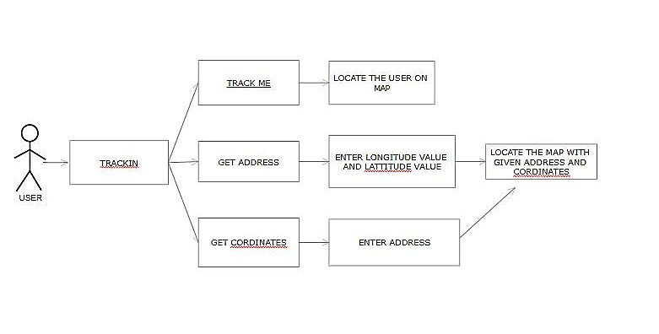

4.2**ACTIVITY DIAGRAM**