**Auditory distraction during reading: A Bayesian meta-analysis of a continuing controversy**

**Martin R. Vasilev**

Abstract

*Keywords*: auditory distraction, reading, background noise, speech, music

Imagine that you are sitting in an open-plan office and reading a paper, while a couple of your colleagues are having a loud conversation just a few meters away. Is this external noise going to affect the time it takes you to read the paper or your ability to understand its contents? For many people, the intuitive answer to this question is “Yes”, as it would seem reasonable that external sounds such as noise, speech or music influence how we read sentences by acting as a distractor. Indeed

Researchers have occupied themselves with this question for at least 80 years.

Citations for: speech is perceived as distracting by office workers (see Haapakangas et al., 2014)

Last few decades have seen the emergence of a broad literature field that has focused on more fundamental skills such as working memory and serial recall. There have been some consistent findings and also theories have been developed to account for these results.

However, more complex cognitive tasks such as reading have received mixed findings. Additionally, it is not known whether findings from simple tasks such as serial recall would generalise to reading. Reading is appealing because it is easier to generalise to everyday tasks- how working memory is used in daily life is more difficult to say.

What we try here is to examine the potential of these theories to explain if, and what types of sounds are distracting during reading. It is necessary to consider theories that make the same predictions and are hard to distinguish from one another based on present findings.

1. **Introductory paragraph**
2. **Overview of the literature**
3. **Theory**
4. **Predictions**

**Method**

**Literature Search**

The search of the literature was conducted by following the PRISMA guidelines (Moher, Liberati, Tetzlaff, Altman, & Prisma Group, 2009). A flowchart of the process is presented in Figure 1[1]. In August 2016, Google Scholar, Scopus, the Web of Science, and ProQuest Dissertations were searched with the following keywords: “background noise AND reading”, “background speech AND reading”, “background music AND reading”. The search for each of the three background sounds was done separately. Additionally, the reference list of screened articles and previous literature reviews and meta-analyses (Beaman, 2005; Clark & Sörqvist, 2012; Dalton, & Behm, 2007; Kämpfe, Sedlmeier, & Renkewitz, 2010; Klatte, Bergström, & Lachmann, 2013; Shield & Dockrell, 2003; Szalma & Hancock, 2011) were also examined. The identified articles were evaluated against the inclusion criteria presented in Appendix A. In short, the studies had to experimentally manipulate background noise, speech or music in a reading or proofreading task, have a sound methodological design, and include silence as a baseline reading condition. Information about the included studies and their effect sizes are presented in Appendix B.

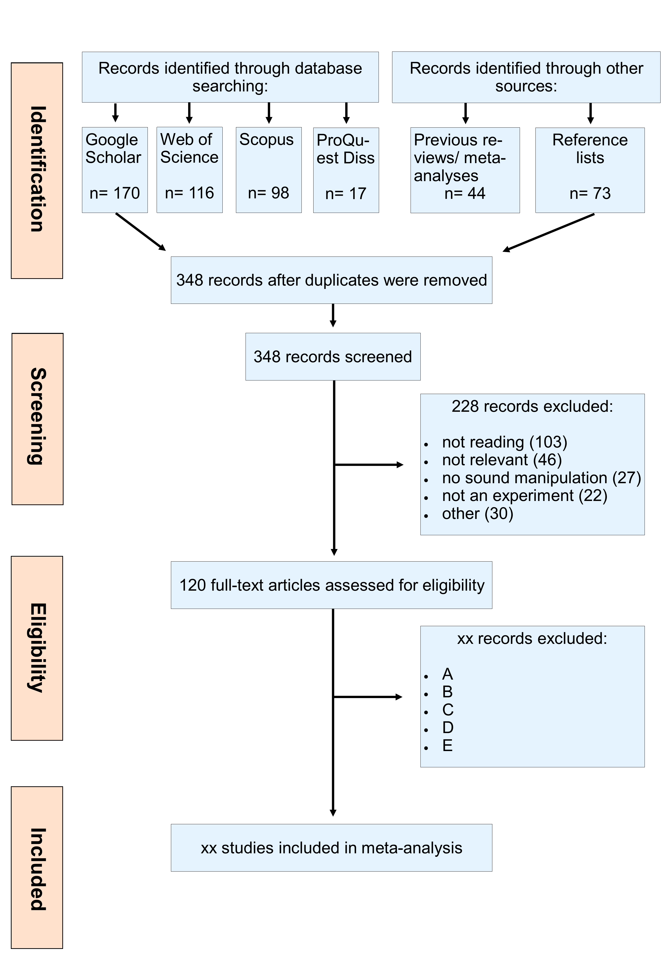

*Figure 1*. A flowchart illustrating the stages of the literature search process.

**Effect Size Calculation**

Standardized effect sizes of the mean difference were calculated from the reported descriptive statistics by first calculating Cohen’s *d* and then applying Hedges’ *g* (Hedges & Olkin, 1985) correction for small sample bias. This was done using formulas 12.11-12.22 from Borenstein (2009). If descriptive statistics were unavailable or incomplete, the effect sizes were calculated by digitalizing graphs (Rohatgi, 2015) or converted/approximated from the reported test statistics by using existing formulas (Borenstein, 2009; Lajeunesse, 2013). In the analysis of reading comprehension accuracy and proofreading accuracy, studies were coded so that negative effect sizes indicate lower comprehension accuracy in the experimental sound conditions. Similarly, in the analysis of reading speed, negative effect sizes also indicate slower reading speed in the experimental sound conditions.

Due to the fact that xx% of the studies used a within-subject design, it was necessary to estimate the population correlation (ρ) between the control and experimental conditions. (Borenstein, 2009; Szalma & Hancock, 2011). Eight statistically-independent estimates were obtained from experiments for which the raw data were available, as well as from one study (Miller, 1947) that reported the require statistics. These represented a wide range of experimental sound types and included both reading comprehension and reading speed measures. We followed Szalma and Hancock’s (2011) approach to meta-analyze the obtained correlations in order to obtain a weighted estimate of ρ. The weighted value of 0.74 was used for calculating the effect sizes for within-subject design studies.

**Publication Bias**

Xx% of the studies included in the present meta-analysis were in the grey literature (i.e. they were not formally published).

A test of funnel plot asymmetry based on a weighted linear regression of the effect estimates on their standard errors (Sterne et al., 2011) indicated no statistically significant evidence for asymmetry for both reading comprehension () and reading speed ().

**Data Analysis**

Comparisons (descriptive/ general purpose):

General (all sound)- acc & speed

General (music)- acc

General (speech)- acc

General (noise)- acc

Theoretical:

* Lyrical vs non-lyrical music (semantic/phonological): argue that phonological contribution is possible; however, several studies so far have failed to provide evidence for a central role of phonology in a reading task
* Lyrical music vs speech (phonological): because on average music contains less phonological information compared to speech (however, both contain semantics/ meaning).
* Changing state hypothesis: acoustic noise (e.g. hissing vs instrumental music). Music will be more variable than random/ white noise
* Attentional capture: think about which sounds would be more attentionally capturing; try to find some references
* Disruption by process: noise and (non-lyrical music) vs speech and lyrical music

Notes:

Not enough studies for foreign vs native

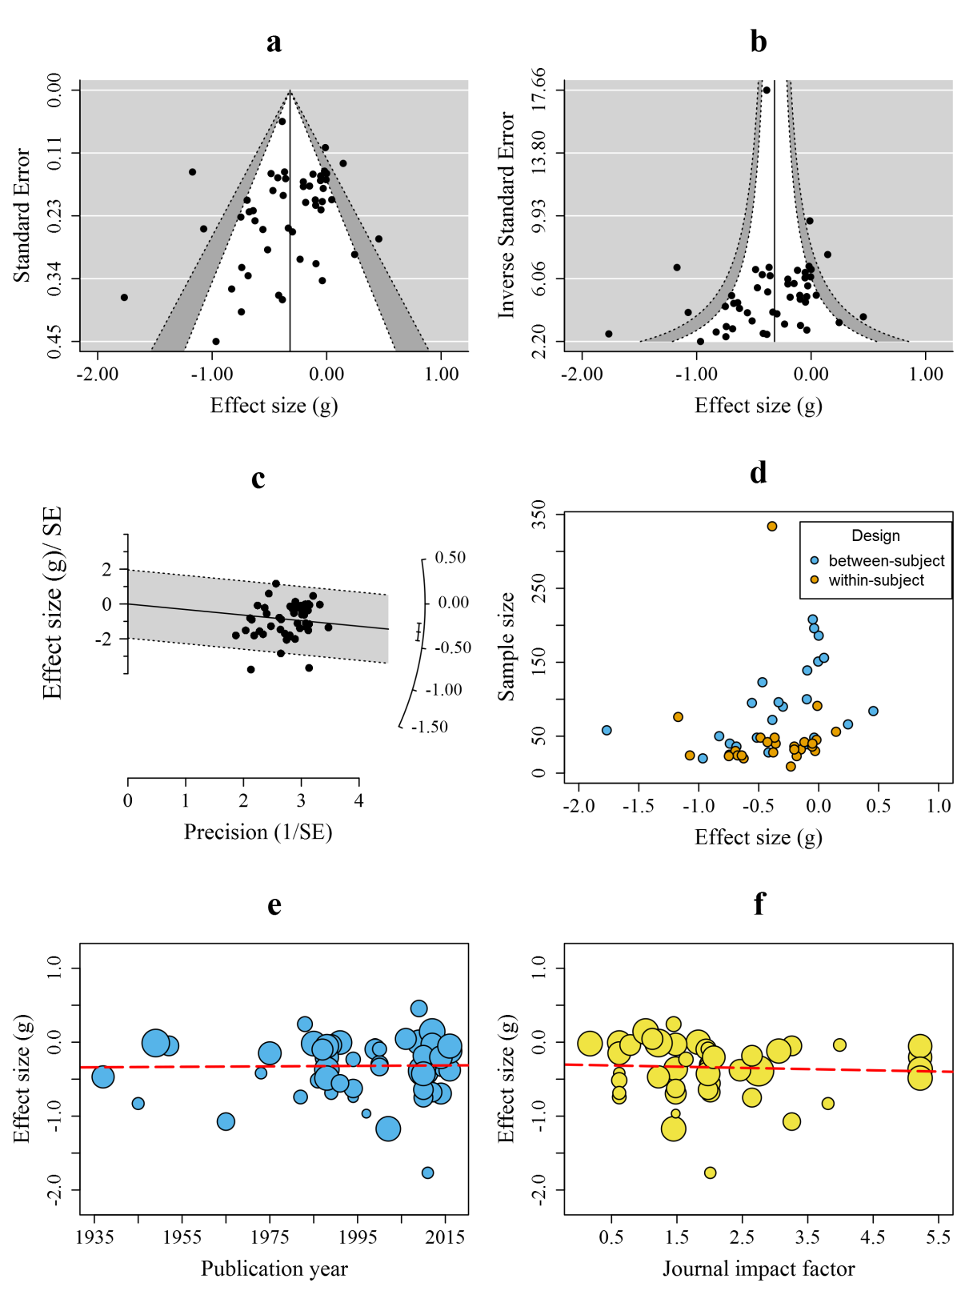

Figure x.

**Data Analysis**

**Results**

**Discussion**

**Acknowledgments**

M.R.V was supported by a PhD studentship from Bournemouth University. The funding body had no role in the design, analysis, the writing of this paper, or decisions to publish. The authors declare no conflicts of interest with respect to this paper.

**Appendix A**

**Appendix B**

Table B1

*A Summary of the Studies and Their Effect Sizes That Were Included in the Meta-analysis*

|  |  |  |  |  |  |  |  |  |  |  |  |
| --- | --- | --- | --- | --- | --- | --- | --- | --- | --- | --- | --- |
| ID | Reference | NC | NE | Sample | Design | Task | Sound | Type | dB(A) | g | var |
| 1 | Somebody et al. (2006) | 67 | | children | within | RC | noise | white | 60 | 1.23 | 0.23 |
| 2 | Somebody else (2007) | 30 | 30 | adults | between | PR | speech | native | 55 | -.03 | 0.10 |

*Note*: NC: number of participants in the control (silence) condition. NE: number of participants in the experimental (sound) condition. RC: Reading comprehension. PR: Proofreading. ES: Effect size in Hedges’ g.

**References**

Rohatgi, A. (2015). digitizeR: Tool to extract numerical data from images of plots, maps, etc.. *R package version 1.0*. Retrieved from http://github.com/ankitrohatgi/digitizeR

Beaman, C. P. (2005). Auditory distraction from low-intensity noise: A review of the consequences for learning and workplace environments. *Applied Cognitive Psychology*, *19*(8), 1041-1064. doi:10.1002/acp.1134

Borenstein, M. (2009). Effect sizes for continuous data. In H. M. Cooper, L. V. Hedges, & J. C. Valentine (Eds.), *The handbook of research synthesis and meta-analysis* (2nd ed., pp. 221-235). New York, USA: Russel Sage Foundation.

Clark, C., & Sörqvist, P. (2012). A 3 year update on the influence of noise on performance and behavior. *Noise and Health*, *14*(61), 292-296. doi:10.4103/1463-1741.104896.

Dalton, B. H., & Behm, D. G. (2007). Effects of noise and music on human and task performance: A systematic review. *Occupational Ergonomics*, *7*(3), 143-152.

Hedges, L. V., & Olkin, I. (1985). *Statistical methods for meta-analysis*. Orlando, FL: Academic Press

Kämpfe, J., Sedlmeier, P., & Renkewitz, F. (2010). The impact of background music on adult listeners: A meta-analysis. *Psychology of Music*, *39*(4), 424-448. doi:10.1177/0305735610376261

Klatte, M., Bergström, K., & Lachmann, T. (2013). Does noise affect learning? A short review on noise effects on cognitive performance in children. *Frontiers in Psychology*, 4, 578. doi:10.3389/fpsyg.2013.00578

Lajeunesse, M. J. (2013). Recovering missing or partial data from studies: A survey of conversions and imputations for meta-analysis. In J. Koricheva, J. Gurevitch, & K. Mengersen (Eds.), *The handbook of meta-analysis in ecology and evolution* (pp. 195–206). Princeton: Princeton University Press.

Miller, L. R. (1947). Some effetcs of radio-listening on the efficiency of reading type study acitivities. *The Journal of Educational Psychology*, *38*(2), 105-118. doi:10.1037/h0062228

Moher, D., Liberati, A., Tetzlaff, J., Altman, D. G., & Prisma Group. (2009). Preferred reporting items for systematic reviews and meta-analyses: The PRISMA statement. *PLoS Medicine*, *6*(7), e1000097. doi:10.1371/journal.pmed.1000097

Shield, B. M., & Dockrell, J. E. (2003). The effects of noise on children at school: A review. *Building Acoustics*, *10*(2), 97-116. doi:10.1260/135101003768965960

Sterne, J. A., Sutton, A. J., Ioannidis, J. P., Terrin, N., Jones, D. R., Lau, J., ... & Tetzlaff, J. (2011). Recommendations for examining and interpreting funnel plot asymmetry in meta-analyses of randomised controlled trials. *BMJ*, *343*, d4002. doi:10.1136/bmj.d4002

Szalma, J. L., & Hancock, P. A. (2011). Noise effects on human performance: A meta-analytic synthesis. *Psychological Bulletin*, *137*(4), 682-707. doi:10.1037/a0023987

1. One eligible (unpublished) study by the first author was also included.