中台技术架构

1. 架构具体地址：

|  |  |  |  |
| --- | --- | --- | --- |
| 序号 | 名称 | IP | 备注 |
| 1 | Jenkins | 192.168.104.128 |  |
|  |  |  |  |
|  |  |  |  |

二、Jdk 安装

首先在jdk下载页面下载jdk,记住centos7只支持64位的jdk，所以下载的时候需要小心，保证下载的jdk位数正确

[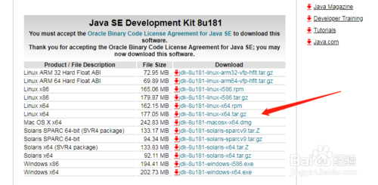](http://jingyan.baidu.com/album/9f7e7ec0f8c26b6f28155433.html?picindex=2)

使用linux管理客户端ssh secure shell,上传刚才下载完成的jdk8按转包，如下图所示

[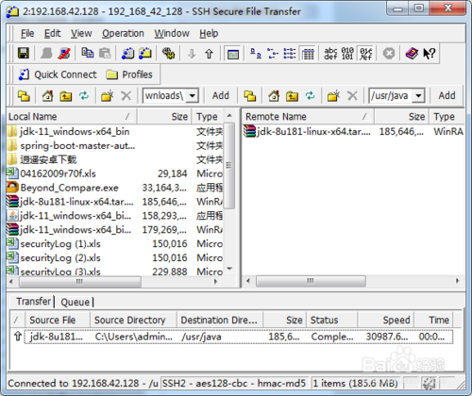](http://jingyan.baidu.com/album/9f7e7ec0f8c26b6f28155433.html?picindex=3)

进入到上传的目录下，使用 ll命令，查看文件列表

[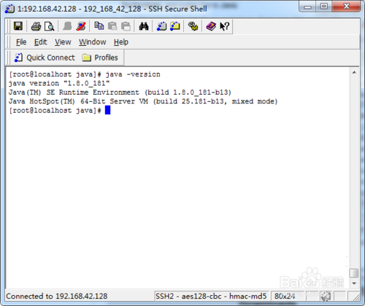](http://jingyan.baidu.com/album/9f7e7ec0f8c26b6f28155433.html?picindex=4)

使用命令

tar -zxvf jdk-8u181-linux-x64.tar.gz

解压压缩包到当前目录下

[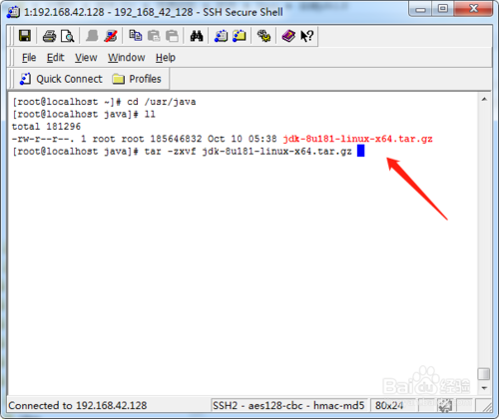](http://jingyan.baidu.com/album/9f7e7ec0f8c26b6f28155433.html?picindex=5)

解压成功之后，使用 ll 命令，查看文件列表，压缩包解压成了 jdk1.8.0_181文件夹

[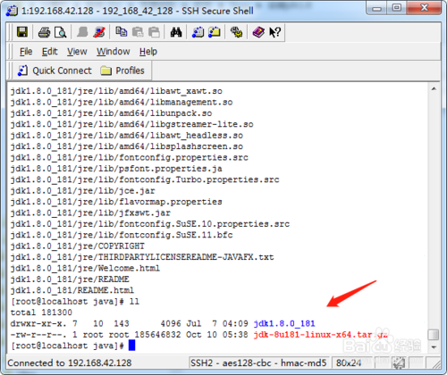](http://jingyan.baidu.com/album/9f7e7ec0f8c26b6f28155433.html?picindex=6)

配置环境变量，修改/etc/profile文件

[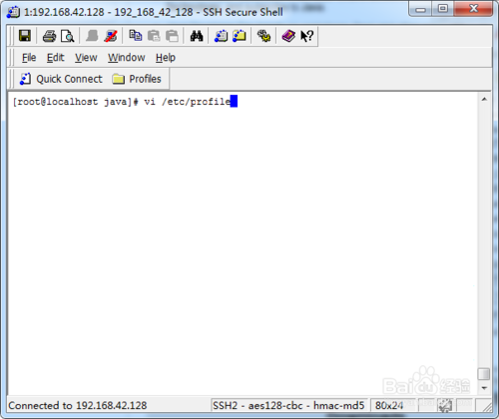](http://jingyan.baidu.com/album/9f7e7ec0f8c26b6f28155433.html?picindex=7)

添加如下环境变量，代码如下

JAVA_HOME=/usr/java/jdk1.8.0_181

CLASSPATH=$JAVA_HOME/lib/

PATH=$PATH:$JAVA_HOME/bin

export PATH JAVA_HOME CLASSPATH

[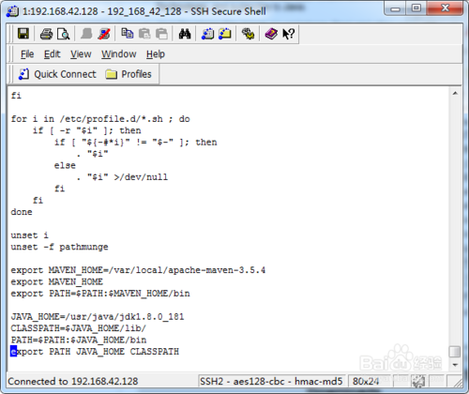](http://jingyan.baidu.com/album/9f7e7ec0f8c26b6f28155433.html?picindex=8)

重新加载/etc/profile配置文件，命令为

source /etc/profile

[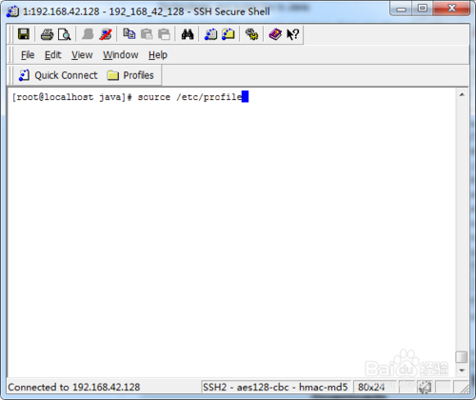](http://jingyan.baidu.com/album/9f7e7ec0f8c26b6f28155433.html?picindex=9)

查看jdk是否安装配置成功，命令如下

java -version

打印java版本信息

[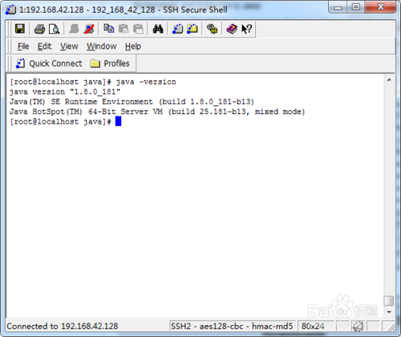](http://jingyan.baidu.com/album/9f7e7ec0f8c26b6f28155433.html?picindex=10)

1. 安装jenkins
2. 、 下载https://mirrors.tuna.tsinghua.edu.cn/jenkins/redhat-stable/ [jenkins-2.176.1-1.1.noarch.rpm](https://mirrors.tuna.tsinghua.edu.cn/jenkins/redhat-stable/jenkins-2.176.1-1.1.noarch.rpm" \o "jenkins-2.176.1-1.1.noarch.rpm)
3. rpm -ivh jenkins-2.32.3-1.1.noarch.rpm 进行安装
4. service jenkins status
5. Service jenkins start
6. 过程中如果出现以下错误
7. Starting jenkins (via systemctl): Job for jenkins.service failed. See 'systemctl status jenkins.service' and 'journalctl -xn' for details. [FAILED]
8. 检查自己的JDK是否安装，如果已经安装，检查 /etc/init.d/Jenkins 文件（可通过vi编辑器修改）中JDK路径是否与本地路径一致，不一致则将Java的正确路径加入。
9. 具体查看： <https://blog.csdn.net/sms15732621690/article/details/71336224>

报错：

java.lang.UnsatisfiedLinkError: /usr/app/java/jdk1.8.0_191/jre/lib/i386/libfontmanager.so: libgcc_s.so.1: 无法打开共享对象文件: 没有那个文件或目录

解决： sudo yum install libgcc.i686 --setopt=protected_multilib=false

访问路径：<http://192.168.104.129:8080/jenkins>

Admin 123456

**gitlab安装包**

**安装依赖软件**

yum -y install policycoreutils openssh-server openssh-clients postfix

wget https://mirrors.tuna.tsinghua.edu.cn/gitlab-ce/yum/el7/gitlab-ce-10.0.0-ce.0.el7.x86_64.rpm

rpm -i gitlab-ce-10.0.0-ce.0.el7.x86_64.rpm

wget https://mirrors.tuna.tsinghua.edu.cn/gitlab-ce/yum/el7/gitlab-ce-10.7.3-ce.0.el7.x86_64.rpm

[root@iZm5ejbpux25ac17foc9e7Z ~]$rpm -i soft/gitlab-ce-10.7.3-ce.0.el7.x86_64.rpm

报错：

warning: soft/gitlab-ce-10.7.3-ce.0.el7.x86_64.rpm: Header V4 RSA/SHA1 Signature, key ID f27eab47: NOKEY

error: Failed dependencies:

        policycoreutils-python is needed by gitlab-ce-10.7.3-ce.0.el7.x86_64

****解决：yum install policycoreutils-python****

****#打开配置文件 gitlab.rb****

****[root@VM_177_101_centos gitlab]# vim /etc/gitlab/gitlab.rb****

****#修改外网访问地址 13行****

****#ip为主机的ip地址，端口默认是8080，这里为了避免出现占用，也进行修改一下，我的配置为9999****

****external_url = 'http://192.168.1.81:9999'****

1. gitlab-ctl reconfigure gitlab-ctl restart

****访问：**<http://192.168.104.129:9001>**

****Maven 安装****

wget <https://mirrors.tuna.tsinghua.edu.cn/apache/maven/maven-3/3.5.4/binaries/apache-maven-3.5.4-bin.tar.gz>

Tar -xzvf apache-maven-3.5.4-bin.tar.gz

当然，解压完下载下来的maven包是现在还不能启用，需要在PATH里面设置一下路径，如下：

当然，你也可以在/etc/profile文件后面加入下面三行，和上面的一样效果:

[root@localhost ~]# vim /etc/profile

MAVEN_HOME=//usr/local/maven

export MAVEN_HOME

export PATH=${PATH}:${MAVEN_HOME}/bin

设置好Maven的路径之后，需要运行下面的命令

[root@localhost ~]# source /etc/profile

<https://blog.csdn.net/u010947098/article/details/61922969>

Publish over ssh

[root@localhost ~]# cat .ssh/id_rsa

cat: .ssh/id_rsa: 没有那个文件或目录

[root@localhost ~]# sudo su - jenkins

[root@localhost ~]# mkdir .ssh

[root@localhost ~]#

[root@localhost ~]# ssh-keygen -t rsa

Generating public/private rsa key pair.

Enter file in which to save the key (/root/.ssh/id_rsa):

Enter passphrase (empty for no passphrase):

Enter same passphrase again:

Your identification has been saved in /root/.ssh/id_rsa.

Your public key has been saved in /root/.ssh/id_rsa.pub.

The key fingerprint is:

SHA256:Em0GSBekWYlyKyE+VECBeqNTe30+gI/z/MArx7amAzk root@localhost.localdomai n

The key's randomart image is:

+---[RSA 2048]----+

|o++o.+*o |

|o.o +=.o |

|+. +o.. + |

|.o= . + |

| +.= o. S |

|o E o.o.. |

| . + +o+ |

| =.*oo |

| .X=o.. |

+----[SHA256]-----+

[root@localhost ~]# vi /root/.ssh/id_rsa.pub

[root@localhost ~]# vi /root/.ssh/id_rsa

[root@localhost ~]# ls /root/.ssh

id_rsa id_rsa.pub

[root@localhost ~]# ls

anaconda-ks.cfg jdk-8u191-linux-i586.tar.gz

[root@localhost ~]# cd /root/.ssh

[root@localhost .ssh]# ls

id_rsa id_rsa.pub

[root@localhost .ssh]# cd id_rsa

-bash: cd: id_rsa: 不是目录

[root@localhost .ssh]# /.ssh/authorized_keys

-bash: /.ssh/authorized_keys: 没有那个文件或目录

[root@localhost .ssh]# sudo jenkins

sudo: jenkins：找不到命令

[root@localhost .ssh]# sudo su jenkins

[root@localhost .ssh]# ls

id_rsa id_rsa.pub

[root@localhost .ssh]# sudo useradd jenkins

useradd：用户“jenkins”已存在

[root@localhost .ssh]# su jenkins

[root@localhost .ssh]# sudo su jenkins

[root@localhost .ssh]# ls

id_rsa id_rsa.pub

[root@localhost .ssh]# ls -l /home/jenkins/.ssh/

ls: 无法访问/home/jenkins/.ssh/: 没有那个文件或目录

[root@localhost .ssh]# pwd

/root/.ssh

[root@localhost .ssh]# cat id_rsa.pub >> authorized_keys

[root@localhost .ssh]# chmod 600 authorized_keys

[root@localhost .ssh]# ls

authorized_keys id_rsa id_rsa.pub