# Analysis FY16 - FY20 federal contract data for Ground Vehicles

The analysis uses awarded amount in the 6 years between the start of fiscal year 2016 and the end of fiscal year 2021 for these major GCS programs: Abrams tank (e.g., M1A1), Bradley fighting vehicle (e.g., M2A1), and Stryker armored personnel carrier (e.g., M1130)

## Awarded amount overall trends for period FY2016-2021

During the FY 2016 and FY 2017, total awarded amount was flat at about $ 3.5 billion. The FY 2018 and 2019 showed a significant increased, reaching nearly $ 6 billion in awarded amounts in the FY 2018 and reaching its peak in FY 2019 at almost almost $ 8 billion. The FY 2020 and FY 2021 reverted the inflated levels of the prior year, with a significant drop in awarded amounts for both years, bringing the total amount for FY 2021 close to the FY 2016 and FY 2017 levels.

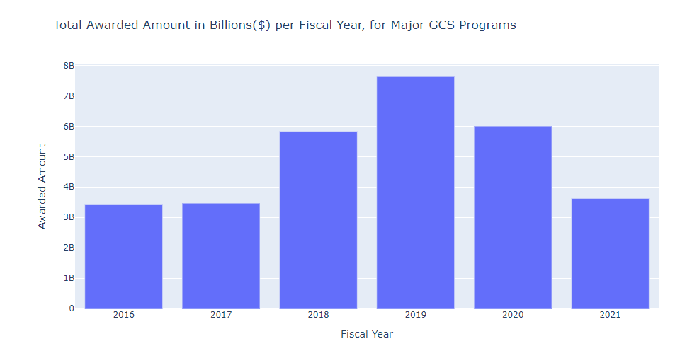

A similar trend can be observed when only looking at vehicular related PSC's. Between FY 2016 and FY 2021, awarded amounts reached a peak amount in 2019, followed by two consecutive years of decline back to FY 2017 levels.

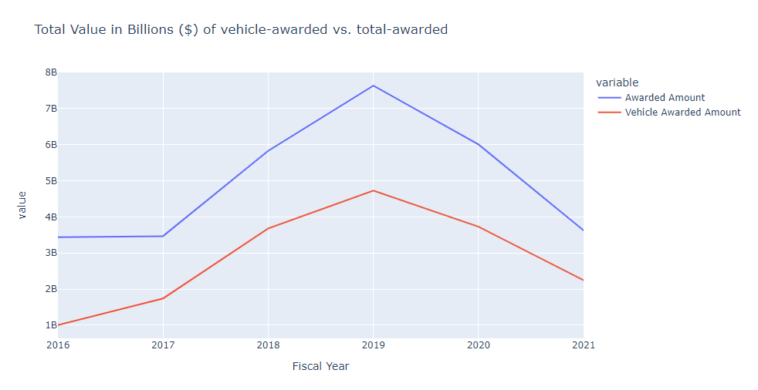

## Major Vendors

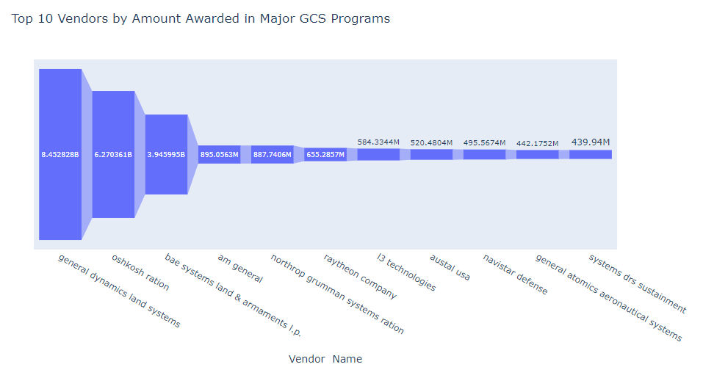

There are 863 vendors that have been awarded in the GCS programs in FY 2016 - FY2021.The top 3 vendors significantly outpace the rest of the vendors in terms of awarded amounts, with 3rd place with BAE systems, Land and Armaments being awarded 4 times more than the 4th place AM General. The complete list of top three vendors includes: General Dynamics Land Systems, Oskosh Ration, and BAE systems, Land and Armaments.

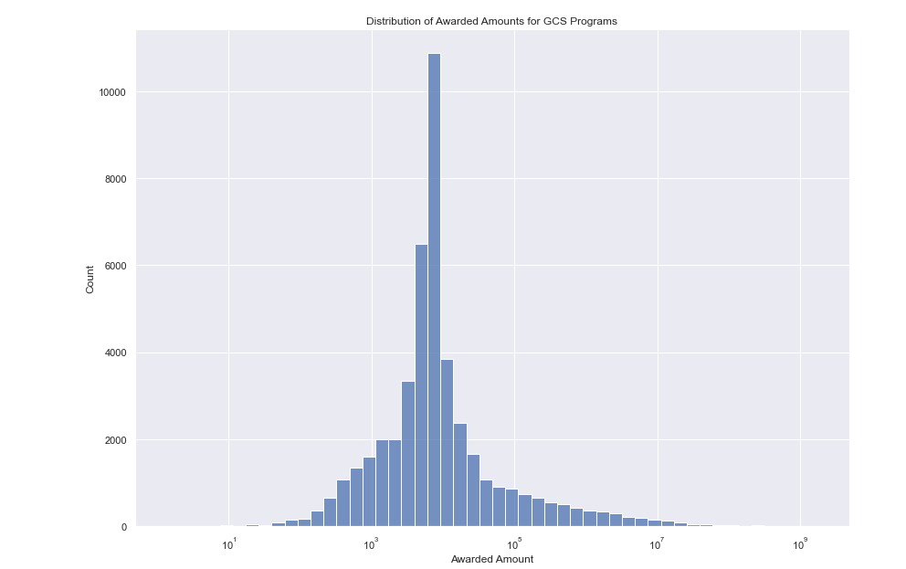

The vast majority of awarded amounts are within $ 1000 - $ 100,000, although the distribution of awarded amounts is heavily skewed to the right, meaning there are large awarded amounts that significantly outweigh the award amounts concentrated in the aforementioned $ 1,000 - $100,000 range.

## Conclusions

Awarded amounts have significantly decreased since 2019, so it will be interesting to findout whether awarded amounts for the major GCS programs will continue to decrease in FY 2022, or if it will level off at the FY 2016 and FY 2017 levels.

There are both large players and large contracts that heavily influence the overall quantity awarded. It would a good strategy to focus efforts on the top three vendors, and contracts awarded over 10 million, as they hold a disproportionate amount of influence in the overall operation of these ground vehicles.