Local Reading · Figure Preservation
A document is more than its text. Figures should stay beside their captions. Click the figure to inspect it.
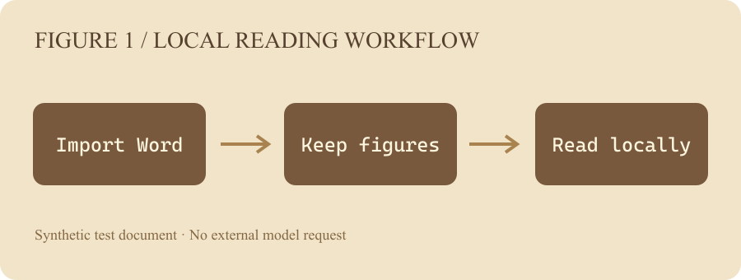
Fig. 1. Local document import retains embedded images. This diagram is a synthetic test fixture.

Evidence and notes
Each claim should point to its direct supporting passage. Different source paragraphs remain individually accessible.

