|  |
| --- |
| **_____ _ _  / ___| | | |  \ `--.| |_ _ __ __ _| |_ ___ __ _ ___   `--. \ __| '__/ _` | __/ _ \/ _` |/ _ \ /\__/ / |_| | | (_| | || __/ (_| | __/ \____/ \__|_| \__,_|\__\___|\__, |\___|  __/ |   |___/** |

**How to Play *Stratege***

*Stratege* is a rather simple game with a simple objective: destroy your opponent’s base before they destroy yours! To do this there are a couple mechanics you should master to ensure victory over your opponent. You will need to know how to create units, move units, attack enemies, and capture oil rigs! But first we will go over game set up!

**Map Settings**

When the game is started up, you will have the option to edit how much of each different terrain you want on the map. Foliage affects affects the balance of plains and hills against forests and swamps, wetness affects the balance of swamps against forests, and hilliness affects the balance of hills and plains. 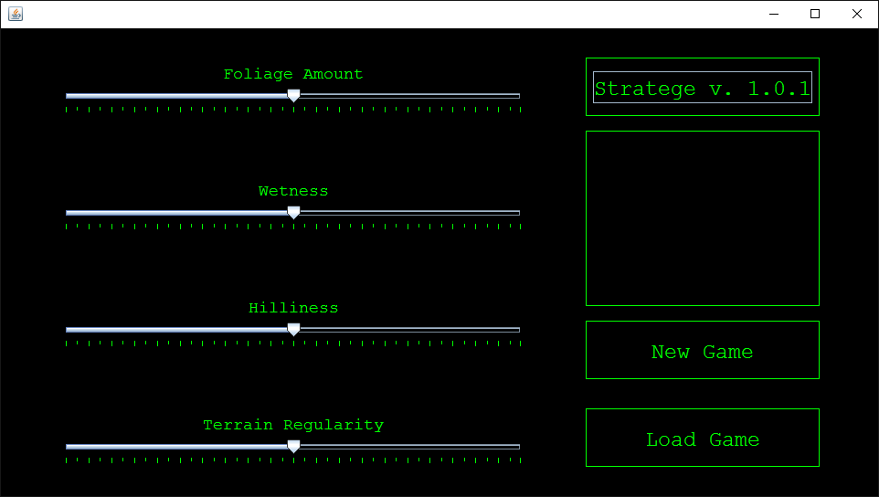

Once you are happy with these settings, click the ‘New Game’ button to start the game!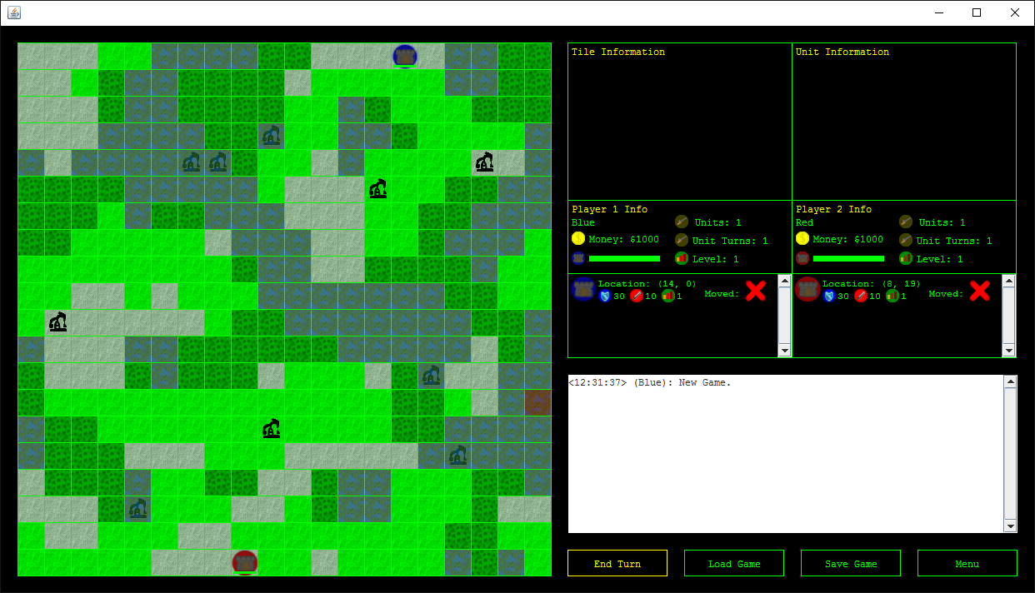

**Unit Creation and Oil Rigs**

At the start of each game each player will have nothing but a city and some money to start off the game. Cities cannot move, but they can create other units! Units will differ from each other in cost depending on how valuable they are. For instance, a simple infantry unit will cost less money than a tank will. Finally not all unit will be unlocked right away. Money can be used to upgrade a player’s city, which in turn unlocks more units.

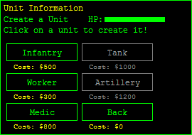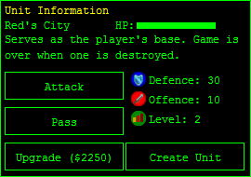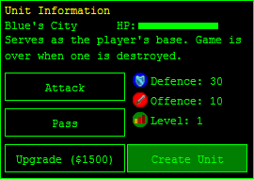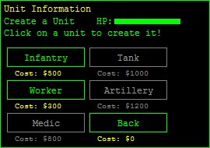

**Moving Units**

Moving units in *Stratege* is as easy as clicking and dragging. First hover your cursor over the unit you would like to move. Then click and hold, while you move your cursor to any adjacent tile that you’d like to move your unit to. Release your mouse click and your unit will move to that tile. There are a couple rules on moving however. You cannot move a unit on top of another unit, you can only move a unit to a tile that is right next to the tile you are currently on, and you can only move once per turn.

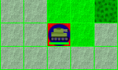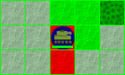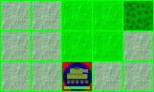

**Attacking Enemies**

Attacking enemies is done slightly differently when compared to moving units. First, select a friendly unit with an enemy unit within range of them (for most units, this means adjacent units, but for artillery units this can be within 2 tiles).Click the enemy you want to attack in order to attack them! The game will calculate how much damage was done by factoring in your attack, and the enemy's defence. In addition, being on different terrains can affect how much attack or defence you will have. This information can be found by clicking on a tile and reading the information in the sidebar. If a unit's health drops to zero, that unit is now dead, and it disappears from the map.

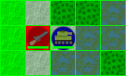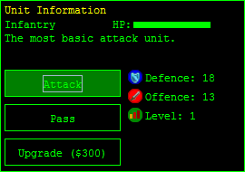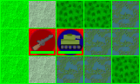

**Economy System**

At the end of each turn every player will obtain a certain amount of money. To increase the amount of money earned per turn, a worker unit can be created to capture oil rigs. Each oil rig you capture will increase the amount of money you get per turn by $300. To take an oil rig from another player, the player occupying the oil rig must move his worker off the oil rig, or you must kill the worker to remove him from that space.

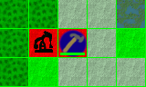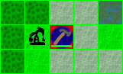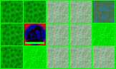

**Ending Your Turn**

Once you have finished all your actions for your turn (or simply cannot do any more), click the yellow ‘End Turn’ button and let the other player take their seat to make their own moves. Be sure that they don’t decide to play for you!

**Saving/Loading Your Game**

If your game of *Stratege* ever needs to be cut short, do not despair! Simply click the ‘Save Game’ button, and the game will save itself to a file. Click the ‘Load Game’ button from either the game screen or the main menu to load it up later. Note that there is only one save file for the game, so don’t expect to save several different games and pick all of them back up later!

Congratulations! You now know how to play *Stratege*!