The Deltaode ASCOM driver cannot be used by more than one client application. For example it is not possible to access it from a planetarium program and an auoguider software at the same time.

This it not ununual for ASCOM drivers. Some drivers can handle more than one client, most drivers not. For these drivers the Generic Hub application has been developed. It works as a connector between the actual telescope driver and the client applications. The clients use the Hub as their ASCOM driver, the Hub uses the actual telescope driver.

Clients, Hub and the telescope driver work in series:

Clients >> Generic Hub >> Telescope driver

To make this work the clients have to be configured to use the Hub as a ASCOM driver, AND the Hub must be configured to use the actual telescope driver as its ASCOM driver.

The following screenshots show the configuration steps needed.

In our ASCOM handbox application click the choose button to select the ASCOM driver:

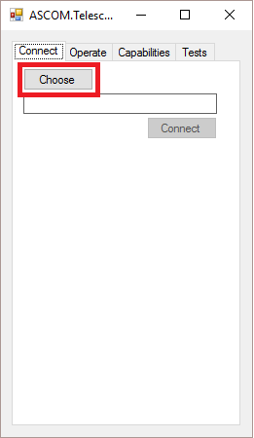

In the ASCOM chooser window you can select the telescope driver type.

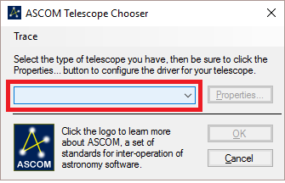

Instead of the actual telecope driver select the Generic Hub, which later will be connected to the Deltacode driver.

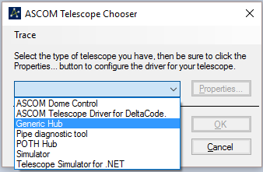

To connect the Generic Hub to the Deltacode driver click on ‘Properties’.

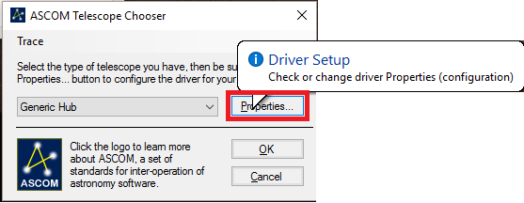

In Hub Setup Window you can select the actual (Deltacode) telecope driver.

Click on ‘Choose Scope’ to open the driver selection window a second time.

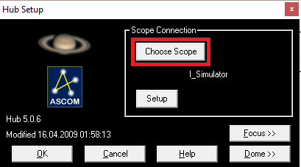

Now you can select the Deltacode driver to be used by the Generic Hub.

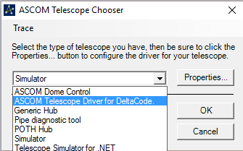

After selecting the Deltacode driver,

the properties windows should be opened to choose the communication port.

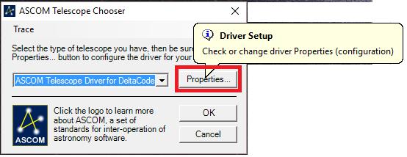

Now select the seriel port for the Deltacode driver (in my test it was COM4).

The COM port baudrate (9600,8,n,1) can be set in the windows device manager.

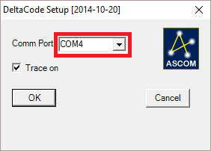

After selecting and configuring the Deltacode driver the ASCOM chooser window can be closed.

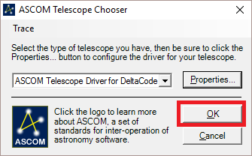

Back to the Generic Hub configuration window, this window can be closed too.

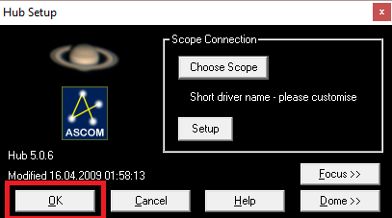

Now the first ASCOM telescope chooser window can be closed.

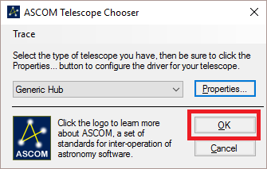

Now the connection can be started.

The client window connects to the Generic Hub, the Generic Hub will connect to the Deltacode driver.

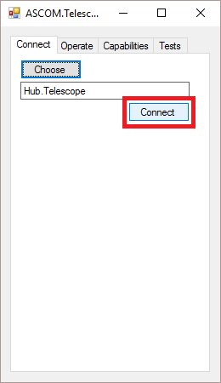

After establishing the connection, the direction buttons can be used.

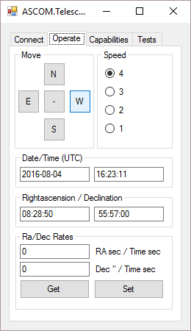

As a second client I connected Cartes Du Ciel tot he Gneric Hub.

Select ASCOM as the telescope connection type:

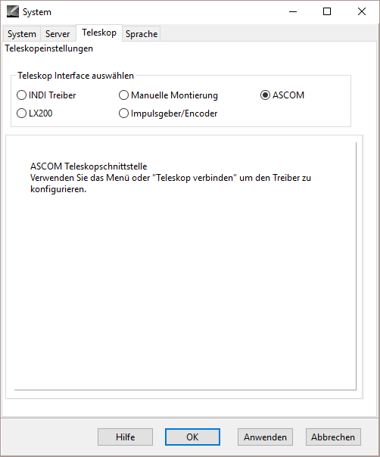

Open the telescope operator windows in CdC:

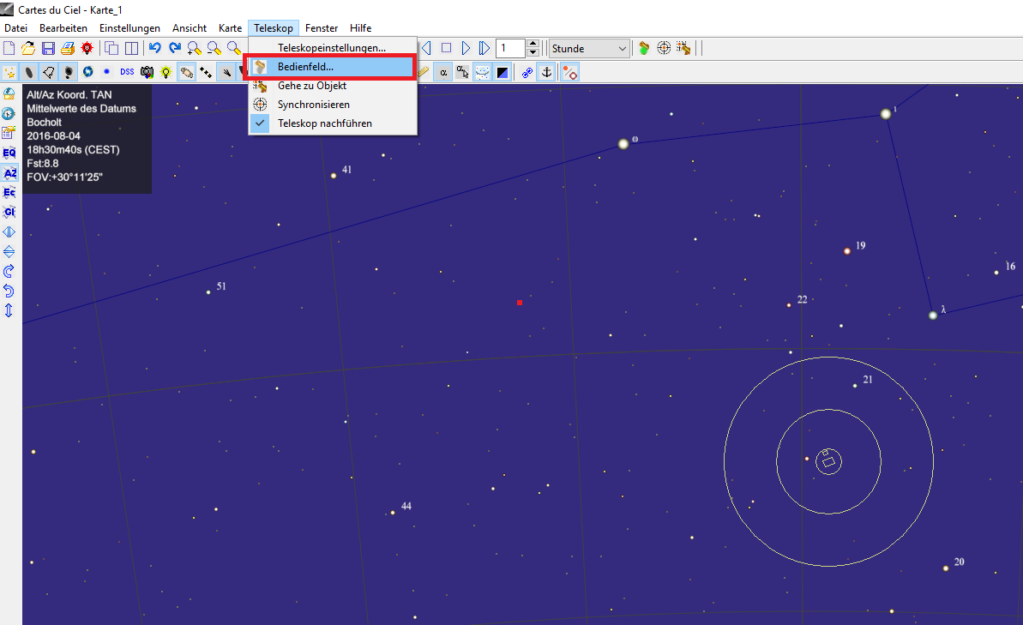

Under ‚Treiberauswahl‘ (‘driver selection’) open the ASCOM Telescope Chooser window, there select the Generic Hub, NOT the Deltacode driver.

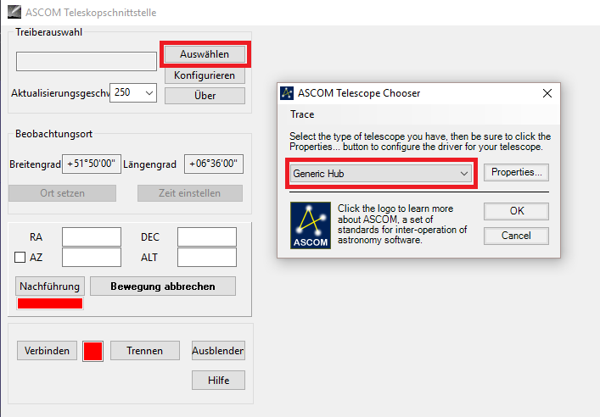

Here the Generic Hub doesn’t have to be configured again because it is already running from the steps before.

After closing the chooser window the connection can be opened:

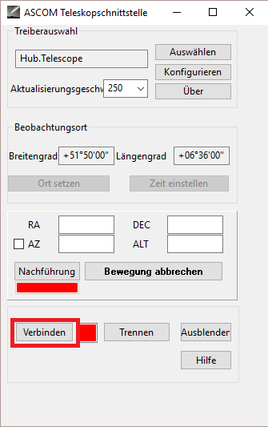

Now both client applications (CdC and our handbox window) are connected tot he Generic Hub,

Which in turn is connected to the Deltacode driver.

