

Challenge Instructions

# Description

Our take home challenge evaluates your skills and experience in an environment not dissimilar to the one you'll encounter while working with us. Give it your best shot!

# Assignment

You have received a link to the repo hosting our challenge. The Readme lists everything you need to do, and some bonus features for you to try if you want to show us your expertise.

To work on and submit your challenge, you must:

* Create a user in [https://git.jobsity.com](https://git.jobsity.com/).
* Fork the repository using the button at the top

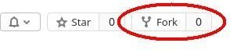

* Within your fork, go to Settings/General/"Visibility, project features, permissions" and set the Project visibility to Private.

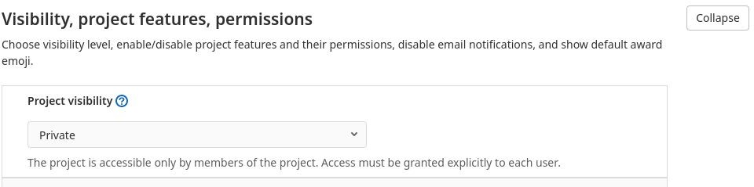

* Create a new branch for you to upload your work.
* Now you can clone your project and work on it.

When you are done:

* Create a Merge Request to your own main branch. You may Merge it if you want.
* Send us the link to your Merge Request.
* Done!

Our evaluators will automatically receive access to your repository and see your Merge Request.

# Considerations

* Make sure to add any information about how to deploy the project on the Readme, and any important details about the features on the Merge Request description.
* Include any API key you use for your project, so that our evaluators can easily launch and use your app.