Common- and rare-variant genetic risk in breast cancer: joint discrimination and age at onset
Zimeng Yu¹
¹Program in Computational Biology and Bioinformatics, Yale University, New Haven, CT 06520 USA.
Corresponding author: [name, address, e-mail]
Word count: 2837
Note: what experiments can be done?
- Bootstrap!!!!
- Analysis for a specific gene like PALB2, ATM, CHEK2
- Survival analysis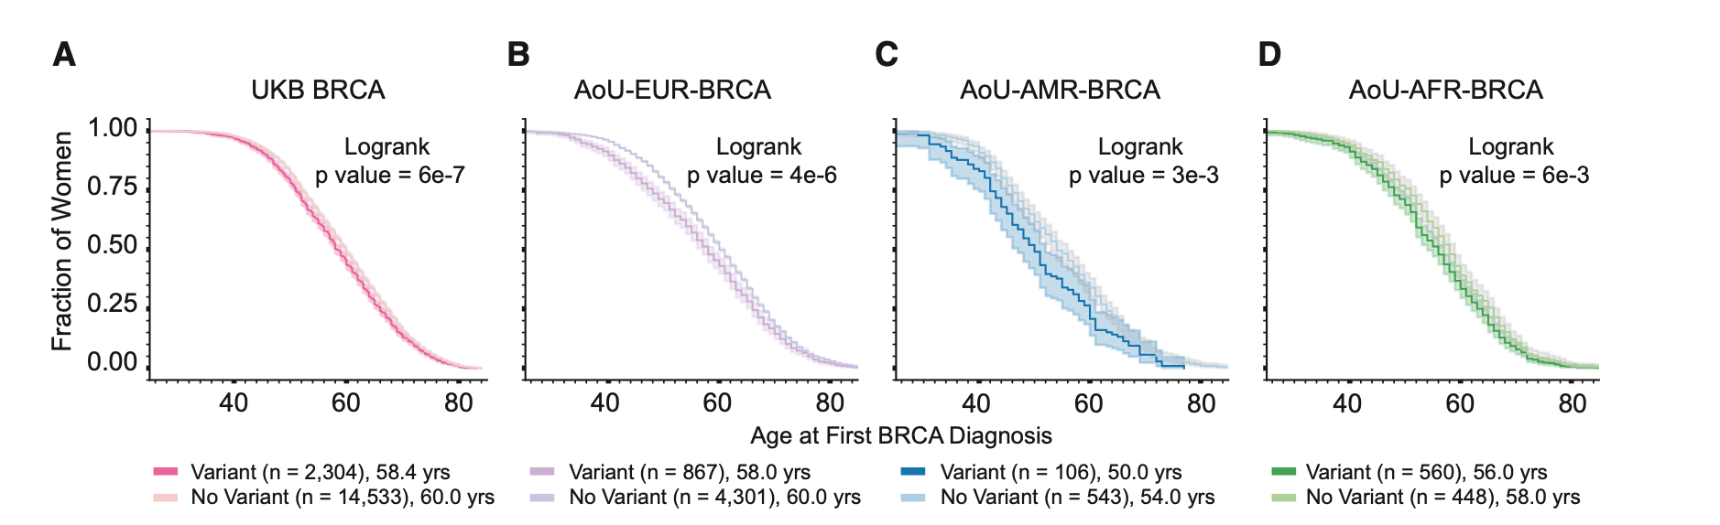
- Annotation to pathogenic/likely pathogenic variations to expand PTV-only
  - Re-define carrier: add annotated missense
  - Plot: x-y: age-PRS in two groups (carrier, non-carrier) to a single plot, and expected to see carrier decrease sharply than non-carrier
- Result: In this exploratory case-only analysis using the expanded nine-gene carrier definition, which included qualifying PTVs and breast cancer-related pathogenic or likely pathogenic missense variants, higher PRS311 was associated with a younger recorded age at diagnosis among non-carriers (-0.44 years per SD; 95% CI, -0.70 to - 0.18) . Among carriers, there was no clear statistical evidence of an association (+0.25 years per SD; 95% CI, -0.87 to +1.37), although the wide confidence interval did not exclude either younger or older diagnosis ages with increasing PRS311. The interaction estimate was also inconclusive (+0.69 years per SD; 95% CI, -0.46 to +1.84), providing no clear evidence that the PRS311 association differed between carriers and non-carriers. These findings concern recorded diagnosis age among breast cancer cases and should not be interpreted as associations with early-onset breast cancer risk in the general population.
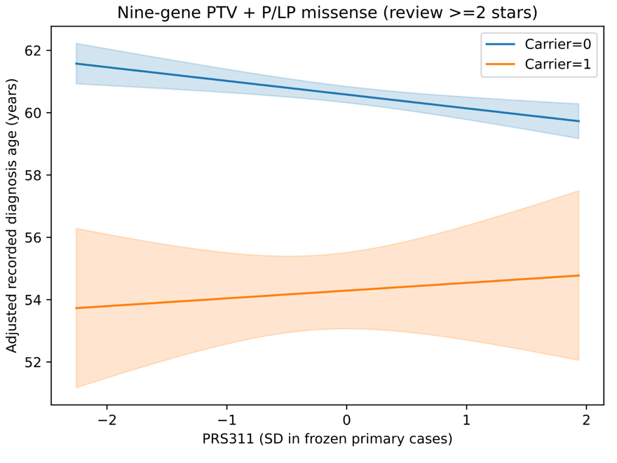
In this exploratory case-only analysis using the expanded nine-gene carrier definition, which included qualifying PTVs and breast cancer-related pathogenic or likely pathogenic missense variants, higher PRS311 was associated with a younger recorded age at diagnosis among non-carriers (-0.44 years per SD; 95% CI, -0.70 to - 0.18). Among carriers, there was no clear statistical evidence of an association (+0.25 years per SD; 95% CI, -0.87 to +1.37), although the wide confidence interval did not exclude either younger or older diagnosis ages with increasing PRS311. The interaction estimate was also inconclusive (+0.69 years per SD; 95% CI, -0.46 to +1.84), providing no clear evidence that the PRS311 association differed between carriers and non-carriers. These findings concern recorded diagnosis age among breast cancer cases and should not be interpreted as associations with early-onset breast cancer risk in the general population.
- Subgroup, considering effect impact (variant burden not just carrier but also add dosage)
- Use alphagnome VAI score
- Carrier * PRS four groups
 | contrast | estimate_years | se_HC1 | ci_low
1 | high_vs_nonhigh_noncarriers | -0.7944935 | 0.23644284 | -1.257913
2 | high_vs_nonhigh_carriers | 0.59500827 | 1.01747438 | -1.3992049
3 | difference_in_differences | 1.38950178 | 1.04446748 | -0.6576169
4 | double_high_vs_noncarrier_nonhigh | -5.812952 | 1.15067177 | -8.0682272
A conclusion for experiment: In an exploratory analysis among cases, participants with both high PRS311 and a qualifying rare PTV were diagnosed 5.81 years earlier than non-carriers without high PRS311 (95% CI, 3.56–8.07 years). However, the difference in the association of high PRS311 with age at diagnosis between carriers and non-carriers was imprecisely estimated (difference in differences, 1.39 years; 95% CI, −0.66 to 3.44), providing no clear evidence of an interaction.

Abstract
Breast cancer affects approximately one in eight US women during their lifetime, and about 10% of new cases occur before age 45. Previous studies have shown that polygenic risk modifies lifetime breast cancer risk including carriers of pathogenic variants in susceptibility genes. However, the independent and combined contributions of common polygenic risk and rare germline variants jointly distinguish breast cancer cases from controls, and how each contributes to variation in age at diagnosis among cases remain unclear. We therefore evaluated the independent and combined contributions of polygenic risk score (PRS) and rare germline variant burden comprising PTVs and qualifying pathogenic/likely pathogenic missense variants in 13 susceptibility genes. Both scores were standardized to facilitate comparison of effect sizes. We used whole-genome sequencing data from roughly 8,000 breast cancer cases and 134,727 controls of genetically inferred European ancestry in the All of Us Research Program. Adding PRS, rare-variant burden, and their interaction to a covariate-only model increased the cross-validated AUC for distinguishing breast cancer cases from controls from 0.745 to 0.782. In the joint model, each standard deviation increase in PRS and rare-variant burden was associated with odds ratios for breast cancer of 1.55 and 1.27, respectively. Among cases, each standard deviation of burden was associated with diagnosis 1.82 years earlier, compared with 0.43 years earlier for PRS. The proportion of cases carrying at least one rare variant in genes declined from 26.5% among those diagnosed before age 35 to 3.2% among those diagnosed at age 70 or older. These findings suggest that common polygenic susceptibility and rare high-impact germline variation capture components of inherited breast cancer risk, with rare variants more strongly associated with younger recorded diagnosis age among cases. Integrating both forms of genetic variation from increasingly available sequencing data may improve understanding and support genomic risk stratification for earlier surveillance and detecion.

Introduction
Inherited susceptibility to breast cancer has two well-characterised components. Common variants each carry small effects, and their combined effect is captured by polygenic risk scores such as the 313-variant PRS developed by the Breast Cancer Association Consortium (BCAC)^{[1]}. Rare protein-truncating variants (PTVs) and qualifying pathogenic missense variants in susceptibility genes, including BRCA1, BRCA2, PALB2, ATM and CHEK2, carry moderate to high relative risks; two large case-control studies published in 2021 established which genes and variant classes matter and estimated their effect sizes^{[2,3]}. Both components may be relevant to the age at which breast cancer is diagnosed.
Evidence from carrier cohorts shows that PRS modifies breast cancer risk among BRCA1/BRCA2 carriers^{[4,5]} and carriers of moderate-risk genes^{[6]}. Population biobanks likewise suggest that polygenic background modifies the penetrance of monogenic variants^{[7,8]}. However, much of this evidence comes from clinically ascertained carrier cohorts or European population biobanks. It remains unclear how much each component adds to case-status discrimination in a US cohort linked to electronic health records (EHR), or whether their associations with age at diagnosis differ among cases. High-penetrance carriers tend to be diagnosed younger, whereas evidence for an association between PRS and age at onset is less consistent^{[8]}.
The All of Us Research Program links whole-genome sequencing to EHRs for a large US cohort^{[9,10]}. We used its genetically inferred European-ancestry subset to assess the separate and joint associations of PRS and rare-variant burden with breast cancer case status. We then compared observed case proportions and adjusted odds ratios across PRS and burden strata and examined whether each measure was associated with age at diagnosis among cases.

Methods

Study population
We used the All of Us controlled-tier Curated Data Repository (CDR) version C2025Q4R6 and its short-read whole-genome sequencing (WGS) callsets^{[10]}. Eligible participants were those recorded as female sex at birth with WGS data. All of Us applies sex-concordance checks before release, so we did not exclude participants again on inferred genetic sex. We restricted the analysis to genetically inferred European ancestry, using the program’s ancestry predictions and requiring a predicted European label with a maximum posterior probability above 0.75. The same rule was applied to cases and controls. We removed related individuals by keeping a maximal unrelated set among pairs with KING kinship $>$0.1^{[11]}, and removed samples with genotype missingness above 3%. The flow of participants is shown in Figure 1 and Supplementary Table S1.

Phenotypes
Cases were participants with at least one EHR condition record mapping to the SNOMED concept “Malignant tumor of breast” (OMOP concept 4112853) or any of its descendants. Controls were all other eligible participants. Age at diagnosis was calculated from the date of the earliest qualifying record. Age at last EHR observation was the later of the last EHR record and the date of death. For the case-status models we required a non-missing age at last observation, which excluded 2,051 participants, all of them controls. For the age-at-diagnosis analysis we additionally excluded 532 cases whose earliest breast cancer record was also their first EHR record, because in these women the recorded date cannot be separated from a diagnosis made before EHR follow-up began. In a sensitivity analysis, cases were redefined as participants with at least two qualifying records.

Polygenic risk score
We used PGS000004, the 313-variant BCAC PRS^{[1,12]}, harmonised to GRCh38. Variants were matched to the All of Us array-and-common-allele-frequency (ACAF) callset by chromosome, position and alleles. Where strand or allele orientation was ambiguous, candidate records were resolved by comparing the cohort allele frequency with the published effect-allele frequency. In total, 304 of 313 variants were used: 281 matched directly, 23 were resolved by allele frequency, one remained ambiguous and eight were absent. Missing genotypes were imputed using PLINK2 reference. The primary score, PRS311, omits two matched variants that tag CHEK2 c.1100delC. This avoids counting that variant twice, since it also enters the rare-variant burden. Thus, the score named PRS311 contains 302 retained scored loci. Scores were standardised within the analysis cohort. In sensitivity analyses we restricted the score to the 281 directly matched variants and repeated the scoring without mean imputation. For participant i, the score was the weighted sum of effect-allele dosages across retained PRS311 loci:
$${PRS311}_{i}=\sum_{j∈J_{311}}{w_{j}}d_{ij}$$
Here J₃₁₁ is the set of matched loci after removing the two CHEK2-tagging variants, wⱼ is the published per-effect-allele weight, and dᵢⱼ is the effect-allele dosage (0, 1 or 2), replaced by the cohort mean dosage when missing.

Rare-variant burden
The panel comprised thirteen genes: ATM, BARD1, BRCA1, BRCA2, CHEK2, PALB2, RAD51C, RAD51D, TP53, CDH1, NF1, PTEN and STK11^{[18]}. Qualifying PTVs were stop-gained, frameshift, splice-donor and splice-acceptor variants with both the qualifying consequence and high-confidence LOFTEE annotation on the same retained transcript of the same gene[14]; eligibility was not restricted to the canonical transcript. Qualifying missense variants required germline pathogenic/likely pathogenic classification in ClinVar (13 September 2026 release), at least two review stars, and relevant disease and inheritance assertions. Low-penetrance variants, risk alleles, conflicting classifications and opposing benign/likely benign assertions were excluded; unresolved records were held out. Both classes required a known, consistent allele frequency below 1% in the All of Us European-ancestry callset. Site filters had to be defined-empty or singleton PASS in the original callset, and individual genotype filters had to pass (FORMAT/FT encoded PASS or .). Carrier genotypes required genotype quality ≥20 and target-alternate allele fraction 0.30–0.80 for heterozygous or ≥0.80 for homozygous-alternate calls. Allele fraction was the target-alternate allelic depth divided by total allelic depth after normalized-allele matching. Missing required QC failed inclusion; no blanket read-depth threshold was applied. A carrier had at least one qualifying PTV or missense variant in any panel gene.
Burden_{rare} was the sum, over panel genes in which a participant carried a qualifying variant, of the gene’s log odds ratio. Gene weights came from the combined PTV and non-PTV pathogenic-variant estimates in Rowlands et al.[18]. These are approximate external gene-level weights because the source variant definitions differ from ours. Multiple qualifying variants within one gene contributed once; variants in different genes contributed separately. To assess the imprecise STK11 weight (OR 1.60, 95% CI 0.48–5.30), we compared the thirteen-gene panel with a twelve-gene panel excluding STK11, using the same participants, PRS, covariates and cross-validation folds. Explicitly, the participant-level score was:
$${Burden}_{i}=\sum_{g∈G}{\ln\left({OR}_{g}\right)} C_{ig}$$
G is the thirteen-gene panel, ORg is the published combined pathogenic-variant odds ratio for gene g, and Cᵢg equals 1 if participant i carried at least one qualifying PTV or missense variant in that gene and 0 otherwise. Multiple qualifying variants within a gene therefore contributed only once.

Statistical analysis
Case-status discrimination. We fitted logistic regression models of case status on standardised PRS311, standardised Burden_{rare} and their product. Covariates were age at last EHR observation, the first ten genetic principal components (PCs), sequencing centre and sequencer model. Four models were compared: covariates only, covariates plus PRS311, covariates plus Burden_{rare}, and a joint model with both scores and their interaction. Coefficients are reported from fits to the full cohort, with heteroskedasticity-robust (HC1) standard errors. Discrimination was estimated with 5-fold cross-validation repeated 10 times, stratified jointly on case status and carrier status. For each repeat we computed the out-of-fold AUC of every model and compared paired models with DeLong’s test^{[15]}. We report mean AUC and ΔAUC over repeats, with DeLong confidence intervals and P values from the first repeat; these intervals are not confidence intervals for the repeated-CV means. Full-cohort fits use sample standard deviations; cross-validation standardization uses training-fold parameters. The logistic model has no tuning parameters and we did no model selection, so nested cross-validation was not needed. To describe the joint distribution, we compared observed case proportions by PRS311 decile and thirteen-gene carrier status with expectations from a logistic model without interaction, adjusted for continuous PRS311, carrier status, age at last EHR observation and PCs 1–10 (Figure 4).
$$\operatorname{logit}{​}\left[\operatorname{Pr}\left(Y_{i}=1\right)\right]=β_{0}+β_{P}P_{i}+β_{B}B_{i}+β_{PB}\left(P_{i}×B_{i}\right)+γ^{T}X_{i}$$
Yᵢ denotes case status; Pᵢ and Bᵢ are the standardised PRS311 and rare-variant burden; and Xᵢ contains age at last EHR observation, PCs 1–10, sequencing centre and sequencer model. The coefficient βPB tests departure from multiplicative odds for the two genetic measures. The reduced comparison models omit the corresponding score terms and interaction.
Age at diagnosis among cases. We then examined whether the genetic measures associated with case status also related to timing among women with breast cancer. We regressed age at diagnosis (years, as a continuous outcome) on standardised Burdenrare and PRS311, adjusting for PCs 1–10, with HC1 standard errors. The contribution of each score was summarised by the change in R² when it was removed from the joint model.
$$A_{i}=α_{0}+α_{B}B_{i}+α_{P}P_{i}+\sum_{k=1}^{10}{δ_{k}}{PC}_{ki}+ε_{i}.$$
Aᵢ is age at diagnosis for case i; Pᵢ and Bᵢ are standardised within the age-at-diagnosis analysis cohort. Coefficients αB and αP therefore give the adjusted difference in age in years per standard deviation of each score.
Sensitivity and post hoc analyses. We repeated the thirteen-gene analysis excluding STK11 (twelve genes), excluding CDH1 (twelve genes), including PTVs only, tightening heterozygous allele fraction to 0.30–0.70 for TP53/NF1, and relaxing the ClinVar review threshold to at least one star while retaining the other exclusions. These eligibility sensitivities were fixed before the expanded-panel association results. Figure 6 also compares the current nine-gene PTV plus missense panel and the historical nine-gene PTV score. Burden was standardized using each model cohort’s own sample SD. Gene–PRS interactions were examined post hoc using separ$<$ate gene-carrier main effects and PRS interaction terms in a joint logistic model; sparse genes were pooled, and nominal P values and Benjamini–Hochberg q values across seven interaction terms are reported (Supplementary Table S7). Additional interaction diagnostics are in Supplementary Table S8. The case-only PRS-by-carrier age interaction was exploratory.
Pre-specification. The analysis plan, thresholds and sensitivity analyses were fixed before this cohort was analysed. However, an earlier version of the analysis had examined a self-reported-White cohort drawn from the same data. The original analysis was therefore pre-specified but not blinded, and it was not registered. The thirteen-gene PTV plus missense extension was developed subsequently, and final manual variant adjudication remains pending.
Disclosure control. In line with the All of Us Data and Statistics Dissemination Policy, no count between 1 and 19 participants (or between 1 and 39 alleles) is reported, either directly or in a form from which it could be derived. Affected cells are shown as “$<$20” and, where needed, a second cell is suppressed so that the first cannot be recovered by subtraction. Test statistics whose inputs include such a cell are not reported.
Software. Analyses used Python with pandas, statsmodels and scikit-learn; Hail 0.2.137; PLINK 2^{[17]}; and bcftools. Analysis code is available at https://github.com/martina-yu/AoU_Comr.

Results

Study cohort
Of 295,706 women with WGS, 150,900 had genetically inferred European ancestry. After relatedness and sample QC, 143,255 remained: 8,528 cases and 134,727 controls (Figure 1; Supplementary Table S1). Cases had a mean age at diagnosis of 59.9 years (SD 11.8). They were older at enrolment than controls (64.0 vs 51.2 years) and more often reported a family history of breast cancer (28.0% vs 19.1%), although family history was missing for 61.6% of controls (Table 1). In the modelling cohort of 141,204 participants, 3,209 (2.3%) carried a qualifying PTV or missense variant in a panel gene (Figure 2).

Case-status discrimination
$r=-0.004$$-0.009$$n=132,676$In the joint model, the odds ratio per standard deviation was 1.55 (1.52–1.59) for PRS311 and 1.27 (1.25–1.29) for Burden_{rare}. These main effects are conditional on the other standardized genetic predictor at its mean. The interaction term was small and negative (OR 0.972, 0.958–0.985; $P=1.2×{10}^{-5}$P=6.0×10−5), which means the PRS gradient was slightly shallower at higher burden (Table 2).
The covariate-only model already reached a cross-validated AUC of 0.745, mostly because of age at last EHR observation. That variable reflects how long participants have been followed in the EHR, not a risk factor, so the absolute AUC should not be read as a measure of predictive performance. The informative quantities are the increments (Figure 3). Adding PRS311 raised mean AUC by 0.023 and adding Burden_{rare} by 0.014. The joint model reached 0.782, 0.036 above covariates alone and 0.01328 above the PRS-only model. For the first repeat, the joint-versus-PRS increment was 0.01328 (95% CI 0.01133–0.01523; paired DeLong P=1.7×10−40). The results varied very little across the ten repeats (AUC range <$<$0.0003 for every model).$R^{2}$

Joint distribution of common and rare risk
Across PRS deciles, the observed case proportion rose steadily among non-carriers and was higher among carriers in every decile (Figure 4). Relative to expectations from a model without interaction, carriers in the upper deciles had fewer cases than expected and carriers in the lower deciles more. These descriptive differences are consistent with the negative interaction term but do not independently establish biological interaction.

Age at diagnosis among cases
Among 7,996 cases, each standard deviation of Burden_{rare} was associated with diagnosis 1.82 years earlier (95% CI 1.53–2.11; $P=7.1×{10}^{-32}$P=1.5×10−35). Each standard deviation of PRS311 was associated with diagnosis 0.43 years earlier (0.18–0.68; $P=0.001$P=0.00075) (Table 3; Figure 5). Both scores together explained little of the variation in age at diagnosis ($R^{2}$R² 2.63%). Almost all of this came from burden: removing Burden_{rare} lowered $R^{2}$R² by 2.37 percentage points. Carrier frequency generally declined with age at diagnosis, from 26.5% (20.1–33.9) in cases diagnosed before 35 years to 3.2% (2.5–4.2) at 70 years or older (Figure 5c).
In exploratory analyses, the PRS311$P=0.76$ association with age at diagnosis did not differ detectably between thirteen-gene carriers and non-carriers (interaction $+0.78$+0.98 years per PRS SD, $-0.37$95% CI −0.08 to 2.04). Gene-specific case-status interaction estimates differed across the seven modeled categories (heterogeneity P=0.0126). The strongest negative estimate was for BRCA1 (interaction OR 0.652, 95% CI 0.514–0.828; q=0.0030); the BRCA2 estimate was 0.786 (0.640–0.965; q=0.0758). Full exploratory estimates and descriptive PRS distributions are shown in Supplementary Table S7 and Figure S7.

Sensitivity analyses
The eligibility sensitivity analyses gave estimates close to the primary ones (Figure 6). Excluding STK11 yielded a mean AUC of 0.78149 versus 0.78151 for thirteen genes, a burden OR of 1.268 versus 1.269, and a diagnosis-age coefficient of −1.819 versus −1.820 years per SD. Across the thirteen-gene eligibility sensitivities, PRS ORs were approximately 1.55 and burden ORs ranged from 1.25 to 1.27; age coefficients ranged from $-1.70$−1.75 to $-1.75$−1.82 years for burden and −0.43$-0.36$ to $-0.59$−0.44 years for PRS. The historical nine-gene PTV analysis is displayed separately as a comparison baseline.

Discussion
In 143,255 women of genetically inferred European ancestry in All of Us, PRS311 and a weighted burden of PTVs plus qualifying missense variants in thirteen susceptibility genes each added to case-status discrimination. Their joint effects were close to multiplicative, with a small negative interaction. Among cases, greater rare-variant burden was associated with earlier diagnosis, whereas the PRS association was smaller. Together, the two scores explained only a small proportion of variation in age at diagnosis.
Our per-standard-deviation PRS odds ratio of 1.55 is close to the 1.61 reported for PRS313 in the BCAC validation^{[1]}. It was obtained in a cohort defined from EHR codes rather than a research case-control design. The sub-multiplicative interaction agrees with reports that the relative effect of PRS is somewhat attenuated among carriers of high-penetrance variants^{[4–6]}. The exploratory gene-specific analysis suggests that this panel-level interaction combines heterogeneous PRS associations, with the clearest negative estimate for BRCA1. Differences in subtype composition or PRS applicability may contribute[5], but no subtype analysis was performed. The logistic interaction does not establish biological antagonism or additive-risk interaction, and PRS boxplots by gene and case status are descriptive.
The stronger association of rare-variant burden with age at diagnosis is consistent with prior evidence that carriers of high-penetrance PTVs tend to be diagnosed younger^{[8]}. The small continuous PRS association suggests a more modest association of common-variant risk with timing in this cohort.
This study has several limitations. First, it is restricted to genetically inferred European ancestry. The 0.75 posterior threshold excludes admixed participants, mostly at the boundary between European and Middle Eastern ancestry, so the exclusion is not random. The findings may not generalise to other ancestries, which will be addressed in follow-up work. Second, phenotypes come from EHR records: age at diagnosis may be misdated, prevalent cases diagnosed before EHR follow-up are only partly removed, and controls may include undiagnosed or unrecorded cases. Third, the covariate-only AUC is inflated by differences in EHR follow-up between cases and controls, so we emphasise increments rather than absolute discrimination. Fourth, sparse genes required pooling in the gene–PRS analysis, limiting gene-specific inference. Fifth, external weights approximate our variant definitions, the STK11 estimate is imprecise, and final manual variant adjudication remains pending. VAF filtering cannot fully exclude clonal hematopoiesis. Finally, the original analysis plan was fixed before this cohort was analysed but after an earlier analysis in a related cohort; the thirteen-gene extension and gene–PRS interaction diagnostics were subsequent analyses. Diagnosis-age associations are restricted to cases and may be affected by case-only selection.
In summary, common and rare germline variation contribute largely independent information on breast cancer risk in a large US EHR-linked cohort, and thirteen-gene PTV plus qualifying missense burden is more strongly associated with younger recorded diagnosis age among cases.

Declarations
Acknowledgements. [Insert the All of Us Research Program acknowledgement verbatim from the program’s “How to acknowledge and cite” guidance, including the NIH grant numbers it lists, and thank the participants.]
Data availability. Individual-level data are available to registered researchers through the All of Us Researcher Workbench (controlled tier, CDR C2025Q4R6). Aggregate results that meet the dissemination policy and the analysis code are available at https://github.com/martina-yu/AoU_Comr.
Ethics. [Statement on All of Us IRB oversight and participant consent.]
Funding. [Funders and grant numbers.]
Competing interests. [To be completed.]
Author contributions. [To be completed.]

References
1. Mavaddat N, Michailidou K, Dennis J, et al. Polygenic risk scores for prediction of breast cancer and breast cancer subtypes. Am J Hum Genet. 2019;104(1):21–34.
2. Breast Cancer Association Consortium; Dorling L, Carvalho S, Allen J, et al. Breast cancer risk genes—association analysis in more than 113,000 women. N Engl J Med. 2021;384(5):428–439.
3. Hu C, Hart SN, Gnanaolivu R, et al. A population-based study of genes previously implicated in breast cancer. N Engl J Med. 2021;384(5):440–451.
4. Kuchenbaecker KB, McGuffog L, Barrowdale D, et al. Evaluation of polygenic risk scores for breast and ovarian cancer risk prediction in BRCA1 and BRCA2 mutation carriers. J Natl Cancer Inst. 2017;109(7):djw302.
5. Barnes DR, Rookus MA, McGuffog L, et al. Polygenic risk scores and breast and epithelial ovarian cancer risks for carriers of BRCA1 and BRCA2 pathogenic variants. Genet Med. 2020;22(10):1653–1666.
6. Gallagher S, Hughes E, Wagner S, et al. Association of a polygenic risk score with breast cancer among women carriers of high- and moderate-risk breast cancer genes. JAMA Netw Open. 2020;3(7):e208501.
7. Fahed AC, Wang M, Homburger JR, et al. Polygenic background modifies penetrance of monogenic variants for tier 1 genomic conditions. Nat Commun. 2020;11(1):3635.
8. Mars N, Widén E, Kerminen S, et al. The role of polygenic risk and susceptibility genes in breast cancer over the course of life. Nat Commun. 2020;11(1):6383.
9. The All of Us Research Program Investigators. The “All of Us” Research Program. N Engl J Med. 2019;381(7):668–676.
10. The All of Us Research Program Genomics Investigators. Genomic data in the All of Us Research Program. Nature. 2024;627(8003):340–346.
11. Manichaikul A, Mychaleckyj JC, Rich SS, Daly K, Sale M, Chen WM. Robust relationship inference in genome-wide association studies. Bioinformatics. 2010;26(22):2867–2873.
12. Lambert SA, Gil L, Jupp S, et al. The Polygenic Score Catalog as an open database for reproducibility and systematic evaluation. Nat Genet. 2021;53(4):420–425.
13. Collister JA, Smith-Byrne K, Atkins J, et al. Meta-analysis of exome-wide gene burden analysis of breast cancer susceptibility genes. npj Breast Cancer. 2025;11:111.
14. Karczewski KJ, Francioli LC, Tiao G, et al. The mutational constraint spectrum quantified from variation in 141,456 humans. Nature. 2020;581(7809):434–443.
15. DeLong ER, DeLong DM, Clarke-Pearson DL. Comparing the areas under two or more correlated receiver operating characteristic curves: a nonparametric approach. Biometrics. 1988;44(3):837–845.
16. Mazzarotto F, Gennarelli M, Murray G, Osimo EF. The complementary roles of rare variant burden scores and common variant polygenic risk scores in genetic risk prediction of complex disorders. bioRxiv. 2025. doi:10.1101/2025.09.15.676308.
17. Chang CC, Chow CC, Tellier LC, Vattikuti S, Purcell SM, Lee JJ. Second-generation PLINK: rising to the challenge of larger and richer datasets. GigaScience. 2015;4:7.
18. Rowlands CF, Allen S, Balmaña J, et al. Population-based germline breast cancer gene association studies and meta-analysis to inform wider mainstream testing. Ann Oncol. 2024;35(10):892–901. doi:10.1016/j.annonc.2024.07.244.

Tables
Table 1. Characteristics of the study cohort. Counts between 1 and 19, and cells from which such a count could be derived, are suppressed.
 | Case-status cases | Case-status controls | Age-analysis cases
N | 8,528 | 134,727 | 7,996
Age at diagnosis, years, mean (SD) | 59.9 (11.8) |  | 60.2 (11.8)
Age at diagnosis, years, median [IQR] | 60.7 [51.5-68.4] |  | 61.1 [51.9-68.7]
Age at enrollment, years, mean (SD) | 64.0 (11.6) | 51.2 (16.8) | 64.1 (11.6)
Age at last EHR observation, years, mean (SD) | 68.1 (11.7) | 53.9 (17.0) | 68.2 (11.7)
BMI, kg/m$​^{2}$, mean (SD) | 28.5 (6.7) | 29.4 (7.9) | 28.5 (6.8)
PRS311 (raw score), mean (SD) | 0.4 (0.6) | 0.1 (0.6) | 0.4 (0.6)
BMI missing, n (%) | 92 (1.1) | 5,107 (3.8) | suppressed (secondary)
Age at last EHR observation missing, n (%) | 0 (0.0) | 2,051 (1.5) | 0 (0.0)
Menopausal status, n (%)
Premenopausal | 620 (7.3) | 49,735 (36.9) | 592 (7.4)
Postmenopausal | 7,610 (89.2) | 75,983 (56.4) | 7,133 (89.2)
Uncertain or unknown | 149 (1.7) | 4,801 (3.6) | suppressed (secondary)
Missing | 149 (1.7) | 4,208 (3.1) | suppressed (secondary)
Family history of breast cancer, n (%)
Positive (first- or second-degree relative) | 2,392 (28.0) | 25,689 (19.1) | 2,236 (28.0)
Negative | 3,393 (39.8) | 26,004 (19.3) | 3,188 (39.9)
Missing | 2,743 (32.2) | 83,034 (61.6) | 2,572 (32.2)
Smoking status, n (%)
Never | 4,932 (57.8) | 80,136 (59.5) | 4,612 (57.7)
Former or unknown currency | 2,974 (34.9) | 35,699 (26.5) | 2,796 (35.0)
Current | 442 (5.2) | 13,614 (10.1) | suppressed (secondary)
Missing | 180 (2.1) | 5,278 (3.9) | suppressed (secondary)
Self-reported race, n (%)
White | 8,117 (95.2) | 126,790 (94.1) | 7,611 (95.2)
Other, multiple, or not reported | 411 (4.8) | 7,937 (5.9) | 385 (4.8)
Sequencing center, n (%)
Broad Institute | 4,963 (58.2) | 79,319 (58.9) | 4,639 (58.0)
University of Washington | 997 (11.7) | 16,069 (11.9) | 936 (11.7)
Baylor College of Medicine | 2,568 (30.1) | 39,339 (29.2) | 2,421 (30.3)
Sequencer, n (%)
NovaSeq6000 S4 | 8,293 (97.2) | 127,580 (94.7) | suppressed (secondary)
NovaSeq X 25B | 235 (2.8) | 7,147 (5.3) | suppressed (secondary)

Table 2. Joint logistic model of case status and cross-validated discrimination. Models adjust for age at last EHR observation, PC1–10, sequencing centre and sequencer. AUC and ΔAUC are means over ten repeats; 95% CIs and paired DeLong P values are from the first repeat and ar$Δ$e not confidence intervals for$P$ the repeated-CV means. $n=141,204$n=141,204 (8,528 cases).
 | Estimate (95% CI) | $P$​
A. Joint model, full cohort (OR per SD)
PRS311 | 1.55 (1.52–1.59) | $<{10}^{-300}$​
Burden$​_{\text{rare}}$ | 1.27 (1.25–1.29) | $3.6×{10}^{-201}$6.9×10−233
PRS311 $×$ Burden$​_{\text{rare}}$ | 0.972 (0.958–0.985) | $1.2×{10}^{-5}$6.0×10−5
B. Out-of-fold AUC, 10 $×$ 5-fold CV (mean; 95% CI from repeat 1)
Covariates-only | 0.745 (0.741–0.750) | –
PRS-only | 0.768 (0.764–0.773) | –
Burden-only | 0.759 (0.754–0.763) | –
Joint | 0.782 (0.777–0.786) | –
C. $Δ$ΔAUC (mean over repeats; repeat-1 DeLong 95% CI and P)
PRS-only vs Covariates-only | 0.023 (0.021–0.025) | $1.1×{10}^{-81}$7.6e-82
Burden-only vs Covariates-only | 0.014 (0.012–0.016) | $3.7×{10}^{-35}$1.2e-41
Joint vs Covariates-only | 0.036 (0.033–0.039) | $3.0×{10}^{-120}$4.7e-127
Joint vs PRS-only | 0.013 (0.011–0.015) | $1.4×{10}^{-34}$1.7e-40
Joint vs Burden-only | 0.023 (0.020–0.025) | $2.3×{10}^{-82}$1.1e-81

Table 3. Age at diagnosis among cases ($n=7,996$). OLS adjusted for PC1–10; negative coefficients indicate earlier diagnosis.
 | Estimate (95% CI) / $R^{2}$ | $P$ / unique $R^{2}$
A. Primary OLS model (years per SD; HC1 robust 95% CI)
Burden$​_{\text{rare}}$ | $-$−1.82 ($-$−2.11 to $-$−1.53) | $7.1×{10}^{-32}$1.5×10−35
PRS311 | $-$−0.43 ($-$−0.68 to $-$−0.18) | 0.00075
B. Explained variance ($R^{2}$R²; burd$R^{2}$en increment relative to PRS311+PCs)
PCs-only | 0.20% | –
PRS311-only+PCs | 0.26% | –
Burden increment over PRS311+PCs | 2.37 percentage points | –
Joint (primary) | 2.63% | –

Figures
[Figure 1 — study flow diagram (to be done)]
Figure 1. Study flow. Women with WGS in All of Us (295,706) $→$ genetically inferred European ancestry (150,900) $→$ unrelated, sample QC passed (143,255; 8,528 cases, 134,727 controls) $→$ case-status modelling cohort with age at last EHR observation (141,204) and age-at-diagnosis cohort excluding cases whose diagnosis was their first EHR record (7,996). Counts at each step are in Supplementary Table S1.
(a)
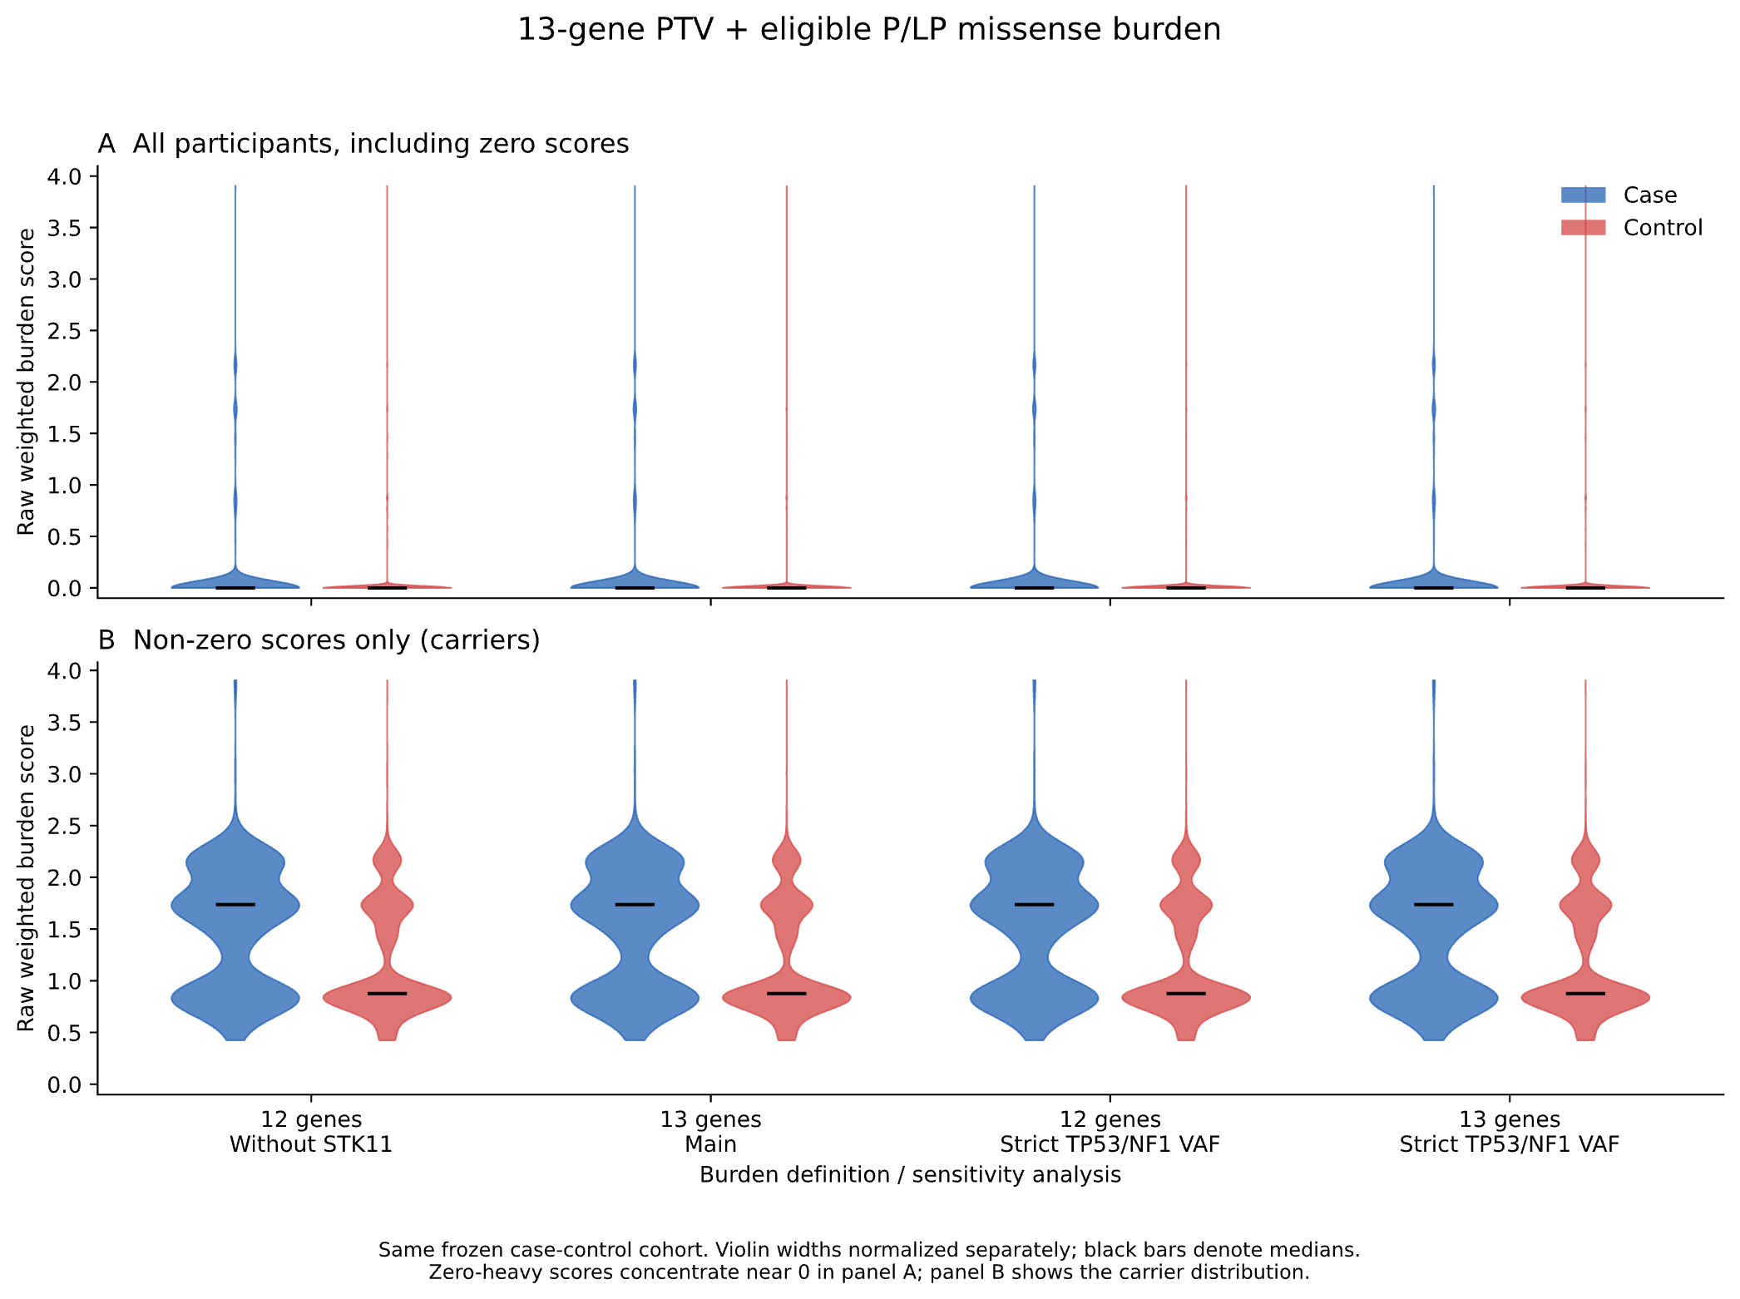
(b)
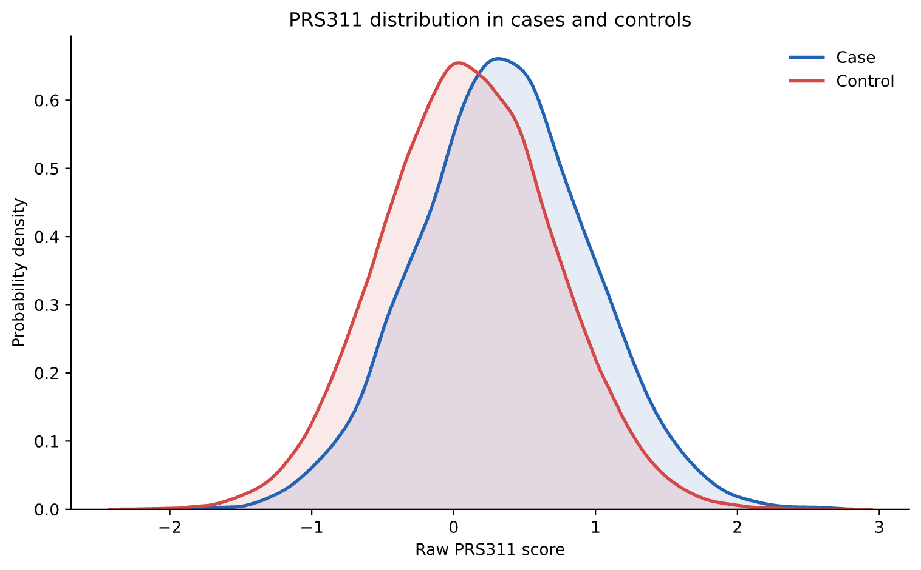
(c)
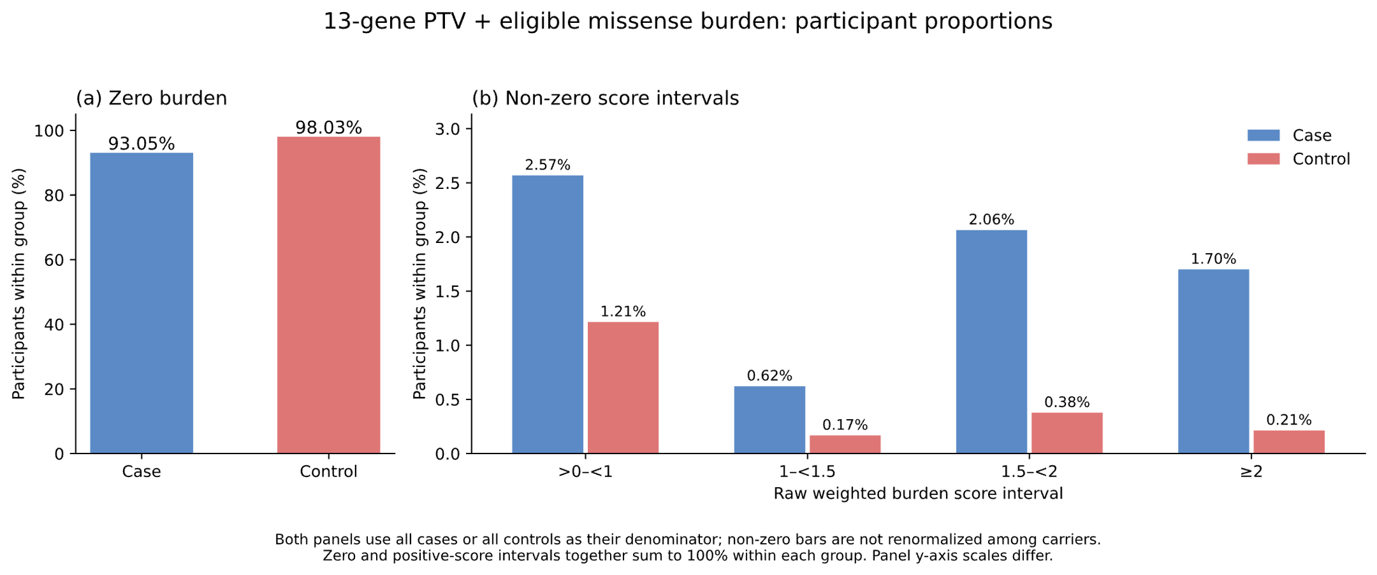
(d)
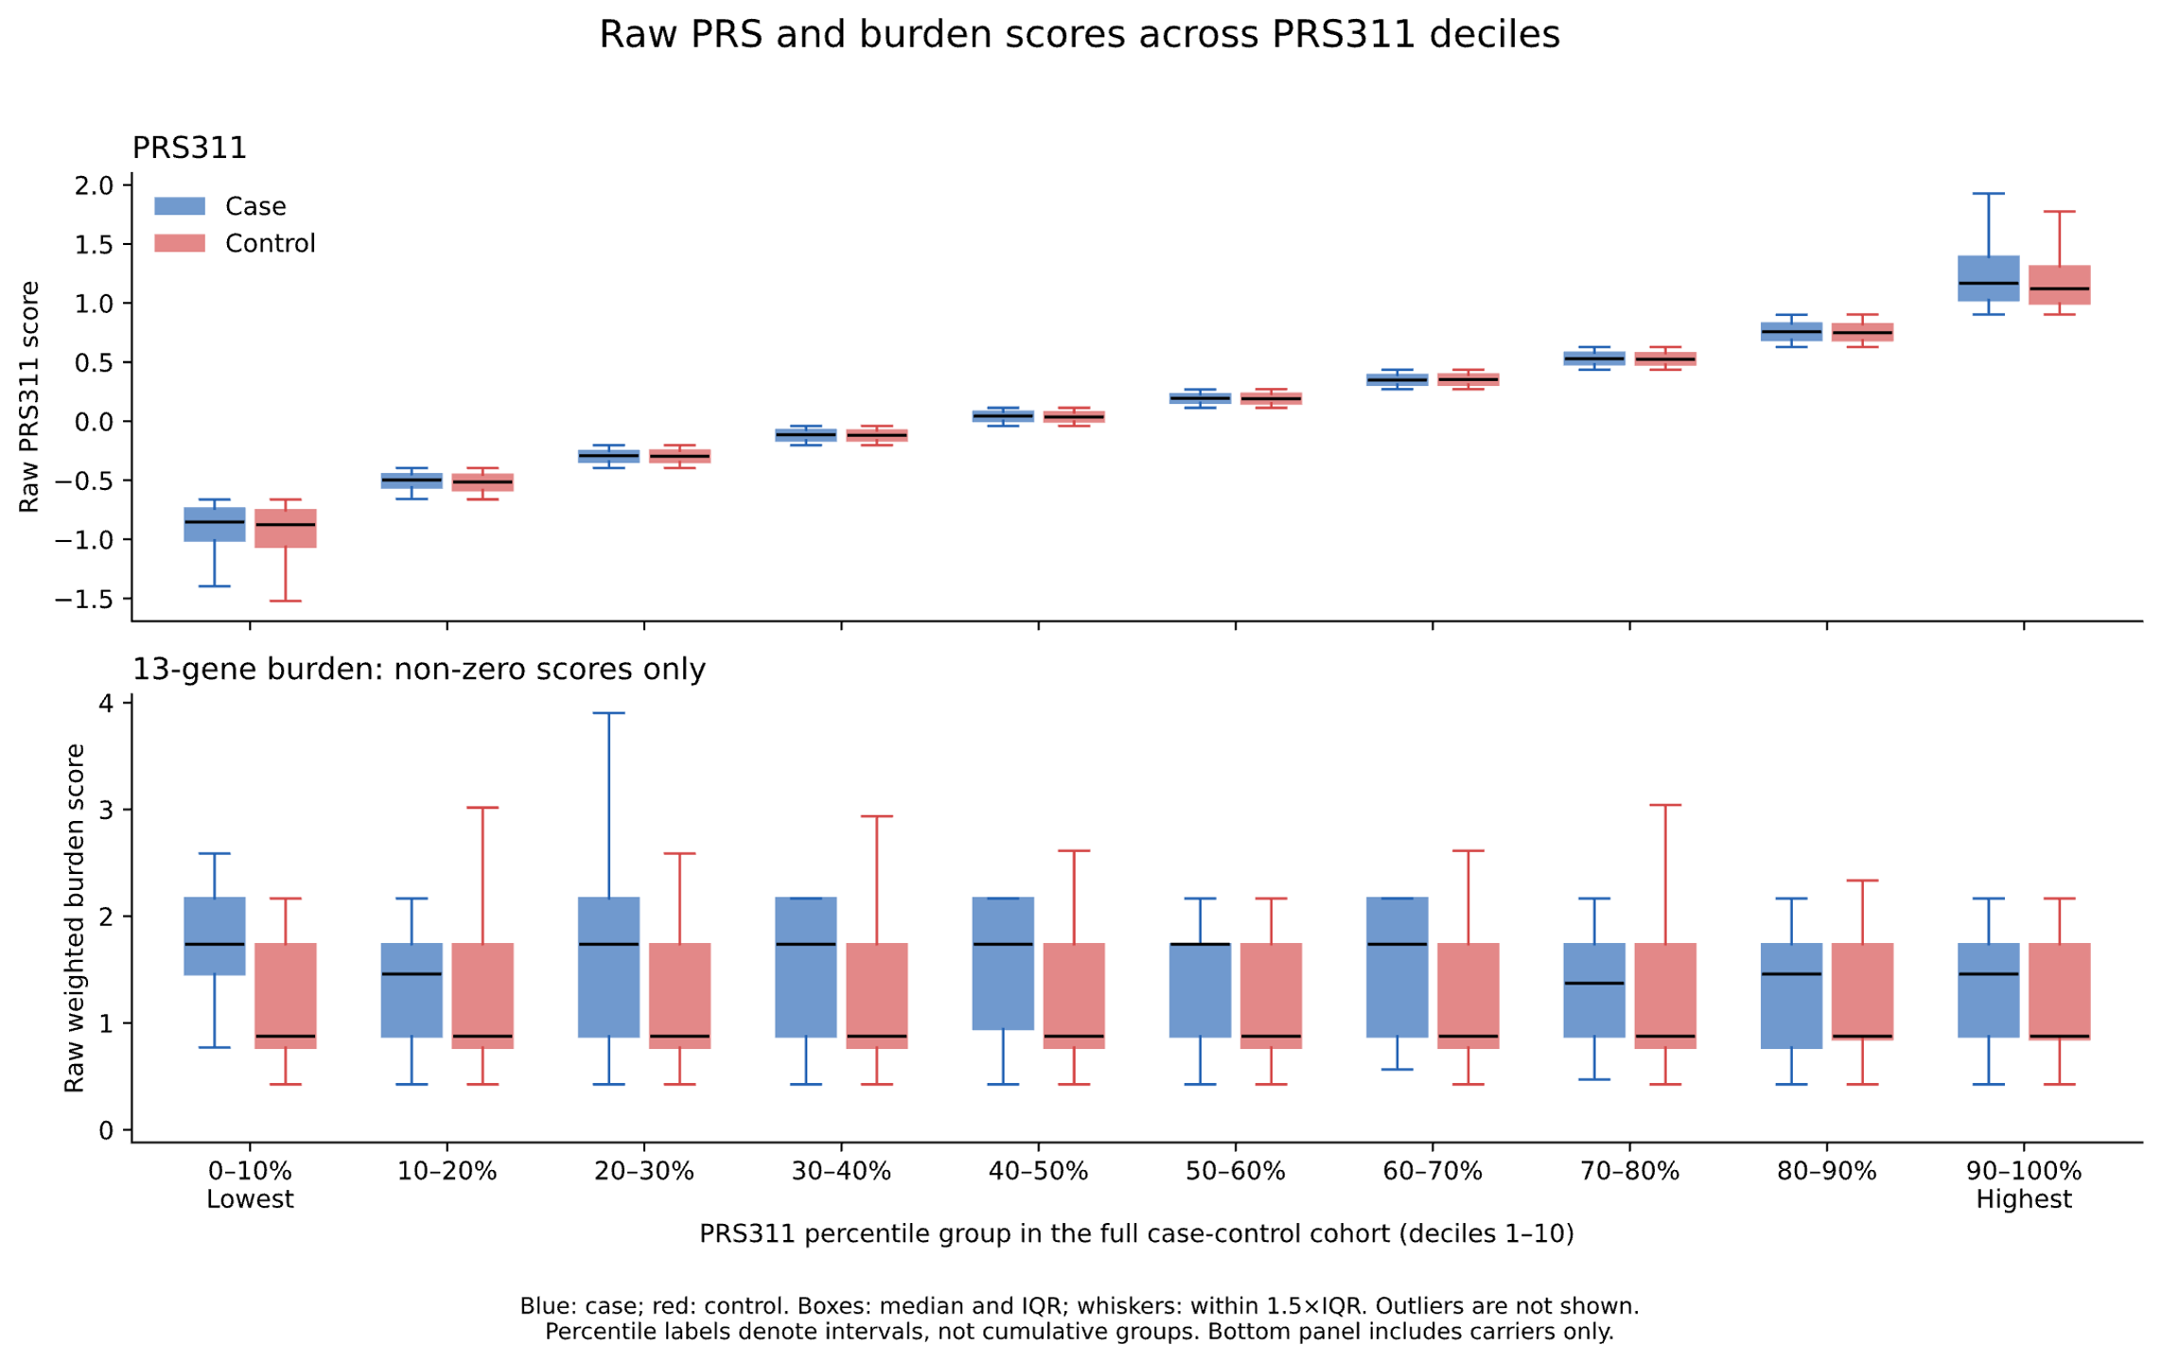
Figure 2. Descriptive distributions of genetic scores in the fixed case-control cohort (n=141,204). (a) Raw burden distributions for the 13-gene and 12-gene (without STK11) panels, with main and stricter TP53/NF1 VAF definitions; upper panel includes all participants and lower panel includes carriers only. Violin widths are normalized separately and black bars denote medians. (b) Kernel density estimates of raw PRS311 by case status. (c) Within-group percentages of zero and positive 13-gene burden scores. (d) Raw PRS311 and nonzero 13-gene burden by full-cohort PRS311 deciles; boxes show median and IQR and whiskers observations within 1.5×IQR; outliers are not shown. Case and control distributions are shown in blue and red, respectively. Burden includes PTVs plus qualifying P/LP missense variants.
(a)
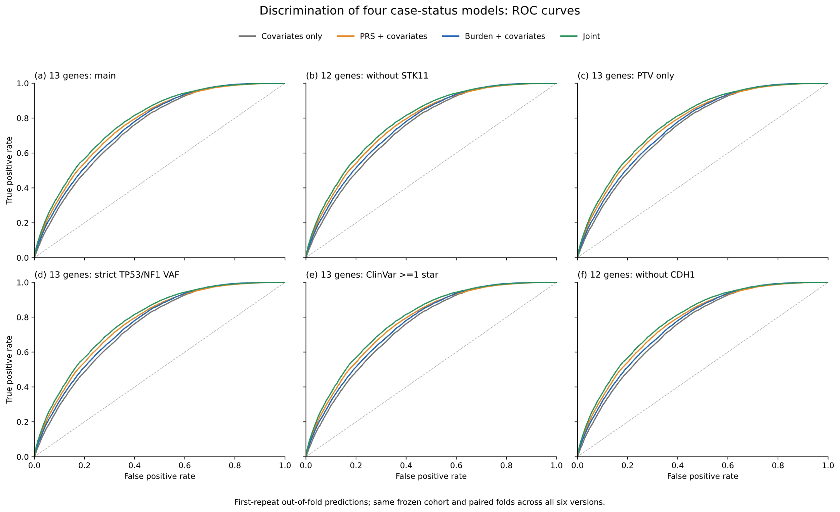
(b)
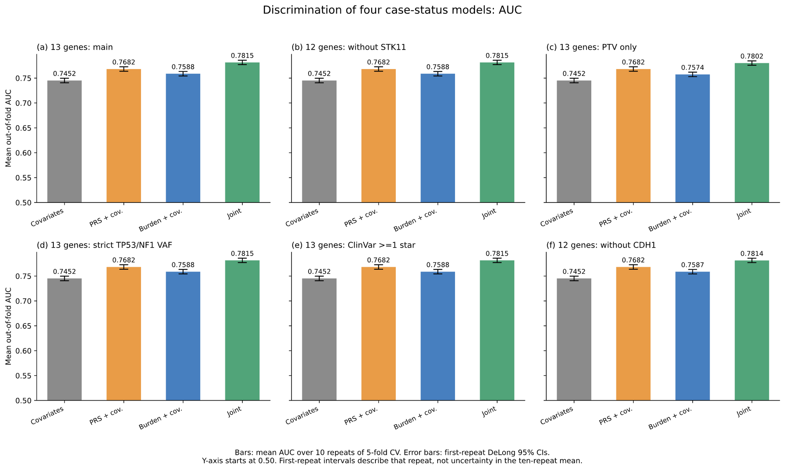
Figure 3. Discrimination of the four case-status models. (a) ROC curves of first-repeat out-of-fold predictions from the four case-status models. (b) Mean out-of-fold AUC over 10 repeats of 5-fold cross-validation. Error bars are DeLong 95% CIs for the first repeat. These intervals are not confidence intervals for the ten-repeat mean. All models include the same clinical/technical covariates; the joint model also includes PRS×burden. Same frozen cohort (N=141,204; cases=8,528) and original paired folds. Existing PRS and joint predictions reused; missing covariates-only and burden-only predictions fitted. Current variant definition remains provisional.
(a)
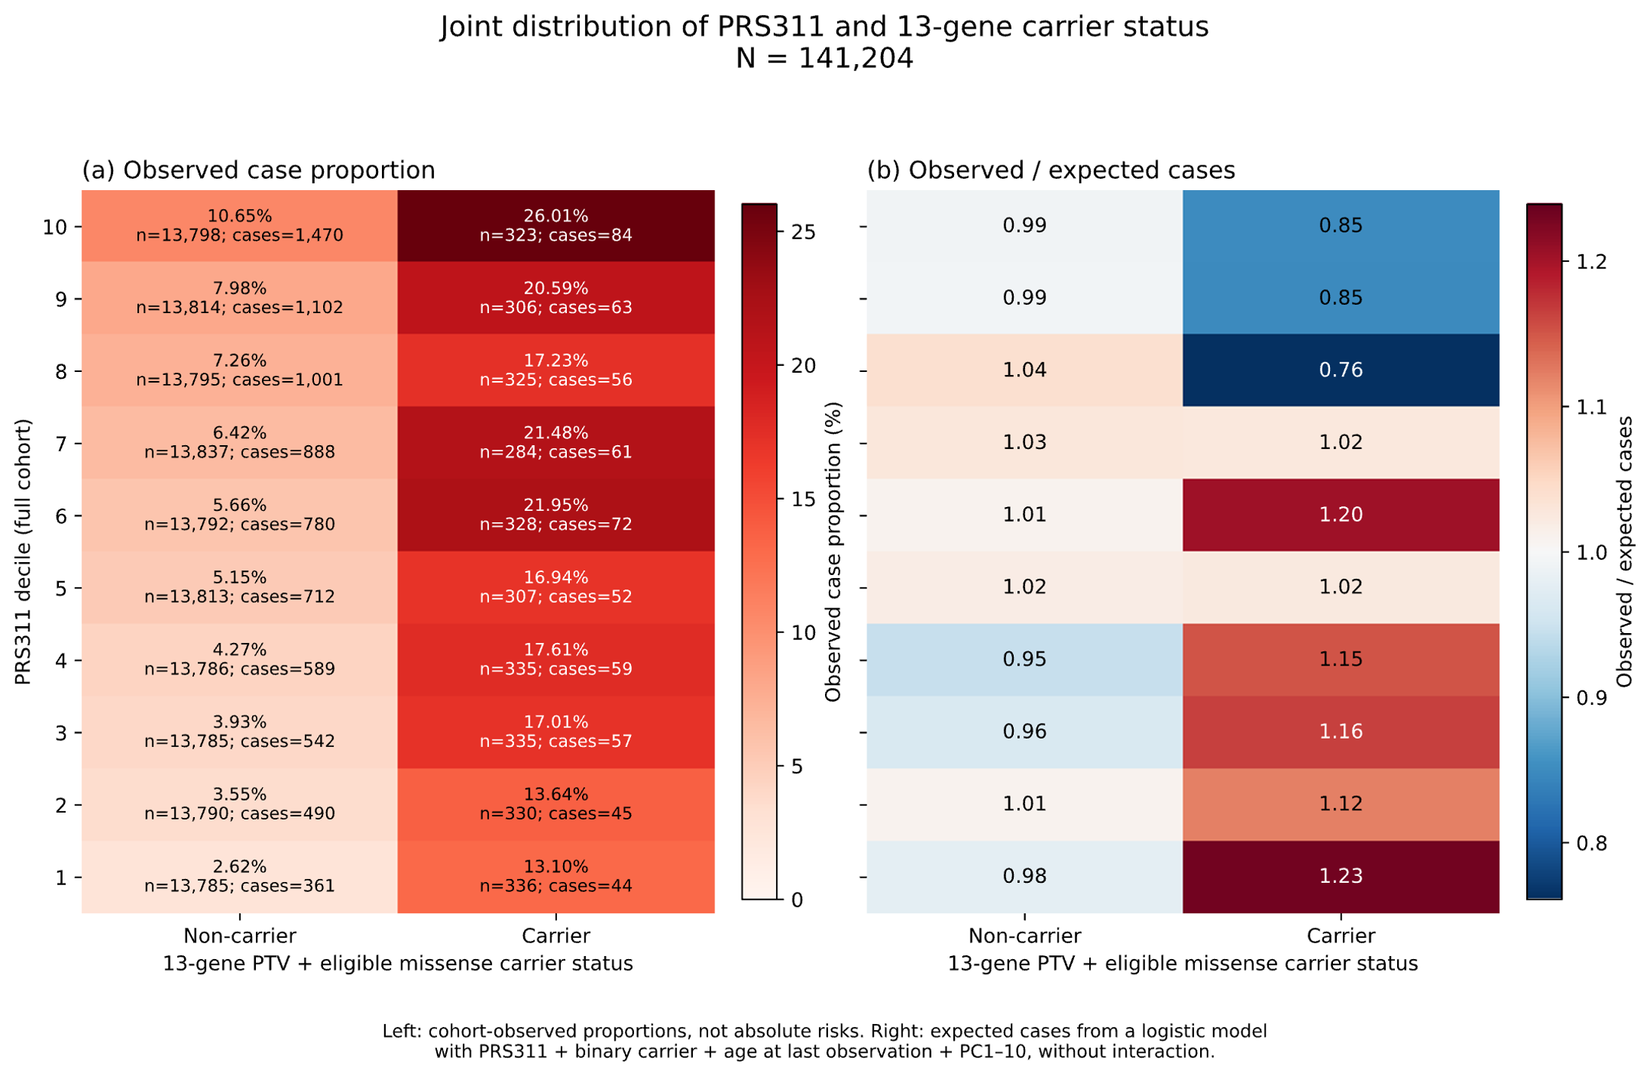
Figure 4. Joint distribution of PRS311 and 13-gene PTV plus eligible P/LP missense carrier status (N=141,204). Left: observed case proportion by full-cohort PRS311 decile and binary carrier status. These proportions depend on the case-control composition of the cohort and are not absolute risks. Right: observed/expected cases; expected counts are sums of fitted probabilities from a logistic model without interaction, adjusted for continuous PRS311, binary carrier status, age at last EHR observation and PC1–10. The adjustment matches the prior figure; sequencing site and sequencer are not included in this descriptive expectation model. O/E differences do not independently establish biological interaction. Current variant definition is provisional.
(a)
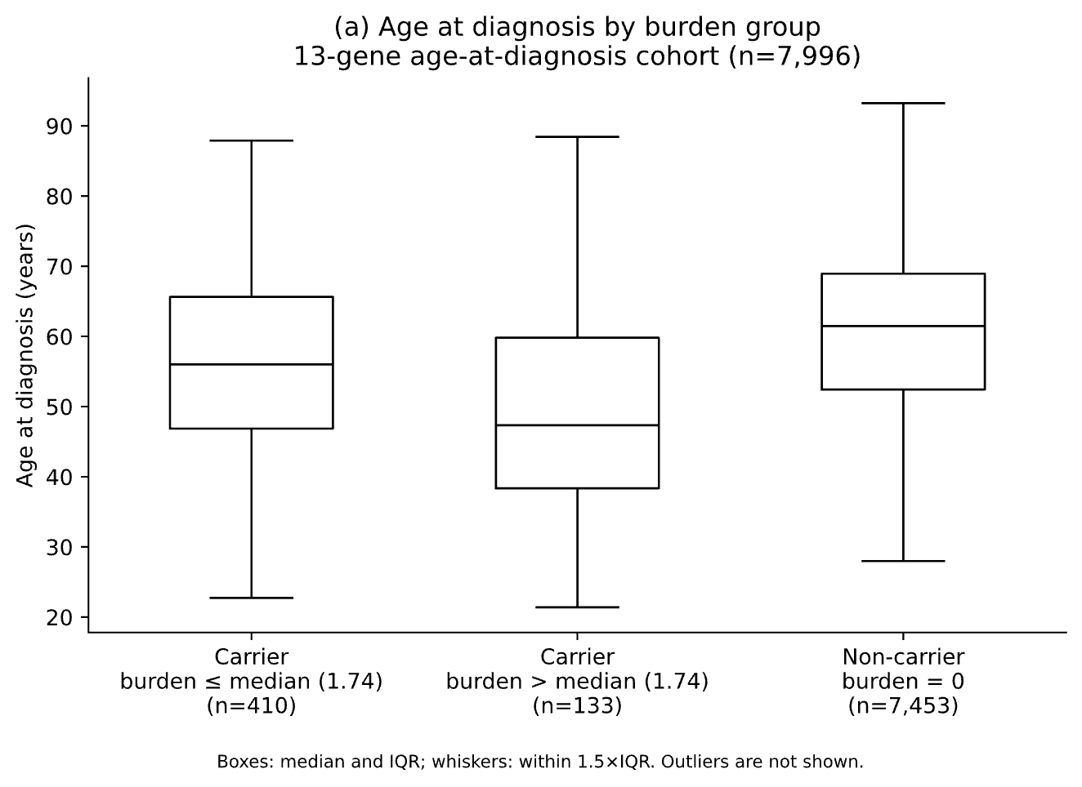
(b)
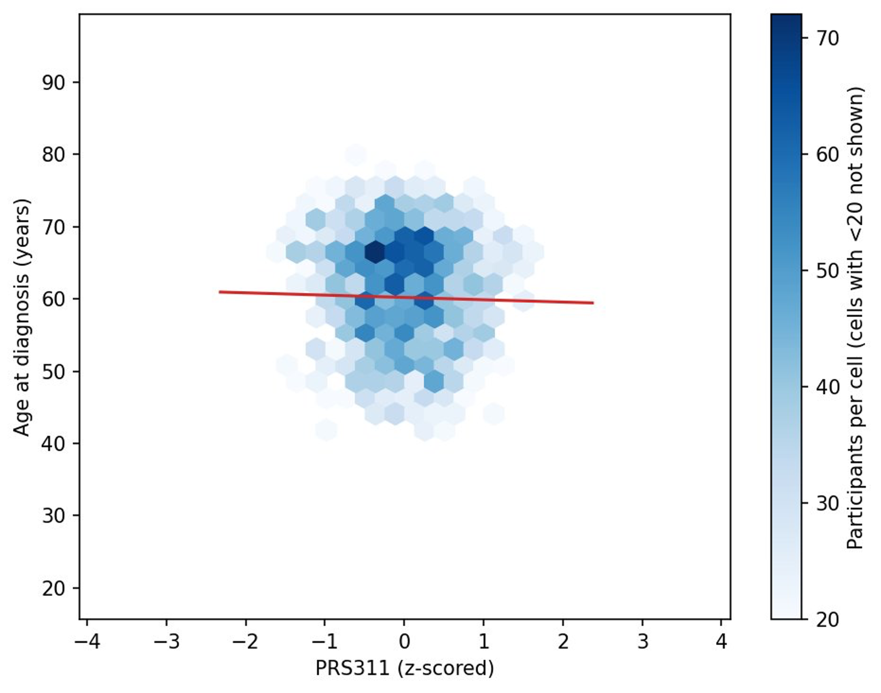
(c)
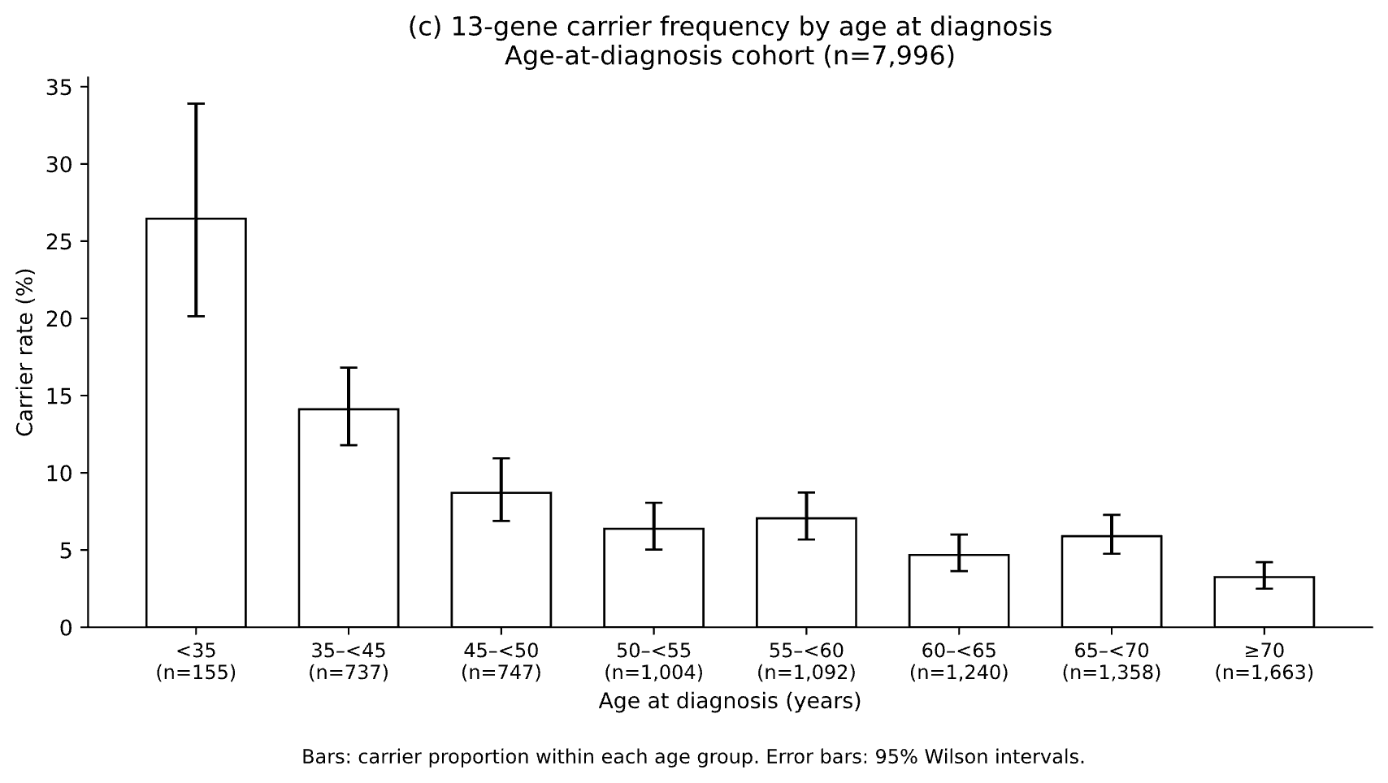
Figure 5. Rare and common risk and recorded age at diagnosis among cases (n=7,996). (a) Age by 13-gene burden group, with carriers divided at their burden median (1.73695, displayed as 1.74) and non-carriers shown separately. Boxes show median and IQR; whiskers extend to observations within 1.5×IQR; outliers are not shown. (b) PRS311 against age at diagnosis, reused unchanged. Hexagonal bins with fewer than 20 cases are not shown; the red line is an unadjusted linear fit. (c) Carrier proportions within age groups with 95% Wilson intervals. Age groups are left-inclusive and right-exclusive, with <35 and ≥70 as the extreme groups. Carrier status uses the current 13-gene PTV plus qualifying P/LP missense definition.
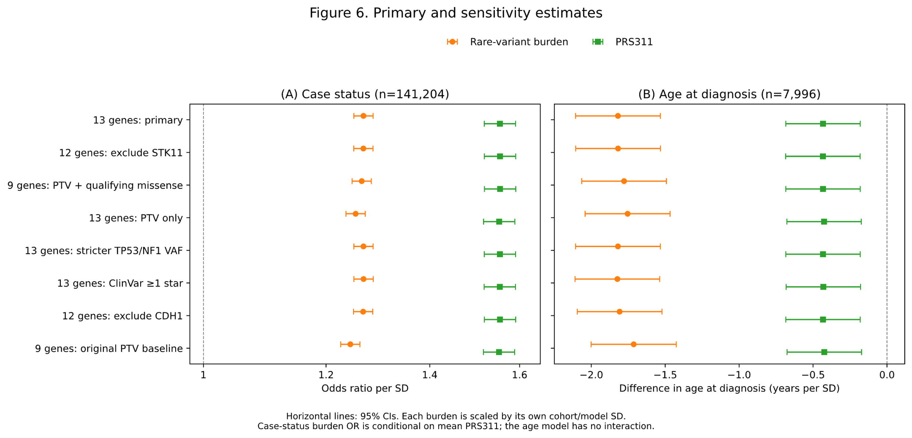
Figure 6. Primary and sensitivity estimates. (A) Case-status odds ratios per SD from the joint logistic model, including PRS311, rare-variant burden, their interaction, age at last EHR observation and PC1–10 (n=141,204). (B) Difference in recorded age at diagnosis per SD among cases from an OLS model including PRS311, burden and PC1–10, without interaction (n=7,996). Points show estimates for burden (orange circles) and PRS311 (green squares); horizontal lines show 95% CIs based on HC1 robust standard errors.
The primary analysis uses the 13-gene PTV plus qualifying P/LP missense burden. Sensitivities exclude STK11 (12 genes), restrict the panel to the nine original genes with the same current PTV/missense rules and Rowlands weights, include PTVs only, apply stricter heterozygous VAF (0.30–0.70) to TP53/NF1, relax the ClinVar review threshold to ≥1 star, or exclude CDH1 (12 genes). The original nine-gene PTV analysis using its original definitions and weights is shown as a historical comparison baseline. It differs from the current nine-gene PTV plus missense analysis in eligibility/QC and weights as well as variant type.
The same fixed participants and PRS311 are used in each model. Burden is scaled by its own SD within each model cohort, so differences in per-SD coefficients do not isolate effects of changing variant definitions. In panel A, the burden OR is conditional on PRS311 at its mean; it is not a marginal carrier OR. The current variant definition remains provisional.

