Common- and rare-variant genetic risk in breast cancer: joint discrimination and age at onset
Zimeng Yu¹
¹Program in Computational Biology and Bioinformatics, Yale University, New Haven, CT 06520 USA.

Corresponding author: [name, address, e-mail]
Word count: 2837
Note: what experiments can be done?
- Analysis for a specific gene like PALB2, ATM, CHEK2
- Survival analysis
- Annotation to pathogenic/likely pathogenic variations to expand PTV-only
  - Re-define carrier: add annotated missense
  - Plot: x-y: age-PRS in two groups (carrier, non-carrier) to a single plot, and expected to see carrier decrease sharply than non-carrier
- Result: In this exploratory case-only analysis using the expanded nine-gene carrier definition, which included qualifying PTVs and breast cancer-related pathogenic or likely pathogenic missense variants, higher PRS311 was associated with a younger recorded age at diagnosis among non-carriers (-0.44 years per SD; 95% CI, -0.70 to - 0.18) . Among carriers, there was no clear statistical evidence of an association (+0.25 years per SD; 95% CI, -0.87 to +1.37), although the wide confidence interval did not exclude either younger or older diagnosis ages with increasing PRS311. The interaction estimate was also inconclusive (+0.69 years per SD; 95% CI, -0.46 to +1.84), providing no clear evidence that the PRS311 association differed between carriers and non-carriers. These findings concern recorded diagnosis age among breast cancer cases and should not be interpreted as associations with early-onset breast cancer risk in the general population.
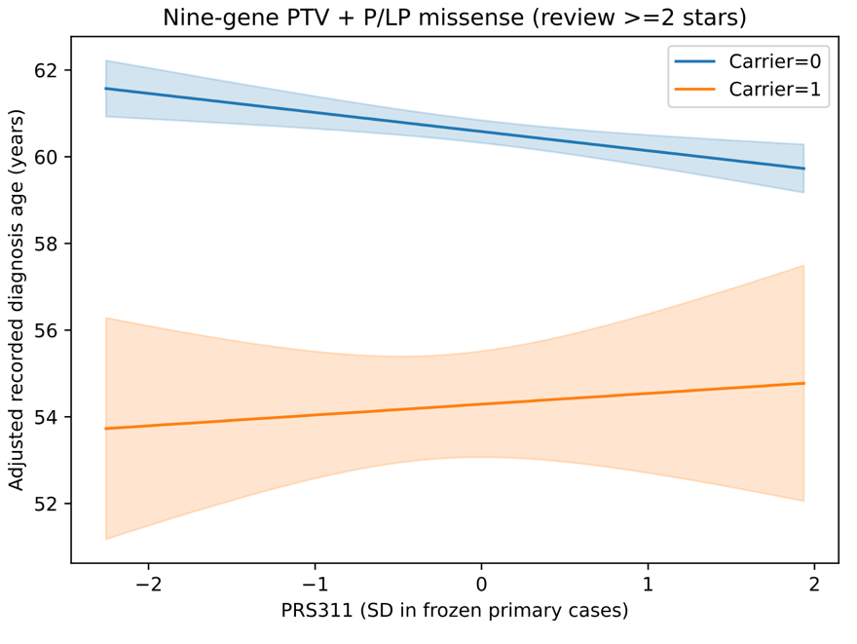
In this exploratory case-only analysis using the expanded nine-gene carrier definition, which included qualifying PTVs and breast cancer-related pathogenic or likely pathogenic missense variants, higher PRS311 was associated with a younger recorded age at diagnosis among non-carriers (-0.44 years per SD; 95% CI, -0.70 to - 0.18). Among carriers, there was no clear statistical evidence of an association (+0.25 years per SD; 95% CI, -0.87 to +1.37), although the wide confidence interval did not exclude either younger or older diagnosis ages with increasing PRS311. The interaction estimate was also inconclusive (+0.69 years per SD; 95% CI, -0.46 to +1.84), providing no clear evidence that the PRS311 association differed between carriers and non-carriers. These findings concern recorded diagnosis age among breast cancer cases and should not be interpreted as associations with early-onset breast cancer risk in the general population.
- Carrier * PRS four groups
 | contrast | estimate_years | se_HC1 | ci_low
1 | high_vs_nonhigh_noncarriers | -0.7944935 | 0.23644284 | -1.257913
2 | high_vs_nonhigh_carriers | 0.59500827 | 1.01747438 | -1.3992049
3 | difference_in_differences | 1.38950178 | 1.04446748 | -0.6576169
4 | double_high_vs_noncarrier_nonhigh | -5.812952 | 1.15067177 | -8.0682272
A conclusion for experiment: In an exploratory analysis among cases, participants with both high PRS311 and a qualifying rare PTV were diagnosed 5.81 years earlier than non-carriers without high PRS311 (95% CI, 3.56–8.07 years). However, the difference in the association of high PRS311 with age at diagnosis between carriers and non-carriers was imprecisely estimated (difference in differences, 1.39 years; 95% CI, −0.66 to 3.44), providing no clear evidence of an interaction.

Abstract
Breast cancer affects approximately one in eight US women during their lifetime, and about 10% of new cases occur before age 45. The joint contribution of common and rare germline variants to breast cancer risk discrimination, and the association of each with age at diagnosis, remain unclear in US cohorts linked to electronic health records. We evaluated a polygenic risk score (PRS311) and a burden score for rare protein-truncating variants in ten susceptibility genes using whole-genome sequencing data from 8,528 breast cancer cases and 134,727 controls of genetically inferred European ancestry in the All of Us Research Program. Using a set of established reference common variants (as well as a set of canonical PTVs in 10 genes), we leveraged composite scores to study breast cancer risk. We computed PRS311() and a rare- variant burden ... Adding PRS311, rare-variant burden, and their interaction to a covariate-only model increased the cross-validated AUC for distinguishing breast cancer cases from controls from 0.745 to 0.780. In the joint model, the odds ratios for breast cancer cases status per standard deviation was 1.55 for PRS311 and 1.25 for rare-variant burden. Among cases, each standard deviation of burden was associated with diagnosis 1.72 years earlier, compared with 0.42 years earlier for PRS311. The proportion carrying a qualifying rare variant declined from 22.6% among cases diagnosed before age 35 to 2.8% among those diagnosed at age 70 or older. Overall, common and rare germline variants provided largely complementary information for distinguish cases from controls, while rare-variant burden was more strongly association with earlier diagnosis age among cases.
${OR}_{\text{PRS}}=e^{β_{\text{PRS}}}$

Introduction
Inherited susceptibility to breast cancer has two well-characterised components. Common variants each carry small effects, and their combined effect is captured by polygenic risk scores such as the 313-variant PRS developed by the Breast Cancer Association Consortium (BCAC)^{[1]}. Rare protein-truncating variants (PTVs) in a small number of genes, including BRCA1, BRCA2, PALB2, ATM and CHEK2, carry moderate to high relative risks; two large case-control studies published in 2021 established which genes and variant classes matter and estimated their effect sizes^{[2,3]}. Both components may be relevant to the age at which breast cancer is diagnosed.
Evidence from carrier cohorts shows that PRS modifies breast cancer risk among BRCA1/BRCA2 carriers^{[4,5]} and carriers of moderate-risk genes^{[6]}. Population biobanks likewise suggest that polygenic background modifies the penetrance of monogenic variants^{[7,8]}. However, much of this evidence comes from clinically ascertained carrier cohorts or European population biobanks. It remains unclear how much each component adds to case-status discrimination in a US cohort linked to electronic health records (EHR), or whether their associations with age at diagnosis differ among cases. High-penetrance carriers tend to be diagnosed younger, whereas evidence for an association between PRS and age at onset is less consistent^{[8]}.
The All of Us Research Program links whole-genome sequencing to EHRs for a large US cohort^{[9,10]}. We used its genetically inferred European-ancestry subset to assess the separate and joint associations of PRS and rare-variant burden with breast cancer case status. We then compared observed case proportions and adjusted odds ratios across PRS and burden strata and examined whether each measure was associated with age at diagnosis among cases.

Methods

Study population
We used the All of Us controlled-tier Curated Data Repository (CDR) version C2025Q4R6 and its short-read whole-genome sequencing (WGS) callsets^{[10]}. Eligible participants were those recorded as female sex at birth with WGS data. All of Us applies sex-concordance checks before release, so we did not exclude participants again on inferred genetic sex. We restricted the analysis to genetically inferred European ancestry, using the program’s ancestry predictions and requiring a predicted European label with a maximum posterior probability above 0.75. The same rule was applied to cases and controls. We removed related individuals by keeping a maximal unrelated set among pairs with KING kinship $>$0.1^{[11]}, and removed samples with genotype missingness above 3%. The flow of participants is shown in Figure 1 and Supplementary Table S1.

Phenotypes
Cases were participants with at least one EHR condition record mapping to the SNOMED concept “Malignant tumor of breast” (OMOP concept 4112853) or any of its descendants. Controls were all other eligible participants. Age at diagnosis was calculated from the date of the earliest qualifying record. Age at last EHR observation was the later of the last EHR record and the date of death. For the case-status models we required a non-missing age at last observation, which excluded 2,051 participants, all of them controls. For the age-at-diagnosis analysis we additionally excluded 532 cases whose earliest breast cancer record was also their first EHR record, because in these women the recorded date cannot be separated from a diagnosis made before EHR follow-up began. In a sensitivity analysis, cases were redefined as participants with at least two qualifying records.

Polygenic risk score
We used PGS000004, the 313-variant BCAC PRS^{[1,12]}, harmonised to GRCh38. Variants were matched to the All of Us array-and-common-allele-frequency (ACAF) callset by chromosome, position and alleles. Where strand or allele orientation was ambiguous, candidate records were resolved by comparing the cohort allele frequency with the published effect-allele frequency. In total, 304 of 313 variants were used: 281 matched directly, 23 were resolved by allele frequency, one remained ambiguous and eight were absent. Missing genotypes were imputed using PLINK2 reference. The primary score, PRS311, omits two variants that tag CHEK2 c.1100delC. This avoids counting that variant twice, since it also enters the rare-variant burden. Scores were standardised within the analysis cohort. In sensitivity analyses we restricted the score to the 281 directly matched variants and repeated the scoring without mean imputation. For participant i, the score was the weighted sum of effect-allele dosages across retained PRS311 loci:
$${PRS311}_{i}=\sum_{j∈J_{311}}{w_{j}}d_{ij}$$
Here J₃₁₁ is the set of matched loci after removing the two CHEK2-tagging variants, wⱼ is the published per-effect-allele weight, and dᵢⱼ is the effect-allele dosage (0, 1 or 2), replaced by the cohort mean dosage when missing.

Rare-variant burden
The panel comprised ten genes: the nine established by BCAC (ATM, BARD1, BRCA1, BRCA2, CHEK2, PALB2, RAD51C, RAD51D, TP53)^{[2]} and MAP3K1, which reached exome-wide significance in a recent meta-analysis^{[13]}. Qualifying variants were stop-gained, frameshift, splice-donor and splice-acceptor variants on the canonical transcript, rated high-confidence by LOFTEE^{[14]}, with an allele frequency below 1% in the All of Us European-ancestry callset (Supplementary Table S3). We defined a PTV carrier as a participant with at least one qualifying PTV passing genotype-level quality filters in any of the ten panel genes; participants with no such variant were classified as non-carriers. Carrier status was used for binary comparisons, whereas the burden score summed the log-odds-ratio weights of genes with qualifying PTVs, counting each gene only once. Carrier genotypes were retained if genotype quality was at least 20 and the variant allele fraction was 0.30–0.80 for heterozygous or at least 0.80 for homozygous-alternate calls. These thresholds were fixed before any association results were examined.
Burden_{rare} was the sum, over the panel genes in which a participant carried a qualifying variant, of the gene’s log odds ratio for PTVs. Gene weights came from BCAC^{[2]}; for CHEK2 the overall PTV estimate (OR 2.54) was used because c.1100delC falls below the 1% frequency threshold. For MAP3K1 the meta-analysis did not report a pooled odds ratio, so we used the only reported estimate, from the Million Women Study (OR 6.25, 95% CI 0.95–41.03)^{[13]}. Given the uncertainty of this weight, we repeated all analyses with the nine-gene panel. A second sensitivity analysis used a uniform frequency threshold of 0.1%. This excludes c.1100delC, so the CHEK2 weight was changed to the estimate without that variant (OR 2.13) and the full PRS313 was used. The weights and the carrier counts per gene are given in Supplementary Table S2. Explicitly, the participant-level score was:
$${Burden}_{i}=\sum_{g∈G}{\ln\left({OR}_{g}\right)} C_{ig}$$
G is the ten-gene panel, ORg is the published PTV odds ratio for gene g, and Cᵢg equals 1 if participant i carried at least one qualifying PTV in that gene and 0 otherwise. Multiple qualifying variants within a gene therefore contributed only once.

Statistical analysis
Case-status discrimination. We fitted logistic regression models of case status on standardised PRS311, standardised Burden_{rare} and their product. Covariates were age at last EHR observation, the first ten genetic principal components (PCs), sequencing centre and sequencer model. Four models were compared: covariates only, covariates plus PRS311, covariates plus Burden_{rare}, and a joint model with both scores and their interaction. Coefficients are reported from fits to the full cohort, with heteroskedasticity-robust (HC1) standard errors. Discrimination was estimated with 5-fold cross-validation repeated 10 times, stratified jointly on case status and carrier status. For each repeat we computed the out-of-fold AUC of every model and compared paired models with DeLong’s test^{[15]}. We report the mean over repeats. The logistic model has no tuning parameters and we did no model selection, so nested cross-validation was not needed. Calibration of the joint model was assessed on out-of-fold predictions. To describe the joint distribution we also estimated odds ratios by PRS311 ventile (reference: lowest ventile) and by burden category (non-carrier; single moderate-risk gene; single high-penetrance gene; two or more genes), following the presentation of Mazzarotto et al.^{[16]}.
$$\operatorname{logit}{​}\left[\operatorname{Pr}\left(Y_{i}=1\right)\right]=β_{0}+β_{P}P_{i}+β_{B}B_{i}+β_{PB}\left(P_{i}×B_{i}\right)+γ^{T}X_{i}$$
Yᵢ denotes case status; Pᵢ and Bᵢ are the standardised PRS311 and rare-variant burden; and Xᵢ contains age at last EHR observation, PCs 1–10, sequencing centre and sequencer model. The coefficient βPB tests departure from multiplicative odds for the two genetic measures. The reduced comparison models omit the corresponding score terms and interaction.
Age at diagnosis among cases. We then examined whether the genetic measures associated with case status also related to timing among women with breast cancer. We regressed age at diagnosis (years, as a continuous outcome) on standardised Burdenrare and PRS311, adjusting for PCs 1–10, with HC1 standard errors. The contribution of each score was summarised by the change in R² when it was removed from the joint model.
$$A_{i}=α_{0}+α_{B}B_{i}+α_{P}P_{i}+\sum_{k=1}^{10}{δ_{k}}{PC}_{ki}+ε_{i}.$$
Aᵢ is age at diagnosis for case i; Pᵢ and Bᵢ are standardised within the age-at-diagnosis analysis cohort. Coefficients αB and αP therefore give the adjusted difference in age in years per standard deviation of each score.
Sensitivity and post hoc analyses. The pre-specified sensitivity analyses were the nine-gene panel, the 0.1% frequency threshold with PRS313, the 281-variant PRS, PRS without mean imputation, class-balanced weighting for the case-status models, inclusion of cases whose diagnosis was their first EHR record in the age-at-diagnosis analysis, and the rule-of-two case definition. Contrasts of early-onset ($<$45 years) with later-onset cases, carrier rates at the extremes of PRS, and PRS-by-carrier interaction on age at diagnosis were not pre-specified. These are reported as exploratory analyses in Supplementary Table S6.
Pre-specification. The analysis plan, thresholds and sensitivity analyses were fixed before this cohort was analysed. However, an earlier version of the analysis had examined a self-reported-White cohort drawn from the same data. The analysis was therefore pre-specified but not blinded, and it was not registered.
Disclosure control. In line with the All of Us Data and Statistics Dissemination Policy, no count between 1 and 19 participants (or between 1 and 39 alleles) is reported, either directly or in a form from which it could be derived. Affected cells are shown as “$<$20” and, where needed, a second cell is suppressed so that the first cannot be recovered by subtraction. Test statistics whose inputs include such a cell are not reported.
Software. Analyses used Python with pandas, statsmodels and scikit-learn; Hail 0.2.137; PLINK 2^{[17]}; and bcftools. Analysis code is available at https://github.com/martina-yu/AoU_Comr.

Results

Study cohort
Of 295,706 women with WGS, 150,900 had genetically inferred European ancestry. After relatedness and sample QC, 143,255 remained: 8,528 cases and 134,727 controls (Figure 1; Supplementary Table S1). Cases had a mean age at diagnosis of 59.9 years (SD 11.8). They were older at enrolment than controls (64.0 vs 51.2 years) and more often reported a family history of breast cancer (28.0% vs 19.1%), although family history was missing for 61.6% of controls (Table 1). In the modelling cohort of 141,204 participants, 2,749 (1.9%) carried a qualifying PTV in a panel gene. Per-gene counts are given in Supplementary Table S2.

Case-status discrimination
In controls, PRS311 was not correlated with carrier status or with Burden_{rare} ($r=-0.004$, 95% CI $-0.009$ to 0.001; $n=132,676$; Supplementary Figure S1). In the joint model, the odds ratio per standard deviation was 1.55 (1.52–1.59) for PRS311 and 1.25 (1.23–1.26) for Burden_{rare}. The interaction term was small and negative (OR 0.97, 0.96–0.98; $P=1.2×{10}^{-5}$), which means the PRS gradient was slightly shallower at higher burden (Table 2).
The covariate-only model already reached a cross-validated AUC of 0.745, mostly because of age at last EHR observation. That variable reflects how long participants have been followed in the EHR, not a risk factor, so the absolute AUC should not be read as a measure of predictive performance. The informative quantities are the increments (Figure 3). Adding PRS311 raised the AUC by 0.023 (0.021–0.025) and adding Burden_{rare} by 0.012 (0.010–0.014). The joint model reached 0.780, 0.035 (0.032–0.037) above covariates alone and 0.011 (0.010–0.013) above the PRS-only model. The results varied very little across the ten repeats (range of mean AUC $<$0.0003 for every model). Out-of-fold predictions were well calibrated (calibration slope 1.00, intercept 0.00; Supplementary Figure S2). McFadden pseudo-$R^{2}$ increments showed the same pattern (Supplementary Table S5).

Joint distribution of common and rare risk
Across PRS deciles, the observed case proportion rose steadily among non-carriers and was higher among carriers in every decile (Figure 4a). Relative to expectations from a model without interaction, carriers in the upper deciles had fewer cases than expected and carriers in the lower deciles more, consistent with the negative interaction term. The odds ratio rose smoothly across PRS ventiles, reaching 5.61 (4.75–6.62) in the top ventile relative to the bottom. By burden category, the odds ratio relative to non-carriers was 2.35 (1.99–2.77) for a single moderate-risk gene and 7.76 (6.68–9.02) for a single high-penetrance gene. The group carrying PTVs in two or more genes had only 24 members and was not interpreted.

Age at diagnosis among cases
Among 7,996 cases, each standard deviation of Burden_{rare} was associated with diagnosis 1.72 years earlier (95% CI 1.43–2.00; $P=7.1×{10}^{-32}$). Each standard deviation of PRS311 was associated with diagnosis 0.42 years earlier (0.17–0.67; $P=0.001$) (Table 3; Figure 5). Both scores together explained little of the variation in age at diagnosis ($R^{2}$ 2.4%). Almost all of this came from burden: removing Burden_{rare} lowered $R^{2}$ by 2.1 percentage points, and removing PRS311 by 0.1. Carrier frequency fell steadily with age at diagnosis, from 22.6% (16.7–29.8) in cases diagnosed before 35 years and 18.7% at 35–39 years to 2.8% (2.1–3.7) at 70 years or older (Figure 5c).
In exploratory analyses, cases diagnosed before 45 years were more often carriers than later-onset cases (13.8% vs 4.9%), but their mean PRS311 was the same ($P=0.76$). The association of PRS311 with age at diagnosis did not differ detectably between carriers and non-carriers (interaction $+0.78$ years, $-0.37$ to 1.92; Supplementary Table S6). Among cases, carriers were less common at the top than at the bottom of the PRS distribution (4.4% vs 9.9%), whereas in controls the two rates were similar (1.7% vs 1.8%). This is expected when two independent causes are conditioned on their common outcome, and it should not be read as a biological relationship between the scores.

Sensitivity analyses
All pre-specified sensitivity analyses gave estimates close to the primary ones (Figure 6; Supplementary Table S4). In the case-status analysis, the odds ratio per standard deviation ranged from 1.54 to 1.58 for PRS311 and from 1.24 to 1.27 for Burden_{rare}. In the age-at-diagnosis analysis, the burden coefficient ranged from $-1.70$ to $-1.75$ years and the PRS coefficient from $-0.36$ to $-0.59$ years. Dropping MAP3K1 changed no estimate by more than 0.01.

Discussion
In 143,255 women of genetically inferred European ancestry in All of Us, PRS311 and a weighted burden of PTVs in ten susceptibility genes were uncorrelated in controls, yet each added to case-status discrimination. Their joint effects were close to multiplicative, with a small negative interaction. Among cases, greater rare-variant burden was associated with earlier diagnosis, whereas the PRS association was smaller. Together, the two scores explained only a small proportion of variation in age at diagnosis.
Our per-standard-deviation PRS odds ratio of 1.55 is close to the 1.61 reported for PRS313 in the BCAC validation^{[1]}. It was obtained in a cohort defined from EHR codes rather than a research case-control design. The odds ratios by burden category are consistent with the gene-level estimates used as weights^{[2,3]}. This agreement is expected in part, because the weights were taken from those studies, but it indicates that case ascertainment from the EHR did not badly distort the relative risks. The sub-multiplicative interaction agrees with reports that the relative effect of PRS is somewhat attenuated among carriers of high-penetrance variants^{[4–6]}. In practical terms, a purely multiplicative model may slightly overstate risk for carriers who also have a high PRS.
The stronger association of rare-variant burden with age at diagnosis is consistent with prior evidence that carriers of high-penetrance PTVs tend to be diagnosed younger^{[8]}. The small continuous PRS association, together with no detectable difference in mean PRS between early- and later-onset cases, suggests a more modest association of common-variant risk with timing in this cohort.
This study has several limitations. First, it is restricted to genetically inferred European ancestry. The 0.75 posterior threshold excludes admixed participants, mostly at the boundary between European and Middle Eastern ancestry, so the exclusion is not random. The findings may not generalise to other ancestries, which will be addressed in follow-up work. Second, phenotypes come from EHR records: age at diagnosis may be misdated, prevalent cases diagnosed before EHR follow-up are only partly removed, and controls may include undiagnosed or unrecorded cases. Third, the covariate-only AUC is inflated by differences in EHR follow-up between cases and controls, so we emphasise increments rather than absolute discrimination. Fourth, carriers of PTVs in two or more genes and carriers in the rarest genes (TP53, RAD51C, RAD51D, MAP3K1) were too few for gene-specific inference, and the MAP3K1 weight is imprecise and derived in part from cohorts that may overlap with All of Us. Fifth, missense variants were not included in the burden score. Finally, the analysis plan was fixed before this cohort was analysed but after an earlier version of the analysis in a related cohort, so it was pre-specified but not blinded.
In summary, common and rare germline variation contribute largely independent information on breast cancer risk in a large US EHR-linked cohort, and rare PTV burden is the stronger marker of early onset.

Declarations
Acknowledgements. [Insert the All of Us Research Program acknowledgement verbatim from the program’s “How to acknowledge and cite” guidance, including the NIH grant numbers it lists, and thank the participants.]
Data availability. Individual-level data are available to registered researchers through the All of Us Researcher Workbench (controlled tier, CDR C2025Q4R6). Aggregate results that meet the dissemination policy and the analysis code are available at https://github.com/martina-yu/AoU_Comr.
Ethics. [Statement on All of Us IRB oversight and participant consent.]
Funding. [Funders and grant numbers.]
Competing interests. [To be completed.]
Author contributions. [To be completed.]

References
1. Mavaddat N, Michailidou K, Dennis J, et al. Polygenic risk scores for prediction of breast cancer and breast cancer subtypes. Am J Hum Genet. 2019;104(1):21–34.
2. Breast Cancer Association Consortium; Dorling L, Carvalho S, Allen J, et al. Breast cancer risk genes—association analysis in more than 113,000 women. N Engl J Med. 2021;384(5):428–439.
3. Hu C, Hart SN, Gnanaolivu R, et al. A population-based study of genes previously implicated in breast cancer. N Engl J Med. 2021;384(5):440–451.
4. Kuchenbaecker KB, McGuffog L, Barrowdale D, et al. Evaluation of polygenic risk scores for breast and ovarian cancer risk prediction in BRCA1 and BRCA2 mutation carriers. J Natl Cancer Inst. 2017;109(7):djw302.
5. Barnes DR, Rookus MA, McGuffog L, et al. Polygenic risk scores and breast and epithelial ovarian cancer risks for carriers of BRCA1 and BRCA2 pathogenic variants. Genet Med. 2020;22(10):1653–1666.
6. Gallagher S, Hughes E, Wagner S, et al. Association of a polygenic risk score with breast cancer among women carriers of high- and moderate-risk breast cancer genes. JAMA Netw Open. 2020;3(7):e208501.
7. Fahed AC, Wang M, Homburger JR, et al. Polygenic background modifies penetrance of monogenic variants for tier 1 genomic conditions. Nat Commun. 2020;11(1):3635.
8. Mars N, Widén E, Kerminen S, et al. The role of polygenic risk and susceptibility genes in breast cancer over the course of life. Nat Commun. 2020;11(1):6383.
9. The All of Us Research Program Investigators. The “All of Us” Research Program. N Engl J Med. 2019;381(7):668–676.
10. The All of Us Research Program Genomics Investigators. Genomic data in the All of Us Research Program. Nature. 2024;627(8003):340–346.
11. Manichaikul A, Mychaleckyj JC, Rich SS, Daly K, Sale M, Chen WM. Robust relationship inference in genome-wide association studies. Bioinformatics. 2010;26(22):2867–2873.
12. Lambert SA, Gil L, Jupp S, et al. The Polygenic Score Catalog as an open database for reproducibility and systematic evaluation. Nat Genet. 2021;53(4):420–425.
13. Collister JA, Smith-Byrne K, Atkins J, et al. Meta-analysis of exome-wide gene burden analysis of breast cancer susceptibility genes. npj Breast Cancer. 2025;11:111.
14. Karczewski KJ, Francioli LC, Tiao G, et al. The mutational constraint spectrum quantified from variation in 141,456 humans. Nature. 2020;581(7809):434–443.
15. DeLong ER, DeLong DM, Clarke-Pearson DL. Comparing the areas under two or more correlated receiver operating characteristic curves: a nonparametric approach. Biometrics. 1988;44(3):837–845.
16. Mazzarotto F, Gennarelli M, Murray G, Osimo EF. The complementary roles of rare variant burden scores and common variant polygenic risk scores in genetic risk prediction of complex disorders. bioRxiv. 2025. doi:10.1101/2025.09.15.676308.
17. Chang CC, Chow CC, Tellier LC, Vattikuti S, Purcell SM, Lee JJ. Second-generation PLINK: rising to the challenge of larger and richer datasets. GigaScience. 2015;4:7.

Tables
Table 1. Characteristics of the study cohort. Counts between 1 and 19, and cells from which such a count could be derived, are suppressed.
 | Case-status cases | Case-status controls | Age-analysis cases
N | 8,528 | 134,727 | 7,996
Age at diagnosis, years, mean (SD) | 59.9 (11.8) |  | 60.2 (11.8)
Age at diagnosis, years, median [IQR] | 60.7 [51.5-68.4] |  | 61.1 [51.9-68.7]
Age at enrollment, years, mean (SD) | 64.0 (11.6) | 51.2 (16.8) | 64.1 (11.6)
Age at last EHR observation, years, mean (SD) | 68.1 (11.7) | 53.9 (17.0) | 68.2 (11.7)
BMI, kg/m$​^{2}$, mean (SD) | 28.5 (6.7) | 29.4 (7.9) | 28.5 (6.8)
PRS311 (raw score), mean (SD) | 0.4 (0.6) | 0.1 (0.6) | 0.4 (0.6)
BMI missing, n (%) | 92 (1.1) | 5,107 (3.8) | suppressed (secondary)
Age at last EHR observation missing, n (%) | 0 (0.0) | 2,051 (1.5) | 0 (0.0)
Menopausal status, n (%)
Premenopausal | 620 (7.3) | 49,735 (36.9) | 592 (7.4)
Postmenopausal | 7,610 (89.2) | 75,983 (56.4) | 7,133 (89.2)
Uncertain or unknown | 149 (1.7) | 4,801 (3.6) | suppressed (secondary)
Missing | 149 (1.7) | 4,208 (3.1) | suppressed (secondary)
Family history of breast cancer, n (%)
Positive (first- or second-degree relative) | 2,392 (28.0) | 25,689 (19.1) | 2,236 (28.0)
Negative | 3,393 (39.8) | 26,004 (19.3) | 3,188 (39.9)
Missing | 2,743 (32.2) | 83,034 (61.6) | 2,572 (32.2)
Smoking status, n (%)
Never | 4,932 (57.8) | 80,136 (59.5) | 4,612 (57.7)
Former or unknown currency | 2,974 (34.9) | 35,699 (26.5) | 2,796 (35.0)
Current | 442 (5.2) | 13,614 (10.1) | suppressed (secondary)
Missing | 180 (2.1) | 5,278 (3.9) | suppressed (secondary)
Self-reported race, n (%)
White | 8,117 (95.2) | 126,790 (94.1) | 7,611 (95.2)
Other, multiple, or not reported | 411 (4.8) | 7,937 (5.9) | 385 (4.8)
Sequencing center, n (%)
Broad Institute | 4,963 (58.2) | 79,319 (58.9) | 4,639 (58.0)
University of Washington | 997 (11.7) | 16,069 (11.9) | 936 (11.7)
Baylor College of Medicine | 2,568 (30.1) | 39,339 (29.2) | 2,421 (30.3)
Sequencer, n (%)
NovaSeq6000 S4 | 8,293 (97.2) | 127,580 (94.7) | suppressed (secondary)
NovaSeq X 25B | 235 (2.8) | 7,147 (5.3) | suppressed (secondary)

Table 2. Joint logistic model of case status and cross-validated discrimination. Models adjust for age at last EHR observation, PC1–10, sequencing centre and sequencer. The AUC 95% CI is DeLong’s interval for the first repeat. For $Δ$AUC, the interval is the mean of the per-repeat DeLong intervals and $P$ is the median over repeats. $n=141,204$ (8,528 cases).
 | Estimate (95% CI) | $P$​
A. Joint model, full cohort (OR per SD)
PRS311 | 1.55 (1.52–1.59) | $<{10}^{-300}$​
Burden$​_{\text{rare}}$ | 1.25 (1.23–1.26) | $3.6×{10}^{-201}$​
PRS311 $×$ Burden$​_{\text{rare}}$ | 0.97 (0.96–0.98) | $1.2×{10}^{-5}$​
B. Out-of-fold AUC, 10 $×$ 5-fold CV (mean; 95% CI from repeat 1)
Covariates-only | 0.745 (0.741–0.750) | –
PRS-only | 0.768 (0.764–0.773) | –
Burden-only | 0.757 (0.752–0.761) | –
Joint | 0.780 (0.775–0.784) | –
C. $Δ$AUC (mean over repeats; DeLong 95% CI and median P)
PRS-only vs Covariates-only | 0.023 (0.021–0.025) | $1.1×{10}^{-81}$​
Burden-only vs Covariates-only | 0.012 (0.010–0.014) | $3.7×{10}^{-35}$​
Joint vs Covariates-only | 0.035 (0.032–0.037) | $3.0×{10}^{-120}$​
Joint vs PRS-only | 0.011 (0.010–0.013) | $1.4×{10}^{-34}$​
Joint vs Burden-only | 0.023 (0.021–0.025) | $2.3×{10}^{-82}$​

Table 3. Age at diagnosis among cases ($n=7,996$). OLS adjusted for PC1–10; negative coefficients indicate earlier diagnosis.
 | Estimate (95% CI) / $R^{2}$ | $P$ / unique $R^{2}$
A. Primary OLS model (years per SD; HC1 robust 95% CI)
Burden$​_{\text{rare}}$ | $-$1.72 ($-$2.00 to $-$1.43) | $7.1×{10}^{-32}$​
PRS311 | $-$0.42 ($-$0.67 to $-$0.17) | 0.001
B. Nested models ($R^{2}$; unique $R^{2}$ = loss when the term is dropped from the joint model)
PCs-only | 0.20% | 0.17%
PRS311-only+PCs | 0.26% | 0.13%
Burden_rare-only+PCs | 2.24% | 2.10%
Joint (primary) | 2.37% | –

Figures
[Figure 1 — study flow diagram (to be done)]
Figure 1. Study flow. Women with WGS in All of Us (295,706) $→$ genetically inferred European ancestry (150,900) $→$ unrelated, sample QC passed (143,255; 8,528 cases, 134,727 controls) $→$ case-status modelling cohort with age at last EHR observation (141,204) and age-at-diagnosis cohort excluding cases whose diagnosis was their first EHR record (7,996). Counts at each step are in Supplementary Table S1.
(a)
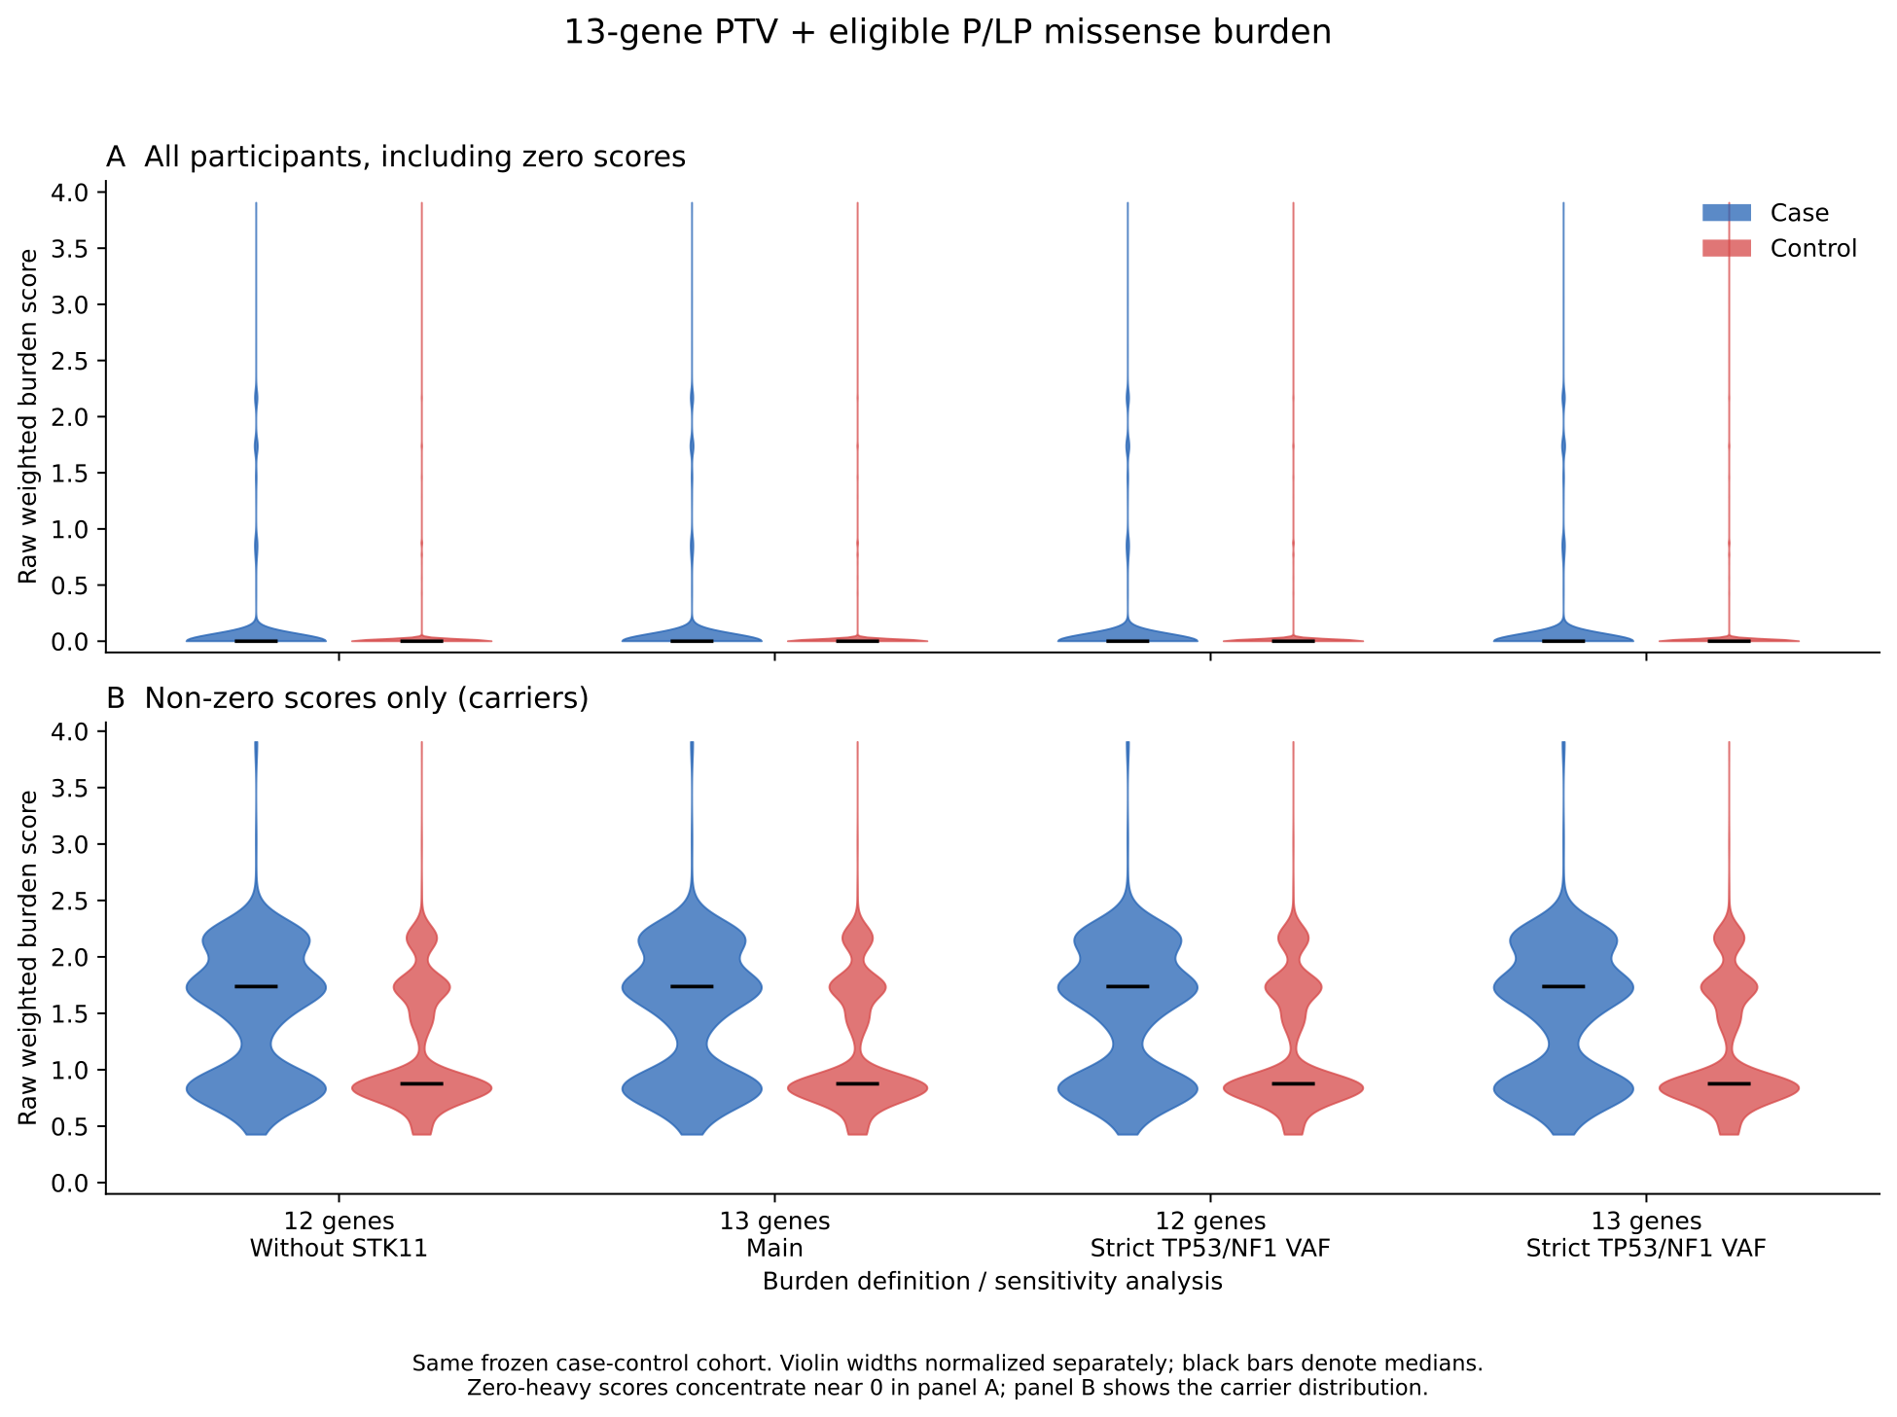
(b)
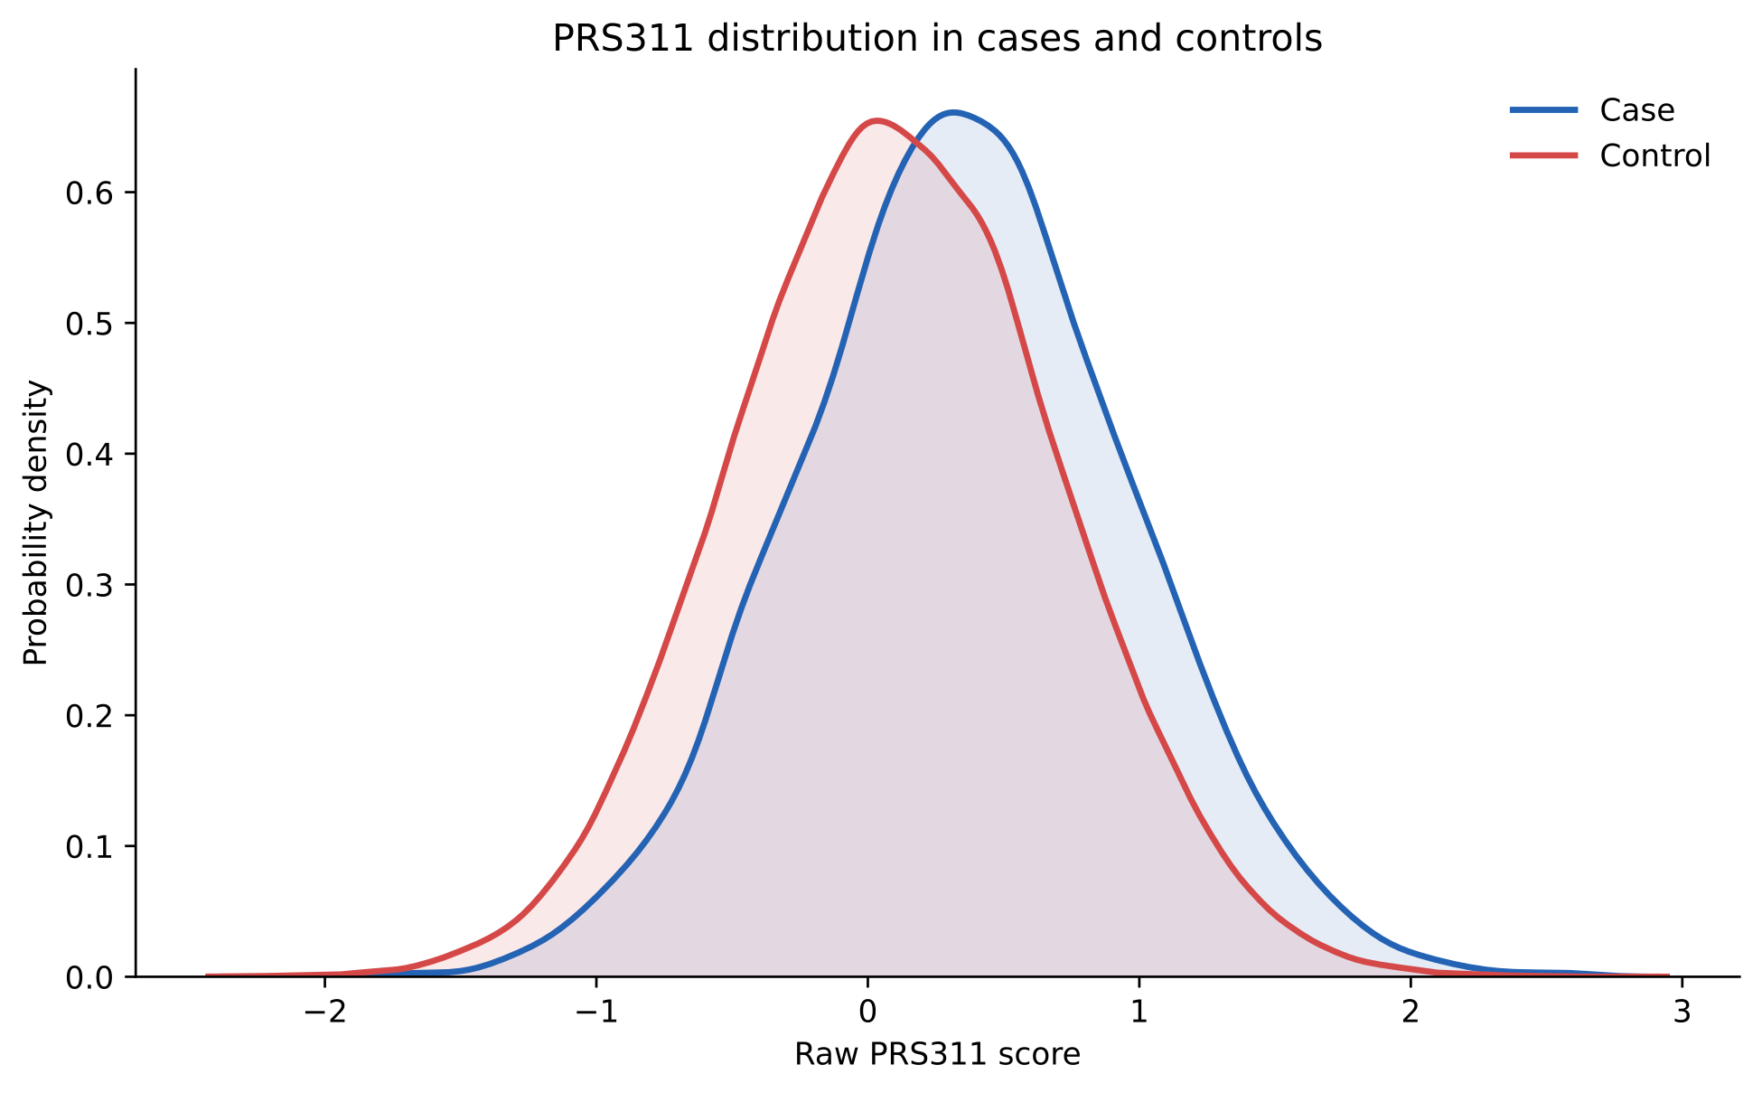
(c)
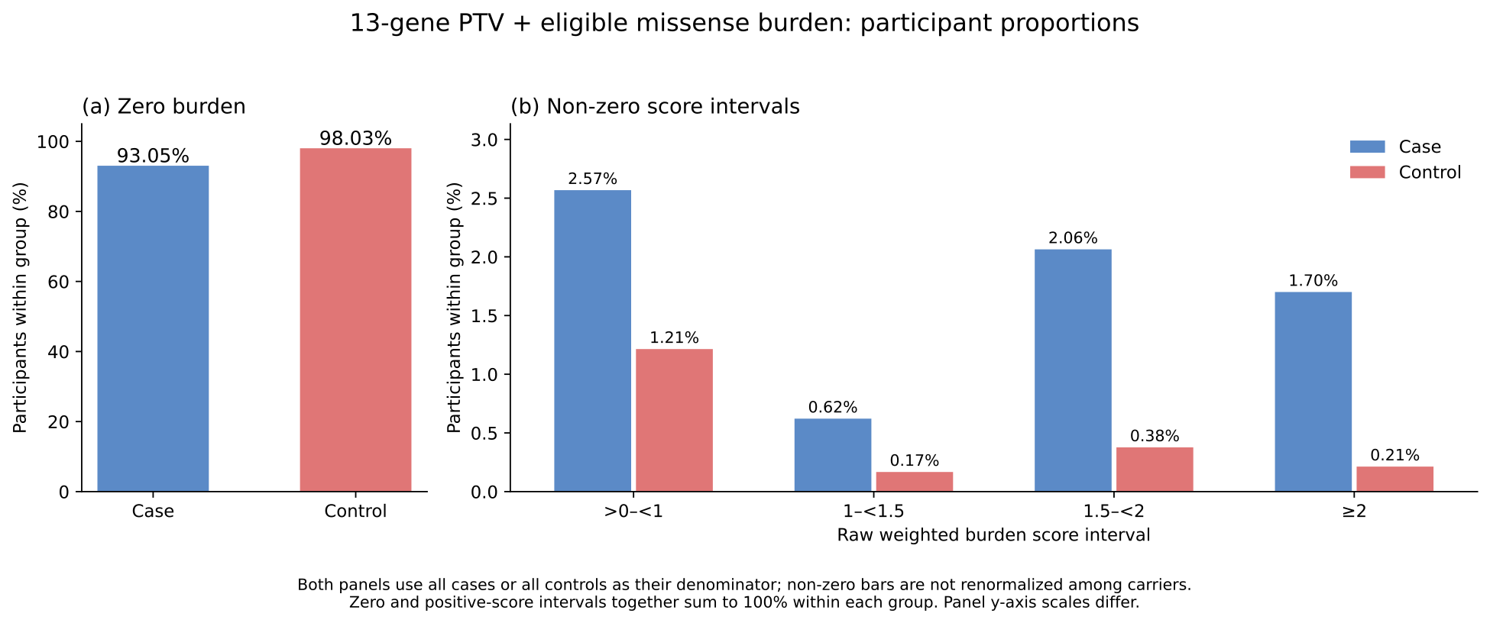
(d)
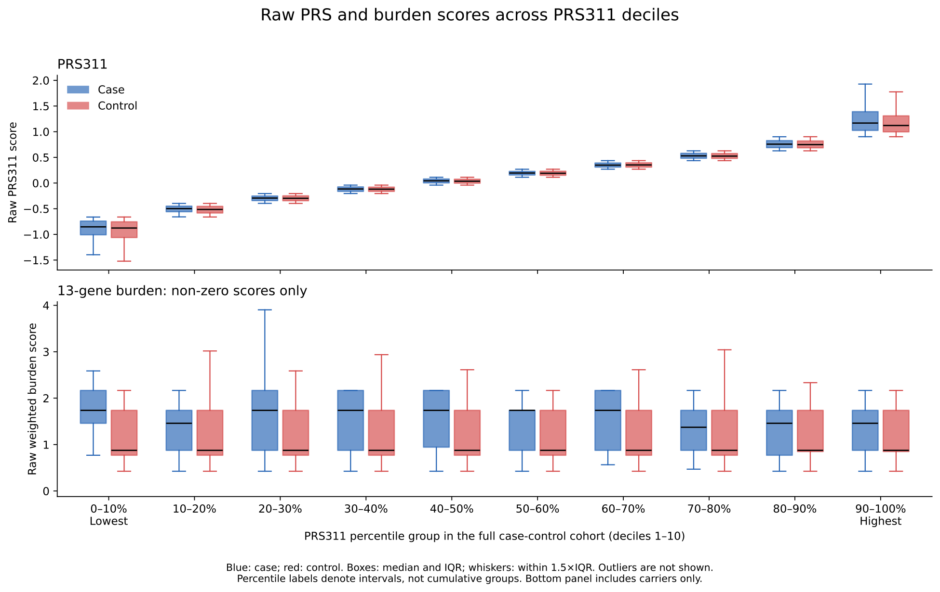
Figure 2. Descriptive distributions of genetic scores in the fixed case-control cohort (n=141,204). (a) Raw burden distributions for the 13-gene and 12-gene (without STK11) panels, with main and stricter TP53/NF1 VAF definitions; upper panel includes all participants and lower panel includes carriers only. Violin widths are normalized separately and black bars denote medians. (b) Kernel density estimates of raw PRS311 by case status. (c) Within-group percentages of zero and positive 13-gene burden scores. (d) Raw PRS311 and nonzero 13-gene burden by full-cohort PRS311 deciles; boxes show median and IQR and whiskers observations within 1.5×IQR; outliers are not shown. Case and control distributions are shown in blue and red, respectively. Burden includes PTVs plus qualifying P/LP missense variants.
(a)
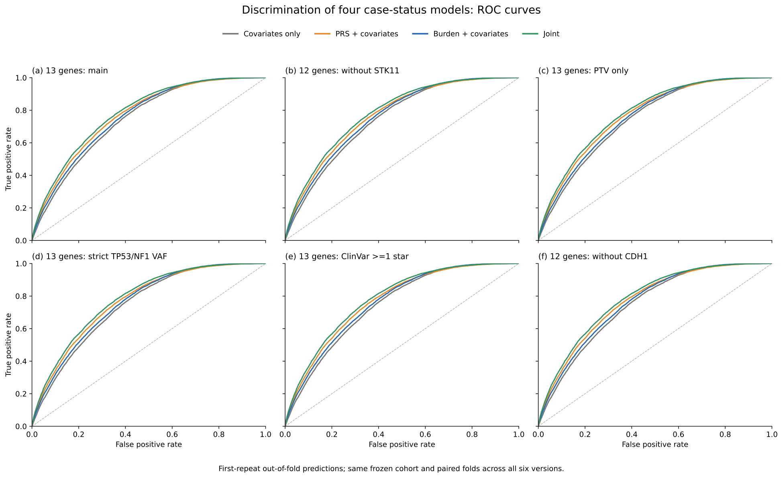
(b)
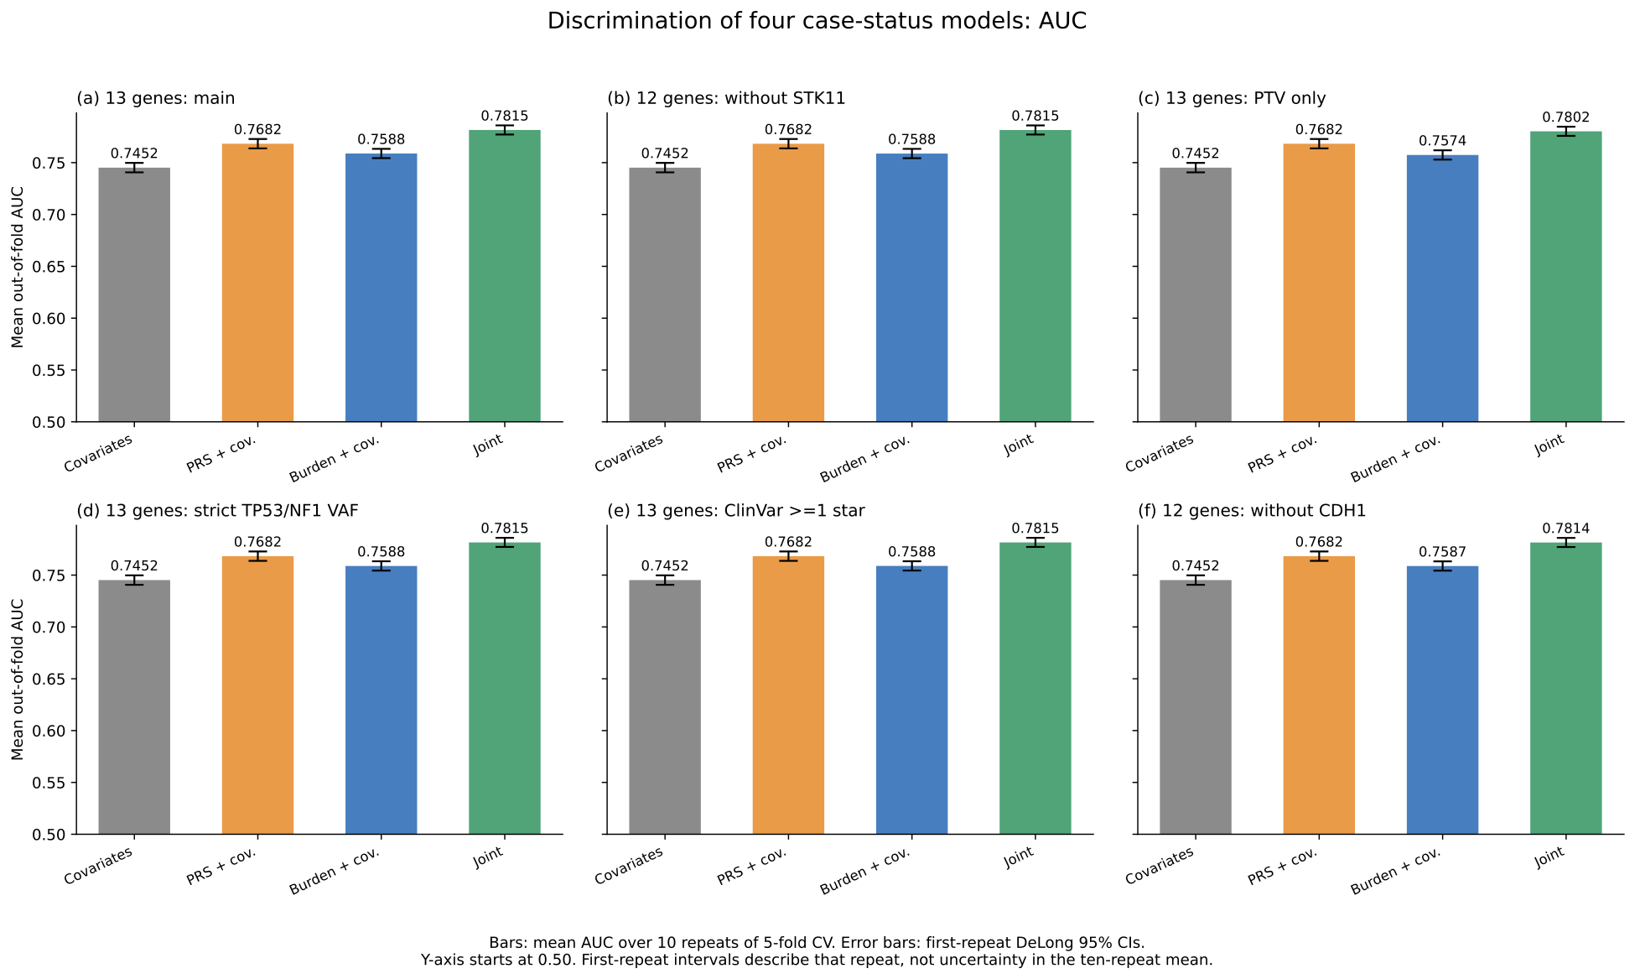
Figure 3. Discrimination of the four case-status models. (a) ROC curves of first-repeat out-of-fold predictions from the four case-status models. (b) Mean out-of-fold AUC over 10 repeats of 5-fold cross-validation. Error bars are DeLong 95% CIs for the first repeat. These intervals are not confidence intervals for the ten-repeat mean. All models include the same clinical/technical covariates; the joint model also includes PRS×burden. Same frozen cohort (N=141,204; cases=8,528) and original paired folds. Existing PRS and joint predictions reused; missing covariates-only and burden-only predictions fitted. Current variant definition remains provisional.
(a)
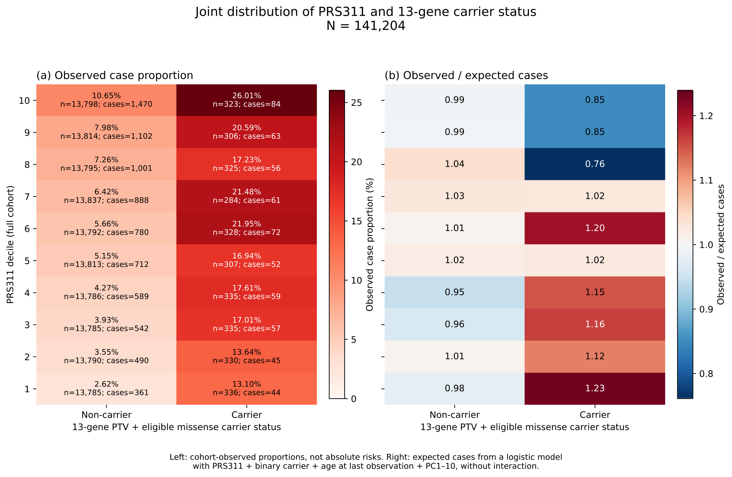
Figure 4. Joint distribution of PRS311 and 13-gene PTV plus eligible P/LP missense carrier status (N=141,204). Left: observed case proportion by full-cohort PRS311 decile and binary carrier status. These proportions depend on the case-control composition of the cohort and are not absolute risks. Right: observed/expected cases; expected counts are sums of fitted probabilities from a logistic model without interaction, adjusted for continuous PRS311, binary carrier status, age at last EHR observation and PC1–10. The adjustment matches the prior figure; sequencing site and sequencer are not included in this descriptive expectation model. O/E differences do not independently establish biological interaction. Current variant definition is provisional.
(a)
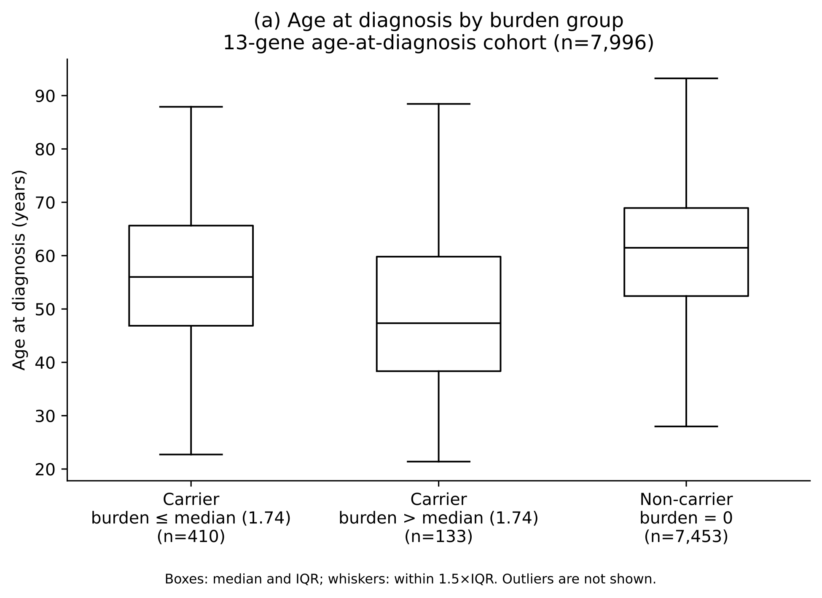
(b)
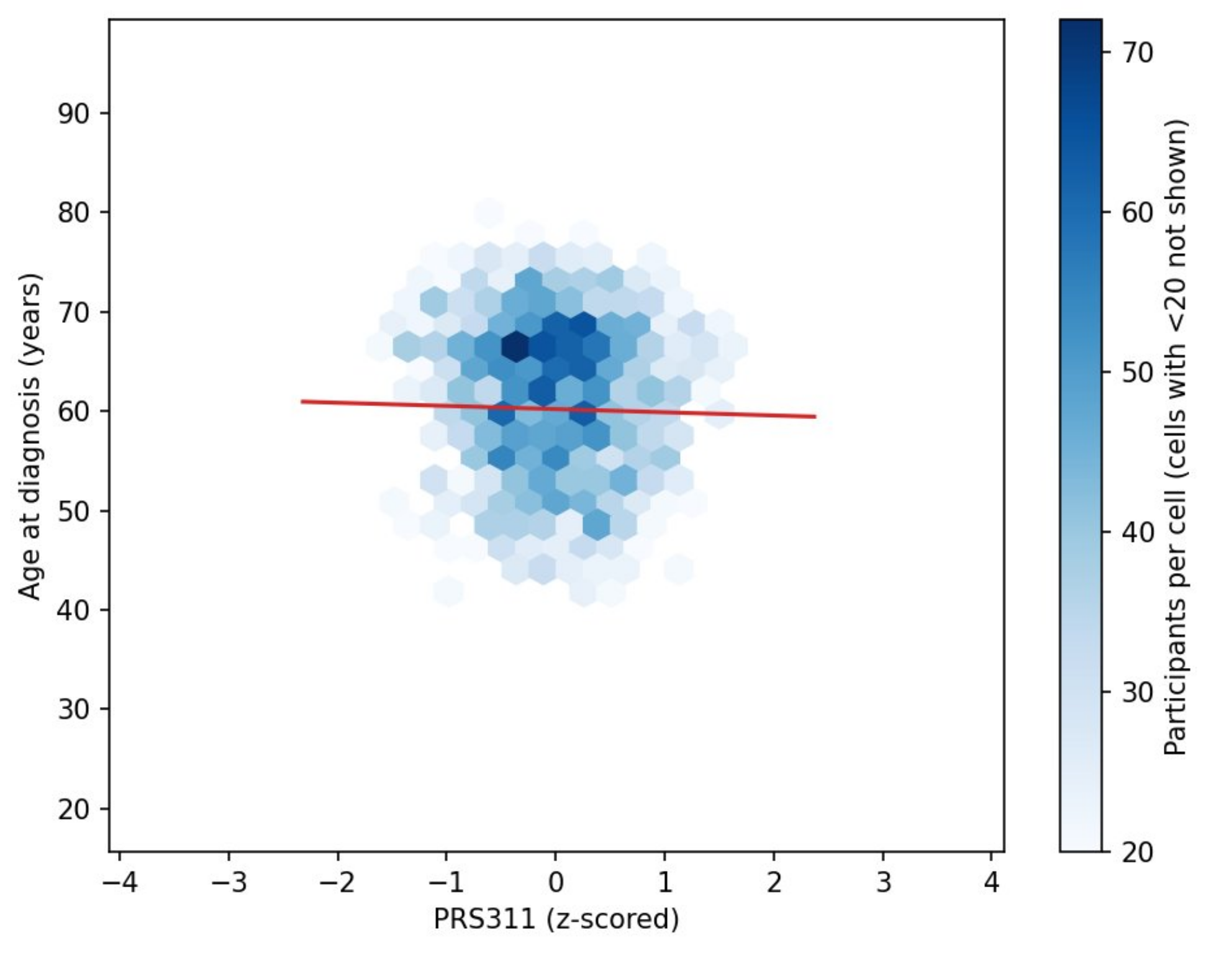
(c)
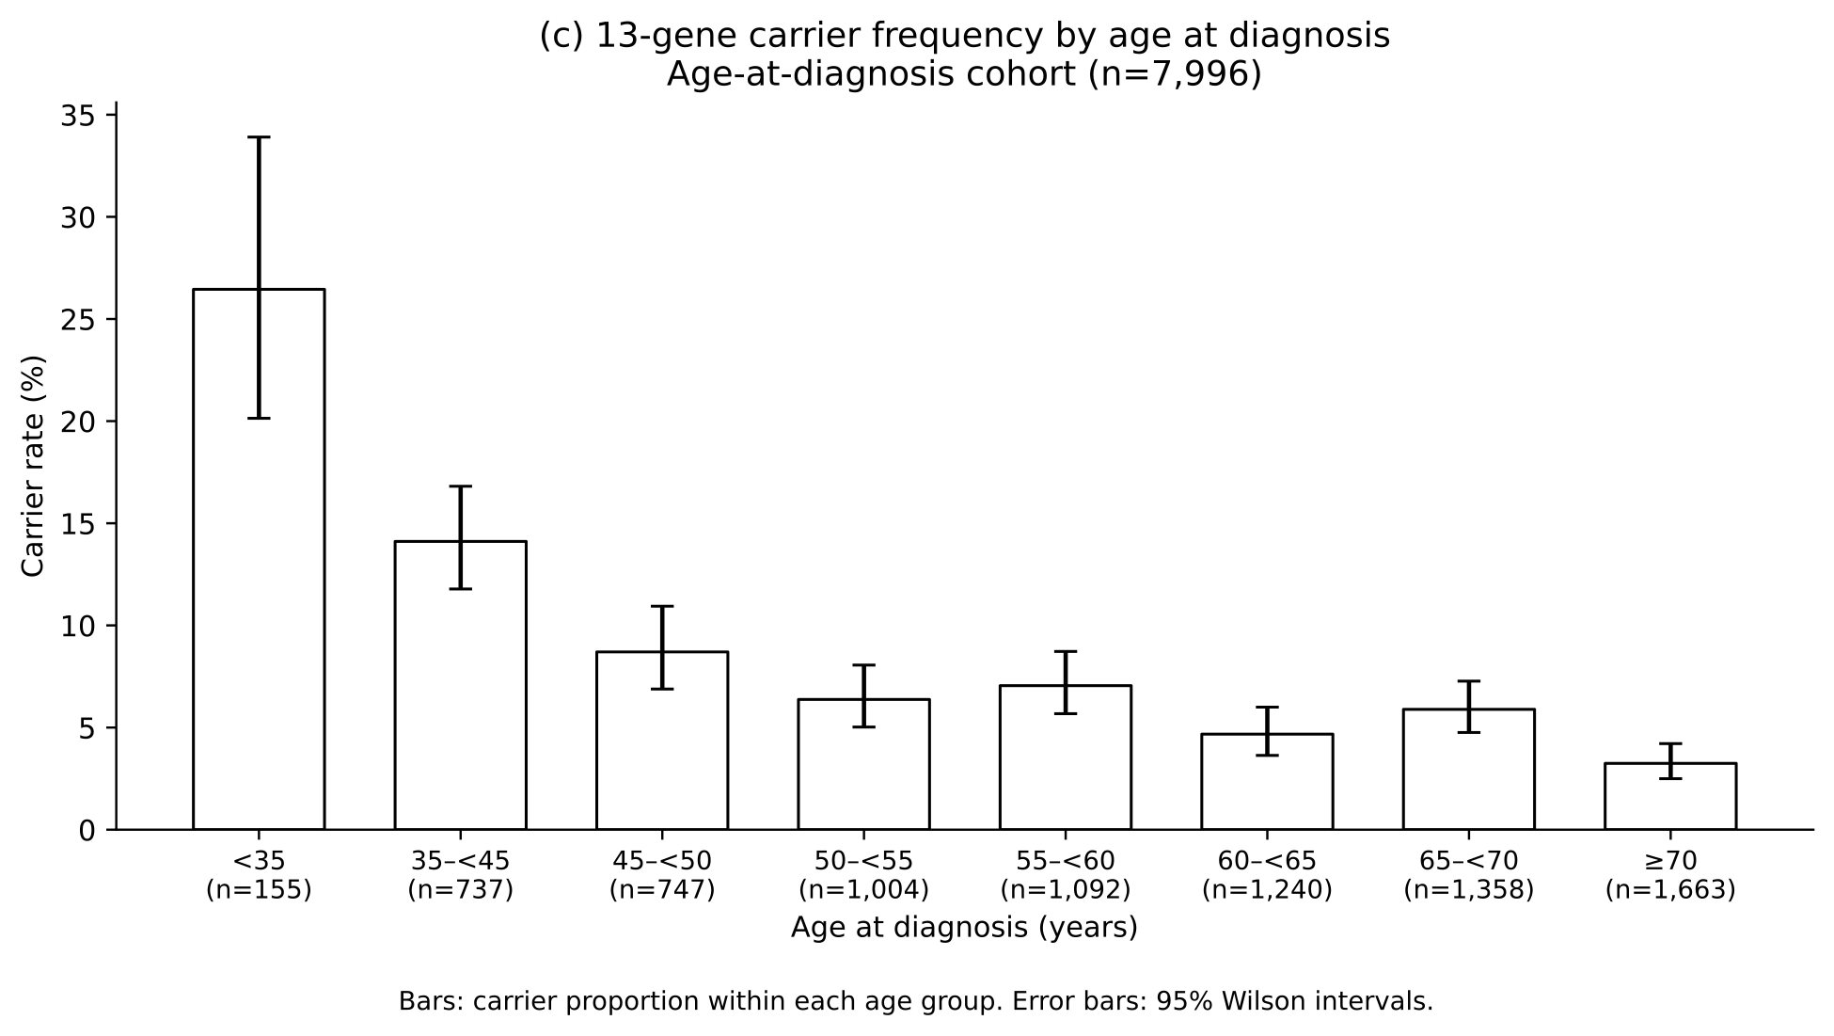
Figure 5. Rare and common risk and recorded age at diagnosis among cases (n=7,996). (a) Age by 13-gene burden group, with carriers divided at their burden median (1.73695, displayed as 1.74) and non-carriers shown separately. Boxes show median and IQR; whiskers extend to observations within 1.5×IQR; outliers are not shown. (b) PRS311 against age at diagnosis, reused unchanged. Hexagonal bins with fewer than 20 cases are not shown; the red line is an unadjusted linear fit. (c) Carrier proportions within age groups with 95% Wilson intervals. Age groups are left-inclusive and right-exclusive, with <35 and ≥70 as the extreme groups. Carrier status uses the current 13-gene PTV plus qualifying P/LP missense definition.
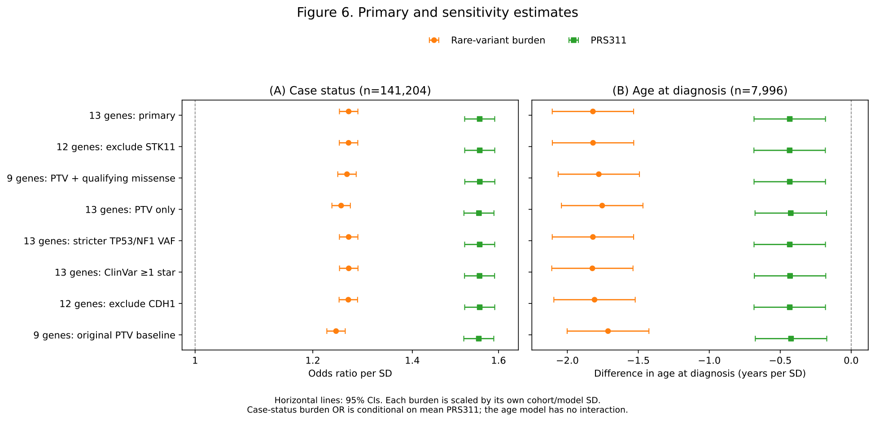
Figure 6. Primary and sensitivity estimates. (A) Case-status odds ratios per SD from the joint logistic model, including PRS311, rare-variant burden, their interaction, age at last EHR observation and PC1–10 (n=141,204). (B) Difference in recorded age at diagnosis per SD among cases from an OLS model including PRS311, burden and PC1–10, without interaction (n=7,996). Points show estimates for burden (orange circles) and PRS311 (green squares); horizontal lines show 95% CIs based on HC1 robust standard errors.
The primary analysis uses the 13-gene PTV plus qualifying P/LP missense burden. Sensitivities exclude STK11 (12 genes), restrict the panel to the nine original genes with the same current PTV/missense rules and Rowlands weights, include PTVs only, apply stricter heterozygous VAF (0.30–0.70) to TP53/NF1, relax the ClinVar review threshold to ≥1 star, or exclude CDH1 (12 genes). The original nine-gene PTV analysis using its original definitions and weights is shown as a historical comparison baseline. It differs from the current nine-gene PTV plus missense analysis in eligibility/QC and weights as well as variant type.
The same fixed participants and PRS311 are used in each model. Burden is scaled by its own SD within each model cohort, so differences in per-SD coefficients do not isolate effects of changing variant definitions. In panel A, the burden OR is conditional on PRS311 at its mean; it is not a marginal carrier OR. The current variant definition remains provisional.

