Supplementary material
Tables S1–S6 are also provided as data in supplementary_tables.xlsx. As in the main text, counts between 1 and 19 and cells from which such counts could be derived are suppressed (“$<$20”, “suppressed (secondary)”). “$≥$20” marks cells reported only as being above the threshold.
Table S1. Sample QC. Participants remaining after each step, with the age at diagnosis of the remaining cases.
Step | Cases | Controls | Total | Age at dx, median [IQR] | Age at dx, mean (SD)
Female (sex at birth) participants with WGS, case or control | 13,536 | 282,170 | 295,706 | 59.2 [50.0-67.4] | 58.7 (12.0)
Genetically inferred European ancestry (ancestry_pred_other = eur) | 8,917 | 141,983 | 150,900 | 60.7 [51.5-68.4] | 59.9 (11.8)
Unrelated (KING kinship $≤$ 0.1, maximal unrelated set); Sample missingness $≤$ 3% (case-status analysis cohort) | 8,528 | 134,727 | 143,255 | 60.7 [51.5-68.4] | 59.9 (11.8)
Diagnosis date not equal to first EHR record (age-at-diagnosis analysis cohort) | 7,996 | – | – | 61.1 [51.9-68.7] | 60.2 (11.8)

Table S2. Burden weights and carriers of qualifying PTVs by gene, in the case-status modelling cohort ($n=141,204$). This is the only table reporting per-gene carrier counts. †Placing MAP3K1 in the moderate tier is debatable; the gene is also a common-variant locus. OR = PTV odds ratio used as the weight (Dorling et al. 2021; MAP3K1: Collister et al. 2025). The CHEK2 weight is 2.13 in the 0.1% frequency analysis.
Gene | Tier | OR | Carriers | Cases | Controls
ATM | moderate | 2.10 | 448 | 55 | 393
BARD1 | moderate | 2.09 | 151 | 26 | 125
BRCA1 | high-penetrance | 10.57 | 374 | 125 | 249
BRCA2 | high-penetrance | 5.85 | 592 | 154 | 438
CHEK2 | moderate | 2.54 | 781 | 89 | 692
PALB2 | high-penetrance | 5.02 | 216 | 41 | 175
RAD51C | moderate | 1.93 | 78 | $<$20 | suppressed (secondary)
RAD51D | moderate | 1.80 | 82 | $<$20 | suppressed (secondary)
TP53 | high-penetrance | 3.06 | 23 | $<$20 | $<$20
MAP3K1 | moderate† | 6.25 | 28 | $<$20 | suppressed (secondary)

Table S3. Qualifying variants per gene and variant set, counted over the All of Us callset. The primary burden uses the first column. PTV, protein-truncating variant (LOFTEE high confidence); MAF, allele frequency in the All of Us European-ancestry callset; REVEL columns are the discovery masks (PTVs plus missense variants with REVEL at or above the threshold, MAF $<$1%). A per-variant list with binned frequencies is in the code repository (results/table/12_qualifying_variants_public.csv.gz).
Gene | PTV $<$1% | PTV $<$0.1% | Missense $<$0.1% | Missense $<$1% | PTV+REVEL$≥$0.75 | PTV+REVEL$≥$0.50 | PTV+REVEL$≥$0.25
ATM | 534 | 534 | 2,818 | 2,830 | 821 | 1,237 | 1,937
BARD1 | 107 | 107 | 877 | 881 | 166 | 252 | 474
BRCA1 | 315 | 315 | 1,700 | 1,703 | 429 | 1,311 | 1,925
BRCA2 | 557 | 557 | 3,350 | 3,365 | 685 | 1,106 | 2,051
CHEK2 | 166 | 165 | 586 | 586 | 267 | 384 | 523
MAP3K1 | 75 | 75 | 1,409 | 1,411 | 85 | 137 | 553
PALB2 | 219 | 219 | 1,148 | 1,151 | 219 | 231 | 349
RAD51C | 95 | 95 | 385 | 388 | 108 | 161 | 236
RAD51D | 91 | 91 | 338 | 338 | 107 | 141 | 230
TP53 | 47 | 47 | 379 | 379 | 203 | 292 | 408
Total | 2,206 | 2,205 | 12,990 | 13,032 | 3,090 | 5,252 | 8,686

Table S4. Primary and sensitivity analyses. Case-status analysis: OR per SD from the joint logistic model. Age-at-diagnosis analysis: difference in age at diagnosis (years) per SD among cases.
Analysis | $$n$$ | Burden (95% CI) | PRS311 (95% CI) | $P$ (burden / PRS)
Case-status analysis (OR per SD)
Primary (10 genes, MAF$<$1%) | 141,204 | 1.25 (1.23–1.26) | 1.55 (1.52–1.59) | $3.6×{10}^{-201}$ / $<{10}^{-300}$
9-gene panel (excl. MAP3K1) | 141,204 | 1.24 (1.23–1.26) | 1.55 (1.52–1.59) | $5.6×{10}^{-198}$ / $<{10}^{-300}$
MAF$<$0.1% burden + PRS313 | 141,204 | 1.24 (1.22–1.25) | 1.55 (1.51–1.59) | $2.8×{10}^{-194}$ / $4.2×{10}^{-300}$
PRS restricted to 281 loci | 141,204 | 1.25 (1.23–1.26) | 1.54 (1.50–1.57) | $2.6×{10}^{-200}$ / $1.1×{10}^{-286}$
PRS without mean imputation | 141,204 | 1.25 (1.23–1.26) | 1.55 (1.52–1.59) | $5.5×{10}^{-201}$ / $<{10}^{-300}$
Class-balanced weights | 141,204 | 1.27 (1.25–1.29) | 1.55 (1.51–1.59) | $1.8×{10}^{-201}$ / $3.2×{10}^{-253}$
Case definition: rule of two | 140,107 | 1.24 (1.22–1.26) | 1.58 (1.54–1.62) | $5.7×{10}^{-187}$ / $2.1×{10}^{-288}$
Age-at-diagnosis analysis (years per SD)
Primary (10 genes, MAF$<$1%) | 7,996 | $-$1.72 ($-$2.00 to $-$1.43) | $-$0.42 ($-$0.67 to $-$0.17) | $7.1×{10}^{-32}$ / 0.001
9-gene panel (excl. MAP3K1) | 7,996 | $-$1.71 ($-$2.00 to $-$1.43) | $-$0.42 ($-$0.68 to $-$0.17) | $2.2×{10}^{-31}$ / $9.7×{10}^{-4}$
PRS restricted to 281 loci | 7,996 | $-$1.71 ($-$2.00 to $-$1.43) | $-$0.38 ($-$0.64 to $-$0.13) | $9.3×{10}^{-32}$ / 0.003
PRS without mean imputation | 7,996 | $-$1.71 ($-$2.00 to $-$1.43) | $-$0.41 ($-$0.66 to $-$0.16) | $7.6×{10}^{-32}$ / 0.001
Including cases with BC as first record | 8,528 | $-$1.75 ($-$2.03 to $-$1.48) | $-$0.36 ($-$0.60 to $-$0.11) | $3.0×{10}^{-36}$ / 0.004
Case definition: rule of two | 6,945 | $-$1.70 ($-$2.00 to $-$1.41) | $-$0.59 ($-$0.86 to $-$0.32) | $1.9×{10}^{-29}$ / $1.5×{10}^{-5}$

Table S5. McFadden pseudo-$R^{2}$ of the four case-status models (full cohort) and increments between nested models.
Model / comparison | Pseudo-$R^{2}$
Covariates-only | 0.0984
PRS-only | 0.1197
Burden-only | 0.1098
Joint | 0.1318
Joint - PRS-only | +0.0121
Joint - Burden-only | +0.0219
PRS-only - Covariates-only | +0.0212
Burden-only - Covariates-only | +0.0114

Table S6. Exploratory (not pre-specified) analyses. (A) Carrier rate at the extremes of PRS311 (full-cohort percentiles). Among cases, the lower carrier rate at high PRS arises from conditioning on case status, not from a relationship between the scores; in controls the two scores are independent. (B) Early- vs later-onset cases (892 vs 7,104); Mann–Whitney test for PRS311, $χ^{2}$ test for carrier rate. (C) Age at diagnosis regressed on PRS311, carrier status and their product, adjusted for PC1–10 (HC1 standard errors). The mixture-category comparison (PRS-high and carrier) is not tested because an input cell has fewer than 20 cases.
 | High vs low / estimate | Difference (95% CI) | $$P$$
A. Carrier rate, highest vs lowest PRS311 group
case, top vs bottom decile | 4.4% vs 9.9% | $-$5.4 ($-$8.5 to $-$2.4) | $$2.1×{10}^{-5}$$
control, top vs bottom decile | 1.7% vs 1.8% | $-$0.2 ($-$0.5 to 0.1) | 0.280
case, top vs bottom quintile | 4.5% vs 8.5% | $-$4.1 ($-$6.0 to $-$2.1) | $$2.5×{10}^{-6}$$
control, top vs bottom quintile | 1.6% vs 1.8% | $-$0.2 ($-$0.4 to 0.0) | 0.090
B. Early ($<$45 y) vs late ($≥$45 y) diagnosis
Carrier rate | 13.8% vs 4.9% | 8.9 pp | $$8.9×{10}^{-27}$$
PRS311 (mean z) | $-$0.008 vs 0.001 | $-$0.009 | 0.758
C. Age at diagnosis $∼$ PRS311 $×$ carrier (OLS, years)
PRS311 (non-carriers) | $-$0.44 | ($-$0.70 to $-$0.18) | $$7.8×{10}^{-4}$$
Carrier | $-$6.16 | ($-$7.40 to $-$4.91) | $$4.0×{10}^{-22}$$
PRS311 $×$ carrier | 0.78 | ($-$0.37 to 1.92) | 0.183
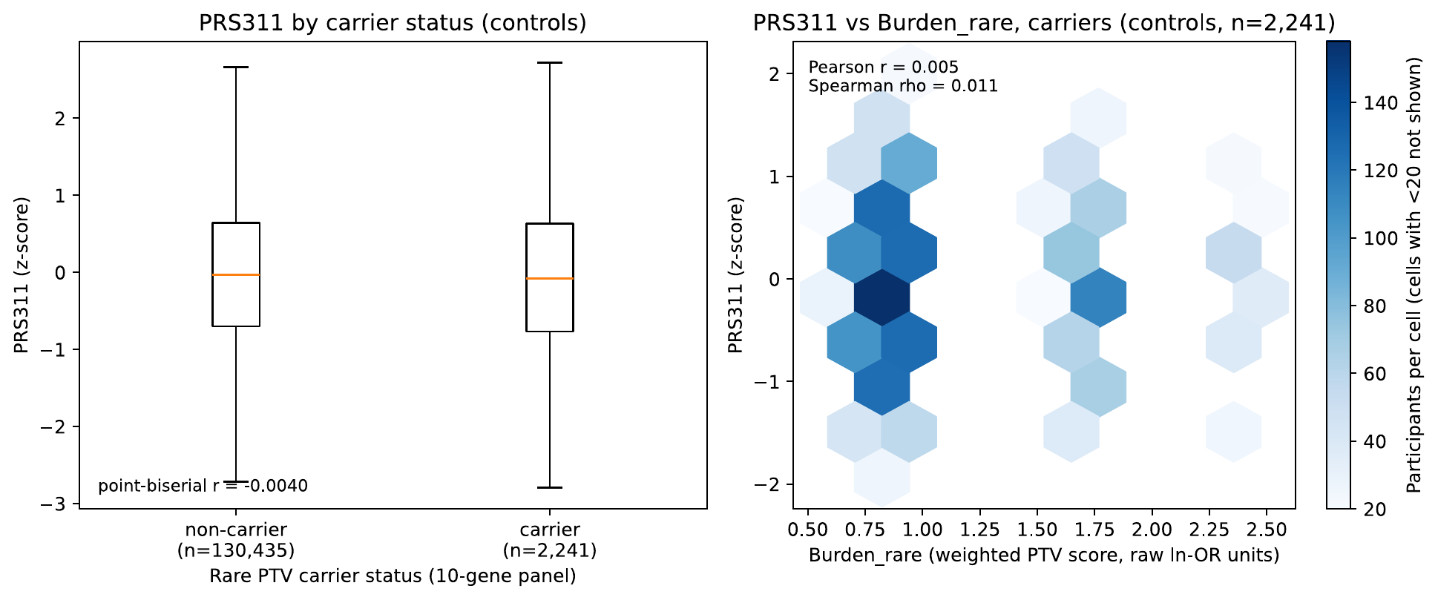
Figure S1. PRS311 and rare-variant burden in controls. Left: PRS311 distribution by carrier status. Right: PRS311 against rare-variant burden among carriers (hexagonal bins with fewer than 20 participants are not shown). Cases are excluded because conditioning on case status induces a correlation between independent risk factors.
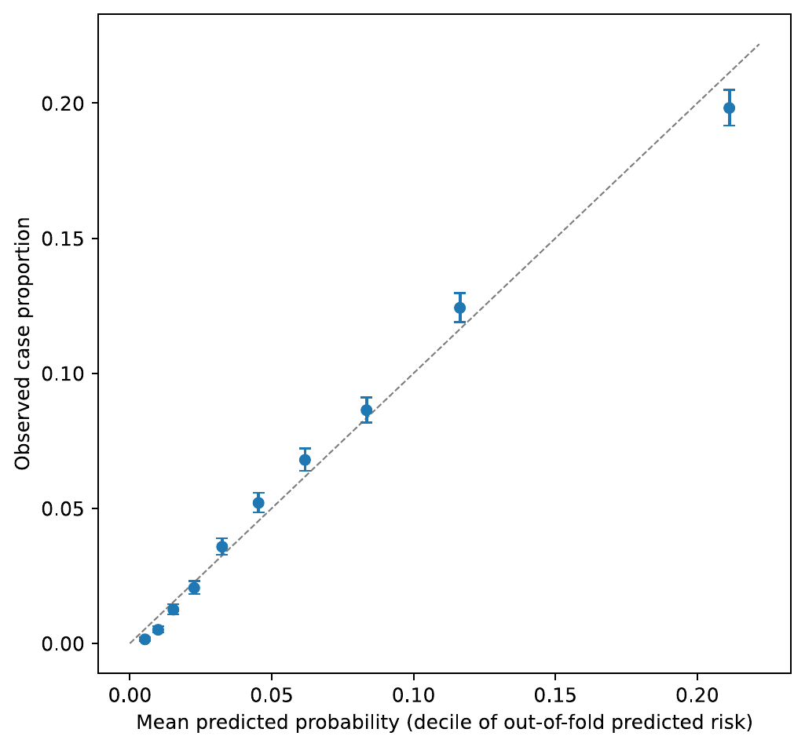
Figure S2. Calibration of the joint case-status model: observed case proportion against mean predicted probability in bins of out-of-fold predictions.
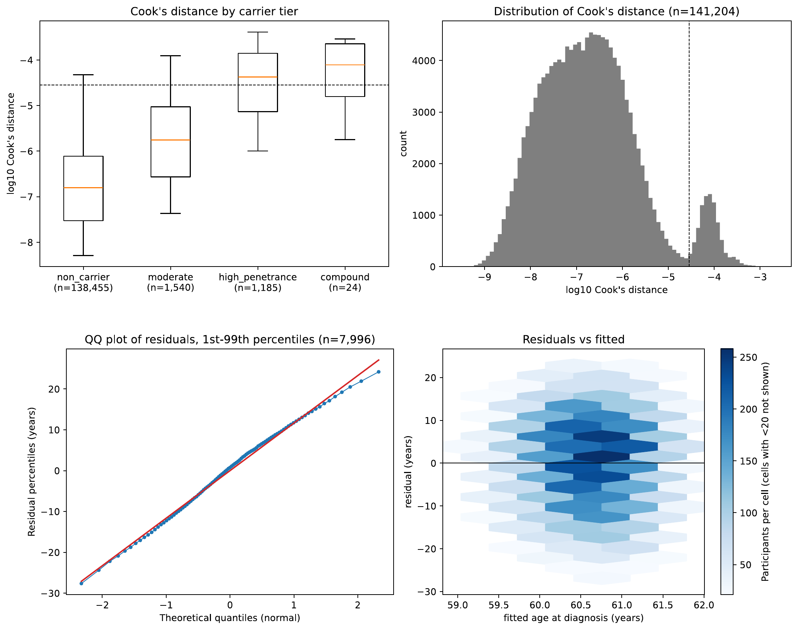
Figure S3. Model diagnostics. (a) Cook’s distance for the joint case-status model by carrier tier (whiskers 5th–95th percentile; dashed line 4/$n$), and its distribution (bins with fewer than 20 participants are not shown). (b) Age-at-diagnosis OLS residuals: QQ plot restricted to the 1st–99th percentiles, and residuals against fitted values (hexagonal bins with fewer than 20 cases are not shown).
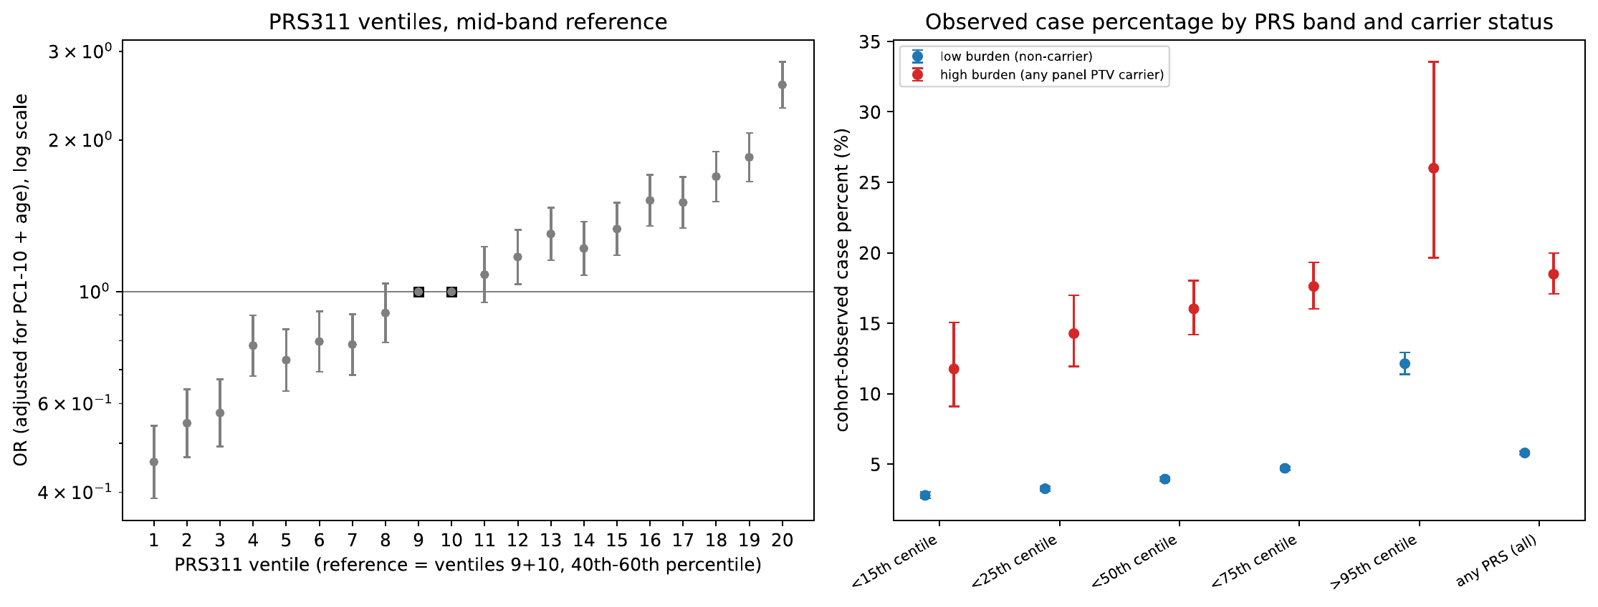
Figure S4. Alternative presentations of the joint distribution. Left: PRS311 ventile odds ratios with the middle ventiles (9–10) as reference. Right: observed case percentage by PRS band and carrier status. The percentages depend on the case-control composition of the cohort; they are not positive predictive values or absolute risks, and only the ratio between carriers and non-carriers is interpretable.
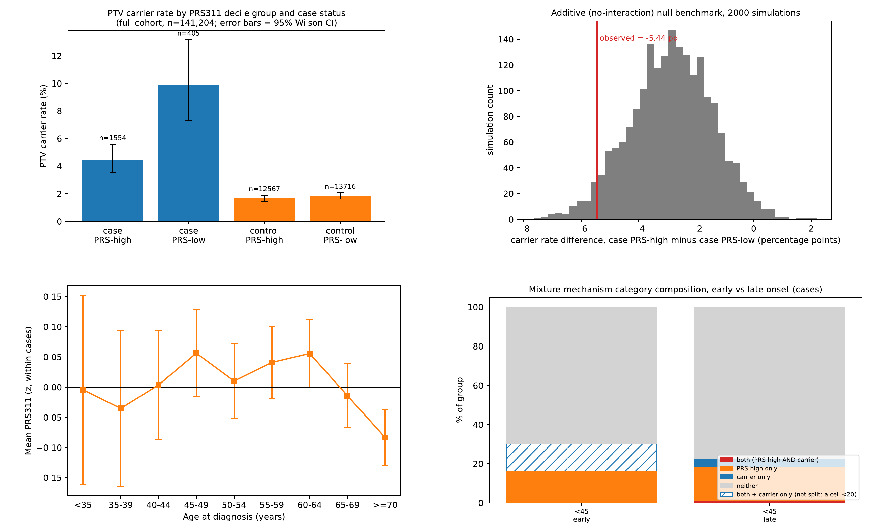
Figure S5. Exploratory analyses. (a) Carrier rate in the top and bottom PRS311 deciles, by case status. (b) Difference in carrier rate between PRS extremes among simulated cases under a model with no interaction: a lower carrier rate at high PRS among cases arises without any interaction. (c) PRS311 by age at diagnosis. (d) Composition of early- and later-onset cases by PRS-high (top decile) and carrier status. In the early-onset group the “both” and “carrier only” categories are merged because one of them has fewer than 20 cases.
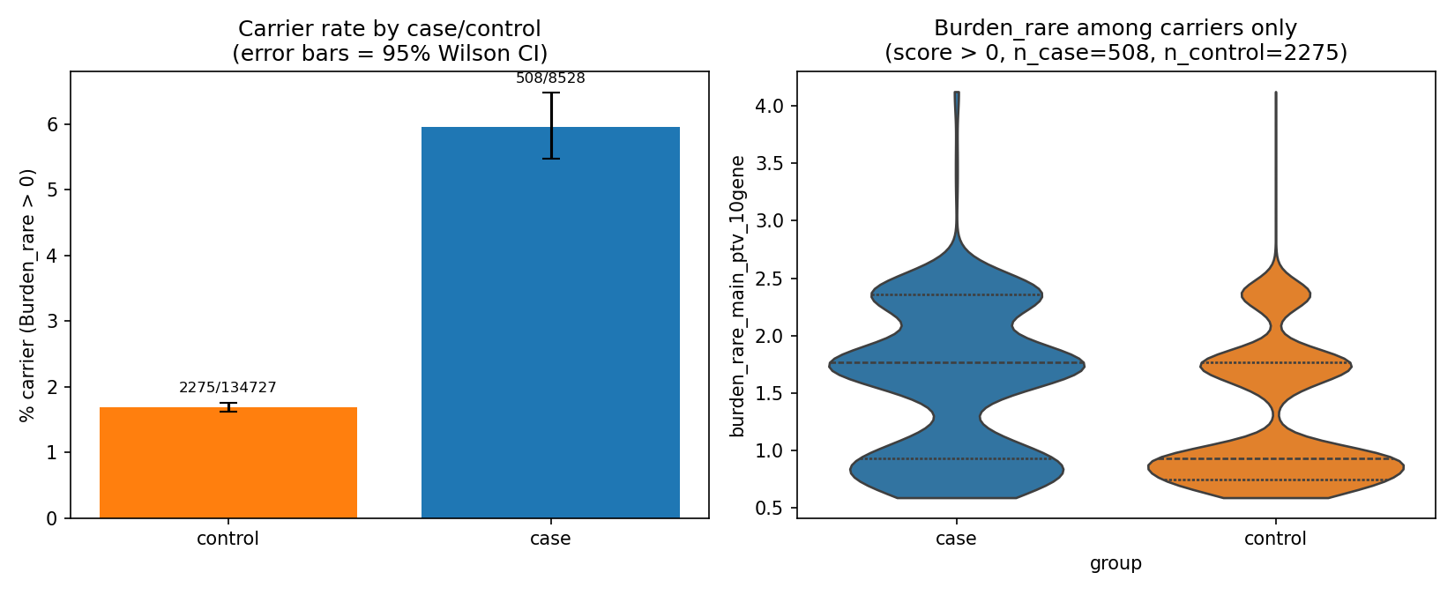 | 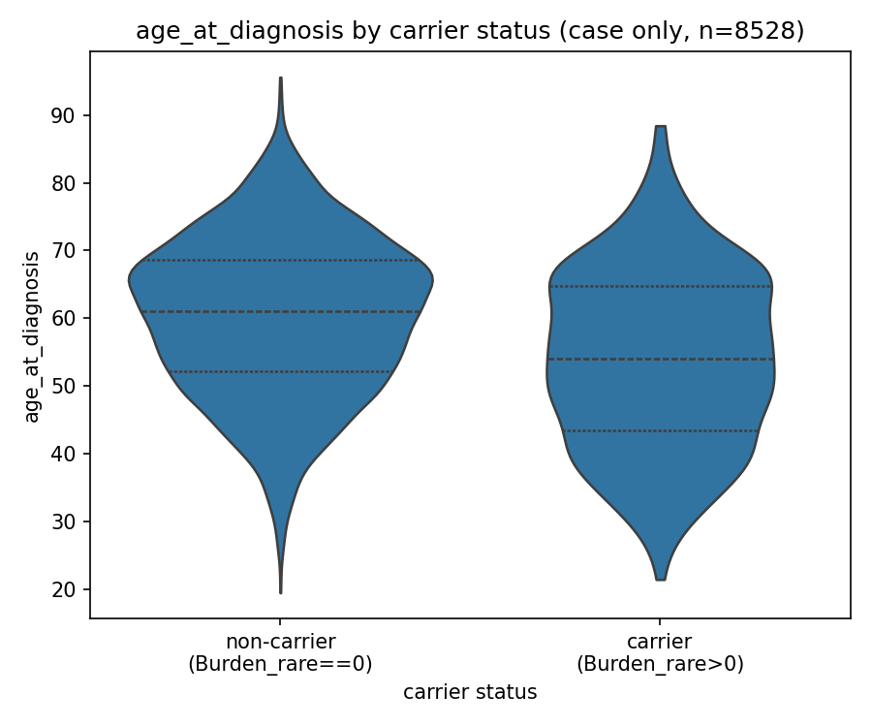
Figure S6. Rare-variant carriers. (a) Carrier rate by case status (95% Wilson intervals) and rare-variant burden among carriers. (b) Age at diagnosis among cases by carrier status.

