Kurzfassung der Studienarbeit
Abteilung | Informatik
Name[n] der Studierenden | Thomas Kallenberg  Martin Schwab
Studienjahr | HS 2010
Titel der Studienarbeit | One Touch C++ Code  Automation for Eclipse CDT
Examinatorin / Examinator | Prof. Peter Sommerlad
Themengebiet | Software
Projektpartner | -
Institut | Institut für Software
Kurzfassung

Current Situation and Motivation
The Eclipse Java Development Toolkit (JDT) has a large set of both quick and useful refactorings. Its sibling the C++ Development Toolkit (CDT) offers just a small range of such code helpers today. In addition, some of them don’t work satisfyingly: Currently, extracting the body of a hello world function takes more than three seconds on our machines. Reliability? Try to extract constant the hello world string of the same program. At the time of this writing, this still failed.

Bachelor students at HSR may visit a C++ programming class where Eclipse is used to solve exercises. For the authors, it was clear after a while that touching the refactoring buttons was a dangerous action because in some cases they broke your code. Compile errors all over the place and difficult exercise assignments didn’t make our life easier.

One annoying problem in C++ is the separation of the source and the header files. This is a pain point for every programmer. Forgetting to update the function signature in one of the files will result in compilation error which causes either lack of understanding for beginners or loss of time.

After two minutes of compile error hunting because of a function signature that was out of sync in the header and the implementation file, it may be asked: Why nobody has yet implemented a solution to prevent such an error? This was the motivation for this semester thesis. An Eclipse refactoring should be developed that provides a failure-proof way of carrying function signatures from one place to another.

Refactorings in CDT present a big field of interesting and unsolved problems. With the support of the Institute of Software IFS at HSR Rapperswil, these problems could be solved. The Institute for Software with its group around Professor Peter Sommerlad and Emanuel Graf has been working on Eclipse refactorings for a long time. Since 2006 nine Eclipse refactoring projects have been completed.

Approach and Used Technologies
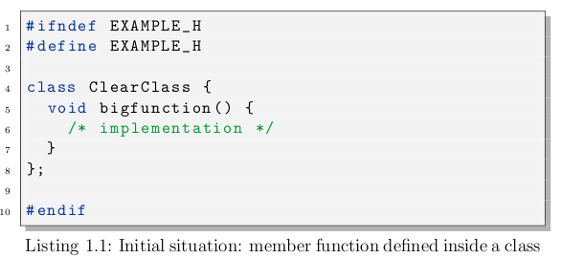
At the beginning, many „should-work-in-this-situation“ code samples were collected on the project wiki to gain a view on what had to be realized, what was planned to take into scope and what had nothing to do with toggling function definitions. Some cases were simple, some exotic. The simplest one, toggling from inside a class to the same file outside the class, was chosen to be implemented first:
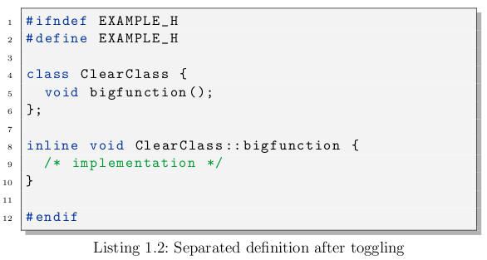
Before, a skeleton plug-in was built with a NullRefactoring to try whether it was possible to develop a separate plug-in instead of directly manipulating the CDT source code. By this approach it was assured that the developed plug-in may be deployed easily even without being integrated into CDT.

After the first refactoring was implemented, more cases were added by priority and order.

The plug-in was developed using Eclipse v3.6.0, Maven v3.0 beta, Eclemma 1.5.1, Git v1.7.0.4, Hudson v1.3.5.2 and other technologies.

Results
The main goal of the project was to create a stable refactoring that would have a chance to be integrated into CDT. In the view of the authors, the developed plug-in became quite handy but should be tested by a larger community before it may be released to the public. A drawback are with whitespaces which are not handled satisfactorily.
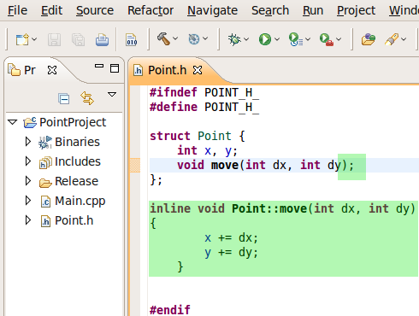Figure 1: an example of changes performed by the Toggle Function Definition inside Eclipse CDT

Anyhow, it should be taken into account that the C++ language specification (and its implemen-tations by different compilers) may offer a lot more features than two developers could ever think of. It is not sure whether the covered special cases are enough general to cover all language constructs that may exist. Even programming against the C++ language specification is no guarantee that the refactoring will behave correctly out in the wild.

All in all, the developer team is proud of the solution although aware of the fact that there may still be some improvements needed to satisfy a large audience.

Further Work
The toggle refactoring was developed as a separate plug-in so integration into the CDT project should be possible if desired.

It should be a small task to provide a solution for multi-toggling. If the user selects more than one definition, all of them could be toggled. An example workflow could be ”Create new class (inherit from an abstract class)”, ”add unimplemented methods”, ”toggle all methods to an implementation file”.

A big problem in this refactoring was the rewriter. Since it is limited in its functionality by limited support for comments, no preprocessor statement support, inserting newlines over and over, and even producing wrong code with the constructor bug, it is extremely time consuming to find workarounds for such problems. Therefore before any new refactoring is developed, the rewriter should be fixed or rewritten. As in the last meeting
of this semester thesis with the supervisor, it was ensured such a work will be done by the Institut fuer Software.

A mechanism could be implemented that fixes indentation after refactoring. Additionally, better user feedback in case of errors could be provided. The planned Override Virtual Member Function refactoring is still left as a semester thesis.

