Kurzfassung der Studienarbeit
Abteilung | Informatik
Name[n] der Studierenden | Thomas Kallenberg  Martin Schwab
Studienjahr | HS 2010
Titel der Studienarbeit | One Touch C++ Code  Automation for Eclipse CDT
Examinatorin / Examinator | Prof. Peter Sommerlad
Themengebiet | Software
Projektpartner | -
Institut | Institut für Software
Kurzfassung

Current Situation

and Motivation
The Eclipse Java Development Toolkit (JDT) has a large set of
both quick and useful refactorings. Its sibling the C++ Development Toolkit (CDT) offers just a small range of such code helpers
today. In addition, some of them don’t work satisfyingly: Currently, extracting the body of a hello world function takes more
than three seconds on our machines. Reliability? Try to extract
constant the hello world string of the same program. At the time
of this writing, this still failed.

Bachelor students at HSR may visit a C++ programming class
where Eclipse is used to solve exercises. For the authors, it was clear after a while that touching the refactoring
buttons was a dangerous action because in some cases they broke your code. Compile errors all over the place and
difficult exercise assignments didn’t make our life easier.

One annoying problem in C++ is the separation of the source
and the header files. This is a pain point for every programmer.
Forgetting to update the function signature in one of the files will
result in compilation error which causes either lack of understanding
for beginners or loss of time.
After two minutes of compile error hunting because of a function
signature that was out of sync in the header and the implementation
file, it may be asked: Why nobody has yet implemented a solution
to prevent such an error?
This was the motivation for this semester thesis. An Eclipse refactoring should be developed that provides a failure-proof way of carrying function signatures from one place to another.

Refactorings in CDT present a big field of interesting and unsolved
problems. With the support of the Institute of Software IFS at
HSR Rapperswil, these problems could be solved. The Institute
for Software with its group around Professor Peter Sommerlad and
Emanuel Graf has been working on Eclipse refactorings for a long
time. Since 2006 nine Eclipse refactoring projects have been completed.

Approach and Used Technologies
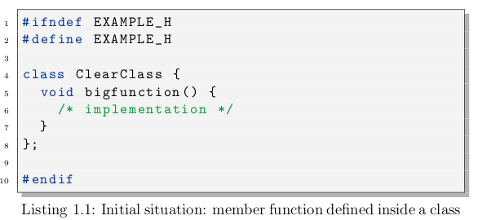
At the beginning, many „should-work-in-this-situation“ code samples were collected on the
project wiki to gain a view on what had to be realized, what was
planned to take into scope and what had nothing to do with toggling
function definitions. Some cases were simple, some exotic. The
simplest one, toggling from inside a class to the same file outside
the class, was chosen to be implemented first:
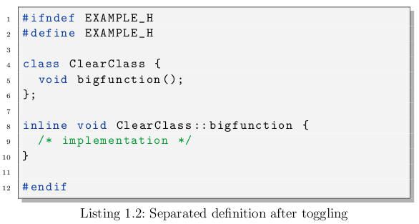
Before, a skeleton plug-in was built with a NullRefactoring to
try whether it was possible to develop a separate plug-in instead of
directly manipulating the CDT source code. By this approach it
was assured that the developed plug-in may be deployed easily even
without being integrated into CDT.

After the first refactoring was implemented, more cases were
added by priority and order.

The plug-in was developed using Eclipse v3.6.0, Maven v3.0 beta, Eclemma 1.5.1, Git v1.7.0.4, Hudson v1.3.5.2 and other technologies.

Results
The main goal of the project was to create a stable refactoring that
would have a chance to be integrated into CDT. In the view of
the authors, the developed plug-in became quite handy but should
be tested by a larger community before it may be released to the
public. A drawback are with whitespaces which
are not handled satisfactorily.

Anyhow, it should be taken into account that the C++ language
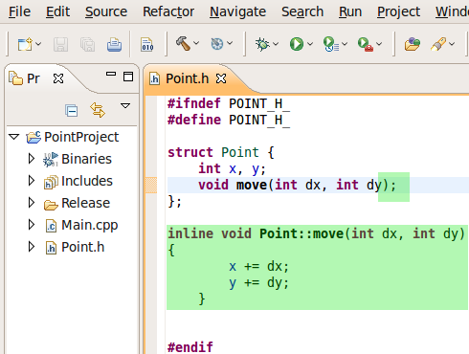Figure 1: an example of changes performed by the Toggle Function Definition inside Eclipse CDT
specification (and its implementations by different compilers) may
offer a lot more features than two developers could ever think of. It
is not sure whether the covered special cases are enough general to
cover all language constructs that may exist. Even programming
against the C++ language specification is no guarantee that the
refactoring will behave correctly out in the wild.

All in all, the developer team is proud of the solution although
aware of the fact that there may still be some improvements needed
to satisfy a large audience.

Further Work
The toggle refactoring was developed as a separate plug-in so integration into the CDT project should be possible if desired.

It should be a small task to provide a solution for multi-toggling.
If the user selects more than one definition, all of them could be
toggled. An example workflow could be ”Create new class (inherit
from an abstract class)”, ”add unimplemented methods”, ”toggle
all methods to an implementation file”.

A big problem in this refactoring was the rewriter. Since it is
limited in its functionality by limited support for comments, no
preprocessor statement support, inserting newlines over and over,
and even producing wrong code with the constructor bug, it is extremely time consuming to find workarounds for
such problems. Therefore before any new refactoring is developed,
the rewriter should be fixed or rewritten. As in the last meeting
of this semester thesis with the supervisor, it was ensured such a
work will be done by the Institut fuer Software.

A mechanism could be implemented that fixes indentation after
refactoring. Better user feedback in case of errors could be provided.

At the end there was no time left to do the Override Virtual
Member Function refactoring. This is still left as a semester thesis.

