We know that B must lie in the range

Thus:

Thus A) must be correct.

Writing :

2) is the answer.

Second interpolation-error theorem

We use interpolation-degree n. .

We know that the derivative takes the largest value at ;

hmm.. Try and calculate the function-values. It seems they all have way to high accuracy, and thus n = 21 (1) is the right answer.

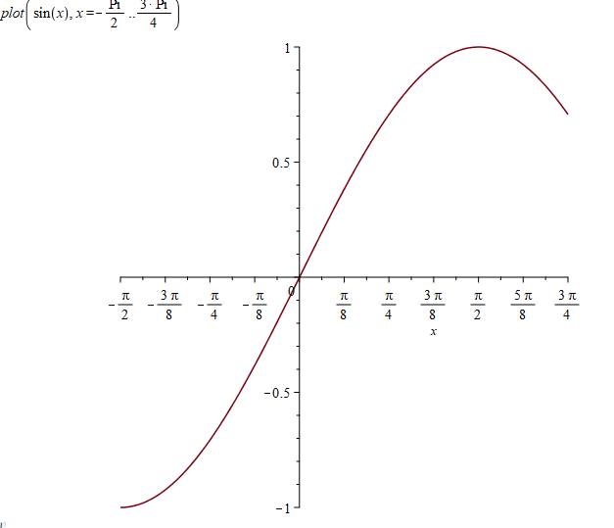

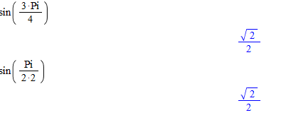

Thus, secant method would fail (start-guess is horizontal secant). Answer 2 is correct.

Global error is .

We thus know:

This constant is the proportionality. Thus:

This is answer 2.

We have the error-term:

with . Thus, it must be between 0 and pi/2.

We have the function:

This differentiated four times is:

The max of this function is when , as , and the functionvalue thus is bounded by .

Now, we can use an inequality:

Which is solved for :

This gives us:

As we are using the composite simpsons rule we need equal of subintervals. Thus:

Using MySimpson:



We get , and an error with the magnitude which is in the bound.

Probably we could use way smaller n in practice, as theoretical upper bound has big overhead for small n.

The basis-functions are:

Thus, matrix takes form:

Which gives us the complete normal equation:

Finding :

Using matlab. Note: we do not explicitly find the inverse, but solve the system , as this is more numerically stable:



Which gives:

F = c(1)*sin(pi*x)+c(2)*cos(pi*x);

err = abs(y-F)

errSum = sum(err)

gives us the errsum (quite bad for such a small interval).

The relative error of the solution is bound by:

Giving us:

Also, for the perturbation in :

We know

Multiplying the two equation gives the relative error in c:

Using

And we are given the relative error of the perturbed data. Thus:

The upper bound for the error in c is 1.5%.

The Euclidean distance may be written as:

The hint suggests we write , and thus we wish to minimize:

The mission is now to find a root for .



We have



Start-guess is newer part of first iteration, brother.

It must be positive definite and be real and symmetric.

Calculating would cost Lops. Also, we know, that calculating the Cholesky factorization takes

Lops. Thus, we would have

In total for strategy one, and the dominating term is .   
  
In strategy 2 we would first use the Cholesky-factorization:

Which would give us a lower triangular with only half the elements. Now we solve the system with half as many elements, but need to solve four triangular systems (2 with L and 2 with LT). This costs in total Lops. In total:

Which thus has dominating term . This Is at least 6 times smaller.

Introducing the following dictionary of variables:

|  |  |  |  |
| --- | --- | --- | --- |
| Old variable | New variable | Initial value | Differential eq. |
|  |  |  |  |
|  |  |  |  |

Now, we need to implement a Matlab-function which can write rhs of diff.eq. column:



Thus, we don’t hit with any of the guesses.

The secant-method gives:

Giving a new shooting:



Which *almost* hits zero but still has a small error. This could be caused by 1. machine precision or 2. is not a completely linear function (and thus secant method needs more iterations).

ics1 = [1,-1];

ics2 = [1,-5];

tspan = [0,2];

[t_sol_1,x_sol_1] = ode45(@odefun,tspan,ics1);

[t_sol_2,x_sol_2] = ode45(@odefun,tspan,ics2);

z1 = -1;

z2 = -5;

f1 = x_sol_1(end,1)-0;

f2 = x_sol_2(end,1)-0;

%secant

z_root = z2-((z2-z1)/(f2-f1))*f2;

[t_sol_3,x_sol_3] = ode45(@odefun,tspan,[1,z_root]);

plot(t_sol_3,x_sol_3(:,1))

hold on

plot(t_sol_2,x_sol_2(:,1),'.')

plot(t_sol_1,x_sol_1(:,1),'.')

plot(2,0,'rx');

legend('shot 3','shot 2','shot 1','goal')

function [X] = odefun(t,x)

X = [x(2);-4*x(2)-4*x(1)+exp(-2*t)];

end

We have a system matrix:

And

Gaussian elimination with partial pivoting:   
We want to reduce the system to a upper triangular.

Swap row 1 and 2 and 2 and 3:

The operations are thus carried out by the permutation matrix, where row 1 becomes row 3, row 2 becomes row 1 and row 3 becomes row 2

And with matrix-operations:

Now we kill column 0 in r2 and r3:

Tada, now it is upper triangular. The same operations must be applied to b:



Doing back-substitution:

Thus the solution is:

The basis-functions are:

Thus the coefficient matrix is:

The normal equation is:

Which gives the system matrix:

And the right hand site:





Yes we could. In every evaluation we are solving a big system of equations with gaussian elimination, which costs LOps for the elimination on every iteration and following LOps for backward/forward-sub for getting the coefficients.. As long as the left-hand-side is the same, we could save some computing power by using a LU-factorization of the system-matrix. The factorization would cost us (when using LU) or LOps when using Cholesky, but can be reused in every data-fit. Afterwards we would use forward/backward-sub which still costs LOps. Thus we would save the gaussian elimination part.

The Jacobian may simply be found as:

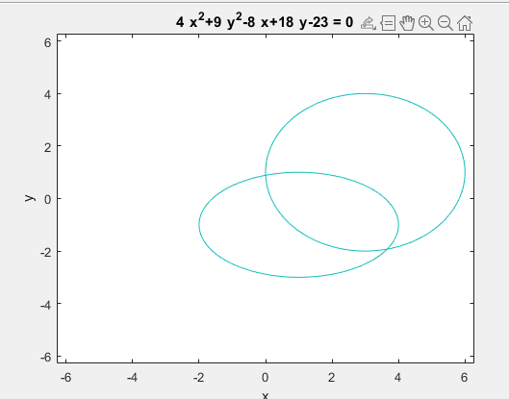

I guess I would choose and ? (must be intersection).

X0 = [4;-2];

x = Newtonsys(@funFdF_1,X0,10)

Sidste kolonne I x er dit svar.

We have:

We calculate :

is:

We know that serves upper bound to the function on the whole interval. The largest value the derivative takes is at the point :

Thus, we can find a value:

!(REMEMBER n and not n+1)!

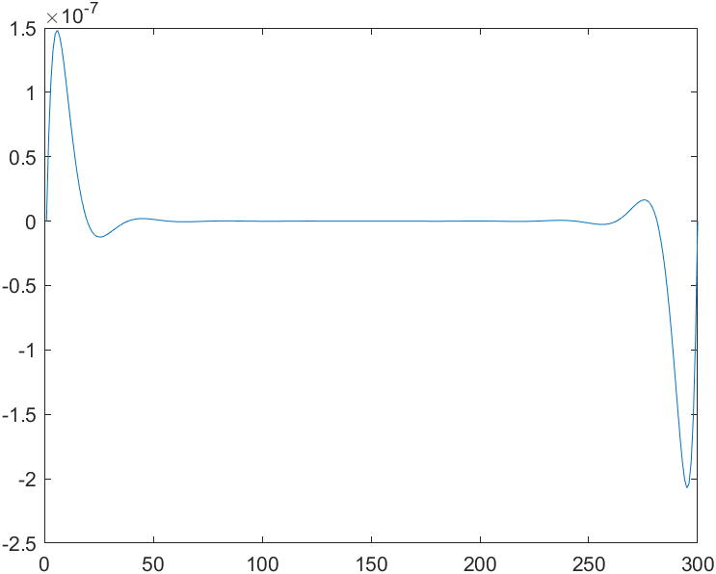

The magnitude is smaller during the whole sample.

We have the new dictionary:

|  |  |  |  |
| --- | --- | --- | --- |
| Old variable | New variable | Initial value | Differential eq. |
|  |  |  |  |
|  |  |  |  |
|  |  |  |  |
|  |  |  |  |

Thus the system becomes:







In each iteration there are 4 function evaluations. Thus multiply these two numbers.

For :

for :

A3

B4)

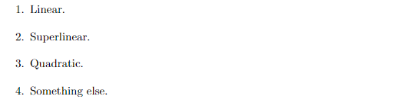

C2)

D2).

We know that:

Thus, the worst result occurs at , and our derivative-function is bounded by:

We can calculate :

Thus, we wish that:

This is solved for :

Which means, that the smallest is 72 (must be equal).

E3.

A1.

B2).

C2.

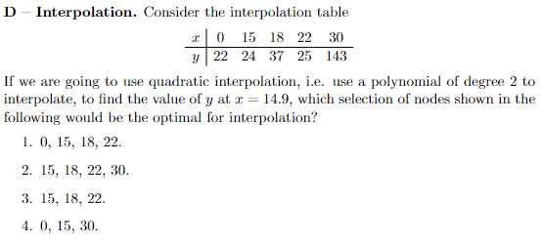

3 – because we want close points

E4).

Se flop-count I PDF og beregn hasithged.

I would use cardinal-polynomials.

And thus, the interpolating polynomial becomes:

Which is a polynomial of order 2.



Second interpolation error theorem is applied:

We need an upper bound for . This is largest when , and thus:

Introducing the dictionary:

|  |  |  |  |
| --- | --- | --- | --- |
| Old variable | New variable | Initial value | Differential eq. |
|  |  |  |  |
|  |  |  |  |
|  |  |  |  |
|  |  |  |  |

Thus, the linearized system:

With .



tspan = [0,2*pi];

n = 50;

h = 2*pi/50;

z0 = [0.4;0;0;2];

[t_sol,x_sol] = MyRK4System(@odefun,tspan,z0,n)

function [Z] = odefun(t,z)

Z = [z(3);z(4);-z(1)/(z(1)^2+z(2)^2)^(3/2);-z(2)/(z(1)^2+z(2)^2)^(3/2)];

end

The solution becomes:

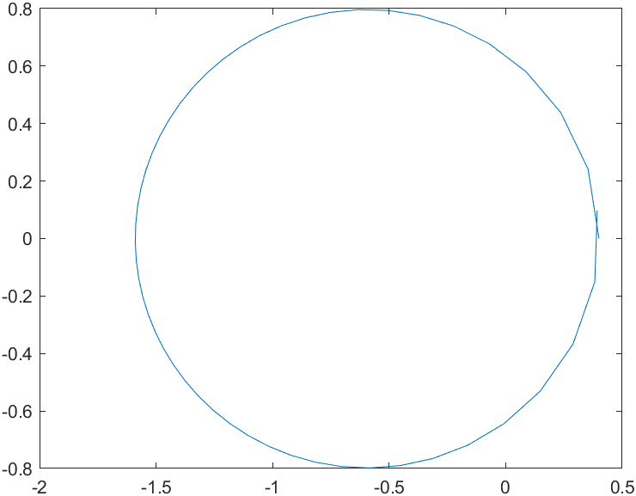

plot(x_sol(1,:),x_sol(2,:))

3.1)

We know, that the fourth derivative is:

This value is the largest at , as . Thus, we know that the error has to be bounded by:

Thus, we can solve for which gives us:

As we are using the composite Simpsons rule, n must be even. Thus, the smallest number of subintervals is .

3.2)

a = 1;

b = 3;

fun = @(x)x*log(x);

A = MySimpson(fun,a,b,n)

Gives

