CineConnect Ticketing System
Software Requirements Specification
Version 1.0
July 13, 2026
Individual Submission
Team Member: Martin Aloka (Red ID: 133942949)
Prepared for
CS 250 – Introduction to Software Systems
Instructor: Gus Hanna, Ph.D.
Summer 2026

Revision History
Date | Description | Author | Comments
July 13, 2026 | Version 1.0 – Sections 1–3.3, 3.5 | Martin Aloka | First submission for Requirements Specification assignment
July 20, 2026 | Version 1.1 – Added Section 6, Software Design Specification | Martin Aloka | Second submission for Software Design Specification assignment

Document Approval
The following Software Requirements Specification has been accepted and approved by the following:
Signature | Printed Name | Title | Date
 | Martin Aloka | Software Engineer (Student)
 | Dr. Gus Hanna | Instructor, CS 250

Table of Contents

1. Introduction
The introduction to this Software Requirements Specification (SRS) provides an overview of the complete document. It is intended to contain the information needed by a software engineer to adequately design and implement the CineConnect movie theater ticketing system described herein.

1.1 Purpose
This SRS defines the functional and non-functional requirements for CineConnect, a movie theater ticketing system for a movie theater chain operating twenty (20) theater locations in the San Diego area. The intended audience for this document is the software development team responsible for designing and building the system, the theater chain's management (the client), and the CS 250 course instructional staff evaluating this specification.

1.2 Scope
CineConnect is a browser-based ticketing platform, accessible identically through public web browsers and in-theater self-service kiosks, both of which display the same live-updated data. The system will:
- Display current movies, showtimes, seat availability, and ticket pricing for each of the 20 theaters.
- Allow customers to purchase up to 20 tickets per transaction, with assigned seat selection at deluxe theaters (75 seats) and general-admission tickets at regular theaters (150 seats).
- Support English, Spanish, and Swedish.
- Apply student, military, and senior discount pricing.
- Offer an optional CineConnect Rewards loyalty membership that stores payment information and purchase history and can be used to reserve tickets.
- Accept credit card, PayPal, and cryptocurrency payments, with consistent pricing across all channels.
- Issue unique, non-replicable digital (email) or printable tickets to deter scalping and duplication.
- Collect post-purchase customer feedback and display aggregated critic reviews and scores.
- Provide an administrator console for correcting purchase errors and managing showtimes and theaters.
In its initial release, the system will not be delivered as a native mobile or desktop application (browser access only, per client direction), will not recommend nearby theaters (deferred to a future iteration), and will not automate refunds (refunds continue to be handled by in-person staff).
The system's primary goal is to reduce the transaction friction and downtime that the client's existing legacy ticketing platform suffers from; the client describes the current system as functionally adequate but slow, with bugs that have accumulated over years of incremental updates. The client has requested a viable prototype for user testing within approximately four months and a budget of approximately $500,000.

1.3 Definitions, Acronyms, and Abbreviations
- SRS – Software Requirements Specification
- Deluxe Theater – an auditorium with 75 assigned seats
- Regular Theater – an auditorium with 150 general-admission (unassigned) seats
- CineConnect Rewards – the system's optional customer loyalty membership program
- Kiosk – an in-theater, self-service ticketing terminal running the same web application as the public site
- FR – Functional Requirement
- NFR – Non-Functional Requirement

1.4 References
- Theater Ticketing System Qs.rtf – client interview transcript, collected Week 1, July 8, 2026
- Theater Ticketing Requirements.rtf – client-supplied requirements notes, collected Week 1, July 8, 2026
- theather-ticketing-questions.txt and theather-ticketing-reqs.txt – supplemental client Q&A and requirements notes, collected Week 1, July 8, 2026
- CS 250 – SRS Template, provided by course instructional staff
- IEEE Guide to Software Requirements Specifications, referenced throughout this template

1.5 Overview
The remainder of this SRS is organized as follows: Section 2 describes the product and its intended users at a general level. Section 3 states specific functional and non-functional requirements, including three representative use cases and an accompanying use-case diagram. Sections 4 and 5 and the Appendices are reserved for analysis models, the change-management process, and supplementary materials, which will be developed in a later phase of this project.

2. General Description
This section describes the general factors that affect the product and its requirements. It does not state specific requirements; it makes those requirements, given in Section 3, easier to understand.

2.1 Product Perspective
CineConnect will replace the theater chain's existing legacy ticketing system, which the client considers functionally adequate but slow and increasingly unstable after years of incremental updates. CineConnect is a new, standalone web application — not an extension of the legacy system — that will interface with a single, chain-wide database logically partitioned by theater. The public website and the in-theater kiosks will use the same application and the same live data, so that ticket availability shown in one channel is immediately reflected in the other.

2.2 Product Functions
At a high level, CineConnect will:
- Present showtimes, seat availability, and pricing for each theater.
- Process ticket purchases, including seat selection, discounts, loyalty membership, and payment.
- Issue and validate unique tickets in digital and printable form.
- Support customer account and loyalty membership management.
- Collect customer feedback and display third-party movie review scores.
- Provide administrators with override and showtime/theater management capabilities.
- Maintain a daily, system-wide log of ticket transactions.

2.3 User Characteristics
CineConnect has two primary classes of user:
- Customer – members of the general public purchasing movie tickets, either online from a personal device or in person at a theater kiosk. Customers are assumed to have no specialized training and a wide range of technical proficiency, so the interface must be simple and intuitive; this reflects the client's explicit requirement that “the UI has to be easy to use.” Customers may interact with the system in English, Spanish, or Swedish.
- Administrator – theater chain staff responsible for correcting erroneous customer transactions and for creating, editing, or removing showtimes and theaters. Administrators are assumed to have basic system training and elevated access privileges not available to Customers.

2.4 General Constraints
- The system must be delivered as a browser-based web application; a native mobile or desktop application is explicitly out of scope for this release.
- The system operates within a single time zone (Pacific) and a single metropolitan market (San Diego) for this release.
- The client's target budget for the initial prototype is approximately $500,000, with a four-month timeline to a user-testable prototype.
- All 20 theaters share a single, partitioned database rather than one database per theater.
- Updates to the production system should be deployed as infrequently as practical, since the client has asked that downtime be minimized.

2.5 Assumptions and Dependencies
- The system assumes continued availability of third-party payment processors for credit card, PayPal, and cryptocurrency payments.
- The system assumes continued access to a third-party data source (e.g., Rotten Tomatoes and/or IMDB) for aggregated movie reviews and critic scores; if this access became unavailable, the review-display functionality would need to be revised.
- The system assumes the theater chain remains confined to the San Diego market for the duration of this release; expansion to additional regions or time zones would affect scheduling and scalability requirements.
- The client-provided seat counts (150 regular / 75 deluxe) and showtime cadence (approximately 6–8 showtimes per theater per day) are assumed to remain stable for this release.

3. Specific Requirements
This is the largest and most important section of the SRS. Customer requirements are embodied within Section 2, but this section gives the requirements that guide the project's software design, implementation, and testing. Each requirement below is intended to be correct, traceable, unambiguous, verifiable, prioritized, complete, consistent, and uniquely identifiable.

3.1 External Interface Requirements

3.1.1 User Interfaces
To be completed in a later phase of this project (user interface requirements).

3.1.2 Hardware Interfaces
To be completed in a later phase of this project (hardware interface requirements).

3.1.3 Software Interfaces
To be completed in a later phase of this project (software interface requirements).

3.1.4 Communications Interfaces
To be completed in a later phase of this project (communications interface requirements).

3.2 Functional Requirements
Functional requirements are organized below into four feature groups. Individual, uniquely identifiable requirements (FR1–FR17) are embedded within the Processing subsection of each feature.

3.2.1 Ticket Search & Purchase

3.2.1.1 Introduction
Allows a Customer, using either the public website or an in-theater kiosk, to find a showtime and complete a ticket purchase.

3.2.1.2 Inputs
- Selected theater and movie
- Desired showtime
- Number of tickets (1–20)
- Seat selection (deluxe theaters only)
- Optional discount type or loyalty membership
- Payment method and payment details

3.2.1.3 Processing
- FR1 – The system shall display, for both the website and kiosk channels, identical, live-synchronized data on movies, showtimes, ticket prices, and remaining availability.
- FR2 – The system shall support English, Spanish, and Swedish throughout the purchase flow.
- FR3 – The system shall allow a Customer to select any showtime within a booking window beginning 2 weeks before and ending 10 minutes after the showtime start.
- FR4 – The system shall limit a single transaction to a maximum of 20 tickets.
- FR5 – For deluxe theaters (75 seats), the system shall require selection of specific, assigned seats; for regular theaters (150 seats), the system shall issue general-admission tickets without seat assignment.
- FR6 – The system shall hold a Customer's in-progress seat/ticket reservation for 5 minutes from the start of checkout, after which the reservation is released if checkout is not completed.
- FR7 – The system shall apply student, military, or senior discount pricing when selected and eligible, and shall apply the corresponding price consistently regardless of access channel.
- FR8 – The system shall accept payment by credit card, PayPal, or cryptocurrency.
- FR9 – Upon successful payment, the system shall generate a unique, non-replicable ticket identifier for each seat/admission purchased.
- FR10 – The system shall deliver each ticket either as a digital ticket sent by email or as a printable ticket at the box office, per Customer selection.

3.2.1.4 Outputs
- Confirmed reservation with unique ticket identifier(s)
- Digital or printable ticket
- Updated seat/ticket availability visible on all channels
- Transaction record written to the daily transaction log

3.2.1.5 Error Handling
- If payment is declined, the system shall notify the Customer and release the held reservation.
- If the 5-minute checkout window expires before payment completes, the system shall release the reservation and notify the Customer that the session has expired.
- If a requested seat becomes unavailable during checkout, the system shall notify the Customer and prompt an alternate selection.
- If a requested ticket quantity exceeds 20 or the showtime falls outside the booking window, the system shall reject the request with an explanatory message.

3.2.2 Account & Loyalty Management

3.2.2.1 Introduction
Allows a Customer to optionally register for and use a CineConnect Rewards loyalty membership.

3.2.2.2 Inputs
- Customer personal information
- Login credentials
- Preferred payment method
- Membership purchase selection

3.2.2.3 Processing
- FR11 – The system shall allow a Customer to optionally register a CineConnect Rewards account storing personal information, payment information, purchase history, and loyalty points.
- FR12 – The system shall allow a registered Customer to purchase and use a loyalty membership to reserve tickets.
- FR13 – The system shall permit only one device to be concurrently authenticated to a given Customer account at a time.
- FR14 – The system shall allow a Customer to exchange a ticket prior to the showtime only if it was purchased under a registered account.

3.2.2.4 Outputs
- Confirmed account registration
- Updated purchase history and loyalty point balance
- Login denial notice when a concurrent-device conflict occurs

3.2.2.5 Error Handling
- If a second device attempts to log into an already-authenticated account, the system shall deny the new login and notify the Customer.
- If registration information is incomplete or invalid, the system shall prompt the Customer to correct it before account creation completes.

3.2.3 Administration & Operations

3.2.3.1 Introduction
Allows Administrators to correct customer purchase errors, manage showtimes and theaters, and allows the system to protect itself against abusive/automated purchasing.

3.2.3.2 Inputs
- Administrator login credentials
- Transaction search criteria (e.g., confirmation number)
- Showtime/theater edits
- Incoming purchase request volume

3.2.3.3 Processing
- FR15 – The system shall provide an administrator mode allowing authorized staff to override erroneous customer purchases, and to create, edit, or remove showtimes and theaters.
- FR16 – The system shall detect and block automated (bot) purchasing behavior, particularly during high-demand showings.
- FR17 – The system shall queue and fairly order incoming purchase requests during periods of high demand for a single showing.
- FR18 – The system shall maintain a system-wide daily log of all ticket purchases.

3.2.3.4 Outputs
- Updated transaction/showtime/theater records
- Daily transaction log entries
- Queue position/wait indication shown to Customers during high-demand periods

3.2.3.5 Error Handling
- If an Administrator attempts to edit a showtime that conflicts with existing reservations, the system shall reject the change and display the conflicting reservations.
- If suspected bot activity is detected, the system shall block or challenge (e.g., CAPTCHA) the requesting client rather than completing the purchase.

3.2.4 Feedback & Content

3.2.4.1 Introduction
Allows Customers to submit post-purchase feedback and view aggregated third-party movie reviews.

3.2.4.2 Inputs
- Customer feedback selection (e.g., smiley-face rating)
- Third-party review/score data for each movie

3.2.4.3 Processing
- FR19 – The system shall prompt the Customer for feedback (a range of smiley-face ratings) after each completed purchase.
- FR20 – The system shall display aggregated critic scores and quotes (e.g., from Rotten Tomatoes and/or IMDB) alongside each movie listing.

3.2.4.4 Outputs
- Stored feedback rating
- Displayed critic scores and quotes on the movie listing page

3.2.4.5 Error Handling
- If third-party review data is temporarily unavailable, the system shall display the movie listing without the review panel rather than failing to load.

3.3 Use Cases
The diagram below shows the actors and use cases for CineConnect and the relationships between them. Three representative use cases are then described in detail, following the flow-of-events format introduced in the course lecture notes on Scenarios and Use Cases.
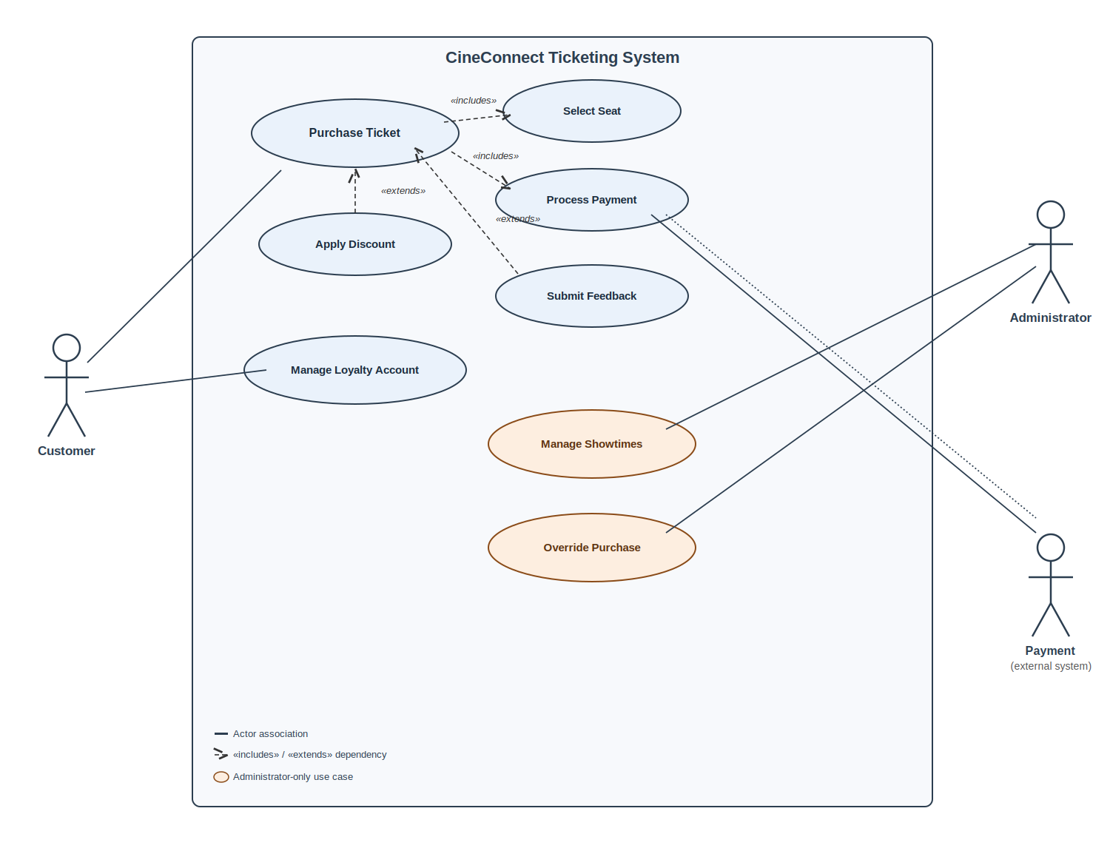
Figure 1. CineConnect use-case diagram.

3.3.1 Use Case #1 – Purchase Ticket
Purpose: describes the use of CineConnect by a representative Customer purchasing movie tickets, from browsing showtimes through receiving a ticket.
Actor(s): Customer

Flow of Events
- Customer accesses CineConnect via a web browser or an in-theater kiosk.
- System displays current movies, showtimes, and available seats/pricing for the selected theater.
- Customer selects a showtime and specifies a ticket quantity (up to 20).
- If the showtime is at a deluxe theater, Customer selects specific seats from the assigned-seating map; if at a regular theater, System prepares general-admission tickets.
- Customer optionally applies a discount (student, military, or senior) or a CineConnect Rewards membership.
- Customer selects a payment method (credit card, PayPal, or cryptocurrency) and completes payment.
- System generates a unique, non-replicable ticket for each seat/admission purchased and delivers it as a digital ticket by email or a printable ticket.
- System records the transaction in the daily transaction log.
- Customer optionally submits post-purchase feedback.

Entry Conditions
- The selected showtime must fall within its booking window (2 weeks before through 10 minutes after showtime start).
- The requested ticket quantity must not exceed 20 per transaction.
- If checkout is not completed within 5 minutes of being started, the reservation is released and the Customer must restart from step 3.

3.3.2 Use Case #2 – Manage Loyalty Account
Purpose: describes how a Customer registers for and uses a CineConnect Rewards loyalty membership.
Actor(s): Customer

Flow of Events
- Customer selects “My Account” from any access channel.
- System checks whether the Customer already has a registered account; if not, System prompts the Customer to register.
- Customer provides personal information, a preferred payment method, and creates login credentials.
- System creates a CineConnect Rewards account and confirms registration.
- On a later visit, Customer logs in with their credentials.
- System verifies that no other device is currently logged into the same account; if one is, System denies the new login and notifies the Customer.
- Customer views stored payment methods, purchase history, and loyalty points, or uses the account to reserve tickets per the Purchase Ticket use case.
- Customer logs out.

Entry Conditions
- Loyalty accounts are optional; a guest Customer may complete Purchase Ticket without one.
- Only one device may be actively logged into a given account at a time.

3.3.3 Use Case #3 – Override Purchase / Manage Showtimes
Purpose: describes how theater staff correct customer purchasing errors and maintain showtime and theater data.
Actor(s): Administrator

Flow of Events
- Administrator logs into CineConnect's administrator console using elevated credentials.
- System displays the administrator dashboard with options to search transactions, manage showtimes, or manage theaters.
- Administrator searches for a specific customer transaction (e.g., by confirmation number).
- Administrator selects a correction action: void ticket, reissue ticket, or adjust seat assignment.
- System applies the override, updates the transaction and daily log accordingly, and notifies the affected Customer if a digital ticket was issued.
- Alternatively, Administrator selects “Manage Showtimes” and adds, edits, or removes a showtime or theater.
- System validates that the change does not conflict with existing reservations before committing it.
- Administrator logs out.

Entry Conditions
- Administrator must possess valid, elevated (admin-role) credentials.
- Overrides to a purchase can be applied only prior to the associated showtime.

3.4 Classes / Objects
To be completed in a later phase of this project (class/object modeling).

3.5 Non-Functional Requirements
Non-functional requirements are stated in measurable terms wherever possible.

3.5.1 Performance
- NFR1 – The system shall support at least 1,000 concurrent users across the 20-theater chain in its initial release, with a horizontally scalable architecture capable of growing toward the client's longer-term aspiration of supporting up to 10 million concurrent users if the chain expands beyond San Diego.
- NFR2 – Showtime, seat-map, and pricing pages shall load and refresh within 2 seconds under normal load.
- NFR3 – The system shall queue and fairly order purchase requests during high-demand showings rather than rejecting or losing requests outright.

3.5.2 Reliability
- NFR4 – Ticket prices for a given showtime shall be identical and consistent across the website and kiosk channels at all times.
- NFR5 – Daily transaction logs shall be retained without data loss for audit purposes.

3.5.3 Availability
- NFR6 – The system shall be available 24 hours a day, 7 days a week, excluding scheduled maintenance windows.
- NFR7 – Production updates shall be deployed as infrequently as practical in order to minimize downtime, per client direction.

3.5.4 Security
- NFR8 – Every issued ticket shall carry a unique, non-replicable identifier to prevent duplication, forgery, and resale/scalping.
- NFR9 – No more than one device shall be concurrently authenticated to a given Customer account.
- NFR10 – Payment data shall be handled in accordance with applicable payment card industry (PCI) standards.
- NFR11 – The system shall detect and block automated (bot) purchasing behavior, particularly for high-demand showings.

3.5.5 Maintainability
- NFR12 – The system shall be built with a modular architecture so that individual components (e.g., payment processing, review aggregation) can be updated independently without extended, system-wide downtime.

3.5.6 Portability
- NFR13 – The system shall run entirely within standard, modern web browsers, with no native mobile or desktop application required.
- NFR14 – The same interface and underlying data shall be used for the public website and the in-theater kiosks.

3.6 Inverse Requirements
To be completed in a later phase of this project (inverse requirements).

3.7 Design Constraints
To be completed in a later phase of this project (design constraints).

3.8 Logical Database Requirements
To be completed in a later phase of this project (logical database requirements).

3.9 Other Requirements
To be completed in a later phase of this project (additional requirements).

4. Analysis Models
To be completed in a later phase of this project (analysis models).

4.1 Sequence Diagrams
To be completed in a later phase of this project (sequence diagrams).

4.2 State-Transition Diagrams (STD)
To be completed in a later phase of this project (state-transition diagrams).

4.3 Data Flow Diagrams (DFD)
To be completed in a later phase of this project (data flow diagrams).

5. Change Management Process
To be completed in a later phase of this project (the change management process).

A. Appendices

A.1 Appendix 1 – Client Interview Notes
This appendix is considered informative background and is not itself part of the SRS's normative requirements. The functional and non-functional requirements above were derived from four client-elicitation documents collected during Week 1 (July 8, 2026): a structured client interview (Theater Ticketing System Qs.rtf), a client-supplied requirements list (Theater Ticketing Requirements.rtf), and a supplemental Q&A/requirements pair (theather-ticketing-questions.txt, theather-ticketing-reqs.txt). These source documents are retained on file and are available on request for traceability.

A.2 Appendix 2
To be completed in a later phase of this project (additional appendix material).

6. Software Design Specification
This section is a continuation of the CineConnect Software Requirements Specification above, added as the second deliverable of the course project. Where Sections 1–5 describe what the system must do (intended for the client), this section describes how the system is organized internally for the development team that will implement and maintain it.

6.1 System Description
CineConnect is a browser-based movie ticketing platform for a 20-theater chain based in San Diego, accessible identically through a public website and in-theater kiosks. Customers browse showtimes, reserve seats (at deluxe theaters) or general-admission tickets (at regular theaters), apply discounts or a loyalty membership, and pay by credit card, PayPal, or cryptocurrency, receiving a unique digital or printable ticket. Administrators can override erroneous purchases and manage showtimes and theaters. The system also collects post-purchase feedback and displays aggregated critic reviews. Full functional and non-functional requirements are given in Section 3 above; this section translates those requirements into a concrete software architecture and object model.

6.2 Software Architecture Overview

6.2.1 Architectural Diagram
CineConnect follows a layered, service-oriented architecture: a thin client layer (web and kiosk), an API gateway that handles routing, authentication, and bot mitigation, a set of application microservices that implement the system's core behaviors, a central partitioned database, and a small set of external integrations (payment processors, review data, email delivery, and kiosk printing).
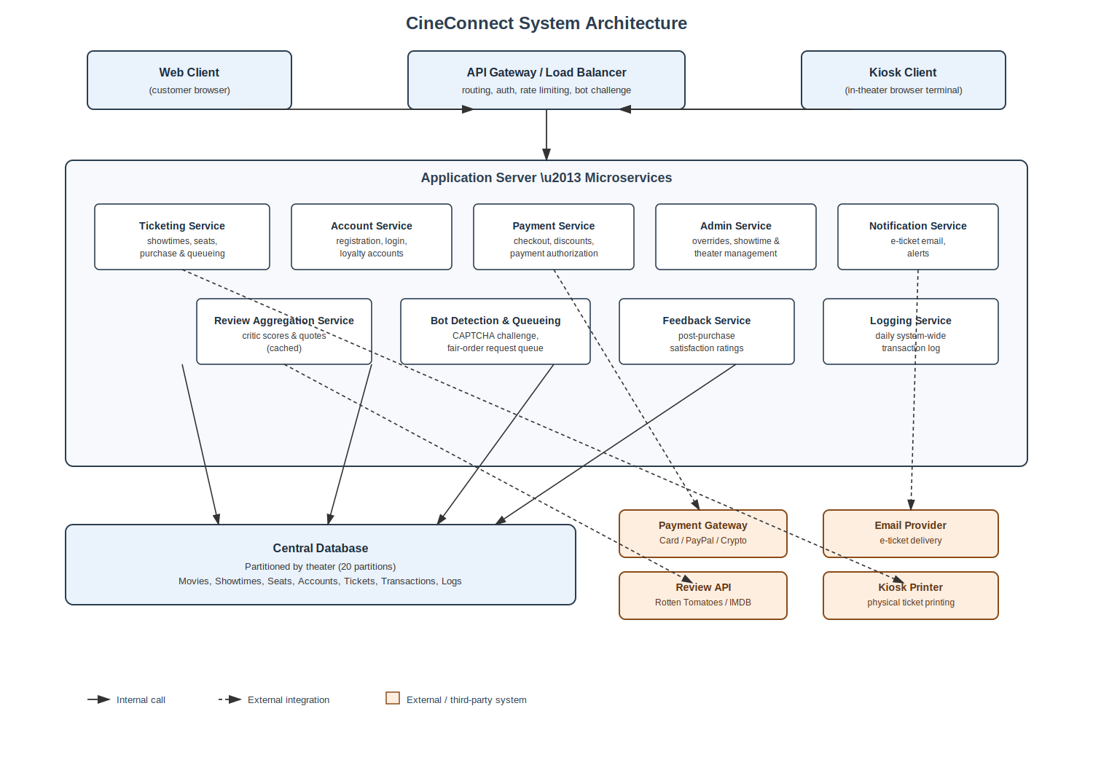
Figure 2. CineConnect system architecture.

6.2.2 UML Class Diagram
The diagram below shows the core domain classes that implement the requirements in Section 3, along with their key attributes, operations, and relationships (association, aggregation, inheritance, and dependency).
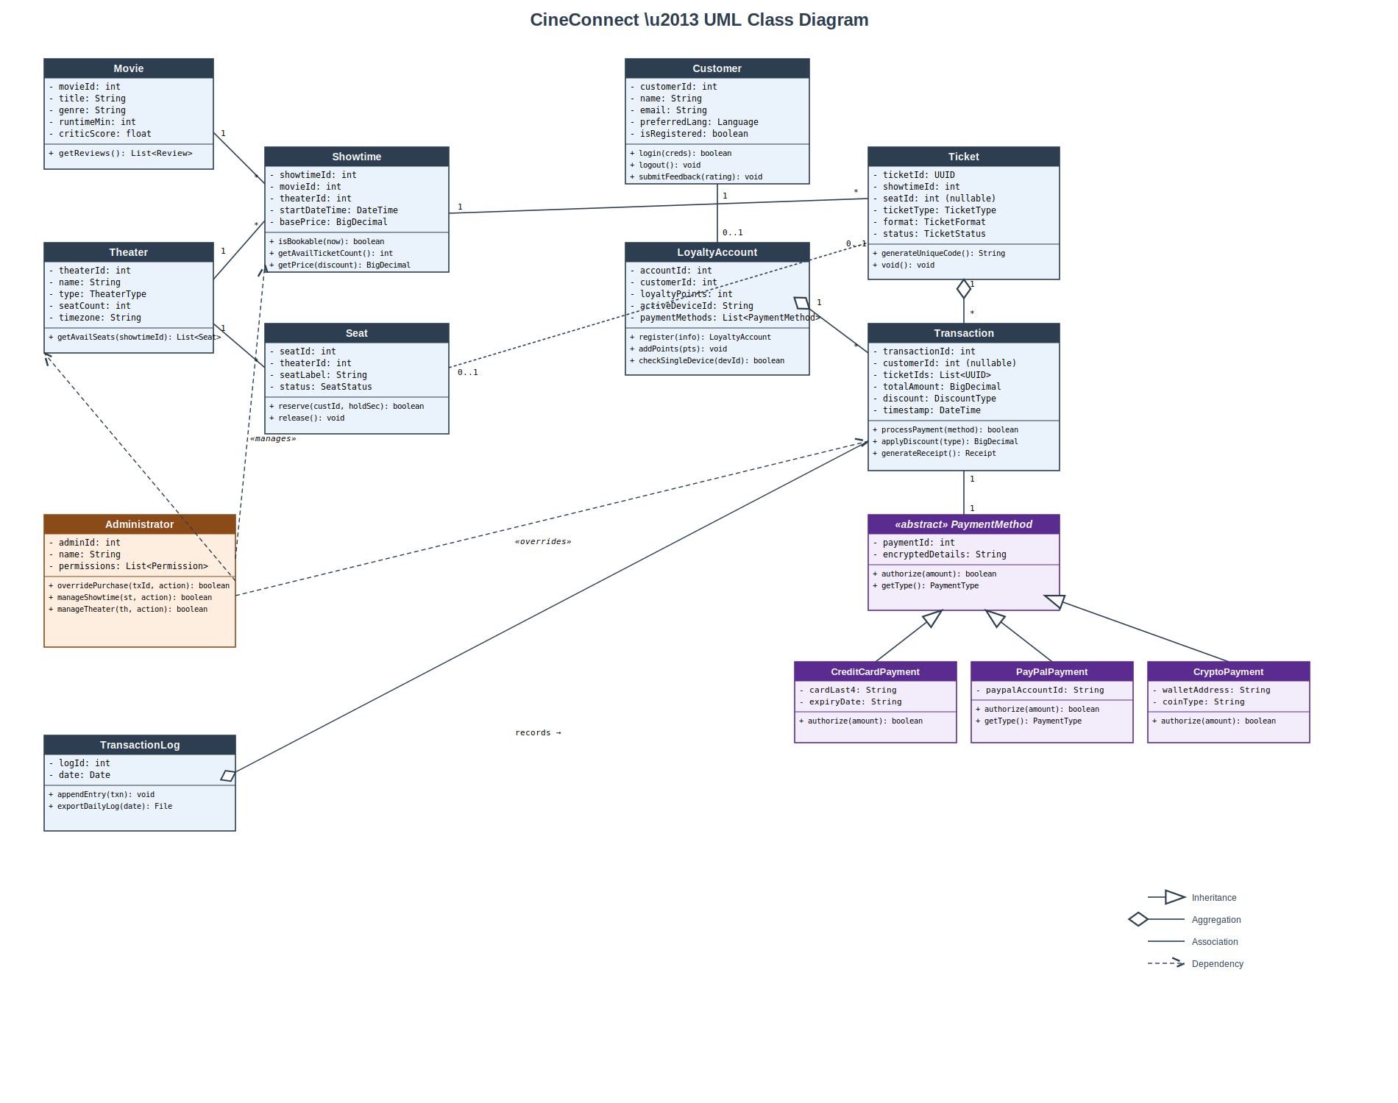
Figure 3. CineConnect UML class diagram.

6.2.3 Description of Classes, Attributes, and Operations
Each class below corresponds to a box in Figure 3. Attribute types and operation signatures are given in full so that they can be implemented directly.

Movie
Represents a film available for showing, along with aggregated third-party critic data.
Attributes
Name | Type | Description
movieId | int | Unique identifier for the movie.
title | String | Movie title.
genre | String | Primary genre classification.
runtimeMin | int | Runtime in minutes.
criticScore | float | Aggregated critic score (e.g., 0–100).

Operations
Operation | Parameters | Returns | Description
getReviews() | none | List<Review> | Retrieves cached critic quotes/scores for the movie (FR20).

Theater
Represents one of the chain's 20 physical theater locations.
Attributes
Name | Type | Description
theaterId | int | Unique identifier for the theater.
name | String | Theater location name.
type | TheaterType {REGULAR, DELUXE} | Determines seating model (150 general-admission vs. 75 assigned seats).
seatCount | int | Total seat capacity.
timezone | String | Local time zone (Pacific for this release).

Operations
Operation | Parameters | Returns | Description
getAvailSeats(showtimeId: int) | showtimeId: int | List<Seat> | Returns seats still available for a given showtime (FR5).

Showtime
Represents a scheduled screening of a Movie at a Theater.
Attributes
Name | Type | Description
showtimeId | int | Unique identifier for the showtime.
movieId | int | Foreign key to Movie.
theaterId | int | Foreign key to Theater.
startDateTime | DateTime | Scheduled start date/time.
basePrice | BigDecimal | Undiscounted ticket price.

Operations
Operation | Parameters | Returns | Description
isBookable(now: DateTime) | now: DateTime | boolean | True if now is within 2 weeks before through 10 minutes after start (FR3).
getAvailTicketCount() | none | int | Returns remaining ticket/seat inventory.
getPrice(discount: DiscountType) | discount: DiscountType | BigDecimal | Returns price after applying an eligible discount (FR7).

Seat
Represents an individual, assignable seat within a deluxe Theater.
Attributes
Name | Type | Description
seatId | int | Unique identifier for the seat.
theaterId | int | Foreign key to Theater.
seatLabel | String | Human-readable seat label (e.g., “D12”).
status | SeatStatus {AVAILABLE, RESERVED, SOLD} | Current seat state.

Operations
Operation | Parameters | Returns | Description
reserve(custId: int, holdSec: int) | custId: int, holdSec: int | boolean | Places a temporary hold on the seat for holdSec seconds (FR6, default 300s).
release() | none | void | Releases a held or cancelled seat back to AVAILABLE.

Customer
Represents any user purchasing tickets, whether or not they hold a LoyaltyAccount.
Attributes
Name | Type | Description
customerId | int | Unique identifier (guest or registered).
name | String | Customer's display name.
email | String | Contact email, used for digital ticket delivery (FR10).
preferredLang | Language {EN, ES, SV} | UI language preference (FR2).
isRegistered | boolean | True if a LoyaltyAccount exists for this customer.

Operations
Operation | Parameters | Returns | Description
login(creds: Credentials) | creds: Credentials | boolean | Authenticates a registered customer.
logout() | none | void | Ends the current session.
submitFeedback(rating: SmileyRating) | rating: SmileyRating | void | Records post-purchase feedback (FR19).

LoyaltyAccount
Represents an optional CineConnect Rewards membership tied to a Customer.
Attributes
Name | Type | Description
accountId | int | Unique identifier for the account.
customerId | int | Foreign key to Customer.
loyaltyPoints | int | Accumulated loyalty points.
activeDeviceId | String | Identifier of the single device currently authenticated (NFR9).
paymentMethods | List<PaymentMethod> | Stored payment methods for faster checkout.

Operations
Operation | Parameters | Returns | Description
register(info: CustomerInfo) | info: CustomerInfo | LoyaltyAccount | Creates a new loyalty account (FR11).
addPoints(pts: int) | pts: int | void | Credits loyalty points after a purchase.
checkSingleDevice(devId: String) | devId: String | boolean | Enforces the single concurrent device rule (FR13).

Ticket
Represents a single, uniquely identifiable admission to one showtime.
Attributes
Name | Type | Description
ticketId | UUID | Globally unique, non-replicable ticket identifier (FR9, NFR8).
showtimeId | int | Foreign key to Showtime.
seatId | int (nullable) | Foreign key to Seat; null for regular-theater general admission.
ticketType | TicketType {REGULAR, STUDENT, MILITARY, SENIOR} | Pricing category applied.
format | TicketFormat {DIGITAL, PRINTED} | Delivery format chosen by the customer (FR10).
status | TicketStatus {ISSUED, USED, VOIDED, REFUNDED} | Current lifecycle state.

Operations
Operation | Parameters | Returns | Description
generateUniqueCode() | none | String | Generates the ticket's non-replicable code at issuance.
void() | none | void | Invalidates the ticket (used by Administrator overrides).

Transaction
Represents a completed or in-progress purchase of one or more Tickets.
Attributes
Name | Type | Description
transactionId | int | Unique identifier for the transaction.
customerId | int (nullable) | Foreign key to Customer; null for guest checkout.
ticketIds | List<UUID> | Tickets included in this transaction (max 20, FR4).
totalAmount | BigDecimal | Final amount charged after discounts.
discount | DiscountType {NONE, STUDENT, MILITARY, SENIOR} | Discount applied, if any.
timestamp | DateTime | Time the transaction was completed.

Operations
Operation | Parameters | Returns | Description
processPayment(method: PaymentMethod) | method: PaymentMethod | boolean | Authorizes and captures payment (FR8).
applyDiscount(type: DiscountType) | type: DiscountType | BigDecimal | Computes the discounted total (FR7).
generateReceipt() | none | Receipt | Produces a receipt/confirmation for the customer.

PaymentMethod (abstract)
Abstract base class for all supported payment types; concrete subclasses implement authorize().
Attributes
Name | Type | Description
paymentId | int | Unique identifier for the stored payment method.
encryptedDetails | String | PCI-compliant encrypted payment details (NFR10).

Operations
Operation | Parameters | Returns | Description
authorize(amount: BigDecimal) | amount: BigDecimal | boolean | Authorizes a charge of the given amount; implemented by each subclass.
getType() | none | PaymentType | Returns CREDIT_CARD, PAYPAL, or CRYPTO.

CreditCardPayment / PayPalPayment / CryptoPayment
Concrete PaymentMethod subclasses corresponding to the three accepted payment types (FR8).
Attributes
Name | Type | Description
cardLast4 / paypalAccountId / walletAddress | String | Type-specific identifying detail, stored in encrypted form.
expiryDate / – / coinType | String | Additional type-specific metadata where applicable.

Operations
Operation | Parameters | Returns | Description
authorize(amount: BigDecimal) | amount: BigDecimal | boolean | Type-specific authorization call to the corresponding external payment gateway.

Administrator
Represents theater-chain staff with elevated permissions.
Attributes
Name | Type | Description
adminId | int | Unique identifier for the administrator.
name | String | Administrator's display name.
permissions | List<Permission> | Set of elevated actions this administrator may perform.

Operations
Operation | Parameters | Returns | Description
overridePurchase(txId: int, action: OverrideAction) | txId: int, action: OverrideAction | boolean | Voids, reissues, or reassigns a seat on an existing transaction (FR15).
manageShowtime(st: Showtime, action: CRUDAction) | st: Showtime, action: CRUDAction | boolean | Creates, edits, or removes a showtime (FR15).
manageTheater(th: Theater, action: CRUDAction) | th: Theater, action: CRUDAction | boolean | Creates, edits, or removes a theater (FR15).

TransactionLog
Represents the system-wide, append-only daily record of ticket purchases.
Attributes
Name | Type | Description
logId | int | Unique identifier for the log entry batch.
date | Date | Calendar date the entries belong to.

Operations
Operation | Parameters | Returns | Description
appendEntry(txn: Transaction) | txn: Transaction | void | Appends a completed transaction to the daily log (FR18).
exportDailyLog(date: Date) | date: Date | File | Exports the full log for a given date for audit purposes (NFR5).

6.3 Development Plan and Timeline
This project is completed by a single-member team (Martin Aloka, Red ID: 133942949). The plan below partitions the remaining implementation work into sequential phases rather than by teammate, and states which requirements/classes from Sections 3 and 6 each phase delivers.

6.3.1 Task Partitioning
Phase | Weeks | Deliverable | Owner
1 | 1–2 | Database schema and core domain classes: Movie, Theater, Showtime, Seat | Martin Aloka
2 | 3–4 | Ticket purchase workflow: Ticket, Transaction, seat holds, discount logic (FR3–FR10) | Martin Aloka
3 | 5 | Account & loyalty workflow: Customer, LoyaltyAccount, single-device login (FR11–FR14) | Martin Aloka
4 | 6 | Payment integration: PaymentMethod hierarchy and gateway integrations (FR8) | Martin Aloka
5 | 7 | Administrator console: overrides, showtime/theater management, daily logging (FR15, FR18) | Martin Aloka
6 | 8 | Bot mitigation, request queueing, feedback, and review aggregation (FR16, FR17, FR19, FR20) | Martin Aloka
7 | 9 | Integration testing against use cases in Section 3.3; bug fixing | Martin Aloka
8 | 10 | Final documentation, deployment prep, and project report | Martin Aloka

6.3.2 Responsibilities
As the sole team member, Martin Aloka is responsible for all design, implementation, and testing tasks above. Each phase is scoped to be completable within its allotted window while still allowing time in later phases for integration and regression testing against requirements delivered in earlier phases.

