*Session 6: Assignment 2*

**Table of Contents**

1. Introduction
2. Problem Statement
3. Output

1. Introduction

This assignment will help you to consolidate the concepts learnt in the session.

1. Problem Statement

This assignment is for visualization using matplotlib:

data to use:

url= https://raw.githubusercontent.com/Geoyi/Cleaning-Titanic-Data/master/titanic_original.csv '

titanic = pd.read_csv(url)

Charts to plot:

1. Create a pie chart presenting the male/female proportion

2. Create a scatterplot with the Fare paid and the Age, differ the plot color by gender

**Note: The solution shared through Github should contain the source code used**

**and the screenshot of the output.**

**3. Solution:**

**Input-1: Create a pie chart presenting the male/female proportion**

*import matplotlib.pyplot as plt*

*%matplotlib inline*

*import pandas as pd*

*titanic = pd.read_csv('https://raw.githubusercontent.com/Geoyi/Cleaning-Titanic-Data/master/titanic_original.csv')*

*female = len(titanic1[titanic1.sex=='female'])*

*male = len(titanic1[titanic1.sex=='male'])*

*fig = plt.figure()*

*chart1 = fig.add_subplot(1,1,1)*

*chart1.axis('equal')*

*chart1.pie([male, female],labels=['male','female'],autopct='%1.1f%%')*

**Input-2: Create a scatterplot with the Fare paid and the Age, differ the plot color by gender**

*import matplotlib.pyplot as plt*

*%matplotlib inline*

*import pandas as pd*

*titanic = pd.read_csv('https://raw.githubusercontent.com/Geoyi/Cleaning-Titanic-Data/master/titanic_original.csv')*

*cond = titanic.sex == 'female'*

*subset_x = titanic[cond]*

*subset_y = titanic[~cond]*

*plt.figure(figsize=(20, 15))*

*plt.scatter(subset_x.fare, subset_x.age, c='r', label='male')*

*plt.scatter(subset_y.fare, subset_y.age, c='b', label='female')*

*plt.title("Fare paid and Age, differed the plot color by Gender")*

*plt.xlabel("Fare Paid")*

*plt.ylabel("Age")*

*plt.legend()*

**Screen Shots:**

**1. A pie chart presenting the male/female proportion:**

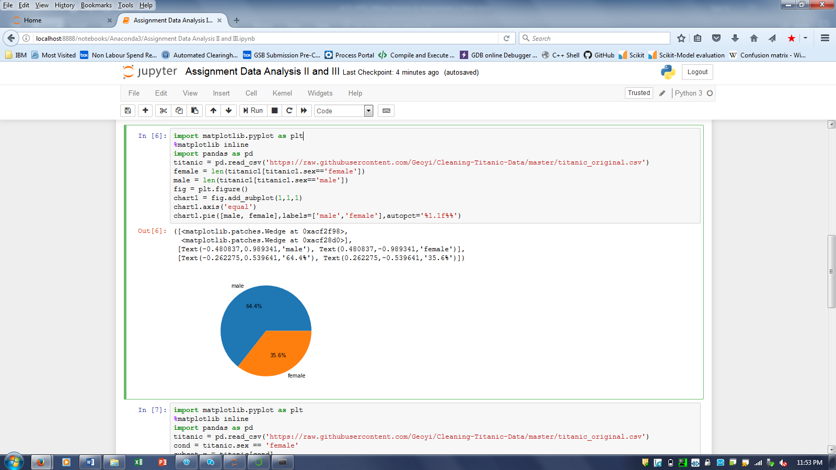

1. **A scatterplot with the Fare paid and the Age, differ the plot color by gender:**

