Obsah
Test 1 There is no piece , borders ,badColour of piece 2
Test 2 Knight not type of piece move 3
Test 3 take friend,take enemy 4
Test 4 blocade 5
Test 5 clasic moves validator 6
Test 6 Validator Repeat S oponentem 8
Test 7 Absolute Arcibishop pro save 7 10
Test 8 pawn free 20
Test 9 pawn blockade 21
Test 10 pawn friendly 21
Test 11 pawn enemy 22
Neutral absolute arcibishop 23
Neutral Pawn 25
Test 26
Test 26
Test 28
Test 29
Test 30
Test big move 31
Test big move s behaviour 32
Chess Setup 33
Test first move 35
Test castle 37
Test The game 38
Test first move castle 44
Test Promotion 46
Test Promotion with také 47
Test airplane rotation 49
Test airplane promotion + fighter moves 50
Test Carrier block and taken 51
Test water interaction 54
Test Enpassant 56
Test torpedo moves 57

Test 1 There is no piece , borders ,badColour of piece
//inicializace hráčů
Player player1 = new Player("Bílý",Colour.White,600);
Player player2 = new Player("Černý",Colour.Black,600);
//konec inicializace hráčů
//inicializace figur
Knight knight1 = new Knight("knight1",0,0,Colour.White);
Knight knight2 = new Knight("knight2",1,1,Colour.White);
//konec inicializace figur
ChessBoard chessBoard = new ChessBoard(8,8);
chessBoard.printBoard();
chessBoard.addPiece(knight1);
chessBoard.addPiece(knight2);
chessBoard.printBoard();
chessBoard.getPosibleMoves();
System.out.println("5,0,9,9");
chessBoard.movePiece(5,0,9,9,player1);
chessBoard.printBoard();
chessBoard.getPosibleMoves();
System.out.println("9,9,9,9");
chessBoard.movePiece(9,9,9,9,player1);
chessBoard.printBoard();
chessBoard.getPosibleMoves();
System.out.println("5,1,1,1");
chessBoard.movePiece(5,1,1,1,player1);
chessBoard.printBoard();
chessBoard.getPosibleMoves();
System.out.println("5,0,2,1");
chessBoard.movePiece(5,0,2,1,player1);
chessBoard.printBoard();
chessBoard.getPosibleMoves();
System.out.println("1,1,5,5");
chessBoard.movePiece(1,1,5,5,player2);
chessBoard.printBoard();
Test 2 Knight not type of piece move
//inicializace hráčů
Player player1 = new Player("Bílý",Colour.White,600);
//konec inicializace hráčů
//inicializace figur
Knight knight1 = new Knight("knight1",0,0,Colour.White);
//konec inicializace figur
ChessBoard chessBoard = new ChessBoard(8,8);
chessBoard.addPiece(knight1);
chessBoard.printBoard();
chessBoard.getPosibleMoves();
System.out.println("0,0,1,1");
chessBoard.movePiece(0,0,1,1,player1);
chessBoard.printBoard();
System.out.println("0,0,2,1");
chessBoard.getPosibleMoves();
chessBoard.movePiece(0,0,2,1,player1);
chessBoard.printBoard();

Test 3 take friend,take enemy

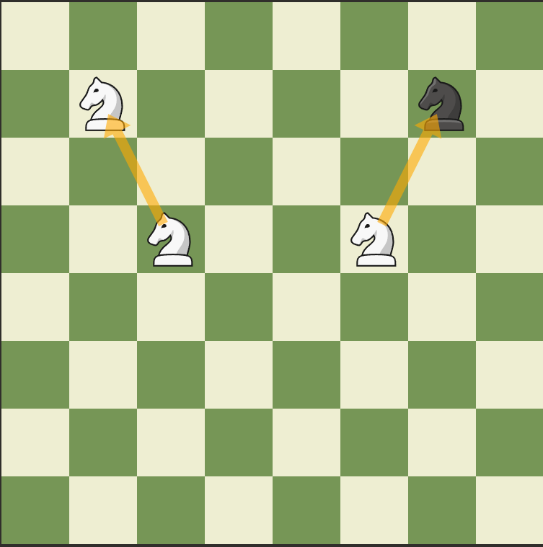
2
1
//inicializace hráčů
Player player1 = new Player("Bílý",Colour.White,600);
//konec inicializace hráčů
//inicializace figur
Knight knight1 = new Knight("knight1",1,1,Colour.White);
Knight knight2 = new Knight("knight2",6,1,Colour.Black);
Knight knight3 = new Knight("knight3",2,3,Colour.White);
Knight knight4 = new Knight("knight4",5,3,Colour.White);
//konec inicializace figur
//inicializace šachovnice
ChessBoard chessBoard = new ChessBoard(8,8);
chessBoard.addPiece(knight1);
chessBoard.addPiece(knight2);
chessBoard.addPiece(knight3);
chessBoard.addPiece(knight4);
chessBoard.printBoard();
//konec inicializace šachovnice
chessBoard.getPosibleMoves();
System.out.println("2,3,1,1");
chessBoard.movePiece(2,3,1,1,player1);
chessBoard.printBoard();
chessBoard.getPosibleMoves();
System.out.println("5,3,6,1");
chessBoard.movePiece(5,3,6,1,player1);
chessBoard.printBoard();

Test 4 blocade
//inicializace hráčů
Player player1 = new Player("Bílý",Colour.White,600);
//konec inicializace hráčů
//inicializace figur
Knight knight1 = new Knight("knight1",0,0,Colour.White);
Piece blokada = new Piece("blokada",2,1,Colour.Blockade);
//konec inicializace figur
//inicializace šachovnice
ChessBoard chessBoard = new ChessBoard(8,8);
chessBoard.addPiece(knight1);
chessBoard.addPiece(blokada);
chessBoard.printBoard();
//konec inicializace šachovnice
chessBoard.getPosibleMoves();
System.out.println("0,0,1,1");
chessBoard.movePiece(0,0,1,1,player1);
chessBoard.printBoard();
System.out.println("0,0,2,1");
chessBoard.getPosibleMoves();
chessBoard.movePiece(0,0,2,1,player1);
chessBoard.printBoard();
System.out.println("0,0,1,2");
chessBoard.getPosibleMoves();
chessBoard.movePiece(0,0,1,2,player1);
chessBoard.printBoard();

Test 5 clasic moves validator

//inicializace hráčů
Player player1 = new Player("Bílý",Colour.White,600);
//konec inicializace hráčů
//inicializace figur
//Knight knight1 = new Knight("knight1",0,0,Colour.White);
Piece bishop = new Piece("bishop",2,4,Colour.White);
bishop.addMove(new MoveType(1,1,true));
bishop.addMove(new MoveType(-1,-1,true));
bishop.addMove(new MoveType(-1,1,true));
bishop.addMove(new MoveType(1,-1,true));
Piece arciBishop = new Piece("arci bishop",4,4,Colour.White);
arciBishop.addMove(new MoveType(1,1,true));
arciBishop.addMove(new MoveType(-1,-1,true));
arciBishop.addMove(new MoveType(-1,1,true));
arciBishop.addMove(new MoveType(1,-1,true));
arciBishop.addMove(new MoveType(2,1,false));
arciBishop.addMove(new MoveType(2,-1,false));
arciBishop.addMove(new MoveType(-2,1,false));
arciBishop.addMove(new MoveType(-2,-1,false));
arciBishop.addMove(new MoveType(1,2,false));
arciBishop.addMove(new MoveType(1,-2,false));
arciBishop.addMove(new MoveType(-1,2,false));
arciBishop.addMove(new MoveType(-1,-2,false));
//konec inicializace figur
//inicializace šachovnice
ChessBoard chessBoard = new ChessBoard(8,8);
chessBoard.addPiece(bishop);
chessBoard.addPiece(arciBishop);
chessBoard.printBoard();
//konec inicializace šachovnice
chessBoard.getPosibleMoves();
System.out.println("moves 1 piece");
chessBoard.getPosibleMovesOnePiece(2,4);
System.out.println("clasic moves");
chessBoard.getClasicalMoves(4,4);
System.out.println("generated moves");
chessBoard.getGeneratedMoves(4,4);
chessBoard.printBoard();
System.out.println("\nmoves piece");
System.out.println("4,4,2,3");
chessBoard.movePiece(4,4,2,3,player1);
chessBoard.printBoard();

Test 6 Validator Repeat S oponentem
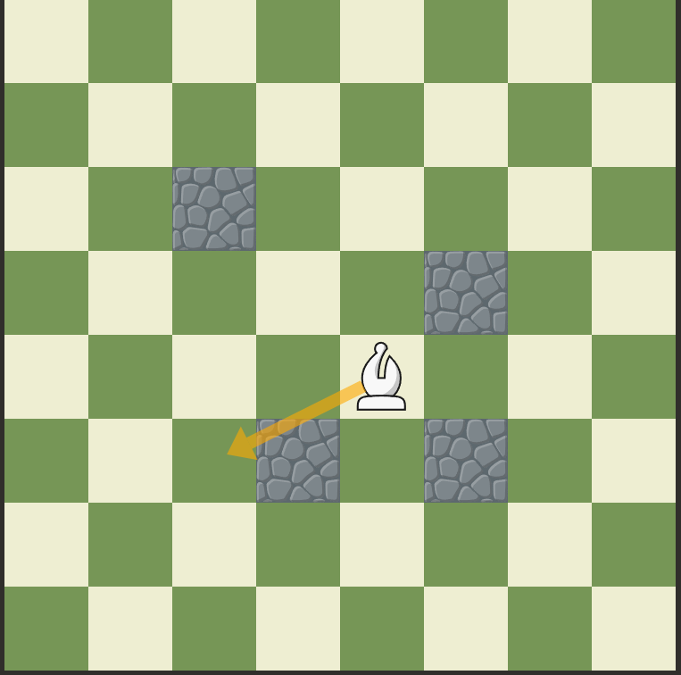
//inicializace hráčů
Player player1 = new Player("Bílý",Colour.White,600);
//konec inicializace hráčů
//inicializace figur
Piece arciBishop = new Piece("arci bishop",4,4,Colour.White);
arciBishop.addMove(new MoveType(1,1,true));
arciBishop.addMove(new MoveType(-1,-1,true));
arciBishop.addMove(new MoveType(-1,1,true));
arciBishop.addMove(new MoveType(1,-1,true));
arciBishop.addMove(new MoveType(2,1,false));
arciBishop.addMove(new MoveType(2,-1,false));
arciBishop.addMove(new MoveType(-2,1,false));
arciBishop.addMove(new MoveType(-2,-1,false));
arciBishop.addMove(new MoveType(1,2,false));
arciBishop.addMove(new MoveType(1,-2,false));
arciBishop.addMove(new MoveType(-1,2,false));
arciBishop.addMove(new MoveType(-1,-2,false));
Piece blokada1 = new Piece("blokada",5,5,Colour.Blockade);
Piece blokada2 = new Piece("blokada",3,5,Colour.Blockade);
Piece blokada3 = new Piece("blokada",5,3,Colour.Blockade);
Piece blokada4 = new Piece("blokada",2,2,Colour.Black);
Knight knight1 = new Knight("kignt",6,2,Colour.Black);
//konec inicializace figur
//inicializace šachovnice
ChessBoard chessBoard = new ChessBoard(8,8);
chessBoard.addPiece(arciBishop);
chessBoard.addPiece(blokada1);
chessBoard.addPiece(blokada2);
chessBoard.addPiece(blokada3);
chessBoard.addPiece(blokada4);
chessBoard.addPiece(knight1);
chessBoard.printBoard();
//konec inicializace šachovnice
chessBoard.getPosibleMoves();
System.out.println("moves 1 piece");
chessBoard.getPosibleMovesOnePiece(2,4);
System.out.println("clasic moves");
chessBoard.getClasicalMoves(4,4);
System.out.println("generated moves");
chessBoard.getGeneratedMoves(4,4);
chessBoard.printBoard();
System.out.println("\nmoves piece");
System.out.println("4,4,2,3");
chessBoard.movePiece(4,4,2,3,player1);
chessBoard.printBoard();

Test 7 Absolute Arcibishop pro save 7
inicializace
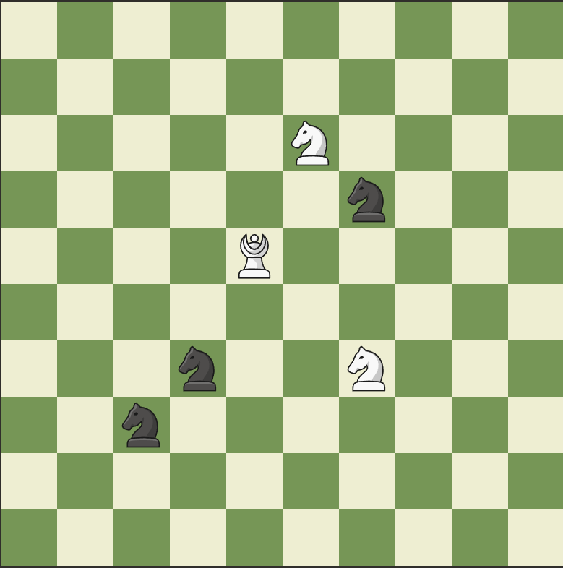
Pokus o move
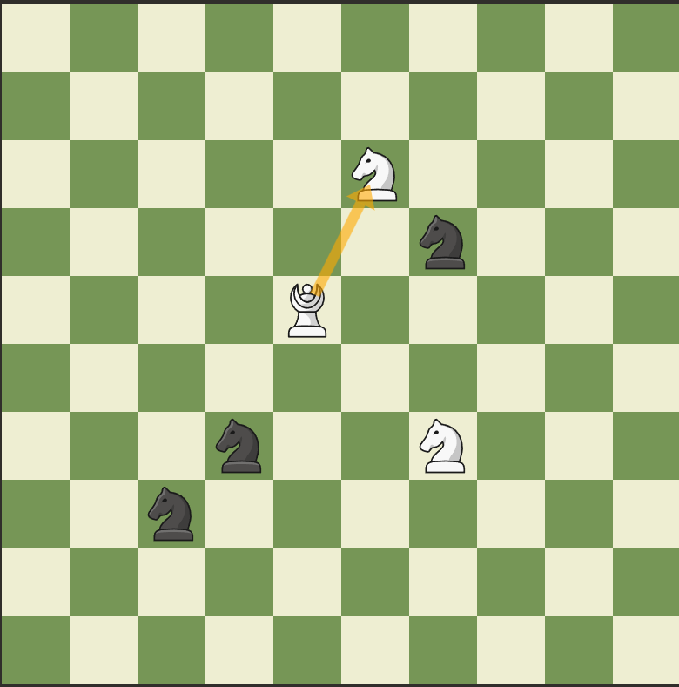
Pokus o move
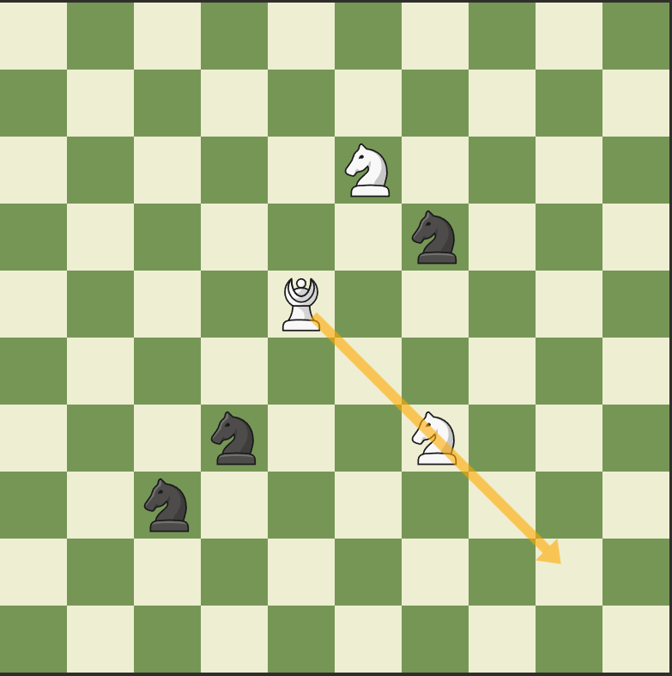

Žere knighta move
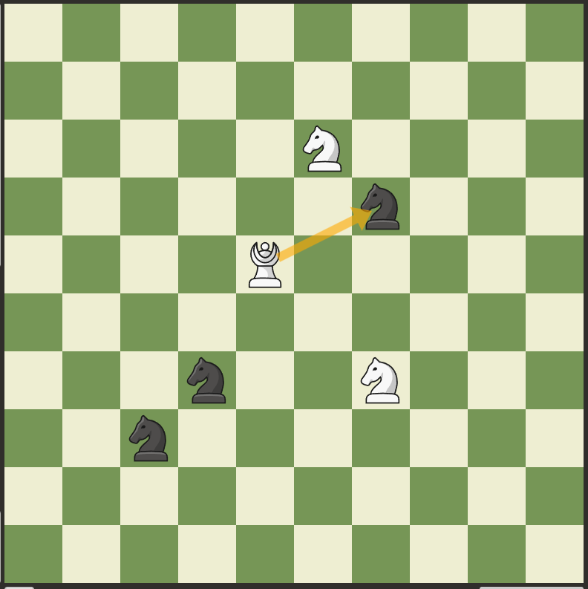
Pokus o move
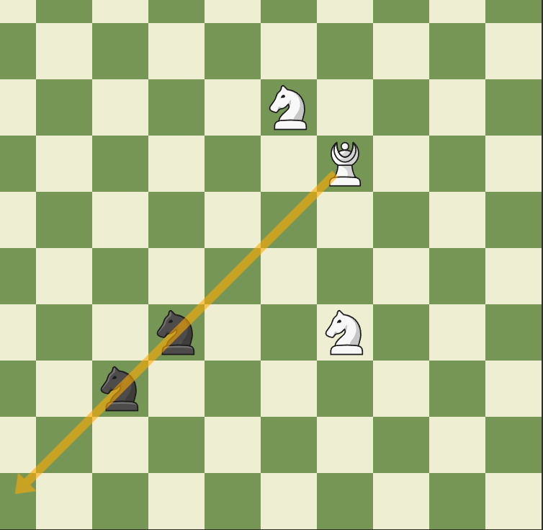

Pokus o move
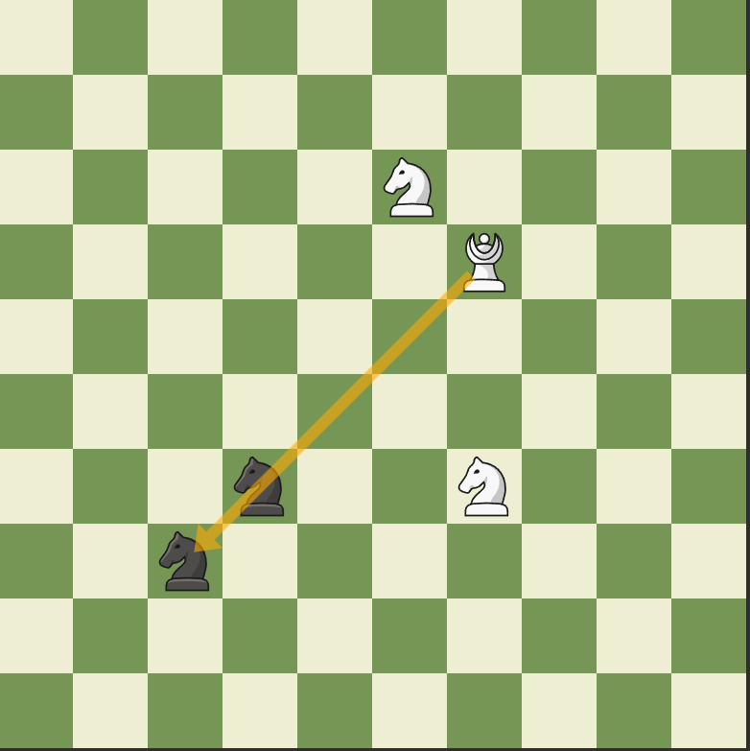
Move
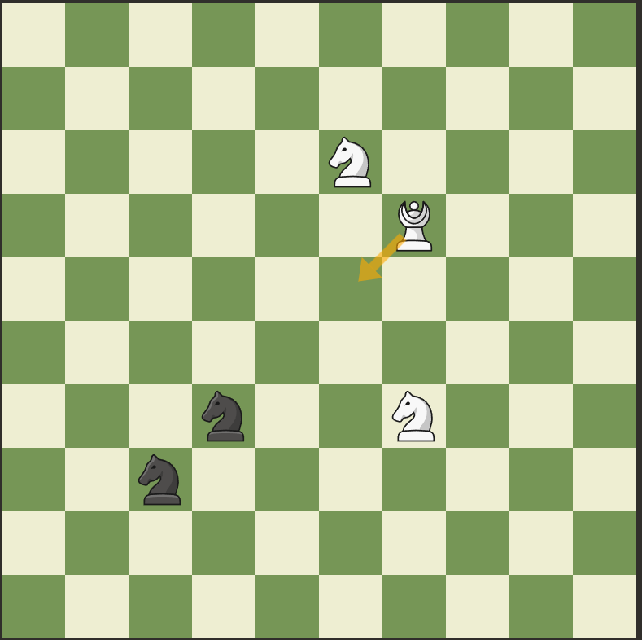

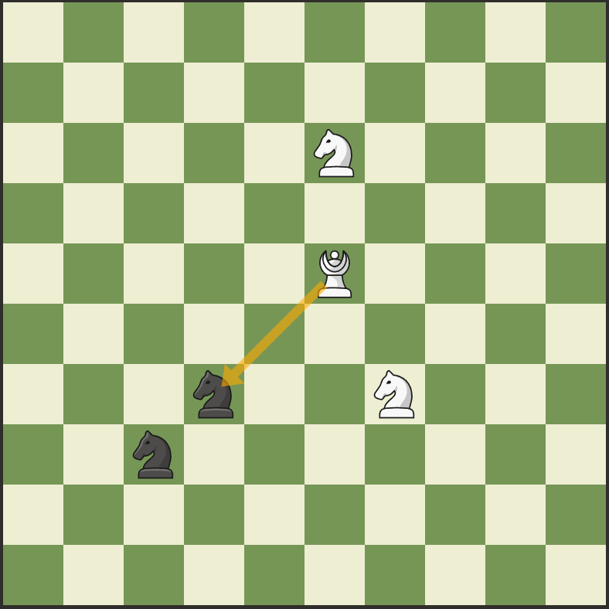
Žere knighta move
konec 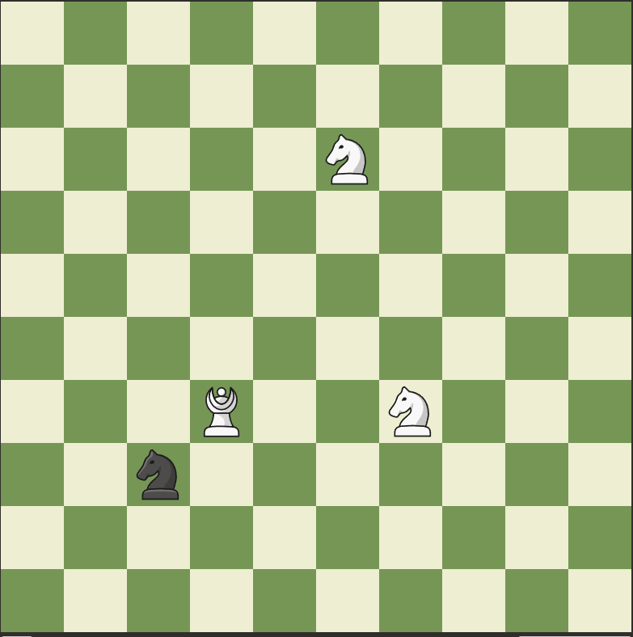
Výstup :
C:\Users\marti\.jdks\openjdk-25\bin\java.exe "-javaagent:C:\Program Files\JetBrains\IntelliJ IDEA 2025.2.2\lib\idea_rt.jar=56671" -Dfile.encoding=UTF-8 -Dsun.stdout.encoding=UTF-8 -Dsun.stderr.encoding=UTF-8 -classpath "C:\Users\marti\Documents\Šachy\hra projekt\chess\out\production\chess" Main

Výpis :

0000 1100 2200 3300 4400 5500 6600 7700 8800 9900

0011 1111 2211 3311 4411 5511 6611 7711 8811 9911

0022 1122 2222 3322 4422 N N 6622 7722 8822 9922

0033 1133 2233 3333 4433 5533 N N 7733 8833 9933

0044 1144 2244 3344 A B 5544 6644 7744 8844 9944

0055 1155 2255 3355 4455 5555 6655 7755 8855 9955

0066 1166 2266 N N 4466 5566 N N 7766 8866 9966

0077 1177 N N 3377 4477 5577 6677 7777 8877 9977

0088 1188 2288 3388 4488 5588 6688 7788 8888 9988

0099 1199 2299 3399 4499 5599 6699 7799 8899 9999

figura : arci bishop White z (4, 4) na (5, 2)

x : 5 y : 5
x : 3 y : 3
x : 2 y : 2
x : 1 y : 1
x : 0 y : 0
x : 3 y : 5
x : 2 y : 6
x : 1 y : 7
x : 0 y : 8
x : 5 y : 3
x : 6 y : 2
x : 7 y : 1
x : 8 y : 0
pohyb neodpovídá typu figury

Výpis :

0000 1100 2200 3300 4400 5500 6600 7700 8800 9900

0011 1111 2211 3311 4411 5511 6611 7711 8811 9911

0022 1122 2222 3322 4422 N N 6622 7722 8822 9922

0033 1133 2233 3333 4433 5533 N N 7733 8833 9933

0044 1144 2244 3344 A B 5544 6644 7744 8844 9944

0055 1155 2255 3355 4455 5555 6655 7755 8855 9955

0066 1166 2266 N N 4466 5566 N N 7766 8866 9966

0077 1177 N N 3377 4477 5577 6677 7777 8877 9977

0088 1188 2288 3388 4488 5588 6688 7788 8888 9988

0099 1199 2299 3399 4499 5599 6699 7799 8899 9999

figura : arci bishop White z (4, 4) na (8, 8)

x : 5 y : 5
x : 3 y : 3
x : 2 y : 2
x : 1 y : 1
x : 0 y : 0
x : 3 y : 5
x : 2 y : 6
x : 1 y : 7
x : 0 y : 8
x : 5 y : 3
x : 6 y : 2
x : 7 y : 1
x : 8 y : 0
pohyb neodpovídá typu figury

Výpis :

0000 1100 2200 3300 4400 5500 6600 7700 8800 9900

0011 1111 2211 3311 4411 5511 6611 7711 8811 9911

0022 1122 2222 3322 4422 N N 6622 7722 8822 9922

0033 1133 2233 3333 4433 5533 N N 7733 8833 9933

0044 1144 2244 3344 A B 5544 6644 7744 8844 9944

0055 1155 2255 3355 4455 5555 6655 7755 8855 9955

0066 1166 2266 N N 4466 5566 N N 7766 8866 9966

0077 1177 N N 3377 4477 5577 6677 7777 8877 9977

0088 1188 2288 3388 4488 5588 6688 7788 8888 9988

0099 1199 2299 3399 4499 5599 6699 7799 8899 9999

figura : arci bishop White z (4, 4) na (6, 3)

x : 5 y : 5
x : 3 y : 3
x : 2 y : 2
x : 1 y : 1
x : 0 y : 0
x : 3 y : 5
x : 2 y : 6
x : 1 y : 7
x : 0 y : 8
x : 5 y : 3
x : 6 y : 2
x : 7 y : 1
x : 8 y : 0

Výpis :

0000 1100 2200 3300 4400 5500 6600 7700 8800 9900

0011 1111 2211 3311 4411 5511 6611 7711 8811 9911

0022 1122 2222 3322 4422 N N 6622 7722 8822 9922

0033 1133 2233 3333 4433 5533 A B 7733 8833 9933

0044 1144 2244 3344 4444 5544 6644 7744 8844 9944

0055 1155 2255 3355 4455 5555 6655 7755 8855 9955

0066 1166 2266 N N 4466 5566 N N 7766 8866 9966

0077 1177 N N 3377 4477 5577 6677 7777 8877 9977

0088 1188 2288 3388 4488 5588 6688 7788 8888 9988

0099 1199 2299 3399 4499 5599 6699 7799 8899 9999

figura : arci bishop White z (6, 3) na (0, 9)

x : 7 y : 4
x : 8 y : 5
x : 9 y : 6
x : 5 y : 4
x : 4 y : 5
x : 3 y : 6
x : 7 y : 2
x : 8 y : 1
x : 9 y : 0
pohyb neodpovídá typu figury

Výpis :

0000 1100 2200 3300 4400 5500 6600 7700 8800 9900

0011 1111 2211 3311 4411 5511 6611 7711 8811 9911

0022 1122 2222 3322 4422 N N 6622 7722 8822 9922

0033 1133 2233 3333 4433 5533 A B 7733 8833 9933

0044 1144 2244 3344 4444 5544 6644 7744 8844 9944

0055 1155 2255 3355 4455 5555 6655 7755 8855 9955

0066 1166 2266 N N 4466 5566 N N 7766 8866 9966

0077 1177 N N 3377 4477 5577 6677 7777 8877 9977

0088 1188 2288 3388 4488 5588 6688 7788 8888 9988

0099 1199 2299 3399 4499 5599 6699 7799 8899 9999

figura : arci bishop White z (6, 3) na (2, 7)

x : 7 y : 4
x : 8 y : 5
x : 9 y : 6
x : 5 y : 4
x : 4 y : 5
x : 3 y : 6
x : 7 y : 2
x : 8 y : 1
x : 9 y : 0
pohyb neodpovídá typu figury

Výpis :

0000 1100 2200 3300 4400 5500 6600 7700 8800 9900

0011 1111 2211 3311 4411 5511 6611 7711 8811 9911

0022 1122 2222 3322 4422 N N 6622 7722 8822 9922

0033 1133 2233 3333 4433 5533 A B 7733 8833 9933

0044 1144 2244 3344 4444 5544 6644 7744 8844 9944

0055 1155 2255 3355 4455 5555 6655 7755 8855 9955

0066 1166 2266 N N 4466 5566 N N 7766 8866 9966

0077 1177 N N 3377 4477 5577 6677 7777 8877 9977

0088 1188 2288 3388 4488 5588 6688 7788 8888 9988

0099 1199 2299 3399 4499 5599 6699 7799 8899 9999

figura : arci bishop White z (6, 3) na (5, 4)

x : 7 y : 4
x : 8 y : 5
x : 9 y : 6
x : 5 y : 4
x : 4 y : 5
x : 3 y : 6
x : 7 y : 2
x : 8 y : 1
x : 9 y : 0

Výpis :

0000 1100 2200 3300 4400 5500 6600 7700 8800 9900

0011 1111 2211 3311 4411 5511 6611 7711 8811 9911

0022 1122 2222 3322 4422 N N 6622 7722 8822 9922

0033 1133 2233 3333 4433 5533 6633 7733 8833 9933

0044 1144 2244 3344 4444 A B 6644 7744 8844 9944

0055 1155 2255 3355 4455 5555 6655 7755 8855 9955

0066 1166 2266 N N 4466 5566 N N 7766 8866 9966

0077 1177 N N 3377 4477 5577 6677 7777 8877 9977

0088 1188 2288 3388 4488 5588 6688 7788 8888 9988

0099 1199 2299 3399 4499 5599 6699 7799 8899 9999

figura : arci bishop White z (5, 4) na (3, 6)

x : 6 y : 5
x : 7 y : 6
x : 8 y : 7
x : 9 y : 8
x : 4 y : 3
x : 3 y : 2
x : 2 y : 1
x : 1 y : 0
x : 4 y : 5
x : 3 y : 6
x : 6 y : 3
x : 7 y : 2
x : 8 y : 1
x : 9 y : 0

Výpis :

0000 1100 2200 3300 4400 5500 6600 7700 8800 9900

0011 1111 2211 3311 4411 5511 6611 7711 8811 9911

0022 1122 2222 3322 4422 N N 6622 7722 8822 9922

0033 1133 2233 3333 4433 5533 6633 7733 8833 9933

0044 1144 2244 3344 4444 5544 6644 7744 8844 9944

0055 1155 2255 3355 4455 5555 6655 7755 8855 9955

0066 1166 2266 A B 4466 5566 N N 7766 8866 9966

0077 1177 N N 3377 4477 5577 6677 7777 8877 9977

0088 1188 2288 3388 4488 5588 6688 7788 8888 9988

0099 1199 2299 3399 4499 5599 6699 7799 8899 9999
Process finished with exit code 0
Vstup :
//inicializace hráčů
Player player1 = new Player("Bílý",Colour.White,600);
//konec inicializace hráčů
//inicializace figur
ArciBishop arciBishop = new ArciBishop("arci bishop White",4,4,Colour.White);
Knight Knight1 = new Knight("knight 1 White",5,2,Colour.White);
Knight Knight2 = new Knight("knight 2 White",6,6,Colour.White);
Knight Knight3 = new Knight("knight 3 Black",6,3,Colour.Black);
Knight Knight4 = new Knight("knight 4 Black",3,6,Colour.Black);
Knight Knight5 = new Knight("knight 5 Black",2,7,Colour.Black);
//konec inicializace figur
//inicializace šachovnice
ChessBoard chessBoard = new ChessBoard(10,10);
chessBoard.addPiece(arciBishop);
chessBoard.addPiece(Knight1);
chessBoard.addPiece(Knight2);
chessBoard.addPiece(Knight3);
chessBoard.addPiece(Knight4);
chessBoard.addPiece(Knight5);
chessBoard.printBoard();
//konec inicializace šachovnice
chessBoard.movePiece(4,4,5,2,player1);
chessBoard.printBoard();
chessBoard.movePiece(4,4,8,8,player1);
chessBoard.printBoard();
chessBoard.movePiece(4,4,6,3,player1);
chessBoard.printBoard();
chessBoard.movePiece(6,3,0,9,player1);
chessBoard.printBoard();
chessBoard.movePiece(6,3,2,7,player1);
chessBoard.printBoard();
chessBoard.movePiece(6,3,5,4,player1);
chessBoard.printBoard();
chessBoard.movePiece(5,4,3,6,player1);
chessBoard.printBoard();

Test 8 pawn free

//inicializace hráčů
Player player1 = new Player("Bílý",Colour.White,600);
//konec inicializace hráčů
//inicializace figur
Pawn pawn1 = new Pawn("pawn1",1,5,Colour.White, 0);
//konec inicializace figur
//inicializace šachovnice
ChessBoard chessBoard = new ChessBoard(6,6);
chessBoard.addPiece(pawn1);
chessBoard.printBoard();
//konec inicializace šachovnice
chessBoard.movePiece(1,5,0,4,player1);
chessBoard.printBoard();
chessBoard.movePiece(1,5,1,4,player1);
chessBoard.printBoard();

Test 9 pawn blockade
//inicializace hráčů
Player player1 = new Player("Bílý",Colour.White,600);
//konec inicializace hráčů
//inicializace figur
Pawn pawn1 = new Pawn("pawn1",1,5,Colour.White, 0);
Blocade piece = new Blocade("piece" ,0,4);
Blocade piece2 = new Blocade("piece" ,1,4);
//konec inicializace figur
//inicializace šachovnice
ChessBoard chessBoard = new ChessBoard(6,6);
chessBoard.addPiece(pawn1);
chessBoard.addPiece(piece);
chessBoard.addPiece(piece2);
chessBoard.printBoard();
//konec inicializace šachovnice
chessBoard.movePiece(1,5,0,4,player1);
chessBoard.printBoard();
chessBoard.movePiece(1,5,1,4,player1);
chessBoard.printBoard();

Test 10 pawn friendly
//inicializace hráčů
Player player1 = new Player("Bílý",Colour.White,600);
//konec inicializace hráčů
//inicializace figur
Pawn pawn1 = new Pawn("pawn1",1,5,Colour.White, 0);
Knight piece = new Knight("piece" ,0,4,Colour.White);
Knight piece2 = new Knight ("piece" ,1,4,Colour.White);
//konec inicializace figur
//inicializace šachovnice
ChessBoard chessBoard = new ChessBoard(6,6);
chessBoard.addPiece(pawn1);
chessBoard.addPiece(piece);
chessBoard.addPiece(piece2);
chessBoard.printBoard();
//konec inicializace šachovnice
chessBoard.movePiece(1,5,0,4,player1);
chessBoard.printBoard();
chessBoard.movePiece(1,5,1,4,player1);
chessBoard.printBoard();

Test 11 pawn enemy
//inicializace hráčů
Player player1 = new Player("Bílý",Colour.White,600);
//konec inicializace hráčů
//inicializace figur
Pawn pawn1 = new Pawn("pawn1",1,5,Colour.White, 0);
Knight piece = new Knight("piece" ,0,4,Colour.Black);
Knight piece2 = new Knight ("piece" ,1,4,Colour.Black);
//konec inicializace figur
//inicializace šachovnice
ChessBoard chessBoard = new ChessBoard(6,6);
chessBoard.addPiece(pawn1);
chessBoard.addPiece(piece);
chessBoard.addPiece(piece2);
chessBoard.printBoard();
//konec inicializace šachovnice
chessBoard.movePiece(1,5,1,4,player1);
chessBoard.printBoard();
chessBoard.movePiece(1,5,0,4,player1);
chessBoard.printBoard();

Neutral absolute arcibishop

//inicializace hráčů
Player player1 = new Player("Bílý",Colour.White,600);
//konec inicializace hráčů
//inicializace figur
ArciBishop arciBishop = new ArciBishop("arci bishop White",4,4,Colour.White);
Knight Knight1 = new Knight("knight 1 White",5,2,Colour.White);
Knight Knight2 = new Knight("knight 2 White",6,6,Colour.White);
Knight Knight3 = new Knight("knight 3 Black",6,3,Colour.Black);
OverClocker overClocker = new OverClocker("overclocker",3,6);
Knight Knight5 = new Knight("knight 5 Black",2,7,Colour.Black);
//konec inicializace figur
//inicializace šachovnice
ChessBoard chessBoard = new ChessBoard(10,10);
chessBoard.addPiece(arciBishop);
chessBoard.addPiece(Knight1);
chessBoard.addPiece(Knight2);
chessBoard.addPiece(Knight3);
chessBoard.addPiece(overClocker);
chessBoard.addPiece(Knight5);
chessBoard.printBoard();
//konec inicializace šachovnice
chessBoard.movePiece(4,4,5,2,player1);
chessBoard.printBoard();
chessBoard.movePiece(4,4,8,8,player1);
chessBoard.printBoard();
chessBoard.movePiece(4,4,6,3,player1);
chessBoard.printBoard();
chessBoard.movePiece(6,3,0,9,player1);
chessBoard.printBoard();
chessBoard.movePiece(6,3,2,7,player1);
chessBoard.printBoard();
chessBoard.movePiece(6,3,5,4,player1);
chessBoard.printBoard();
chessBoard.movePiece(5,4,3,6,player1);
chessBoard.printBoard();
System.out.println(player1.toString());
}}

Neutral Pawn
//inicializace hráčů
Player player1 = new Player("Bílý",Colour.White,600);
//konec inicializace hráčů
//inicializace figur
Pawn pawn1 = new Pawn("pawn1",1,5,Colour.White, 0);
OverClocker piece = new OverClocker("Overclocker",1,4);
OverClocker piece2 = new OverClocker("Overclocker" ,0,4);
//konec inicializace figur
//inicializace šachovnice
ChessBoard chessBoard = new ChessBoard(6,6);
chessBoard.addPiece(pawn1);
chessBoard.addPiece(piece);
chessBoard.addPiece(piece2);
chessBoard.printBoard();
//konec inicializace šachovnice
chessBoard.movePiece(1,5,1,4,player1);
chessBoard.printBoard();
chessBoard.movePiece(1,5,0,4,player1);
chessBoard.printBoard();
System.out.println( player1.toString());

Test
//inicializace hráčů
Player player1 = new Player("Bílý",Colour.White,600);
//konec inicializace hráčů
//inicializace figur
Piece test1 = new Piece("test1",0,4,Colour.White);
Piece test2 = new Piece("test2",1,4,Colour.White);
Piece test3 = new Piece("test3",2,4,Colour.White);
Piece test4 = new Piece("test4",3,4,Colour.White);
test1.addMove(new MoveType(0,-1,MoveBehaviour.BOTH,MoveClass.REPEAT));
test2.addMove(new MoveType(0,-1,MoveBehaviour.TAKE,MoveClass.REPEAT));
test3.addMove(new MoveType(0,-1,MoveBehaviour.MOVE,MoveClass.REPEAT));
test4.addMove(new MoveType(0,-1,MoveBehaviour.NONE,MoveClass.REPEAT));
//konec inicializace figur
//inicializace šachovnice
ChessBoard chessBoard = new ChessBoard(5,5);
chessBoard.addPiece(test1);
chessBoard.addPiece(test2);
chessBoard.addPiece(test3);
chessBoard.addPiece(test4);
chessBoard.printBoard();
chessBoard.movePiece(0,4,0,0,player1);
chessBoard.movePiece(1,4,1,0,player1);
chessBoard.movePiece(2,4,2,0,player1);
chessBoard.movePiece(3,4,3,0,player1);
chessBoard.printBoard();

Test

//inicializace hráčů
Player player1 = new Player("Bílý",Colour.White,600);
//konec inicializace hráčů
//inicializace figur
Piece test1 = new Piece("test1",0,4,Colour.White);
Piece test2 = new Piece("test2",1,4,Colour.White);
Piece test3 = new Piece("test3",2,4,Colour.White);
Piece test4 = new Piece("test4",3,4,Colour.White);
test1.addMove(new MoveType(0,-1,MoveBehaviour.BOTH,MoveClass.REPEAT));
test2.addMove(new MoveType(0,-1,MoveBehaviour.TAKE,MoveClass.REPEAT));
test3.addMove(new MoveType(0,-1,MoveBehaviour.MOVE,MoveClass.REPEAT));
test4.addMove(new MoveType(0,-1,MoveBehaviour.NONE,MoveClass.REPEAT));
Knight knight1 = new Knight("knight",0,0,Colour.White);
Knight knight2 = new Knight("knight",1,0,Colour.White);
Knight knight3 = new Knight("knight",2,0,Colour.White);
Knight knight4 = new Knight("knight",3,0,Colour.White);
//konec inicializace figur
//inicializace šachovnice
ChessBoard chessBoard = new ChessBoard(5,5);
chessBoard.addPiece(test1);
chessBoard.addPiece(test2);
chessBoard.addPiece(test3);
chessBoard.addPiece(test4);
chessBoard.addPiece(knight1);
chessBoard.addPiece(knight2);
chessBoard.addPiece(knight3);
chessBoard.addPiece(knight4);
chessBoard.printBoard();
chessBoard.movePiece(0,4,0,0,player1);
chessBoard.movePiece(1,4,1,0,player1);
chessBoard.movePiece(2,4,2,0,player1);
chessBoard.movePiece(3,4,3,0,player1);
chessBoard.printBoard();

Test
//inicializace hráčů
Player player1 = new Player("Bílý",Colour.White,600);
//konec inicializace hráčů
//inicializace figur
Piece test1 = new Piece("test1",0,4,Colour.White);
Piece test2 = new Piece("test2",1,4,Colour.White);
Piece test3 = new Piece("test3",2,4,Colour.White);
Piece test4 = new Piece("test4",3,4,Colour.White);
test1.addMove(new MoveType(0,-1,MoveBehaviour.BOTH,MoveClass.REPEAT));
test2.addMove(new MoveType(0,-1,MoveBehaviour.TAKE,MoveClass.REPEAT));
test3.addMove(new MoveType(0,-1,MoveBehaviour.MOVE,MoveClass.REPEAT));
test4.addMove(new MoveType(0,-1,MoveBehaviour.NONE,MoveClass.REPEAT));
Knight knight1 = new Knight("knight",0,0,Colour.Black);
Knight knight2 = new Knight("knight",1,0,Colour.Black);
Knight knight3 = new Knight("knight",2,0,Colour.Black);
Knight knight4 = new Knight("knight",3,0,Colour.Black);
//konec inicializace figur
//inicializace šachovnice
ChessBoard chessBoard = new ChessBoard(5,5);
chessBoard.addPiece(test1);
chessBoard.addPiece(test2);
chessBoard.addPiece(test3);
chessBoard.addPiece(test4);
chessBoard.addPiece(knight1);
chessBoard.addPiece(knight2);
chessBoard.addPiece(knight3);
chessBoard.addPiece(knight4);
chessBoard.printBoard();
chessBoard.movePiece(0,4,0,0,player1);
chessBoard.movePiece(1,4,1,0,player1);
chessBoard.movePiece(2,4,2,0,player1);
chessBoard.movePiece(3,4,3,0,player1);
chessBoard.printBoard();

Test
//inicializace hráčů
Player player1 = new Player("Bílý",Colour.White,600);
//konec inicializace hráčů
//inicializace figur
Piece test1 = new Piece("test1",0,4,Colour.White);
Piece test2 = new Piece("test2",1,4,Colour.White);
Piece test3 = new Piece("test3",2,4,Colour.White);
Piece test4 = new Piece("test4",3,4,Colour.White);
test1.addMove(new MoveType(0,-1,MoveBehaviour.BOTH,MoveClass.REPEAT));
test2.addMove(new MoveType(0,-1,MoveBehaviour.TAKE,MoveClass.REPEAT));
test3.addMove(new MoveType(0,-1,MoveBehaviour.MOVE,MoveClass.REPEAT));
test4.addMove(new MoveType(0,-1,MoveBehaviour.NONE,MoveClass.REPEAT));
Blocade knight1 = new Blocade("knight",0,0);
Blocade knight2 = new Blocade("knight",1,0);
Blocade knight3 = new Blocade("knight",2,0);
Blocade knight4 = new Blocade("knight",3,0);
//konec inicializace figur
//inicializace šachovnice
ChessBoard chessBoard = new ChessBoard(5,5);
chessBoard.addPiece(test1);
chessBoard.addPiece(test2);
chessBoard.addPiece(test3);
chessBoard.addPiece(test4);
chessBoard.addPiece(knight1);
chessBoard.addPiece(knight2);
chessBoard.addPiece(knight3);
chessBoard.addPiece(knight4);
chessBoard.printBoard();
chessBoard.movePiece(0,4,0,0,player1);
chessBoard.movePiece(1,4,1,0,player1);
chessBoard.movePiece(2,4,2,0,player1);
chessBoard.movePiece(3,4,3,0,player1);
chessBoard.printBoard();

Test
//inicializace hráčů
Player player1 = new Player("Bílý",Colour.White,600);
//konec inicializace hráčů
//inicializace figur
Piece test1 = new Piece("test1",0,4,Colour.White);
Piece test2 = new Piece("test2",1,4,Colour.White);
Piece test3 = new Piece("test3",2,4,Colour.White);
Piece test4 = new Piece("test4",3,4,Colour.White);
test1.addMove(new MoveType(0,-1,MoveBehaviour.BOTH,MoveClass.REPEAT));
test2.addMove(new MoveType(0,-1,MoveBehaviour.TAKE,MoveClass.REPEAT));
test3.addMove(new MoveType(0,-1,MoveBehaviour.MOVE,MoveClass.REPEAT));
test4.addMove(new MoveType(0,-1,MoveBehaviour.NONE,MoveClass.REPEAT));
OverClocker knight1 = new OverClocker("knight",0,0);
OverClocker knight2 = new OverClocker("knight",1,0);
OverClocker knight3 = new OverClocker("knight",2,0);
OverClocker knight4 = new OverClocker("knight",3,0);
//konec inicializace figur
//inicializace šachovnice
ChessBoard chessBoard = new ChessBoard(5,5);
chessBoard.addPiece(test1);
chessBoard.addPiece(test2);
chessBoard.addPiece(test3);
chessBoard.addPiece(test4);
chessBoard.addPiece(knight1);
chessBoard.addPiece(knight2);
chessBoard.addPiece(knight3);
chessBoard.addPiece(knight4);
chessBoard.printBoard();
chessBoard.movePiece(0,4,0,0,player1);
chessBoard.movePiece(1,4,1,0,player1);
chessBoard.movePiece(2,4,2,0,player1);
chessBoard.movePiece(3,4,3,0,player1);
chessBoard.printBoard();

Test big move
//inicializace hráčů
Player player1 = new Player("Bílý",Colour.White,600);
//konec inicializace hráčů
//inicializace figur
Pawn pawn = new Pawn("pawn",0,4,Colour.White,0);
//konec inicializace figur
//inicializace šachovnice
ChessBoard chessBoard = new ChessBoard(5,5);
chessBoard.addPiece(pawn);
chessBoard.printBoard();
//konec inicializace šachovnice
chessBoard.movePiece(0,4,0,2,player1);
chessBoard.printBoard();

Test big move s behaviour

//inicializace hráčů
Player player1 = new Player("Bílý",Colour.White,600);
//konec inicializace hráčů
//inicializace figur
Pawn pawn = new Pawn("pawn",0,4,Colour.White,0);
Blocade blocade = new Blocade("blocade",0,3);
Piece test = new Piece("test",1,4,Colour.White);
test.addMove(new MoveType(0,-2,MoveBehaviour.BOTH,MoveClass.BIG));
OverClocker overClocker1 = new OverClocker("Overclocker",0,2);
OverClocker overClocker2 = new OverClocker("Overclocker",1,2);
//konec inicializace figur
//inicializace šachovnice
ChessBoard chessBoard = new ChessBoard(5,5);
chessBoard.addPiece(pawn);
// chessBoard.addPiece(blocade);
chessBoard.addPiece(test);
chessBoard.addPiece(overClocker1);
chessBoard.addPiece(overClocker2);
chessBoard.printBoard();
//konec inicializace šachovnice
chessBoard.movePiece(0,4,0,2,player1);
chessBoard.printBoard();
chessBoard.movePiece(1,4,1,2,player1);
chessBoard.printBoard();

Chess Setup

//inicializace hráčů
Player player1 = new Player("Bílý",Colour.White,600);
Player player2 = new Player("Bílý",Colour.Black,600);
//konec inicializace figur
//inicializace figur
// White pawns
Pawn wp0 = new Pawn("White Pawn", 0, 6, Colour.White, 0);
Pawn wp1 = new Pawn("White Pawn", 1, 6, Colour.White, 0);
Pawn wp2 = new Pawn("White Pawn", 2, 6, Colour.White, 0);
Pawn wp3 = new Pawn("White Pawn", 3, 6, Colour.White, 0);
Pawn wp4 = new Pawn("White Pawn", 4, 6, Colour.White, 0);
Pawn wp5 = new Pawn("White Pawn", 5, 6, Colour.White, 0);
Pawn wp6 = new Pawn("White Pawn", 6, 6, Colour.White, 0);
Pawn wp7 = new Pawn("White Pawn", 7, 6, Colour.White, 0);
// Black pawns
Pawn bp0 = new Pawn("Black Pawn", 0, 1, Colour.Black, 2);
Pawn bp1 = new Pawn("Black Pawn", 1, 1, Colour.Black, 2);
Pawn bp2 = new Pawn("Black Pawn", 2, 1, Colour.Black, 2);
Pawn bp3 = new Pawn("Black Pawn", 3, 1, Colour.Black, 2);
Pawn bp4 = new Pawn("Black Pawn", 4, 1, Colour.Black, 2);
Pawn bp5 = new Pawn("Black Pawn", 5, 1, Colour.Black, 2);
Pawn bp6 = new Pawn("Black Pawn", 6, 1, Colour.Black, 2);
Pawn bp7 = new Pawn("Black Pawn", 7, 1, Colour.Black, 2);
// White
Rook wr1 = new Rook("White Rook", 0, 7, Colour.White);
Knight wn1 = new Knight("White Knight", 1, 7, Colour.White);
Bishop wb1 = new Bishop("White Bishop", 2, 7, Colour.White);
Queen wq = new Queen("White Queen", 3, 7, Colour.White);
King wk = new King("White King", 4, 7, Colour.White,0);
Bishop wb2 = new Bishop("White Bishop", 5, 7, Colour.White);
Knight wn2 = new Knight("White Knight", 6, 7, Colour.White);
Rook wr2 = new Rook("White Rook", 7, 7, Colour.White);
Rook br1 = new Rook("Black Rook", 0, 0, Colour.Black);
Knight bn1 = new Knight("Black Knight", 1, 0, Colour.Black);
Bishop bb1 = new Bishop("Black Bishop", 2, 0, Colour.Black);
Queen bq = new Queen("Black Queen", 3, 0, Colour.Black);
King bk = new King("Black King", 4, 0, Colour.Black,0);
Bishop bb2 = new Bishop("Black Bishop", 5, 0, Colour.Black);
Knight bn2 = new Knight("Black Knight", 6, 0, Colour.Black);
Rook br2 = new Rook("Black Rook", 7, 0, Colour.Black);
//konec inicializace figur
// inicializace šachovnice
ChessBoard chessBoard = new ChessBoard(8,8);
chessBoard.addPiece(wp0);
chessBoard.addPiece(wp1);
chessBoard.addPiece(wp2);
chessBoard.addPiece(wp3);
chessBoard.addPiece(wp4);
chessBoard.addPiece(wp5);
chessBoard.addPiece(wp6);
chessBoard.addPiece(wp7);
chessBoard.addPiece(bp0);
chessBoard.addPiece(bp1);
chessBoard.addPiece(bp2);
chessBoard.addPiece(bp3);
chessBoard.addPiece(bp4);
chessBoard.addPiece(bp5);
chessBoard.addPiece(bp6);
chessBoard.addPiece(bp7);
chessBoard.addPiece(wr1);
chessBoard.addPiece(wn1);
chessBoard.addPiece(wb1);
chessBoard.addPiece(wq);
chessBoard.addPiece(wk);
chessBoard.addPiece(wb2);
chessBoard.addPiece(wn2);
chessBoard.addPiece(wb2);
chessBoard.addPiece(wr2);
chessBoard.addPiece(br1);
chessBoard.addPiece(bn1);
chessBoard.addPiece(bb1);
chessBoard.addPiece(bq);
chessBoard.addPiece(bk);
chessBoard.addPiece(bb2);
chessBoard.addPiece(bn2);
chessBoard.addPiece(bb2);
chessBoard.addPiece(br2);
chessBoard.printBoard();

Test first move
//inicializace hráčů
Player player1 = new Player("Bílý",Colour.White,600);
//konec inicializace figur
//inicializace figur
// White pawns
Pawn wp0 = new Pawn("White Pawn", 0, 6, Colour.White,0);
Piece test1 = new Piece ("test1",1,6,Colour.White);
Piece test2 = new Piece ("test1",2,6,Colour.White);
test1.addMove(new MoveType(0,-1,true,MoveBehaviour.BOTH,MoveClass.REPEAT));
test2.addMove(new MoveType(0,-2,true,MoveBehaviour.BOTH,MoveClass.LEAP));
//konec inicializace figur
// inicializace šachovnice
ChessBoard chessBoard = new ChessBoard(8,8);
chessBoard.addPiece(wp0);
chessBoard.addPiece(test1);
chessBoard.addPiece(test2);
chessBoard.printBoard();
//konec inicializace figur
chessBoard.movePiece(0,6,0,4,player1);
chessBoard.printBoard();
chessBoard.movePiece(0,4,0,2,player1);
chessBoard.printBoard();
chessBoard.movePiece(1,6,1,4,player1);
chessBoard.printBoard();
chessBoard.movePiece(1,4,1,2,player1);
chessBoard.movePiece(2,6,2,4,player1);
chessBoard.printBoard();
chessBoard.movePiece(2,4,2,2,player1);
chessBoard.printBoard();

Test castle

//inicializace hráčů
Player player1 = new Player("Bílý",Colour.White,600);
//konec inicializace hráčů
//inicializace figur
King king1 = new King("king",4,5,Colour.White,0);
Rook rook1 = new Rook("rook",3,5,Colour.White);
King king2 = new King("king",4,4,Colour.White,0);
Rook rook2 = new Rook("rook",2,4,Colour.White);
King king3 = new King("king",4,3,Colour.White,0);
Rook rook3 = new Rook("rook",1,3,Colour.White);
King king4 = new King("king",4,2,Colour.White,0);
Rook rook4 = new Rook("rook",0,2,Colour.White);
//konec inicializace figur
// inicializace šachovnice
ChessBoard chessBoard = new ChessBoard(8,8);
chessBoard.addPiece(king1);
chessBoard.addPiece(rook1);
chessBoard.addPiece(king2);
chessBoard.addPiece(rook2);
chessBoard.addPiece(king3);
chessBoard.addPiece(rook3);
chessBoard.addPiece(king4);
chessBoard.addPiece(rook4);
chessBoard.printBoard();
//konec inicializace figur
chessBoard.movePiece(4,5,2,5,player1);
chessBoard.printBoard();
chessBoard.movePiece(4,4,2,4,player1);
chessBoard.printBoard();
chessBoard.movePiece(4,3,2,3,player1);
chessBoard.printBoard();
chessBoard.movePiece(4,2,2,2,player1);
chessBoard.printBoard();
}}

Test The game
1. e4 e5 2. Nf3 Nc6 3. Bb5 Bc5 4. Bxc6 $6 bxc6 5. Nxe5 Qf6 $2 6. Nf3 $6 d5 7. e5 Qf5
8. d4 Bb6 9. O-O Ba6 $6 10. Re1 Ne7 $6 11. a4 O-O 12. a5 Bxd4 13. Nxd4 Qd7 14. Bg5
Nf5 15. Nxf5 Qxf5 16. Nd2 $2 Rfe8 $9 17. Nf3 Rab8 18. b3 Rb4 19. c3 Re4 20. Rxe4 $4
Qxe4 $9 21. Ra4 Qf5 22. Bf4 Rxe5 $6 23. Bxe5 1-0

//inicializace hráčů
Player player1 = new Player("Bílý",Colour.White,600);
Player player2 = new Player("Bílý",Colour.Black,600);
//konec inicializace figur
//inicializace figur
// White pawns
Pawn wp0 = new Pawn("White Pawn", 0, 6, Colour.White, 0);
Pawn wp1 = new Pawn("White Pawn", 1, 6, Colour.White, 0);
Pawn wp2 = new Pawn("White Pawn", 2, 6, Colour.White, 0);
Pawn wp3 = new Pawn("White Pawn", 3, 6, Colour.White, 0);
Pawn wp4 = new Pawn("White Pawn", 4, 6, Colour.White, 0);
Pawn wp5 = new Pawn("White Pawn", 5, 6, Colour.White, 0);
Pawn wp6 = new Pawn("White Pawn", 6, 6, Colour.White, 0);
Pawn wp7 = new Pawn("White Pawn", 7, 6, Colour.White, 0);
// Black pawns
Pawn bp0 = new Pawn("Black Pawn", 0, 1, Colour.Black, 2);
Pawn bp1 = new Pawn("Black Pawn", 1, 1, Colour.Black, 2);
Pawn bp2 = new Pawn("Black Pawn", 2, 1, Colour.Black, 2);
Pawn bp3 = new Pawn("Black Pawn", 3, 1, Colour.Black, 2);
Pawn bp4 = new Pawn("Black Pawn", 4, 1, Colour.Black, 2);
Pawn bp5 = new Pawn("Black Pawn", 5, 1, Colour.Black, 2);
Pawn bp6 = new Pawn("Black Pawn", 6, 1, Colour.Black, 2);
Pawn bp7 = new Pawn("Black Pawn", 7, 1, Colour.Black, 2);
// White
Rook wr1 = new Rook("White Rook", 0, 7, Colour.White);
Knight wn1 = new Knight("White Knight", 1, 7, Colour.White);
Bishop wb1 = new Bishop("White Bishop", 2, 7, Colour.White);
Queen wq = new Queen("White Queen", 3, 7, Colour.White);
King wk = new King("White King", 4, 7, Colour.White,0);
Bishop wb2 = new Bishop("White Bishop", 5, 7, Colour.White);
Knight wn2 = new Knight("White Knight", 6, 7, Colour.White);
Rook wr2 = new Rook("White Rook", 7, 7, Colour.White);
Rook br1 = new Rook("Black Rook", 0, 0, Colour.Black);
Knight bn1 = new Knight("Black Knight", 1, 0, Colour.Black);
Bishop bb1 = new Bishop("Black Bishop", 2, 0, Colour.Black);
Queen bq = new Queen("Black Queen", 3, 0, Colour.Black);
King bk = new King("Black King", 4, 0, Colour.Black,0);
Bishop bb2 = new Bishop("Black Bishop", 5, 0, Colour.Black);
Knight bn2 = new Knight("Black Knight", 6, 0, Colour.Black);
Rook br2 = new Rook("Black Rook", 7, 0, Colour.Black);
//konec inicializace figur
// inicializace šachovnice
ChessBoard chessBoard = new ChessBoard(8,8);
chessBoard.addPiece(wp0);
chessBoard.addPiece(wp1);
chessBoard.addPiece(wp2);
chessBoard.addPiece(wp3);
chessBoard.addPiece(wp4);
chessBoard.addPiece(wp5);
chessBoard.addPiece(wp6);
chessBoard.addPiece(wp7);
chessBoard.addPiece(bp0);
chessBoard.addPiece(bp1);
chessBoard.addPiece(bp2);
chessBoard.addPiece(bp3);
chessBoard.addPiece(bp4);
chessBoard.addPiece(bp5);
chessBoard.addPiece(bp6);
chessBoard.addPiece(bp7);
chessBoard.addPiece(wr1);
chessBoard.addPiece(wn1);
chessBoard.addPiece(wb1);
chessBoard.addPiece(wq);
chessBoard.addPiece(wk);
chessBoard.addPiece(wb2);
chessBoard.addPiece(wn2);
chessBoard.addPiece(wb2);
chessBoard.addPiece(wr2);
chessBoard.addPiece(br1);
chessBoard.addPiece(bn1);
chessBoard.addPiece(bb1);
chessBoard.addPiece(bq);
chessBoard.addPiece(bk);
chessBoard.addPiece(bb2);
chessBoard.addPiece(bn2);
chessBoard.addPiece(bb2);
chessBoard.addPiece(br2);
chessBoard.printBoard();
//konec inicializace figur
// 1. e4 e5
chessBoard.movePiece(4,6,4,4,player1);
chessBoard.printBoard();
chessBoard.movePiece(4,1,4,3,player2);
chessBoard.printBoard();
// 2. Nf3 Nc6
chessBoard.movePiece(6,7,5,5,player1);
chessBoard.printBoard();
chessBoard.movePiece(1,0,2,2,player2);
chessBoard.printBoard();
// 3. Bb5 Bc5
chessBoard.movePiece(5,7,1,3,player1);
chessBoard.printBoard();
chessBoard.movePiece(5,0,2,3,player2);
chessBoard.printBoard();
// 4. Bxc6 bxc6
chessBoard.movePiece(1,3,2,2,player1);
chessBoard.printBoard();
chessBoard.movePiece(1,1,2,2,player2);
chessBoard.printBoard();
// 5. Nxe5 Qf6
chessBoard.movePiece(5,5,4,3,player1);
chessBoard.printBoard();
chessBoard.movePiece(3,0,5,2,player2);
chessBoard.printBoard();
// 6. Nf3 d5
chessBoard.movePiece(4,3,5,5,player1);
chessBoard.printBoard();
chessBoard.movePiece(3,1,3,3,player2);
chessBoard.printBoard();
// 7. e5 Qf5
chessBoard.movePiece(4,4,4,3,player1);
chessBoard.printBoard();
chessBoard.movePiece(5,2,5,3,player2);
chessBoard.printBoard();
// 8. d4 Bb6
chessBoard.movePiece(3,6,3,4,player1);
chessBoard.printBoard();
chessBoard.movePiece(2,3,1,2,player2);
chessBoard.printBoard();
// 9. O-O
chessBoard.movePiece(4,7,6,7,player1);
chessBoard.printBoard();
// 9... Ba6
chessBoard.movePiece(2,0,0,2,player2);
chessBoard.printBoard();
// 10. Re1 Ne7
chessBoard.movePiece(5,7,4,7,player1);
chessBoard.printBoard();
chessBoard.movePiece(6,0,4,1,player2);
chessBoard.printBoard();
// 11. a4 O-O
chessBoard.movePiece(0,6,0,4,player1);
chessBoard.printBoard();
chessBoard.movePiece(4,0,6,0,player2);
chessBoard.printBoard();
// 12. a5 Bxd4
chessBoard.movePiece(0,4,0,3,player1);
chessBoard.printBoard();
//až sem funguje
chessBoard.movePiece(1,5,3,4,player2);
chessBoard.printBoard();
// 13. Nxd4 Qd7
chessBoard.movePiece(1,7,3,4,player1);
chessBoard.printBoard();
chessBoard.movePiece(5,4,3,1,player2);
chessBoard.printBoard();
// 14. Bg5 Nf5
chessBoard.movePiece(2,7,6,3,player1);
chessBoard.printBoard();
chessBoard.movePiece(4,1,5,3,player2);
chessBoard.printBoard();
// 15. Nxf5 Qxf5
chessBoard.movePiece(3,4,5,3,player1);
chessBoard.printBoard();
chessBoard.movePiece(3,1,5,3,player2);
chessBoard.printBoard();
// 16. Nd2
chessBoard.movePiece(5,5,3,6,player1);
chessBoard.printBoard();
// 16... Rfe8
// rook f8 -> e8

Test first move castle
//inicializace hráčů
Player player1 = new Player("Bílý",Colour.White,600);
//konec inicializace hráčů
//inicializace figur
King king4 = new King("king",4,2,Colour.White,0);
Rook rook4 = new Rook("rook",0,2,Colour.White);
King king3 = new King("king",4,3,Colour.White,0);
Rook rook3 = new Rook("rook",0,3,Colour.White);
//konec inicializace figur
// inicializace šachovnice
ChessBoard chessBoard = new ChessBoard(8,8);
chessBoard.addPiece(king3);
chessBoard.addPiece(rook3);
chessBoard.addPiece(king4);
chessBoard.addPiece(rook4);
chessBoard.printBoard();
//konec inicializace šachovnice
//fist king
chessBoard.movePiece(4,2,3,2,player1);
chessBoard.printBoard();
chessBoard.movePiece(3,2,4,2,player1);
chessBoard.printBoard();
chessBoard.movePiece(4,2,2,2,player1);
chessBoard.printBoard();
//first rook
chessBoard.movePiece(0,3,1,3,player1);
chessBoard.printBoard();
chessBoard.movePiece(1,3,0,3,player1);
chessBoard.printBoard();
chessBoard.movePiece(4,3,2,3,player1);
chessBoard.printBoard();

Test Promotion
//inicializace hráčů
Player player1 = new Player("Bílý",Colour.White,600);
//konec inicializace hráčů
//inicializace figur
Pawn pawn = new Pawn("pawn",4,6,Colour.White,0);
Rook rook = new Rook("rook",7,7,Colour.White);
//konec inicializace figur
// inicializace šachovnice
ChessBoard chessBoard = new ChessBoard(8,8);
chessBoard.addPiece(pawn);
chessBoard.addPiece(rook);
for(int i=0;i<8;i++){
chessBoard.addPromotionSquares(i,0,Colour.White);
}
for(int i=0;i<8;i++){
chessBoard.addPromotionSquares(i,3,Colour.Black);
}
chessBoard.printBoard();
//konec inicializace šachovnice
chessBoard.movePiece(4,6,4,4,player1);
chessBoard.printBoard();
//pawn moves
chessBoard.movePiece(4,4,4,3,player1);
chessBoard.printBoard();
chessBoard.movePiece(4,3,4,2,player1);
chessBoard.printBoard();
chessBoard.movePiece(4,2,4,1,player1);
chessBoard.printBoard();
chessBoard.movePiece(4,1,4,0,player1);
chessBoard.printBoard();
//rook move
chessBoard.movePiece(7,7,7,0,player1);
chessBoard.printBoard();
//reverse pawn
chessBoard.movePiece(4,0,4,2,player1);
chessBoard.printBoard();

Test Promotion with také
//inicializace hráčů
Player player1 = new Player("Bílý",Colour.White,600);
//konec inicializace hráčů
//inicializace figur
Pawn pawn = new Pawn("pawn",4,6,Colour.White,0);
Rook rook = new Rook("rook",7,7,Colour.White);
OverClocker overClocker = new OverClocker("oc",5,0);
//konec inicializace figur
// inicializace šachovnice
ChessBoard chessBoard = new ChessBoard(8,8);
chessBoard.addPiece(pawn);
chessBoard.addPiece(rook);
chessBoard.addPiece(overClocker);
for(int i=0;i<8;i++){
chessBoard.addPromotionSquares(i,0,Colour.White);
}
for(int i=0;i<8;i++){
chessBoard.addPromotionSquares(i,3,Colour.Black);
}
chessBoard.printBoard();
//konec inicializace šachovnice
chessBoard.movePiece(4,6,4,4,player1);
chessBoard.printBoard();
//pawn moves
chessBoard.movePiece(4,4,4,3,player1);
chessBoard.printBoard();
chessBoard.movePiece(4,3,4,2,player1);
chessBoard.printBoard();
chessBoard.movePiece(4,2,4,1,player1);
chessBoard.printBoard();
chessBoard.movePiece(4,1,5,0,player1);
chessBoard.printBoard();
//rook move
chessBoard.movePiece(7,7,7,0,player1);
chessBoard.printBoard();
//reverse pawn
chessBoard.movePiece(5,0,5,2,player1);
chessBoard.printBoard();

Test airplane rotation
//inicializace hráčů
Player player1 = new Player("Bílý",Colour.White,600);
//konec inicializace hráčů
//inicializace figur
Airplane airplane = new Airplane("pawn",4,6,Colour.White,0);
//konec inicializace figur
// inicializace šachovnice
ChessBoard chessBoard = new ChessBoard(8,8);
chessBoard.addPiece(airplane);
chessBoard.printBoard();
//konec inicializace šachovnice
chessBoard.movePiece(4,6,5,7,player1);
chessBoard.printBoard();
chessBoard.movePiece(4,6,1,player1);
chessBoard.printBoard();
chessBoard.movePiece(4,6,5,7,player1);
chessBoard.printBoard();

Test airplane promotion + fighter moves
//inicializace hráčů
Player player1 = new Player("Bílý",Colour.White,600);
//konec inicializace hráčů
//inicializace figur
Airplane airplane = new Airplane("airplane",4,6,Colour.White,0);
//konec inicializace figur
// inicializace šachovnice
ChessBoard chessBoard = new ChessBoard(8,8);
chessBoard.addPiece(airplane);
for(int i=0;i<8;i++){
chessBoard.addPromotionSquares(i,0,Colour.White);
}
for(int i=0;i<8;i++){
chessBoard.addPromotionSquares(i,3,Colour.Black);
}
chessBoard.printBoard();
//konec inicializace šachovnice
chessBoard.movePiece(4,6,5,5,player1);
chessBoard.printBoard();
chessBoard.movePiece(5,5,3,player1);
chessBoard.printBoard();
chessBoard.movePiece(5,5,4,3,player1);
chessBoard.printBoard();
chessBoard.movePiece(4,3,3,1,player1);
chessBoard.printBoard();
chessBoard.movePiece(3,1,1,player1);
chessBoard.printBoard();
chessBoard.movePiece(3,1,2,0,player1);
chessBoard.printBoard();
//fighter moves
chessBoard.movePiece(2,0,2,3,player1);
chessBoard.printBoard();
chessBoard.movePiece(2,3,3,player1);
chessBoard.printBoard();
chessBoard.movePiece(2,3,5,3,player1);
chessBoard.printBoard();
chessBoard.movePiece(5,3,2,player1);
chessBoard.printBoard();
chessBoard.movePiece(5,3,2,3,player1);
chessBoard.printBoard();

Test Carrier block and taken
//inicializace hráčů
Player player1 = new Player("Bílý",Colour.White,600);
Player player2 = new Player("Bílý",Colour.Black,600);
//konec inicializace hráčů
//inicializace figur
LandCarrier landCarrier = new LandCarrier("land carrier",3,3,Colour.White);
LandCarrier landCarrier2 = new LandCarrier("land carrier",6,6,Colour.White);
Pawn pawn1 = new Pawn("pawn1",2,2,Colour.White,0) ;
Pawn pawn2 = new Pawn("pawn2",3,2,Colour.White,0) ;
Pawn pawn3 = new Pawn("pawn3",4,2,Colour.White,0) ;
Pawn pawn4 = new Pawn("pawn4",2,3,Colour.White,0) ;
Pawn pawn5 = new Pawn("pawn5",4,3,Colour.White,0) ;
Pawn pawn6 = new Pawn("pawn6",2,4,Colour.White,0) ;
Pawn pawn7 = new Pawn("pawn7",3,4,Colour.White,0) ;
Pawn pawn8 = new Pawn("pawn8",4,4,Colour.White,0) ;
Queen queen = new Queen("qeen",2,1,Colour.White) ;
Queen queenBl = new Queen("qeenBl",1,3,Colour.Black) ;
Knight knight = new Knight("knight",4,5,Colour.White) ;
//konec inicializace figur
// inicializace šachovnice
ChessBoard chessBoard = new ChessBoard(8,8);
chessBoard.addPiece(landCarrier);
chessBoard.addPiece(landCarrier2);
chessBoard.addPiece(pawn1);
// chessBoard.addPiece(pawn2);
chessBoard.addPiece(pawn3);
// chessBoard.addPiece(pawn4);
// chessBoard.addPiece(pawn5);
// chessBoard.addPiece(pawn6);
chessBoard.addPiece(pawn7);
chessBoard.addPiece(pawn8);
// chessBoard.addPiece(queen);
chessBoard.addPiece(queenBl);
chessBoard.addPiece(knight);
for(int i=0;i<8;i++){
chessBoard.addPromotionSquares(i,0,Colour.White);
}
/* for(int i=0;i<8;i++){
chessBoard.addPromotionSquares(i,0,Colour.Black);
}*/
chessBoard.printBoard();
//konec inicializace šachovnice
// queen land on carrier , move carrier , take carrier with queen
chessBoard.movePiece(1,3,2,3,player2);
chessBoard.printBoard();
chessBoard.movePiece(3,3,3,2,player1);
chessBoard.printBoard();
chessBoard.movePiece(2,2,3,2,player2);
chessBoard.printBoard();
chessBoard.movePiece(3,2,3,1,player2);
chessBoard.printBoard();
chessBoard.movePiece(3,1,3,0,player2);
chessBoard.printBoard();
//carrier 2 ,block
chessBoard.movePiece(6,6,5,6,player1);
chessBoard.printBoard();

Test water interaction
//inicializace hráčů
Player player1 = new Player("Bílý",Colour.White,600);
Player player2 = new Player("Bílý",Colour.Black,600);
//konec inicializace hráčů
//inicializace figur
LandCarrier landCarrier = new LandCarrier("land carrier",3,3,Colour.White);
LandCarrier landCarrier2 = new LandCarrier("land carrier",6,6,Colour.White);
Pawn pawn1 = new Pawn("pawn1",2,2,Colour.White,0) ;
Pawn pawn2 = new Pawn("pawn2",3,2,Colour.White,0) ;
Pawn pawn3 = new Pawn("pawn3",4,2,Colour.White,0) ;
Pawn pawn4 = new Pawn("pawn4",2,3,Colour.White,0) ;
Pawn pawn5 = new Pawn("pawn5",4,3,Colour.White,0) ;
Pawn pawn6 = new Pawn("pawn6",2,4,Colour.White,0) ;
Pawn pawn7 = new Pawn("pawn7",3,4,Colour.White,0) ;
Pawn pawn8 = new Pawn("pawn8",4,4,Colour.White,0) ;
Queen queen = new Queen("qeen",2,1,Colour.White) ;
Queen queenBl = new Queen("qeenBl",1,3,Colour.Black) ;
Knight knight = new Knight("knight",4,5,Colour.White) ;
Pawn pawnSave = new Pawn("pawnSave",0,7,Colour.White,0) ;
//konec inicializace figur
// inicializace šachovnice
ChessBoard chessBoard = new ChessBoard(8,8);
chessBoard.addPiece(landCarrier);
chessBoard.addPiece(landCarrier2);
chessBoard.addPiece(pawn1);
// chessBoard.addPiece(pawn2);
chessBoard.addPiece(pawn3);
// chessBoard.addPiece(pawn4);
// chessBoard.addPiece(pawn5);
// chessBoard.addPiece(pawn6);
chessBoard.addPiece(pawn7);
chessBoard.addPiece(pawn8);
// chessBoard.addPiece(queen);
chessBoard.addPiece(queenBl);
chessBoard.addPiece(knight);
chessBoard.addPiece(pawnSave);
for(int i=0;i<8;i++){
chessBoard.addPromotionSquares(i,0,Colour.White);
}
/* for(int i=0;i<8;i++){
chessBoard.addPromotionSquares(i,0,Colour.Black);
}*/
for(int j=0;j<7;j++){
for(int i=0;i<8;i++){
chessBoard.addWaterSquares(i,j);
}
}
chessBoard.printBoard();
//konec inicializace šachovnice
// queen land on carrier , move carrier , take carrier with queen
chessBoard.movePiece(1,3,2,3,player2);
chessBoard.waterInterAction();
chessBoard.printBoard();
chessBoard.movePiece(3,3,3,2,player1);
chessBoard.printBoard();
chessBoard.movePiece(2,2,3,2,player2);//carrier taken
chessBoard.waterInterAction();
chessBoard.printBoard();
chessBoard.movePiece(3,2,3,1,player2);
chessBoard.printBoard();
chessBoard.movePiece(3,1,3,0,player2);
chessBoard.printBoard();
//carrier 2 ,block
chessBoard.movePiece(6,6,5,6,player1);
chessBoard.printBoard();
chessBoard.movePiece(0,7,0,6,player1);//carrier taken
chessBoard.waterInterAction();
chessBoard.printBoard();

Test Enpassant
//inicializace hráčů
Player player1 = new Player("Bílý",Colour.White,600);
Player player2 = new Player("Černá",Colour.Black,600);
//konec inicializace hráčů
//inicializace figur
Pawn pawmW = new Pawn("pawnW",0,6,Colour.White,0);
Pawn pawmB = new Pawn("pawnB",1,1,Colour.Black,2);
Pawn pawm2 = new Pawn("pawnW",7,6,Colour.White,0);
//konec inicializace figur
// inicializace šachovnice
ChessBoard chessBoard = new ChessBoard(8,8);
chessBoard.addPiece(pawmW);
chessBoard.addPiece(pawmB);
chessBoard.addPiece(pawm2);
chessBoard.printBoard();
//konec inicializace šachovnice
chessBoard.movePiece(0,6,0,4,player1);
chessBoard.printBoard();
chessBoard.movePiece(0,4,0,3,player1);
chessBoard.printBoard();
chessBoard.movePiece(1,1,1,3,player2);
chessBoard.printBoard();
chessBoard.movePiece(7,6,7,4,player1);
chessBoard.printBoard();
chessBoard.movePiece(0,3,1,2,player1);
chessBoard.printBoard();

Test torpedo moves
//inicializace hráčů
Player player1 = new Player("Bílý",Colour.White,600);
ArrayList<Player> players = new ArrayList<>();
players.add(player1);
//konec inicializace hráčů
//inicializace figur
Torpedo torpedo1 = new Torpedo("torpedo",0,6,Colour.White,0);
Torpedo torpedo2 = new Torpedo("torpedo",1,6,Colour.White,0);
Torpedo torpedo3 = new Torpedo("torpedo",2,6,Colour.White,0);
Torpedo torpedo4 = new Torpedo("torpedo",3,6,Colour.White,0);
Torpedo torpedo5 = new Torpedo("torpedo",4,6,Colour.White,0);
Knight knight = new Knight("knight",0,5,Colour.Black);
Knight knight2 = new Knight("knight",1,5,Colour.White);
Blocade blocade = new Blocade("blocad" , 2,5);
OverClocker overClocker = new OverClocker("overClocker" , 3,5);
//konec inicializace figur
// inicializace šachovnice
ChessBoard chessBoard = new ChessBoard(8,8);
chessBoard.addPiece(torpedo1);
chessBoard.addPiece(torpedo2);
chessBoard.addPiece(torpedo3);
chessBoard.addPiece(torpedo4);
chessBoard.addPiece(torpedo5);
chessBoard.addPiece(knight);
chessBoard.addPiece(knight2);
chessBoard.addPiece(blocade);
chessBoard.addPiece(overClocker);
chessBoard.printBoard();
//konec inicializace šachovnice
chessBoard.movePiece(0,6,0,4,player1);
chessBoard.printBoard();
chessBoard.movePiece(1,6,1,4,player1);
chessBoard.printBoard();
chessBoard.movePiece(2,6,2,4,player1);
chessBoard.printBoard();
chessBoard.movePiece(3,6,3,4,player1);
chessBoard.printBoard();
chessBoard.movePiece(4,6,4,4,player1);
chessBoard.printBoard();
System.out.println(player1.toString());

Test Lifebuoy
//inicializace hráčů
Player player1 = new Player("Bílý",Colour.White,600);
Player player2 = new Player("Bílý",Colour.Black,600);
//konec inicializace hráčů
//inicializace figur
LandCarrier landCarrier = new LandCarrier("land carrier",3,3,Colour.White);
LandCarrier landCarrier2 = new LandCarrier("land carrier",6,6,Colour.White);
Pawn pawn1 = new Pawn("pawn1",2,2,Colour.Black,0) ;
Pawn pawn3 = new Pawn("pawn3",4,2,Colour.White,0) ;
Pawn pawn7 = new Pawn("pawn7",3,4,Colour.Black,0) ;
Pawn pawn8 = new Pawn("pawn8",4,4,Colour.Black,0) ;
Queen queenBl = new Queen("qeenBl",1,3,Colour.Black) ;
Lifebuoy lifebuoy = new Lifebuoy("ring",2,3);
Knight knight = new Knight("knight",4,5,Colour.White) ;
Pawn pawnSave = new Pawn("pawnSave",0,7,Colour.Black,0) ;
Pawn pawnDarwin = new Pawn("pawnDarwin",1,7,Colour.White,0) ;
//konec inicializace figur
// inicializace šachovnice
ChessBoard chessBoard = new ChessBoard(8,8);
chessBoard.addPlayer(player1);
chessBoard.addPlayer(player2);
chessBoard.addPiece(landCarrier);
chessBoard.addPiece(landCarrier2);
chessBoard.addPiece(pawn1);
chessBoard.addPiece(pawn3);
chessBoard.addPiece(pawn7);
chessBoard.addPiece(pawn8);
chessBoard.addPiece(lifebuoy);
// chessBoard.addPiece(queen);
chessBoard.addPiece(queenBl);
chessBoard.addPiece(knight);
chessBoard.addPiece(pawnSave);
chessBoard.addPiece(pawnDarwin);
for(int i=0;i<8;i++){
chessBoard.addPromotionSquares(i,0,Colour.White);
}
/* for(int i=0;i<8;i++){
chessBoard.addPromotionSquares(i,0,Colour.Black);
}*/
for(int j=0;j<7;j++){
for(int i=0;i<8;i++){
chessBoard.addWaterSquares(i,j);
}
}
chessBoard.printBoard();
//konec inicializace šachovnice
// queen land on carrier , move carrier , take carrier with queen
chessBoard.movePiece(1,3,2,3,player2);
chessBoard.waterInterAction();
chessBoard.printBoard();
chessBoard.movePiece(3,3,3,2,player1);
chessBoard.waterInterAction();
chessBoard.printBoard();
chessBoard.movePiece(2,2,3,2,player2);//carrier taken
chessBoard.waterInterAction();
chessBoard.printBoard();
chessBoard.movePiece(3,2,3,1,player2);
chessBoard.waterInterAction();
chessBoard.printBoard();
chessBoard.movePiece(3,1,3,0,player2);
chessBoard.waterInterAction();
chessBoard.printBoard();
//carrier 2 ,block
chessBoard.movePiece(6,6,5,6,player1);
chessBoard.waterInterAction();
chessBoard.printBoard();
chessBoard.movePiece(0,7,0,6,player2);//carrier taken
chessBoard.waterInterAction();
chessBoard.printBoard();
chessBoard.movePiece(1,7,1,6,player1);//carrier taken
chessBoard.waterInterAction();
chessBoard.printBoard();

Test linebraker

//inicializace hráčů
Player player1 = new Player("Bílý",Colour.White,600);
//konec inicializace hráčů
//inicializace figur
LinebreakerRook linebreakerRook = new LinebreakerRook("kamikadzeRook ",4,4,Colour.White);
Knight knight1 = new Knight("knight",4,2,Colour.Black);
Knight knight2 = new Knight("knight",4,3,Colour.Black);
Knight knight3 = new Knight("knight",2,4,Colour.Black);
Knight knight4 = new Knight("knight",3,4,Colour.White);
Knight knight5 = new Knight("knight",5,4,Colour.Black);
Blocade blocade = new Blocade("blocade",6,4);
//konec inicializace figur
//inicializace šachovnice
ChessBoard chessBoard = new ChessBoard(10,10);
chessBoard.addPlayer(player1);
chessBoard.addPiece(linebreakerRook);
chessBoard.addPiece(knight1);
chessBoard.addPiece(knight2);
chessBoard.addPiece(knight3);
chessBoard.addPiece(knight4);
chessBoard.addPiece(knight5);
chessBoard.addPiece(blocade);
chessBoard.printBoard();
//konec inicializace šachovnice
chessBoard.movePiece(4,4,4,2,player1);
chessBoard.printBoard();

