Pieceology

Game recomendations :
- Resolution 16:9

Lures :
- 3 times same position = draw
- 70 moves without taking piece = draw
- no check protection
- castle is allowed on hit king
- target of game is take King

- white promotion on gold squares
- black promotion on red squares
- white and black promotion on purple squares

Water


Pawns are drowning when they step on water squares .
Pieces of Carrier class can take them on water squares .
When piece of Carrier class is taken ,Pawns on it will drown .
Player can take Lifebuoy power up and powns are immune to water squares .

Move types

colours (behaviour)
Green – move only
Yellow – take only
Red – take and move

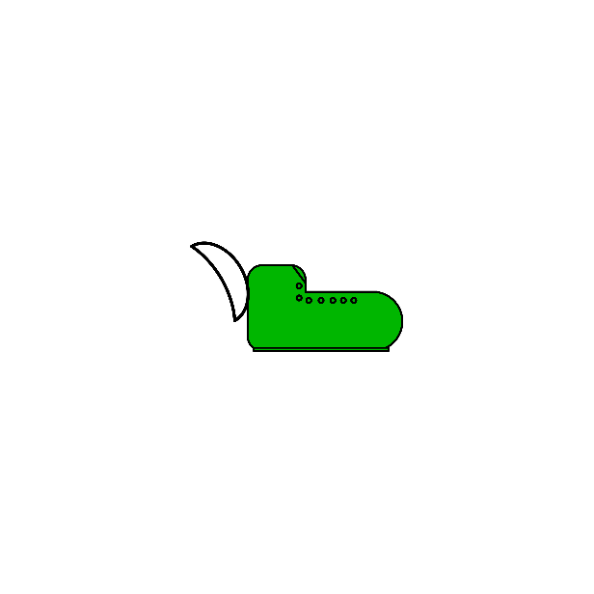

Jump Moves
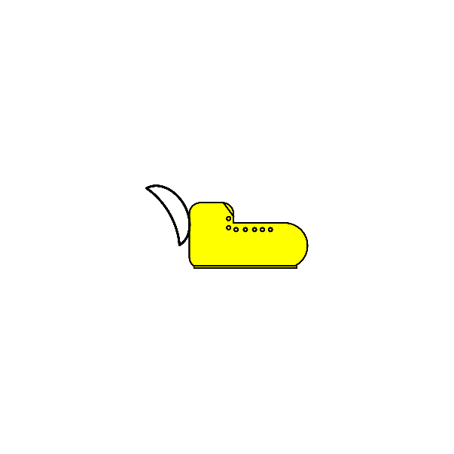
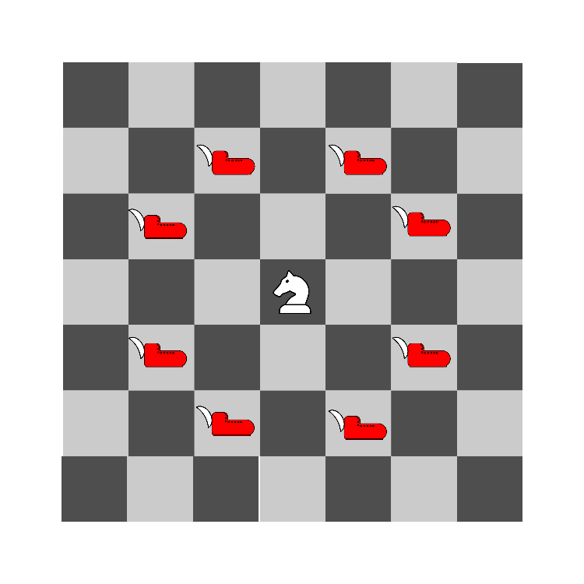
Teleportation of your piece to targeted square ,

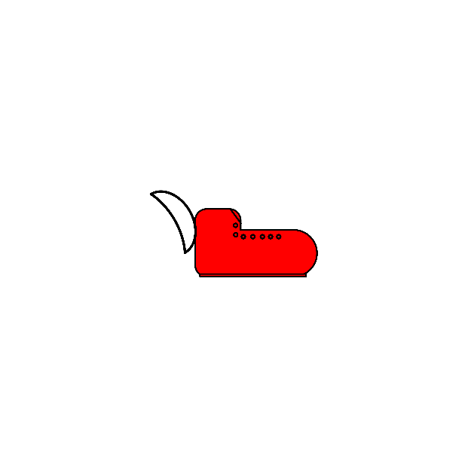


Repeat Moves



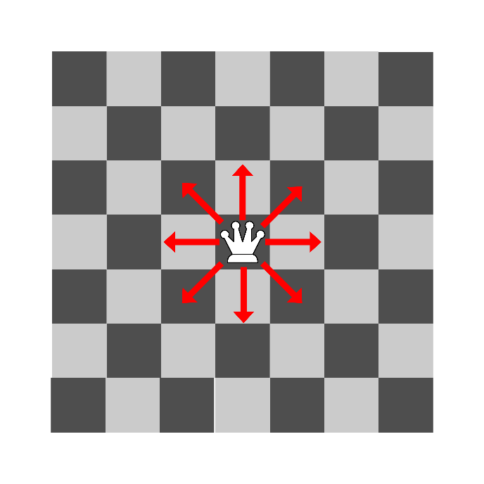
Blockable infinte range move .

Big Moves
Between targeted and starting position can not be pieces in line .

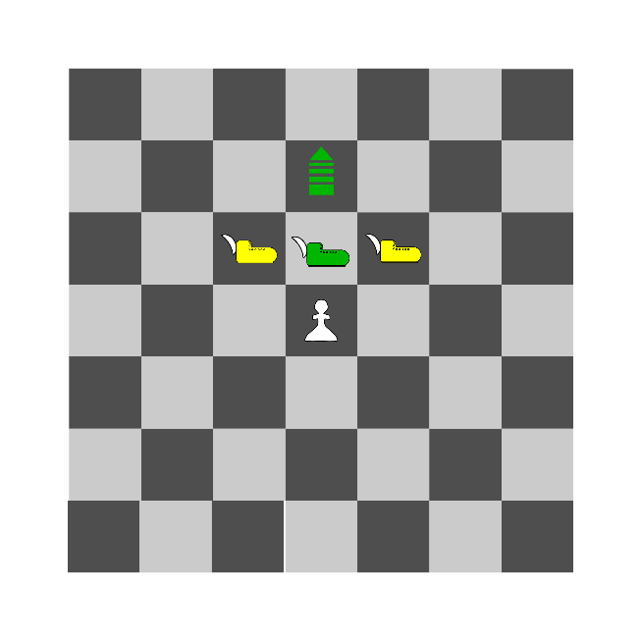






Castle Moves
Special move that switches King and Rook .
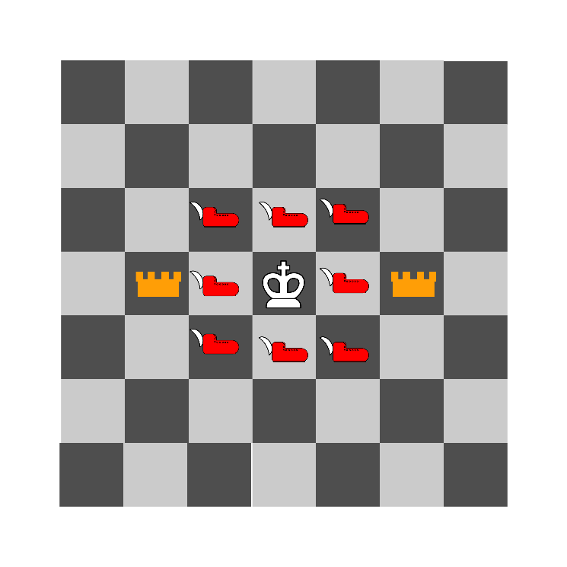

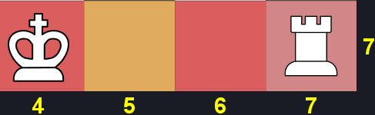



Rotate Moves

You can click on rotable piece , if arrows change colour
on right side of board ,you can click on them and it change
orientation of piece . You can also press arrows on keyboard
to change orientation . Orientation is displayed on piece
with tic mark .

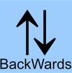




Carrier Moves
Special move of carrier class pieces .
If there is no piece on multiple squares in direction
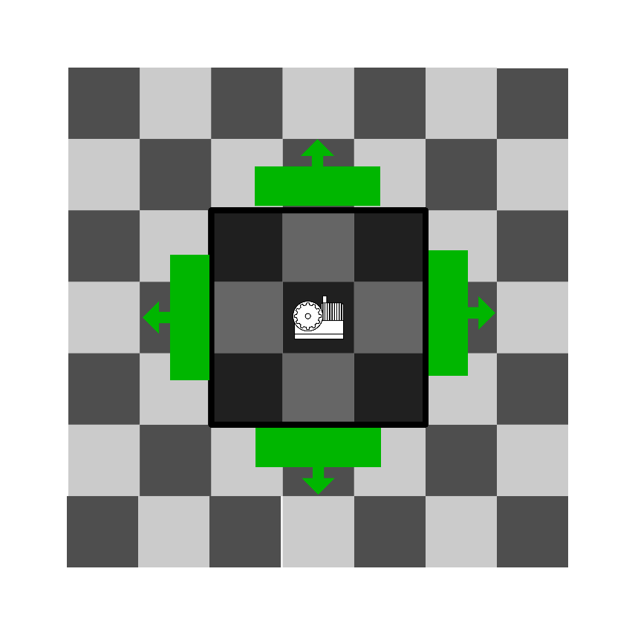
of move ,then moves carrier and multiple pieces on it .

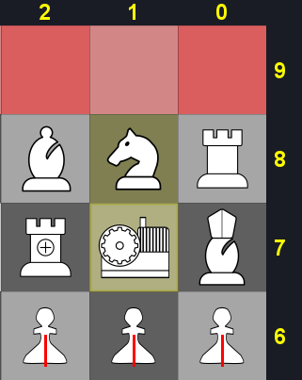

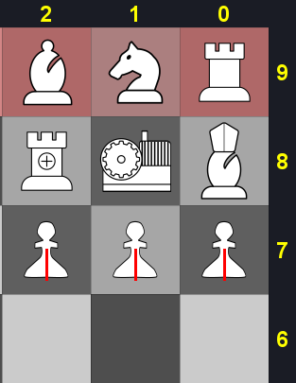

Linebreaker Moves
Infinite range blockable moves .


If there are 2 neighboring pieces in line ,
you can use this move . Its on more distant piece .
If you use this move ,your pice will destroy itself
and destroy both enemy pieces .


Torpedo Moves
Targeting line move .
If there are some pieces between starting
and targeting squares they will be taken .
Also be taken your pice becase this is friedly fire move .



Pieces

Airplane
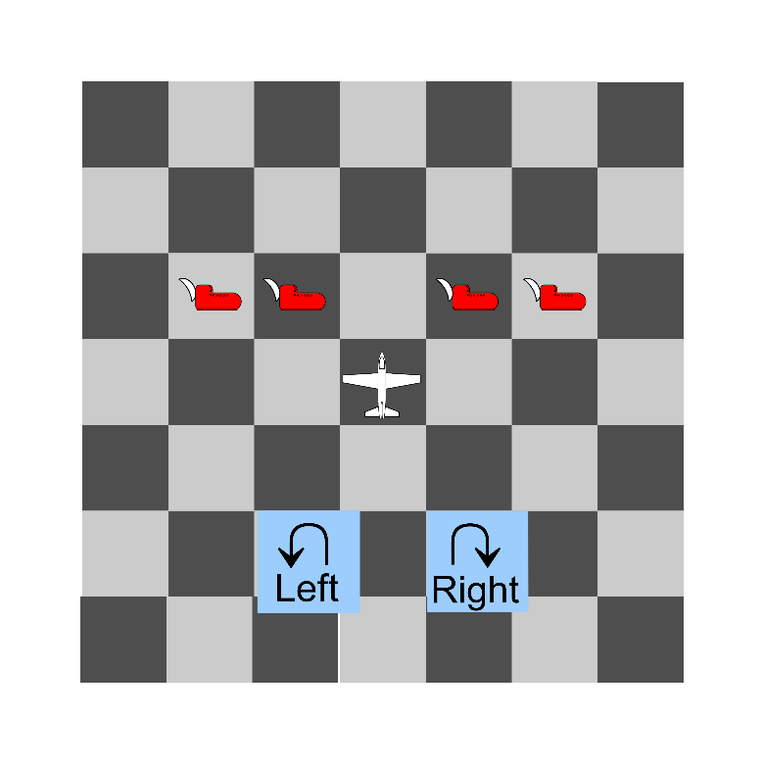
rotable class , promotable

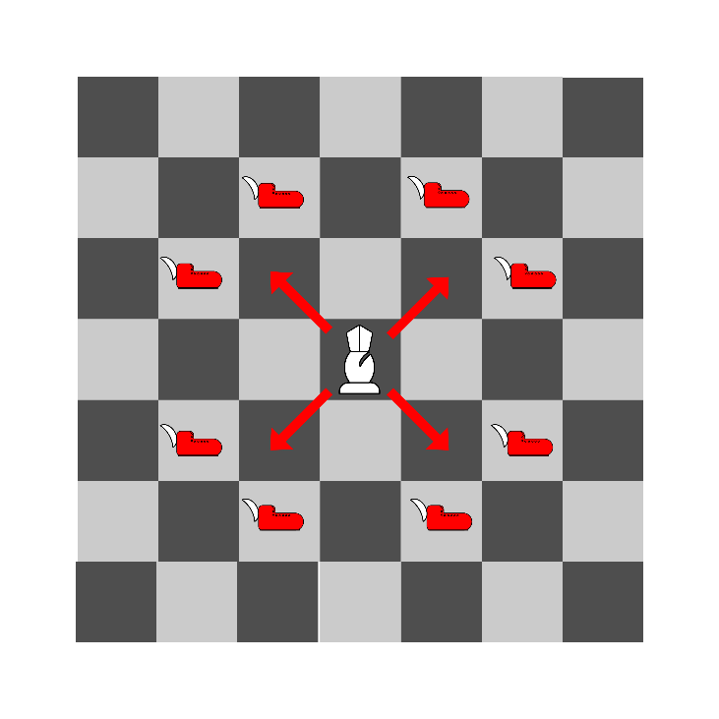
Arci Bishop

Emperor
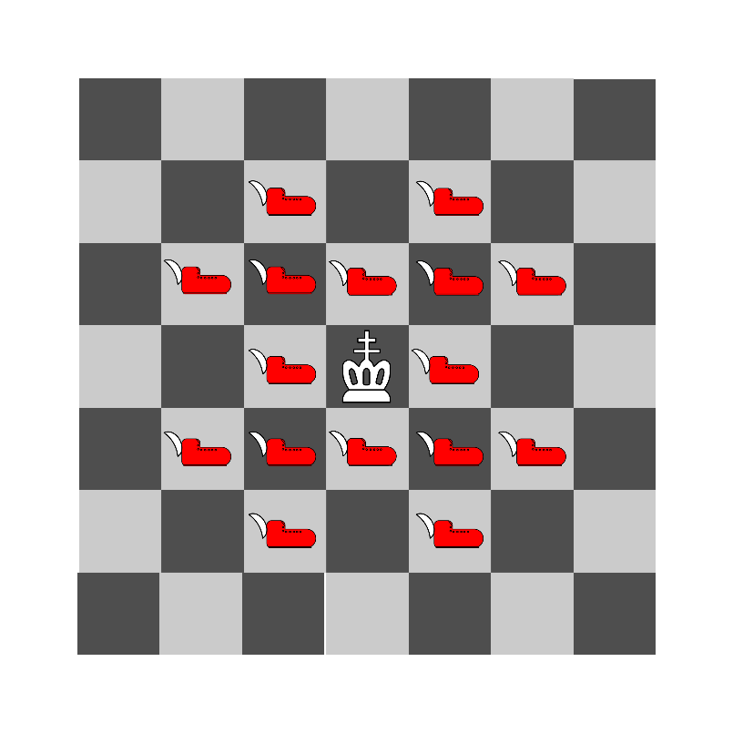
king class

Fighter
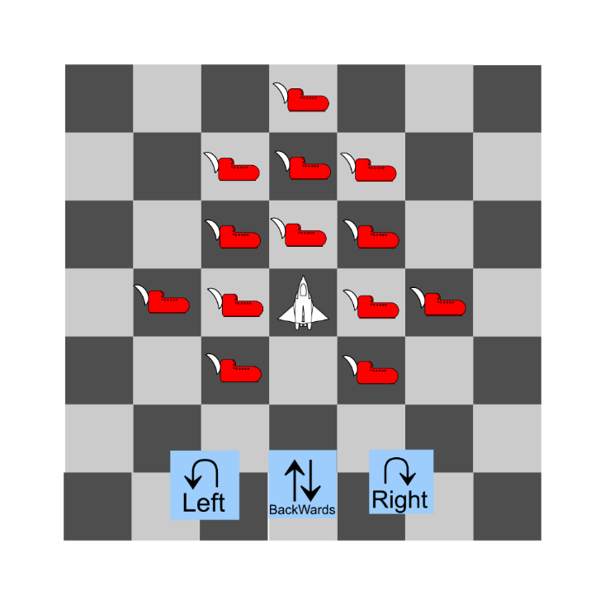
rotable class

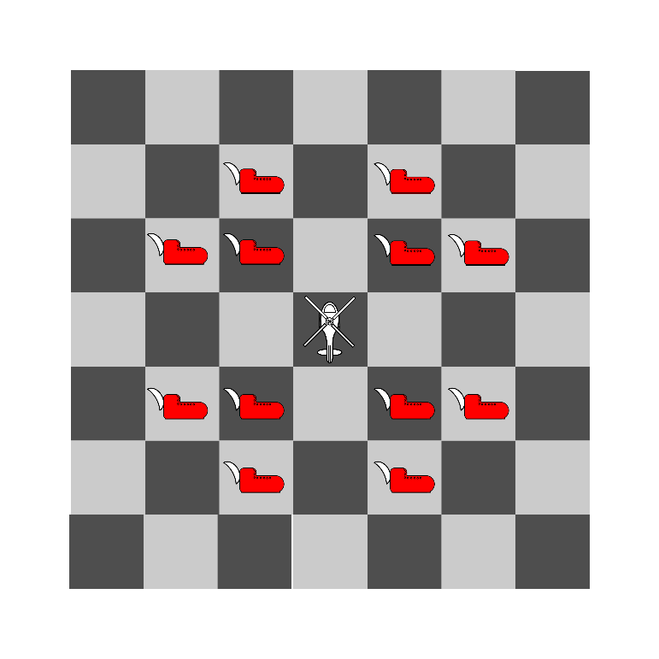
Helicopter

King
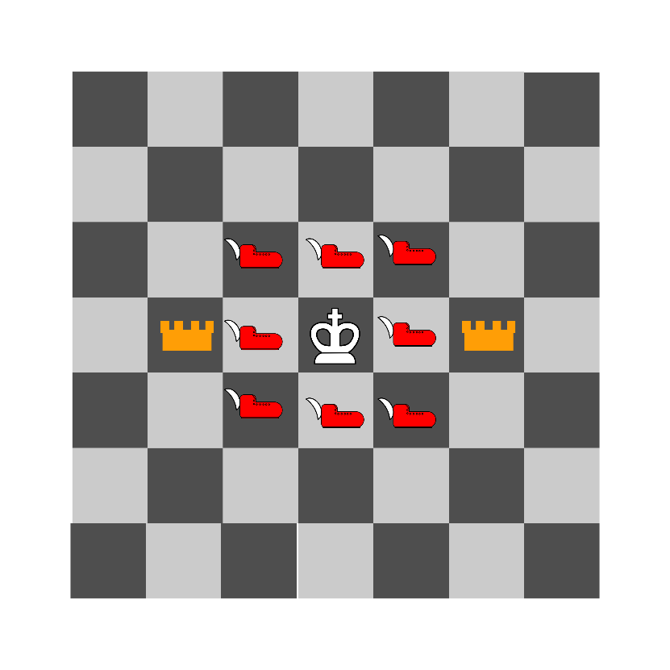
king class

Land Carrier
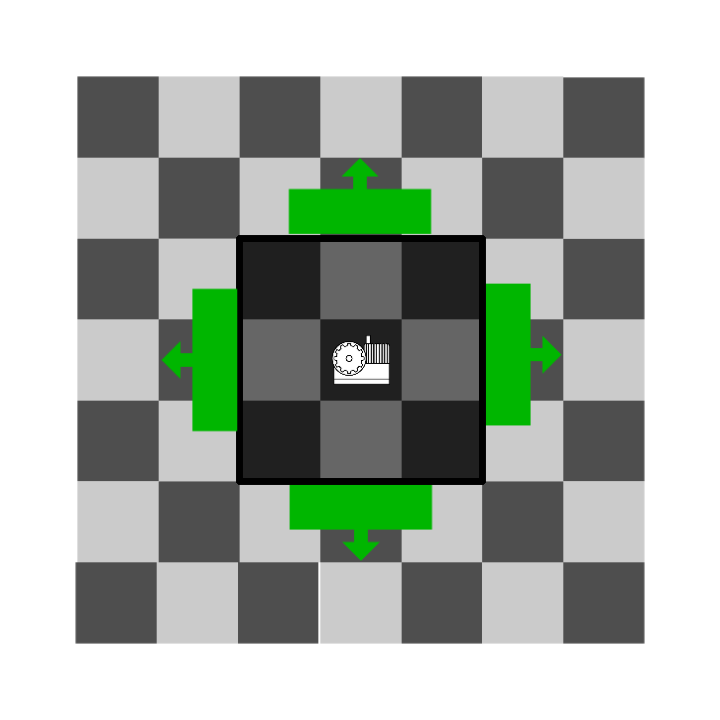
carrier class

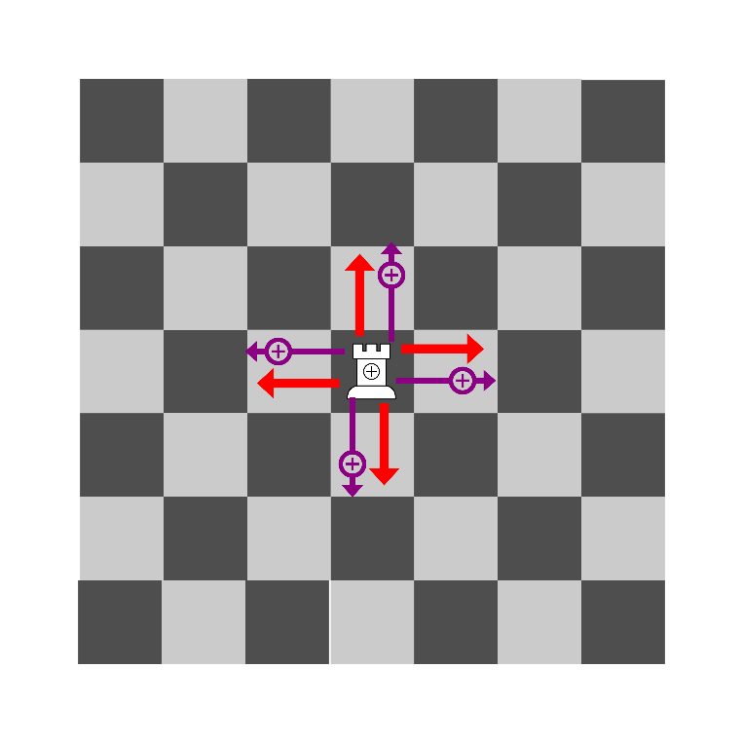
Linebreaker Rook

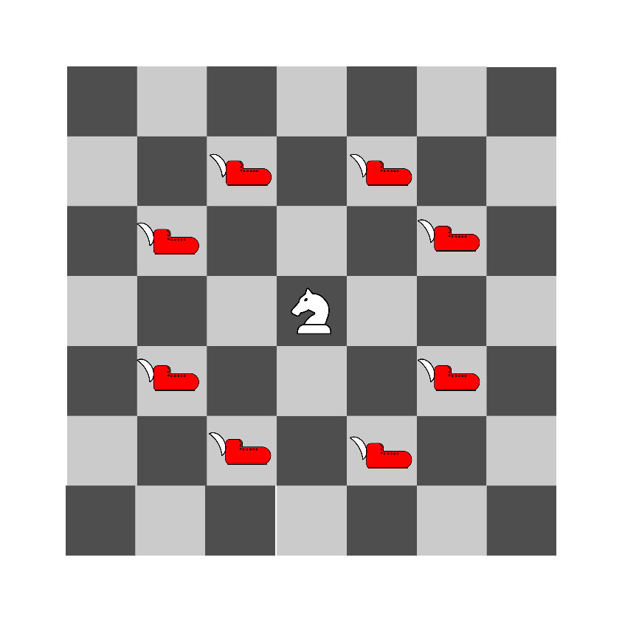
Night

Pawn
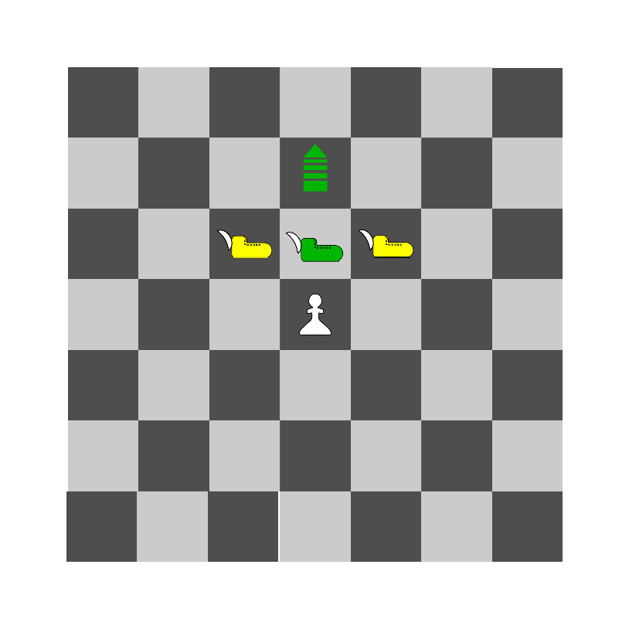
promotable

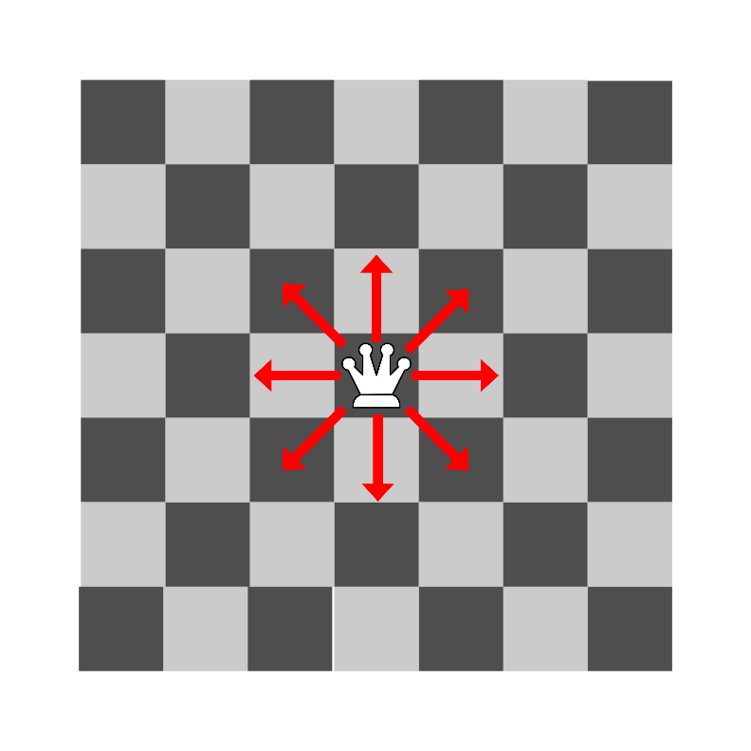
Queen

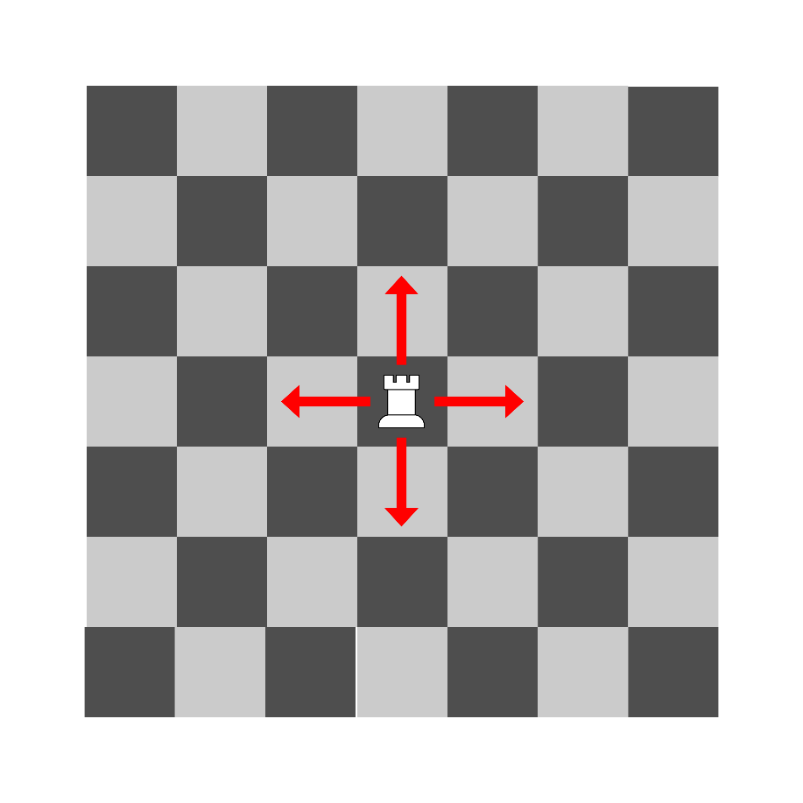
Rook

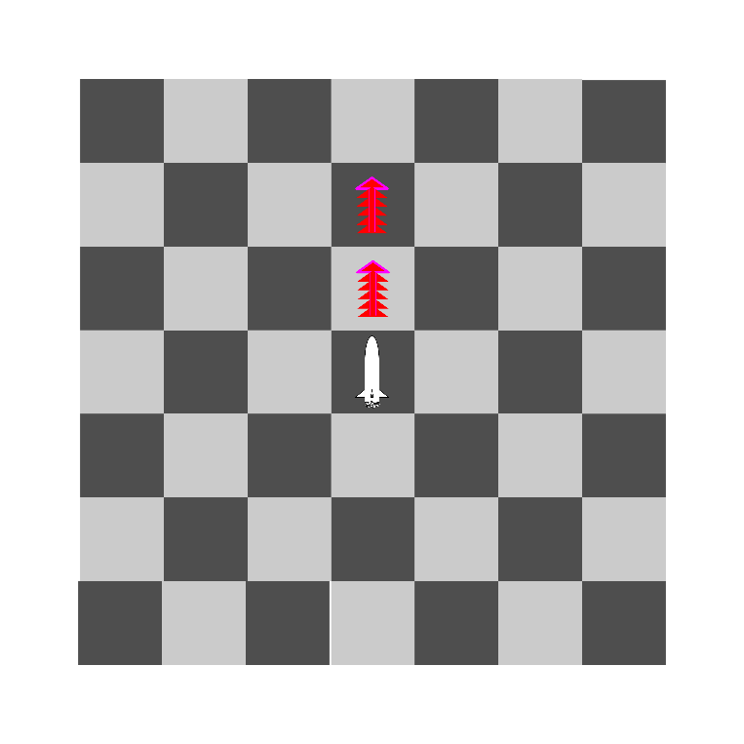
Torpedo

Piece classes

King class
Who take king ,wins

Carrier class
Can move multiple pieces

Power Ups

Lifebuoy
Saves pawns from water .


Contents
Pieceology 1
Game recomendations : 1
Lures : 1
Water 1
Move types 2
colours (behaviour) 2
Jump Moves 2
Repeat Moves 3
Big Moves 3
Castle Moves 4
Rotate Moves 4
Carrier Moves 5
Linebreaker Moves 5
Torpedo Moves 6
Pieces 7
Airplane 7
Arci Bishop 7
Emperor 7
Fighter 7
Helicopter 8
King 8
Land Carrier 8
Linebreaker Rook 8
Night 9
Pawn 9
Queen 9
Rook 9
Torpedo 10
Piece classes 11
King class 11
Carrier class 11
Power Ups 12
Lifebuoy 12

