

Captain and Vice Captain Guide
The complete match night process for team officials
For appointed captains and vice captains
Gravesend and District Indoor Games League | 2026 and 2027 season

Your role in the app
Captains and vice-captains manage the official pre-match lineup and match result for their team. Both roles use the same Captain Results workflow once a league officer has assigned the role.
The home team enters its lineup first. The away team responds after the home lineup has been submitted. Once both lineups are locked, the scorecard becomes available for match entry.

Match night quick reference
Step | Action | What to do
1 | Open the fixture | Open Captain Results and select tonight's match.
2 | Submit lineups | Home submits first; away responds. Complete digital lineups before 19:30.
3 | Open Scorecard | Check both lineups, then switch from Lineup to Scorecard.
4 | Record every frame | Enter players, points and any break of 30 or more.
5 | Review the card | Check every player, score and break with both teams.
6 | Submit the result | The home team normally submits by midnight on the following day.

The captain screen step by step
These screenshots show the live mobile view. The fixture and team names will change, but the controls and sequence remain the same.
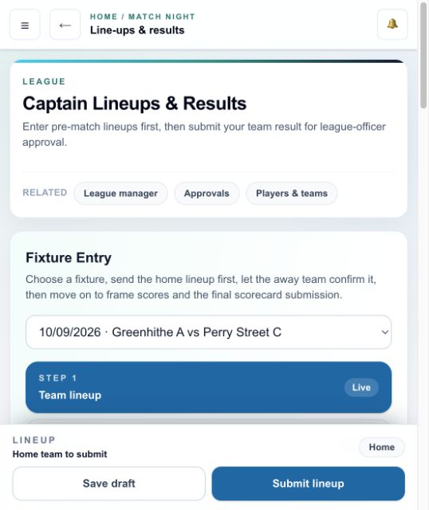
Choose the fixture. Team lineup is Step 1; Scorecard unlocks only after the lineup process is complete.

Check the fixture status
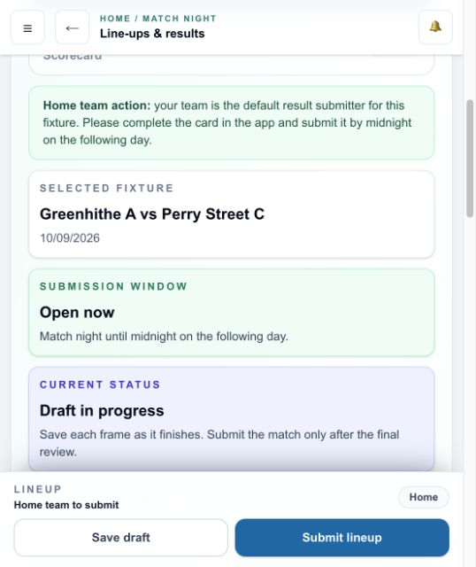
Check the selected fixture, submission window and current status before entering players.

Entering and sending the lineup
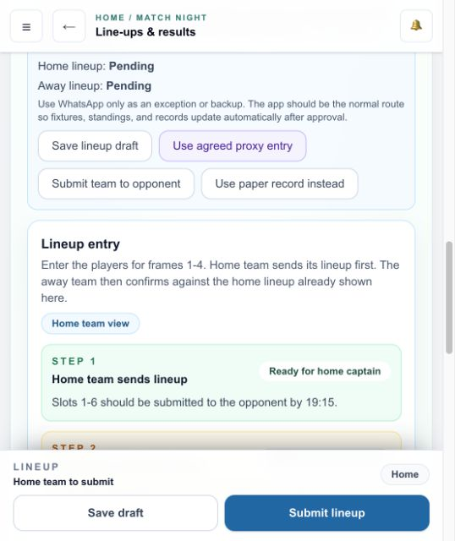
The screen confirms who acts first. Home sends the lineup; away confirms after receiving it.

Choose and submit the players
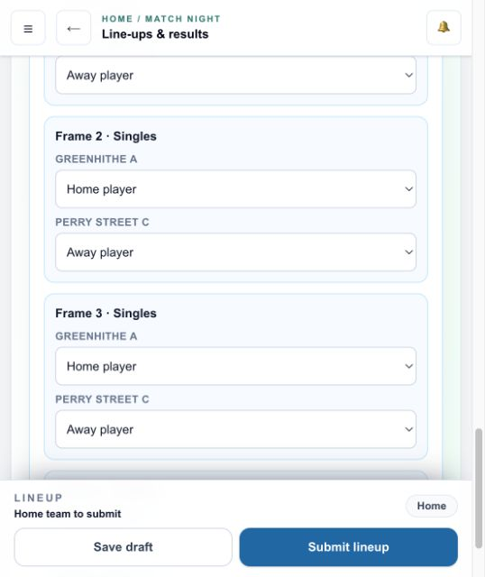
Choose the correct player in each frame. Save draft keeps work in progress; Submit lineup sends the final lineup.

Entering frame scores and breaks
The remaining screenshots use sample players in a safe training fixture. Nothing shown here was saved to the live league, but the controls and order match the real match-night process.
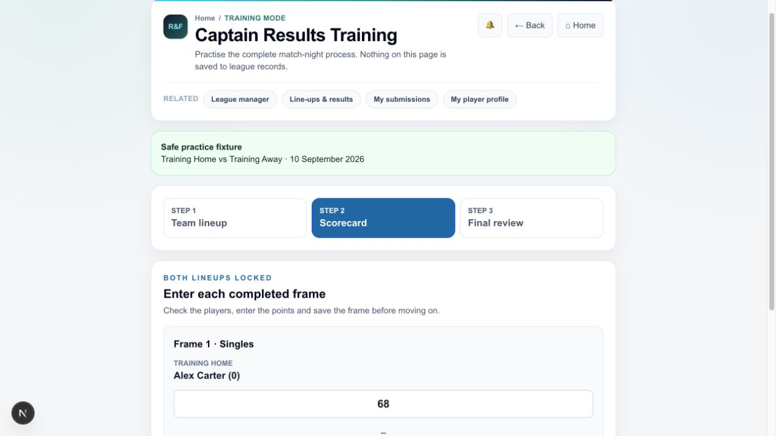
After both lineups are locked, open Step 2: Scorecard. For each completed frame, check the players, enter both scores and select Save completed frame.

Recording a break of 30 or more
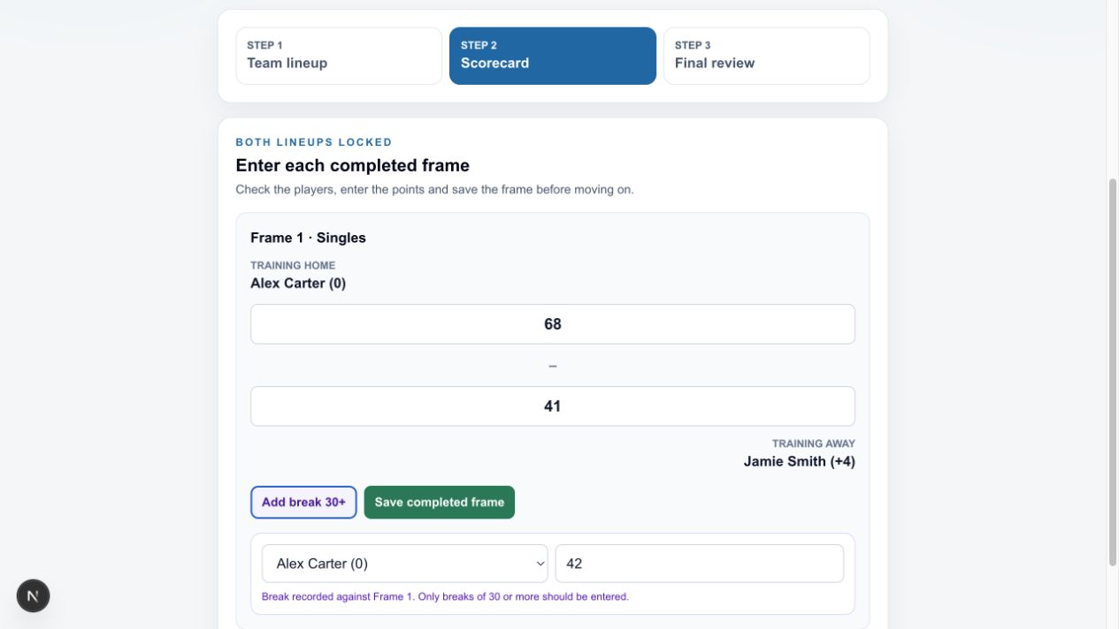
For a break of 30 or more, select Add break 30+, choose the player and enter the break before saving the frame.

Reviewing and submitting the result
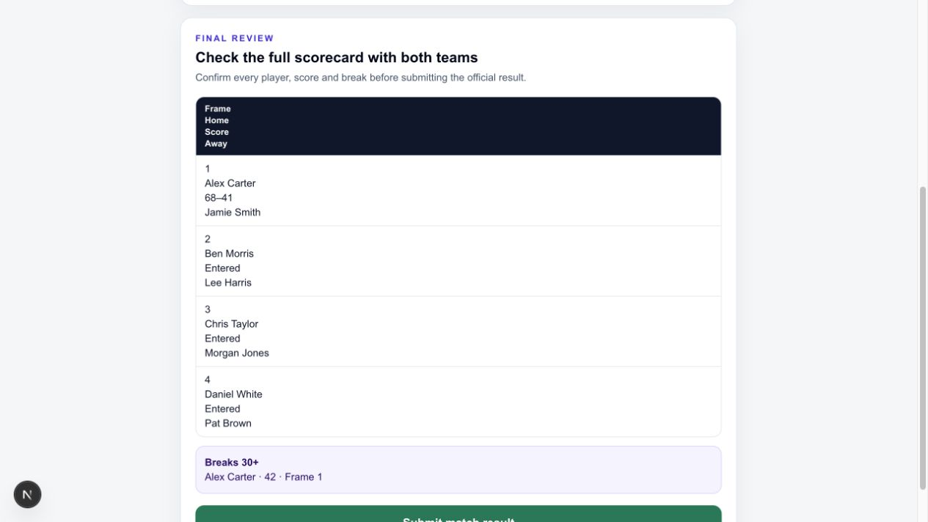
At Step 3: Final review, check every player, score and qualifying break with both teams. Correct anything that is wrong before submitting.

Submission confirmation
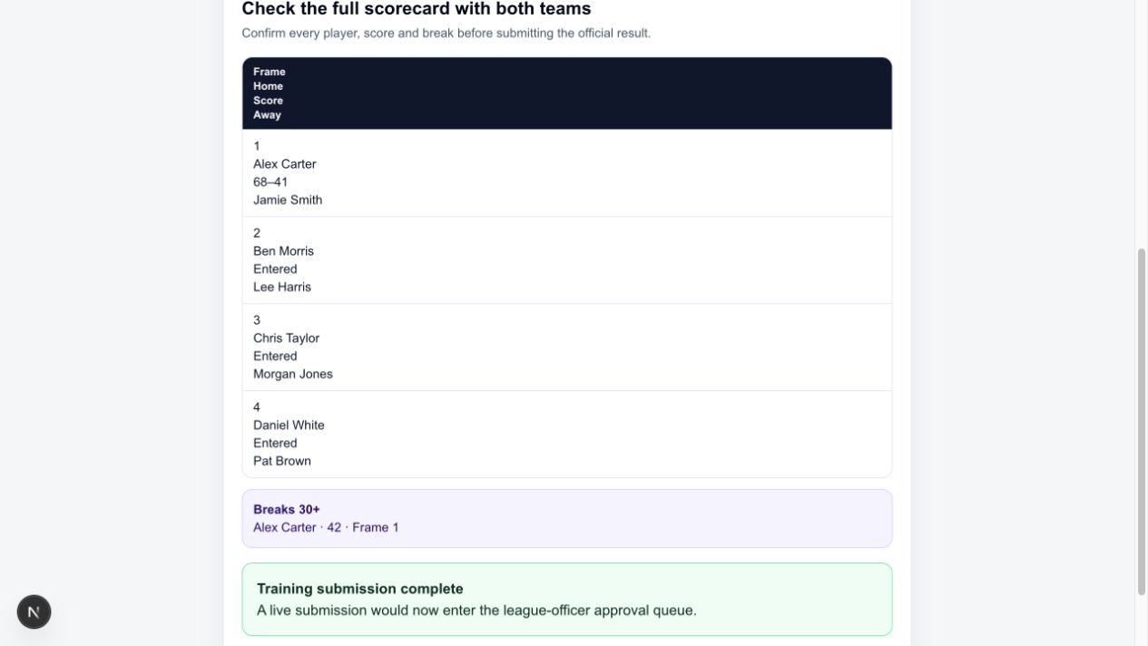
Select Submit match result once both teams agree the card is correct. A live result then enters the league-officer approval queue.

Before the match
Check access Sign in with your usual account. If Captain Results or the fixture is missing, ask a league officer to check your role rather than creating another account.
Read notifications Check lineup prompts, fixture reminders and league messages.
Open the fixture In Captain Results, select the correct match and confirm the teams and date.
Home submits first The home captain or vice-captain enters and submits the home lineup on the day of the fixture.
Away responds The away captain receives a notification and submits the away lineup.
Meet the deadline Complete required digital lineup activity before 19:30.

Lineup checks
- Select each player carefully and confirm the order before submitting.
- Player selectors display current handicaps where relevant.
- Once both teams submit, the lineups lock and feed into the result card.
- If both teams agree to use paper for the lineup, select the paper-record option so the choice is recorded.

Proxy entry
- Use proxy entry only when one side cannot operate the app and both teams agree that one captain or vice-captain will handle the fixture in the app.
- The acting official must still confirm both lineups and the final result with both teams.
- Proxy use is recorded in the audit trail and does not remove the normal submission requirements.

During the match
Switch to Scorecard The scorecard opens after both lineups are locked, or after paper record has been selected.
Enter frame details Check the players and enter the points for each completed frame.
Record breaks Add every qualifying break of 30 or more against the correct player and frame.
Save as you go Completed frames save as you advance. Current work is also retained on the device until final submission.
Keep play moving Use the same controlling device where possible, but do not delay the match to operate the app.

League checks
- The 2026 and 2027 Premier League uses reviewed handicaps with a maximum playing start of 40 points.
- Division 1 is played off scratch, although Elo continues to be recorded in the background.
- For summer leagues, check the two-singles-per-player rule.
- For winter leagues, check nominated-player and no-show rules before submitting.

After the final frame
Review Check all player assignments, points and breaks with the other team.
Submit The home team should normally press Submit match result unless a league officer has agreed another arrangement.
Meet the deadline Submit the completed result by midnight on the following day.
Wait for approval The submission enters the league-officer queue. Only approval updates standings, player records and Elo history.

If the app causes a problem
- Keep an accurate manual scorecard and continue the match.
- Message the League Secretary and explain what has happened. Please allow time for a reply on match evenings.
- A result-upload link can be supplied if the normal app process cannot be completed.
- A manually uploaded result needs league-officer authorisation, so it will update more slowly than a normal app submission.
- WhatsApp is a backup communication route, not the normal result-submission process.

Correcting mistakes and fixture dates
- Correct an error immediately if the result has not yet been submitted.
- After submission, contact the League Secretary, Chairman or Treasurer. A league officer can deal with the correction during review.
- Use the fixture date request process when a fixture needs to move. Do not rely only on an informal message.
- Report a missing break or player problem promptly so it can be corrected cleanly.

Captain deadlines
Step | Action | What to do
1 | Before 19:30 | Complete any required digital lineup activity.
2 | During the match | Record completed frames and qualifying breaks without delaying play.
3 | After the final frame | Review the full card with both teams before submission.
4 | By midnight next day | Submit the completed result.

When you need help
- Use password reset if you cannot sign in. Do not create another account.
- If your account is linked to the wrong player, use the claim or player update process.
- If a result, player or break is wrong, contact your captain or a league officer promptly. Do not submit a duplicate result.
- If the app causes a problem on match night, keep the match moving, retain an accurate paper scorecard and message the League Secretary. Please allow time for a reply. The app should support the match, not delay it. Snooker takes priority.

