Main Tables. Documentation.

- Common Foundations:
Each table may have:
- caption to define common title of a table
- th for defining columns titles

Simple example of a pure table without styles:
<table class="table-main" summary="Table Summary" title="Table Title">
<caption></caption>
<tr>
<th style="width:"></th>
<th style="width:"></th>
<th style="width:"></th>
</tr>
<tr>
<td></td>
<td></td>
<td></td>
</tr>
</table>
- Types of tables:
We have 3 types of Main Table with some differences:
- Common Table without borders: class=”table-main”
- Table with right vertical borders inside each column: class=”table-vert-border”
- Table with bottom horizontal borders inside each row: class=”table-horiz-border”

- Avalable Classes:
caption - Gives table a caption

<tr> subheader - left aligned subheader – use with colspan
divider - Defines a top border to separate rows
tdstrong - Applies bold, font color and size to row
bgr - Applies background color #f2f2f2;
left / right /center- text align classes already defines in style.css
basket - blue background for <th> to sit on

<td> tdstrong - Applies bold, font color and size to cell
noborder - removes border – applied to last <td> in <tr>
left / right /center- text align classes already defines in style.css
highlight - magenta text formatting – can be used with <del> and <em>

Common Table class=”table-main”

<table class="table-main" summary="Table Summary" title="Table Title">
<caption>table-main</caption>
<tr>
<th style="width:25%">Header 1</th>
<th style="width:25%">Header 2</th>
<th style="width:25%">Header 3</th>
<th style="width:25%">Header 4</th>
</tr>
<tr class="subheader">
<td colspan="4">Subheader - Table with no horizontal/verical borders</td>
</tr>
<tr>
<td class="bgr" colspan="4">4 coloumn cell span with background</td>
</tr>
<tr class="center">
<td class="tdstrong">Offer 1</td>
<td >&pound;50</td>
<td class="left">&pound;75</td>
<td class="right">&pound;99</td>
</tr>
<tr class="bgr">
<td class="center tdstrong">Offer 2</td>
<td class="center">&pound;50</td>
<td class="left">&pound;75</td>
<td class="right">&pound;99</td>
</tr>
<tr>
<td class="center tdstrong">Offer 3</td>
<td class="center">&pound;50</td>
<td class="left">&pound;75</td>
<td class="right">&pound;99</td>
</tr>
<tr>
<td class="center tdstrong bgr">Offer 4</td>
<td class="center">&pound;50</td>
<td class="left bgr">&pound;75</td>
<td class="right">&pound;99</td>
</tr>
<tr>
<td class="center tdstrong">Offer 5</td>
<td class="center">&pound;50</td>
<td class="left">&pound;75</td>
<td class="right">&pound;99</td>
</tr>
<tr class="divider">
<td class="noborder" colspan="4">&nbsp;</td>
</tr>
</table>

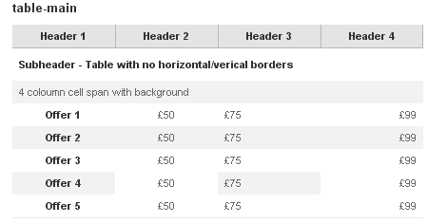

Common Table class=”table-vert-border”
<table class="table-vert-border" summary="Table Summary" title="Table Title">
<caption>table-vert-border</caption>
<tr>
<th style="width:25%">Header 1</th>
<th style="width:25%">Header 2</th>
<th style="width:25%">Header 3</th>
<th style="width:25%">Header 4</th>
</tr>
<tr class="subheader">
<td colspan="4">Subheader goes here - no vert bars</td>
</tr>
<tr>
<td class="bgr" colspan="4">4 coloumn cell span with background</td>
</tr>
<tr>
<td class="center tdstrong">Offer 1</td>
<td class="center">&pound;50</td>
<td class="left">&pound;75</td>
<td class="right">&pound;99</td>
</tr>
<tr class="bgr">
<td class="center tdstrong">Offer 2</td>
<td class="center">&pound;50</td>
<td class="left">&pound;75</td>
<td class="right">&pound;99</td>
</tr>
<tr>
<td class="center tdstrong">Offer 3</td>
<td class="center">&pound;50</td>
<td class="left">&pound;75</td>
<td class="right">&pound;99</td>
</tr>
<tr>
<td class="center tdstrong">Offer 4</td>
<td class="center">&pound;50</td>
<td class="left bgr">&pound;75</td>
<td class="right bgr">&pound;99</td>
</tr>
<tr>
<td class="center tdstrong">Offer 5</td>
<td class="center">&pound;50</td>
<td class="left bgr tdstrong"><del>&pound;75</del><span class="highlight"> now &pound;60!</span></td>
<td class="right bgr"><del>&pound;99</del><span class="highlight"> now &pound;80!</span></td>
</tr>
<tr class="divider">
<td class="noborder" colspan="4">&nbsp;</td>
</tr>
</table>

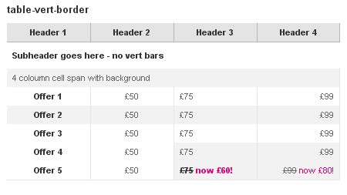

Common Table class=”table-horiz-border”

<table class="table-horiz-border" summary="Table Summary" title="Table Title">
<caption>table-horiz-border</caption>
<tr>
<th style="width:25%">Header 1<br />
<select name="select" id="select">
<option value="0" selected="selected" >Option 1</option>
<option value="1">Option 2</option>
<option value="2">Option 3</option>
</select>
</th>
<th style="width:25%">Header 2</th>
<th style="width:25%">Header 3</th>
<th style="width:25%">Header 4</th>
</tr>
<tr class="subheader">
<td colspan="4">Subheader goes here - </td>
</tr>
<tr>
<td class="center tdstrong bgr">Offer 1</td>
<td class="center">&pound;50</td>
<td class="left bgr">&pound;75</td>
<td class="right">&pound;99</td>
</tr>
<tr>
<td class="center tdstrong bgr">Offer 2</td>
<td class="center">&pound;50</td>
<td class="left bgr">&pound;75</td>
<td class="right">&pound;99</td>
</tr>
<tr>
<td class="center tdstrong bgr">Offer 3</td>
<td class="center">&pound;50</td>
<td class="left bgr">&pound;75</td>
<td class="right">&pound;99</td>
</tr>
<tr>
<td class="center tdstrong bgr">Offer 4</td>
<td class="center">&pound;50</td>
<td class="left bgr">&pound;75</td>
<td class="right">&pound;99</td>
</tr>
<tr>
<td class="center tdstrong bgr">Offer 5</td>
<td class="center">&pound;50</td>
<td class="left bgr">&pound;75</td>
<td class="right">&pound;99</td>
</tr>
</table>

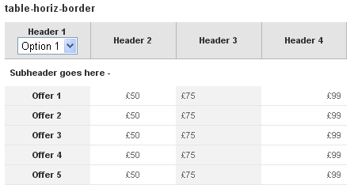

Common Table class=”table-horiz-border” - basket
<table class="table-horiz-border" summary="Table Summary" title="Table Title">
<caption>table-horiz-border</caption>
<tr class="basket">
<th style="width:25%">Header 1</th>
<th style="width:25%">Header 2</th>
<th style="width:25%">Header 3</th>
<th style="width:25%">Header 4</th>
</tr>
<tr class="subheader">
<td colspan="4">Subheader goes here - </td>
</tr>
<tr>
<td class="center tdstrong bgr">Offer 1</td>
<td class="center">&pound;50</td>
<td class="left bgr">&pound;75</td>
<td class="right">&pound;99</td>
</tr>
<tr>
<td class="center tdstrong bgr">Offer 2</td>
<td class="center">&pound;50</td>
<td class="left bgr">&pound;75</td>
<td class="right">&pound;99</td>
</tr>
<tr>
<td class="center tdstrong bgr">Offer 3</td>
<td class="center">&pound;50</td>
<td class="left bgr">&pound;75</td>
<td class="right">&pound;99</td>
</tr>
<tr>
<td class="center tdstrong bgr">Offer 4</td>
<td class="center">&pound;50</td>
<td class="left bgr">&pound;75</td>
<td class="right">&pound;99</td>
</tr>
<tr>
<td class="center tdstrong bgr">Offer 5</td>
<td class="center">&pound;50</td>
<td class="left bgr">&pound;75</td>
<td class="right">&pound;99</td>
</tr>
</table>

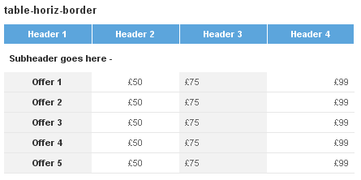

<table class="table-horiz-border" summary="Test table" title="test table">
<caption>Varied Options</caption>
<tr>
<th style="width:25%">Header 1</th>
<th style="width:25%">Header 2</th>
<th style="width:25%">Header 3</th>
<th style="width:25%">Header 4</th>
</tr>
<tr class="subheader">
<td colspan="4">Subheader goes here</td>
</tr>
<tr class="bgr">
<td colspan="4">4 column cell span with background</td>
</tr>
<tr class="center">
<td class="tdstrong">Offer 1</td>
<td><a href="#">&pound;50</a></td>
<td class="left">&pound;75</td>
<td class="right">&pound;99</td></tr>
<tr class="center bgr">
<td class="tdstrong">Offer 2</td>
<td><a href="#">&pound;50</a></td>
<td class="left">&pound;75</td>
<td class="right">&pound;99</td>
</tr>
<tr class="center">
<td class="tdstrong noborder">Offer 3</td>
<td class="noborder"><a href="#">&pound;50</a></td>
<td class="left">&pound;75</td>
<td class="right">&pound;99</td>
</tr>
<tr class="center">
<td class="tdstrong">Offer 4</td>
<td><a href="#">&pound;50</a></td>
<td class="tdstrong left bgr"><del>&pound;75</del> <span class="highlight"> Now &pound;60</span></td>
<td class="right bgr"><del>&pound;99</del><span class="highlight"> Now &pound;80</span></td>
</tr>
</table>
