

Functional Area: CSA Portal

33 CSA Create MTM Account

Screen Specifications

Document History
Version | Date | Description | Name
0.1 | 08/11/2005 | Initial draft | Alexander Fyodorov
0.2 | 26/1/2006 | Modified workflow to reflect new security model | Simon Thody
0.3 | 27/1/2006 | Synchronised with domain model | Simon Thody
0.4 | 19/02/2006 | The whole create MTM account area has been reworked. New screens inc Account role and PAYG registration match failure. | Nicholas Cole
0.5 | 20/02/2006 | Internal Review with ST and AF. Different screen specification for Account Role screen. Username options added. | Nicholas Cole
0.6 | 21/02/06 | Domain Model attributes defined. | Nicholas Cole
0.7 | 22/02/06 | Review with EL and TW  Changes to the Account Role screen.  Baseline by business  BAN min & Max updated  Error messages for CTN validation updated. | Nicholas Cole  Nicholas Cole  Nicholas Cole

1.1.1 Screens 3
1.1.1.1 Screen – Account Role 3
1.1.1.2 Screen – Customer Details 6
1.1.1.3 Screen – Confirm PAYG address 9
1.1.1.4 Screen – Your security details 10
1.1.1.5 Screen – Confirmation 13
1.1.1.6 Screen – PAYG Registration Match Failure 14
1.1.1.7 Domain Model 15

Screens

Screen – Account Role
The purpose of this screen is to capture the customer’s role on the account and also the T-Mobile CTN/BAN.

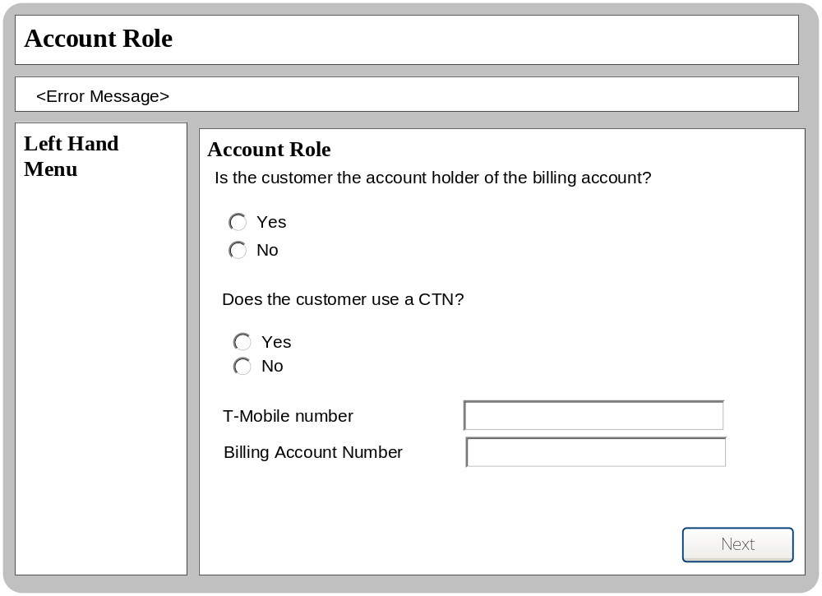

Business Logic Content

Name | Type | Description/Condition
Account Role | Screen Title | The title of the screen
Error Messages | Dynamic Text | The Error Messages will be displayed if any of the validation rules are not met.
Account role Tile
This tile will capture the account role and CTN or BAN.
On entry none of the radio buttons should be pre selected.

Yes  (Is the account Holder?) | Radio Button | Indicates the customer is the account holder.  Active on entry.  Not pre selected on entry.  Activates the Yes and No (Use CTN?) radio buttons when selected.  Either Yes or No is mandatory.
No  (Is the account Holder?) | Radio Button | Indicates the customer is the subscriber.  Active on entry.  Not pre selected on entry.  Activates the Yes and No (Use CTN?) radio buttons when selected.  Either Yes or No is mandatory.
Yes  (Use CTN?) | Radio Button | Confirms that the CUSTOMER uses a CTN.  Either Yes or No is mandatory.  Not active on entry.
No  (Use CTN?) | Radio Button | Confirms that the CUSTOMER uses a CTN.  Either Yes or No is mandatory.  Not active on entry.
T-Mobile Number | Data Entry Field | Please refer to the Standard Validation rules document  Not active on entry  Only active when both sets (Is the account holder? And Use CTN?) of radio buttons have been selected.
BAN | Data Entry Field | The BAN of the account holder which will be associated to the MTM account.  Min = 6 Max = 9  Not Active on entry  Only active when both sets (Is the account holder? And Use CTN?) of radio buttons have been selected and the customer is the account holder who does not use a CTN.

Links

Name | Destination | Description/Condition
Next (Account Holder Details) | Account Role | Reloads the screen when the CTN/BAN details are not valid.
Next (Account Holder Details) | Customer Details | Leads user to the ‘Your Details’ screen when the CTN /BAN details are valid

Validation

Name | State / Response
Mandatory Fields | If any of the mandatory fields are null:  Error Message = “Please complete the mandatory fields.”
T-Mobile Number (Account Holder Section) | If the CTN is not a valid T-Mobile CTN:  Error Message = “The CTN is not a valid T-Mobile CTN, please try a different CTN.”
T-Mobile Number (Account Holder Section) | The system will validate the entered CTN to check if it is the primary CTN of another MTM Account  Error Message = “The CTN is a primary CTN of an existing MTM account, please try a different CTN.”
BAN | If the BAN is not a valid T-Mobile BAN:  Error Message = “The BAN is not a valid T-Mobile BAN, please try again.”
BAN | The system will validate the entered BAN to check if it is a valid T-Mobile BAN and if it is associated to another MTM account  Error Message = “The BAN is associated to another MTM account at account holder level.”
T-Mobile Number (Account Holder Section) | If the CTN is not a valid status on Excalibur  Error Message = “The CTN does not have a valid status on Excalibur, please try a different CTN.”

Screen – Customer Details
The purpose of this screen is to gather Customer’s details which are needed to create a MTM Account.

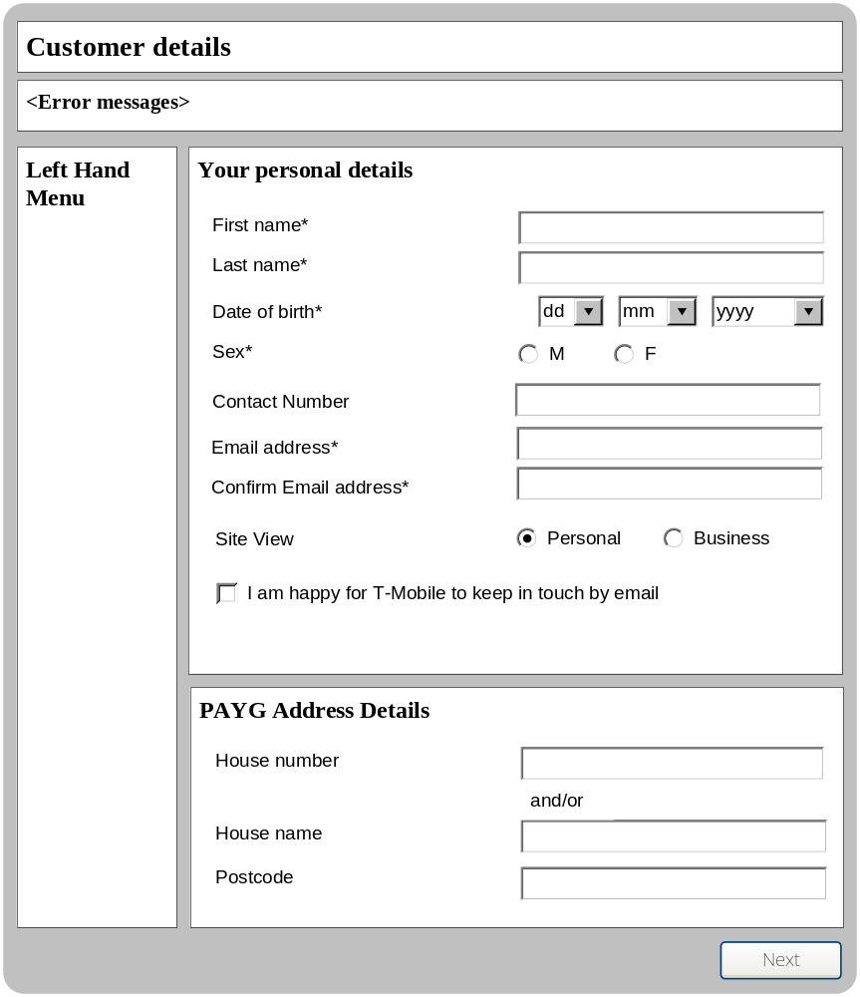

Business Logic Content
Name | Type | Description/Condition
Customer Details | Screen Title | The title of the screen
Error Messages | Dynamic Text | The Error Messages will be displayed if any of the validation rules are not met.
Your Personal Details Tile
This tile will capture the person details of the customer who is creating a new MTM account.
This tile is always active and displayed on entry.
First Name | Text Field | Please refer to the Standard Validation rules document
Last Name | Text Field | Please refer to the Standard Validation rules document
Date of birth | Combo Box | Contains a list of days in a month: {dd, [from 01 to 31]}; mandatory.  Default value is ‘dd’.
Date of birth | Combo Box | Contains a list of months in a year: {mm, [from 01 to 12]}; mandatory.  Default value is ‘mm’.
Date of birth | Combo Box | Contains a list of years: {yyyy, [from 1916 to 2005]}; mandatory.  Default value is ‘yyyy’.
Sex | Radio Button  Radio Button | The Customer’s gender; mandatory.  M – male  F – female  No default value.
Contact Number | Text Field | Please refer to the Standard Validation rules document.  Only mandatory if a T-Mobile CTN has not been entered on the previous screen.
E-mail | Text Field | Please refer to the Standard Validation rules document
Confirm E-mail | Text Field | Please refer to the Standard Validation rules document
Personal | Radio Button | Personal of view of the site when the user logs in.  Selected as default on entry.
Business | Radio Button | Business of view of the site when the user logs in.  Not selected on entry.
I am happy for T-Mobile to keep in touch by email | Check Box | The Customer’s choice of whether they’d like to keep in touch by their email.  Default state is unchecked.
PAYG Address Details Tile
This tile will capture the PAYG address details of the customer who is creating a new MTM account.
This tile will only be displayed if the MTM account being created is PAYG and the account role is Account Holder.
House number | Text Field | The house number of the Customer’s billing address.  Default value is empty.
House name | Text Field | The house name of the Customer’s billing address.  Default value is empty.
Postcode | Text Field | The postcode of the Customer’s billing address.  Please refer to the Standard Validation rules document  Default value is empty.

Links
Name | Destination | Description/Condition
Next | Confirm PAYG address | In case if the Customer is PAYG Account Holder. The user will be asked to confirm the PAYG address.
Next | Your security details | If all mandatory fields are entered correctly.
Next | Customer details | Reloads the screen if any the mandatory fields are not completed correctly.

Validation
Name | State / Response
First Name | First Name - If the value length is < XX or > XXX  Error Message = “Please enter a First Name between XX and XXX characters.”  First Name - If the value contains characters which are not letters:  Error Message = “Please enter a First Name without spaces, digits and special characters”
Last Name | Last Name - If the value length is < XX or > XX  Error Message = “Please enter a Last Name between xx and xx characters.”  Last Name - If the value contains characters which are not letters:  Error Message = “Please enter a Last Name without spaces, digits and special characters”
Date of birth | Date of birth - If at least one of three values is not numeric (i.e. ‘dd’, ’mm’‘ or ‘yyyy’), or it is not one of the relevant combo-box list at all:  Error Message = “Please enter your date of birth”
Sex | Sex - If neither of Radio Button is checked:  Error Message = “Please indicate your sex”.
Contact Number | Contact Number - If ‘T-Mobile number’ value is empty, this field is mandatory,  The field can contain a mobile number (different from entered T-Mobile CTN) or a landline number.
E-Mail | E-Mail - If the value is empty:  Error Message = “Please enter your email address”  E-Mail - If the value is invalid:  Error Message = “Email address format is invalid”
Confirm E-mail | Confirm E-Mail - If the value doesn’t match the Email value:  Error Message = “Both e-mail addresses must be the same”
House Number or House Name | House Number & House Name - If the value is empty:  Error Message = “You must enter either a house number or house name”
Postcode | Postcode – Invalid postcode format  Error Message = “Please enter a valid postcode format.”

Screen – Confirm PAYG address
The purpose of this screen is for Customer to select a PAYG address found by PAF.

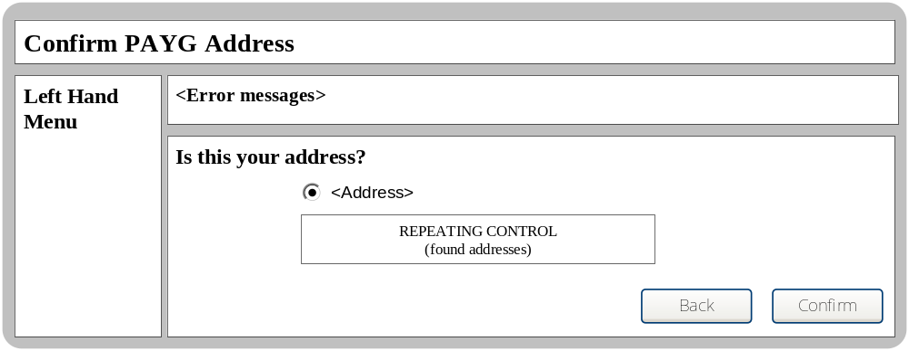

Business Logic Content
Name | Type | Description/Condition
Confirm PAYG Address | Screen Title | The title of the screen
Error Message | Dynamic Text | The Error Messages will be displayed if any of the validation rules are not met.
<<< REPEATING DATA BEGIN
Address  (and repeating) | Radio Button with dynamic text | One of Customer’s addresses found by PAF.
REPEATING DATA END >>>

Links
Name | Destination | Description/Condition
Confirm | Confirm PAYG Address | Reloads the screen if an address has not been selected.
Confirm | Security Details | Leads the user to the security details screen.
Back | Customer Details | Take the user back to the Customer details

Validation
Name | State / Response
No address Found | No Addresses Found  Error Message – “No address found, please go back and submit a different address”
No address selected | No address selected  Error Message – “Please select an address”

Screen – Your security details
The purpose of this screen is to gather Customer’s security details which are needed to create a MTM Account.

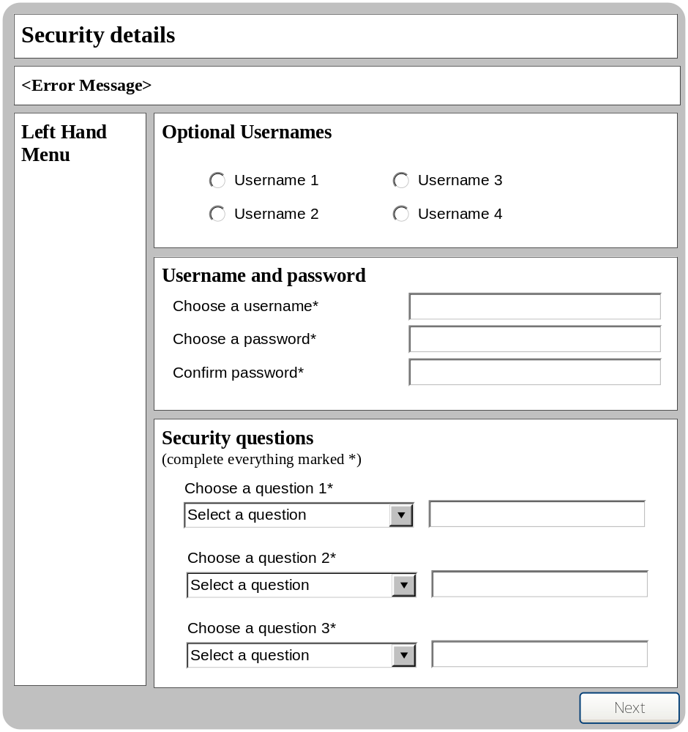

Business Logic Content

Name | Type | Description/Condition
Security Details | Screen Title | The title of the screen
Error Messages | Dynamic Text | Displays the error messages when validation error occurs.
Optional Usernames Tile:
This tile will display optional usernames which are available for selection.
This tile is only displayed if a duplicate username error occurs.
This tile is not displayed on entry.
<<< REPEATING DATA BEGIN
Username | Radio Button with dynamic text | Available username the user can select.
REPEATING DATA END >>>
Username and password Tile:
This tile captures the MTM username and password.
This tile is always active.
Username | Text Field | The customer’s desired username; mandatory.  Please refer to the Standard Validation rules document  Default value is empty.
Password | Text Field | The customer’s desired password; mandatory.  Please refer to the Standard Validation rules document  Default value is empty.
Confirm password | Text Field | The Customer confirms desired password; mandatory.  Please refer to the Standard Validation rules document  Default value is empty.
Security questions Tile:
This tile captures the MTM security questions and answers.
This tile is always active.
Security question 1 | Combo Box | The customer’s first desired security question; mandatory.  Contains a list of available questions: (Refer to domain model for list)  Default value is ‘Select a question’.
Security answer 1 | Text Field | The customer’s answer to their first desired security question; mandatory.  No spaces allowed.
Security question 2 | Combo Box | The customer’s second desired security question; mandatory.  Contains a list of available questions (Refer to domain model for list)  Default value is ‘Select a question’.
Security answer 2 | Text Field | The customer’s answer to their second desired security question; mandatory.  No spaces allowed.
Security question 3 | Combo Box | The customer’s third desired security question; mandatory.  Contains a list of available questions: (Refer to domain model for list)  Default value is ‘Select a question’.
Security answer 3 | Text Field | The customer’s answer to their third desired security question; mandatory.  No spaces allowed.

Links
Name | Destination | Description/Condition
Next | Confirmation | Leads the user to the confirmation screen if all validation rules are met.
Next | Security details | Reloads the screen if at least one validation rule is not met.

Validation

Name | State / Response
Username | Username - If the value length < 2 OR > 15 chars OR value contains spaces/symbols:  Error Message = “Username must be between 2 and 15 characters long. Use letters or numbers but no spaces”
Password | Password - If the value length < 8 OR > 15 chars OR value contains spaces/symbols OR value contains no numbers  Error Message = “Password must be at least 8 characters long and include at least 1 number. Use letters, or numbers but no spaces’
Confirm Password | Confirm Password - If the value doesn’t match the Password value:  Error Message = “Both passwords must be the same”
Security Questions | Security Questions - If the value is ‘Select a question’ or it is not one of the combo-box list at all:  Error Message = “Please select three security questions”  Security Questions - If two or more questions are the same  Error Message = “Please select three different security questions”
Security Answers | Security Answers - If the value is empty:  Error Message = “Please enter all your security answers”  Security Answers – If the entry contains spaces  Error Message = “Security Answers must not contain spaces”

Screen – Confirmation
This screen will either confirm the MTM account has been successfully created.

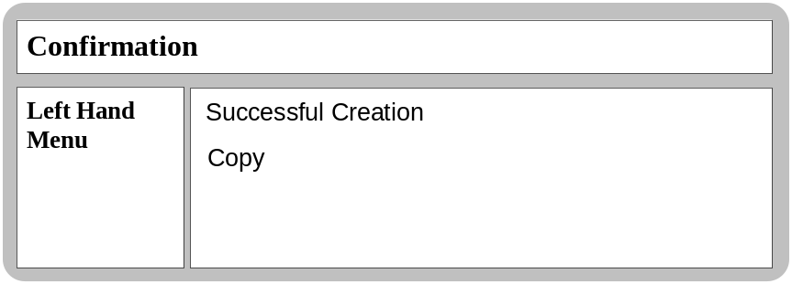

Business Logic Content

Name | Type | Description/Condition
Confirmation | Screen Title | The title of the screen
Copy | Text | To be define by business

Links
None

Validation
None

Screen – PAYG Registration Match Failure
This screen will be displayed when a PAYG registration match failure occurs. The user will be advised to change the PAYG address on Excalibur before resubmitting.

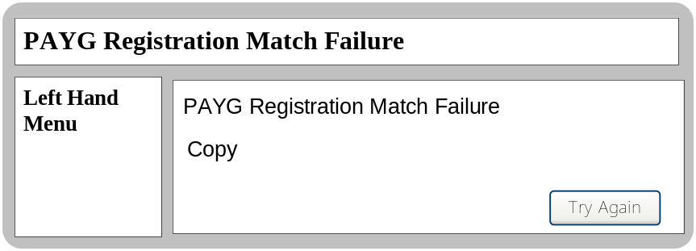

Business Logic Content

Name | Type | Description/Condition
PAYG Registration Match Failure | Screen Title | The title of the screen
Copy | Text | To be define by business

Links

Name | Destination | Description/Condition
Try Again | Confirmation | Leads the user to the confirmation screen if a successful PAYG match occurs
Try Again | Security details | Reloads the screen if a PAYG Registration Match failure occurs.

Validation
None

Domain Model

Field | Domain Model Name
Account Holder | MTMUser.MTMUserProfile.BusinessRole.MTMRole.AccountHolder
Subscriber | MTMUser.MTMUserProfile.BusinessRole.MTMRole.Subscriber
T-Mobile Number | MTMUser.MTMUserProfile.UserProfileMobile.Mobile.ctn
BAN | MTMUser.MTMUserProfile.BillingAccount.accountnumber
First Name | MTMUser.Person.firstName
Last Name | MTMUser.Person.lastName
Date of birth | MTMUser.Person.dateOfBirth
Sex | MTMUser.person.gender
Contact Number | MTMUser.contactNumber
E-mail | MTMUser.Person.email
Personal | MTMUser.PartyType.name
Business | MTMUser.PartyType.name
I am happy for T-Mobile to keep in touch by email | MTMUser.contactByEmail
House number | MTMUser.MTMUserProfile.Address.buildingNumber
House name | MTMUser.MTMUserProfile.Address.buildingName
Postcode | MTMUser.MTMUserProfile.Address.locale
Address | MTMUser.MTMUserProfile.Address
Username | MTMUser.User.userid
Password | MTMUser.User.password
Security Questions 1 | MTMUser.SecurityQuestion.description
Security Answers 1 | MTMUser.securityAnswer1
Security Questions 2 | MTMUser.SecurityQuestion.description
Security Answers 2 | MTMUser.securityAnswer1
Security Questions 3 | MTMUser.SecurityQuestion.description
Security Answers 3 | MTMUser.securityAnswer1
Date Created | LocalUser.dateCreated

Methods | Descriptions
Validate Username | Validates if the username has been used by another MTM user.
Get Optional Usernames | When the entered username has been already been taken, this method will return available options.
Create MTM account | Creates the MTM Account
PAYG Registration | Registers the PAYG details to Excalibur
PAYG Check | Checks if PAYG details exists on Excalibur
PAYG Match | Matches the details entered by the user and what is stored on Excalibur.
CTN Check | Checks if the CTN is T-Mobile and if it is PAYG
Validate PAYG Address | Validates PAYG account holders address.

