Content panels. Documentation.
- main concept:
- Content Panel is a restangular block with grey border.
- All site panels differs by their types according to their mockup`height size of each one.
PANEL-TYPE:
  - smallPanel (class=”panel-small”)
  - mediumPanel (class=”panel-med”)
  - largePanel (class=”panel-large”)
  - xLargePanel (class=”panel-xlarge”)
  - Double-panel (class=”double-panel”)
- Any panel can contain an ActionLink at its bottom
- Each panel consists of containers with all content. (For more details see “Basic Features”)
- If Pannel consist of several containers than we must set line-divider between them, so, in that case, panel must not contain an ActionLink.

- special widths
As we see, panel types was made to control its height value too, cause width value was fixed according to style guide. In some special cases (like double-panel) we need more width for current type of a panel. There`re some bacis styles which must be attached to current to control width. They are made according to a main content width and its percent parts (like 100% is 432px):
- If we need panel width = 136px we must add to parent class=”panel-conainer” new one width33;
- Width=142px : width66
- Width=278px : width75
- Width=432px : width100
Note: Everytime we`re using Double-panel we MUST add style width100 to parent class=”panel-conainer”.
Example:
- Panel’ common Structure:
  - simple Panel’ Structure:
Here is an example of a simplest panel. Note that class marked by bold italic must be changed according to documentation “Main Concept p.I.2”.

<div class="panel-container">
<div class="(insert PANEL-TYPE here)">
<div class="container" id="boxN-N">
<h2 class="title"><span>Alerts</span></h2>
<div class="content">Stay sharp. Get updated fast about what ever&rsquo;s important to you</div>
</div>
</div>
</div>
  - simple Panel’ structure with action link:
All types of panels may contain an actionLink at their bottoms. In that case we must redefine class of current panel cause of changes in its height size of it . So just add to needed class “PANEL-TYPE” dash and word “link” (was before: class=”panel-double”, became after: class=”panel-double-link”)

<div class="panel-container">
<div class="(insert PANEL-TYPE here)-link">
<div class="container" id="boxN-N">
<h2 class="title"><span>Free Motorola E680i</span></h2>
<div class="content">Any content goes here</div>
</div>
</div>
<div class="actionLink"><a href="#">Free Motorola E680i<span>&nbsp;</span></a></div>
</div>

  - LARGE multi-containers Panel’ structure (example):
Note, that Panel is just a parent and container - a child. So, if we have multi-container panels called as xLargePanels, we just need to neste containers one after another without any changing in their structure.

<div class="panel-container">
<div class="panel-xlarge">

<div class="container" id="box1-1">
<h2 class="title"><span>Messaging</span></h2>
<div class="content">Sign up and sit back. We'll do the sending.</div>
</div>

<div class="line"></div>

<div class="container" id="box1-2">
<h2 class="title"><span>Picture</span></h2>
<div class="content">Get cool pics send your mobile everyday. For Free!<br /><a href="javascript">Check the keywords</a></div>
</div>

<div class="line"></div>

<div class="container" id="box1-3">
<h2 class="title"><span>Text Alerts</span></h2>
<div class="content">From horoscopes to fatest scores, lottery resuits to chat-up lines.<br /><a href="javascript">Show me how</a></div>
</div>

</div>
</div>

- basic features plan:
Any panel’ container may consist of:
- Title
  - Magenta
  - Dark Grey (#333)
- Picture
  - Background
  - Image
- Content
- Digit
  - Right-sided by default
  - Can be left-sided by defining this in special page css

- Title
Main titles concepts lays on a sIFR method. In that case we have some features.
Formating of headlines (both: “Page Title” and “Panel Title”):
- You can use break-lines inside headline <br /> , but keep in mind that you MUST NEVER put <br /> at the end of headline!
<h2 class=”title”><span>Headline<br />goes here<br /></span></h2>
- To increase font size of panel` headline in some special cases do next:
  - When you defined a container by ID=”boxN-N” create in additional page css a style for
#boxN-N .title{height:Npx;} so after this you can see that font-size was increased and you can tune it in this way. See CVS: ISG/UILibrary/Panels_sifr/xLargePanel.html for example (box2)

  - magenta
Magenta color used in headlines by default.
  - grey
Sometimes we need to mark out some parts of headline, according to styleguide we can do this using one additional color: Dark Grey #333
- To change colour of a part or a whole headline onto dark grey (#333) just enclose needed text into tag <em>
  - <h2 class=”title”><span>Headline <em>goes here</em></span></h2>

- picture
All pictures inside panel’ content must be defined by next 2 groups

  - background
All offseted pictures and pictures without any context weight must be used as backgrounds inside panel’ containers. To set background propely we must define it inside “special page” css. In short words, every panel’ container has its own ID like #box2-1, so we can control panel` backgrounds through such IDs. Also we must set height for such containers through this IDs too.
Example (in “special-page.css”):

#box2-1{height:118px; background:url(../imgs/2_1_specialoffers_banner.gif) 100% 0px no-repeat;}
  - image
There`re many cases where we need to set normal images inside container’ content. Basicaly, we a speaking about panels with handsets offers and promos.
- content
Regarding to panel container code example we have a very simple structure. So, all content stuff must be setted into div with class=”content”. Inside this div, we can use next things:
  - Unordered listings;
  - Paragraphs;
  - Buttons
  - Items of a forms
  - Active images
Also we must care about width of a panel, and trying to use content gentle and without any extra and fixed width stuff.

- digit
  - DIGIT right
Digit is a magenta offer-boxes. Their position is defined to the right-side by default. As seen in example code we must set a digit and a title into first container of this panel. Next container is used only for content block.

<div class="panel-container">
<div class="PANEL-TYPE">
<div class="container" id="boxN-N">
<div class="digits"><img src="imgs/containers/digit.gif" width="72" height="72" alt="Last few days" /></div>
<h2 class="title"><span>3 months<br />half price<br />line rental</span></h2>
</div>
<div class="container">
<div class="content">500<br /> Anytime minutes<br /> &pound;25<br /> per month</div>
</div>
</div>
</div>

  - DIGIT left
Sometimes we need to align digit to the left, so in that case we must define digit and container style in “special-page.css” like this:

#boxN-N{ height:65px;}
/*Right Aligned Sifr Headline*/
#boxN-N .title {float:right; width:100px;}
/*Left Aligned Digit */
#boxN-N .digits{left:9px;}

- illustrations
smallPanel
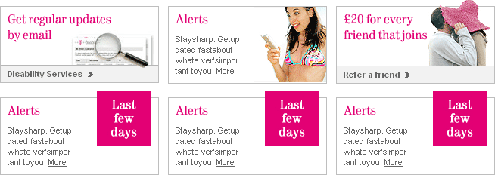

mediumPanel
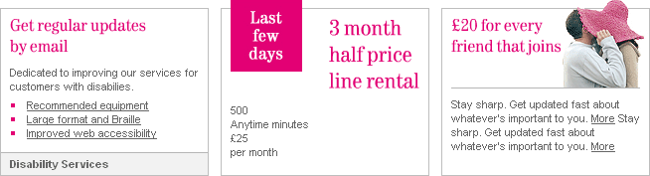
largePanel
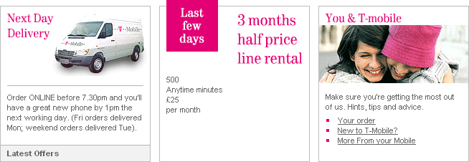
xLargePanel
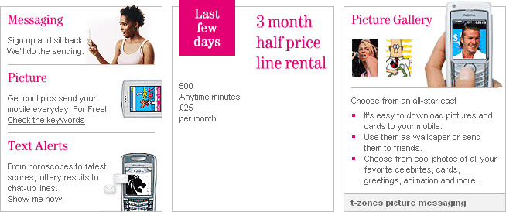
Double-panel
