PETROURDANETA
FIELD DEVELOPMENT PLAN
FDP v9-DRAFT — COMPLETE CONSOLIDATED REVISION
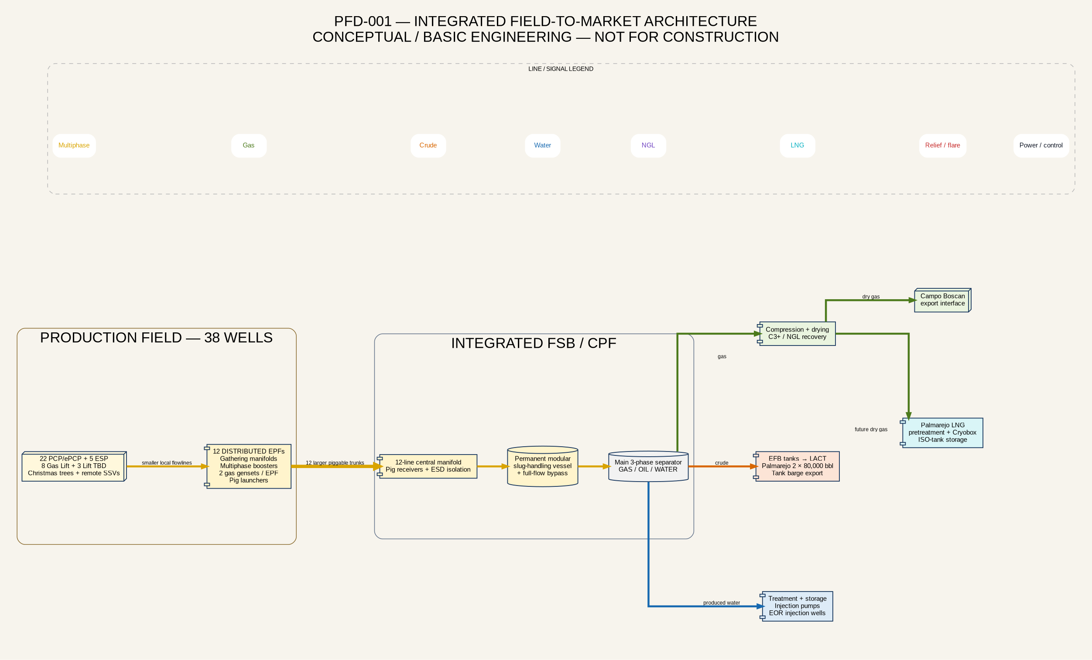
Conceptual / Basic Engineering Under Revision
Not Issued for Construction
29 August 2026

Revision Control
Revision | Date | Status | Principal change
v8 | 2026 | Source baseline | Original FDP source record.
v9-DRAFT Complete | 29 Aug 2026 | Conceptual/basic engineering | Full standalone consolidation of uploaded sources, project decisions, assurance work and industrial schematics.
This draft replaces the prior addendum-only v9 issue. It is complete as a controlled information package but remains subject to FEED validation, owner/partner approval and applicable Venezuelan requirements.

Table of Contents
1. Document Control, Source Hierarchy and Engineering Maturity | 15. Produced Water Treatment, Injection and EOR
2. Executive Summary | 16. Crude Storage, LACT, Palmarejo and Lake Export
3. Asset, Concession and Existing Infrastructure | 17. Utilities and Electrical Power Systems
4. Subsurface, Reservoirs and Reserves | 18. Process Safety, ESD/PSD, Fire Protection and Loss Prevention
5. Development Cases and Production Forecast | 19. Flow Assurance, Production Chemistry, Materials and Integrity
6. Wells, Reactivation, Drilling and Constraints | 20. Environmental, Social, Security and Regulatory Basis
7. Artificial Lift, Well Systems and Electrification | 21. Operations, Maintenance, Reliability and Readiness
8. Well Testing, Measurement and Production Allocation | 22. Export, Marine, Road and Product Logistics
9. Field Gathering and Standard Modular EPFs | 23. Project Execution, Contracting and Modular Deployment
10. Piggable Multiphase Trunk Network and Flexible Pipe | 24. Capital, Operating Cost and Economics
11. Integrated FSB/CPF Inlet, Slug Handling and Main Separation | 25. Risk Register, Decision Gates and FDP Closeout
12. Gas Compression, Fuel Gas, Gas Lift and Central Flare | 26. Controlled Project Sources and References
13. Gas Quality, Treatment, NGL and Campo Boscan Export | Appendices A–M. Schematics, FEED requirements, data, registers and source records
14. Palmarejo LNG and ISO-Tank Export
All chapters use Word heading styles and are available through the Navigation Pane. Page numbers can be refreshed after editorial changes.

1. Document Control, Source Hierarchy and Engineering Maturity
This FDP is the complete consolidated successor to FDP v8. It integrates the original FDP, the FEED Class 3 initial draft, the PDVSA–PetroUrdaneta planning workbook, the binary production forecast, the La Paz well-reactivation workbook, the EOR water-injection statement, the La Paz Sur technical memorandum, the 2016 gas chromatography report and the approved owner changes. The source files remain controlled records; this FDP provides the integrated development interpretation.
Data class | Meaning | Use in this FDP
Confirmed project basis | Owner-confirmed configuration or directly reported project fact. | Used as the reference concept unless contradicted by a regulatory or physical constraint.
Source-reported value | Value transcribed from a named project document. | Preserved with its source scope and date; not blended with other cases.
Calculated screening value | Transparent calculation from source inputs. | Used for option comparison only; not equipment sizing.
Conceptual recommendation | Engineering recommendation based on current evidence. | Requires owner endorsement and FEED validation.
FEED decision gate | Issue requiring calculation, survey, test, vendor guarantee, partner acceptance or permit. | Must close before the associated AFE, purchase order or construction package.

The document is not a final process design. Line sizes, relief loads, ESD/PSD setpoints, valve closure times, equipment duties, generator ratings, flare radiation zones, flexible-pipe specifications and injection limits remain subject to controlled FEED calculations. API, NORSOK, COVENIN and applicable Venezuelan requirements shall be mapped in the design-basis and regulatory registers before package procurement.

2. Executive Summary
PetroUrdaneta’s development strategy is a phased, modular restoration and expansion of the La Paz-area production system, followed by Mara, Mara West, La Paz Sur, El Moján and later infill opportunities. The development prioritizes reactivation before infill, early use of existing infrastructure, self-contained EPFs and incremental central-facility upgrades. The production system is deliberately based on normal multiphase flow from the well to the EPF and from the EPF to the integrated FSB/CPF complex.
The owner-approved reference concept contains 38 Phase 1 wells, comprising 22 PCP/ePCP wells, 5 ESP wells, 8 retained gas-lift wells and 3 wells whose lift method remains to be selected. Twelve distributed EPFs gather several wells each. Every EPF contains a local multiphase manifold, chemical-injection provisions, one VFD-controlled multiphase booster package, bypass, non-return and emergency-isolation valves, two gas gensets, switchgear, SCADA and a pig-valve launcher. Larger piggable trunklines connect the EPFs to one central manifold at the integrated FSB/CPF complex.
At FSB, pig receivers feed a permanent modular two-phase slug-handling vessel with isolation and full-flow bypass before the main three-phase separator. The separator divides production into gas, crude and produced water. Gas is compressed centrally and allocated to field/FSB fuel, eight gas-lift wells, early Campo Boscan export and later NGL recovery and Palmarejo LNG. Crude passes through EFB storage, transfer pumps and a LACT unit, then to the two 80,000-bbl Palmarejo tanks and the lake-export terminal. Produced water is treated, stored and reinjected for disposal and pressure support/EOR.
The original FDP v8 reported approximately 8.6 billion barrels OOIP, 4.6 Tcf OGIP, a current La Paz baseline near 1,300 BOPD, a 13,500-BOPD Phase 1 plateau, and a 40,000-BOPD strategic full-field target [S01]. The PDVSA/business-planning and binary forecast sources contain larger portfolio cases, including approximately 27–28 kbopd oil, 49–52 MMscfd gas and long-term produced-water rates approaching 96.9 kbwpd [S03] [S04]. These are different scopes and are maintained as separate design envelopes.
The present configuration is credible as a modular development concept but is not yet a frozen facilities design. The highest-priority closures are the controlled well-by-well production and pressure basis; FSB brownfield integrity/capacity; integrated multiphase transient model; multiphase-pump operating envelope; pigging and slug-vessel sizing; gas allocation and composition; water-treatment/injectivity basis; power-system stability and black start; relief/flare/depressuring study; and terminal/marine assurance.

Integrated field-to-market architecture

3. Asset, Concession and Existing Infrastructure
The PetroUrdaneta portfolio covers La Paz, Mara, Mara West, La Paz Sur and El Moján. La Paz is the Phase 1 cash-flow engine because it has existing producing wells, shut-in reactivation candidates, the FSB gathering/processing hub, the LF-B gas-compression system and access to Palmarejo export infrastructure. Development beyond La Paz must remain gated by production performance, subsurface confidence, infrastructure availability and partner/concession approvals.
Existing FSB capacity is reported at approximately 5,000 BOPD and 0.9 MMscfd, while the LF-B gas-compression plant is reported at 19.5 MMscfd [S01] [S10]. These values are not design guarantees. The existing plant requires a condition, capacity, relief, control-system and integrity assessment before it can be credited for Phase 1. The main line to Palmarejo has reported active leaks and has been treated as limited to approximately 10,000 BOPD pending repairs. The subsurface line toward Puerto Miranda lacks a current integrity and pigging basis.
The PDVSA–PetroUrdaneta workbook identifies upgrades to stations H7, L7, K8, C, MRV1, MRV2 and MRV3 as multiphase pumping stations, a 20-slot production/measurement manifold at EFB in two phases, a water-treatment/injection plant from 2029, replacement of the PetroWayuu Coriolis unit with a LACT unit, maritime cabotage as a contingency and security/community programs. These items are part of the consolidated infrastructure plan and require scope/ownership confirmation.
Existing interface | Reported condition or limitation | Required closure
FSB / CPF | Existing capacity below Phase 1 target; brownfield condition unknown. | Survey, capacity test, relief review, tie-in plan and staged debottlenecking.
LF-B compression | 19.5-MMscfd reported capacity; current map and availability unverified. | Compressor curves, anti-surge, liquids protection, availability and gas-allocation model.
Palmarejo crude tanks | Two tanks of 80,000 bbl each. | Working volume, heel, overfill, integrity and transfer-rate confirmation.
Main line to Palmarejo | Active leaks and throughput constraint reported. | Intelligent/integrity inspection, repair/isolation scope, pressure test and leak detection.
Puerto Miranda subsurface line | Integrity status and piggability uncertain. | Ownership/interface review, survey and acceptance decision.
Lake terminal | Crude barge and dry-cargo ISO-tank concepts. | Bathymetry, berth, mooring, weather, loading-rate, ESD and spill-response studies.

4. Subsurface, Reservoirs and Reserves
The development includes Eocene, Paleocene, Cretaceous and basement intervals with materially different pressures, fluids, lift needs and recovery mechanisms. The original FDP reports La Paz Eocene/Paleocene pressure near 900 psi and Cretaceous pressure near 4,405 psi, while La Paz Sur data report a Cretaceous initial pressure of approximately 4,340 psig at 9,000 ft and a 2025 estimate near 4,490 psi. These values require depth-datum and fluid-system reconciliation.
The La Paz Sur memorandum reports 402 MMbbl STOIIP, a 26.1% recovery factor, 105.05 MMbbl oil plus 32.57 Bscf gas, totaling 110.48 MMBOE, and a minimum PDVSA commitment of 55.24 MMBOE [S07]. The reported development area is 16.32 km², with average net pay 82.49 m, porosity 6.81%, water saturation 23.07%, formation volume factor 1.19, GOR 310 scf/STB and oil gravity 25° API. The proposed program contains fourteen wells: two reactivations, two delineation/exploration wells and ten development wells.
A material structural uncertainty exists. A prior interpretation separated P-191 and P-201 through inferred faults, whereas the recent technical view challenges the existence or sealing nature of those faults. No Cretaceous oil-water contact has been established in the evaluated block. The FDP therefore treats the 26.1% recovery factor and development continuity as contingent on static/dynamic model reconciliation and delineation evidence.
Water-injection evidence indicates reservoir-pressure recovery from a trough near 1,200–1,400 psia toward approximately 1,700 psia at cumulative production above 210 MMSTB [S06]. The 2026 year-to-date injection average is reported near 1.2 MBWIPD versus 1.3 MBWIPD planned, with a plan of 1.4 MBWIPD from July onward. The favorable pressure response supports continued injection, but it does not replace well-integrity, compatibility, fracture-margin, surveillance and voidage-replacement studies.

5. Development Cases and Production Forecast
The project sources contain incompatible scopes and shall not be averaged. Facility design must preserve at least the controlled Phase 1 case, a portfolio/high case and turndown/decline cases.
Case | Reported or derived envelope | Intended use
La Paz current baseline | Approximately 1,300 BOPD. | Existing-operations and restart basis.
La Paz reactivation workbook | Latest 4,719 BOPD; 12,254 BOPD on opening plus 1,374 BOPD from workovers. | Well-candidate and reactivation screening.
FDP Phase 1 | 13,500-BOPD target plateau; theoretical 14,982 BOPD. | Sanction and modular Phase 1 reference.
PDVSA/business-plan portfolio | Approximately 27–28 kbopd and 49–52 MMscfd peak. | Central facilities and gas-disposition sensitivity.
Strategic concession | 40,000 BOPD by Year 4. | Long-range infrastructure and export envelope.
La Paz Sur module | Approximately 20.7-kbopd high-rate development case. | Separate appraisal/development gate; not additive until sanctioned.
Long-term water case | Produced water approaching 96.9 kbwpd late in field life. | Water-treatment/injection expansion envelope.

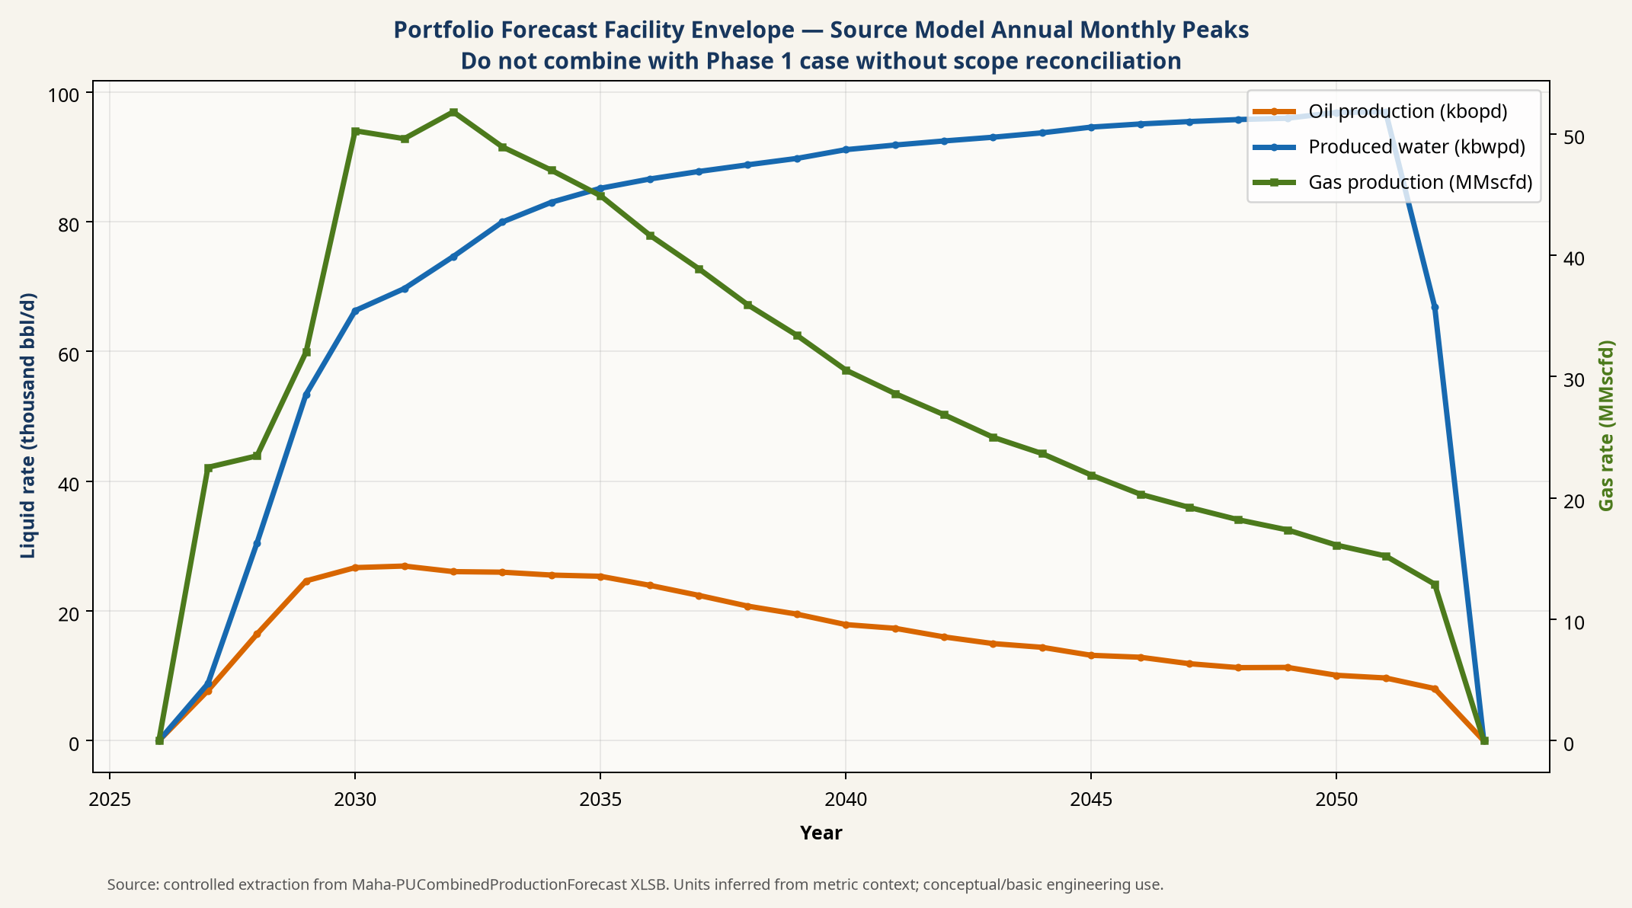
Portfolio oil, gas and water facility envelope
The original schedule contains conflicting first-oil dates. Some sections target first oil at Month 5, while other execution tables indicate D+1. The consolidated basis treats the schedule as unapproved until a single D0 definition, well sequence, package delivery plan and facility-readiness gate are issued. Rigs must be coordinated with EPF, line and FSB readiness. Following pump installation, each well undergoes a 72-hour test; the rig may be released 12 hours after stable surface flow is established, provided the well is secure and the test package is independent of the rig.

6. Wells, Reactivation, Drilling and Constraints
Reactivation has priority over infill drilling. The FDP v8 describes 32 La Paz wells, the reactivation workbook lists 35 wells, the owner concept uses 38 Phase 1 wells, and the binary model contains 86 unique La Paz well names. These populations must be reconciled through a controlled well master identifying ownership, status, completion, reservoir, rate, pressure, lift, intervention, EPF and forecast case.
The reactivation workbook reports five wells with community/access issues—P-108, P-173, P-95, P-180 and P-152—four wells with uneconomic surface equipment—P-192, P-82, P-61 and P-88—P-161 requiring major subsurface repair, P-91 with high water production and P-52 awaiting abandonment [S05]. These constraints are development gates, not footnotes. Each reactivation AFE must include rig days/cost, completion/lift hardware, flowline/power tie-in, 72-hour test, waste handling, expected production, uncertainty and abandonment fallback.
La Paz Sur requires a separate appraisal-to-development sequence. The two reactivations and two delineation/exploration wells should precede the final commitment to all ten development wells unless partner-approved evidence justifies parallelization. The structural-continuity uncertainty and absence of a defined OWC require explicit subsurface decision gates.

7. Artificial Lift, Well Systems and Electrification
The confirmed Phase 1 concept contains 22 PCP/ePCP wells, 5 ESP wells and 8 gas-lift wells, with three lift selections outstanding. ePCP denotes a progressive cavity pump driven by a downhole electric motor with no rotating shaft to surface. The ePCP protection philosophy therefore resembles an ESP electrical completion while retaining PCP-specific torque, viscosity, solids and differential-pressure constraints.
ESP and ePCP wells are powered from the EPF through a high-voltage field feeder, a wellsite step-down transformer, protection/MCC and a VFD. Final voltages are intentionally not frozen. The electrical study must include load flow, fault levels, motor starting, harmonic distortion, cable ampacity/voltage drop, earthing, lightning, hazardous-area interfaces, protection coordination and black start.
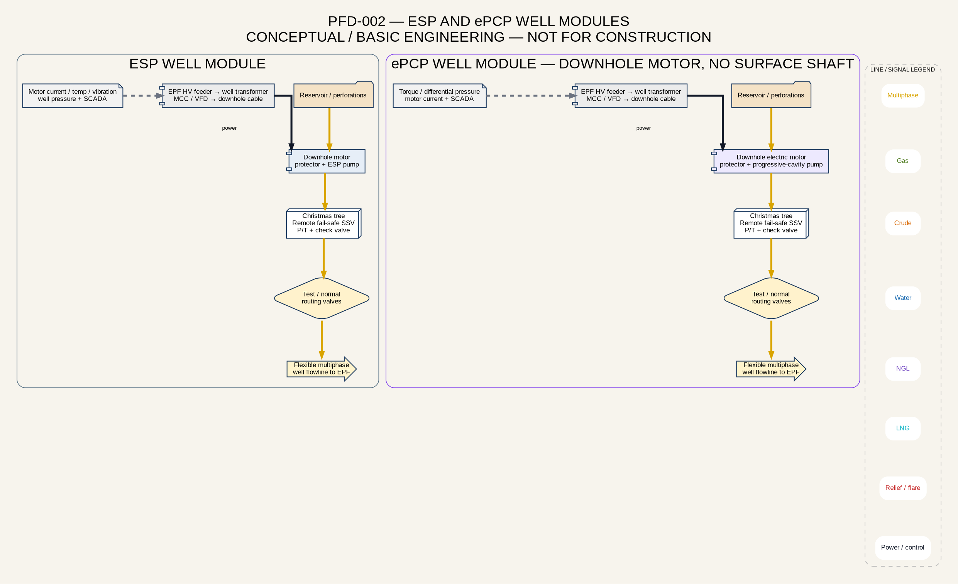
ESP and ePCP well systems
The eight gas-lift wells remain on gas lift. Injection gas is compressed at FSB, metered and controlled at the well, travels down the annulus and enters the production tubing through gas-lift valves. Produced gas returning with the wellstream is recovered at FSB; gas lift is therefore a recycle loop, and only unrecovered losses should be treated as net consumption.
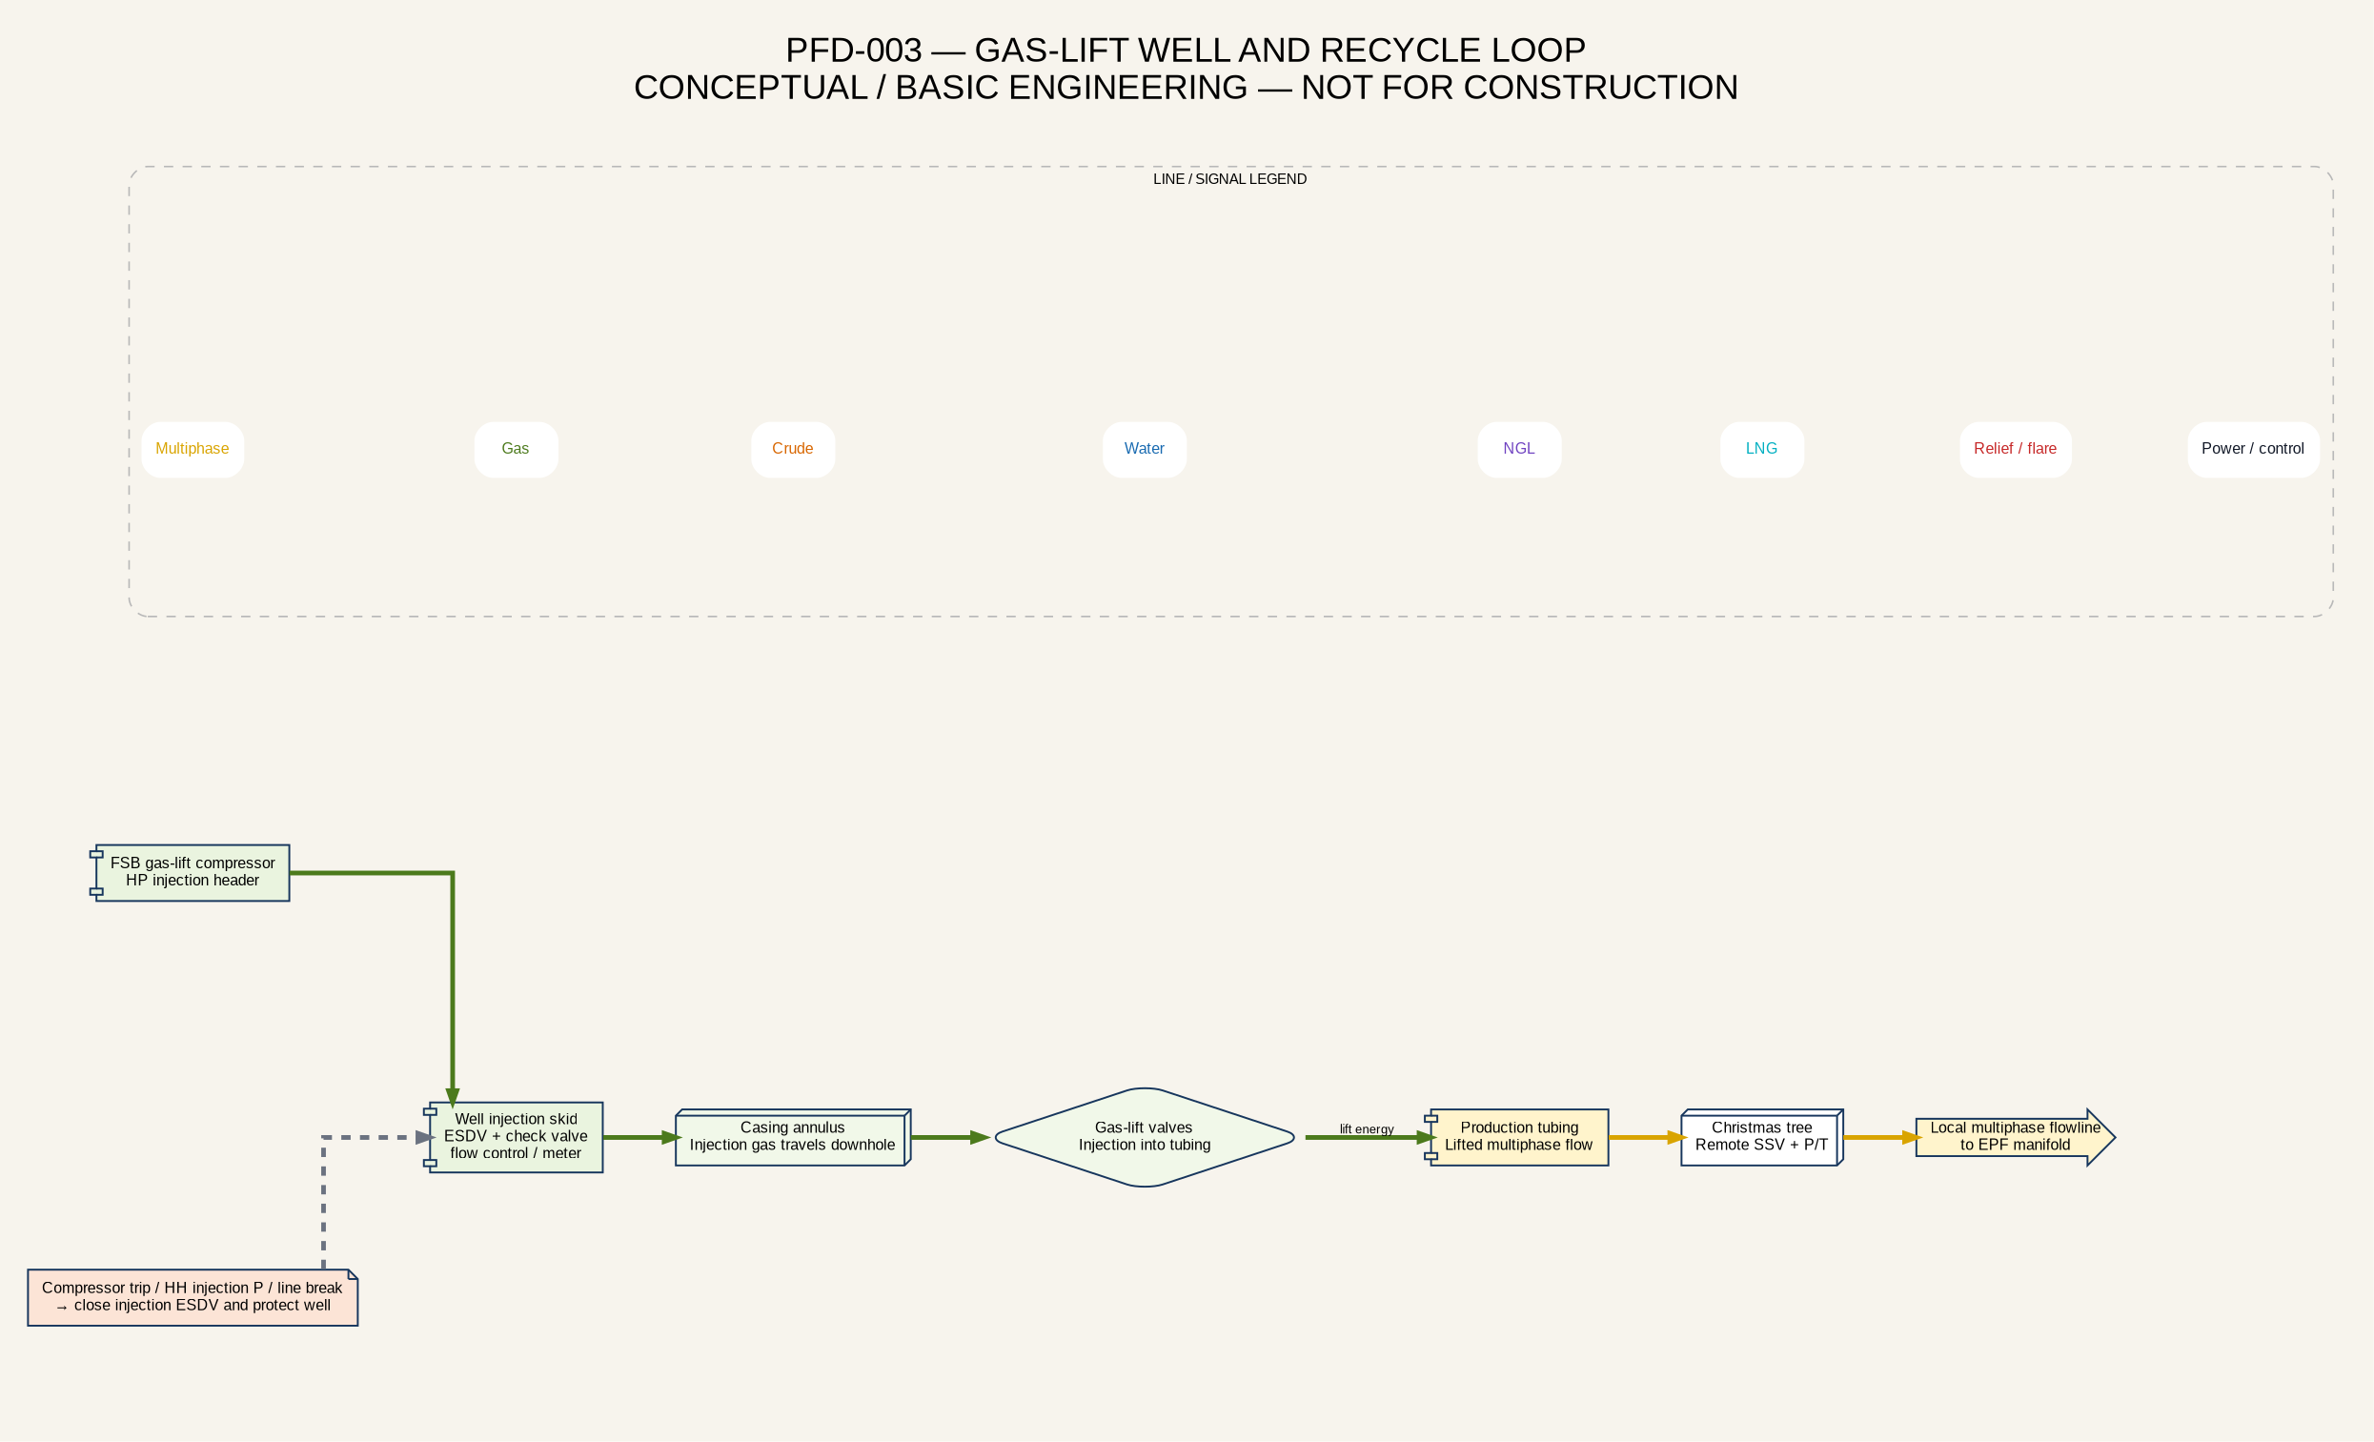
Gas-lift well and recycle loop
Lift system | Principal protections | FEED requirements
ESP | VFD trip, motor-current/temperature protection, low intake pressure, high discharge pressure, remote wellhead isolation and controlled restart. | Inflow, TDH, gas-handling, cable, transformer, start/restart and annular-gas assessment.
ePCP | VFD trip, torque/current, differential pressure, temperature, solids/viscosity and remote isolation. | Pump elastomer/fluid compatibility, speed/torque envelope, gas fraction and downhole-motor qualification.
Gas lift | Injection ESDV/check valve, high/low pressure, compressor trip logic and wellhead isolation. | Per-well injection/return optimization, valve design, compressor pressure and production response.
Conventional PCP / rod pump | Surface-drive/rod protection where retained. | Confirm whether any of the 22 PCP-class wells use surface drive; reconcile with ePCP designation.

8. Well Testing, Measurement and Production Allocation
The confirmed base case is a temporary modular well-test package at the selected wellsite. Production is diverted through a controlled test manifold to a three-phase test separator. Test gas is metered and flared during the 72-hour test, while measured oil and water are recombined and returned to the normal multiphase line toward the EPF. The EPFs do not contain permanent test separators.
The test package requires a flare knockout vessel, radiation/dispersion assessment, exclusion zone, ignition and flame monitoring, gas detection, ESD, liquid carryover protection, stable flow measurement and Ministry/environmental authorization. Routine atmospheric venting is not accepted as a substitute for a test flare.
A Roxar-type multiphase flowmeter is retained as a lower-flare alternative, subject to Ministry approval and project validation across gas-volume fraction, viscosity, emulsion, water cut, flow regime and PVT. The alternative keeps the full multiphase stream in the production line, but it must demonstrate allocation accuracy against a separator test.
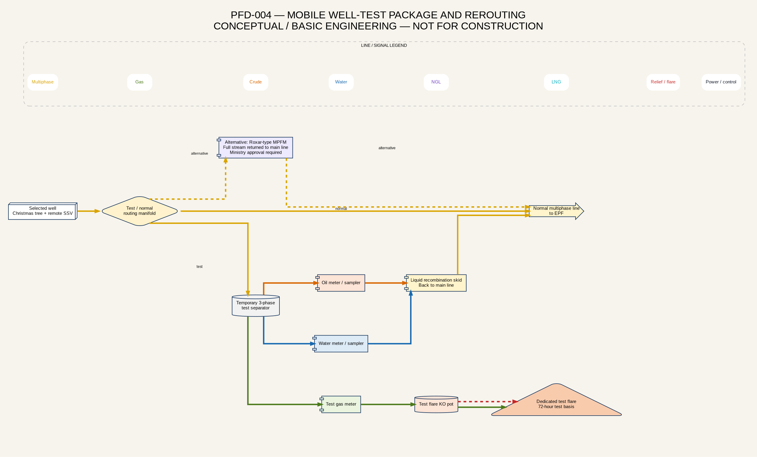
Mobile well-test package

9. Field Gathering and Standard Modular EPFs
Each EPF is a staffed, modular gathering, power and boosting facility. It is not a local processing plant. Several wells flow through smaller local multiphase laterals to a production manifold. The commingled stream passes through a VFD-controlled multiphase booster, non-return valve, ESD isolation and pig-valve launcher into the larger EPF-to-FSB trunk. A full-flow bypass is provided for start-up, maintenance or natural-flow operation only when validated by hydraulics.
The FEED draft identifies the following tag basis: MAN-101 production manifold; TH-101 test header; CI-101 chemical injection; PMP-101 twin-screw multiphase pump; NRV-101 check valve; PL-101 pig launcher; ESDV-101/102 emergency isolation; FG-101 fuel-gas package; GEN-101 gas genset; and SCADA-101 controls. The final pump technology is not frozen. Twin-screw, helico-axial or other qualified multiphase technologies shall be compared against gas-volume fraction, viscosity, sand, suction pressure, differential pressure, turndown, slug tolerance, seal requirements, power and maintenance.
The owner basis is one modular multiphase booster package at every EPF. Because this creates a local single-point dependency, FEED shall compare duty-only plus mobile spare, installed duty/standby and rapid-change cartridge/package strategies. Each package requires suction/discharge isolation, check valve, pressure/temperature instrumentation, minimum-flow or recycle philosophy where applicable, vibration/seal monitoring, ESD integration and vendor-confirmed operating envelope.
Each EPF has two gas-engine generators. The gensets supply EPF loads and the well-field electrical network through switchgear and a step-up transformer. Fuel gas comes from the central gas system or an approved local interface and requires scrubber/separation, pressure regulation, metering, trip isolation and off-spec protection. The staffed EPF basis includes a control-room operator, one or two field operators and security personnel; occupied-building siting and evacuation must reflect credible gas and fire scenarios.
A small closed-drain drum may be installed for defined intermittent drains from the manifold, booster skid and pig launcher. It is not an upset separator and shall not receive continuous production or full pigging slugs. It requires independent high-level alarm, pressure/vacuum protection, controlled vapor disposition and a closed, grounded vacuum-truck connection.
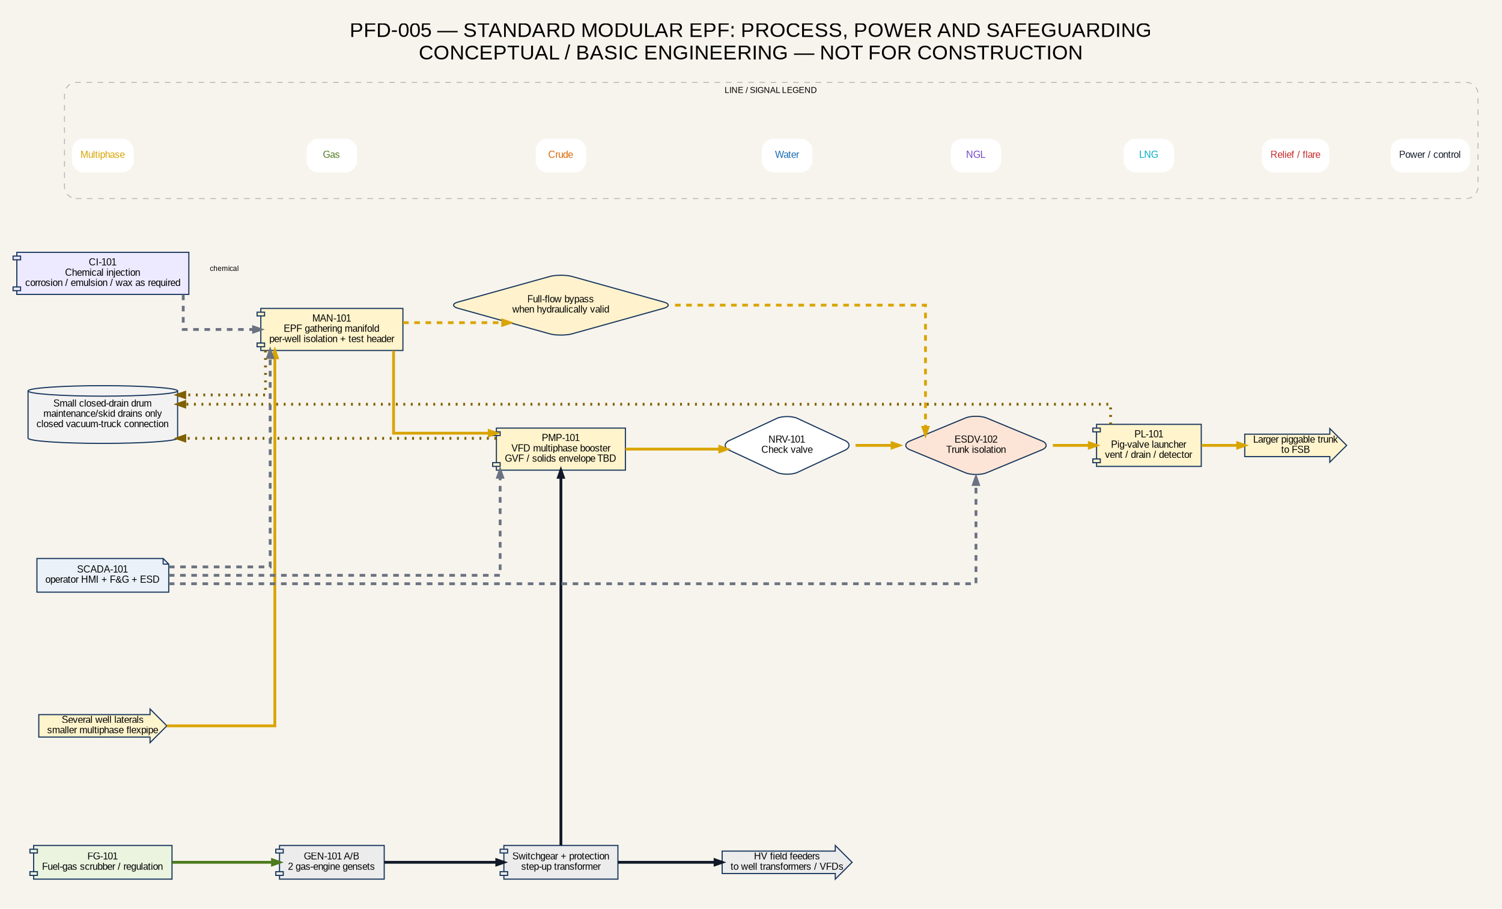
Standard modular EPF

10. Piggable Multiphase Trunk Network and Flexible Pipe
The field has two gathering levels. Well-to-EPF laterals are smaller multiphase lines and may use qualified spoolable RTP/composite pipe where pressure, temperature, chemistry, sour service, rapid-gas decompression, gas permeation, sand, external damage and installation criteria are satisfied. The larger EPF-to-FSB trunklines are the piggable segment. Each trunk has a pig-valve launcher at its EPF and a matching pig-valve receiver at the FSB central manifold.
All twelve trunklines converge on one central manifold. The architecture is retained because it preserves independent EPF isolation and central processing, but it creates congestion and a common receiving interface. The central manifold shall allow individual trunk isolation, pressure monitoring, pig detection, controlled routing to the slug vessel, drain/vent isolation and maintenance without shutting all production where practical.
The owner considers six-inch piggable flexible pipe a base screening option. It is not frozen. Liquid-only screening shows that 4-, 6- and 8-inch clear bores yield materially different velocities, but liquid-only velocity cannot size a multiphase line. FEED shall model well/EPF minimum, normal, maximum and decline cases; gas fraction; water cut; viscosity; temperature; route elevations; pump curves; FSB arrival pressure; erosion; liquid holdup; slugging; shutdown and restart; and pigging transients. Four-, six- and eight-inch internal-bore options shall be compared per EPF or trunk class rather than forcing a uniform diameter.
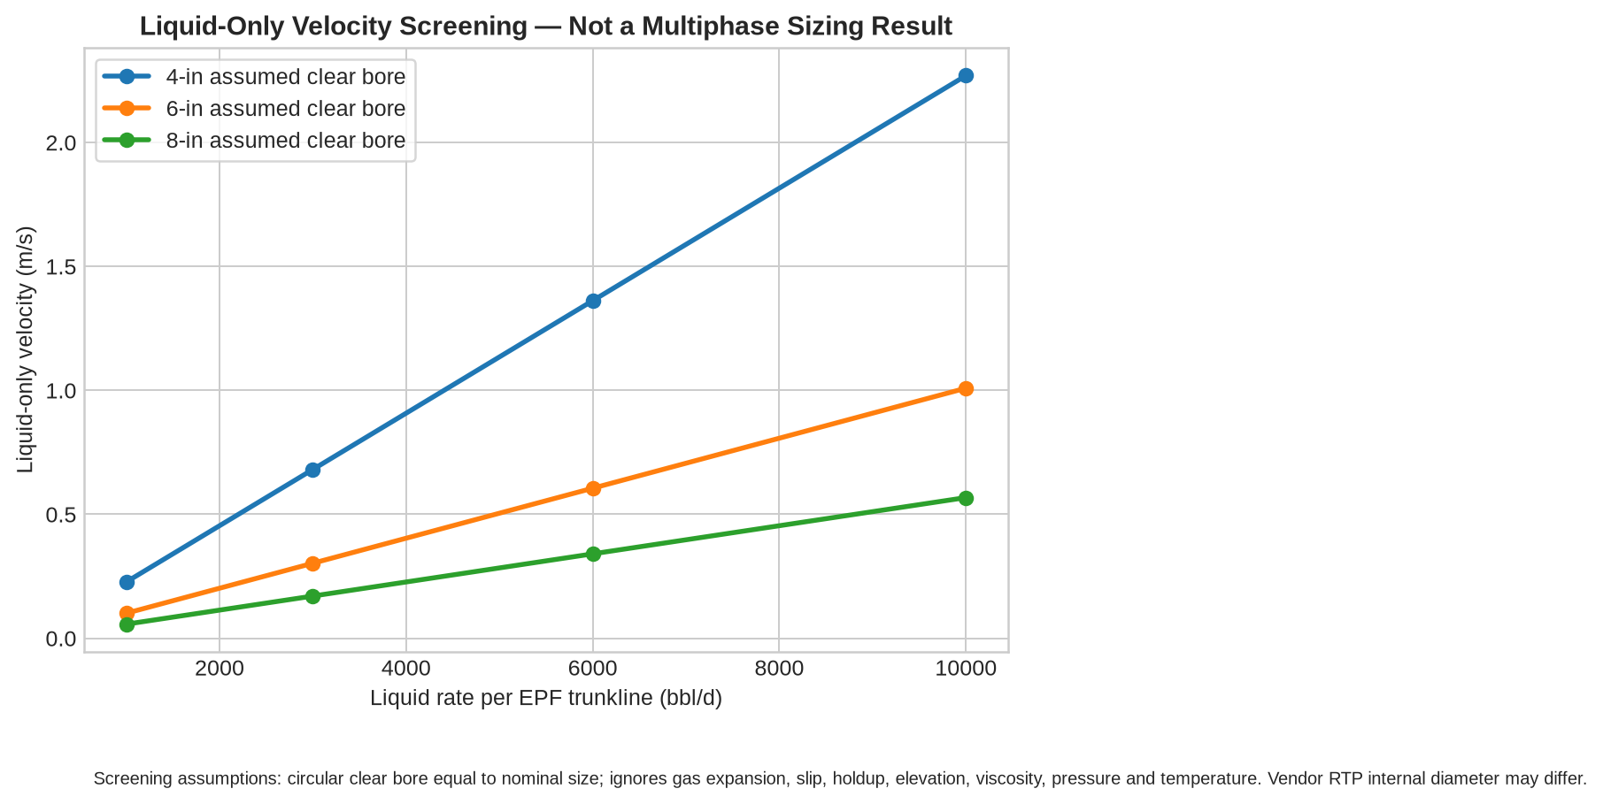
Liquid-only 4/6/8-inch screening
Flexible-pipe piggability must be demonstrated for the complete installed system. Qualification includes constant internal diameter, bend radius, couplings/end fittings, full-bore pig valves, tees, pig type, cleaning/inspection capability, pressure cycles, permeation, rapid-gas decompression and mechanical protection. Steel remains the fallback at Christmas trees, manifolds, pump nozzles, pig launchers/receivers, ESD stations, vessels, compressors, flare/depressuring, NGL and cryogenic LNG service.
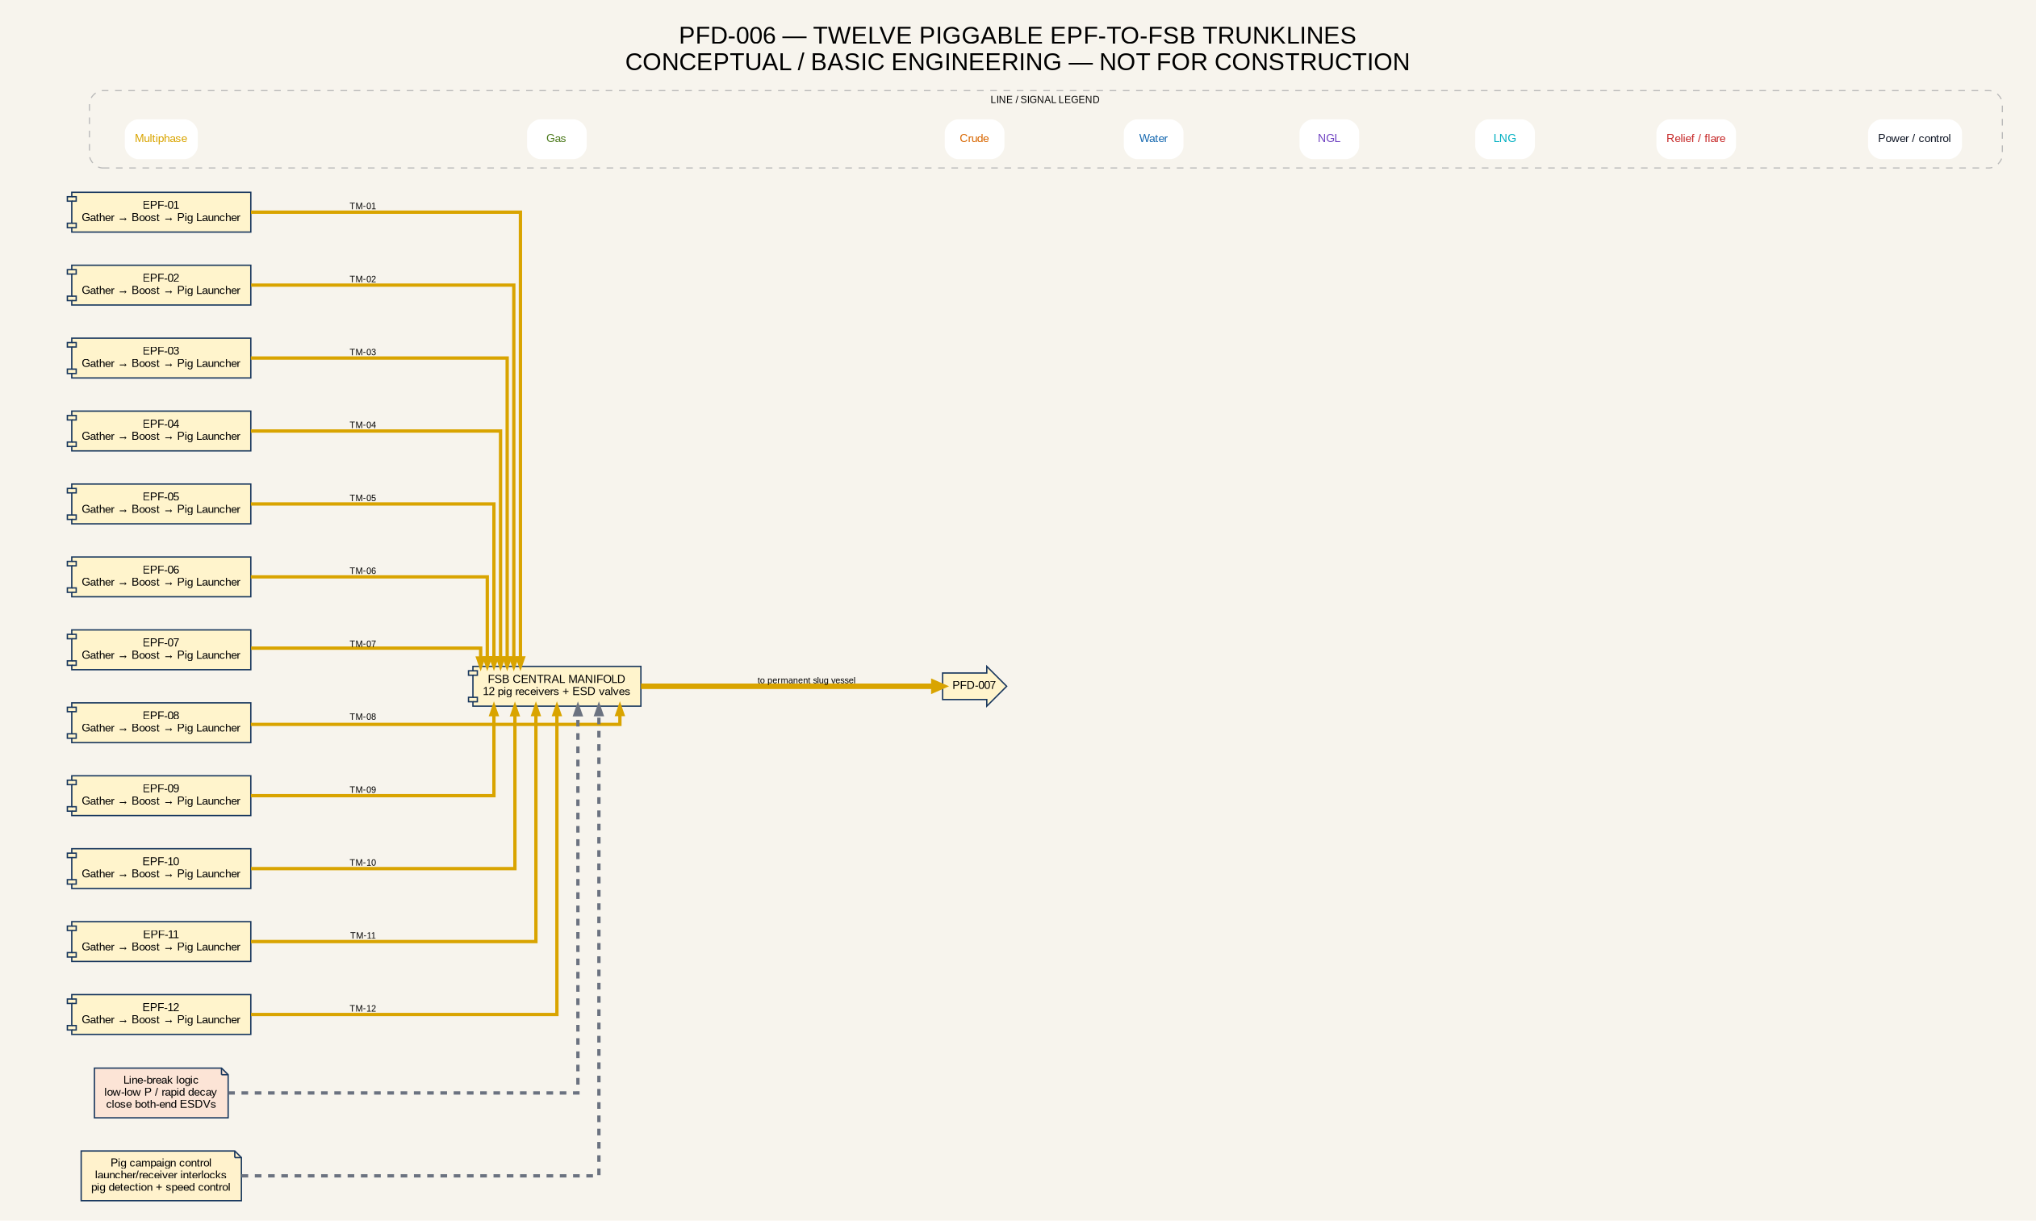
Twelve piggable trunks

11. Integrated FSB/CPF Inlet, Slug Handling and Main Separation
FSB and CPF are one integrated central complex. All twelve piggable trunks terminate at pig receivers and the central manifold. A permanently installed modular two-phase slug-handling vessel is located upstream of the main three-phase separator. The vessel is required because pigging and transient terrain/hydrodynamic behavior can deliver concentrated liquid volumes that upset the main separator.
The slug vessel is not sized by judgment. Its working/surge volume must come from integrated transient modeling of each trunk and coincident operating cases. It requires inlet isolation, full-capacity bypass, gas equalization, high-high level/pressure protection, controlled liquid transfer, drains/vents and ESD. The bypass permits maintenance or a validated operating route; it is not a depressuring system and shall not be used to defeat protection.
The main separator receives a multiphase inlet. Gas bubbles rise into the gas-disengagement zone, with a mist extractor limiting liquid carryover. Oil settles above the water interface, while produced water occupies the lower layer. Solids/sand collect in the bottom drainage zone. Separate level/interface controls route gas, crude and water to their respective treatment systems.
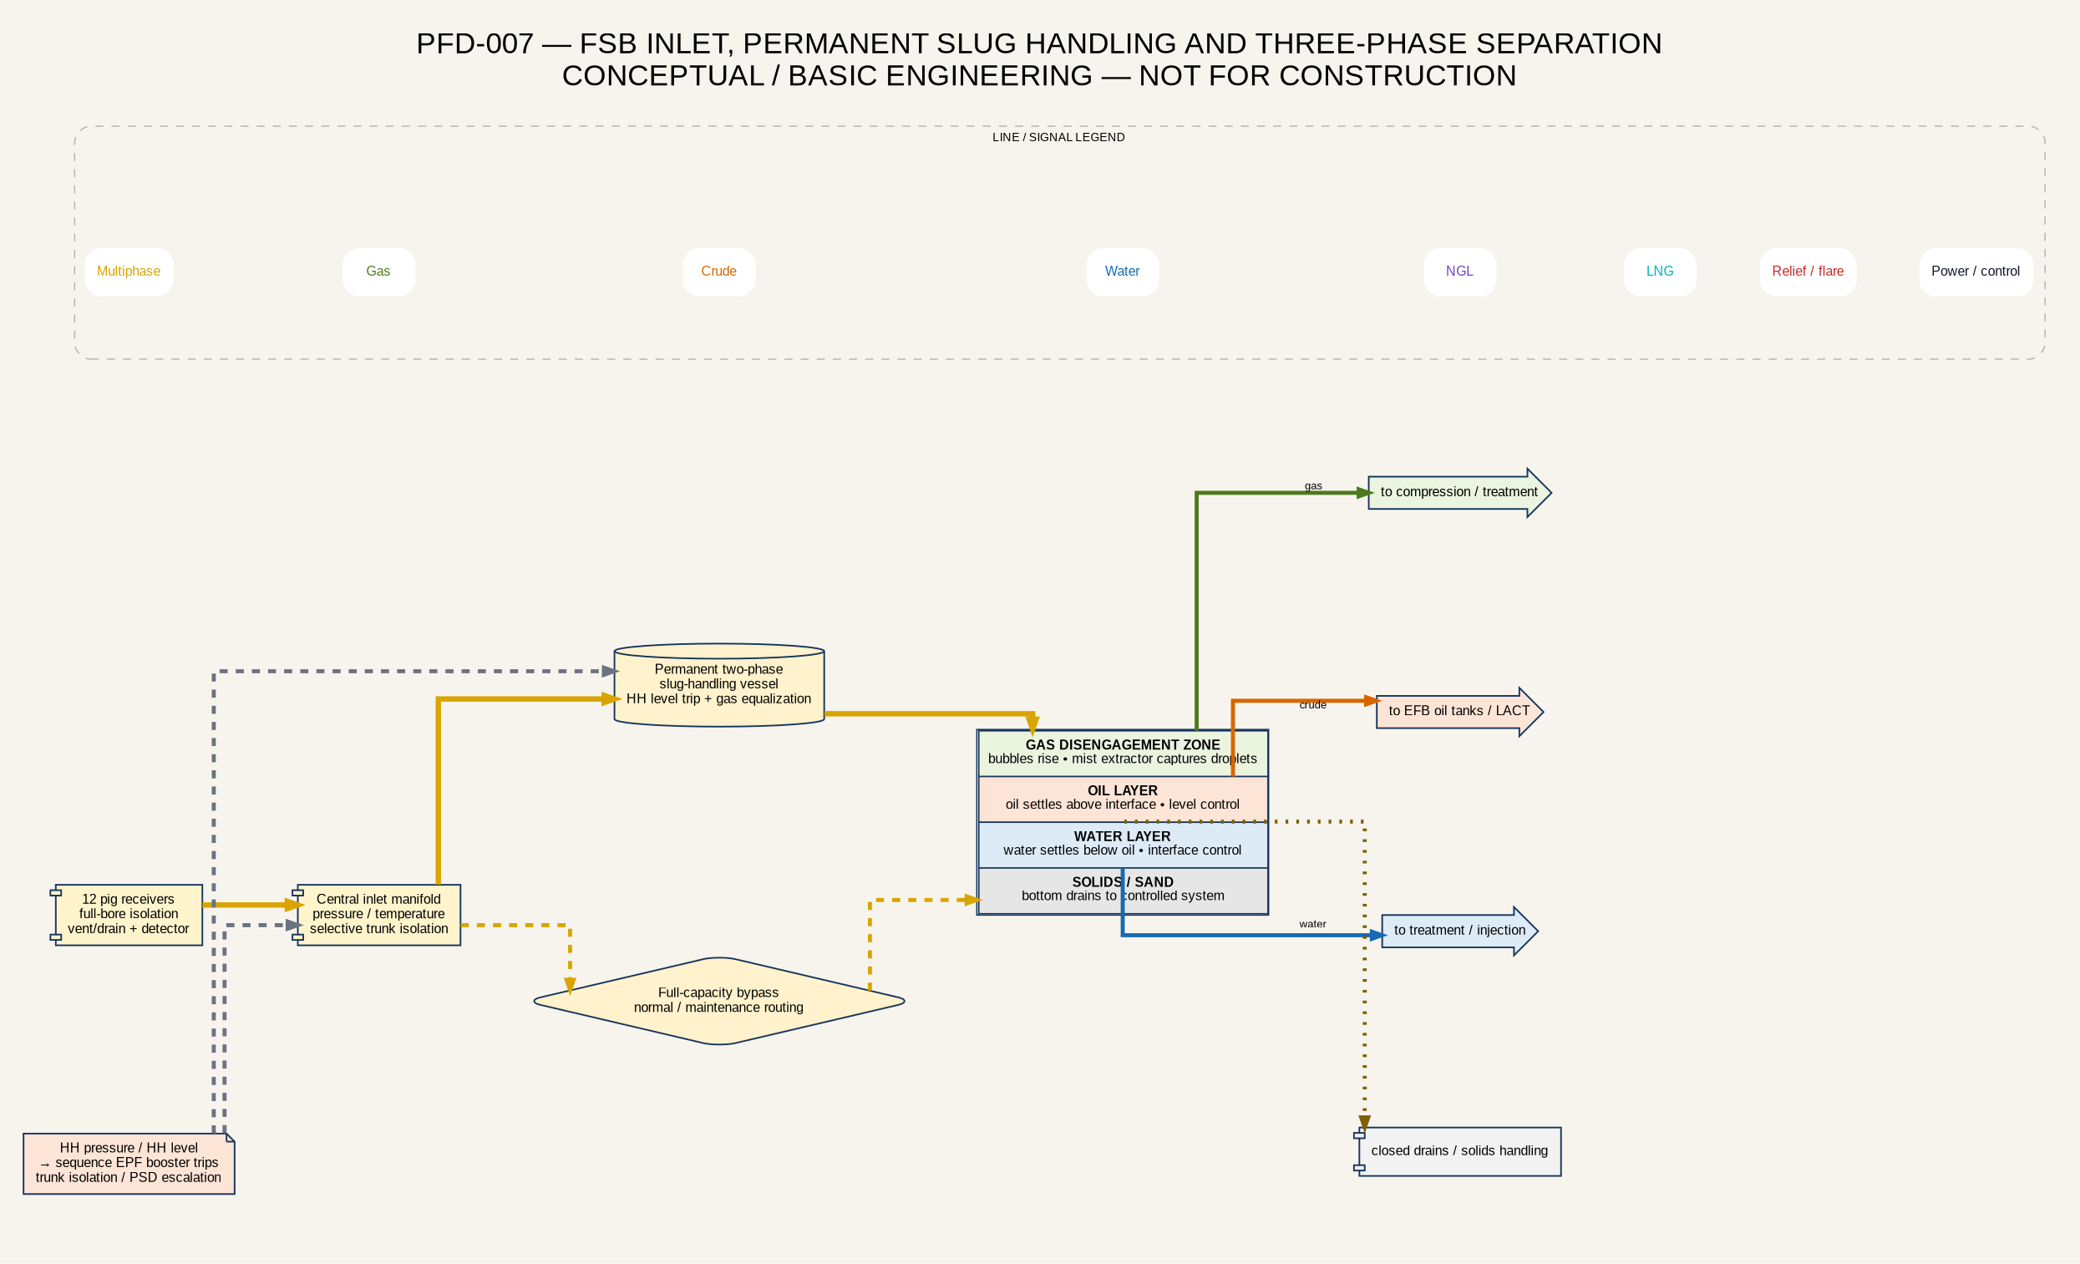
FSB slug handling and main separator
The existing FSB cannot be credited for the Phase 1 or portfolio cases until the brownfield assessment verifies vessel dimensions, internals, control valves, relief capacity, corrosion allowance, foundations, piping, supports, electrical classification, fire/gas coverage, instrumentation and tie-in windows. Staged upgrades shall be based on an approved production case rather than one fixed full-field capacity.

12. Gas Compression, Fuel Gas, Gas Lift and Central Flare
All gas compression is located at FSB. The process begins with liquid protection at the compressor suction. Parallel or staged compressor packages discharge through cooling and knockout to a central gas header. The header feeds the eight gas-lift wells, EPF/FSB fuel gas, treatment/Campo Boscan export and later Palmarejo LNG.
Centralization reduces distributed equipment but creates a common-mode risk. The design requires train availability analysis, liquid carryover protection, anti-surge control, trip sequencing, one-train-down capacity, turndown/recycle, independent starting fuel, black-start strategy, critical spares and load shedding. Compressor trips must not create excessive upstream pressure; the cause-and-effect logic shall sequence booster trips, well shut-in and trunk isolation while preserving separator control.
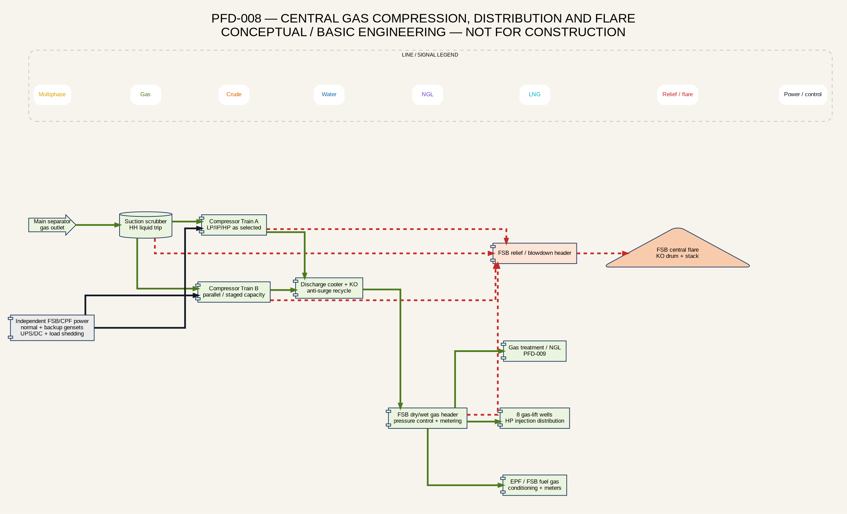
Central gas compression and flare
The central FSB flare is the primary relief and depressuring system for the processing complex. It shall include a complete relief-case register, segmented depressuring philosophy, flare-network hydraulics, backpressure verification, knockout drum, liquid handling, radiation/noise/dispersion assessment, ignition reliability, smokeless capability if required and emergency power. A permanent flare at every EPF is not the default. EPF pressure is normally controlled through safe shutdown and isolation; maintenance inventory is displaced or recovered where practical and otherwise managed through an approved controlled vent or portable flare after dispersion and permit review.

13. Gas Quality, Treatment, NGL and Campo Boscan Export
The 2016 gas chromatography provides three screening compositions [S08]. The La Paz rich sample reports approximately 77.75 mol% methane, 11.90 mol% ethane, 6.21 mol% propane, 0.50 mol% CO₂, 15 ppm H₂S, 1,294 BTU/scf and 3.342 GPM C3+. A flow-station sample reports 9.75 mol% CO₂, approximately 190 ppm H₂S, 1,060 BTU/scf and 1.499 GPM C3+. A Mara sample reports 2.35 mol% CO₂, approximately 8 ppm H₂S, 1,204 BTU/scf and 2.344 GPM C3+.
The variability is too large for one treatment design without fresh sampling. The project shall obtain pressure-preserved samples by reservoir/cluster and a blended FSB stream, including full composition, water, H₂S, CO₂, nitrogen, mercury screening, hydrocarbon dew point and representative pressure/temperature. Materials, corrosion, fuel-gas derating, Boscan specification and LNG pretreatment depend on these data.
The staged gas-treatment concept is modular. The early system uses inlet separation/coalescing, acid-gas removal if required, pipeline dehydration and hydrocarbon-dew-point control. TEG is a conventional pipeline/fuel-gas dehydration option, while membranes, JT/MEG or mechanical refrigeration may be advantageous depending on CO₂, pressure and NGL economics. Condensed C3+ falls into an NGL receiver, then passes to pressurized storage, metering and a dedicated road-loading bay.
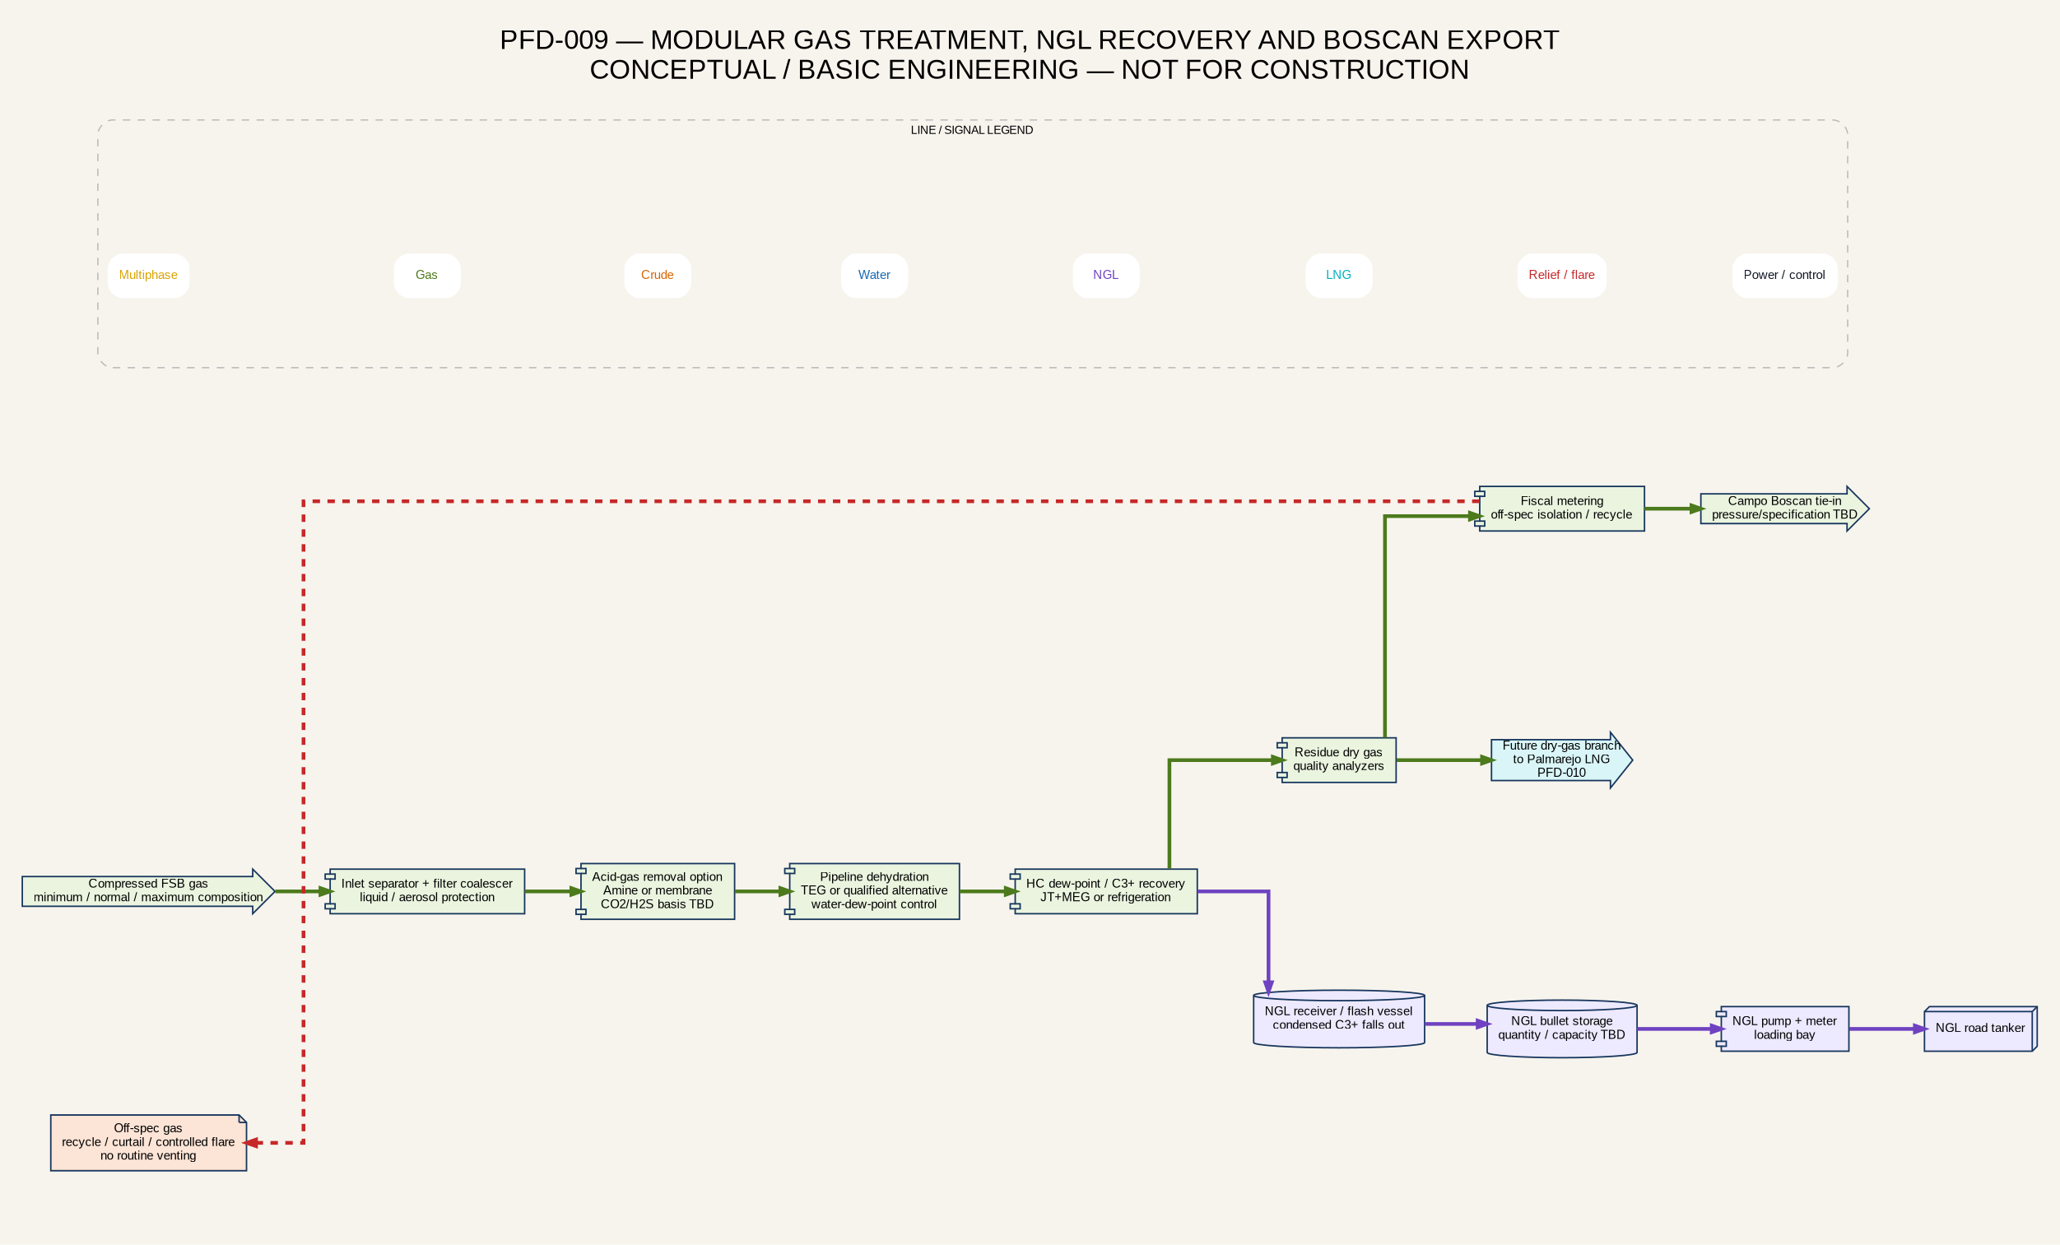
Gas treatment, NGL and Boscan export
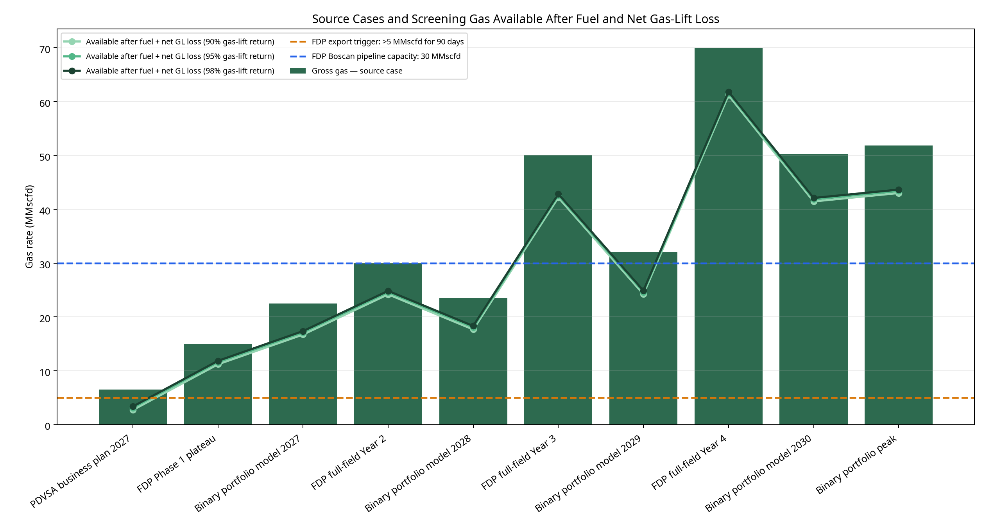
Screening gas-disposition envelope
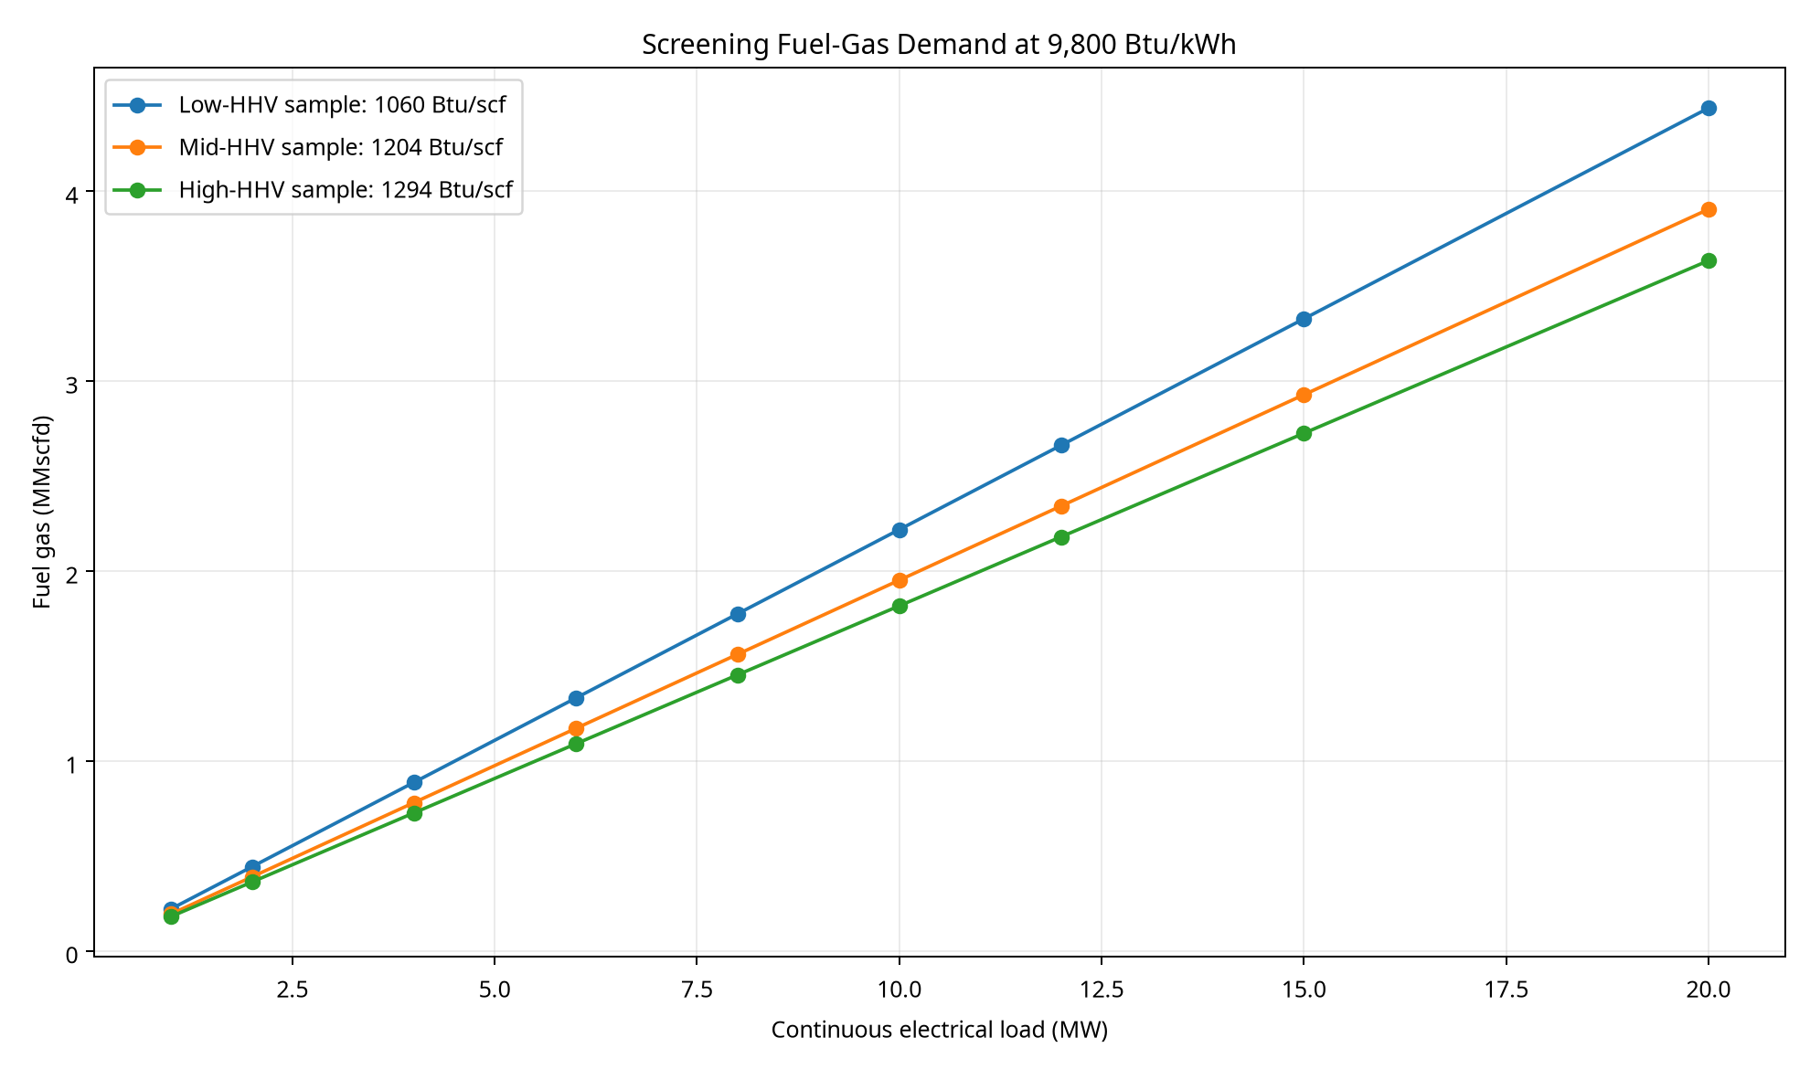
Fuel-gas sensitivity versus continuous power
A 5–6-MMscfd Campo Boscan pilot train is the preferred early export concept, expandable through parallel modules toward 15 and 30 MMscfd when surplus gas is firm. Natgas Global Resources has published a 6-MMscfd skid-mounted JT/MEG project and broader compression/refrigeration integration experience; it is a credible integrator candidate, not a selected vendor [E01] [E02]. The published package pressure reduction and product basis shall not be assumed suitable until Boscan provides receipt pressure, water/HC dew point, CO₂, H₂S, heating value, contaminants and custody-metering requirements.
Gas accounting shall meter separator gas, gas-lift injection and return, EPF/FSB fuel, flare/blowdown, Boscan export, NGL and later LNG. Gas lift is a recycle; only leakage, flare and other unrecovered losses are deducted as net consumption. Off-spec gas requires automated isolation and a defined recycle, curtailment or controlled flare route.

14. Palmarejo LNG and ISO-Tank Export
Palmarejo LNG is a deferred CAPEX stage implemented after the gas balance, Boscan strategy, fresh composition and market/logistics are established. All field and FSB compression remains at FSB. Dry treated gas is sent to the liquefaction facility close to the Palmarejo terminal, where final pressure conditioning and cryogenic pretreatment are provided.
TEG alone is not an LNG pretreatment basis. The Palmarejo train may require acid-gas polishing, mercury removal, molecular-sieve dehydration, heavy-hydrocarbon/freeze-out control and nitrogen confirmation. Galileo Cryobox modules are scalable, but the module count and production are subject to a site-specific vendor guarantee, feed composition, ambient conditions, inlet pressure, uptime and BOG strategy [E07].
All LNG is stored in ISO tanks. The facility requires BOG recovery/control, filling metering, overfill protection, ESD, grounding, hazardous-area control, fire/gas detection, separation distances, spill impoundment where applicable, road loading and dry-cargo-barge handling. The terminal does not send bulk LNG through a product hose to the dry-cargo barge; filled ISO tanks are cargo.
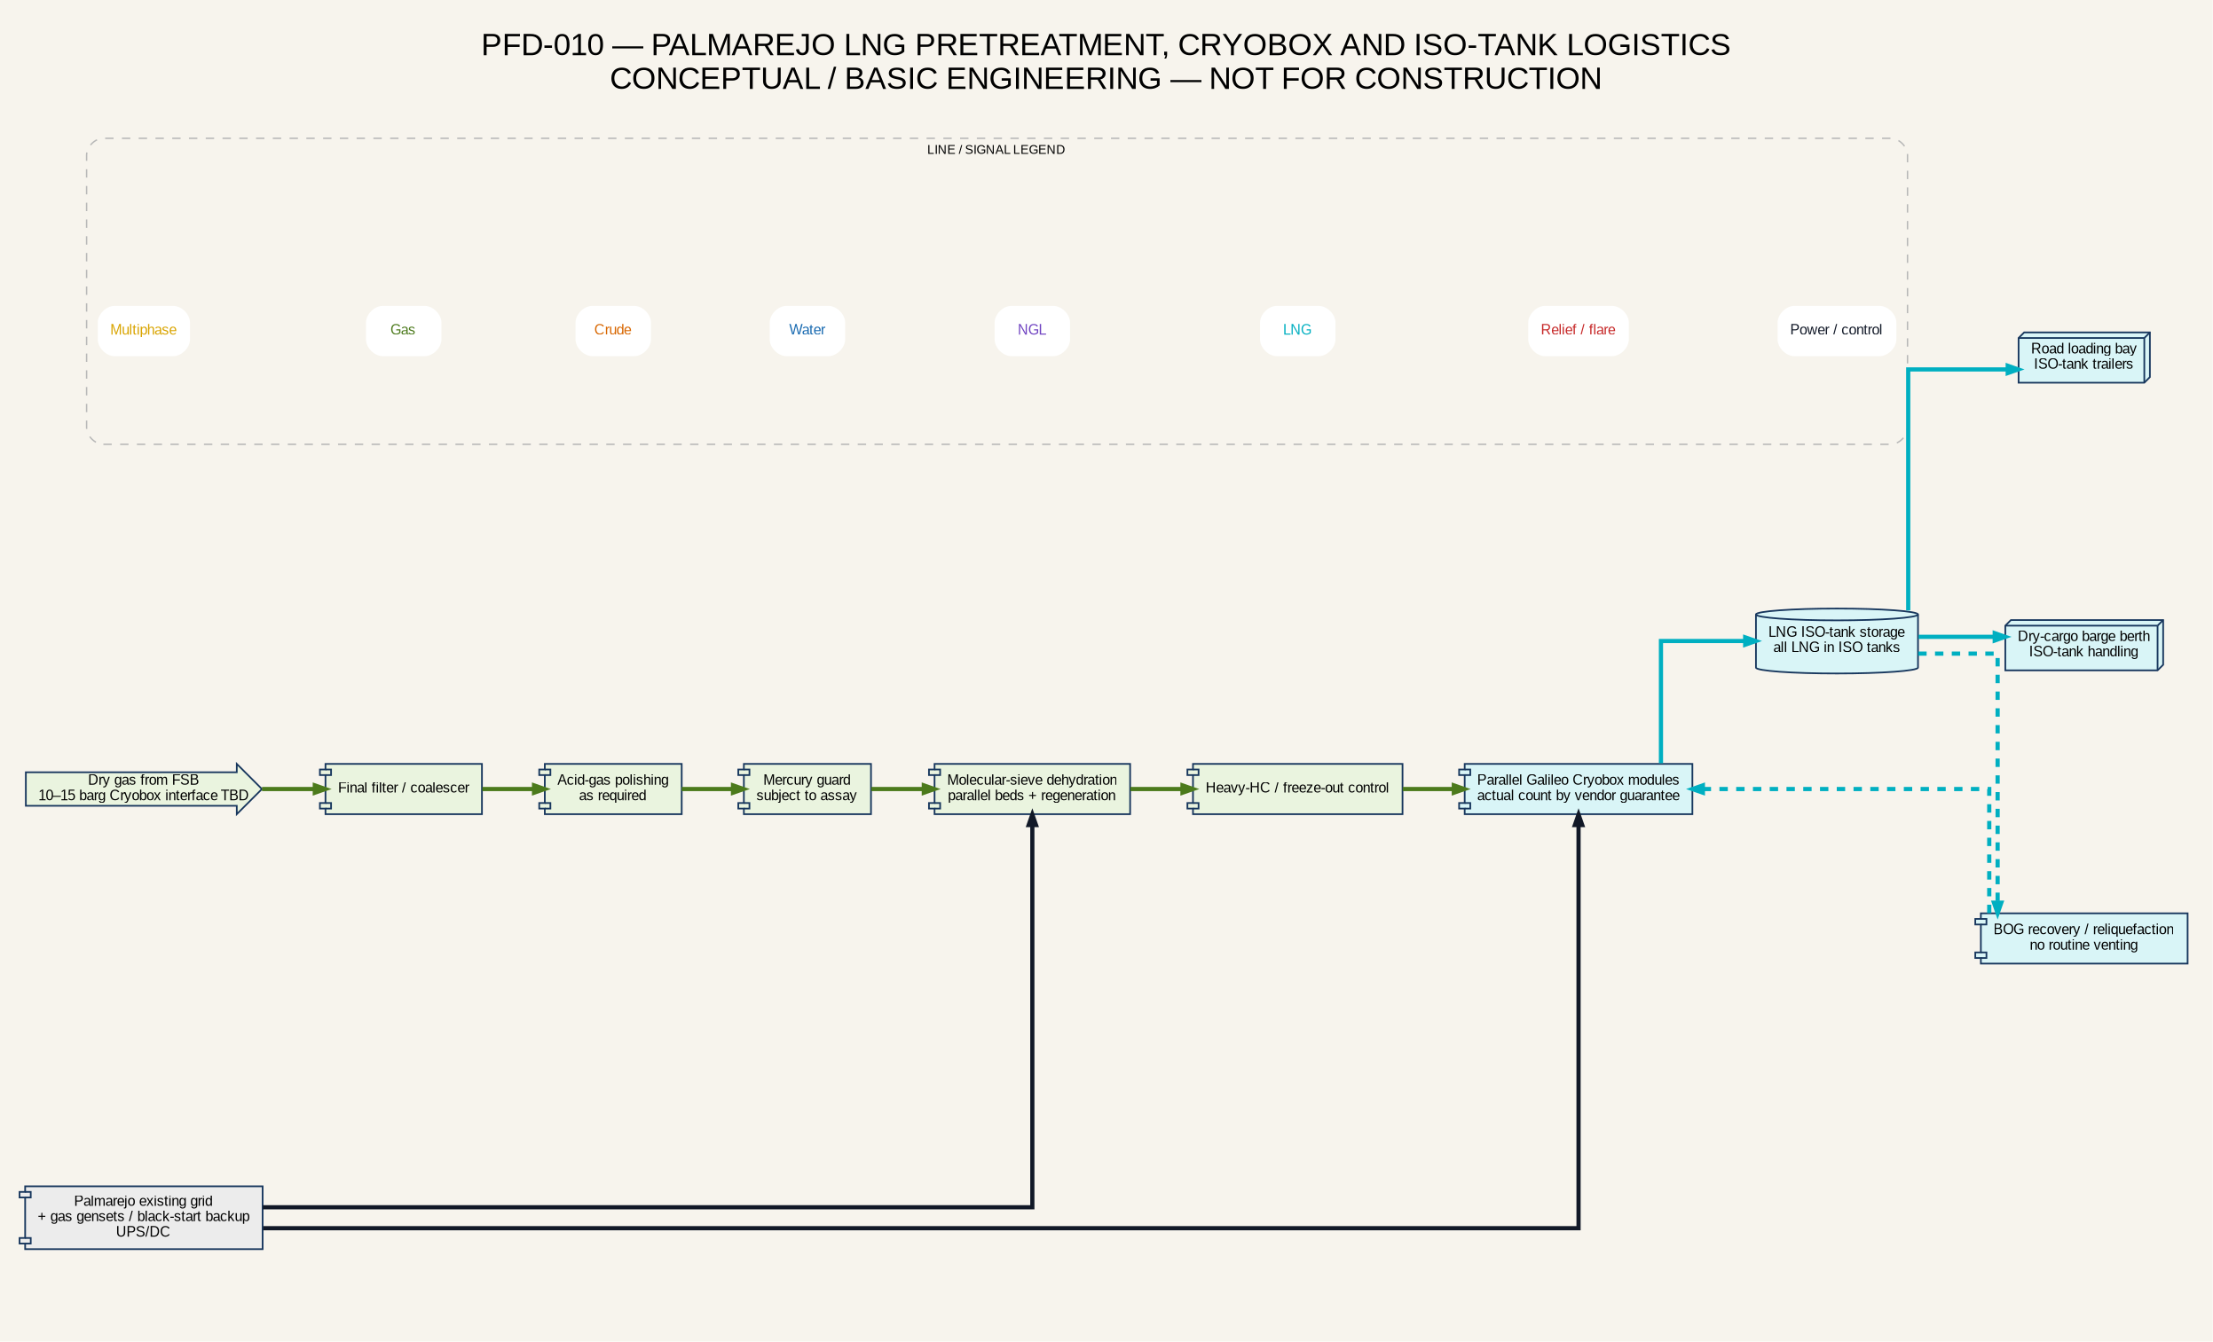
Palmarejo LNG and ISO-tank logistics

15. Produced Water Treatment, Injection and EOR
Produced water leaves the lower section of the main separator and flows through a treatment train selected to meet injection-water quality. The conceptual sequence is deoiling/coalescing, flotation or equivalent polishing, filtration, chemical treatment, storage, high-pressure injection pumps, metering/header allocation and injection wells.
The project basis is 100% produced-water reinjection, with no routine disposal to surface pits. Injection targets include Eocene, Paleocene and basement intervals subject to reservoir plans, containment and compatibility. The EOR statement reports favorable pressure response and 2026 injection performance near 1.2 MBWIPD versus 1.3 MBWIPD planned, increasing toward 1.4 MBWIPD. Future facility sizing must also test the portfolio produced-water envelope, which is materially larger than the current EOR rates.
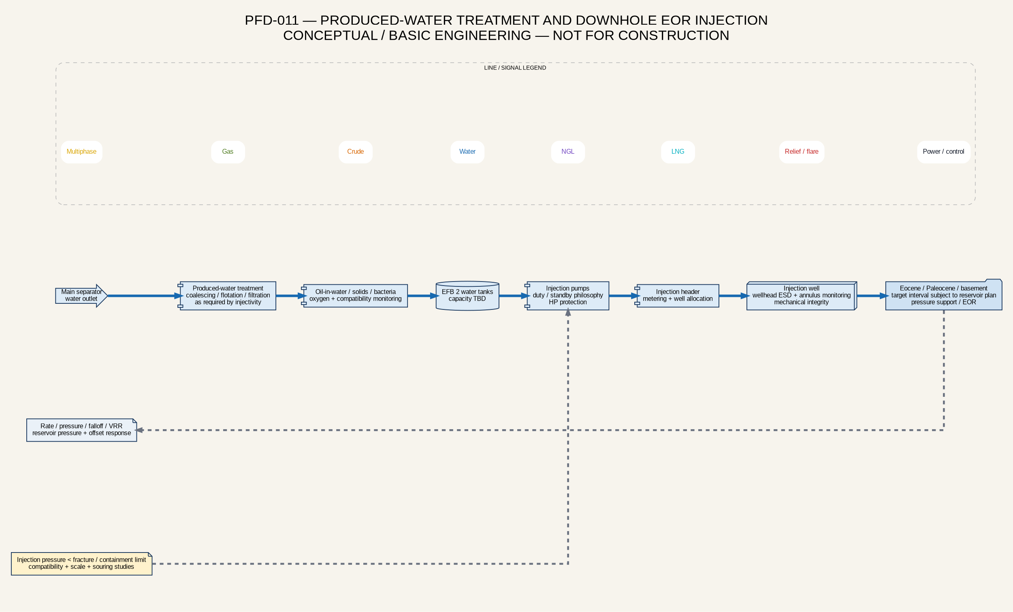
Produced-water treatment and EOR injection
Water-injection FEED requires formation-water and produced-water chemistry; suspended oil/solids limits; oxygen, bacteria and sulfate strategy; scale/souring/corrosion studies; injectivity/falloff tests; fracture-pressure margin; well mechanical-integrity tests; annulus monitoring; VRR targets; reservoir-pressure surveillance and response plans. Pump discharge pressure shall remain below the approved containment/fracture limit with high-pressure trip and relief protection.

16. Crude Storage, LACT, Palmarejo and Lake Export
Crude leaves the oil compartment of the main separator and enters two EFB tanks whose capacity remains to be defined. The tanks require working-volume basis, high-high independent overfill protection, fire/gas detection, containment, water draw-off, vapor management and transfer-pump suction protection.
A LACT unit is located downstream of EFB storage and before the transfer pipeline to Palmarejo. The conceptual LACT includes transfer/charge pumps, strainer, air eliminator, custody-transfer Coriolis meter, automatic sampler, BS&W and density monitoring, control valve, proving connection and off-spec diversion. The fiscal boundary, ownership and uncertainty class require partner agreement.
Palmarejo contains two 80,000-bbl crude tanks. Gross autonomy is approximately 5.7 days at 27.9 kbopd and 4.0 days at 40 kbopd before working-volume, heel, off-spec and outage deductions. Storage and barge-cycle modeling is required to avoid production curtailment.
Crude is transferred from the Palmarejo tanks through export pumps and a dedicated terminal loading arm/hose to a tank barge. A simple mooring buoy secures the barge and carries no product. Marine ESD, emergency release, drip/spill containment, berth/mooring loads, bathymetry, weather limits, communications and oil-spill response require FEED. Cabotage from Palmarejo to Puerto Miranda is retained as a contingency route subject to commercial and regulatory agreement.
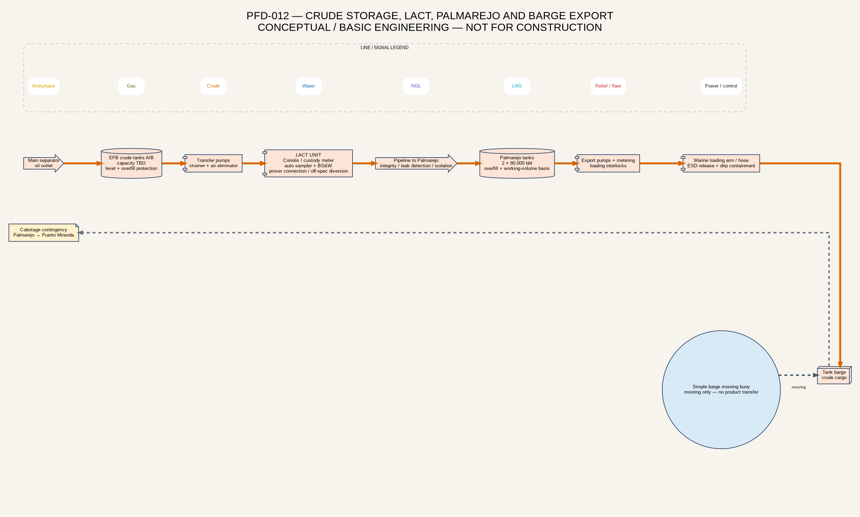
Crude LACT and barge export

17. Utilities and Electrical Power Systems
The project uses three separated modular power systems.
Power system | Normal basis | Required resilience
Field / EPFs / wells | Owner-built network; two gas gensets per EPF; HV field feeders to well transformers and VFDs. | Protection coordination, N+1 or mobile-spare decision, sectionalization, SCADA, black start and fuel-gas continuity.
Integrated FSB/CPF | Independent normal and backup gas generation for compression, separation, pumps, treatment, flare auxiliaries and utilities. | Independent start fuel, UPS/DC, emergency board, selective load shedding and one-train-down study.
Palmarejo LNG/export | Existing Palmarejo grid plus gas gensets for backup, capacity support and black start. | Islanding/stability study, LNG emergency loads, BOG/control continuity and terminal transfer interlocks.

A normally open emergency intertie between field/EPF and FSB systems may be evaluated, but a permanently common bus could create an unacceptable common-mode failure. Palmarejo is not assumed to be powered by FSB.
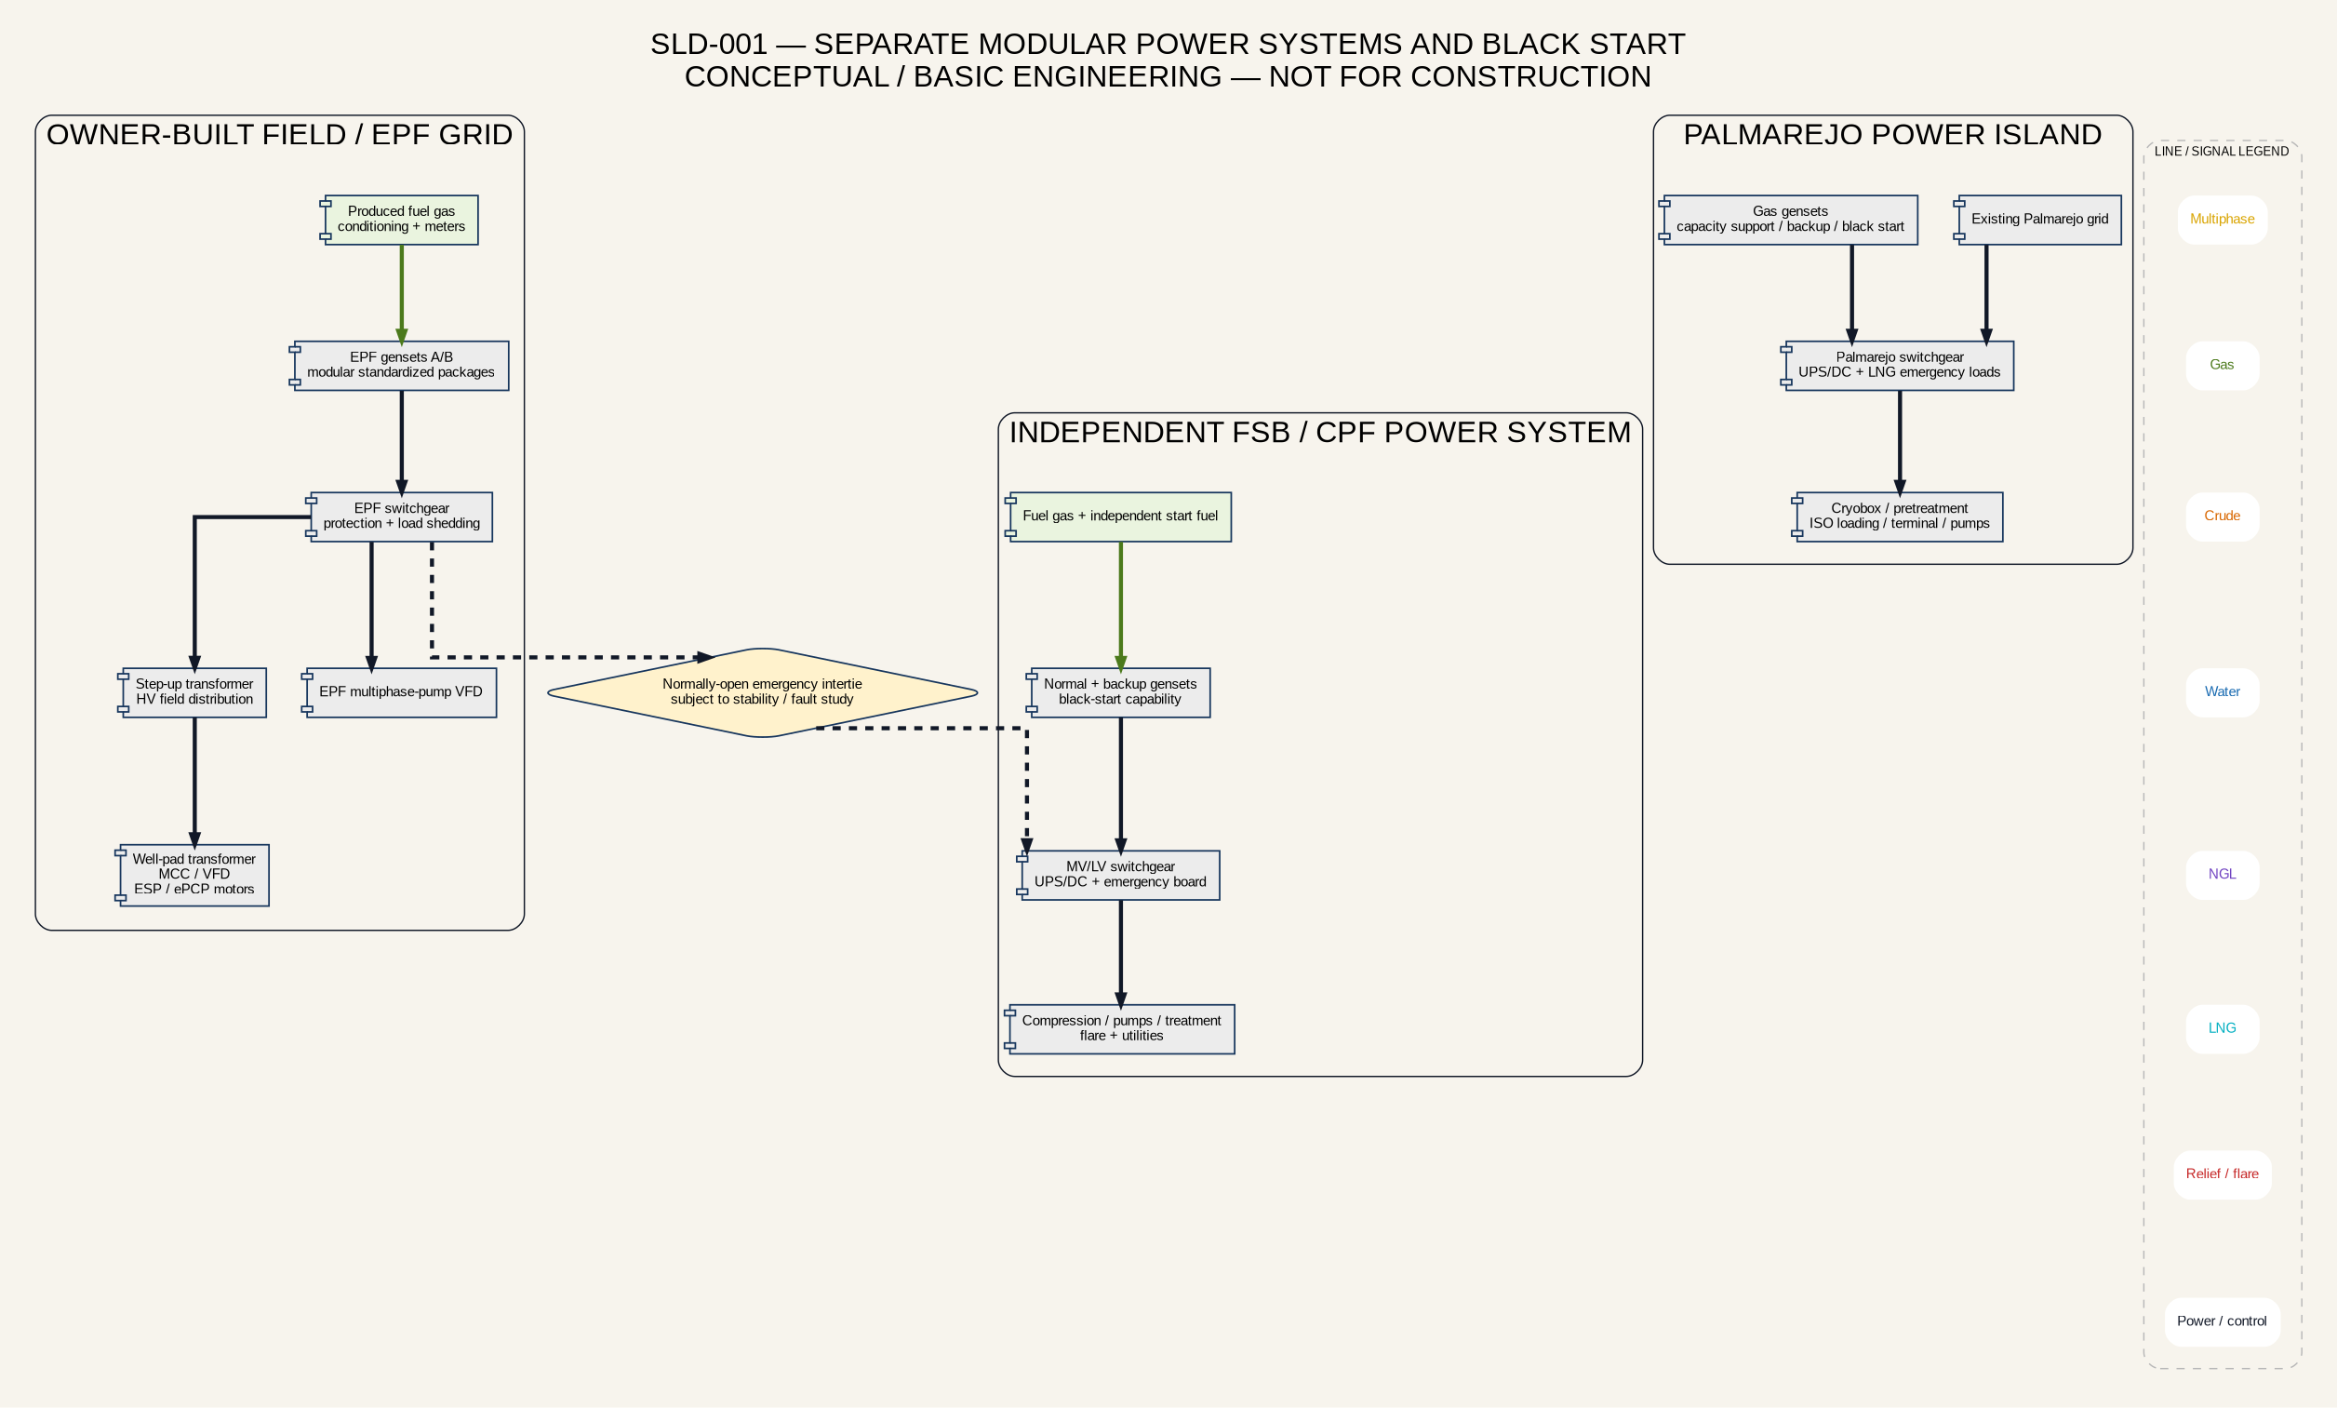
Project power systems

18. Process Safety, ESD/PSD, Fire Protection and Loss Prevention
Normal operation is multiphase from the well through the EPF and trunk network to FSB. Safeguarding must therefore prevent one pressure or containment event from escalating through the connected network. The conceptual protection layers are: inherent design/MAWP hierarchy; basic process control and alarms; PSD/ESD isolation; relief/depressuring to the FSB flare; fire/gas detection and emergency response.
The well, EPF, trunk and FSB are separate isolation zones. High well/flowline pressure trips the lift equipment and closes the remote well shutdown valve. Low-low well/lateral pressure or rapid decay initiates a suspected-rupture response. High EPF manifold or trunk pressure trips the booster and closes both-end isolation. High-high slug-vessel level/pressure curtails incoming EPFs in a defined sequence. High-high main-separator pressure trips compression, restricts inflow and escalates to ESD/depressuring if pressure continues to rise.
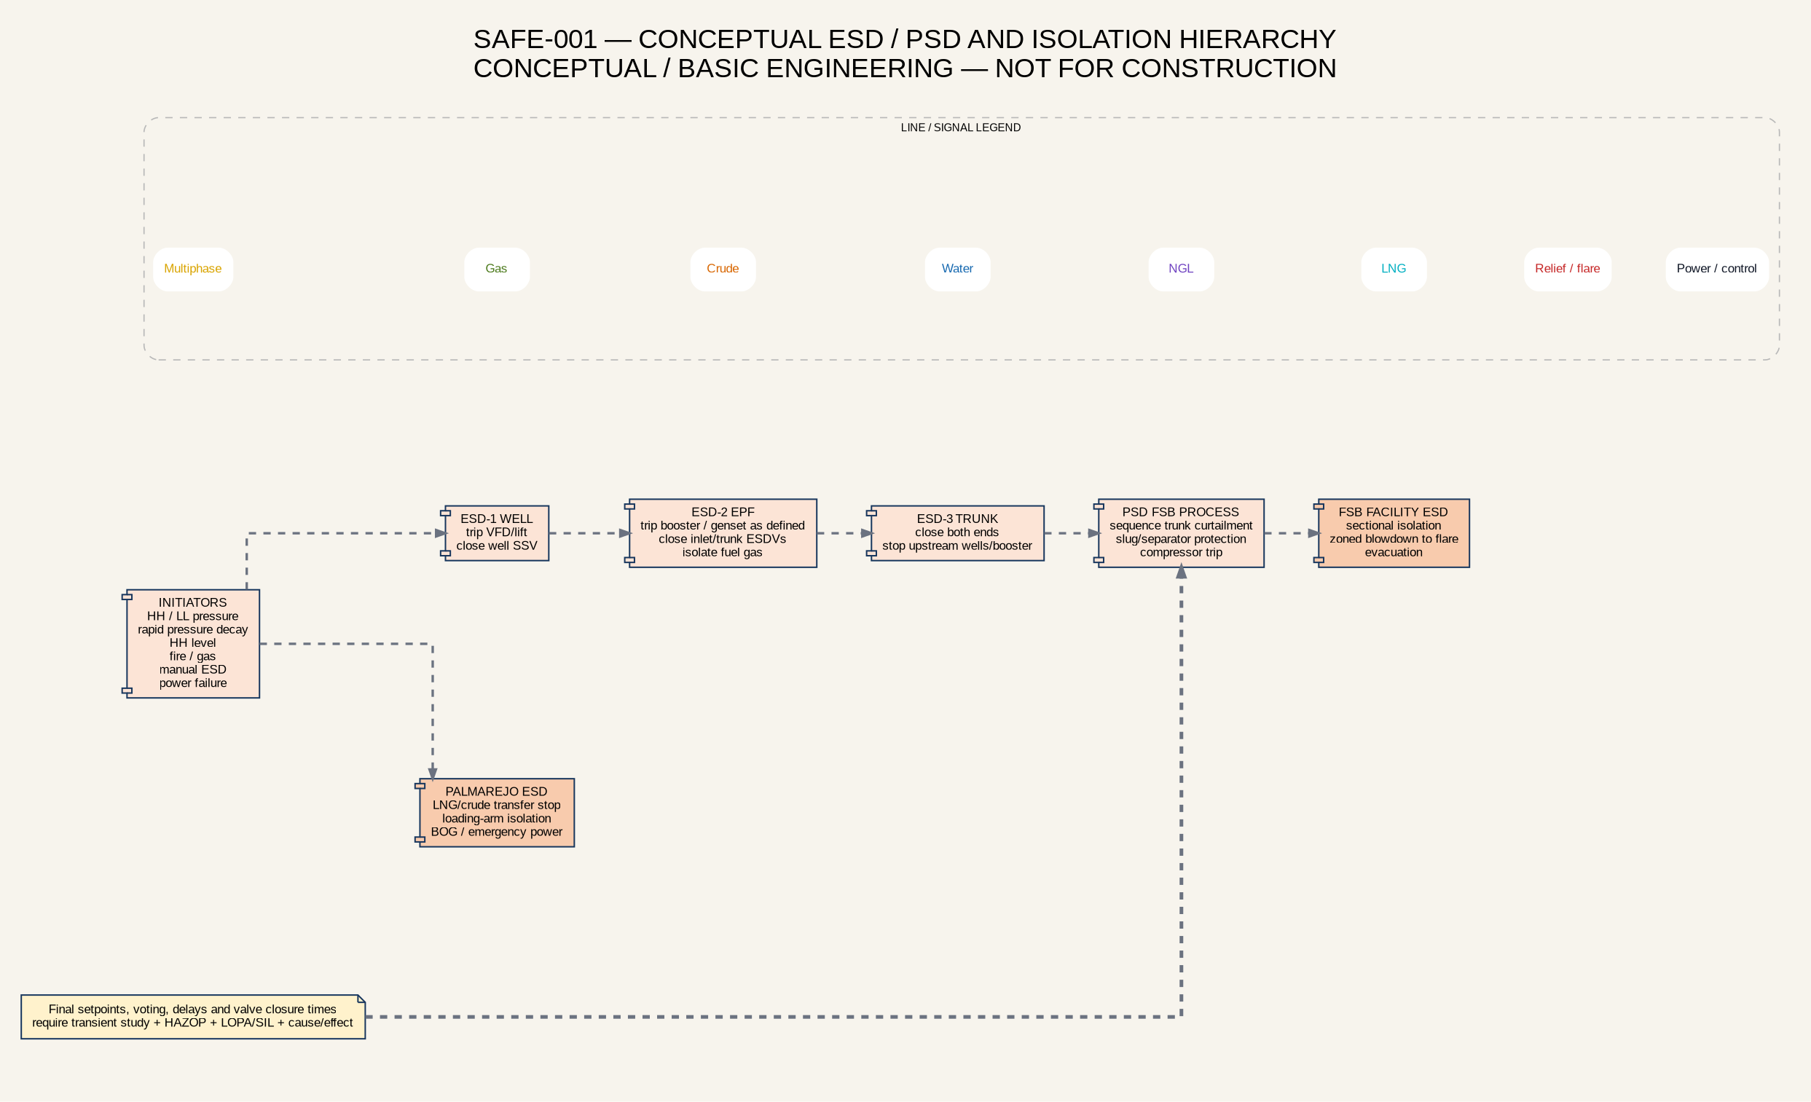
Conceptual ESD and PSD hierarchy
Initiating condition | Automatic conceptual response | Operator action | FEED evidence required
Well/lateral high pressure | Trip VFD/lift, close remote well SSV and alarm EPF. | Confirm isolation, diagnose downstream blockage and authorize controlled restart. | Shut-in pressure, lift deadhead, transient model, valve closure time.
Well/lateral low-low pressure or rapid decay | Stop lift, close well SSV; assess line break. | Verify leak, isolate local section, mobilize response. | Leak-detection thresholds and false-trip analysis.
EPF manifold/trunk high-high pressure | Trip booster; close EPF trunk ESDV and FSB receiver ESDV. | Confirm both-end isolation and manage trapped inventory. | MAWP hierarchy, pressure-wave study and line-pack calculation.
Slug-vessel high-high level | Stop liquid transfer if failed state dictates; curtail EPFs in sequence; isolate affected trunks. | Stabilize separator and drain/transfer under procedure. | Dynamic vessel/separator model and cause/effect.
Confirmed gas or fire at EPF | ESD affected wells/EPF; isolate fuel and trunk; trip nonessential power; alarm/evacuate. | Muster and emergency response; no intervention without gas-free confirmation. | F&G mapping, hazardous-area classification, fire-risk study and occupied-building siting.
Fire/gas at FSB | Facility ESD, sectional isolation, compressor trip and zoned blowdown to flare. | Evacuate, initiate incident command and protect adjacent systems. | HAZOP/LOPA, QRA, flare/depressuring and emergency-response study.
Total power failure | Fail valves to defined safe positions; trip rotating equipment; preserve UPS/DC. | Start black-start sequence and controlled restart. | Load list, stability, protection and black-start study.

The assumption that only gensets can burn is rejected. Credible EPF fire sources include manifold/valve/flange leaks, multiphase booster seals, pig launcher connections, fuel-gas skid, temporary test connections, hot exhausts, electrical arcs, static and lightning. Fire/gas coverage shall be performance-based. NFPA 59A is applicable to Palmarejo LNG scope, not as the default EPF firewater design standard.
The need for a conventional firewater arrangement with electric pump, diesel standby pump and jockey pump shall be established by fire-demand and layout studies. It is unlikely to be economic or necessary at every small EPF if separation, isolation, dry-chemical/portable response and emergency services provide adequate protection; FSB and Palmarejo may require dedicated firewater systems based on quantified fire scenarios.
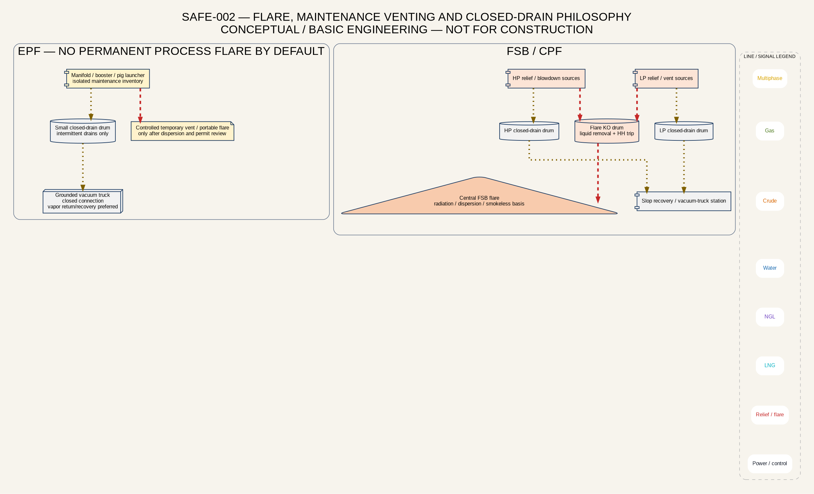
Flare, venting and closed drains
Bypass lines are process-routing devices and cannot replace depressuring. Hydrocarbon maintenance venting is minimized. Isolated inventory is displaced/recovered where practical; residual low-pressure gas may use a controlled safe vent or portable flare only after dispersion, ignition-control, emissions and permit review. FSB process depressuring is routed to the central flare.

19. Flow Assurance, Production Chemistry, Materials and Integrity
The multiphase concept depends on validated operating envelopes throughout field life. Principal threats are terrain and hydrodynamic slugging, pigging slugs, high liquid holdup at decline, excessive velocity/erosion at peak, gas breakout and pump instability, wax/asphaltene, hydrates, emulsion/foam, sand, CO₂/H₂S corrosion, scale, flexible-pipe permeation/rapid-gas decompression and restart after shutdown.
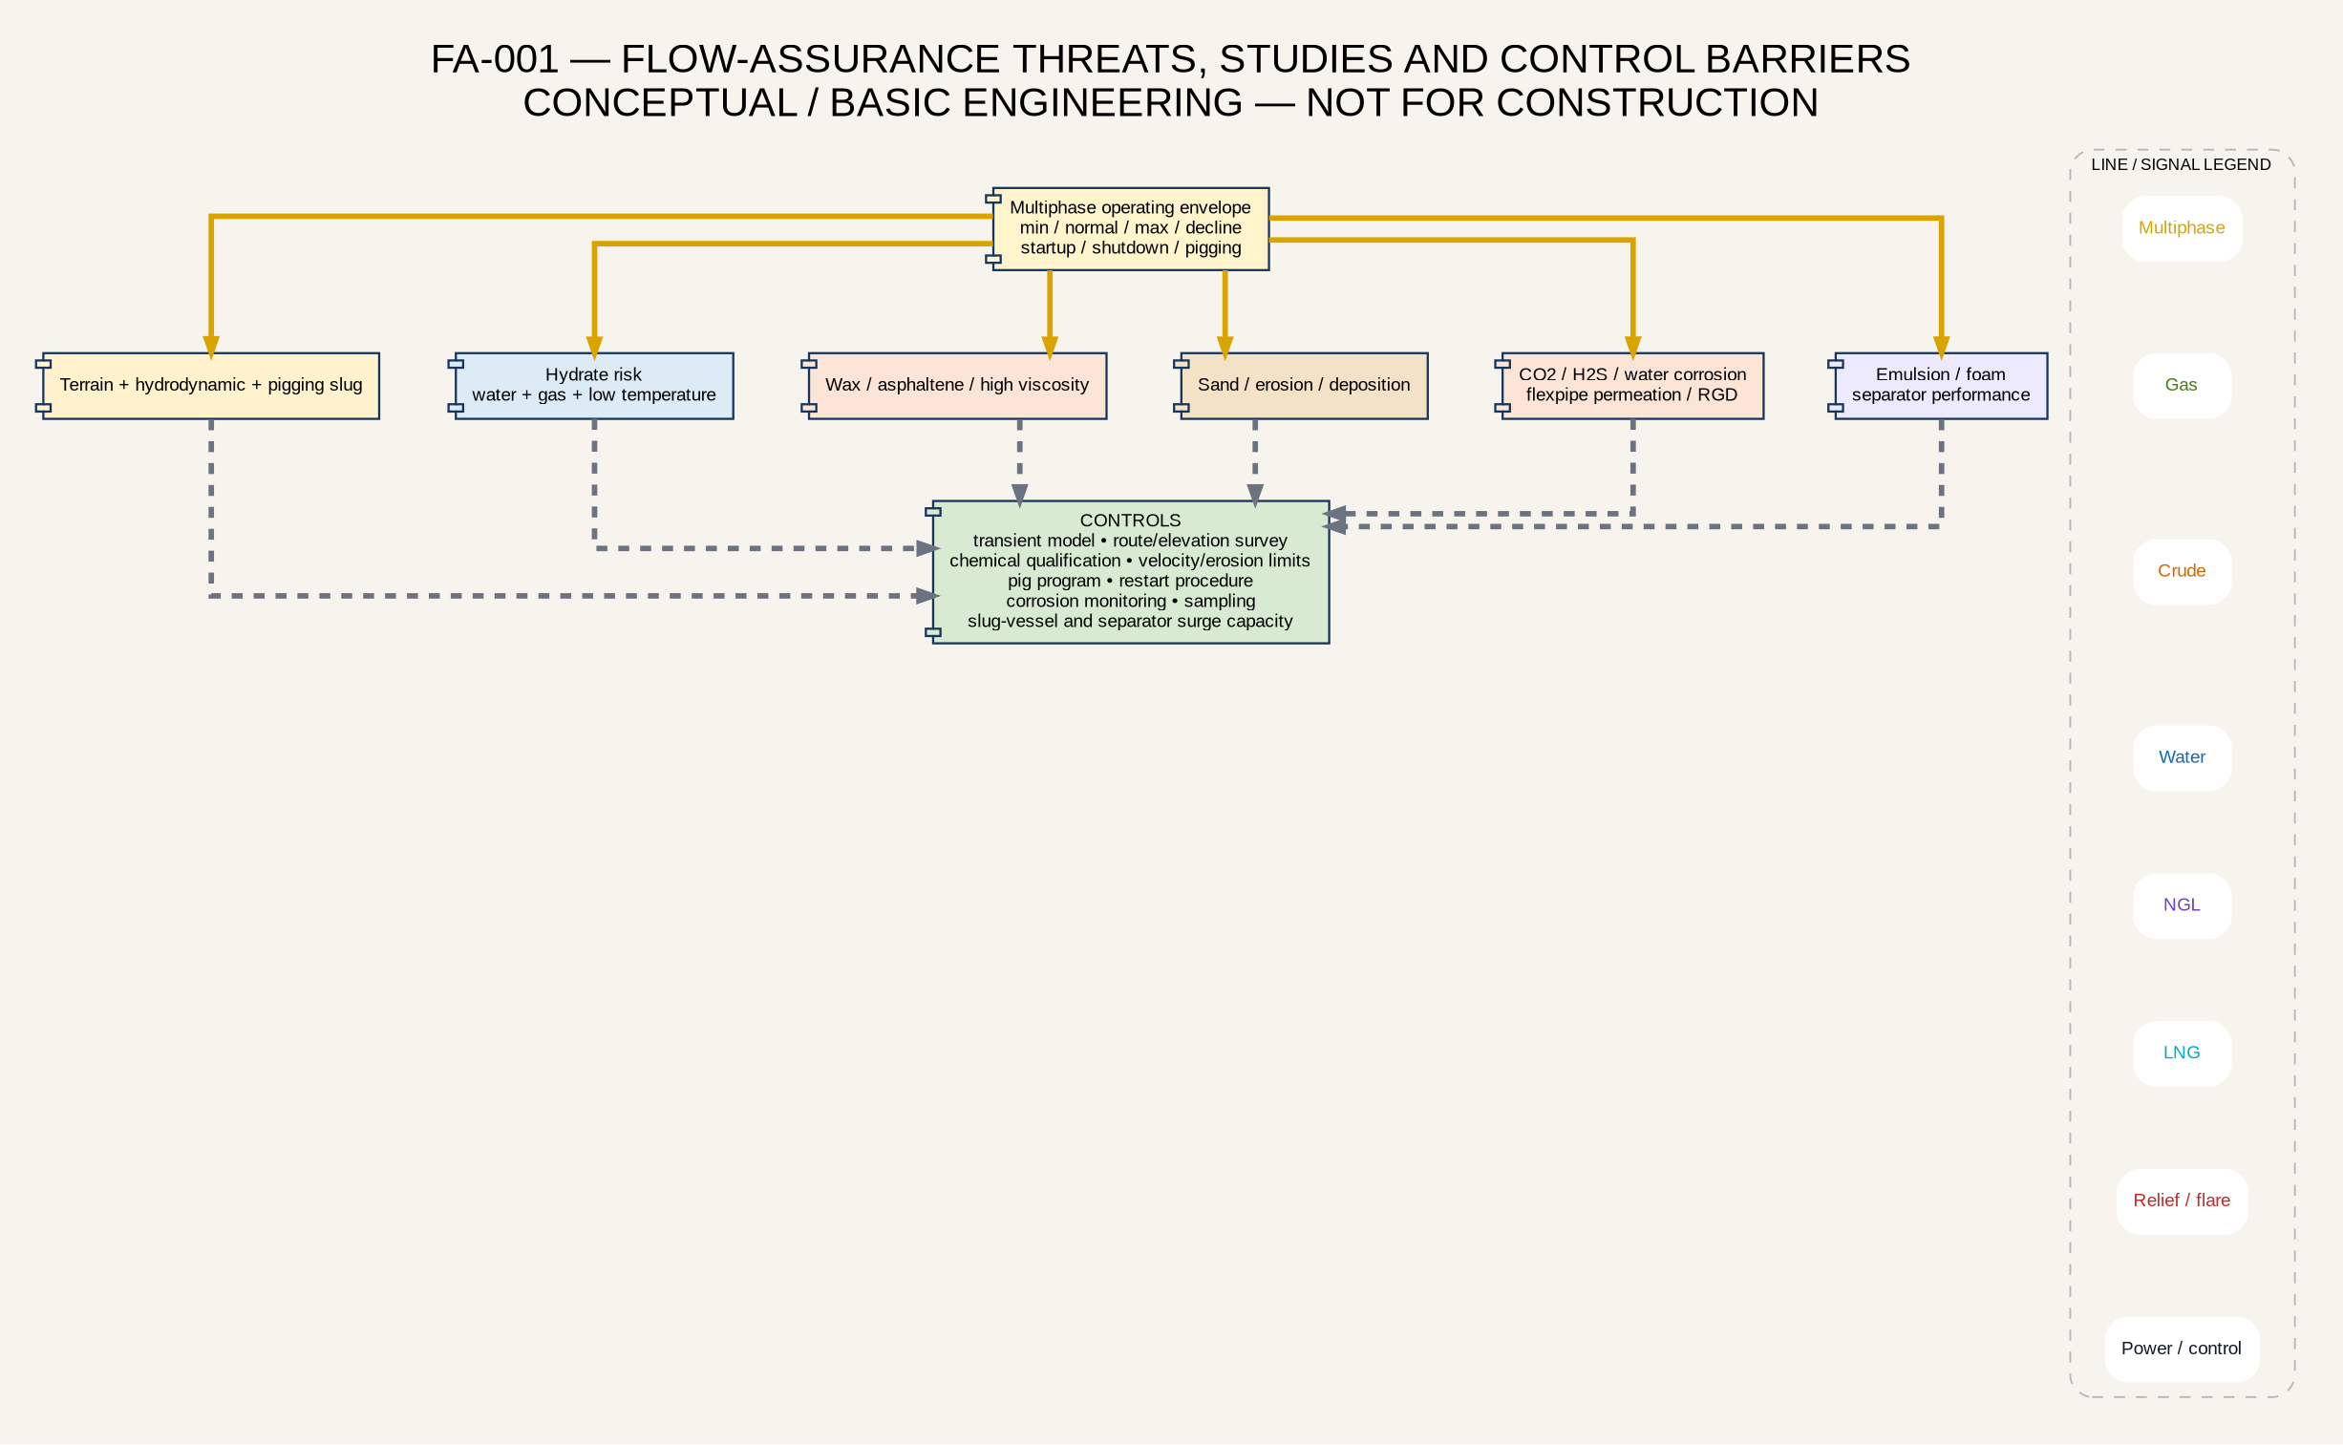
Flow-assurance threats and controls
The integrated steady-state and transient model shall include individual wells, local laterals, EPF manifolds/boosters, twelve trunks, route/elevation profiles, central manifold, slug vessel, separator and backpressure from the central process. Required cases include minimum, normal, maximum, decline, one EPF shutdown, compressor trip, full-field shutdown, restart, pigging, high-water-cut, high-GVF and line-blockage scenarios.
The pigging philosophy prevents deposit accumulation and line restriction but can create the maximum liquid surge. Pig campaigns require controlled pig speed, launch/receive interlocks, pig detection, receiver capacity, chemical batching if required, slug-vessel routing and a defined upstream curtailment sequence. The slug vessel shall be sized to the modelled credible surge with operating margin.
A field sampling and production-chemistry program shall establish wax appearance temperature, pour point/rheology, asphaltene tendency, emulsion stability, foaming, scale indices, corrosion, solids/sand, produced-water chemistry and bacteria. Chemical injection is included as a provision, not a fixed chemical program. Materials selection shall cover carbon steel, corrosion allowance/monitoring, inhibitors, sour-service applicability, flexible-pipe qualification, elastomers, NGL and cryogenic materials.

20. Environmental, Social, Security and Regulatory Basis
The environmental basis includes no routine produced-water discharge, control of well-test flaring, no routine atmospheric process venting, spill containment, historical pit/spill remediation, waste management, water-injection containment, emissions accounting and lake-terminal oil-spill response. The 72-hour well-test flare is an operating requirement but still needs Ministry and environmental approval, radiation/dispersion controls and gas accounting.
Social constraints affect at least P-108, P-173, P-95, P-180 and P-152. The development schedule shall not assume access until community engagement and right-of-way requirements are closed. The PDVSA workbook also identifies domestic gas-network regularization in Campo La Paz following ESP implementation.
Security risk includes theft, vandalism, unauthorized access, pipeline damage and personnel movement. The facility design requires controlled perimeters, security lighting, communications, access control, surveillance, line patrol/leak detection and coordination with approved state-security interfaces while preserving HSE command authority.
A current approval matrix shall identify the Venezuelan ministry, PDVSA/partner, environmental, land/right-of-way, water injection, flaring, custody metering, pressure equipment, electrical, hazardous area, marine and port approvals. International API, IEC, NFPA, NORSOK and DNV practices support design but do not replace applicable COVENIN and Venezuelan requirements.

21. Operations, Maintenance, Reliability and Readiness
Each EPF is normally staffed by a control-room operator, one or two field operators and security personnel. Staffing requires competency matrices, control-room alarm philosophy, field rounds, permit to work, simultaneous-operations rules, lockout/tagout, confined-space and hot-work control, emergency response and fatigue management.
FSB operations require trained process, compression, electrical/instrument, laboratory, maintenance and emergency-response staff. Palmarejo adds LNG/cryogenic and marine competencies. Operations readiness begins during design and includes operating procedures, cause/effect validation, alarm rationalization, spare parts, computerized maintenance, FAT/SAT, loop tests, mechanical completion, pre-startup safety review, commissioning and assisted operation.
The existing FDP targets more than 95% availability. That target is not yet supported by RAM modeling. The reliability study shall compare duty-only plus mobile spare, duty/standby and installed parallel capacity for EPF boosters, central compression, water injection, crude transfer, LACT and LNG modules. Long-lead spares include ESP/ePCP assemblies, VFDs, transformers, pump rotors/stators or screws, compressor components, analyzer spares, ESD valves, generator controls and flexible-pipe fittings.

22. Export, Marine, Road and Product Logistics
The logistics system has three product routes: crude by tank barge, NGL by road tanker and LNG by ISO tanks through road and dry-cargo barge modes. Custody points, product specifications, loading rates, storage working volumes, turnaround times, fleet size, berth availability, weather downtime and off-spec handling must be integrated with production forecasts.
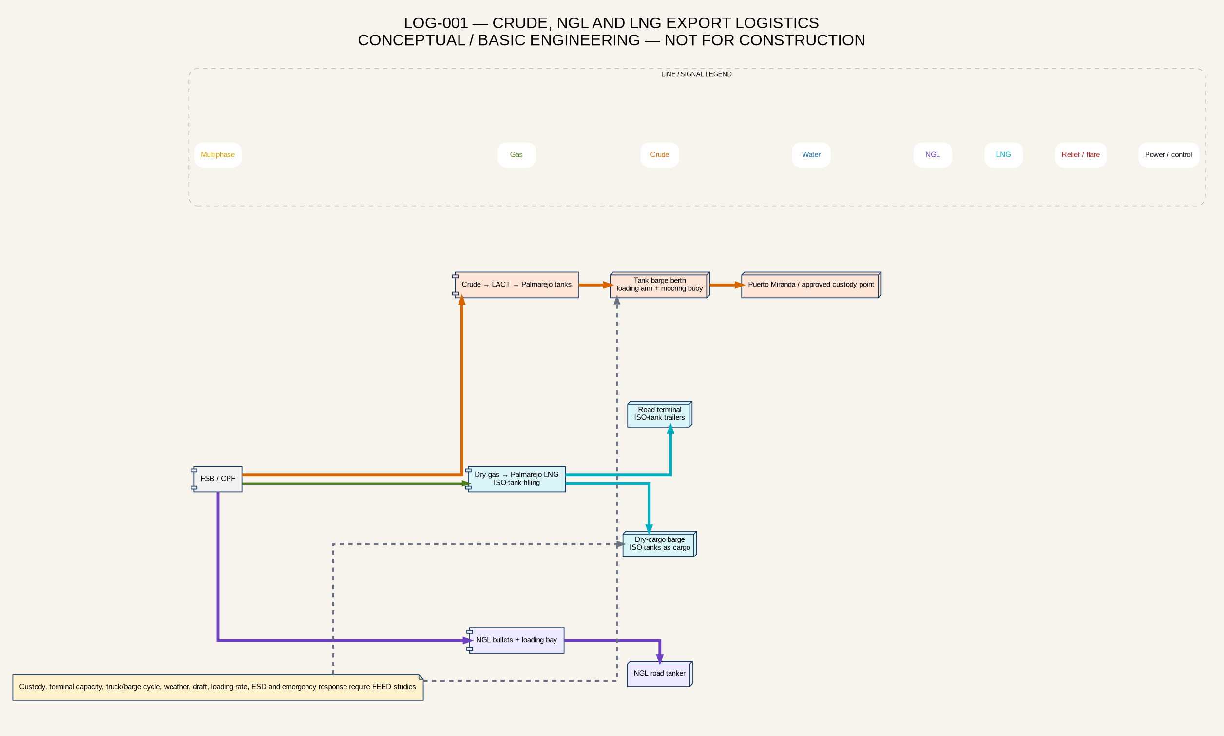
Integrated export logistics
The crude commercial model is sensitive to cargo size. The original FDP assumes approximately 100,000-bbl barge parcels for early sales; a requirement to accumulate 500,000-bbl parcels delays self-funding. The commercial team shall confirm acceptable parcels, title transfer, pricing, inspection and terminal interfaces before relying on the schedule.
LNG ISO-tank logistics require a complete cycle model: tank fleet, fill duration, cooling/heel, inspection, truck supply, road limits, terminal crane/handling, barge capacity, return cycle, weather and maintenance. All LNG inventory is in ISO tanks, so production can be constrained by container availability even when liquefaction capacity is available.

23. Project Execution, Contracting and Modular Deployment
The development follows parallel workstreams but uses strict readiness gates. Reactivation rigs shall not outrun EPF, line and FSB readiness. EPF fabrication capacity, well equipment delivery, flexible-pipe/fittings, transformers/VFDs, pig valves, boosters, compressors, test packages and LACT equipment require a controlled procurement schedule.
Workstream | Required commercial and execution sequence
Well services / rigs / lift | Tender → technical/commercial evaluation → contract → well AFE/service order → equipment readiness → intervention → 12-hour stable-flow rig-release gate → 72-hour test.
EPFs and field power | Basis/concept → standardized engineering → vendor prequalification → AFE → batch fabrication → FAT → site/civil readiness → hookup → loop test → commissioning.
FSB/CPF and compression | Brownfield survey → capacity/HAZID → FEED → shutdown/tie-in plan → AFE → procurement/fabrication → construction → PSSR → staged startup.
Trunklines | GIS/route and hydraulic study → material/diameter selection → right-of-way → AFE → installation/testing → pigging baseline → startup.
Water injection | Reservoir/injectivity basis → water specification → treatment/pump FEED → well integrity → AFE → commissioning → surveillance.
Boscan gas export | Term sheet/specification → route survey → treatment/compression FEED → custody interface → AFE → construction → performance test.
Palmarejo terminal/LNG | Market/logistics gate → marine and LNG siting studies → FEED/vendor guarantees → AFE → staged modules → terminal commissioning.

The contracting model uses separate MSAs for well services, EPCM/facilities, compression/gas treatment and other specialized scopes, integrated by a dedicated EPCM/PMO function. Each project requires an individual AFE with engineering time, execution time, mobilization, unit prices, contractor equipment, performance KPIs, downtime/NPT tracking, QA/QC, incident investigation, failure analysis and replacement provisions.

24. Capital, Operating Cost and Economics
The original FDP reports total program CAPEX near US$256 million, including approximately US$70 million for Phase 1 La Paz, US$75 million for Mara/Mara West, US$40 million for La Paz Sur, US$45 million for El Moján and US$26 million for gas expansion [S01]. Other tables report different all-field or post-contract totals. These are planning figures, not a reconciled Class 3 estimate.
The PDVSA workbook uses US$65/bbl Brent, oil sales around 95% of Brent and US$1.06/Mcf gas [S03]. These assumptions shall be retained as a source case and compared with downside/base/upside sensitivities. Costs must be rebuilt from current vendor RFIs, local quotations, quantities and execution schedules.
The staged investment logic is retained: early well reactivation, EPFs, FSB debottlenecking and Boscan pilot; expand only when production and gas surplus are sustained; defer full NGL recovery and Palmarejo LNG until composition, market, logistics and vendor guarantees justify CAPEX. Abandonment, environmental liabilities, import/logistics, security and foreign-exchange exposure shall be included.

25. Risk Register, Decision Gates and FDP Closeout
The earlier assurance review identified 66 material gaps, including 52 high-priority FDP blockers and 14 moderate FEED gates.
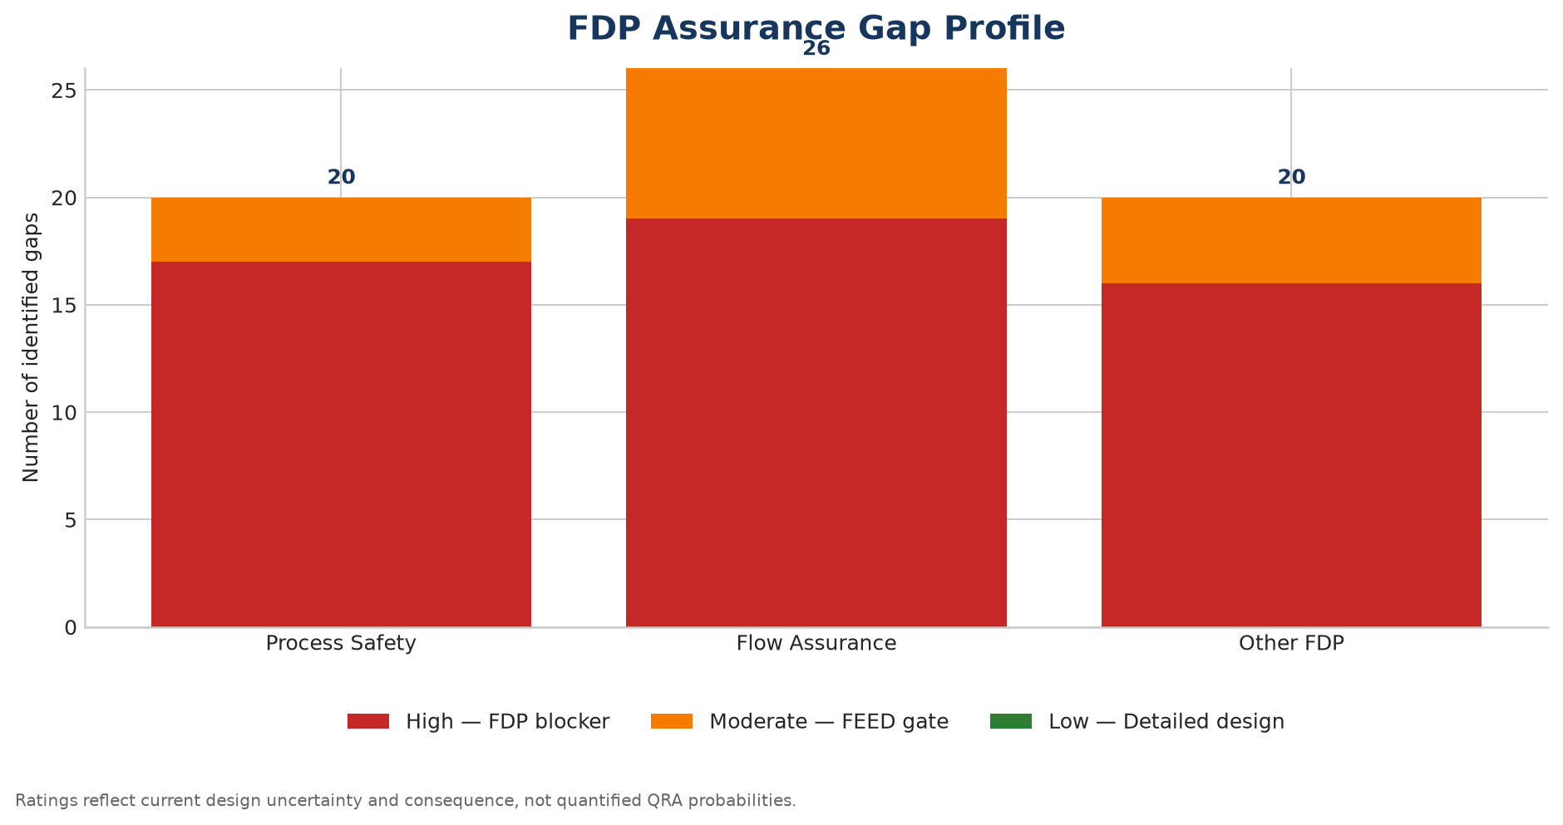
FDP risk profile
Gate | Required closure | Required before
G-01 Controlled development case | Reconcile wells, schedules, oil/gas/water profiles and source scopes. | Facilities FEED basis.
G-02 PVT and fluid sampling | Pressure-preserved oil/gas/water samples, contaminants, rheology and dew points. | Pump, line, gas-treatment and materials freeze.
G-03 FSB brownfield capacity | Survey, integrity, dynamic separation and relief assessment. | FSB upgrade AFE.
G-04 Multiphase network | Steady-state/transient model, route survey, 4/6/8-inch comparison and pump envelopes. | Trunk/pump procurement.
G-05 Pigging and slug handling | Pig program, transient slug volumes and separator/slug-vessel capacity. | Trunk and inlet-vessel freeze.
G-06 ESD/PSD and relief | HAZOP, LOPA/SIL, cause/effect, relief/depressuring and flare hydraulics. | Construction issue / PSSR.
G-07 Power and black start | Controlled load list, short circuit, protection, stability, load shedding and restart. | Generator/switchgear procurement.
G-08 Water injection | Water specification, injectivity, fracture limit, compatibility and containment. | Water plant/injection AFE.
G-09 Boscan interface | Receipt pressure/specification, route, title transfer, off-spec and capacity. | Export pilot AFE.
G-10 NGL economics | Updated rich-gas composition, process simulation, product specification and market. | NGL package AFE.
G-11 Palmarejo LNG | Pretreatment, Cryobox guarantee, module count, BOG and ISO-tank logistics. | LNG AFE.
G-12 Crude/export assurance | LACT/fiscal boundary, pipeline integrity, storage autonomy and marine studies. | Terminal/export sanction.
G-13 Regulatory/social/security | Approval matrix, flaring, injection, environmental/social and security closure. | Field construction and operations.

26. Controlled Project Sources and References

Primary project sources
- [S01] PetroUrdaneta_FDP_v8.docx — original FDP baseline.
- [S02] PU-DBM-001_FEED_Class3_Initial_Draft.docx — initial FEED/design-basis draft.
- [S03] BARRAPDVSAEMPETROURDANETA24072026.xlsx — PDVSA–PetroUrdaneta business/investment plan.
- [S04] Maha-PUCombinedProductionForecastv3.8.92026-05-18LQ-WithPUScheduleAdjusted7-14.xlsb — production/well forecast model.
- [S05] WellStatusforReactivitions-LaPazField.REV3.xlsx — well reactivation status and production basis.
- [S06] eor_water_injection_statement.pdf — water-injection performance and reservoir-pressure statement.
- [S07] La_Paz_Sur_Technical_Memorandum_EN.pdf — La Paz Sur subsurface and development memorandum.
- [S08] 2016CromatografiadelGas.pdf — historical gas chromatography.
- [S09] approved_change_register.md — owner-approved conceptual architecture and corrections.
- [S10] Conceptual_Engineering_Assurance_Register_v2.xlsx and associated assurance reports.
- [S11] Gas_Utilization_and_Treatment_Options_Model.xlsx and gas-strategy report.

External technical and vendor references
- [E01] Natgas Global Resources, Professional Services: https://natgasgr.com/services/
- [E02] Natgas Global Resources, Projects: https://natgasgr.com/projects/
- [E03] Kinder Morgan Treating, TEG Dehydration: https://www.kindermorgan.com/Operations/KM-Treating/Products/Dehydration
- [E04] Enerflex, Dehydration: https://www.enerflex.com/equipment/gas-treating/dehydration/
- [E05] QB Johnson, Molecular Sieve Units: https://qbjohnson.com/molecular-sieve-units/
- [E06] Generon, Gas Dehydration: https://www.generon.com/product/gas-dehydration/
- [E07] Galileo Technologies, Cryobox LNG Production Station: https://www.galileotechnologies.com/products/lng-solutions/cryobox-lng-production-station

External technical references
The design shall use current applicable editions of API, IEC, NFPA, NORSOK, DNV, COVENIN and Venezuelan requirements. Vendor publications for ESP/ePCP, flexible pipe, MPFM, gas treatment, generators and Cryobox are screening inputs only and require project-specific guarantees.

Appendix A. Complete Industrial Schematic Register
ID | Drawing
PFD-001 | Integrated field-to-market architecture.
PFD-002 | ESP and ePCP well modules.
PFD-003 | Gas-lift well and recycle loop.
PFD-004 | Mobile well-test package and rerouting.
PFD-005 | Standard modular EPF process and power.
PFD-006 | Twelve piggable EPF-to-FSB trunks.
PFD-007 | FSB slug handling and three-phase separation.
PFD-008 | Central gas compression and flare.
PFD-009 | Gas treatment, NGL and Boscan export.
PFD-010 | Palmarejo LNG and ISO-tank logistics.
PFD-011 | Produced-water treatment and EOR injection.
PFD-012 | Crude storage, LACT and barge export.
SLD-001 | Separate modular power systems.
SAFE-001 | ESD/PSD and isolation hierarchy.
SAFE-002 | Flare, vent and closed-drain philosophy.
FA-001 | Flow-assurance threats and controls.
LOG-001 | Integrated product logistics.

Appendix B. Required FEED Deliverables
The minimum FEED package includes the approved design basis; process simulation and heat/material balances; PFDs; preliminary P&IDs; equipment, line, valve, instrument, relief and tie-in registers; plot plans and 3D model; HAZID/HAZOP/LOPA/SIL; fire/gas and QRA studies; relief/flare/depressuring report; steady-state/transient multiphase model; production chemistry; corrosion/materials; flexible-pipe qualification; electrical load/short-circuit/stability/black-start studies; telecommunications/SCADA; water-injection plan; marine/terminal studies; RAM; operations readiness; execution schedule; Class 3 estimate; and regulatory/approval matrix.

Appendix C. Explicit Open Data Requirements
The following data remain mandatory: controlled 38-well allocation; minimum/normal/maximum oil, water and gas per well/EPF over field life; wellhead flowing and shut-in pressures; separator and FSB MAWP; PVT and current gas/oil/water composition; wax/asphaltene/rheology; sand; route/elevation surveys; actual pipe internal diameters; pump/compressor curves; slug/separator geometry; Boscan specification; injection-water quality and pressure limits; complete electrical load list; EFB tank capacities; and current ownership/condition of export infrastructure.

Appendix D. Complete Industrial Schematic Package

PFD-001 integrated field to market


PFD-002 esp epcp well modules


PFD-003 gas lift well


PFD-004 mobile well test


PFD-005 epf process power


PFD-006 twelve trunk network


PFD-007 fsb slug separator


PFD-008 gas compression flare


PFD-009 gas treatment ngl boscan


PFD-010 palmarejo lng iso


PFD-011 water treatment eor


PFD-012 crude lact barge


SLD-001 project power systems


SAFE-001 esd psd hierarchy


SAFE-002 flare vent closed drains


FA-001 flow assurance threats controls


LOG-001 integrated export logistics

Appendix E. Detailed Well Reactivation Source Table
The source workbook contains 35 scenario rows and 32 unique well names. Repeated names represent separate baseline/pilot rows and are retained. The table is split for readability; the source workbook remains the controlling raw record.

D-1 Well, reservoir and production data
Well | Scenario Row | Project | Reservoir | Depth ft | Reservoir Pressure psi | Latest BOPD | Opening Forecast BOPD | Workover Forecast BOPD
P-16 | 1 | Baseline | EOC/PAL P 0003 | 2065 | 552 | 57 | 67 | 56
P-108 | 1 | Baseline | EOC/PAL P 0003 | 10106 | 803 | 3 | 30 | 25
P-173 | 1 | Baseline | EOC/PAL P 0003 | 2868 | 508 | 93 | 76 | 63
P-176 | 1 | Baseline | EOC/PAL P 0003 | 3690 | 1140 | 40 | 30 | 25
P-179 | 1 | Baseline | EOC/PAL P 0003 | 3950 | 1014 | 59 | 30 | 25
P-152 | 1 | Baseline | CRET CAMPO | 10407 | 913 | 142 | 60 | -
P-207 | 1 | Baseline | BASMTO PPAL | 7546 | 1100 | 89
P-180 | 1 | Baseline | BASMTO PPAL | 10512 | 1723 | 197 | 166 | -
P-199A | 1 | Baseline | BASMTO PPAL | 8952 | 1162 | 987 | 799 | -
P-184 | 1 | La Paz EOC/PAL Re-activaitons | EOC/PAL P 0003 | 2519 | 701 | 65 | 60 | 102
P-76 | 1 | La Paz EOC/PAL Re-activaitons | EOC/PAL P 0003 | 3011 | 550 | 182 | 81 | 138
P-95 | 1 | La Paz EOC/PAL Re-activaitons | EOC/PAL P 0003 | 9003 | 675 | 101 | 44 | -
P-182 | 1 | La Paz EOC/PAL Re-activaitons | EOC/PAL P 0003 | 3167 | 315 | 60 | 60 | 102
P-189 | 1 | La Paz EOC/PAL Re-activaitons | EOC/PAL P 0003 | 2900 | 701 | 100 | 127 | 223
P-198A | 1 | La Paz EOC/PAL Re-activaitons | EOC/PAL P 0003 | 4250 | 912 | 99 | 70 | -
P-205 | 1 | La Paz EOC/PAL Re-activaitons | EOC/PAL P 0003 | 3552 | 1328 | 123 | 95 | 162
P-162 | 1 | La Paz EOC/PAL Re-activaitons | EOC/PAL P 0003 | 3170 | 462 | 37 | 100 | 176
P-63 | 1 | La Paz EOC/PAL Re-activaitons | EOC/PAL P 0003 | 2741 | 409 | 30 | 42 | 71
P-163 | 1 | La Paz EOC/PAL Re-activaitons | EOC/PAL P 0003 | 2700 | 409 | 13 | 42 | 71
P-181 | 1 | La Paz EOC/PAL Re-activaitons | EOC/PAL P 0003 | 3022 | 462 | 40 | 42 | 71
P-69 | 1 | La Paz EOC/PAL Re-activaitons | EOC/PAL P 0003 | 3082 | 856 | 69 | 38 | 64
P-82 | 1 | La Paz EOC/PAL Re-activaitons | EOC/PAL P 0003 | 3845 | 780 | 24 | 50 | -
P-180 | 2 | ESP Pilot | BASMTO PPAL | 10512 | 1312 | 197 | 2577 | -
P-152 | 2 | ESP Pilot | CRET CAMPO | 10407 | 913 | 142 | 1512 | -
P-52 | 1 | La Paz EOC/PAL Re-activaitons | EOC/PAL P 0003 | 3247 | 409 | 26 | 100 | -
P-190 | 1 | La Paz EOC/PAL Re-activaitons | EOC/PAL P 0003 | 10500 | 462 | 28 | 100 | -
P-199A | 2 | ESP Pilot | BASMTO PPAL | 8952 | 1162 | 987 | 1907 | -
P-161 | 1 | La Paz EOC/PAL Re-activaitons | EOC/PAL P 0003 | 2937 | 788 | 28 | 100 | -
P-204 | 1 | La Paz EOC/PAL Re-activaitons | EOC/PAL P 0003 | 4030 | 1328 | 119 | 100 | -
P-91 | 1 | La Paz EOC/PAL Re-activaitons | EOC/PAL P 0003 | 8452 | - | 46 | 150 | -
P-88 | 1 | La Paz EOC/PAL Re-activaitons | BASMTO PPAL | 6662 | - | 4 | 100 | -
P-77 | 1 | La Paz EOC/PAL Re-activaitons | EOC/PAL P 0003 | 2936 | 765 | 21 | 100 | -
P-61 | 1 | La Paz EOC/PAL Re-activaitons | EOC/PAL P 0003 | 2776 | - | 5 | 75 | -
P-192 | 1 | ESP Pilot | BASMTO PPAL | 10260 | 1724 | 210 | 1198 | -
P-195 | 1 | ESP Pilot | BASMTO PPAL | 9853 | 1100 | 296 | 2126 | -

D-2 Lift, flowline and constraint data
Well | Scenario Row | Lift Source | Flowline Diameter in | Distance to FS km | Final Flow Station | Constraint Comment
P-16 | 1 | PCP | 3.5 | 1.31 | LF-B
P-108 | 1 | PCP | 3.5 | 2.92 | LF-B | COMUNITY
P-173 | 1 | PCP | 3.5 | 1.65 | LF-B | COMUNITY
P-176 | 1 | Rod Pump | 3.5 | 2.42 | LF-B
P-179 | 1 | Rod Pump | 3.5 | 1.62 | LF-B
P-152 | 1 | GL | 3,5/4/6 | 6.11 | LF-B | COMUNITY
P-207 | 1 | GL | 6/4 | 1.22 | LF-B
P-180 | 1 | GL | 8/6 | 1.94 | LF-B | COMUNITY | It has a chemical injection room with a pump (it has a pressure gauge)
P-199A | 1 | GL | 6 | 5.16 | LF-B
P-184 | 1 | PCP | 4,5 | 0.8 | LF-B
P-76 | 1 | Rod Pump | 4 | 1 | LF-B
P-95 | 1 | PCP | 4 | 1.67 | LF-B | COMUNITY
P-182 | 1 | Rod Pump | 4 | 2.72 | LF-B
P-189 | 1 | PCP | 4 | 0.93 | LF-B
P-198A | 1 | PCP | 3.5 | 2.61 | LF-B
P-205 | 1 | PCP | 4 | - | LF-B
P-162 | 1 | PCP | 3.5 | 0.7 | LF-B
P-63 | 1 | Rod Pump |  | 1.35 | LF-B
P-163 | 1 | Rod Pump |  | 1.68 | LF-B
P-181 | 1 | Rod Pump |  | 1.54 | LF-B
P-69 | 1 | Rod Pump |  | 1.11 | LF-B
P-82 | 1 | Rod Pump |  | - | LF-B | Surface Equipment Uneconomical
P-180 | 2 | GL | 8/6 | 1.94 | LF-B | COMUNITY | It has a chemical injection room with a pump (it has a pressure gauge)
P-152 | 2 | GL | 3,5/4/6 | 6.11 | LF-B | COMUNITY
P-52 | 1 | Rod Pump |  | - | LF-B | Awaiting Abandonment
P-190 | 1 | GL |  | - | LF-B
P-199A | 2 | GL | 6 | 5.16 | LF-B
P-161 | 1 | Rod Pump |  | 1 | LF-B | Major Sub-surface Repairs
P-204 | 1 | GL | 3.5 | 0.8 | LF-B
P-91 | 1 | GL |  | - | LF-B | High water production
P-88 | 1 | GL |  | - | LF-B | Surface Equipment Uneconomical
P-77 | 1 | GL |  | 1.64 | LF-B
P-61 | 1 | Rod Pump |  | - | LF-B | Surface Equipment Uneconomical
P-192 | 1 | GL |  | 4.24 | LF-B | Surface Equipment Uneconomical
P-195 | 1 | GL | 6/4 | 1.24 | LF-B

Appendix F. Controlled Portfolio Forecast Envelope
Year | Oil annual monthly peak (BOPD) | Water annual monthly peak (BWPD) | Gas annual monthly peak (Mscfd)
2027 | 7,740.8 | 8,807.7 | 22,529.2
2028 | 16,438.8 | 30,494.0 | 23,477.9
2029 | 24,643.5 | 53,402.2 | 32,035.2
2030 | 26,684.8 | 66,285.5 | 50,262.4
2031 | 26,926.4 | 69,678.2 | 49,610.3
2032 | 26,066.2 | 74,625.0 | 51,818.6
2033 | 25,979.8 | 79,943.2 | 48,936.8
2034 | 25,536.4 | 82,987.9 | 47,009.5
2035 | 25,347.7 | 85,141.0 | 44,911.2
2036 | 23,961.1 | 86,564.7 | 41,671.9
2037 | 22,411.1 | 87,727.6 | 38,902.7
2038 | 20,751.7 | 88,757.7 | 35,925.7
2039 | 19,515.8 | 89,739.8 | 33,414.0
2040 | 17,902.4 | 91,094.3 | 30,542.2
2041 | 17,333.5 | 91,801.9 | 28,615.2
2042 | 16,005.6 | 92,432.7 | 26,866.7
2043 | 14,976.4 | 93,008.8 | 25,009.8
2044 | 14,402.1 | 93,686.8 | 23,662.7
2045 | 13,171.3 | 94,568.4 | 21,897.3
2046 | 12,873.8 | 95,050.6 | 20,315.8
2047 | 11,879.4 | 95,423.3 | 19,227.4
2048 | 11,272.1 | 95,732.5 | 18,208.9
2049 | 11,307.0 | 95,937.4 | 17,373.5
2050 | 10,090.7 | 96,830.5 | 16,120.7
2051 | 9,677.7 | 96,914.1 | 15,226.4
2052 | 8,045.4 | 66,856.8 | 12,900.6
Units are inferred from the model metric context. These portfolio rows are a separate design envelope and shall not be averaged with the Phase 1 FDP case.

Appendix G. 2026 Water-Injection Performance
Month | Plan (MBWIPD) | Actual (MBWIPD) | Comment
Jan | 1.3 | 1.4 | Above plan
Feb | 1.3 | 1.4 | Above plan
Mar | 1.3 | 0.9 | Below plan
Apr | 1.3 | 0.9 | Below plan
May | 1.3 | 1.6 | Recovery
Jun | 1.3 | 1.4 | Above plan
Jul–Dec | 1.4 | Not reported | Forward plan
Source: eor_water_injection_statement.pdf. The reported 2026 YTD average is approximately 1.2 MBWIPD versus 1.3 MBWIPD planned.

Appendix H. PDVSA–PetroUrdaneta Business-Plan Premises and Control Metrics
Premisas
Este Plan de Negocio estima extraer durante el período de evaluación desde el año 2025 al 2036 (19 de Octubre 2036) una producción de 83,9 MMBls de Petróleo y 167,1 MMMPC de Gas, para ello se clasificaron los perfiles de producción OPEX y CAPEX en función de las segregaciones existentes (PCML, MARP y MELIV) de los Campos La Paz, Mara y El Moján.
SUBSUELO
1. Para la evaluación de este proyecto se inició con una producción base de 1388 BND asociado a 9 pozos categoría 1 (P-016, P-108, P-152, P-173, P-199A, P-207, P-180, P-179 y P-176) para el cierre Diciembre 2025.
2. Este ejercio considera la reapertura de 102 pozos categoría 2,3,5 y 9 para el paquete de mantenimiento, 38 nuevos pozos a ser perforados dentro del paquete de crecimiento, 10 estimulaciones, reacondicionamiento de 3 pozos inyectores de agua existente y la conversión de 13 pozos inyectores de agua como disposal (Basamento y Cretáceo).
3. Durante el periodo 2027-2028 se realizará la evaluación de cambio de método a Sistema de Bombeo Electro Sumergible de 5 pozos piloto del Campo La Paz, que aportará la información necesaria para la extensión de la propuesta a partir del año 2029.
4. Para la reactivación de los pozos pertenecientes al yacimiento EOC/PAL se propone la instalación de equipos de control arena (rejillas).
5. Para garantizar la actividad de reacondicionamiento de pozos se debe contar con un Taladro de 750 hp para los pozos asociados a los yacimientos del cretáceo y basamento y un taladro de 350 hp para los pozos someros asociados a los yacimientos del EOC PAL.
6. Se estima iniciar la perforación de pozos en el año 2028, para ello se debe contar con un taladro de 750 hp para los pozos someros y un taladro de 1500 hp para los pozos profundos.
7. En 2 años se propone evaluar el Plan de Negocio basados en la evaluación realizada del proyecto de cambio de método a bombeo electro sumergible implementado en el Campo La Paz y resultados de los EEII propuestos.
8. Respecto La Paz Sur se estima el inicio de la producción en el 2028; posteriormente se realizará un estudio integrado para la evaluación.
9. Los Campos Mara y El Moján actualmente se encuentran inactivos, se estima iniciar producción en el año 2026 con la apertura de 4 pozos (flujo natural) cuya producción será manejada mediante cabotaje terrestre hasta EF B de Campo La Paz. Luego del acondicionamiento de la infraestructura se procederá a la reapertura de los pozos a partir del año 2029.
10. La estrategia de producción de los pozos del Campo Mara está condicionada a la evaluación del Proyecto Piloto de Pozos BES del Campo La Paz, al Estudio Integrado propuesto para el área, y al cumplimiento de las condiciones de seguridad física y operativa requeridas.
11. Los servicios a pozos para el mantenimiento de producción se establecieron por método, para bombeo de cavidad progresiva cada 5 años, para bombeo electrosumergible 2,5 años y 7 años para levantamiento artificial por gas lift.
12. El sistema de levantamiento artificial por gas es un sistema cerrado y no requiere de un volumen de gas adicional para su funcionamiento. El uso del gas de formacion está distribuido a: Gas combustible, venta de gas a tercero (PDVSA GAS), mermas y perdidas/venteo.
13. Un total de 6 pozos, 4 del Campo Mara (DM-0021, DM-0023, DM-0010 y DM-123) y 2 del Campo El Moján (DMM-0002 y DMM-003), fueron considerados para su reapertura (en 2026) y debido a sus características de producción por despresurización de tubería (intermitente), no fueron asociados gastos de subsuelo en esta actividad, además el esquema de producción será por cabotaje terrestre (camión de vacío). No obstante que para el periodo entre los años 2029 y 2032 se consideró el tendido de línea de flujo de los pozos mencionados, exceptuando el DMM-003.
14. Las estimaciones del perfil volumétrico requieren una mayor recolección de datos a fin de reducir las incertidumbres. Se prevé la realización de actividades para obtener la información necesaria que permita mejorar los análisis.
15. Se prevén ajustes operativos en bombas y pruebas con rejillas para optimizar la producción, aunque las estimaciones se basan en datos preliminares y podrían presentar desviaciones. Las operaciones de reacondicionamiento implicarán el retiro de liners antiguos, con posibles riesgos de falla, por lo que se evaluará cada caso de forma individual.
16. En el área de La Paz Sur, a partir de la interpretación de la línea sísmica 2D, se tiene la propuesta de perforación de dos (2) pozos exploratorios con la finalidad de delinear los límites del yacimiento para someter la incorporación de reservas probadas, extender la poligonal del área y concebir un posible plan de explotación del área.
17. Debido al comportamiento reciente de los pozos del Campo Mara Pesado, se ha evidenciado un aumento en la producción de agua atribuible al avance del frente de agua, así como un reacomodo de la capa de gas en los yacimientos Cret DM 115 y Cret DM 151, lo que incrementa el nivel de incertidumbre sobre las condiciones actuales de dichos yacimientos. Frente a esta incertidumbre, las reservas remanentes establecidas en el presente perfil serán drenadas con los pozos a reactivar, sin considerar el drenaje de reservas remanentes asociadas a actividades de perforación, la cual quedará sujeta a los resultados de los Estudios Integrados de Yacimientos.
18. Considerando la calidad del gas reflejada en las cromatografías recientes y los volúmenes a recuperar en el campo La Paz, se establece la extracción de las fracciones pesadas del gas para su comercialización, así como la venta del excedente de gas seco resultante, luego de satisfacer el autoconsumo requerido para generación.
SUPERFICIE
1. Durante el primer año se debe garantizar la instalación de una unidad de medición fiscal que permita la medición de la producción.
2. Realizar el tendido de 7057 metros de tubería de 10 pulgadas de diámetro desde la EF B hasta la trampa El Maluco para mejorar la confiabilidad operacional y mantener la ruta de entrega de la producción.
3. Realizar oportunamente mientras se vaya requiriendo los tendidos de líneas de flujo con tubería flexible de los pozos que se vayan reactivando tanto en el Campo La Paz como en el Campo Mara.
4. Realizar en el primer año el mantenimiento mayor de tres (3) bombas reciprocantes, dos (2) para el despacho de crudo y una (1) para el sistema de agua salada, y paulatinamente el mantenimiento mayor de otras tres (3) bombas para garantizar el manejo de todos los volúmenes plasmados en el Plan de Negocio.
5. Iniciar en el año 2027 un sistema de generación Eléctrico independiente al Sistema Eléctrico Nacional que garantice la distribución a La Planta Compresora, Estaciones de Flujo y a todos los pozos.
6. Durante los 2 primeros años se debe gestionar y construir un nuevo tanque multifuncional de 20 mil barriles en la EF B del Campo La Paz, que permita en una primera instancia realizar el mantenimiento mayor en el año 2027 de los tanques activos (1, 2 y 4) en la EF B del Campo La Paz y luego servir para manejar la producción proveniente del Campo Mara.
7. Se plantea el manejo de la Producción del Campo Mara Liviano mediante anillos para el sistema de levantamiento artificial por gas lift y troncales de recolección de la producción, pero una vez valiado el proyecto del sistema de levantamiento artificial mediante el sistema BES en el Campo La Paz, se evaluará la implementación de este sistema en este campo lo que implicaría una reformación del manejo y distribución de la Infraestructura.
8. La Gerencia de Coordinación Operacional Deberá ser responsable por la ejecución de los proyectos de la infraestructura involucrada bajo su custodia, que garantice la confiablidad de la ruta de entrega de la producción a partir del patio de Tanque Palmarejo de Mara hasta el Puerto de Embarque Puerto Miranda. (esto cambiaría cuando se instale la unidad LACT en la EF B).
9. En vista de la inexistencia de infraestructura adecuada para el transporte del gas producido por la Empresa Mixta, inicialmente, el volumen de Gas Producido será reinyectado una vez se compruebe la viabilidad del proyecto mediante un Estudio Integrado de Yacimientos, al igual que será utilizado para fines operativos. La entrega y comercialización a PDVSA Gas de parte o de la totalidad del gas producido, de igual forma, podrá ser evaluada y está sujeta a la disponibilidad y adecuación de la infraestructura necesaria, lo cual depende de la negociación de un acuerdo económico viable para las partes.
10. Se reactivará la Estación de Flujo K8 en el Campo La Paz como Sala de Bombeo K8, debido al incremento de la cantidad de pozos que contempla este Plan para el año 2029.
11. En los Campos La Paz y Mara Pesado se usará la filosofía de bombeo multifásico y troncales de recolección para el manejo de la producción, en consecuencia, la Estaciones de Flujo H7, L7, K8 y C de la Segregación La Paz y MRV1, MRV2 y MRV3 de la Segregación Mara Pesado cambian su filosofía de operación y pasan a ser Estaciones de Bombeo Multifásico.
12. Se realizará la medición de las variables de los pozos a nivel de cabezal mediante equipos portátiles de medición multifásico tanto en el Campo La Paz como en Mara.
13. Para garantizar la atención de las actividades asociadas a operaciones de producción, mantenimiento, seguridad y resguardo del personal e instalaciones, SIAHO, servicios generales y administrativos, en el año 2027 se alquilarán 10 vehículos, considerando las 5 unidades con las que ya cuenta actualmente la Empresa Mixta. Conforme a las necesidades, podrán alquilarse más vehículos. Asimismo, a partir del año 2029, se iniciará de manera progresiva la adquisición de 24 unidades adicionales."
14. Se construirá un múltiple de producción y medida de 20 cupos en la EF B del Campo La Paz el cual se ejecutará en 2 fases para soportar el crecimiento de los pozos.
15. En el año 2029 se construirá una planta de tratamiento para el agua a inyectar en los yacimientos del campo La Paz la cual manejará los volúmenes de agua de ambos Campos.
16. Basados en la información de los levantamientos actuales en Campo, se contempla realizar saneamientos y remediación de los pasivos ambientales existentes en las áreas operacionales.
17. La ejecución de las inversiones puede variar en función de la conclusión de los acuerdos entre el Socio B y PDVSA.
18. Se construirá una planta de pretratamiento de gas, previo análisis técnico-económico, con el propósito de extraer las fracciones pesadas destinadas a la comercialización y de acondicionar el gas seco para su venta en los puntos de entrega establecidos.
19. Considerando los volúmenes de gas estimados en el perfil de producción hasta el año 2052, se plantea la construcción de un gasoducto, que permitan la comercialización del gas seco excedente. El dimensionamiento definitivo de ambas líneas quedará sujeto a los estudios de ingeniería correspondientes.
OTROS
1. Las Mesa Técnicas de Trabajo realizadas se basan en la actualización del perfil de producción, inversiones y gastos 2025-2036 realizado entre los equipos técnicos de la Empresa Mixta, CVP y Socio B.
2. Los desembolsos asociados a 2026 corresponden a la mejor visión presupuestaria de la Empresa Mixta.
2. Luego de evaluación de los proyectos de cambio de método a sistema BES en el Campo La Paz, se estudiará la implantación de proyectos con las comunidades para regular la red gas doméstico del Campo.
3. Establecer un plan de seguridad integral con el apoyo de los cuerpos de seguridad del Estado para disminuir y erradicar hurtos y vandalismo en el área y garantizar la continuidad operativa de la EM PetroUrdaneta.
4. En caso de falla del oleoducto desde Patio de Tanques Palmarejo de Mara hasta el Terminal de Embarque Puerto Miranda, una de las posibilidades que se podrá utilizar como contingencia es el cabotaje marítimo desde el PDT Palmarejo hasta el TDE Puerto Miranda. Asimismo, deberán analizarse otras opciones logísticas viables.
5. Considerando el perfil volumétrico previsto para el período 2026–2046 de la Empresa Mixta PetroWayuu, dado que dicha producción será transportada a través de la infraestructura operada actualmente por la E.M Petrourdaneta S.A, es necesario anticipar posibles limitaciones en la capacidad el sistema frente al crecimiento proyectado, en este contexto, se recomienda establecer un Acuerdo de Servicio no solo entre la EEMM PetroWayuu S.A y Petrourdaneta S.A, sino también con la Gerencia de Coordinación Operacional, con el fin de evaluar alternativas que garanticen el uso eficiente de la infraestructura existente y aseguren que la participación de Petrourdaneta en el transporte resulte técnica y económicamente favorable. Por último, es necesario que la EM PetroWayuu garantice la sustitución de su unidad Coriolis ubicada en la EF-B por una nueva unidad LACT para la correcta medición de los volúmenes en cada ciclo de bombeo.
6. La elaboración del presupuesto 2026 de PetroUrdaneta fue anterior al inicio de esta mesa de trabajo. En consecuencia, las actividades previstas en dicho presupuesto que no hayan sido ejecutadas antes de la fecha de incorporación formal de Maha a la Empresa Mixta no deberán considerarse como obligaciones que deban ser asumidas por Maha con posterioridad a esa fecha.
7. Se debe llevar a cabo un estudio integrado para evaluar el potencial de recursos de La Paz Sur y las áreas adyacentes. Las inversiones estarán condicionadas a los resultados de dicho estudio y a la capacidad de la Empresa Mixta para asegurar los derechos de producción sobre los yacimientos conectados, lo cual podría requerir la ampliación del límite actual de la concesión.

G-1 Selected 2026–2035 control-panel metrics
Metric | Units | 2026 | 2028 | 2030 | 2031 | 2035
Oil Production | kbbls/d | 1.50 | 12.22 | 26.96 | 27.90 | 26.46
Gas Production | MMcf/d | 6.29 | 22.83 | 38.72 | 47.67 | 42.26
Total Production | kboe/d | 2.55 | 16.03 | 33.41 | 35.85 | 33.51
Oil Production | MMbbls | 0.23 | 4.47 | 9.84 | 10.18 | 9.66
Gas Production | Bcf | 0.96 | 8.36 | 14.13 | 17.40 | 15.43
Total Production | Mmboe | 0.39 | 5.87 | 12.20 | 13.08 | 12.23
Oil Sold | MMbbls | 0.23 | 4.47 | 9.84 | 10.18 | 9.66
Gas Sold | Bcf | 0.14 | 1.56 | 14.13 | 17.40 | 15.43
Brent Price | USD/bbl | 65.00 | 65.00 | 65.00 | 65.00 | 65.00
Oil Sale Price | USD/bbl | 61.75 | 61.75 | 61.50 | 61.56 | 61.46
% of Brent | % | 0.95 | 0.95 | 0.95 | 0.95 | 0.95
Gas Sale Price | USD/mcf | 1.06 | 1.06 | 1.06 | 1.06 | 1.06
% of Brent | % | 0.02 | 0.02 | 0.02 | 0.02 | 0.02
Oil Revenue | USD m | 14.17 | 276.24 | 605.20 | 626.91 | 593.63
Gas Revenue | USD m | 0.15 | 1.66 | 14.98 | 18.44 | 16.35
Total Revenue | USD m | 14.32 | 277.89 | 620.18 | 645.35 | 609.99
OPEX | USD m | -2.47 | -72.13 | -114.86 | -113.12 | -124.18
OPEX/bbls | USD/bbls | 10.76 | 16.12 | 11.67 | 11.11 | 12.86
EBITDA | USD m | 6.84 | 108.50 | 288.26 | 306.36 | 272.31
EBITDA Margin |  | 0.48 | 0.39 | 0.46 | 0.47 | 0.45

G-2 Selected 2040–2052 control-panel metrics
Metric | Units | 2040 | 2045 | 2050 | 2052 | Total or Average
Oil Production | kbbls/d | 18.80 | 13.80 | 10.53 | 8.42 | 17.42
Gas Production | MMcf/d | 28.84 | 20.62 | 15.30 | 12.57 | 27.76
Total Production | kboe/d | 23.61 | 17.24 | 13.07 | 10.52 | 22.04
Oil Production | MMbbls | 6.88 | 5.04 | 3.84 | 0.96 | 167.32
Gas Production | Bcf | 10.56 | 7.53 | 5.58 | 1.43 | 266.63
Total Production | Mmboe | 8.64 | 6.29 | 4.77 | 1.20 | 211.76
Oil Sold | MMbbls | 6.88 | 5.04 | 3.84 | 0.96 | 167.32
Gas Sold | Bcf | 10.56 | 7.53 | 5.58 | 1.43 | 249.02
Brent Price | USD/bbl | 65.00 | 65.00 | 65.00 | 65.00 | 65.00
Oil Sale Price | USD/bbl | 61.51 | 61.57 | 61.65 | 61.64 | 61.54
% of Brent | % | 0.95 | 0.95 | 0.95 | 0.95 | 0.95
Gas Sale Price | USD/mcf | 1.06 | 1.06 | 1.06 | 1.06 | 1.06
% of Brent | % | 0.02 | 0.02 | 0.02 | 0.02 | 0.02
Oil Revenue | USD m | 423.23 | 310.16 | 236.84 | 59.17 | 10,296.17
Gas Revenue | USD m | 11.19 | 7.98 | 5.92 | 1.52 | 263.96
Total Revenue | USD m | 434.42 | 318.13 | 242.76 | 60.69 | 10,560.13
OPEX | USD m | -109.59 | -101.43 | -92.04 | -26.70 | -2,658.94
OPEX/bbls | USD/bbls | 15.93 | 20.14 | 23.96 | 27.82 | 15.89
EBITDA | USD m | 172.78 | 105.36 | 65.75 | 12.75 | 4,205.15
EBITDA Margin |  | 0.40 | 0.33 | 0.27 | 0.21 | 0.40
These values remain the PDVSA/business-plan case. They shall not be averaged with the Phase 1 FDP case or the independent binary forecast without a controlled scope reconciliation.

Appendix I. 2016 Gas Chromatography — Screening Composition
The scanned laboratory report is a screening source only. Values are provisional transcriptions and require current pressure-preserved sampling and laboratory reissue before FEED freeze.
Parameter | Sample A — La Paz / S-0609 | Sample B — Flow Station / S-538 | Sample C — Mara / S-568
Sample pressure, psi | 60 | 50 | Not transcribed
H2S, ppm | 15 | 190 | ~8
Methane, mol% | 77.7479 | 78.2332 | 80.7601
Ethane, mol% | 11.8999 | 6.9118 | 8.8933
Propane, mol% | 6.2084 | 3.1096 | 4.4426
i-Butane, mol% | 1.0479 | 0.4794 | 1.3327
n-Butane, mol% | 2.1696 | 0.6718 | 0.7396
CO2, mol% | ~0.50 | 9.7468 | 2.3501
Nitrogen, mol% | ~1.94 | 0.1391 | 0.2760
Property | Sample A | Sample B | Sample C
C3+ liquid content, GPM | 3.3421 | 1.4990 | 2.3436
C4+ liquid content, GPM | 1.6362 | 0.6438 | 1.1229
C7+ liquid content, GPM | 0.0450 | 0.0710 | 0.0837
Gas specific gravity | 0.7712 | 0.7440 | 0.7189
Gross heating value, BTU/scf | 1294.04 | 1059.86 | 1204.47
Net heating value, BTU/scf | 1175.96 | 959.24 | 1091.74
Gas viscosity, cP | 0.0206 | 0.0196 | 0.0195
The cross-sample range—approximately 0.5–9.75 mol% CO2, 1,060–1,294 BTU/scf and 1.50–3.34 GPM C3+—is large enough to change corrosion, compression, Boscan export, NGL and LNG pretreatment design.

Appendix J. Conceptual Engineering Assurance Registers

Overview
 | Conceptual Engineering Assurance Register — Revision 2
 | Integrated evidence package for a concept/basic-engineering design under revision. Numerical setpoints and final equipment sizes remain open until calculations and approvals are complete.
 | Generated | 2026-08-28 |  | Maturity | Conceptual / basic engineering under revision
 | EXECUTIVE STATUS
 | Metric | Count | Interpretation
 | Updated assurance gaps | 40 | All require disposition and evidence.
 | High — concept/FEED blockers | 37 | Close before design freeze or carry under approved action plan.
 | Moderate — FEED gates | 3 | Close during FEED with named owner and due date.
 | Low — detailed design | 0 | Track to detailed design/start-up.
 | Source documents reconciled | 7 | Conflicts preserved rather than silently merged.
 | KEY DATA-BACKED CONCLUSIONS
 | • Normal multiphase operation remains the reference concept, but the 38-well/12-EPF allocation is an owner decision not reproduced consistently in the source package.
 | • Six-inch piggable RTP is a screening candidate, not a frozen minimum. The source model contains both four- and six-inch assumptions, and future EPF duties are not allocated.
 | • The binary model peaks near 26.9 kbopd oil, 51.8 MMscfd gas and 96.9 kbwpd water; these portfolio envelopes must not be imposed indiscriminately on the Phase 1 module.
 | • Remote wellhead SDVs, sectional trunk ESDVs, independent SIS/UPS and controlled restart are mandatory concept safeguards; numerical setpoints remain TBD.
 | • No permanent EPF flare or three-pump firewater set should be installed by assumption. Relief/depressuring and fire-risk studies must select the architecture.
 | WORKBOOK CONTENTS
 | Development Cases | Separate Phase 1, portfolio, strategic and La Paz Sur capacity cases.
 | Safety & FA Register | Updated issue-by-issue risk, maturity and closeout register.
 | ESD-PSD Matrix | Conceptual trigger/action sequence; final timing and setpoints require HAZOP/LOPA/SIL.
 | FEED Closeout | Minimum studies and decisions required before design freeze.
 | Evidence & Sources | Controlled source and external-reference index.
The complete editable worksheet is delivered separately; this document view includes the first 100 rows and nine principal columns.

Development Cases
 | Reconciled Development Cases
 | Cases are intentionally separated to avoid sizing Phase 1, full-field and La Paz Sur as one simultaneous system.
 | Case | Scope | Reported / calculated production basis | Use in design | Maturity
 | Existing baseline | 8–9 active wells | ~1.3–1.388 kbopd | Existing/brownfield minimum-flow basis | Reported; reconcile date cut-off
 | Phase 1 La Paz | 32 wells in FDP; owner concept 38 wells/12 EPFs | 13.5 kbopd conservative; 14.982 kbopd theoretical | Initial modular development | Conflicting conceptual basis
 | Portfolio scheduled model | Multi-field scheduled case | 26.926 kbopd Apr-2031; 51.819 MMscfd Jan-2032; 96.914 kbwpd Feb-2051 | Life-of-field central utilities/capacity screening | Cached model values; formula/schedule audit needed
 | PDVSA business plan | Broader program | 27.90 kbopd 2031; 49.45 MMscfd 2032 | Annual business-plan staging | Reported workbook output
 | Strategic concession target | All fields | 40 kbopd by Year 4 | Strategic expansion target only | Conceptual/FEL IV
 | La Paz Sur | 14 wells | 20.743 kbopd Year 8 | Separate future module | Surface integration undefined

Safety & FA Register
 | Updated Process-Safety and Flow-Assurance Register
 | Ratings reflect conceptual uncertainty and potential consequence, not quantified QRA frequency. Yellow cells are editable project-control fields.
 | ID | Severity | Area | Finding | Credible issue / consequence | Required safeguard or closeout | Maturity | Primary owner
 | PS-01 | High | Design basis | Controlled production/PVT basis | Phase 1, portfolio and La Paz Sur cases are mixed; well rates, GOR, water cut, PVT and contaminants are not frozen. | Issue approved 38-well/12-EPF allocation, field-life low/normal/high cases and PVT/composition envelope. | Concept / source conflict
 | PS-02 | High | Pressure protection | MSWHP and MAWP hierarchy | Reservoir pressures are available, but maximum shut-in wellhead and facility design pressures are not; numerical PSD/ESD/PSV setpoints cannot be justified. | Complete well deliverability, line-pack, pump deadhead and relief studies; issue MAWP/design-pressure hierarchy. | Concept
 | PS-03 | High | Wells/ESD | Remote wellhead isolation | Centralized multiphase operation requires rapid removal of well energy; installed fail-safe actuated tree SDVs are not confirmed. | Verify/rebuild tree barriers; provide fail-safe remote well SDV and local/manual ESD; validate closure time and proof testing. | Mandatory concept safeguard
 | PS-04 | High | Wells/ESD | ePCP and ESP shutdown sequencing | Incorrect VFD trip/tree-closure timing can deadhead pumps, reverse flow or trap pressure. | Develop per-lift cause/effect: trip VFD, confirm run-down/check valve, close well SDV and inhibit restart until EPF acceptance is proven. | Concept
 | PS-05 | High | Wells/ESD | Gas-lift isolation sequencing | Continued injection after downstream shutdown can maintain energy, cause crossflow or overpressure. | Coordinate closure of gas-lift injection and production SDVs; monitor annulus/tubing pressure and define safe restart. | Concept
 | PS-06 | High | EPF process | Booster blocked discharge/deadhead | A manifold or export blockage can overpressure pump casing, flexpipe and well flowlines. | PSHH trips booster and lift; export/inlet isolation; check valve; full-flow bypass/recycle or relief as vendor study requires; thermal relief on blocked liquids. | Concept
 | PS-07 | High | EPF process | Low pressure and leak detection | Low pressure may indicate rupture, seal failure, pump starvation, gas breakthrough or failed instrument. | Use confirmed rapid-pressure-drop logic plus export/receipt imbalance, pump diagnostics and F&G; isolate both trunk ends after validated voting. | Concept
 | PS-08 | High | Trunklines | Sectional isolation at EPF and FSB | A trunk rupture requires both-end isolation and removal of well/pump energy without unnecessary total-field shutdown. | Fail-safe export ESDV at EPF and receiver ESDV at FSB for each trunk; central control plus local manual ESD; validate closure surge. | Concept selected
 | PS-09 | High | Pigging | Launcher/receiver trapped pressure | Opening a pig trap under pressure can cause projectile, toxic/flammable exposure and spill. | Mechanical/key interlock, closure indication, double isolation, proof of zero pressure, controlled vent, closed drain, pig detection and exclusion zone. | Concept
 | PS-10 | High | FSB inlet | Slug-vessel overflow | Pigging/startup slugs can overflow the vessel and flood the separator/compression system. | Permanent two-phase slug-control vessel with LAHH/LAHHH, controlled transfer, bypass, gas equalization and one-line-at-a-time pigging; size dynamically. | Concept selected; size open
 | PS-11 | High | Separation | Separator flooding/blow-by | High liquid can carry over to compression; low liquid/interface failure can send gas to oil/water systems. | Independent level/interface measurements, HH/LL trips, inlet isolation/load shedding, suction KO protection and off-spec diversion. | Concept
 | PS-12 | High | Compression | Common-mode compression trip | Loss of centralized compression can remove gas lift, fuel and Palmarejo supply and back up the FSB inlet. | Sectionalized trains/headers, suction KO, anti-surge, staged EPF load shedding, essential-gas priority and black-start sequence. | Concept
 | PS-13 | High | Relief/flare | Incomplete relief and depressuring basis | Blocked outlets, fire, compressor trips, test flaring and LNG/NGL relief may overlap; flare backpressure and liquid carryover are unknown. | API 521 relief-case register, network hydraulics, KO sizing, dynamic depressuring, radiation/dispersion/noise and simultaneous-case basis. | FEED blocker
 | PS-14 | High | EPF depressuring | Isolation may leave hazardous trapped inventory | No permanent EPF flare is preferred, but isolation alone may not address every fire, gas inventory or maintenance case. | Segment inventory study; evaluate recovery, hard-piped closed vent, approved portable recovery/flare or engineered small vent; no unrestricted venting. | Open concept decision
 | PS-15 | Moderate | Maintenance | Bypass mistaken for depressuring | A bypass reroutes production but does not prove zero energy for maintenance. | Positive isolation, LOTO, pressure verification, closed drain/vent and controlled reinstatement; blinds/spades where required. | Operating philosophy
 | PS-16 | High | Closed drains | Closed-drain drum misuse/overpressure | A small drum could be wrongly used for live production or slug handling; vapor destination is unresolved. | Maintenance/post-isolation liquids only; inventory sizing; HP/LP segregation; P/V protection; closed vapor destination; HH alarm and ESD. | Concept change
 | PS-17 | High | Vacuum truck | Ignition and exposure during liquid removal | Truck connection near live hydrocarbons can release vapors, spill product or introduce ignition. | Closed connection outside highest-risk zone, bonding/grounding, wheel chocks, overfill protection, gas test, ESD and vapor return/recovery where required. | Concept
 | PS-18 | High | Fire & gas | Detector coverage not mapped | Staffed EPFs contain releases beyond gensets: manifolds, pumps, pigging, fuel gas, test packages and drains. | F&G mapping for flammable gas/flame/heat as appropriate; manual call/ESD; HVAC actions; voting and performance standards. | FEED blocker
 | PS-19 | High | Occupied buildings | EPF staffing increases personnel exposure | Control room, field staff and security require siting and emergency provisions. | Dispersion/fire/explosion study; occupied-building review; HVAC intake detection/isolation; escape, muster, communications and emergency lighting. | Owner basis conflict with draft
 | PS-20 | Moderate | Firewater | Three-pump firewater set assumed without demand basis | NFPA 59A applies to LNG; it does not automatically prescribe the same architecture at each EPF. | Fire-risk/demand/source study; central FSB/Palmarejo firewater where justified; define EPF passive/mobile/fixed response. | Open concept decision
 | PS-21 | High | Power/SIS | Loss of power during upset | Owner-built grid and numerous VFDs create blackout, restart and common-mode risks. | Independent SIS/UPS/DC autonomy, fail-safe valves, emergency lighting/communications, load shedding, islanding and black start. | Concept
 | PS-22 | High | Temporary testing | 72-hour test flare risk | Routine 72-hour gas flaring creates radiation, ignition-failure, emissions and permit exposure. | Approved test HAZOP, KO/ignition, exclusion zone, wind/radiation limits, emissions/value balance and Ministry approval; evaluate MPFM alternative. | Owner basis
 | PS-23 | High | Start/restart | Unsafe restart into blocked or liquid-loaded system | Simultaneous well/pump restart can overload trunks, slug vessel, separator, compression and power system. | Permissive-based staged restart: FSB ready, trunk open, pig/slug vessel available, compressor destination available, then EPF pumps and selected wells. | Concept
 | PS-24 | High | Tanks/export | Overfill and transfer surge | Tank switching, LACT control, marine ESD or valve closure can overpressure lines or spill to Lake Maracaibo. | Independent overfill prevention, surge study, controlled valve timing, linked shore/barge ESD, breakaway and spill response. | Concept
 | FA-01 | High | Network | Commingling/back-out | Strong wells and changing lift methods can raise manifold pressure and suppress weaker wells. | Integrated nodal/network model, check/control philosophy and per-well operating envelope. | FEED blocker
 | FA-02 | High | Trunk sizing | Uniform six-inch minimum unproven | Source models contain both four- and six-inch lines; actual EPF grouping and rates are absent. | Compare 4/6/8-inch actual internal bores per trunk using low/normal/high field-life cases and route profiles. | Screening only
 | FA-03 | High | Flexible pipe | Piggable RTP system not project-qualified | API 15S covers multiphase service, but pipe, connectors, bends, valves and pigs must work as one system. | Vendor qualification to API 15S/15SIH/15SA; pressure/temperature/chemistry/permeation/RGD/cycles/fire and pig-tool evidence. | Qualified option
 | FA-04 | High | Pigging | Pig-induced liquid surge | Pigging can sweep accumulated liquids/solids into FSB and create the governing slug. | Transient pigging model, one-line-at-a-time sequence, controlled pig speed, receiver/slug-vessel capacity and liquid-transfer logic. | FEED blocker
 | FA-05 | High | Multiphase pumps | GVF/viscosity/sand/turndown outside pump envelope | One EPF pump handles several wells and can stop the whole cluster. | Vendor-neutral selection, fluid testing, guaranteed envelope, bypass/restart logic and RAM/spare strategy. | FEED blocker
 | FA-06 | High | Deposits | Wax/hydrate/asphaltene risk undefined | Shutdown cooling, pressure reduction, commingling and long routes can cause plugs, gelled restart or unstable deposits. | PVT/rheology/deposition program; thermal transient; chemical/pigging/insulation and restart strategy. | Data absent
 | FA-07 | High | Solids/integrity | Sand, erosion and corrosion basis incomplete | Solids can damage pumps/pigs/valves and occupy separator volume; water/CO2/H2S/chlorides can attack lines. | Sand prediction/monitoring, erosion analysis, materials/corrosion loops, inhibition, inspection/ILI and cleanout strategy. | Data absent
 | FA-08 | High | Separation quality | Emulsion and foam | Pump shear and chemicals can stabilize emulsions/foam and corrupt interface control. | Representative-fluid tests, chemical selection, heat/coalescence options and dynamic separator turndown validation. | Data absent
 | FA-09 | High | Water system | Produced-water scale/MIC/oxygen and injectivity | Late-life produced-water case approaches 97 kbwpd; current injection statement is only about 1.3 MBWIPD-equivalent. | Water compatibility/coreflood, oil/solids/bacteria/oxygen limits, staged treatment/injection capacity, injectivity and containment studies. | Scope conflict
 | FA-10 | High | Gas export | Dry-gas condensation and off-spec LNG feed | Water/heavy hydrocarbons may condense between EFB and Palmarejo or freeze in cryogenic equipment. | Gas composition/contaminant envelope, dew-point margin, pipeline thermal model, online analyzers and off-spec recycle/shutdown. | FEED blocker
 | FA-11 | High | Crude export | Pipeline surge and column separation | Pump trip, LACT action or marine ESD can cause pressure rise or low-pressure vapor cavity. | Transient surge/column-separation model, valve timing, pump control, relief/accumulator if needed and leak detection. | FEED blocker
 | OT-01 | High | Development staging | Different cases used as one facility basis | Phase 1 13.5 kbopd, portfolio 27–28 kbopd, 40-kbopd target and La Paz Sur 20.7-kbopd module are distinct. | Approve module-by-module capacity and tie-in plan; prevent double counting. | Source reconciliation
 | OT-02 | High | FSB brownfield | Existing FSB capacity/integrity unknown for expansion | Reported existing capacity is about 5,000 BOPD/0.9 MMscfd and cannot be assumed reusable for the new envelope. | Brownfield survey, inspection, relief/layout review and reuse/replace/debottleneck decision. | FEED blocker
 | OT-03 | High | Power | Generation basis not reconciled with lift/facility loads | ePCP/ESP VFDs, 12 boosters, compression, injection and LNG loads may exceed staged generation or fuel-gas availability. | Controlled load list; load flow, short circuit, starting, harmonics, stability, N+1, fuel-gas balance and black start. | FEED blocker
 | OT-04 | Moderate | Modularity | Twelve EPFs may over-duplicate infrastructure | Existing stations H7/L7/K8/C may support fewer/larger clusters; 12 packages add generators, crews, spares and pig traps. | Compare 4-station reuse, 12-EPF and intermediate cluster cases with hydraulics, RAM, CAPEX/OPEX and schedule. | Concept select
 | OT-05 | High | Data governance | Source schedules/counts do not reconcile | FDP, FEED, PDVSA plan, binary forecast and well-status files contain conflicting counts, timing and data quality. | Controlled data-room index, source hierarchy, revision control, calculation ownership and reconciliation sign-off. | Immediate
The complete editable worksheet is delivered separately; this document view includes the first 100 rows and nine principal columns.

ESD-PSD Matrix
 | Conceptual ESD / PSD and Isolation Matrix
 | This is a functional philosophy only. Trip setpoints, voting, action extent, valve timing and SIL are TBD by HAZOP, LOPA/SIL, hydraulic transient and relief studies.
 | Ref. | Initiating event | Conceptual automatic actions | Shutdown level | Open engineering item
 | S-01 | Well flowline PSHH | Trip ePCP/ESP VFD or close gas-lift injection; close affected well SDV after validated sequencing; alarm EPF. | Local PSD escalating to well isolation | Timing/setpoint TBD
 | S-02 | Well/flowline rapid pressure decrease | Confirm with voting/rate balance/F&G; trip lift; close affected well SDV; isolate local flowline. | Well ESD | Leak algorithm TBD
 | S-03 | EPF manifold PSHH | Trip booster; stop/close assigned wells; close EPF export ESDV if pressure persists. | EPF PSD/ESD | Surge/line-pack study
 | S-04 | EPF pump suction PSLL | Trip booster; prevent dry running/cavitation; alarm; keep wells controlled or isolate by validated logic. | Equipment PSD | Vendor envelope
 | S-05 | EPF pump discharge PSHH/deadhead | Trip booster; close lift/well inflow; open approved recycle/bypass only if safe; thermal relief protects trapped liquid. | Equipment PSD escalating to EPF ESD | Vendor/relief study
 | S-06 | Confirmed trunk rupture | Trip EPF booster; close EPF export and FSB receiver ESDVs; close assigned wells; inhibit restart. | Trunk ESD | Both-end closure times TBD
 | S-07 | Pig receiver not ready / closure unsafe | Block pig launch; retain trunk route to normal manifold; alarm and require zero-pressure proof/interlock before opening. | Operational interlock | Mechanical key logic TBD
 | S-08 | Slug vessel LAHH | Reduce/stop corresponding EPF; increase controlled liquid transfer within separator capacity; block additional pigging. | FSB inlet PSD | Dynamic model
 | S-09 | Slug vessel LAHHH | Trip incoming affected trunks or staged/all EPFs per validated capacity; isolate inlet; protect separator/compression. | FSB inlet ESD | Cause extent TBD
 | S-10 | Separator LAHH / interface failure | Stop/reduce inlet; isolate gas outlet or trip compression as required; prevent oil/water cross-routing; alarm. | FSB process PSD/ESD | Dynamic separator study
 | S-11 | Separator LSLL / gas blow-by risk | Close affected liquid outlet; isolate downstream low-pressure system; reduce feed. | FSB process PSD | Valve response TBD
 | S-12 | Compression train trip | Maintain anti-surge/recycle during run-down; isolate train; staged EPF load shedding if separator/slug capacity is insufficient. | Train PSD / FSB load shedding | Dynamic compression/inlet study
 | S-13 | Confirmed EPF gas/fire detection | Trip booster; close well SDVs and trunk ESDV; isolate fuel gas; stop nonessential power/HVAC; retain SIS/UPS/emergency systems. | EPF ESD | F&G mapping/HAZOP
 | S-14 | Confirmed FSB gas/fire detection | Isolate affected area/trains and relevant trunks; stop ignition sources; initiate depressuring only for justified segments; emergency response. | Area or total FSB ESD | Fire/QRA/depressuring study
 | S-15 | Total normal-power loss | Equipment trips to safe state; fail-safe valves act; SIS/communications/emergency lighting remain on UPS/DC; controlled black start. | Facility ESD / restoration | Autonomy and sequence TBD
 | S-16 | Manual ESD | Same isolation scope as selected ESD level; event logging and restart lockout. | Manual protective layer | Station zoning TBD
 | S-17 | Maintenance isolation | Stop and isolate; LOTO/DBB or blind; verify zero pressure; route liquid to closed drain and vapor to approved destination. | Planned safe isolation | Not an automatic ESD

FEED Closeout
 | Concept / Basic-Engineering Closeout Plan
 | Minimum integrated work needed before line, pump, vessel, flare, electrical and safeguarding design can be frozen.
 | ID | Study / deliverable | Required decision or output | Timing gate | Primary owner | Status | Evidence / document number
 | C-01 | Controlled development and well-allocation basis | Freeze 38-well list, lift method, coordinates, EPF grouping and production cases | Before concept select | Subsurface / Production | Open
 | C-02 | PVT, composition, contaminants and fluid-assurance program | Define phase behavior, gas treatment, corrosion and deposition risks | Before process/network models | Subsurface / Process / FA | Open
 | C-03 | GIS route and elevation survey | Separate well laterals, EPF trunks and legacy distances; establish route profiles | Before line selection | Survey / Pipelines | Open
 | C-04 | Integrated well-to-FSB steady-state model | Check commingling, back-out, 4/6/8-inch options, arrival pressure and booster duty | Concept select blocker | Flow Assurance | Open
 | C-05 | Transient startup/shutdown/restart/pigging study | Size slug vessel and define pigging/restart operating envelope | Concept select blocker | Flow Assurance / Process | Open
 | C-06 | RTP/composite qualification program | Confirm API 15S/15SIH/15SA, connectors, RGD, permeation, fatigue, fire and pig-tool compatibility | Before vendor/line freeze | Pipelines / Integrity | Open
 | C-07 | Multiphase pump technology and RAM study | Select pump type, envelope, bypass, sparing and mobile-spare strategy | Before procurement | Rotating / Reliability | Open
 | C-08 | FSB brownfield survey and debottleneck study | Validate integrity/capacity of inlet, separator, compression, flare, tanks and utilities | Immediate | Process / Integrity | Open
 | C-09 | Heat-and-material balance and staged facility plan | Separate Phase 1, portfolio and La Paz Sur capacities | FDP/basic engineering | Process / Project | Open
 | C-10 | Relief, flare and dynamic depressuring study | Define PSVs, blowdown segments, EPF planned vent/recovery and FSB flare loads | FEED blocker | Process Safety | Open
 | C-11 | HAZID, occupied-building, fire/explosion/dispersion study | Set staffed EPF layout, F&G and emergency response | Before plot freeze | Technical Safety | Open
 | C-12 | HAZOP, LOPA/SIL and SIS lifecycle package | Finalize cause/effect, SRS, SIL and proof-test basis | FEED | Process Safety / Control | Open
 | C-13 | Closed-drain and vacuum-truck philosophy | Size drums and define vapor destination, truck connection and operating frequency | Basic engineering | Process / Operations | Open
 | C-14 | Firewater and firefighting philosophy | Decide EPF versus FSB/Palmarejo fixed/mobile systems and pump configuration | Basic engineering | Technical Safety | Open
 | C-15 | Electrical load, stability, harmonics and black-start studies | Size owner grid and Palmarejo grid/genset support; define load shedding | Before major orders | Electrical | Open
 | C-16 | Water treatment, compatibility, injectivity and containment program | Separate current injection duty from late-life produced-water capacity | FDP/basic engineering | Reservoir / Water / Wells | Open
 | C-17 | Crude storage, LACT, surge and lake-export study | Confirm autonomy, custody, surge, barge/mooring and spill response | Before pipeline/terminal freeze | Terminal / Marine / Metering | Open
 | C-18 | Gas treatment, NGL and LNG integrated study | Confirm 52-MMscfd envelope, specs, recovery, LNG staging and ISO-tank logistics | Before vendor guarantees | Process / LNG / Commercial | Open
 | C-19 | Data governance and model audit | Reconcile workbooks, schedules, counts, assumptions and calculation lineage | Immediate | Project Controls / Engineering | Open

Evidence & Sources
 | Evidence and Source Index
 | User-supplied documents are the project evidence base. External references define framework or technology capability, not project guarantees.
 | Source | File or URL | Use in this revision | Type
 | FEED draft | PU-DBM-001_FEED_Class3_Initial_Draft.docx | EPF functional sequence, isolation safe state and preliminary facilities philosophy | User-supplied
 | FDP v8 | PetroUrdaneta_FDP_v8.docx | Phase 1 and full-concession strategy, existing facilities and gas compression | User-supplied
 | Business plan | BARRAPDVSAEMPETROURDANETA24072026.xlsx | Annual production, facilities, LACT, gas and water program | User-supplied
 | Binary forecast | Maha-PUCombinedProductionForecast...xlsb | Monthly well/field schedule, production profiles, line-distance and 4/6-inch fields | User-supplied
 | Well status | WellStatusforReactivitions-LaPazField.REV3.xlsx | Lift, pressures, integrity flags, legacy distances and line sizes | User-supplied
 | EOR statement | eor_water_injection_statement.pdf | Current injection/pressure-support observations | User-supplied
 | La Paz Sur memo | La_Paz_Sur_Technical_Memorandum_EN.pdf | Separate 14-well/20.7-kbopd future module | User-supplied
 | API 15S | https://store.accuristech.com/standards/api-spec-15s?product_id=2251536 | Spoolable reinforced plastic line-pipe qualification for multiphase/hydrocarbon/water service | External
 | DNV-ST-F119 | https://www.dnv.com/energy/standards-guidelines/dnv-st-f119-thermoplastic-composite-pipes/ | TCP design philosophy and load/global analysis; stated offshore scope | External
 | Non-metallic pigging | https://www.pipetechcorp.com/resource/pigging-non-metallic-pipelines/ | ID transitions, purpose-built pigs and non-aggressive sweeping philosophy | External
 | Pigging emissions | https://www.epa.gov/natural-gas-star-program/pipeline-pig-launching-and-receiving | Pig-trap depressuring emissions, liquids and recovery considerations | External
 | API 521 | https://www.api.org/products-and-services/standards/important-standards-announcements/standard521 | Relief, flare and depressuring framework | External
 | IEC 61511 | https://webstore.iec.ch/en/publication/24241 | SIS lifecycle, SRS, verification and proof testing | External
 | NFPA 59A | https://www.nfpa.org/product/nfpa-59a-standard-for-the-production-storage-and-handling-of-liquefied-natural-gas-lng/p0059acode | Palmarejo LNG siting and fire protection | External

Appendix K. Controlled Source and Deliverable Inventory
ID | Controlled file path
1 | /home/ubuntu/projeto_campo_integrado/Conceptual_Engineering_Assurance_Register_v2.xlsx
2 | /home/ubuntu/projeto_campo_integrado/FDP_Assurance_Review_Final.md
3 | /home/ubuntu/projeto_campo_integrado/FDP_Risk_and_Closeout_Register.xlsx
4 | /home/ubuntu/projeto_campo_integrado/Gas_Utilization_Strategy_and_Scalable_Drying_Options.md
5 | /home/ubuntu/projeto_campo_integrado/Gas_Utilization_and_Treatment_Options_Model.xlsx
6 | /home/ubuntu/projeto_campo_integrado/PetroUrdaneta_FDP_v9-DRAFT.docx
7 | /home/ubuntu/projeto_campo_integrado/PetroUrdaneta_FDP_v9-DRAFT_Revision_Log.md
8 | /home/ubuntu/projeto_campo_integrado/PetroUrdaneta_FDP_v9-DRAFT_Validation_Summary.md
9 | /home/ubuntu/projeto_campo_integrado/animation/clip01_master_opening.mp4
10 | /home/ubuntu/projeto_campo_integrado/animation/clip02_wells_to_epf.mp4
11 | /home/ubuntu/projeto_campo_integrado/animation/clip03_fsb_slug_separator.mp4
12 | /home/ubuntu/projeto_campo_integrado/animation/clip04_gas_compression.mp4
13 | /home/ubuntu/projeto_campo_integrado/animation/clip05_gas_drying_ngl.mp4
14 | /home/ubuntu/projeto_campo_integrado/animation/clip06_palmarejo_lng.mp4
15 | /home/ubuntu/projeto_campo_integrado/animation/clip07_crude_to_palmarejo.mp4
16 | /home/ubuntu/projeto_campo_integrado/animation/clip08_crude_barge_export.mp4
17 | /home/ubuntu/projeto_campo_integrado/animation/clip09_water_treatment.mp4
18 | /home/ubuntu/projeto_campo_integrado/animation/clip10_eor_closing.mp4
19 | /home/ubuntu/projeto_campo_integrado/animation/concat_list.txt
20 | /home/ubuntu/projeto_campo_integrado/animation/final_assembly.log
21 | /home/ubuntu/projeto_campo_integrado/animation/industrial_process_bgm_75s.wav
22 | /home/ubuntu/projeto_campo_integrado/animation/integrated_process_flow_animation_final.mp4
23 | /home/ubuntu/projeto_campo_integrado/animation/keyframes/clip02_first.png
24 | /home/ubuntu/projeto_campo_integrado/animation/keyframes/clip05_first.png
25 | /home/ubuntu/projeto_campo_integrado/animation/keyframes/clip08_first.png
26 | /home/ubuntu/projeto_campo_integrado/animation/keyframes/clip10_first.png
27 | /home/ubuntu/projeto_campo_integrado/animation/media_integrity_manifest.txt
28 | /home/ubuntu/projeto_campo_integrado/animation/video_labels.filter
29 | /home/ubuntu/projeto_campo_integrado/approved_change_register.md
30 | /home/ubuntu/projeto_campo_integrado/arquitetura_processo.d2
31 | /home/ubuntu/projeto_campo_integrado/arquitetura_processo.dot
32 | /home/ubuntu/projeto_campo_integrado/arquitetura_processo.png
33 | /home/ubuntu/projeto_campo_integrado/brief_visual.md
34 | /home/ubuntu/projeto_campo_integrado/build_conceptual_assurance_v2.py
35 | /home/ubuntu/projeto_campo_integrado/build_fdp_register.py
36 | /home/ubuntu/projeto_campo_integrado/build_fdp_v9_draft.py
37 | /home/ubuntu/projeto_campo_integrado/build_gas_balance.py
38 | /home/ubuntu/projeto_campo_integrado/build_gas_options_workbook.py
39 | /home/ubuntu/projeto_campo_integrado/combined_process_animation_storyboard.md
40 | /home/ubuntu/projeto_campo_integrado/conceptual_engineering_reassessment.md
41 | /home/ubuntu/projeto_campo_integrado/connected_12_slide_content.md
42 | /home/ubuntu/projeto_campo_integrado/connected_modular_deck_v2/compression_power.xml
43 | /home/ubuntu/projeto_campo_integrado/connected_modular_deck_v2/cover.xml
44 | /home/ubuntu/projeto_campo_integrado/connected_modular_deck_v2/crude_export.xml
45 | /home/ubuntu/projeto_campo_integrado/connected_modular_deck_v2/design.xml
46 | /home/ubuntu/projeto_campo_integrado/connected_modular_deck_v2/epf_gathering.xml
47 | /home/ubuntu/projeto_campo_integrado/connected_modular_deck_v2/esp_module.xml
48 | /home/ubuntu/projeto_campo_integrado/connected_modular_deck_v2/gas_drying_ngl.xml
49 | /home/ubuntu/projeto_campo_integrado/connected_modular_deck_v2/integrated_overview.xml
50 | /home/ubuntu/projeto_campo_integrado/connected_modular_deck_v2/lng_logistics.xml
51 | /home/ubuntu/projeto_campo_integrado/connected_modular_deck_v2/palmarejo_lng.xml
52 | /home/ubuntu/projeto_campo_integrado/connected_modular_deck_v2/pcp_module.xml
53 | /home/ubuntu/projeto_campo_integrado/connected_modular_deck_v2/slide_notes.json
54 | /home/ubuntu/projeto_campo_integrado/connected_modular_deck_v2/slide_notes.md
55 | /home/ubuntu/projeto_campo_integrado/connected_modular_deck_v2/slide_state.json
56 | /home/ubuntu/projeto_campo_integrado/connected_modular_deck_v2/trunks_separator.xml
57 | /home/ubuntu/projeto_campo_integrado/connected_modular_deck_v2/water_eor.xml
58 | /home/ubuntu/projeto_campo_integrado/critical_design_review.md
59 | /home/ubuntu/projeto_campo_integrado/deck_acceptance_review.md
60 | /home/ubuntu/projeto_campo_integrado/english_label_mapping.md
61 | /home/ubuntu/projeto_campo_integrado/especificacao_correcao_v3.md
62 | /home/ubuntu/projeto_campo_integrado/especificacao_distribuicao_epfs_v5.md
63 | /home/ubuntu/projeto_campo_integrado/especificacao_separador_ngl_v6.md
64 | /home/ubuntu/projeto_campo_integrado/fdp_assurance_framework.md
65 | /home/ubuntu/projeto_campo_integrado/fdp_issue_assessment.md
66 | /home/ubuntu/projeto_campo_integrado/fdp_review_workstreams.md
67 | /home/ubuntu/projeto_campo_integrado/fdp_risk_profile.png
68 | /home/ubuntu/projeto_campo_integrado/fdp_v8_structure_map.md
69 | /home/ubuntu/projeto_campo_integrado/fdp_v9_revision_map.md
70 | /home/ubuntu/projeto_campo_integrado/fdp_v9_revisions_content.md
71 | /home/ubuntu/projeto_campo_integrado/fdp_v9_validation/PetroUrdaneta_FDP_v9-DRAFT.pdf
72 | /home/ubuntu/projeto_campo_integrado/fdp_v9_validation/PetroUrdaneta_FDP_v9-DRAFT.txt
73 | /home/ubuntu/projeto_campo_integrado/fdp_v9_validation_notes.md
74 | /home/ubuntu/projeto_campo_integrado/fdp_verified_baseline.md
75 | /home/ubuntu/projeto_campo_integrado/final_asset_and_overlay_map.md
76 | /home/ubuntu/projeto_campo_integrado/full_file_inventory.txt
77 | /home/ubuntu/projeto_campo_integrado/gas_balance_chart_review.md
78 | /home/ubuntu/projeto_campo_integrado/gas_balance_outputs/fdp_phase1_monthly_balance.csv
79 | /home/ubuntu/projeto_campo_integrado/gas_balance_outputs/fuel_gas_sensitivity.csv
80 | /home/ubuntu/projeto_campo_integrado/gas_balance_outputs/fuel_gas_vs_power.png
81 | /home/ubuntu/projeto_campo_integrado/gas_balance_outputs/gas_balance_scenarios.csv
82 | /home/ubuntu/projeto_campo_integrado/gas_balance_outputs/gas_disposition_envelope.png
83 | /home/ubuntu/projeto_campo_integrado/gas_balance_outputs/ngl_theoretical_screen.csv
84 | /home/ubuntu/projeto_campo_integrado/gas_balance_outputs/source_cases.csv
85 | /home/ubuntu/projeto_campo_integrado/gas_balance_outputs/summary.md
86 | /home/ubuntu/projeto_campo_integrado/gas_chromatography_2016_findings.md
87 | /home/ubuntu/projeto_campo_integrado/integrated_production_processing_lng_system_english.png
88 | /home/ubuntu/projeto_campo_integrado/map_fdp_v8.py
89 | /home/ubuntu/projeto_campo_integrado/modular_12_slide_brief.md
90 | /home/ubuntu/projeto_campo_integrado/modular_deck_asset_review.md
91 | /home/ubuntu/projeto_campo_integrado/modular_deck_assets/slide01_cover.png
92 | /home/ubuntu/projeto_campo_integrado/modular_deck_assets/slide02_modular_overview.png
93 | /home/ubuntu/projeto_campo_integrado/modular_deck_assets/slide02_modular_overview_final.png
94 | /home/ubuntu/projeto_campo_integrado/modular_deck_assets/slide02_modular_overview_final_v2.png
95 | /home/ubuntu/projeto_campo_integrado/modular_deck_assets/slide02_modular_overview_final_v3.png
96 | /home/ubuntu/projeto_campo_integrado/modular_deck_assets/slide02_modular_overview_fixed.png
97 | /home/ubuntu/projeto_campo_integrado/modular_deck_assets/slide03_esp_well.png
98 | /home/ubuntu/projeto_campo_integrado/modular_deck_assets/slide04_pcp_well.png
99 | /home/ubuntu/projeto_campo_integrado/modular_deck_assets/slide04_pcp_well_final.png
100 | /home/ubuntu/projeto_campo_integrado/modular_deck_assets/slide05_epf_electrification.png
101 | /home/ubuntu/projeto_campo_integrado/modular_deck_assets/slide05_epf_electrification_final.png
102 | /home/ubuntu/projeto_campo_integrado/modular_deck_assets/slide05_epf_electrification_final_v2.png
103 | /home/ubuntu/projeto_campo_integrado/modular_deck_assets/slide05_epf_electrification_final_v3.png
104 | /home/ubuntu/projeto_campo_integrado/modular_deck_assets/slide05_epf_electrification_final_v4.png
105 | /home/ubuntu/projeto_campo_integrado/modular_deck_assets/slide06_epf_to_cpf.png
106 | /home/ubuntu/projeto_campo_integrado/modular_deck_assets/slide06_epf_to_cpf_final.png
107 | /home/ubuntu/projeto_campo_integrado/modular_deck_assets/slide07_efb_compression.png
108 | /home/ubuntu/projeto_campo_integrado/modular_deck_assets/slide07_efb_compression_final.png
109 | /home/ubuntu/projeto_campo_integrado/modular_deck_assets/slide08_gas_drying_ngl.png
110 | /home/ubuntu/projeto_campo_integrado/modular_deck_assets/slide08_gas_drying_ngl_final.png
111 | /home/ubuntu/projeto_campo_integrado/modular_deck_assets/slide09_water_eor.png
112 | /home/ubuntu/projeto_campo_integrado/modular_deck_assets/slide10_crude_barge_buoy.png
113 | /home/ubuntu/projeto_campo_integrado/modular_deck_assets/slide10_crude_barge_buoy_final.png
114 | /home/ubuntu/projeto_campo_integrado/modular_deck_assets/slide11_palmarejo_lng.png
115 | /home/ubuntu/projeto_campo_integrado/modular_deck_assets/slide11_palmarejo_lng_final.png
116 | /home/ubuntu/projeto_campo_integrado/modular_deck_assets/slide12_lng_iso_terminal.png
117 | /home/ubuntu/projeto_campo_integrado/reconciled_development_cases_and_maturity.md
118 | /home/ubuntu/projeto_campo_integrado/research/spe_slugging.pdf
119 | /home/ubuntu/projeto_campo_integrado/research/spe_slugging.txt
120 | /home/ubuntu/projeto_campo_integrado/revisao_epfs_v5.md
121 | /home/ubuntu/projeto_campo_integrado/revisao_final.md
122 | /home/ubuntu/projeto_campo_integrado/revised_safeguarding_design_basis.md
123 | /home/ubuntu/projeto_campo_integrado/scalable_gas_treatment_market_findings.md
124 | /home/ubuntu/projeto_campo_integrado/sistema_integrado_isometrico.png
125 | /home/ubuntu/projeto_campo_integrado/sistema_integrado_isometrico_final.png
126 | /home/ubuntu/projeto_campo_integrado/sistema_integrado_isometrico_final_v2.png
127 | /home/ubuntu/projeto_campo_integrado/sistema_integrado_isometrico_v3.png
128 | /home/ubuntu/projeto_campo_integrado/sistema_integrado_isometrico_v4_final.png
129 | /home/ubuntu/projeto_campo_integrado/sistema_integrado_isometrico_v5.png
130 | /home/ubuntu/projeto_campo_integrado/sistema_integrado_isometrico_v6.png
131 | /home/ubuntu/projeto_campo_integrado/sistema_integrado_isometrico_v7_final.png
132 | /home/ubuntu/projeto_campo_integrado/sistema_integrado_isometrico_v8_final.png
133 | /home/ubuntu/projeto_campo_integrado/sistema_integrado_isometrico_v9_final.png
134 | /home/ubuntu/projeto_campo_integrado/six_slide_deck/cpf_separation.xml
135 | /home/ubuntu/projeto_campo_integrado/six_slide_deck/design.xml
136 | /home/ubuntu/projeto_campo_integrado/six_slide_deck/distributed_epfs.xml
137 | /home/ubuntu/projeto_campo_integrado/six_slide_deck/efb_processing.xml
138 | /home/ubuntu/projeto_campo_integrado/six_slide_deck/integrated_overview.xml
139 | /home/ubuntu/projeto_campo_integrado/six_slide_deck/palmarejo_lng.xml
140 | /home/ubuntu/projeto_campo_integrado/six_slide_deck/product_logistics.xml
141 | /home/ubuntu/projeto_campo_integrado/six_slide_deck/slide_notes.json
142 | /home/ubuntu/projeto_campo_integrado/six_slide_deck/slide_notes.md
143 | /home/ubuntu/projeto_campo_integrado/six_slide_deck/slide_state.json
144 | /home/ubuntu/projeto_campo_integrado/six_slide_technical_brief.md
145 | /home/ubuntu/projeto_campo_integrado/slide_content.md
146 | /home/ubuntu/projeto_campo_integrado/slides_assets/slide01_integrated_overview.png
147 | /home/ubuntu/projeto_campo_integrado/slides_assets/slide02_field_epfs.png
148 | /home/ubuntu/projeto_campo_integrado/slides_assets/slide03_cpf_separator.png
149 | /home/ubuntu/projeto_campo_integrado/slides_assets/slide04_efb_ngl.png
150 | /home/ubuntu/projeto_campo_integrado/slides_assets/slide05_palmarejo_lng.png
151 | /home/ubuntu/projeto_campo_integrado/slides_assets/slide06_logistics.png
152 | /home/ubuntu/projeto_campo_integrado/source_evidence_reconciliation_notes.md
153 | /home/ubuntu/projeto_campo_integrado/trunkline_liquid_velocity_screen.csv
154 | /home/ubuntu/projeto_campo_integrado/trunkline_liquid_velocity_screen.png
155 | /home/ubuntu/projeto_campo_integrado/trunkline_liquid_velocity_screen.py
156 | /home/ubuntu/projeto_campo_integrado/video_refs/ref_a_master_system.png
157 | /home/ubuntu/projeto_campo_integrado/video_refs/ref_b_wells_epf.png
158 | /home/ubuntu/projeto_campo_integrado/video_refs/ref_c_slug_separator.png
159 | /home/ubuntu/projeto_campo_integrado/video_refs/ref_d_compression_gas_treatment.png
160 | /home/ubuntu/projeto_campo_integrado/video_refs/ref_e_palmarejo_lng.png
161 | /home/ubuntu/projeto_campo_integrado/video_refs/ref_f_crude_export.png
162 | /home/ubuntu/projeto_campo_integrado/video_refs/ref_g_water_eor.png
163 | /home/ubuntu/upload/2016CromatografiadelGas.pdf
164 | /home/ubuntu/upload/BARRAPDVSAEMPETROURDANETA24072026.xlsx
165 | /home/ubuntu/upload/Clipboard_0_9EAA3C19.jpeg
166 | /home/ubuntu/upload/La_Paz_Sur_Technical_Memorandum_EN.pdf
167 | /home/ubuntu/upload/Maha-PUCombinedProductionForecastv3.8.92026-05-18LQ-WithPUScheduleAdjusted7-14.xlsb
168 | /home/ubuntu/upload/PU-DBM-001_FEED_Class3_Initial_Draft.docx
169 | /home/ubuntu/upload/PetroUrdaneta_FDP_v8.docx
170 | /home/ubuntu/upload/WellStatusforReactivitions-LaPazField.REV3.xlsx
171 | /home/ubuntu/upload/eor_water_injection_statement.pdf
172 | /home/ubuntu/upload/iclg.com_practice-areas_oil-and-gas-laws-and-regulations_venezuela__1787952371220.md
173 | /home/ubuntu/upload/sistema_integrado_isometrico_v9_final.png
174 | /home/ubuntu/upload/www.bakerhughes.com_company_stories_7-things-you-should-know-about-nonmetallic-flexible-pipe_1787958118043.md
175 | /home/ubuntu/upload/www.bakerhughes.com_onshore-composite-pipe_1787958007290.md
176 | /home/ubuntu/upload/www.bakerhughes.com_production_artificial-lift_electrical-submersible-pump-systems_control-and-power_1787943977506.md
177 | /home/ubuntu/upload/www.cat.com_en_US_by-industry_electric-power_Articles_White-papers_reciprocating-generator-sets-a-vi_1787959093645.md
178 | /home/ubuntu/upload/www.emerson.com_en_measurement-instrumentation_products_roxar-2600-multiphase-flow-meter.md
179 | /home/ubuntu/upload/www.slb.com_products-and-services_innovating-in-oil-and-gas_well-production_processing-and-separatio_1787953485110.md
180 | /home/ubuntu/upload/www.slb.com_products-and-services_innovating-in-oil-and-gas_well-production_processing-and-separatio_1787959144715.md
181 | /home/ubuntu/upload/www.slb.com_resource-library_oilfield-review_defining-series_defining-esp_1787943973069.md
182 | /home/ubuntu/upload/www.slb.com_resource-library_oilfield-review_defining-series_defining-pcp_1787943973162.md
183 | /home/ubuntu/upload/www.worldbank.org_en_programs_gasflaringreduction_about_1787953467685.md

Appendix L. Legacy FDP v8 — Complete Source Record
The following document is appended in full for traceability. Where it conflicts with the consolidated v9 body, the v9 body and its decision gates control.

PetroUrdaneta Field Development Plan

FINAL BASIS OF DESIGN

Prepared for: PetroUrdaneta / KEO Energy
Date: May 30, 2026
Author: MArtin in del Castillo

PRELIMINARY BASIS OF DESIGN DISCLAIMER

CRITICAL NOTICE: This Field Development Plan (FDP) and the associated cost estimates, scheduling timelines, and technical specifications are preliminary and based on initial planning data. All parameters are subject to direct validation through upcoming site surveys, contractor facility integrity assessments, vendor firm quotations, downhole well diagnostics, and AFE-level engineering. Figures presented herein are classified as FEL Level IV estimates (±30-40% accuracy) and are intended to establish the operational framework and strategic gates. Actual capital deployment is strictly conditional upon final contractor findings and formal AFE approval.

Table of Contents

Sections

- 1. Project Oversight & Asset Description
  - Asset Overview
  - ​Current Production & Operational Baseline
  - ​Crude Flow, Gathering & Export Infrastructure
  - ​Gas Gathering, Compression & Utilization
  - ​Geological & Reservoir Characteristics of the Five Fields

- 2. Executive Summary
  - ​Dual-Phase Infrastructure Strategy : Modular vs. Definite Facilities

- 3. Development Philosophy
  - ​Project Development Assumptions
  - ​Post-Stabilization Reservoir Evaluation

- 4. Development Areas
- 5. Production Forecast
  - ​Monthly Production Buildup (Phase 1 - La Paz)
  - Annual Production Forecast (Phases 1 to 4)

- 6. Well Inventory & Prioritization
- 7. Artificial Lift Strategy
  - ​ESP vs. ESPCP Evaluation
  - ​Mobile Gas Compression for ESP Annular Gas Recovery

- 9. Cluster Strategy
- 10. Modular EPF Strategy
10.1 Sizing and Engineering Concept of Wellsite Packages

- 11. Testing Philosophy
- 12. Flow Station B Upgrade Roadmap
- 13. Gas Strategy & Monetization
  - ​Gas Export Pipeline & Campo Boscan Interconnection
  - ​Gas Strategy Contingency Ranking

- 14. Modular Package Redeployment Strategy
14.1 Reliability , Spare Parts & Long Lead Items Strategy

- 15. Capital Allocation and Decision Gates
- 16. Capital Expenditure (CAPEX) & Execution
  - ​EPCM Cost Breakdown & Facility Execution Strategy
  - ​Water Reinjection Strategy & Facility Upgrades
  - ​Palmarejo Terminal & Barge Export CAPEX

- 17. Operating Expenditure (OPEX) & SG&A
  - ​IPM & Backoffice Structure
  - ​SG&A Personnel Cost Model
  - ​SG&A Infrastructure, Vehicles, Office, IT & Support Cost Model

- 18. Strategic Comparison: PetroUrdaneta Modular Model vs. PDVSA Traditional Model
  - ​Production Ramp-Up Comparison
  - ​CAPEX Expenditure Profile Comparison
  - ​OPEX Structure Comparison
  - ​Key Disadvantages of the PDVSA Traditional Model
  - ​Head-to-Head Execution Philosophy Comparison
  - ​Conclusion: Why the Modular & Hybrid Model is the Only Viable Solution

- 19. Board Dashboard, Risks & Execution Timeline
  - ​Board Dashboard KPIs
  - ​Key Risks and Mitigations
  - ​Midstream Export Constraints & Palmarejo Barge Terminal Strategy
  - ​Project Execution Timeline
  - ​Contracting Strategy — Four MSA Framework
  - ​Parallel Operations & Fast-Track Execution Scheduling
  - ​Comprehensive Project Constraints

- 20. Overall Project Timeline Summary
20.1 Key Insight: The D- Phase Advantage

- 21. Cost Sourcing Reference Appendix
- 22. Monthly Project Execution Summary
- References

List of Tables

Table | Title | Section
Table 1.2A | La Paz Field: Complete Well Inventory (32 Wells) | 1.2
Table 1.2C | Field-Level Production Summary (All Fields) | 1.2
Table 4A | Development Areas and Confidence Levels | 4
Table 5A | Phase 1 — La Paz Monthly Production & CAPEX Buildup | 5.1
Table 5B | Full Field Annual Production Profile | 5.2
Table 6A | Master Well Screening & Prioritization Matrix (La Paz — 25 Candidates) | 6
Table 8A | Artificial Lift Selection Matrix | 8
Table 8B | Technical Comparison — ESP vs. ESPCP | 8.1
Table 9A | Geographic Cluster & Wellsite Package Strategy (La Paz - 32 Wells) | 9
Table 10A | Wellsite Package Specifications, Sizing & Cost Summary (Fuel Gas / Dual Fuel) | 10
Table 10B | Wellsite Package Engineering Concept & Dimensioning (All Fuel Gas Rated) | 10.1
Table 10C | ESP Dedicated Package BOM (1 Well per Package) | 10.1
Table 10D | PCP/ESPCP Cluster Package BOM (4 Wells per Package) | 10.1
Table 10E | Gas Lift Cluster Package BOM (4 Wells per Package) | 10.1
Table 10F | Rod Pump Cluster Package BOM (5 Wells per Package) | 10.1
Table 11A | Well Testing & Allocation Philosophy | 11
Table 12A | Flow Station B Phased Upgrades | 12
Table 13A | Gas Export Pipeline Cost Breakdown (La Paz to Campo Boscan) | 13.1
Table 13B | Gas Strategy Contingency Ranking | 13.2
Table 14A | Modular Package Redeployment Matrix | 14
Table 14B | Critical Spare Parts and Long-Lead Inventory Matrix | 14.1
Table 15A | Capital Allocation Investment Gates | 15
Table 16A | Consolidated Program CAPEX | 16
Table 16B | Fixed/Permanent Facilities EPCM Cost Breakdown | 16.1
Table 16C | Hybrid/Modular Facilities EPCM Cost Breakdown (Skid-Mounted) | 16.1
Table 16D | Water Injection Facility Improvement & EPCM Cost Breakdown | 16.2
Table 17A | IPM, Drilling & Well Services Cost Breakdown | 17.1
Table 17B | IPM Backoffice Support — Technical & Operational Positions | 17.1
Table 17C | SG&A Personnel Cost Model | 17.2
Table 17C-2 | Well Reactivation AFE Breakdown per Lift Method (La Paz Basis) | 17.2
Table 17D | SG&A Infrastructure, Vehicles, Office, IT & Support Cost Model | 17.3
Table 18A | Production Ramp-Up Timeline Comparison | 18.1
Table 18B | CAPEX Expenditure Profile Comparison (Cumulative US$ Million) | 18.2
Table 18C | OPEX Structure Comparison (Annual at Plateau) | 18.3

Table | Title | Section
Table 18D | PDVSA Model — Structural Disadvantages | 18.4
Table 18E | Execution Model Comparison | 18.5
Table 19A | Board Dashboard KPIs | 19.1
Table 19B | Critical Project Milestones | 19.1
Table 19C | Risk Register & Mitigation Strategy | 19.2
Table 19D-2 | D+ Phase Activities (Post-PDVSA Contract) | 19.4
Table 19D-3 | Activity Classification (D- vs. D+) | 19.4
Table 20A | Master Timeline Summary (D- Phase + D+ Phase 1 Execution) | 20
Table 20B | Capital Investment Triggers by Phase | 20
Table 21A | Equipment & Services Cost Sourcing Basis | 21
Table 22B | Consolidated Monthly CAPEX & OPEX Summary — All Cost Categories | 22.1
Table 22A | Monthly Project Execution — Costs, Workover Campaigns & Production | 22.2

Project Oversight & Asset Description

Asset Overview

The PetroUrdaneta project is a major oil and gas redevelopment concession located in Zulia State, Venezuela, on the western shore of Lake Maracaibo [1]. The concession comprises five distinct fields: La Paz, La Paz Sur, Mara, Mara Oeste, and El Mojan [1] [2]. These fields represent a massive hydrocarbon resource with an estimated Original Oil in Place (OOIP/POES) exceeding 8.6 Billion barrels and Original Gas in Place (OGIP/GOES) of 4.6 Trillion cubic feet [2].

Current Production & Operational Baseline

Currently, active operations and production are conducted only from the La Paz field [1]. The current asset production baseline is approximately 1,300 BOPD of medium-to-heavy crude [1] [2]. The other four fields (Mara, Mara Oeste, La Paz Sur, and El Mojan) are currently shut-in or inactive, awaiting systematic reactivation and redevelopment under this Field Development Plan (FDP).

Table 1.2A — La Paz Field: Complete Well Inventory (32 Wells)

The following table presents the complete La Paz well inventory — 8 currently operative wells and 24 shut-in reactivation candidates. Two production scenarios are compared:
- Basic Reactivation: Simple workover only (clean out, tubing change, restore gas lift) — no change in artificial lift method or surface facilities.
- Optimized (Modular System): PetroUrdaneta modular philosophy — ESP/ESPCP installation, dedicated wellsite package (MP pump, genset, SCADA), proper gas handling, and optimized drawdown.

# | Well | Status | Reservoir | Depth (ft) | Last Recorded (BOPD) | Basic Reactivation (BOPD) | Optimized — Modular (BOPD) | Lift Method | Priority
1 | P-199A | Operative | Basamento | 8,952 | 987 | 700 | 1,971 | ESP | 1
2 | P-195 | Shut-in | Basamento | 9,853 | 296 | 250 | 2,126 | ESP | 2
3 | P-180 | Operative | Basamento | 10,512 | 197 | 350 | 2,602 | ESP | 3
4 | P-192 | Shut-in | Basamento | 10,260 | 210 | 180 | 1,198 | ESP | 4
5 | P-152 | Operative | Cretacico | 10,407 | 142 | 280 | 1,409 | ESP | 5
6 | P-207 | Operative | Basamento | 7,546 | 89 | 150 | 1,881 | ESP | 6
7 | P-76 | Shut-in | EOC/PAL | 3,011 | 182 | 120 | 200 | ESPCP | 7
8 | P-205 | Shut-in | EOC/PAL | 3,552 | 123 | 90 | 180 | ESPCP | 8
9 | P-204 | Shut-in | EOC/PAL | 4,030 | 119 | 85 | 175 | ESPCP | 9
10 | P-95 | Operative | EOC/PAL | 9,003 | 101 | 130 | 250 | ESPCP | 10
11 | P-189 | Shut-in | EOC/PAL | 2,900 | 100 | 75 | 180 | ESPCP | 11
12 | P-198A | Operative | EOC/PAL | 4,250 | 99 | 100 | 180 | ESPCP | 12
13 | P-173 | Operative | EOC/PAL | 2,868 | 93 | 90 | 160 | PCP | 13
14 | P-69 | Shut-in | EOC/PAL | 3,082 | 69 | 50 | 120 | PCP | 14
15 | P-184 | Shut-in | EOC/PAL | 2,519 | 65 | 45 | 110 | PCP | 15
16 | P-182 | Shut-in | EOC/PAL | 3,167 | 60 | 45 | 110 | PCP | 16
17 | P-179 | Shut-in | EOC/PAL | 3,950 | 59 | 40 | 100 | PCP | 17
18 | P-16 | Operative | EOC/PAL | 2,065 | 57 | 60 | 120 | PCP | 18
19 | P-91 | Shut-in | EOC/PAL | 8,452 | 46 | 35 | 200 | ESPCP | 19
20 | P-181 | Shut-in | EOC/PAL | 3,022 | 40 | 30 | 90 | PCP | 20
21 | P-176 | Shut-in | EOC/PAL | 3,690 | 40 | 30 | 90 | PCP | 21
22 | P-162 | Shut-in | EOC/PAL | 3,170 | 37 | 28 | 150 | ESPCP | 22
23 | P-63 | Shut-in | EOC/PAL | 2,741 | 30 | 22 | 80 | PCP | 23
24 | P-161 | Shut-in | EOC/PAL | 2,937 | 28 | 20 | 150 | ESPCP | 24
25 | P-190 | Shut-in | EOC/PAL | 10,500 | 28 | 20 | 150 | ESPCP | 25
26 | P-52 | Shut-in | EOC/PAL | 3,247 | 26 | 18 | 150 | ESPCP | 26
27 | P-82 | Shut-in | EOC/PAL | 3,845 | 24 | 18 | 100 | PCP | 27
28 | P-77 | Shut-in | EOC/PAL | 2,936 | 21 | 15 | 150 | ESPCP | 28
29 | P-163 | Shut-in | EOC/PAL | 2,700 | 13 | 10 | 80 | PCP | 29
30 | P-61 | Shut-in | EOC/PAL | 2,776 | 5 | 5 | 120 | ESPCP | 30
31 | P-88 | Shut-in | Basamento | 6,662 | 4 | 4 | 150 | ESPCP | 31
32 | P-108 | Shut-in | EOC/PAL | 10,106 | 3 | 3 | 150 | ESPCP | 32
 | TOTAL | 8 Operative / 24 Shut-in |  |  | 3,354 | 3,058 | 14,982

Key Insight: A basic reactivation of all 32 wells (simple workovers, restore gas lift) would yield only 3,058 BOPD — barely economic. The PetroUrdaneta modular system for la Paz delivers 13.500 BOPD from the same wells — a 4.9x multiplier — by deploying ESP/ESPCP/PCP technology with dedicated power generation, gas handling, and optimized drawdown through wellsite packages. The value is not in the wells themselves, but in the execution philosophy and surface infrastructure model.

La Paz Phase 1 — Production Build-Up Summary by Reservoir & Lift Method

The La Paz FDP target of 13,500 BOPD is achieved primarily through the ESP wells in the Basamento and Cretaceous reservoirs, which are high-productivity, high-PI wells capable of delivering 1,000-2,600 BOPD each when equipped with electrical submersible pumps. The EOC/PAL wells (shallower, lower PI, heavier crude) provide a secondary base volume using ESPCP and PCP technology.

Category | Wells | Reservoir | Lift Method | Optimized Rate (BOPD) | Contribution
ESP Pilot — Operative | P-199A, P-180, P-152, P-207 | Basamento / Cretacico | ESP | 7,863 | 58%
ESP Pilot — Reactivation | P-195, P-192 | Basamento | ESP | 3,324 | 25%
Subtotal ESP Wells | 6 wells | Basamento / Cretacico | ESP | 11,187 | 83%
EOC/PAL Operative (optimized) | P-95, P-198A, P-173, P-16 | EOC/PAL | ESPCP / PCP | 710 | 5%
EOC/PAL Reactivation (22 wells) | P-76, P-205, P-204, etc. | EOC/PAL | ESPCP / PCP | 3,085 | 23%
Subtotal EOC/PAL Wells | 26 wells | EOC/PAL | ESPCP / PCP | 3,795 | 28%
TOTAL (32 existing wells) | 32 | All | Mixed | 14,982 | 111%
La Paz FDP Target (conservative) |  |  |  | 13,500 | 100%

Key Conclusion: The 13,500 BOPD target is driven by 6 ESP wells in the Basamento/Cretaceous formations, which alone deliver 11,187 BOPD (83% of target). These are deep, high-PI wells (>5 STB/d/psi) with proven reservoir quality and significant remaining reserves. The 26 EOC/PAL wells provide an additional 3,795 BOPD (28%) as base volume, creating a combined theoretical maximum of 13.500 BOPD (Conservative) 14.982 111%
The FDP target of 13,500 BOPD is a conservative plateau (90% of theoretical maximum) that accounts for natural decline, maintenance downtime, ESP run-life replacements, and well availability (~85% uptime). Not all 32 wells need to produce at maximum simultaneously. Infill drilling will be evaluated during the post-stabilization reservoir study (Section 3.1) to offset future decline.

Table 1.2C — Field-Level Production Summary (All Fields)

Field | Current Status | Wells Available | Current Production (BOPD) | Last Recorded Field Production (BOPD) | FDP Potential Production (BOPD) | Development Phase
La Paz | Active (8 wells) | 55 (8 operative + 24 reactivation + 23 infills) | 1,300 | 1,765 (from 8 wells) | 13,500 | Phase 1
Mara / Mara Oeste | Shut-in | 73 reactivation candidates | 0 | ~4,500 (historical peak before shut-in) | 8,500 | Phase 2
La Paz Sur | Shut-in | TBD (southern extension of La Paz) | 0 | ~1,200 (historical) | 8,000 | Phase 3
El Mojan | Shut-in | 2+ identified candidates | 0 | ~2,000 (historical peak) | 10,000 | Phase 4
TOTAL |  | 130+ | 1,300 | 9,465 | 40,000
The following table presents the field-level production summary for all five PetroUrdaneta fields, showing current status, last recorded total field production, and potential production under the FDP:

Source: Well Status data from PU Well Prioritization Matrix v1.0 (May 2026); Potential production from Recon Additional Wells Reserve Assessment (D&M, May 2026); Historical field production from Maha Capital 2025YE Reserve Report [1][2].

Crude Flow, Gathering & Export Infrastructure

The existing surface infrastructure and flow path for produced crude are structured as follows:

    - Wellhead Gathering: Active wells in the La Paz field produce multiphase fluids (oil, water, and gas) which are routed via individual flowlines to local headers.
    - Flow Station B (FSB): Multiphase fluids are routed to Flow Station B, the central gathering and primary separation facility for the La Paz field [1]. At FSB, primary separation of gas, oil, and water takes place.
    - Palmarejo Tank Facilities: Partially stabilized crude oil from FSB is pumped via a land trunkline to the Palmarejo Tank Facilities
(storage and shipping terminal) located on the coast [2].
    - Export to Puerto Miranda: From Palmarejo, the crude is pumped through an offshore subsurface pipeline across Lake Maracaibo to the Puerto Miranda Terminal on the eastern shore.
    - Blending & Sales: At Puerto Miranda, PDVSA takes custody of the PetroUrdaneta crude and blends it with other regional light/medium crudes (such as Mesa 30 or Santa Barbara) to meet export or domestic refinery specifications [2].

Gas Gathering, Compression & Utilization

Gas management is a critical component of the asset’s daily operations:

    - LF-B Gas Compression Plant: Associated gas separated at FSB is routed to the LF-B Gas Compression Plant (La Paz Gas Plant) [1].
    - Compression Infrastructure: LF-B operates Solar Centauro and Ruston TB-5006 gas turbine-driven compressors, compressing gas through Low-Pressure (50 to 280 psi), Intermediate-Pressure (270 to 536 psi), and High-Pressure (526 to 1,125 psi) stages, with a total plant capacity of 19.5 MMscfd [1].

Gas Utilization Hierarchy:
      - Gas Lift Methodology: The majority of the compressed gas (15.8 MMscfd) is reinjected into the active wells as the primary artificial lift mechanism for the field [1].
      - Fuel Gas: Approximately 3.0 MMscfd is used internally as fuel gas to power the Ruston/Solar compression turbines and local field generators [1].
      - Local Community & Losses: The remaining gas is allocated to local community support (0.4 MMscfd) or accounted for as system shrinkage/losses (0.7 MMscfd) [1].

Geological & Reservoir Characteristics of the Five Fields

Field | Producing Formations | Reservoir Depth (ft) | Initial Pressure (psi) | API Gravity (°) | Viscosity (cp) | Historical Status & Remaining Potential
La Paz | Misoa (Eocene), Marcelina/Guasare (Paleocene), Cretacico (Maraca/Lisure/Apon), Basamento | 2,000 –  9,000+ | 900 (Eoc/Pal)  4,405  (Cretacico) | 22.0°  (Eoc/Pal) 33.5°  (Cretacico) | 19.0  (Eoc/Pal) 1.0  (Cretacico) | Active. 212 wells drilled (199 producers). Main focus of Phase 1 redevelopment [2].
Mara | Eoceno/Paleoceno, Cretacico, Basamento | 2,500 –  9,000+ | 1,300  (Eoc/Pal) 5,200  (Basamento) | 17.0°  (Heavy) 30.0° (Light) | 30.0  (Eoc/Pal) 0.7  (Basamento) | Inactive. 145 wells drilled (137 historical producers). Target for Phase 2 expansion [2].
Mara Oeste | Eoceno/Paleoceno, Cretacico | 2,500 –  9,000 | 1,300  (Eoc/Pal) | 17.0° –  25.0° | 25.0 – 30.0 | Inactive. Progressively de-risked by adjacent Mara performance during Phase 2 [2].
La Paz Sur | Cretacico, Basamento | 8,500 –  10,000+ | 4,200  (Cretacico) | 30.0° –  33.0° | 1.0 – 1.5 | Inactive. Southern extension of La Paz. Target for Phase 3 tie-back to FSB [2].
El Mojan | Cretacico | 9,000+ | 4,500  (Cretacico) | 30.0° | 1.2 | Inactive. 1 major reservoir. Target for Phase 4 pilot and regional export debottlenecking [2].
The five fields of PetroUrdaneta tap into multiple stacked reservoirs, ranging from shallow Eocene sands to deep Cretaceous limestones and fractured basement rock [2]:

Executive Summary

PetroUrdaneta will pursue a production-led, modular redevelopment strategy to increase total crude production from the current baseline of 1,300 BOPD to approximately 40,000 BOPD by Year 4 [1]. The development encompasses four distinct fields in the Maracaibo Basin, Zulia State, Venezuela: La Paz, Mara / Mara Oeste, La Paz Sur, and El Mojan.
The cash-flow engine of the project is the La Paz field (Phase 1), which will be managed on a strict month-by-month control basis to achieve first oil through packages by Month 5 (~February 2027), reach 10,000 BOPD by Month 10 (~July 2027), and attain self-funding at plateau by Month 12 (~September 2027). The subsequent expansion fields are treated with progressively higher subsurface and operational uncertainty and will be managed on a year-by-year basis through strict capital allocation decision gates [1] [2].

Dual-Phase Infrastructure Strategy: Modular vs. Definite Facilities ( PDVSA MODEL)

To protect investor capital and optimize cash flow, the project implements a Dual-Phase Infrastructure Strategy:

    - Early Production Phase (Modular/Hybrid): Rather than constructing permanent, centralized processing plants upfront, the project will deploy skid-mounted, modular wellsite packages (EPFs) and flexible gathering lines. These packages gather, power, boost, and send multiphase production directly to the existing Flow Station B (FSB) [2]. This allows rapid first-oil and immediate cash flow generation, avoiding oversized, expensive upfront investments.
    - Definite Production Phase (Sized/Permanent): Once production declines and reservoir behavior are stabilized and verified (typically after 12-18 months of operation), permanent (definite) facilities can be properly sized and built, avoiding stranded capital.
    - Redeployment Replication: Modular packages are then disconnected, refurbished, and redeployed to subsequent fields (Mara, El Mojan, La Paz Sur) to replicate this early-cash-flow strategy, while permanent or hybrid facilities are evaluated for the mature field.

Development Philosophy

The PetroUrdaneta development philosophy is built on three core tenets:

- Existing Infrastructure First: Maximize the utilization of existing assets (Flow Station B, existing gas lift networks, and wellheads) to minimize initial CAPEX [1].
- Modular Production Systems Second: Deploy standardized, skid-mounted, leased or modular equipment to establish early production and generate cash flow.
- Permanent Facilities Last: Construct permanent, centralized processing facilities only after the reservoir performance is stabilized and the field’s ultimate potential is confirmed.
The model is specifically designed not to overspend or oversize infrastructure, since larger facilities do not accelerate production or increase ultimate recovery but do significantly increase capital risk and payback periods [2].

Project Development Assumptions

To guide the valuation and economic modeling of the PetroUrdaneta concession, the following table consolidates the foundational project development assumptions. These assumptions are based on the Master Economic Model v4 and reflect the phased, production-led modular philosophy of the project [1] [2]:

Assumption Category | Parameter / Metric | Planning Value / Detail | Strategic Philosophy & Reference
Production Targets | Current Production Baseline | 1,300 BOPD | Starting point of active operations in La Paz field [1].
 | Phase 1 Target (La Paz) | 10,000 – 12,000 BOPD (P90/P50) | Target achieved within 10 months of D0 through 32 reactivations [1].
 | Full Concession Plateau | 40,000 BOPD | Year 4 target across all 5 fields [1].
Well Sizing & Count | Phase 1 Wells (La Paz) | 32 Wells (8 operative, 24 shut-in candidates) | Focused on low-risk reactivations and ESP pilots [1] [2].
 | Future Expansion Wells | Progressive campaign based on gates | Additional workovers and infill drilling in Mara, La Paz Sur, and El Mojan [2].
Surface Packages | Phase 1 Wellsite Packages | 12 Packages (6 ESP Dedicated, 2 PCP/ESPCP Cluster, 2 GL Cluster, 2 Rod Pump Cluster) | 1 ESP per dedicated package (max); 4-5 wells per cluster package. All fuel gas rated with N+1 genset redundancy [2].
 | Modular Sizing Capacity | 1,500 – 5,000 BLPD per package | Standardized, skid-mounted, non-processing facilities [2].
 | Pipeline to Permanent | Flexlines to permanent trunklines | Early production uses flexible lines; permanent lines built only after stabilization [2].
 | Package Redeployment | La Paz &rarr; Mara &rarr; El Mojan / La Paz Sur | Movable asset strategy to avoid stranded capital and minimize program CAPEX [2].
Gas Sizing & Triggers | Gas Intensity (GOR) | ~1.1 Mscf/bbl (early La Paz estimate) | Planning assumption for gross gas production [1] [2].
 | Fuel Gas Sizing | 3.0 MMscfd (at 10,000 BOPD plateau) | Central power generation, wellsite packages, and FSB support [1].
 | Gas Export Trigger | >5 MMscfd surplus + 90 days stable | Technical trigger before deploying gas export pipeline CAPEX [2].
 | Gas Export Capacity | Up to 30 MMscfd (8-inch, 22 km pipeline) | Chevron / Campo Boscan export interconnection project [2].
Capital & Timeline | Phase 1 CAPEX | US$ 65.0 – 70.0 Million | Monthly monitored capital for La Paz reactivation [1].
 | Total Program CAPEX | US$ 256.0 Million | Cumulative 4-phase capital including midstream gas and water injection [1].
 | Self-Funding Point | Month 12 post-D0 | Contingent on commercial team negotiating small oil batch sales (<1,000,000 BBL) [1].
 | Annual OPEX at Plateau | US$ 25.0 – 30.0 Million | Sized lifting and operational costs (excludes fiscal/tax terms) [1].
 | Annual SG&A | US$ 4.81 Million (US$ 400,500/month) | Owner organization, corporate backoffice, office leases, and physical security [1].

Post-Stabilization Reservoir Evaluation

After each field reaches production stability (defined as 6+ consecutive months of plateau production with <5% monthly decline), a comprehensive reservoir evaluation must be conducted to verify optimum production and identify secondary/tertiary recovery opportunities. This evaluation is a prerequisite before authorizing permanent facilities or the next phase of development.
The post-stabilization reservoir evaluation will include:

Evaluation Component | Objective | Expected Deliverables | Timeline
Pressure Transient Analysis (PTA) | Determine reservoir boundaries, permeability, skin, and drainage radius for each producing well. | Reservoir model calibration; identification of compartmentalization. | 3-6 months of production data required
Material Balance / Decline Curve Analysis | Verify OOIP, drive mechanism, and ultimate recovery factor (RF) under current depletion. | Updated reserves estimate; RF comparison vs. analogues. | 6-12 months of stable production
Water Injection Feasibility Study | Identify where water injection can be improved or implemented to maintain reservoir pressure, improve sweep efficiency, and increase recovery factor from 8-12% (primary) to 20-30% (secondary). | Injection well candidates; required injection rates and pressures; surface facility sizing. | Post-stabilization (Month 12-18 per field)
Waterflood Pattern Optimization | Determine optimal injector-producer spacing, injection rates, and voidage replacement ratios. | Pattern maps; injection manifold and pipeline requirements. | After injection feasibility confirmed
Depletion Rate Assessment | Quantify current depletion rate and remaining reserves under primary production; determine if acceleration is economically justified or if rate management is required. | Optimal plateau rate per field; recommended rate caps to avoid premature water breakthrough. | 6 months post-stabilization
Infill Well Identification | Use production data, pressure maps, and seismic (if available) to identify unswept areas and new infill drilling locations. | Infill well location map; expected rates and reserves per infill; drilling priority ranking. | 12-18 months post-stabilization
New Well Targets (Step-Out / Exploration) | Evaluate deeper or laterally offset targets (Cretaceous, basement) that were not part of the initial reactivation campaign. | Prospect inventory; risk-weighted resources; drilling cost estimates. | After infill evaluation complete
EOR Screening | Screen for enhanced oil recovery applicability (polymer, ASP, CO2, thermal) based on reservoir and fluid properties. | EOR feasibility ranking; pilot design if applicable. | 18-24 months post-stabilization

Critical Principle: No permanent facility will be sized, and no Phase 2/3/4 field will be authorized for full development, until this post-stabilization reservoir evaluation has been completed for the preceding phase. This ensures that infrastructure is sized to actual — not theoretical — reservoir performance, and that capital is deployed only where subsurface data confirms economic viability.
The expected outcome of this evaluation is a Field Development Plan Update (FDP Rev.C) for each field, incorporating:

    - Revised production forecasts based on actual performance (not analogues)
    - Water injection implementation plan with injector locations and rates
    - Infill drilling campaign design (locations, depths, expected rates, AFEs)
    - Permanent facilities sizing based on confirmed plateau rates
    - Updated economic model with actual OPEX, decline rates, and recovery factors

Development Areas

Each of the five development areas has a distinct risk, confidence, and target profile:

Table 4A: Development Areas and Confidence Levels

Area | Confidence | Target Production | Role & Notes
La Paz | High | 13,000-15,000  BOPD | Phase 1 cash flow engine; leverages existing Flow Station B and extensive gas lift network [1]
Mara | Medium | 6,000-8,000 BOPD | Phase 2 expansion; utilizes redeployed modular packages from La Paz after permanent tie-in
Mara Oeste | Medium | 3,000-4,000 BOPD | Phase 2 expansion; progressively de-risked through adjacent Mara performance
La Paz Sur | Medium-High | 4,000-5,000 BOPD | Phase 3 expansion; can leverage La Paz/FSB infrastructure and redeployed ESP-capable packages
El Mojan | Medium-Low | 4,000-5,000 BOPD | Phase 4 pilot and expansion; highly dependent on early pilot results and regional pipeline debottlenecking

Production Forecast

Monthly Production Buildup (Phase 1 - La Paz)

The Phase 1 development of the La Paz field is tracked on a monthly basis. The field is expected to achieve first oil through modular packages by Month 5, reach the critical 10,000 BOPD milestone by Month 10, and exit Year 1 at a stabilized plateau of 13,500 BOPD
[1] [2].

Table 5A: Phase 1 — La Paz Monthly Production & CAPEX Buildup

Month | Calendar Date | Oil Production (BOPD) | Gross Gas (MMscfd) | Fuel Gas (MMscfd) | Export Gas (MMscfd) | Cumulative CAPEX (USD MM) | Milestone / Key Activity
M0 | Sep 2026 | 1,300 | 3.0 | 1.0 | 0.0 | 0.0 | FID; project sanction; Service Orders issued
M1 | Oct 2026 | 1,300 | 3.0 | 1.0 | 0.0 | 5.0 | SOW finalized; long-lead orders placed; fabrication starts
M2 | Nov 2026 | 1,500 | 3.2 | 1.1 | 0.0 | 12.0 | Rig mobilized; first well interventions begin (Campaign 1)
M3 | Dec 2026 | 1,800 | 3.5 | 1.2 | 0.0 | 18.0 | First 3-4 wells under workover; Batch 1 fabrication ongoing
M4 | Jan 2027 | 2,200 | 4.0 | 1.4 | 0.0 | 25.0 | Batch 1 FAT complete; delivery to field; first wells completed
M5 | Feb 2027 | 3,500 | 6.0 | 2.0 | 0.0 | 32.0 | First oil through packages (Batch 1 online — ESPCP-A, GL-M)
M6 | Mar 2027 | 5,000 | 8.5 | 2.5 | 0.0 | 40.0 | 5,000 BOPD milestone; Batch 2 delivered and commissioned
M7 | Apr 2027 | 7,000 | 10.5 | 3.0 | 0.0 | 48.0 | Batch 2 fully ramped; Batch 3 delivered; Campaign 2 ongoing
M8 | May 2027 | 8,500 | 12.0 | 3.0 | 0.0 | 54.0 | All packages online (Batch 3 commissioned); 4-8 units producing
M9 | Jun 2027 | 9,500 | 13.5 | 3.0 | 0.0 | 58.0 | Full-field optimization; remaining wells from Campaign 2 online
M10 | Jul 2027 | 10,000 | 14.5 | 3.0 | 2.0 | 62.0 | 10,000 BOPD milestone; gas export evaluation triggered
M11 | Aug 2027 | 12,000 | 15.0 | 3.0 | 3.0 | 66.0 | Ramp-up continues; self-funding confirmed
M12 | Sep 2027 | 13,500 | 15.0 | 3.0 | 5.0 | 70.0 | Phase 1 stabilized plateau; self-funding achieved

Annual Production Forecast (Phases 1 to 4)

The long-term development program scales to 40,000 BOPD by Year 4 as subsequent fields are brought online using redeployed and new modular infrastructure [1].

Table 5B: Full Field Annual Production Profile

Period | Oil Production (BOPD) | Gross Gas (MMscfd) | Fuel Gas (MMscfd) | Export Gas (MMscfd) | Active Fields / Phases
Start | 1,300 | 3.0 | 1.0 | 0.0 | La Paz Baseline
Year 1 | 14,000 | 15.0 | 3.0 | 0.0 | Phase 1: La Paz Reactivation
Year 2 | 22,000 | 30.0 | 5.0 | 25.0 | Phase 2: Mara & Mara Oeste
Year 3 | 32,000 | 50.0 | 7.0 | 43.0 | Phase 3: La Paz Sur
Year 4 | 40,000 | 70.0 | 8.0 | 62.0 | Phase 4: El Mojan & Full Field Plateau

Well Inventory

The primary candidate basis for the La Paz reactivation is a set of 25 key candidate wells categorized by priority and recommended lift mechanism. These wells represent the highest-probability, lowest-risk targets for immediate production restoration [1].

Table 6A: Master Well Screening & Prioritization Matrix (La Paz — 25 Candidates)

The following integrated table combines the well inventory, recommended lift method, CAPEX allocation, capital efficiency (USD/BOPD), mechanical complexity, subsurface risk scoring, and final prioritization ranking for all La Paz candidate wells. Wells are ranked by Screening Score to optimize the allocation of capital and rigs [1] [2].

Rank | Well | Status | Reservoir | Depth (ft) | Latest Rate (BOPD) | Expected BOPD | Lift Method | CAPEX (USD MM) | USD/BOPD | Complexity (1-5) | Risk (1-5) | Score | Pri Sta
1 | P-16 | Operative | EOC/PAL | 2,065 | 57 | 68 | Retained GL | 0.24 | $3,529 | 2 | 2 | 0 | Im (Lo Co
2 | P-173 | Operative | EOC/PAL | 2,868 | 93 | 76 | Retained GL | 0.24 | $3,158 | 2 | 2 | 0 | Im (Lo Co
3 | P-198A | Operative | EOC/PAL | 4,250 | 99 | 70 | Retained GL | 0.24 | $3,429 | 2 | 2 | 0 | Im (Lo Co
4 | P-95 | Operative | EOC/PAL | 9,003 | 101 | 44 | Retained GL | 0.24 | $5,455 | 2 | 2 | 0 | Im (Lo Co
5 | P-199A | Shut-in | BASMTO | 7,200 | 0 | 1,500 | ESP | 2.12 | $1,413 | 4 | 3 | 1 | Hig Pri ES
6 | P-195 | Shut-in | BASMTO | 7,410 | 0 | 1,200 | ESP | 2.12 | $1,767 | 4 | 4 | 2 | Hig Pri ES
7 | P-184 | Shut-in | EOC/PAL | 3,100 | 0 | 450 | ESPCP | 0.49 | $1,089 | 2 | 2 | 0 | Hig Pri ES
8 | P-189 | Shut-in | EOC/PAL | 3,050 | 0 | 400 | ESPCP | 0.49 | $1,225 | 2 | 2 | 0 | Hig Pri ES
9 | P-182 | Shut-in | EOC/PAL | 3,400 | 0 | 450 | ESPCP | 0.49 | $1,089 | 3 | 2 | 1 | Me Pri ES
10 | P-204 | Shut-in | EOC/PAL | 3,300 | 0 | 400 | ESPCP | 0.49 | $1,225 | 3 | 2 | 1 | Me Pri ES
11 | P-207 | Shut-in | BASMTO | 7,546 | 89 | 1,881 | ESP | 2.12 | $1,127 | 4 | 4 | 2 | ES  Val
12 | P-180 | Shut-in | BASMTO | 7,850 | 0 | 1,000 | ESP / ESPCP | 2.12 | $2,120 | 5 | 5 | 3 | ES ES  Alt
13 | P-201 | Shut-in | BASMTO | 7,600 | 0 | 900 | ESP | 2.12 | $2,356 | 4 | 4 | 2 | ES  Val
14 | P-205 | Shut-in | EOC/PAL | 3,200 | 0 | 350 | ESPCP | 0.49 | $1,400 | 2 | 2 | 0 | Hig Pri ES
15 | P-76 | Shut-in | EOC/PAL | 2,950 | 0 | 300 | ESPCP | 0.49 | $1,633 | 2 | 2 | 0 | Hig Pri ES
16 | P-179 | Shut-in | EOC/PAL | 3,150 | 0 | 350 | ESPCP | 0.49 | $1,400 | 3 | 3 | 2 | Me Pri ES

Rank | Well | Status | Reservoir | Depth (ft) | Latest Rate (BOPD) | Expected BOPD | Lift Method | CAPEX (USD MM) | USD/BOPD | Complexity (1-5) | Risk (1-5) | Score | Pri Sta
17 | P-176 | Shut-in | EOC/PAL | 3,250 | 0 | 300 | ESPCP | 0.49 | $1,633 | 3 | 3 | 2 | Me Pri ES
18 | P-181 | Shut-in | EOC/PAL | 3,600 | 0 | 400 | ESPCP | 0.49 | $1,225 | 4 | 3 | 2 | Lo Pri ES
19 | P-63 | Shut-in | EOC/PAL | 2,800 | 0 | 350 | ESPCP | 0.49 | $1,400 | 4 | 3 | 2 | Lo Pri ES
20 | P-162 | Shut-in | EOC/PAL | 3,500 | 0 | 250 | ESPCP | 0.49 | $1,960 | 3 | 3 | 2 | Me Pri ES
21 | P-163 | Shut-in | EOC/PAL | 3,450 | 0 | 300 | ESPCP | 0.49 | $1,633 | 4 | 4 | 3 | Lo Pri ES
22 | P-69 | Shut-in | EOC/PAL | 3,100 | 0 | 250 | ESPCP | 0.49 | $1,960 | 4 | 4 | 3 | Lo Pri ES
23 | P-52 | Shut-in | EOC/PAL | 3,350 | 0 | 200 | ESPCP | 0.49 | $2,450 | 4 | 4 | 3 | Lo Pri ES
24 | P-DIAG1 | Shut-in | Cretaceous | 11,500 | 0 | 500 | Diagnostic | 0.15 | $300 | 4 | 5 | 4 | Dia We
25 | P-DIAG2 | Shut-in | Cretaceous | 12,000 | 0 | 400 | Diagnostic | 0.15 | $375 | 4 | 5 | 4 | Dia We

Screening Methodology: Wells are scored on a 0-4 scale combining mechanical complexity, subsurface risk, and capital efficiency. Lower scores indicate lower risk and higher priority. The ranking optimizes rig allocation by sequencing low-risk, high-return wells first (Base/Optimization and Tier 1 ESPCP), followed by high-value ESP wells, and finally diagnostic wells that require subsurface evaluation before commitment [1] [2].

Artificial Lift Strategy

The artificial lift selection is tailored to the specific reservoir characteristics, depth, fluid properties, and expected production rates of each well category [1] [2].

Table 8A: Artificial Lift Selection Matrix

Lift Method | Role in FDP | Typical Depth (ft) | Target Rate (BOPD) | CAPEX /  Well (USD) | Key Advantages | Key Disadvantages / Risks
Natural Flow | Initial assessment of wells with sufficient reservoir energy | 2,000 -  7,000 | 50 - 300 | $50,000 | Zero artificial lift CAPEX; simplest completion; no mechanical failure risk | Limited drawdown due to hydrostatic head and reservoir pressure constraints; insufficient drawdown resulting from hydrostatic head and declining or depleted reservoir pressure; rapid decline without pressure support
Existing Gas Lift (GL) | Retained where efficient; optimize existing gas lift network | 2,000 -  9,000 | 100 - 400 | $240,000 | Low incremental CAPEX; utilizes existing FSB infrastructure | High gas consumption; low efficiency in heavy oil
ESPCP | Preferred redevelopment method for shallow/moderate wells | 2,500 -  4,000 | 200 - 700 | $490,000 | High efficiency; excellent gas/sand tolerance; low OPEX | Depth limitations; temperature limitations
ESP (Electric Submersible) | Applied selectively to high-productivity deep wells | 7,000 -  8,000 | 500 -  1,500 | $2,120,000 | High volume capability; excellent drawdown control | High CAPEX; sensitive to gas/sand; high power demand
Rod PCP | Contingency fallback if ESPCP is unavailable | 2,000 -  3,500 | 100 - 300 | $350,000 | Simple operation; low CAPEX | Mechanical wear on rods; lower rate capability

  - ESP vs. ESPCP Evaluation

The project is actively evaluating the transition of high-productivity wells from traditional ESP (Electrical Submersible Pumps) to ESPCP (Electrical Submersible Progressing Cavity Pumps). ESPCP combines the high-volume downhole motor of an ESP with the positive displacement pump of a PCP, making it ideal for the Maracaibo Basin’s viscous, gassy, and sandy crudes [2].

Table 8B: Technical Comparison — ESP vs. ESPCP

Metric | Traditional ESP | ESPCP (Alternative) | Selection Rationale for PetroUrdaneta
Viscosity Tolerance | Poor (< 100 cP) | Excellent (< 5,000 cP) | Maracaibo crude is highly viscous; ESPCP prevents severe head degradation.
Gas Handling | Poor (gas locking at  >15% GVF) | Excellent (handles up to 40% GVF) | High GOR in Cretaceous/EOC; ESPCP avoids gas-locking.
Sand/Solids Tolerance | Very Poor (rapid wear) | Excellent (handles up to 5% solids) | Sand production is common in PAL/EOC; ESPCP increases run life.
System Efficiency | Medium (35-45%) | High (60-70%) | Reduces fuel gas/diesel consumption for wellsite generators.
Power Demand | High (typically 150-250 kW) | Medium (typically 80-120 kW) | Lowers wellsite generator sizing and power CAPEX.
Motor Speed | High (3,000 - 3,600 RPM) | Low (100 - 500 RPM via  gearbox) | Lower RPM significantly reduces mechanical wear and increases run life.
Run Life (Target) | 12 - 18 months | 24 - 36 months | Reduces costly workover interventions in Venezuela.
Initial CAPEX | High (US$ 2.12 MM fully loaded) | Medium-High (US$ 1.85 MM loaded) | 12% CAPEX saving per well on equipment.
VSD Requirement | Mandatory (High Frequency) | Mandatory (Low Frequency) | Standard VSD panels can be adapted for both.
Completion Constraints | Standard casing sizes | Requires larger casing for downhole gear | P-180 has completion constraints; ESPCP is the preferred candidate.
Pilot Well Candidates | P-199A, P-195 | P-180, P-201 | ESPCP Pilot Program scheduled for Month 6 to validate performance.

Mobile Gas Compression for ESP Annular Gas Recovery

When ESPs or ESPCPs are installed, gas accumulates in the casing-tubing annulus, causing casing pressure to build up. This backpressure suppresses the fluid level, reducing pump submergence and risking pump run-dry or gas-locking. To mitigate this, the project will deploy Mobile Gas Compressor Units at ESP clusters:
- Equipment: Trailer-mounted, rotary screw compressor (0.5 MMscfd capacity, 150 HP gas engine) [2].
- Operation: Automatically draws gas from the well annulus, drawing pressure down to <50 psi, and compresses it to 250 psi to inject directly into the fuel gas header.
- Cost: US$ 280,000 per unit (CAPEX under MSA-4).
- Benefit: Recovers valuable fuel gas, reduces wellsite emissions, and increases ESP run life by maintaining optimal submergence.
- Downhole Monitoring Synergy: Downhole sensor data from ESP systems will provide valuable information for validating casing flow conditions and ensuring reliable operation within the optimal pump operating envelope. This reinforces the benefit of using these compression systems on the casing/annulus side, as real-time pressure and temperature data enables proactive compression scheduling and prevents gas-lock events before they impact production.

Cluster Strategy

To optimize power generation, fluid gathering, and pipeline routing, wells are grouped into 12 clusters/wellsites, each served by a dedicated wellsite package (EPF) [1] [2]. This strategy implements dedicated packages for ESP wells (maximum 1 ESP per package due to high power draw) and cluster packages for PCP, Gas Lift, and Rod Pump wells.

Table 9A: Geographic Cluster & Wellsite Package Strategy (La Paz - 32 Wells)

Wellsite Package | Connected Wells | Lift Basis | Sized Package Type | Expected Rate (BOPD) | Infrastructure & Gathering Rationale
ESP-1 | P-207 | ESP  Dedicated | ESP Dedicated (1 well) | 1,881 | Deep Cretaceous well; requires high-power dedicated 500 kW Waukesha fuel gas genset and VSD [1]
ESP-2 | P-195 | ESP  Dedicated | ESP Dedicated (1 well) | 2,126 | Deep Cretaceous well; requires dedicated power and casing gas compressor to prevent gas lock [1]
ESP-3 | P-152 | ESP  Dedicated | ESP Dedicated (1 well) | 1,409 | Deep Cretaceous well; dedicated package for high-pressure drawdown and independent monitoring
ESP-4 | P-199A | ESP  Dedicated | ESP Dedicated (1 well) | 1,971 | Deep Cretaceous well; dedicated package with dual-fuel generator backup and SCADA
ESP-5 | P-180 | ESP  Dedicated | ESP Dedicated (1 well) | 2,602 | Deep Cretaceous well; highest producer in La Paz; requires maximum power and dedicated casing gas compressor
ESP-6 | P-192 | ESP  Dedicated | ESP Dedicated (1 well) | 1,198 | Deep Cretaceous well; dedicated package with gas conditioning skid for fuel gas utilization
PCP-1 | P-16, P-95, P-173, P-198A | PCP Cluster | PCP/ESPCP  Cluster (4 wells) | 258 | Sited in shallow Eocene sector; 4 wells share a single multiphase pump (MPP) and 250 kW Waukesha genset
PCP-2 | P-184, P-189, P-205, P-182 | PCP Cluster | PCP/ESPCP  Cluster (4 wells) | 342 | Sited in central Eocene sector; 4 wells share a single package with 4 smaller VSDs and MPP
GL-1 | P-204, P-190, P-91, P-88 | Gas Lift Cluster | GL Cluster (4 wells) | 450 | Sited near existing gas lift headers; package includes fuel gas compressor and MPP
GL-2 | P-82, P-77, P-108 | Gas Lift Cluster | GL Cluster (3 wells) | 250 | Sited near central gas lift headers; package includes fuel gas compressor and MPP
RP-1 | P-76, P-179, P-176, P-162, P-181 | Rod Pump Cluster | Rod Pump Cluster (5 wells) | 307 | Sited in shallow western sector; 5 wells share a single package with 200 kW Cummins genset
RP-2 | P-63, P-163, P-69,  P-52, P-161, P-61 | Rod Pump Cluster | Rod Pump Cluster (6 wells) | 397 | Sited in shallow western sector; 6 wells share a single package with 200 kW Cummins genset

Modular EPF Strategy

The modular wellsite packages (EPFs) are designed as standardized, skid-mounted, non-processing facilities. They do not perform phase separation or water treatment; instead, they gather, protect, boost, power, monitor, and send multiphase production directly to Flow Station B [2].

Table 10A: Wellsite Package Specifications, Sizing & Cost Summary (Fuel Gas / Dual Fuel)

Package Type | Wells per Pkg | Sizing Capacity | Unit CAPEX (USD) | Cost/Well  (USD) | Power Generation | Total Power (kW) | Efficiency | Key Equipment on Skid | Lead Time
 |  |  |  |  |  |  |  | 1-well manifold, 500 HP
ESP  Dedicated | 1 | 4,000-  5,000  BLPD | $1,916,000 | $1,916,000 | 2× Waukesha  L7044G 500  kW (fuel gas/dual) | 460 | 9,200  BTU/kWh (37.1%) | VSD, step-down transformer, casing gas compressor, SCADA  RTU, gas conditioning | 6  months [1]
 |  |  |  |  |  |  |  | skid
 |  |  |  |  |  |  |  | Twin-screw MPP (75
PCP/ESPCP  Cluster | 4 | 3,000  BLPD | $2,106,000 | $526,500 | 2× Waukesha  VGF 250 kW  (fuel gas/dual) | 224 | 9,800  BTU/kWh (34.8%) | HP), 4-slot manifold, 4× 75 HP VSDs, SCADA  RTU, gas conditioning | 5  months [1]
 |  |  |  |  |  |  |  | skid
 |  |  |  |  |  |  |  | Twin-screw MPP (75
GL Cluster | 4 | 2,500  BLPD | $2,420,000 | $605,000 | 2× Cummins  GTA19 200 kW  (fuel gas/dual) | 180 | 10,200  BTU/kWh (33.4%) | HP), reciprocating GL compressor (150 HP),  TEG dehydration, GL | 4  months [1]
 |  |  |  |  |  |  |  | manifold
 |  |  |  |  |  |  |  | Twin-screw MPP (50
Rod Pump Cluster | 5 | 2,000  BLPD | $2,306,000 | $461,200 | 2× Cummins  GTA19 200 kW  (fuel gas/dual) | 167 | 10,200  BTU/kWh (33.4%) | HP), 5× beam pumping units, 5× 30 HP VSDs,  SCADA RTU, gas | 4  months [1]
 |  |  |  |  |  |  |  | conditioning skid

  - Sizing and Engineering Concept of Wellsite Packages

Each wellsite package is engineered to accommodate a specific number of wells within its cluster. Rather than installing individual power and pumping facilities at each wellhead, the package centralizes these utilities [2]:
- Multiphase Pump (MPP): High-gas-volume fraction (GVF) twin-screw pumps handle the entire multiphase stream (oil, water, gas) without requiring separation at the wellsite, pumping directly to FSB [1].
- Safety Devices: Automated High-Integrity Pressure Protection Systems (HIPPS) and emergency shutdown (ESD) valves connected to SCADA prevent overpressuring the flexible gathering lines.
- Instrumentations: Multi-phase flow meters (MPFM) and automated chokes allow continuous monitoring of individual well performance without permanent test separators.

Table 10B: Wellsite Package Engineering Concept & Dimensioning (All Fuel Gas Rated)

The following table provides the comprehensive engineering concept, utility dimensioning, safety devices, and instrumentation for each modular wellsite package type. This table discloses the power generation required, safety devices, instrumentation, multiphase pump specs, and how many wells each package will accommodate [1] [2]:

Engineering Parameter | ESP Dedicated Class | PCP/ESPCP Cluster Class | GL Cluster Class | Rod Pump Cluster Class
Application Basis | ESP High-Rate Wells | PCP / ESPCP Wells | Retained Gas Lift Wells | Beam Pumping Wells
Wells Accommodated | 1 Well (Dedicated) | 4 Wells | 3 – 4 Wells | 5 – 6 Wells
Liquid Capacity | 4,000 BLPD | 3,000 BLPD | 2,500 BLPD | 2,000 BLPD
Multiphase Pump (MPP) | None (ESP downhole head) | Twin-screw MPP, 95% GVF, 75 HP motor | Twin-screw MPP, 90% GVF, 75 HP motor | Twin-screw MPP, 90% GVF, 50 HP motor
Power Generation | 2× Waukesha L7044G 500 kW (fuel gas/dual) | 2× Waukesha VGF 250 kW  (fuel gas/dual) | 2× Cummins GTA19 200 kW (fuel gas/dual) | 2× Cummins GTA19 200 kW (fuel gas/dual)
Backup Redundancy | 100% capacity backup  (duty/standby) | 100% capacity backup  (duty/standby) | 100% capacity backup  (duty/standby) | 100% capacity backup  (duty/standby)
Gas Conditioning | Gas scrubber, filter, pressure regulator | Gas scrubber, filter, pressure regulator | Gas scrubber, filter, pressure regulator | Gas scrubber, filter, pressure regulator
Gas Compression | Casing Gas Compressor  (annular) | None | Gas Lift Compressor (150 HP reciprocating) | None
Safety Devices | Automated HIPPS, ESDV, relief valves, Fire & Gas panel | ESDV, high/low pressure pilots, relief valves, Fire & Gas panel | ESDV, high/low pressure pilots, relief valves, basic Fire & Gas | ESDV, high/low pressure pilots, relief valves, Fire & Gas panel
Instrumentation | Emerson Roxar MPFM, Coriolis mass flow meters, P/T transmitters, RTU | Coriolis mass flow meters, P/T transmitters, RTU, VSD controllers | Orifice meters, P/T transmitters, RTU, gas metering skid | Coriolis mass flow meters, P/T transmitters, RTU, dynamometers
SCADA  Integration | Starlink satellite uplink, real-time VSD parameter tracking | Starlink satellite uplink, PCP HPU status tracking | Starlink satellite uplink, gas lift injection rate tracking | Starlink satellite uplink, rod pump diagnostics
Civil & Foundation | Concrete pad (gravel base), containment dike, security fence | Gravel pad, containment dike, security fencing, lighting | Gravel pad, containment dike, security fencing, lighting | Concrete pad + 5x pumping unit foundations, fencing
Total Package CAPEX | US$ 1,916,000 | US$ 2,106,000 | US$ 2,420,000 | US$ 2,306,000
Cost Reference | Table 10C / Vendor Quote | Table 10D / Vendor Quote | Table 10E / Vendor Quote | Table 10F / Vendor Quote

Key Design Principle: Each wellsite package is a fully integrated, self-contained production module. By centralizing power generation and multiphase pumping at the package level, the project avoids the high capital cost of individual wellhead utilities. All safety and instrumentation devices are integrated onto the single steel skid, allowing for rapid deployment, hookup, and eventual redeployment to other fields as part of the modular replication strategy [2].
Wellsite Package Cost Attribution: Rather than attributing facilities costs per well tier, the cost of the wellsite package and associated equipment (test plant, civil, flexible flowlines, field gas flexpipe headers) is attributed as a percentage to each well within the cluster. This is because each wellsite package energizes and serves a specific cluster of wells (PCPs, rod/gas lift, or ESPs) [2].

Wellsite Package Bill of Materials (BOM) — Detailed Equipment Lists & Costs

The following subsections provide the complete Bill of Materials for each wellsite package type, including every piece of equipment, its quantity, description, unit cost, total cost, and sourcing reference. These BOMs form the basis for procurement planning, fabrication contracts, and CAPEX allocation.

Table 10C: ESP Dedicated Package BOM (1 Well per Package)

Design Basis: 1 ESP well, ~2,000 BOPD, depth ~9,500 ft, motor 400-600 HP (300-450 kW)

Power Load Calculation:

Load Item | Power (kW)
ESP Motor (500 HP) | 373
Casing Gas Compressor (75 HP) | 56
MPP — Not required (ESP pumps to surface) | 0
VSD Losses (5%) | 19
Instrumentation, SCADA, Lighting | 12
TOTAL LOAD | 460 kW

Generator Selection: 2× Waukesha L7044G or Cat CG18 — 500 kW each, fuel gas rated (100% capacity each, duty/standby alternation)

Item | Qty | Description | Unit Cost (USD) | Total (USD) | Source
Fuel Gas Generator 500 kW | 2 | Waukesha L7044G, containerized, field gas | $155,000 | $310,000 | Waukesha VHP Series
Gas Conditioning Skid | 2 | Filter + regulator + moisture separator | $18,000 | $36,000 | Industry standard
ATS (Auto Transfer Switch) | 1 | Duty/standby changeover | $8,000 | $8,000 | Industry standard
Diesel Day Tank (backup) | 1 | 500 gal, double-wall | $8,000 | $8,000 | Industry standard
VSD 500 HP | 1 | Medium voltage, ESP motor control | $120,000 | $120,000 | Baker Hughes / SLB
Step-Down Transformer | 1 | Oil-filled, outdoor rated | $35,000 | $35,000 | ABB / Siemens
MCC | 1 | Auxiliaries control | $25,000 | $25,000 | Schneider / Eaton
ESP Power Cable (10,000 ft) | 1 | 3-conductor, armored | $200,000 | $200,000 | Baker Hughes; $20/ft
Casing Gas Compressor (75 HP) | 1 | Reciprocating, annular gas evacuation | $65,000 | $65,000 | AZS Compressor 2024
Gas Scrubber | 1 | Vertical, liquid dump valve | $15,000 | $15,000 | Industry standard
Xmas Tree (ESP, 3,000 psi) | 1 | With ESP penetrator, flanged | $95,000 | $95,000 | FMC / Cameron
Adjustable Choke Valve | 1 | 3” 1500#, needle type | $18,000 | $18,000 | Cameron / Master Flo
ESDV | 2 | 4” 600#, fail-close, pneumatic | $22,000 | $44,000 | Emerson / Cameron
PSV | 2 | ASME VIII certified | $8,000 | $16,000 | Consolidated / Crosby
HIPPS (SIL-3) | 1 | High integrity pressure protection | $85,000 | $85,000 | Emerson / Yokogawa
SDV | 1 | 4” 600#, fail-close | $18,000 | $18,000 | Cameron / Emerson
Fire & Gas Panel | 1 | UV/IR, gas sensors, heat detectors | $35,000 | $35,000 | Det-Tronics / MSA
Blowdown Valve | 1 | 3” quick-opening | $12,000 | $12,000 | Industry standard
MPFM (Roxar 2600) | 1 | 3-phase measurement | $250,000 | $250,000 | Emerson Roxar
Gas Flow Meter (Coriolis) | 1 | 2” gas line | $25,000 | $25,000 | Endress+Hauser
Pressure Transmitters | 4 | Wellhead, flowline, separator, gas | $3,500 | $14,000 | Emerson Rosemount
Temperature Transmitters | 3 | Wellhead, flowline, gas | $2,500 | $7,500 | Emerson Rosemount
Downhole Gauge (P/T) | 1 | Permanent, fiber optic | $30,000 | $30,000 | Baker Hughes / SLB
RTU + PLC + HMI | 1 | SCADA integration | $35,000 | $35,000 | ABB / Schneider
Radio/Satellite Comm | 1 | VSAT or VHF | $15,000 | $15,000 | Hughes / Motorola
Production Manifold (1 well) | 1 | 4” 600#, with isolation valves | $25,000 | $25,000 | Fabricated locally
Flowline Piping | 1 | 4” Sch 80, 200m | $35,000 | $35,000 | Industry standard
Gas Line Piping | 1 | 3” Sch 40, 300m | $20,000 | $20,000 | Industry standard
Concrete Pad & Foundation | 1 | For gensets, VSD, instruments | $45,000 | $45,000 | Local contractor
Containment Berm & Drainage | 1 | Secondary containment | $25,000 | $25,000 | Local contractor
Fencing & Access Road | 1 | Chain-link, gravel 500m | $20,000 | $20,000 | Local contractor
Lighting (Ex-proof) | 1 | LED, Zone 1⁄2 rated | $15,000 | $15,000 | Industry standard
TOTAL ESP PACKAGE |  |  |  | $1,916,000

Table 10D: PCP/ESPCP Cluster Package BOM (4 Wells per Package)

Design Basis: 4 PCP/ESPCP wells, ~150 BOPD total, depth ~3,800 ft avg, motor 30-75 HP each

Power Load Calculation:

Load Item | Power (kW)
4× PCP/ESPCP Motors (avg 50 HP) | 149
MPP (75 HP) | 56
4× VSD Losses (5%) | 7
Instrumentation, SCADA, Lighting | 12
TOTAL LOAD | 224 kW

Generator Selection: 2× Waukesha VGF or Cummins QSK8.3G — 250 kW each, fuel gas rated

Item | Qty | Description | Unit Cost  (USD) | Total (USD) | Source
Fuel Gas Generator 250 kW | 2 | Waukesha VGF, containerized, field gas | $125,000 | $250,000 | PSI (125K); KohlerGSA(  148K)
Gas Conditioning Skid | 2 | Filter + regulator + moisture separator | $15,000 | $30,000 | Industry standard
ATS | 1 | Duty/standby changeover | $6,000 | $6,000 | Industry standard
Diesel Day Tank (backup) | 1 | 300 gal, double-wall | $6,000 | $6,000 | Industry standard
VSD 75 HP | 4 | Low voltage, PCP motor control | $18,000 | $72,000 | ABB ACS580 / Schneider
MCC | 1 | MPP + auxiliaries | $20,000 | $20,000 | Schneider / Eaton
PCP Power Cable (4,000 ft) | 4 | 3-conductor, for PMM motor | $40,000 | $160,000 | Netzsch / SLB; $10/ft
MPP (Twin-screw, 75 HP) | 1 | 95% GVF, cluster transfer to EFB | $180,000 | $180,000 | Leistritz / Redhead Lift
Xmas Tree (PCP, 2,000 psi) | 4 | With stuffing box, flanged | $45,000 | $180,000 | Wood Group / local
Adjustable Choke Valve | 4 | 2” 1500#, needle type | $12,000 | $48,000 | Cameron / Master Flo
ESDV | 4 | 3” 600#, fail-close, per well | $18,000 | $72,000 | Emerson / Cameron
PSV | 4 | Per well, MAWP | $6,000 | $24,000 | Consolidated / Crosby
SDV | 4 | 3” 600#, fail-close, per well | $15,000 | $60,000 | Cameron / Emerson
HIPPS (SIL-3) | 1 | Cluster level | $85,000 | $85,000 | Emerson / Yokogawa
Fire & Gas Panel | 1 | UV/IR, gas sensors | $35,000 | $35,000 | Det-Tronics / MSA
Blowdown Valve | 1 | 3” quick-opening | $12,000 | $12,000 | Industry standard
MPFM (Roxar 2600) | 1 | Cluster total measurement | $250,000 | $250,000 | Emerson Roxar
Gas Flow Meter (Coriolis) | 1 | 2” gas line | $25,000 | $25,000 | Endress+Hauser
Pressure Transmitters | 8 | 2 per well | $3,500 | $28,000 | Emerson Rosemount
Temperature Transmitters | 4 | 1 per well | $2,500 | $10,000 | Emerson Rosemount
Downhole Gauge (P/T) | 4 | 1 per well, permanent | $25,000 | $100,000 | Baker Hughes / SLB
RTU + PLC + HMI | 1 | SCADA integration | $35,000 | $35,000 | ABB / Schneider
Radio/Satellite Comm | 1 | VSAT or VHF | $15,000 | $15,000 | Hughes / Motorola
Production Manifold (4 wells) | 1 | 4” 600#, 4-inlet | $45,000 | $45,000 | Fabricated locally
Flowline Piping (4 wells) | 4 | 3” Sch 80, ~150m each | $18,000 | $72,000 | Industry standard
Gas Line Piping | 1 | 3” Sch 40, 300m | $20,000 | $20,000 | Industry standard
Concrete Pad & Foundation | 1 | For gensets, VSD, MPP | $55,000 | $55,000 | Local contractor
Containment Berm & Drainage | 1 | Secondary containment | $30,000 | $30,000 | Local contractor
Fencing & Access Road | 1 | Chain-link, gravel | $25,000 | $25,000 | Local contractor
Lighting (Ex-proof) | 1 | LED, Zone 1⁄2 rated | $18,000 | $18,000 | Industry standard
TOTAL PCP/ESPCP PACKAGE |  |  |  | $2,106,000

Table 10E: Gas Lift Cluster Package BOM (4 Wells per Package)

Design Basis: 4 GL wells, ~175 BOPD total, depth ~6,600 ft avg, gas injection (no downhole motor)

Power Load Calculation:

Load Item | Power (kW)
Gas Lift Compressor (150 HP) | 112
MPP (75 HP) | 56
Instrumentation, SCADA, Lighting | 12
TOTAL LOAD | 180 kW

Generator Selection: 2× Cummins GTA19 or Cat CG132-8 — 200 kW each, fuel gas rated

Item | Qty | Description | Unit Cost  (USD) | Total (USD) | Source
Fuel Gas Generator 200 kW | 2 | Cummins GTA19, containerized, field gas | $95,000 | $190,000 | Cummins (89Kused,95-110K new)
Gas Conditioning Skid | 2 | Filter + regulator + moisture separator | $15,000 | $30,000 | Industry standard
ATS | 1 | Duty/standby changeover | $6,000 | $6,000 | Industry standard
Diesel Day Tank (backup) | 1 | 300 gal, double-wall | $6,000 | $6,000 | Industry standard
GL Compressor (150 HP, reciprocating) | 1 | 2-stage, 1,200 psi discharge | $180,000 | $180,000 | Ariel / Dresser-Rand
Gas Scrubber (inlet) | 1 | Vertical, liquid dump | $15,000 | $15,000 | Industry standard
Gas Dehydration Unit (TEG) | 1 | Small package, injection gas quality | $45,000 | $45,000 | Industry standard
MPP (Twin-screw, 75 HP) | 1 | 90% GVF, cluster transfer | $180,000 | $180,000 | Leistritz / Redhead Lift
Xmas Tree (GL, 3,000 psi) | 4 | With GL wing valve, flanged | $55,000 | $220,000 | FMC / Cameron
GL Mandrels (5 per well) | 20 | Side-pocket, 1” retrievable valves | $8,000 | $160,000 | Weatherford / SLB
GL Valves (injection) | 20 | 1” nitrogen-charged, orifice type | $3,500 | $70,000 | Weatherford / Camco
Adjustable Choke Valve | 4 | 3” 1500#, needle type | $15,000 | $60,000 | Cameron / Master Flo
GL Injection Choke (per well) | 4 | Gas injection rate control | $8,000 | $32,000 | Industry standard
ESDV | 4 | 3” 600#, fail-close, per well | $18,000 | $72,000 | Emerson / Cameron
PSV | 5 | 4 wells + 1 compressor | $6,000 | $30,000 | Consolidated / Crosby
SDV | 4 | 3” 600#, fail-close, per well | $15,000 | $60,000 | Cameron / Emerson
HIPPS (SIL-3) | 1 | Cluster level | $85,000 | $85,000 | Emerson / Yokogawa
Fire & Gas Panel | 1 | UV/IR, gas sensors | $35,000 | $35,000 | Det-Tronics / MSA
Blowdown Valve | 1 | 3” quick-opening | $12,000 | $12,000 | Industry standard
MPFM (Roxar 2600) | 1 | Cluster total | $250,000 | $250,000 | Emerson Roxar
Gas Flow Meter — injection | 1 | Coriolis, 3” | $30,000 | $30,000 | Endress+Hauser
Gas Flow Meter — production | 1 | Coriolis, 2” | $25,000 | $25,000 | Endress+Hauser
Pressure Transmitters | 12 | 2 per well (THP+CHP) + 4 system | $3,500 | $42,000 | Emerson Rosemount
Temperature Transmitters | 4 | 1 per well | $2,500 | $10,000 | Emerson Rosemount
Downhole Gauge (P/T) | 4 | 1 per well, permanent | $25,000 | $100,000 | Baker Hughes / SLB
RTU + PLC + HMI | 1 | SCADA integration | $35,000 | $35,000 | ABB / Schneider
Radio/Satellite Comm | 1 | VSAT or VHF | $15,000 | $15,000 | Hughes / Motorola
Production Manifold (4 wells) | 1 | 4” 600#, 4-inlet | $45,000 | $45,000 | Fabricated locally
GL Injection Manifold (4 wells) | 1 | 3” 1500#, 4-outlet | $35,000 | $35,000 | Fabricated locally
Flowline Piping (4 wells) | 4 | 3” Sch 80, ~150m each | $18,000 | $72,000 | Industry standard
GL Injection Lines (4 wells) | 4 | 2” Sch 160, ~150m, high pressure | $15,000 | $60,000 | Industry standard
Gas Export Line | 1 | 3” Sch 40, 300m | $20,000 | $20,000 | Industry standard
Concrete Pad & Foundation | 1 | For gensets, compressor, MPP | $60,000 | $60,000 | Local contractor

Item | Qty | Description | Unit Cost  (USD) | Total (USD) | Source
Containment Berm & Drainage | 1 | Secondary containment | $30,000 | $30,000 | Local contractor
Fencing & Access Road | 1 | Chain-link, gravel | $25,000 | $25,000 | Local contractor
Lighting (Ex-proof) | 1 | LED, Zone 1⁄2 rated | $18,000 | $18,000 | Industry standard
TOTAL GL PACKAGE |  |  |  | $2,420,000

Table 10F: Rod Pump Cluster Package BOM (5 Wells per Package)

Design Basis: 5 Rod Pump wells, ~140 BOPD total, depth ~3,100 ft avg, surface pumping units

Power Load Calculation:

Load Item | Power (kW)
5× Pumping Unit Motors (avg 30 HP) | 112
MPP (50 HP) | 37
5× VSD | 6
Instrumentation, SCADA, Lighting | 12
TOTAL LOAD | 167 kW

Generator Selection: 2× Cummins GTA19 or Cat CG132-8 — 200 kW each, fuel gas rated

Item | Qty | Description | Unit Cost  (USD) | Total (USD) | Source
Fuel Gas Generator 200 kW | 2 | Cummins GTA19, containerized, field gas | $95,000 | $190,000 | Cummins (89Kused,95-110K new)
Gas Conditioning Skid | 2 | Filter + regulator + moisture separator | $15,000 | $30,000 | Industry standard
ATS | 1 | Duty/standby changeover | $6,000 | $6,000 | Industry standard
Diesel Day Tank (backup) | 1 | 300 gal, double-wall | $6,000 | $6,000 | Industry standard
VSD 30 HP | 5 | Low voltage, pumping unit speed control | $8,000 | $40,000 | ABB ACS580 / Schneider
MCC | 1 | MPP + auxiliaries | $18,000 | $18,000 | Schneider / Eaton
Beam Pumping Unit (C-228D) | 5 | 228” stroke, 25,000 lb capacity | $55,000 | $275,000 | Lufkin / Weatherford
Prime Mover Motor (30 HP) | 5 | TEFC, explosion-proof | $5,000 | $25,000 | WEG / Siemens
Polished Rod & Stuffing Box | 5 | With BOP | $4,000 | $20,000 | Industry standard
Rod String (3⁄4”+7⁄8” tapered) | 5 | ~3,100 ft each, Grade D | $12,000 | $60,000 | Tenaris; $4/ft
Downhole Pump (insert, 2-1⁄4”) | 5 | Barrel + plunger + valves | $8,000 | $40,000 | Weatherford / Harbison
MPP (Twin-screw, 50 HP) | 1 | 90% GVF, smaller capacity | $150,000 | $150,000 | Leistritz / Redhead Lift
Xmas Tree (Rod Pump, 2,000 psi) | 5 | With polished rod lubricator | $35,000 | $175,000 | Local / Cameron
Adjustable Choke Valve | 5 | 2” 1500#, needle type | $10,000 | $50,000 | Cameron / Master Flo
ESDV | 5 | 3” 600#, fail-close, per well | $18,000 | $90,000 | Emerson / Cameron
PSV | 5 | Per well, MAWP | $6,000 | $30,000 | Consolidated / Crosby
SDV | 5 | 3” 600#, fail-close, per well | $15,000 | $75,000 | Cameron / Emerson
HIPPS (SIL-3) | 1 | Cluster level | $85,000 | $85,000 | Emerson / Yokogawa
Fire & Gas Panel | 1 | UV/IR, gas sensors | $35,000 | $35,000 | Det-Tronics / MSA
Blowdown Valve | 1 | 3” quick-opening | $12,000 | $12,000 | Industry standard
MPFM (Roxar 2600) | 1 | Cluster total | $250,000 | $250,000 | Emerson Roxar
Gas Flow Meter (Coriolis) | 1 | 2” gas line | $25,000 | $25,000 | Endress+Hauser
Pressure Transmitters | 10 | 2 per well | $3,500 | $35,000 | Emerson Rosemount
Temperature Transmitters | 5 | 1 per well | $2,500 | $12,500 | Emerson Rosemount
Dynamometer Cards | 5 | Surface + downhole, pump diagnostics | $8,000 | $40,000 | Lufkin / Weatherford
Downhole Gauge (P/T) | 5 | 1 per well, permanent | $20,000 | $100,000 | Baker Hughes / SLB
RTU + PLC + HMI | 1 | SCADA integration | $35,000 | $35,000 | ABB / Schneider
Radio/Satellite Comm | 1 | VSAT or VHF | $15,000 | $15,000 | Hughes / Motorola
Production Manifold (5 wells) | 1 | 4” 600#, 5-inlet | $50,000 | $50,000 | Fabricated locally
Flowline Piping (5 wells) | 5 | 3” Sch 80, ~150m each | $15,000 | $75,000 | Industry standard
Gas Line Piping | 1 | 2” Sch 40, 300m | $15,000 | $15,000 | Industry standard
Concrete Pad & Foundation | 1 | For gensets, MPP | $50,000 | $50,000 | Local contractor

Item | Qty | Description | Unit Cost  (USD) | Total (USD) | Source
Pumping Unit Foundations | 5 | Reinforced concrete, per API 11E | $8,000 | $40,000 | Local contractor
Containment Berm & Drainage | 1 | Secondary containment | $30,000 | $30,000 | Local contractor
Fencing & Access Road | 1 | Chain-link, gravel | $25,000 | $25,000 | Local contractor
Lighting (Ex-proof) | 1 | LED, Zone 1⁄2 rated | $18,000 | $18,000 | Industry standard
TOTAL ROD PUMP PACKAGE |  |  |  | $2,306,000

Design Notes: (1) All generators are Fuel Gas / Dual Fuel — run on field gas with diesel backup for start-up or gas interruption. (2) All packages include 2 generators at 100% capacity for duty/standby alternation. (3) Each generator has a dedicated Gas Conditioning Skid. (4) ESP package includes casing gas compressor for annular gas evacuation. (5) GL package includes gas lift compressor + TEG dehydration. (6) All packages include MPFM (Roxar 2600) for fiscal-quality measurement. (7) All packages include HIPPS (SIL-3). (8) Costs are equipment + materials only; installation labor is MSA-2 EPCM scope. (9) Downhole equipment (ESP pump, PCP pump, tubing) is in the Well Reactivation AFE (Section 17). (10) OPEX Advantage: Using field gas eliminates
~$8,500/day diesel cost per package. (11) Cost/Well and Efficiency data previously shown in Table 10G are now integrated into Table 10A above.

Testing Philosophy

To minimize upfront capital and avoid duplicate equipment, the project excludes permanent test separators at individual wellsites. The testing philosophy is structured around three distinct functions: well testing after recompletion, custody/allocation metering, and fiscal export measurement [2].

Table 11A: Well Testing & Allocation Philosophy

Item | FDP  Status | Function | Operational Description | Equipment & Sizing | Duration / Frequency | Cost Allocation
Permanent Test Separators | Excluded | — | Avoids redundant piping, valves, and vessel CAPEX at every wellsite cluster. Permanent separators are not required because all fluids are routed as multiphase to FSB. | None | — | US  0(SavedUS  4.5 MM)
Mobile Well Test Plant | Included (1 Unit) | Well Testing After Recompletion | Trailer-mounted 3-phase test separator deployed to each well immediately after workover/recompletion to measure individual well rates, water cut, GOR, and flowing pressures. Provides critical data for artificial lift optimization and decline curve initialization. | 3-phase horizontal test separator (5,000  BLPD, 10 MMscfd capacity), trailer-mounted, with Coriolis mass flow meters and gas orifice plate | 1 day per well test (mobilize, connect, test, disconnect, demobilize to next well) | US$ 450,000  CAPEX (under MSA-1)
Roxar Multiphase Ultrasonic Meter | Included (1 Unit) | Custody Testing & Production Allocation | Mobile Roxar multiphase ultrasonic meter used for continuous production allocation between wells within each cluster. Measures oil, water, and gas rates simultaneously without separation. Rotated between clusters on a weekly/monthly schedule for allocation verification. | Roxar 2600 Multiphase Ultrasonic Flow Meter (or equivalent), trailer-mounted with flexible hoses and data logger | Continuous allocation; rotated weekly between clusters | US$ 320,000  CAPEX (under MSA-1)
LACT Unit (Lease Automatic Custody Transfer) | Included (1 Unit) | Fiscal Export Measurement | Installed downstream of Flow Station B on the export pipeline to Palmarejo. Provides fiscal-grade custody transfer measurement for all crude oil leaving the field. Measures net oil volume, BS&W, temperature, and density for sales/royalty accounting. | Coriolis LACT unit (10,000 BOPD  capacity), with prover loop, sampler, BS&W analyzer, and fiscal data transmitter | Continuous (24⁄7 fiscal metering) | US$ 285,000 CAPEX  (included in  FSB Stage 1)
FSB Central Test Separator | Included | Backup / Validation Testing | Existing central test separator at Flow Station B, refurbished for periodic validation of individual well performance when mobile test plant is unavailable. | Existing 3-phase test separator (refurbished) | As-needed basis | Included in FSB Stage 1 CAPEX

Testing Workflow:

- After Recompletion (Day 1): The mobile well test plant is connected to the newly completed well via temporary flowlines. A full 24-hour flow test is conducted to establish initial production rate (IP), water cut, GOR, and flowing tubing/casing pressures. Results are used to confirm artificial lift sizing and update the decline forecast.
- Ongoing Allocation: The Roxar multiphase ultrasonic meter is rotated between clusters to provide continuous, non-intrusive production allocation without requiring well shutdowns or flow diversions.
- Fiscal Export: The LACT unit downstream of FSB provides continuous fiscal-grade measurement of all exported crude, ensuring accurate royalty and sales volume accounting.
All production from the clusters is routed as multiphase fluids (oil + water + gas commingled) through flexible gathering lines and trunklines, and processed centrally at Flow Station B (FSB). No phase separation occurs at the wellsite level [2].

Flow Station B Upgrade Roadmap

Flow Station B (FSB) is the central processing hub for the entire PetroUrdaneta development. It must be upgraded in stages to match the production ramp-up [1] [2].

Table 12A: Flow Station B Phased Upgrades

Stage | Timing | Target Capacity | Key Equipment & Scope | Estimated CAPEX | Operational Trigger
FSB-1 | Months 0 - 6 (Sep 2026 – Mar 2027) | 15,000  BOPD | Inlet manifold rehabilitation, central separator refurbishment, water-cut meters, fuel gas scrubber, SCADA RTU, ESD system | US$ 4.0  Million | Project sanction; Phase 1 La Paz startup
FSB-2 | Months 10 - 15 (Jul 2027 – Dec 2027) | 20,000  BOPD | Gas export compression (5 MMscfd), TEG dehydration unit, fiscal gas metering (LACT), Campo Boscan tie-in | US$ 6.0  Million | La Paz production >10,000 BOPD and >5 MMscfd surplus gas stable for 90 days
FSB-3 | Years 2 - 3 | 30,000  BOPD | Second oil-water separator train, free water knockout (FWKO), electrostatic treater, expanded water injection pumps | US$ 8.0  Million | Mara field startup; production  >20,000 BOPD
FSB-4 | Year 4+ | 40,000  BOPD | Permanent gas compression plant, custody transfer oil LACT, pipeline looping, regional gas hub facilities | US$ 12.0  Million | Full field plateau; regional gas commercialization

Gas Strategy & Monetization

Gas is managed under a strict hierarchy: Fuel Gas first, Gas Export second, Reinjection third, and Gas-to-Wire last [1] [2].

Gas Export Pipeline & Campo Boscan Interconnection

To fulfill the gas export potential to Campo Boscan (Chevron), a dedicated midstream gas export project is planned:

- Pipeline Specification: 22 km, 8-inch carbon steel pipeline (API 5L X52), buried, with external anti-corrosion coating [2].
- Capacity: Sized for up to 30 MMscfd gas export.
- Compression: 1x 2-stage reciprocating compressor package (1,200 HP, gas-engine driven) located at FSB.
- Infrastructure: Inlet/outlet headers, TEG dehydration unit (to meet Chevron water-dew-point specs), and fiscal custody-transfer metering.

Table 13A: Gas Export Pipeline Cost Breakdown (La Paz to Campo Boscan)

Item | Description | Quantity / Sizing | Unit Cost | Total Cost (USD) | Cost Source / Reference
Pipeline Construction | 8-inch buried carbon steel line | 22 km | $180,000 /  km | $3,960,000 | Solimoes Pipeline CAPEX Plan / Industry Benchmark
Gas Compressor Package | 2-stage reciprocating, gas-driven | 1 Unit (1,200 HP) | $2,200,000 | $2,200,000 | Gas Plant LF-B Specifications
Dehydration & Metering | TEG unit + fiscal LACT gas meter | 30 MMscfd | $1,100,000 | $1,100,000 | Gas Plant LF-B Specifications
Inlet/Outlet Headers | Manifolds, valves, ESDs at FSB | Lump Sum | $450,000 | $450,000 | EPCM Project Database
Right of Way & Permitting | Land access, environmental permits | Lump Sum | $350,000 | $350,000 | Local Venezuelan Contractor Quote
EPCM &  Commissioning | Detailed engineering, PM, testing | 15% of CAPEX | Lump Sum | $640,000 | Industry EPCM Standard
TOTAL GAS CAPEX | Complete Export Project | — | — | $8,700,000 | FDP Master Economic Model v3

Gas Strategy Contingency Ranking

In the event that the gas export contract with PetroBoscan (Chevron) cannot be fulfilled or is delayed, the project will implement the following prioritized contingency options:

Table 13B: Gas Strategy Contingency Ranking

Priority | Option | Technical Scope | Sizing / Sourcing | Key Commercial Condition | Strategic Rationale
1 | Reinject & Fuel Gas | Route gas to wellsite gensets, FSB heaters, and reinject surplus into Cretaceous/EOC reservoirs. | Convert 2 existing wells to gas injection; install 1x injection compressor (800 HP). | None (100% internal control). | Safest fallback; maintains reservoir pressure and achieves zero flaring.
2 | Provide CNG | Compress gas to 3,600 psi and transport via “virtual pipeline” trucks to local industrial users in Maracaibo. | Modular CNG mother station at FSB; 4x CNG tube trailers. | Requires off-take agreements with local cement/power plants. | Generates early local revenue with low infrastructure CAPEX.
3 | Modular LNG | Install a skid-mounted, small-scale liquefaction plant to produce LNG for regional distribution. | 1x Modular LNG skid (5 MMscfd capacity). | Requires sustained surplus  >15 MMscfd and LNG truck logistics. | High-value product; opens larger domestic industrial markets.
4 | Gas-to-Wire (GTW) | Install modular gas turbine generators at FSB and feed power directly into the national grid (SEN). | 3x 5 MW modular gas turbines (15 MW total). | PDVSA and Corpoelec must commit to good pricing AND guaranteed payment (or oil swap). | Highest risk. Only feasible if backed by a sovereign guarantee or oil-swap mechanism due to grid payment risks.

Modular Package Redeployment Strategy

To minimize total program CAPEX, the project treats wellsite packages as movable, temporary assets. Once a cluster’s production is stabilized and connected to permanent gathering lines, the modular package is disconnected, refurbished, and redeployed to the next field [2].

Table 14A: Modular Package Redeployment Matrix

Asset Skid | Phase 1 (Months 0-  12) | Phase 2 (Months  12-24) | Phase 3⁄4 (Months 24-48) | Refurbishment Cost | Release Trigger from Previous Field
ESPCP-A | La Paz (Cluster ESPCP-A) | Mara Este | La Paz Sur | $500,000 | Redeploy after La Paz permanent tie-in is stable
ESPCP-B | La Paz (Cluster ESPCP-B) | Mara Oeste | El Mojan | $500,000 | Redeploy after La Paz stabilization and decline confirmation
ESPCP-C | La Paz (Cluster ESPCP-C) | Mara Oeste | La Paz Sur | $500,000 | Redeploy after cluster debottlenecking is complete
GL-M | La Paz (Cluster GL-M) | Mara Este GL | — | $400,000 | Redeploy only where gas lift remains highly efficient
ESP-S2 | La Paz (Cluster ESP-A) | La Paz Sur | — | $700,000 | Redeploy only after ESP performance is proven stable
DIAG-S | La Paz Diagnostics | El Mojan Pilot | — | $300,000 | Redeploy immediately after diagnostic well testing is complete

  - Reliability, Spare Parts & Long Lead Items Strategy

To guarantee an operational uptime of >95% across all modular packages and wellsites, the project implements a rigorous Reliability and Spare Parts Strategy. Given the geographical and supply chain constraints of operating in Zulia State, Venezuela, relying on standard “just-in-time” parts delivery is a high-risk approach that would lead to extended well downtime and deferred production [2].

Table 14B: Critical Spare Parts and Long-Lead Inventory Matrix

The table below outlines the critical spare parts, back-up equipment, and long-lead items that must be held in inventory. To optimize capital efficiency, these items are provided and maintained by the respective contractors under the four MSA frameworks. However, to ensure immediate availability and align incentives, they are partially billed to the operator through a structured mobilization and standby rate agreement [1] [2]:

Critical Equipment / Spare Part | Sourcing Lead Time | Required Stock Level | MSA Framework | Contractor Sourcing Basis | Operator Cost Allocation
ESP Complete Downhole Assembly | 6 Months | 2 Units (1x 400 HP, 1x  250 HP) | MSA-1 (Well Services) | Baker Hughes / SLB standard warehouse stock | 40% Standby Rate (charged monthly as insurance)
ESP Variable Speed Drive (VSD) | 5 Months | 1 Unit (400 HP rated) | MSA-1 (Well Services) | Baker Hughes / ChampionX VSD panel | 30% Standby Rate
PCP Drive Heads & HPUs | 4 Months | 2 Units (Standard hydraulic) | MSA-1 (Well Services) | PCM / Netzsch hydraulic power units | 30% Standby Rate
Multiphase Pump (MPP) Screws | 5 Months | 2 Sets (High-wear rotors/stators) | MSA-1 (EPF  skids) | ITT Bornemann / Leistritz spare kits | 50% Spare Cost  (capitalized upfront)
Dual-Fuel Genset Spare Parts | 3 Months | 1 Complete Kit per 5 gensets | MSA-1 (EPF  skids) | Caterpillar (CAT) 3512⁄3516  rebuild kits | 25% Standby Rate
HIPPS & ESDV  Actuators | 4 Months | 2 Units (High-pressure rated) | MSA-2 (EPCM) | Emerson / Fisher safety valves | 100% Pass-Through  (operator owned)
SCADA RTU &  Starlink Terminals | 2 Months | 2 Complete Sets  (Terminal + RTU) | MSA-2 (EPCM) | Starlink Business / Emerson ROC800 | 100% Pass-Through  (operator owned)
Workover Rig Critical Spares | 3 Months | 1 Kit (Drawworks, mud pump parts) | MSA-3 (Drilling) | Onshore Rig Contractor warehouse | Included in Rig Day Rate  (0% operator direct)
Annular Gas Compressor Screws | 5 Months | 1 Unit (Rotary screw rebuild kit) | MSA-4  (Compression) | Ariel / GE compressor components | 35% Standby Rate

Operational & Commercial Rationale:

- Contractor-Held Inventory (The MSA Advantage): By mandating that the primary contractors under MSA-1, MSA-2, MSA-3, and MSA-4 maintain these critical spares in their local Maracaibo warehouses, the operator avoids the full upfront capital expenditure of carrying millions of dollars in inventory. The contractors leverage their global supply chains and regional hubs (e.g., Houston, Colombia, Trinidad) to maintain these stock levels [1].
- Partial Billing Structure: To compensate contractors for the capital tied up in holding these long-lead items exclusively for PetroUrdaneta, the project pays a standby/insurance rate (typically 25% to 40% of the amortized equipment cost). If a spare part is deployed, the remaining balance is billed as an active CAPEX event under the respective well’s AFE. This ensures that the contractor is incentivized to maintain high-quality, ready-to-deploy equipment [2].
- Preventive Maintenance (PM) Integration: To prevent catastrophic failures, the field operations team under the O&M Manager conducts bi-weekly vibration analysis, thermographic imaging, and oil sampling on all active MPPs and gensets. If early degradation is detected, the standby spare is mobilized and swapped during a scheduled 12-hour maintenance window, avoiding unplanned shutdowns [2].

Capital Allocation and Decision Gates

Capital is released in phases, controlled by strict Investment Gates tied to production and gas milestones. This prevents over-investment in permanent facilities before reservoir potential is proven [1] [2].

Table 15A: Capital Allocation Investment Gates

Gate | Target Milestone / Trigger | Strategic Decision Authorized | Capital Released (USD) | Key Validation Required
Gate 1 | 5,000 BOPD sustained for 30 days | Continue full La Paz Phase 1 rollout; authorize remaining workovers | US$ 15.0 Million | Well decline curves match P50 forecast
Gate 2 | 10,000 BOPD + 5 MMscfd  surplus gas | Authorize Chevron/Campo gas export pipeline and compression | US$ 8.7 Million | 90 days of stable surplus gas volume confirmed
Gate 3 | 12,000-15,000 BOPD  sustained | Authorize Phase 2 Mara & Mara Oeste engineering and rig mobilization | US$ 25.0 Million | La Paz permanent tie-ins complete and stable
Gate 4 | 20,000 BOPD cumulative production | Authorize Phase 3 La Paz Sur execution and package redeployment | US$ 15.0 Million | FSB Stage 3 upgrades complete
Gate 5 | 25,000 BOPD cumulative production | Authorize Phase 4 El Mojan pilot well drilling and package setup | US$ 10.0 Million | Regional midstream export capacity confirmed
Gate 6 | 30 MMscfd sustained surplus gas | Authorize regional gas commercialization and regional hub expansion | US$ 12.0 Million | Gas sales agreement (GSA) signed with Chevron

Capital Expenditure (CAPEX) & Execution

The total program CAPEX is estimated at US$ 256.0 Million across all phases, including gas expansions [1].

Table 16A: Consolidated Program CAPEX

Phase | Sized CAPEX (USD MM) | Core Scope of Work | Sourcing / Scribing Basis
Phase 1 - La Paz | $70.0 | 25 reactivations, artificial lift, 5 modular EPFs, flexlines, FSB Stage 1 upgrades [1] | Master Economic Model v3
Phase 2 - Mara & Mara Oeste | $75.0 | Redeployed packages, new tie-ins, 15 workovers/infill wells, gathering lines | Master Economic Model v3
Phase 3 - La Paz Sur | $40.0 | Redeployed ESP/ESPCP packages, 8 well reactivations, tie-back to La Paz/FSB | Master Economic Model v3
Phase 4 - El Mojan | $45.0 | 10 well reactivations, pilot well, staged expansion, pipelines, and packages | Master Economic Model v3
Gas Expansion | $26.0 | FSB gas export compression, pipeline to Campo Boscan, regional gas hub [2] | Gas Plant LF-B Specifications
TOTAL PROGRAM CAPEX | $256.0 | Complete 4-Phase Field Development | PetroUrdaneta Master Model

  - EPCM Cost Breakdown & Facility Execution Strategy

EPCM (Engineering, Procurement, Construction & Management) costs are managed under two distinct strategies: Fixed/Permanent Facilities (high EPCM load due to civil/site-specific engineering) and Hybrid/Modular Facilities (low EPCM load due to standardized, repeatable skid designs) [2].

Table 16B: Fixed/Permanent Facilities EPCM Cost Breakdown — PDVSA Reactivation Model (Central Upgrades)

Project Element | Sized CAPEX (USD) | EPCM  % | EPCM Cost (USD) | Scope & Contractor Rationale | Cost Reference
FSB Stage 1 Upgrade | $4,000,000 | 15% | $600,000 | Detailed engineering for manifolds, scrubbers, ESD, and SCADA integration | EPCM Project Database
FSB Stage 2 (Gas Export) | $6,000,000 | 12% | $900,000 | Engineering for reciprocating compressor, TEG dehydration, fiscal gas meter | Gas Plant LF-B Specs
FSB Stage 3 (Separation) | $8,000,000 | 10% | $960,000 | Engineering for second oil-water separator train, FWKO, electrostatic treater | EPCM Project Database
FSB Stage 4 (Regional Hub) | $12,000,000 | 10% | $1,200,000 | Detailed engineering for regional gas hub, permanent compression, LACT | EPCM Project Database
Water Injection Plant | $6,120,000 | 12% | $734,400 | Engineering for filtration skids, high-pressure pumps, disposal well tie-ins | Water Injection Study
Central Power Facility | $8,500,000 | 10% | $850,000 | Engineering for 12 MW gas-turbine CPF, substation, 13.8 kV lines | Power Transition Study
Palmarejo Terminal | $7,500,000 | 12% | $900,000 | Engineering for storage tanks, jetty, pumps, and pipeline tie-ins | Palmarejo Terminal Study
SUBTOTAL FIXED | $52,120,000 | 11.8% | $6,144,400 | High civil/structural engineering load | FDP Master Model

Table 16C: Hybrid/Modular Facilities EPCM Cost Breakdown (Skid-Mounted)

Modular Skid Type | Sized CAPEX (USD) | EPCM  % | EPCM Cost (USD) | Scope & Repeatability Rationale | Cost Reference
ESP-S Package | $2,112,000 | 6% | $126,720 | Standardized twin-screw pump skid; minimal engineering reuse charge | Vendor Skid Proposal
ESPCP-M Package | $2,123,000 | 5% | $127,380 | Standardized hydraulic PCP skid; repeatable civil foundation design | Vendor Skid Proposal
GL-M Package | $1,512,500 | 5% | $75,625 | Standardized gas lift skid; minimal piping design changes | Vendor Skid Proposal
DIAG-S Package | $723,750 | 4% | $28,950 | Trailer-mounted portable package; zero civil engineering required | Vendor Lease Quote
Roxar Mobile MPFM | $320,000 | 3% | $9,600 | Off-the-shelf mobile unit; software configuration only | Vendor Quote
Mobile Test Plant | $450,000 | 4% | $18,000 | Trailer-mounted separator; standard piping connections | Vendor Lease Quote
Mobile Gas Compressor | $280,000 | 5% | $14,000 | Trailer-mounted screw compressor; standard hookup | Vendor Quote
SUBTOTAL HYBRID | $7,521,250 | 5.3% | $400,275 | Highly repeatable, standardized designs | FDP Master Model

Water Reinjection Strategy & Facility Upgrades

To comply with Venezuelan environmental regulations and maintain reservoir pressure in the EOC/PAL and Cretaceous formations, the project adopts a 100% water reinjection strategy. No produced water will be discharged to surface pits or evaporation ponds [2].

Table 16D: Water Injection Facility Improvement & EPCM Cost Breakdown

Stage | Sized CAPEX (USD) | EPCM  % | EPCM Cost (USD) | Sizing / Equipment Scope | Operational Milestone / Trigger | Cost Reference
WIP-1 | $1,200,000 | 15% | $180,000 | Refurbish 2 existing water disposal wells; install modular cartridge filtration skid (5,000 bwpd) | Phase 1 water cut reaches  >10% (~Month 6, March 2027) | Water Injection Study
WIP-2 | $1,850,000 | 12% | $222,000 | Install 2x high-pressure quintuplex injection pumps (gas-engine driven, 10,000 bwpd capacity) | Phase 1 production reaches 10,000 BOPD (~Month 10, July  2027) | Water Injection Study
WIP-3 | $1,570,000 | 10% | $157,000 | Lay 4.5 km, 6-inch water injection line from FSB to disposal wells; upgrade manifold | Phase 2 Mara startup (Year 2) | Pipeline CAPEX Plan
WIP-4 | $1,500,000 | 10% | $150,000 | Install automated water-quality monitoring system, de-oiling hydrocyclones | Production reaches 25,000  BOPD (Year 3) | Water Injection Study
TOTAL | $6,120,000 | 11.6% | $709,000 | 100% Produced Water Reinjection Capacity | — | FDP Master Model

Injection patterns will be optimized based on injector well integrity considerations and reservoir injectivity to ensure produced water provides effective areal sweep efficiency while targeting an optimal voidage replacement ratio (VRR), thereby maximizing ultimate recovery within each pattern. The VRR target will be maintained between 0.9 and 1.1 during the early production phase, with adjustments made based on real-time pressure monitoring and periodic interference testing between injector-producer pairs.

Palmarejo Terminal & Barge Export CAPEX

To bypass midstream pipeline constraints, the project includes the construction of a dedicated barge terminal at Palmarejo [2]:

- Pipeline Repair: Repairing 4.2 km of the existing main line to Palmarejo: US$ 1,200,000 (CAPEX under MSA-2).
- Terminal Storage: 2x 50,000 BBL carbon steel storage tanks, transfer pumps, and custody transfer LACT meters: US$ 4,500,000
(CAPEX under MSA-2).
- Jetty & Loading: Loading dock, loading arms, mooring dolphins, and marine safety systems: US$ 1,800,000 (CAPEX under MSA-2).
- Total Terminal CAPEX: US$ 7,500,000.

Operating Expenditure (OPEX) & SG&A

IPM & Backoffice Structure

The PetroUrdaneta project operates under an Integrated Project Management (IPM) contract model, where the operator (Maha Energy) provides comprehensive project management, technical oversight, and corporate backoffice support to the field operations [1]. The IPM structure is designed to be lean, scalable, and fully transparent in its cost allocation to the project.
The IPM structure is organized into two distinct cost layers:

- IPM Backoffice Support (US$ 141,500/month): Provides dedicated technical specialists (Reservoir Engineer, Geologist, Artificial Lift Specialist, Drilling & Completion Specialist, Facilities Engineer), remote production real-time monitoring, simulation software licenses, plus operational support (Cost Control, PMO, Logistics, HSE) and a consolidated corporate overhead & IT/Admin lump sum. These resources are shared across the project and allocated on a part-time or full-time basis depending on project phase. Detailed in Table 17A below.
- Field Operations Team (US$ 180,500/month): Direct owner-team positions permanently located in Maracaibo — COO, O&M Manager, Drilling Manager, Technical Manager, Reservoir Engineering Manager, Infrastructure Manager, HSE Manager, Social Responsibility Manager, PMO Lead, Admin Support, and Executive Secretary. Detailed in Table 17B below.

Organizational Chart — Reporting Structure

The following organizational chart defines the full reporting hierarchy for the Maha Business Unit in Venezuela (Maha + PU). The structure distinguishes between Maha direct-hire positions (Operations Maha) and PU Secondments — Maha staff who are seconded into PetroUrdaneta to fulfill operational roles within the joint venture. Positions with PU secondments are highlighted in orange.
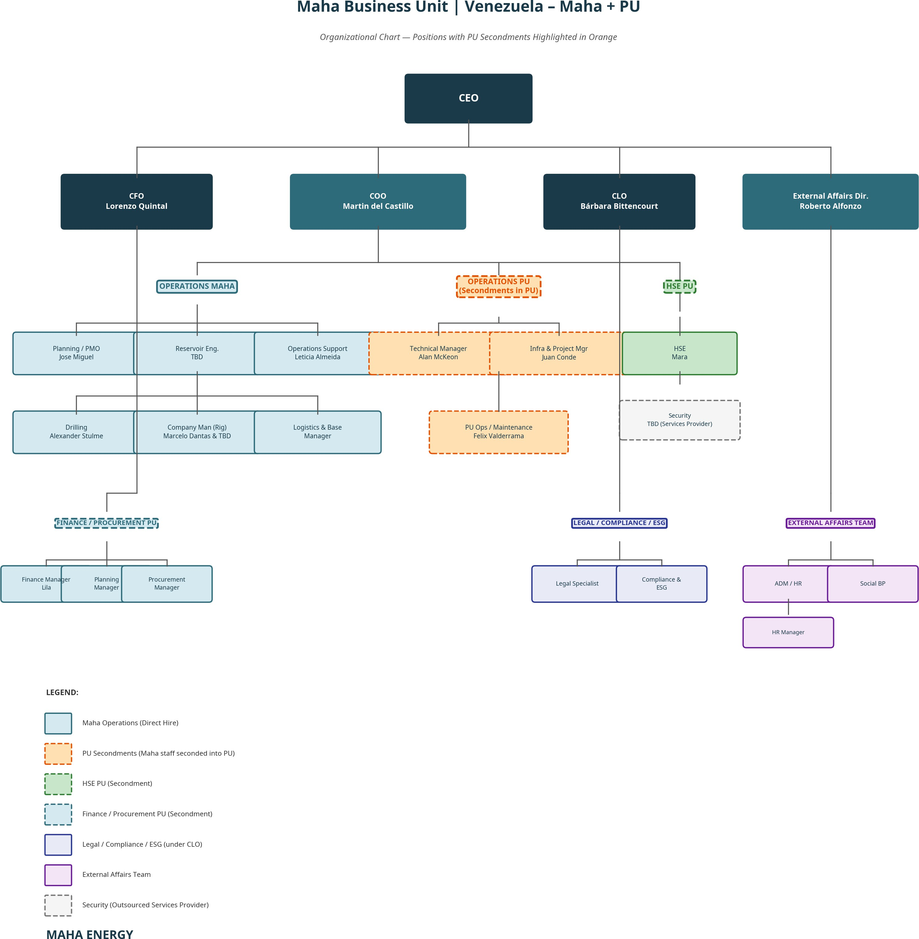

Note on PU Secondments: The Technical Manager (Alan McKeon), Infrastructure & Project Manager (Juan Conde), and PU Operations/Maintenance Manager (Felix Valderrama) are Maha employees seconded into PetroUrdaneta. Their costs are charged to the project through the IPM backoffice structure. HSE (Mara) and Finance/Procurement PU (Lila) are also secondment positions. Security is outsourced to a services provider (TBD).
Note on Lean Structure: There are no in-house Production Engineers or Facilities Engineers. Production optimization is managed directly by the O&M Manager, and all facilities engineering, construction supervision, and commissioning support is provided by the EPCM contractor under MSA-2, supervised by the Infrastructure Manager.

Key Reporting Lines:

Position | Reports To | PU Secondment | Key Interface
CEO | Shareholders | No | Strategic direction; investor relations
CFO (Lorenzo Quintal) | CEO | No | Finance, treasury, procurement oversight
CLO (Bárbara Bittencourt) | CEO | No | Legal, compliance, ESG
COO (Martin del Castillo) | CEO | No | Overall project delivery; PDVSA interface; team leadership. Located in Caracas; rotation only for first 6 months, then resident.
External Affairs Dir. (Roberto Alfonzo) | CEO | No | Government relations; ADM/HR; community; social BP
Planning/PMO (Jose Miguel) | COO | No | Project controls; cost tracking; scheduling
Reservoir Engineering (TBD) | COO | No | Decline analysis; reservoir modeling; reserves
Operations Support (Leticia Almeida) | COO | No | Operational logistics and support
Drilling (Alexander Stulme) | COO | No | Workover campaigns; infill drilling; well integrity
Company Man (Marcelo Dantas & TBD) | COO | No | Rig-site supervision
Technical Manager (Alan McKeon) | COO | Yes — Seconded to PU | Geology; well targeting; formation evaluation
Infra & Project Manager (Juan Conde) | COO | Yes — Seconded to PU | FSB upgrades; pipeline; package commissioning (EPCM contractor support)
PU Ops/Maintenance (Felix Valderrama) | COO | Yes — Seconded to PU | Daily production; well optimization; artificial lift
HSE (Mara) | COO | Yes — Seconded to PU | Safety compliance; environmental permits
Security (TBD) | COO | No (Outsourced) | Physical security — services provider
Finance Manager (Lila) | CFO | Yes — Seconded to PU | Finance; controllership; local tax compliance
ADM/HR | External Affairs Dir. | No | Human resources; administration
Legal Specialist | CLO | No | Legal advisory; contract review
Compliance & ESG | CLO | No | Regulatory compliance; ESG reporting
Social BP | External Affairs Dir. | No | Community relations; social investment

Table 17A: IPM, Drilling & Well Services Cost Breakdown

To evaluate the economic viability and execute the project efficiently, the table below provides a comprehensive IPM, Drilling & Well Services Cost Breakdown. This matrix details the costs associated with each artificial lift method, typical well service interventions, drilling services per reactivation strategy, and the dedicated backoffice support from the company [1] [2]:

Service / Cost Element | Cost (USD) | Frequency / Unit Basis | Scope of Services & Backoffice Disclosure | Sourcing Basis / Reference
Artificial Lift & Well AFE CAPEX (La Paz Basis)
- ESP Well AFE | $1,354,200 | Per ESP well | 8 rig days, ESP downhole assembly, VSD, step-down transformer, tubing (9,500 ft), wellhead, 72-hr test [1] | Section 17.2 / AFE Model
- PCP/ESPCP Well AFE | $588,550 | Per PCP well | 6 rig days, PCP downhole assembly, VSD, tubing (3,800 ft), wellhead, 72-hr test [1] | Section 17.2 / AFE Model
- Gas Lift Well AFE | $650,700 | Per GL well | 7 rig days, 5 side-pocket mandrels, GL valves, packer, tubing (6,600 ft), wellhead, 72-hr test [1] | Section 17.2 / AFE Model
- Rod Pump Well AFE | $487,850 | Per RP well | 5 rig days, downhole insert pump, rod string, tubing (3,100 ft), wellhead, 72-hr test [1] | Section 17.2 / AFE Model
Drilling & Workover Services
- Rig Mob / Demob | $250,000 | Per campaign rig | Mobilization/demobilization of heavy workover rig, cranes, support [1]. | MSA-3 Drilling Contract
- Rig Daily Rate | $45,000 | Per operating day | Daily rig rate, crew, tools, and supervisor (Company Man) [1]. | MSA-3 Drilling Contract
- Rig Fuel (Diesel) | $8,500 | Per operating day | Fuel consumption for rig power generators and engines (~3,500 liters/day) [1]. | Fuel Distributor Quote
Wellhead & Completion Equipment
- ESP Wellhead & Xmas Tree | $85,000 | Per ESP well | API 6A wellhead, master valve, wing valves, choke manifold (10,000 psi WP) [1]. | FMC Technologies  / SLB
- PCP Wellhead & Xmas Tree | $45,000 | Per PCP well | API 6A wellhead, master valve, stuffing box, polished rod (5,000 psi WP) [1]. | Netzsch / Wood Group
Drilling Consumables & Services
- Drill Bits & Reamers | $35,000 | Per run / bit | Tricone and PDC bits (8.5” and 12-1⁄4” sizes) for sidetracks or cleanouts [1]. | Baker Hughes / SLB
- Crossover Subs & PUP Joints | $12,000 | Per well set | Crossover subs, PUP joints, and handling tools for drillstring [1]. | Local Machine Shop
Well Remediation & Intervention
- Fishing Operations | $22,000 | Per day (as required) | Wireline/tubing fishing tools, overshots, spears, and specialist supervisor [1]. | MSA-1 Well Services (Baker)
- Milling & Cleanout | $18,500 | Per day (as required) | Section milling, casing scrapers, and cleanout runs to remove scale/cement [1]. | MSA-1 Well Services (SLB)
- Casing Caliper & CBL | $95,000 | Per well | Run cement bond log (CBL) and casing caliper to verify well integrity [1]. | MSA-1 Well Services
- Stimulation / Acid Job | $80,000 | Per well (as required) | Matrix acid treatment to remove skin damage and restore permeability [1]. | MSA-1 Well Services
Integrated Backoffice Support
- IPM Technical Specialists | $50,000 | Monthly lump sum | Part-time (0.5 FTE) Reservoir, Geologist, Artificial Lift, Drilling, and Facilities engineers [1]. | IPM Contract Schedule B

Service / Cost Element | Cost (USD) | Frequency / Unit Basis | Scope of Services & Backoffice Disclosure | Sourcing Basis / Reference
- IPM SG&A Support | $29,000 | Monthly lump sum | Full-time (1.0 FTE) Cost Control, PMO, Logistics, and HSE specialists [1]. | IPM Contract Schedule A
- Real-Time SCADA Monitoring | $15,000 | Monthly lump sum | 24⁄7 remote surveillance of ESP/PCP parameters, wellhead pressures [1]. | IPM Contract Schedule B
- Simulation Software | $12,000 | Monthly lump sum | Eclipse/CMG, Prosper/GAP, PIPESIM, Harmony, Petrel licenses [1]. | IT Service Agreement
- Corporate Overhead | $25,000 | Monthly lump sum | Executive oversight, treasury, legal, insurance, audit, ERP [1]. | IPM Contract Schedule C
TOTAL IPM BACKOFFICE | $141,500 | Monthly total | All corporate, technical, and remote monitoring support  [1]. | IPM Contract Basis

Table 17B: IPM Backoffice Support — Technical & Operational Positions

The IPM backoffice provides dedicated technical and operational support to the field team. These are specialist resources available on a shared/part-time or full-time basis depending on project phase, charged through the IPM contract as disclosed below:

IPM Backoffice Position | Function | Allocation | Monthly Cost (USD) | Allocation Category | Cost Reference
Reservoir Engineer | Decline analysis, pressure modeling, reserves estimation, well performance diagnostics | Part-time (0.5 FTE) | $12,500 | Technical Support | IPM Contract Schedule B
Geologist | Formation evaluation, well targeting, correlation, log interpretation | Part-time (0.5 FTE) | $12,500 | Technical Support | IPM Contract Schedule B
Artificial Lift Specialist | ESP/ESPCP/PCP/GL design, run-life optimization, failure analysis | Part-time (0.5 FTE) | $12,500 | Technical Support | IPM Contract Schedule B
Drilling & Completion Specialist | Well design, casing programs, completion strategy, workover supervision | Part-time (0.5 FTE) | $12,500 | Technical Support | IPM Contract Schedule B
Cost Control / Planning | Budget tracking, AFE preparation, cost forecasting, variance analysis | Full-time (1.0 FTE) | $8,000 | SG&A | IPM Contract Schedule A
PMO (Project Management Office) | Scheduling, milestone tracking, reporting, document control | Full-time (1.0 FTE) | $8,000 | SG&A | IPM Contract Schedule A
Logistics Coordinator | Material movements, customs, warehouse management, crew changes | Full-time (1.0 FTE) | $6,000 | SG&A | IPM Contract Schedule A
HSE Specialist | Safety audits, incident investigation, environmental monitoring, permit compliance | Full-time (1.0 FTE) | $7,000 | SG&A | IPM Contract Schedule A
Facilities Engineer | Process engineering support, package design review, commissioning support | Part-time (0.5 FTE) | $10,000 | Technical Support | IPM Contract Schedule B
Remote Production Real-Time Monitoring | 24⁄7 remote surveillance of ESP/PCP parameters, wellhead pressures, flow rates, and alarms via SCADA/cloud dashboards; remote optimization and early failure detection | Full-time (1.0 FTE +  platform) | $15,000 | Technical Support | IPM Contract Schedule B
Simulation Software & Licenses | Reservoir simulation (Eclipse/CMG), nodal analysis (Prosper/GAP), production optimization (PIPESIM), decline curve (Harmony), geological modeling (Petrel) | Lump sum licenses | $12,000 | Technical Support | IT Service Agreement
Subtotal — Technical & Operational |  |  | $116,500
Corporate Overhead & IT/Admin | Executive oversight (CEO/CFO part-time), treasury, legal, corporate finance, insurance, audit, IT infrastructure, ERP licenses, cloud | Lump sum | $25,000 | Overhead | IPM Contract Schedule C
TOTAL IPM BACKOFFICE | All Disclosed IPM Support |  | $141,500 | — | IPM Contract Basis

Note: Technical specialists (Reservoir Engineer, Geologist, Artificial Lift, Drilling & Completion, Facilities) are allocated on a part-time (0.5 FTE) basis during Phase 1. As the project scales to Phases 2-4, these positions may transition to full-time (1.0 FTE) with proportional cost increase. Remote Production Real-Time Monitoring includes a dedicated engineer plus cloud-based SCADA platform subscription for 24⁄7 surveillance and optimization. Simulation Software covers all subsurface and production engineering licenses required for reservoir management and well optimization. Corporate Overhead & IT/Admin is a fixed lump sum that covers all remaining corporate functions not itemized above.

SG&A Personnel Cost Model

The field operations are supported by a lean owner organization. During the first 6 months, all managers operate on rotation only. After 6 months, all positions become permanently resident (no more rotation). The COO is based in Caracas [1].

Table 17C: SG&A Personnel Cost Model

Position | Location | Rotation | Monthly Base (USD) | Monthly Benefits (USD) | Monthly Loaded Cost (USD) | Annual Cost (USD MM) | Key Operational Role
COO (Chief Operating Officer) | Caracas | Rotation 6 months → Resident | $30,000 | $16,000 | $46,000 | $0.55 | Overall project delivery; PDVSA interface; team leadership. Located in Caracas.  Rotation only for first 6 months, after that permanently resident. Stock options and performance bonuses over achieved milestones TBD [1]
O&M Manager | Maracaibo / Field | Rotation 6 months → Resident | $15,000 | $10,000 | $25,000 | $0.30 | Field operations, production, maintenance, and artificial lift optimization
Drilling Manager | Maracaibo / Field | Rotation 6 months → Resident | $16,000 | $10,000 | $26,000 | $0.31 | Workover and drilling campaign execution; well integrity
Technical Manager (Geologist) | Maracaibo / Field | Rotation 6 months → Resident | $12,000 | $6,000 | $18,000 | $0.22 | Geology studies; well targeting; formation evaluation
Reservoir Engineering Manager | Maracaibo / Caracas | Rotation 6 months → Resident | $12,000 | $6,000 | $18,000 | $0.22 | Decline analysis; reservoir modeling; reserves booking
Infrastructure Manager | Maracaibo / Field | Rotation 6 months → Resident | $12,000 | $6,000 | $18,000 | $0.22 | FSB upgrades; pipeline construction; package commissioning. All engineering support from EPCM contractor (MSA-2)
HSE Manager | Maracaibo / Field | Rotation 6 months → Resident | $5,000 | $3,000 | $8,000 | $0.10 | Safety compliance, environmental permits
Social Resp. Manager | Maracaibo | Rotation 6 months → Resident | $4,000 | $3,000 | $7,000 | $0.08 | Community relations, labor union interface
PMO Lead | Maracaibo | Rotation 6 months → Resident | $5,000 | $3,000 | $8,000 | $0.10 | Project controls, cost tracking, AFE admin, scheduling
Admin Support | Maracaibo | Resident | $2,500 | $1,000 | $3,500 | $0.04 | Field logistics, local procurement
Executive Secretary | Maracaibo | Resident | $2,000 | $1,000 | $3,000 | $0.04 | Administrative support

Rotation Policy: All managers operate on rotation for the first 6 months only. After 6 months, all positions become permanently resident (no more rotation). Admin Support and Executive Secretary are resident from Day 1. COO is based in Caracas.
Note: There are no in-house Production Engineers or Facilities Engineers. Production optimization is managed directly by the O&M Manager, and all facilities engineering, construction, and commissioning support is provided by the EPCM contractor under MSA-2, supervised by the Infrastructure Manager. This lean owner-team model minimizes fixed SG&A while leveraging contractor scalability.

Table 17C-2: Well Reactivation AFE Breakdown per Lift Method (La Paz Basis)

To provide transparency on downhole and completion costs, the table below details the estimated AFE (Authorization for Expenditure) for each well reactivation type. These estimates assume the workover rig is released 12 hours after pump start and flow confirmation, and the subsequent 72-hour well test is conducted independently by the production team [1]:

AFE Cost Element | ESP Well AFE (USD) | PCP/ESPCP Well AFE (USD) | Gas Lift Well AFE (USD) | Rod Pump Well AFE (USD)
Sonda (Workover Rig) | $360,000 (8 days) | $270,000 (6 days) | $315,000 (7 days) | $225,000 (5 days)
Rig Mob/Demob (Pro-rata) | $10,000 | $10,000 | $10,000 | $10,000
Rig Fuel (Diesel Backup) | $68,000 | $51,000 | $59,500 | $42,500
Artificial Lift System | $250,000 (ESP) | $120,000 (PCP) | $45,000 (Mandrels) | $85,000 (SRP Unit)
Xmas Tree & Wellhead | $85,000 | $45,000 | $35,000 | $35,000
Production Tubing | $142,500 (9,500 ft) | $57,000 (3,800 ft) | $99,000 (6,600 ft) | $46,500 (3,100 ft)
Power Cable / Rod String | $95,000 (ESP Cable) | $15,200 (Drive Rods) | $0 (N/A) | $12,400 (Sucker Rods)
Casing Caliper & CBL | $95,000 | $0 (CBL not required) | $0 (CBL not required) | $0 (CBL not required)
Downhole Accessories | $47,000 (Subs/Packer) | $12,350 (Subs/Anchor) | $18,200 (Packer/Subs) | $9,450 (Anchor/Subs)
Drilling Consumables | $35,000 (Bits/Reamers) | $0 (N/A) | $0 (N/A) | $0 (N/A)
Fishing / Cleanout | $110,000 (5 days standby) | $0 (N/A) | $0 (N/A) | $0 (N/A)
72-Hour Well Test (Non-Rig) | $56,700 | $18,000 | $14,000 | $17,000
Engineering & Supervision | $45,000 | $30,000 | $35,000 | $25,000
TOTAL WELL AFE | $1,354,200 | $588,550 | $650,700 | $487,850
Well Sourcing Basis | Vendor / Rig Contract | Vendor / Rig Contract | Vendor / Rig Contract | Vendor / Rig Contract

SG&A Infrastructure & Support Estimates

The non-personnel SG&A and support costs are estimated based on local operating conditions in Venezuela [2].

Table 17D: SG&A Infrastructure, Vehicles, Office, IT & Support Cost Model

The following integrated table provides the complete breakdown of administrative infrastructure costs, including both initial CAPEX (hard assets) and recurring monthly/annual OPEX for all non-personnel support functions. This table consolidates all SG&A support categories for investor reference [1] [2]:

Expense Category / Asset | Initial CAPEX (USD) | Monthly OPEX (USD) | Annual OPEX (USD MM) | Sizing, Scope & Fleet Dimensioning | Sourcing Basis
Corporate Vehicles | $280,000 | $12,000 | $0.14 | Fleet of 6x 4WD armored pickup trucks (Toyota Hilux or equivalent) for secure personnel transport between Maracaibo and wellsites | Local Dealership Quote
Operational Vehicles | $150,000 | $18,000 | $0.22 | Fleet of 5x standard 4WD utility trucks, 2x flatbed light trucks, and 1x diesel fuel tanker truck | Local Dealership Quote
Caracas Office Setup | $45,000 | $10,000 | $0.12 | Rent and outfitting of a 300 m² corporate headquarters in Chacao, Caracas. Includes security doors, back-up power, and meeting rooms | Local Lease Agreement
Maracaibo Field Base | $35,000 | $3,000 | $0.04 | Outfitting of existing Maracaibo operational office (refurbish HVAC, backup generator, security gates). No rent — PU existing asset | PU Asset Register
IT Systems & ERP | $95,000 | $8,000 | $0.10 | Starlink Business satellite dishes (x6), UHF/VHF radio network, local servers, field rugged laptops, and SAP/ERP local licenses | Starlink Business Quote
Office Furniture | $40,000 | $1,500 | $0.02 | Ergonomic desks, chairs, conference tables, storage cabinets, and breakroom appliances for both Caracas and Maracaibo bases | Local Supplier Quote
Administrative Support | $15,000 | $5,500 | $0.07 | Local secretary, cleaning services, office consumables, and administrative support services | Local Services Agreement
Travel & Logistics | — | $5,000 | $0.06 | Domestic flights, crew change transport, local vehicles | Travel Agent Quote
Lean Security Program | — | $52,500 | $0.63 | Physical security at wellsite packages, FSB, and Caracas office | Security Contractor Quote
Fleet Fuel (Gasoline/Diesel) | — | $12,500 | $0.15 | Monthly fuel allocation for 6x corporate armored vehicles and 8x operational field trucks | Fuel Distributor Quote
Catering & Field Camp Food | — | $28,000 | $0.34 | Catering services for field crew, supervisors, and base operators (~45 people daily, $20/day/person) | Catering Contractor Quote
TOTAL | $660,000 | $156,000 | $1.87 | Consolidated administrative CAPEX and non-personnel operational support OPEX | FDP Master Model

Consolidated Total SG&A & Field Support (IPM Backoffice + Field Operations Team + Support Infrastructure + Hard Assets Support + Field Catering & Fuel) is US499, 000/month(US 5.99 Million/year) including amortized administrative CAPEX and operational support [1].

Strategic Comparison: PetroUrdaneta Modular Model vs. PDVSA Traditional Model

The primary driver of PetroUrdaneta’s success is not a change in reservoir understanding, but a fundamental shift in the project execution and contracting model. While the reservoir potential has always existed, the PDVSA traditional approach has consistently failed to unlock it due to sequential execution, oversized infrastructure, and front-loaded capital requirements that never generate returns within a reasonable timeframe. The PetroUrdaneta modular and hybrid system delivers production organically and incrementally, with each barrel of oil produced funding the next phase of development [1] [2].

Production Ramp-Up Comparison

The most critical difference between the two models is the time to first oil and the production build-up profile. The PDVSA model requires all infrastructure to be completed before a single barrel flows; the PetroUrdaneta model produces oil within months of FID.

Table 18A: Production Ramp-Up Timeline Comparison

Timeline | PDVSA Traditional Model (BOPD) | PetroUrdaneta Modular Model (BOPD) | Difference
Month 0 (FID) | 0 | 1,300 (baseline) | PU already producing
Month 3 | 0 (still in engineering) | 1,300 (baseline + first workovers) | +1,300
Month 5 | 0 (still in procurement) | 2,500 (first packages online) | +2,500
Month 6 | 0 (still in procurement) | 5,000 (Batch 1 + 2 ramping) | +5,000
Month 8 | 0 (still in construction) | 8,000 (all packages online) | +8,000
Month 10 | 0 (still in construction) | 10,000 (target achieved) | +10,000
Month 12 | 0 (still in commissioning) | 13,500 (La Paz plateau) | +13,500
Month 18 | 0 (first commissioning trials) | 18,000 (La Paz + Mara start) | +18,000
Month 24 | 2,000-5,000 (first oil, ramp-up) | 22,000 (Mara plateau) | +17,000 to +20,000
Month 36 | 10,000-15,000 (partial ramp-up) | 30,000 (La Paz Sur online) | +15,000 to +20,000
Month 48 | 20,000-25,000 (design plateau) | 40,000 (full field plateau) | +15,000 to +20,000

Key Insight: The PDVSA model takes 18-24 months to produce its first barrel of oil. The PetroUrdaneta modular model achieves 10,000 BOPD in Month 10 — before the PDVSA model has even completed commissioning. This means the PetroUrdaneta model generates 12-18 months of cumulative revenue before the PDVSA model produces a single dollar.

CAPEX Expenditure Profile Comparison

The PDVSA model requires massive upfront capital commitment (“front-loaded CAPEX”) with no revenue offset for 2+ years. The PetroUrdaneta model deploys capital incrementally and becomes self-funding before the heaviest CAPEX phases (drilling, permanent facilities).

Table 18B: CAPEX Expenditure Profile Comparison (Cumulative US$ Million)

Timeline | PDVSA Model — Cumulative CAPEX | PDVSA Model — Cumulative Revenue | PetroUrdaneta — Cumulative CAPEX | PetroUrdaneta — Cumulative Revenue | PU Net Position
Month 6 | $45 MM | $0 | $18 MM | $8 MM | -$10 MM
Month 12 | $95 MM | $0 | $42 MM | $35 MM | -$7 MM
Month 18 | $140 MM | $5 MM | $65 MM | $72 MM | +$7 MM (self-funding)
Month 24 | $180 MM | $25 MM | $90 MM | $120 MM | +$30 MM
Month 36 | $220 MM | $80 MM | $145 MM | $210 MM | +$65 MM
Month 48 | $256 MM | $160 MM | $200 MM | $330 MM | +$130 MM

Key Insight: The PDVSA model reaches cumulative breakeven at approximately Month 42-48 (3.5-4 years). The PetroUrdaneta modular model reaches self-funding at Month 12-18 and generates positive cumulative cash flow by Month 18. The total capital at risk at any point is dramatically lower.

OPEX Structure Comparison

The PDVSA model carries a heavy fixed OPEX burden from Day 1 (large permanent staff, centralized facilities maintenance, grid power costs) regardless of production level. The PetroUrdaneta model has a variable OPEX structure that scales with production.

Table 18C: OPEX Structure Comparison (Annual at Plateau)

OPEX Category | PDVSA Model (US$/year) | PetroUrdaneta Model (US$/year) | Savings | Reason for Difference
Lifting Cost (per barrel) | $18-22/bbl | $10-14/bbl | 35-45% | Modular gensets use free associated gas; no grid dependency
Power & Electricity | $8-12 MM | $2-4 MM | 60-75% | Self-generated fuel gas vs. Corpoelec grid (unreliable  + expensive)
Facilities Maintenance | $6-10 MM | $3-5 MM | 40-50% | Standardized skids with vendor warranties vs. aging bespoke infrastructure
Personnel (Field Ops) | $12-18 MM | $4-6 MM | 60-70% | Lean IPM model (8-10 staff) vs. PDVSA bloated payroll (80-150 staff)
SG&A / Overhead | $8-12 MM | $3.1 MM | 60-75% | No Caracas bureaucracy; no political appointments
Well Services (Workovers) | $5-8 MM | $4-6 MM | 20% | Similar scope but faster execution under MSA
Chemical Treatment | $2-4 MM | $1.5-3 MM | 25% | Smaller, optimized treatment volumes
Transportation & Export | $3-5 MM | $9 MM (barge) | Higher | Barge cost premium until pipeline repairs completed
TOTAL ANNUAL OPEX | $52-81 MM | $25-40 MM | 40-55%
Unit OPEX (per barrel) | $18-22/bbl | $10-14/bbl | 35-45%

Key Disadvantages of the PDVSA Traditional Model

The following table summarizes the structural disadvantages of the PDVSA centralized model that make it fundamentally unsuitable for the current Venezuelan operating environment:

Table 18D: PDVSA Model — Structural Disadvantages

Disadvantage | Description | Impact on Project | PetroUrdaneta Mitigation
No revenue for 18-24 months | All infrastructure must be completed before first oil flows. Engineering, procurement, fabrication, installation, and commissioning run sequentially. | Total capital at risk exceeds $100 MM before a single barrel is produced. Investors bear 100% downside risk with no validation. | First oil at Month 5; revenue generation begins immediately; capital at risk never exceeds $18 MM before first cash flow.
Oversized infrastructure | Facilities are designed for “peak plateau” production that may never materialize due to reservoir uncertainty. | 30-50% of installed capacity may be stranded if wells underperform.  Permanent facilities cannot be resized or moved. | Modular packages sized for actual, proven production. If wells underperform, packages are redeployed elsewhere — zero stranded capital.
Grid dependency | Relies on Corpoelec national grid for power, which suffers chronic instability, blackouts, and non-payment disputes. | Production losses of 10-30% due to power outages. No backup for 20+ MW centralized loads. | Self-generated power at each cluster (dual-fuel gensets on free associated gas). Zero grid dependency.
Single-EPC contracting | Lump-sum EPC contracts lock in scope and price before subsurface data is validated. Change orders are expensive and contentious. | Cost overruns of 30-80% are typical in Venezuelan EPC projects.  Disputes delay completion by 12-18 months. | Four MSAs with AFE-triggered Service Orders. Scope is defined well-by-well based on actual diagnostics. No lump-sum commitment.
Bloated organization | PDVSA operational model requires 80-150 field staff plus Caracas support functions, political appointments, and union obligations. | Personnel OPEX of $12-18 MM/year regardless of production level. Productivity per employee is extremely low. | Lean IPM team of 10 staff + EPCM contractor support. Personnel OPEX of  $3.1 MM/year.
No redeployment capability | Permanent facilities are fixed assets. If a field declines or wells fail, the infrastructure is abandoned. | Historical precedent: multiple PDVSA facilities across Zulia are idle/abandoned after 5-10 years. | Modular packages are movable assets. La Paz packages redeploy to Mara, then El Mojan — extending asset life to 15+ years.
Procurement bottlenecks | Large-scale equipment (compressors, separators, power turbines) requires 12-24 month lead times for import into Venezuela. | Project schedule is hostage to international shipping, customs delays, and sanctions compliance. | Standardized skid packages fabricated locally or regionally (Colombia/Trinidad) in 8-12 weeks. No large-vessel imports required.
No early validation | Reservoir performance is assumed from historical data (often unreliable). First production data arrives 2+ years after FID. | If reservoir underperforms, $100+ MM is already committed with no recovery mechanism. | Diagnostic wells and early workovers validate reservoir within Months 2-5. Capital gates prevent further investment if results disappoint.
Political and regulatory exposure | 2-4 year execution timeline exposes the project to multiple political cycles, regulatory changes, and potential expropriation risk. | Long-duration projects in Venezuela have historically been nationalized, renegotiated, or suspended mid-execution. | 10-month time to 10,000 BOPD minimizes political exposure. Project generates value before any political cycle can disrupt it.
Environmental liability accumulation | Large construction footprint generates significant environmental liabilities (deforestation, soil disturbance, water table impact) before any revenue is generated. | Environmental bonds and remediation costs accumulate during 2+ years of construction with zero offsetting revenue. | Minimal footprint (skid-mounted on existing well pads). No new deforestation. Environmental costs are minimal and offset by early revenue.

Head-to-Head Execution Philosophy Comparison

Table 18E: Execution Model Comparison

Metric / Dimension | PDVSA Traditional Model | PetroUrdaneta Modular & Hybrid Model | Strategic Advantage
Execution Philosophy | Sequential: complete engineering, procurement, and facilities construction before starting production. | Parallel: execute well reactivations, artificial lift, modular EPF, and FSB upgrades simultaneously. | Reduces time-to-first-oil by 75% (5 months vs. 18-24 months).
Infrastructure Design | Permanent, centralized, and oversized facilities built upfront. | Standardized, skid-mounted modular packages deployed first; permanent facilities sized after 12-18 months of actual production data. | Prevents stranded capital; matches facility capacity to proven reservoir performance.
Power Strategy | Grid-dependent or large centralized power plants. | Modular, dual-fuel gas/diesel gensets at each cluster; centralize only after stable load is proven. | Eliminates grid reliance; slashes upfront power CAPEX by 70%.
Gas Strategy | Large centralized gas processing built before production. | Fuel gas self-consumption first; export only after stable surplus (>5 MMscfd for 90 days). | Self-funds gas export CAPEX from early oil revenues.
Pipeline Philosophy | Permanent, buried, carbon steel networks laid early. | Flexible, surface-laid multiphase flexlines first; permanent trunklines after performance validation. | Installation time reduced from months to weeks; allows rapid redeployment.
Production Growth | Step-change: 0 → plateau after 24-  36 months. | Organic, incremental: production grows well-by-well, month-by-month from Month 5 onward. | Revenue begins immediately; each well funds the next; organic growth de-risks the project.
Capital Risk | Front-loaded: 100% committed before first oil. | Phased, gated, production-led: capital released only when production triggers are achieved. | Project becomes self-funding at Month 12; investor capital protected by gates.
Redeployment | No reuse: facilities are fixed, stranded if wells decline. | Modular packages are movable assets; redeployed to subsequent fields after La Paz transitions to permanent facilities. | Replicates early-cash-flow strategy across Mara, El Mojan, La Paz Sur at minimal incremental cost.
Contracting | Lump-sum, single-EPC with high upfront commitment. | Four MSAs with AFE-triggered Service Orders; 4 vendors per MSA. | Capital spent only against proven crude return; competitive tension maintained.
Organization | 80-150 staff; political appointments; union constraints. | 10 lean IPM staff + EPCM contractor support. | 60-70% lower personnel OPEX; faster decision-making.

Conclusion: Why the Modular & Hybrid Model is the Only Viable Solution

The traditional centralized model is structurally unviable in the current Venezuelan operating environment due to:

- Capital constraints: Upfront funding of US100 + Millionisunavailableorcarriesanextremelyhighcostofcapital.Noinvestorwillcommit100 MM with a 24-month wait for first oil in Venezuela.
- Logistical bottlenecks: Importing large-scale equipment takes 18-24 months and is subject to sanctions, customs, and port congestion.
- Subsurface uncertainty: Historic well data is unreliable after decades of deferred maintenance. Oversizing permanent facilities is almost certain.
- Political risk: A 3-4 year execution timeline exposes the project to multiple political cycles and regulatory changes.
- No organic growth: The PDVSA model produces zero revenue for 2+ years, creating a binary outcome (success or total loss) rather than an incremental, de-risked growth path.
The PetroUrdaneta Modular & Hybrid Model eliminates these risks by:

  - Generating first oil at Month 5 and 10,000 BOPD by Month 10
  - Achieving self-funding by Month 12-18 (no further external capital required)
  - Growing production organically — each well validates the next investment
  - Maintaining redeployment optionality — if any field disappoints, assets move to the next opportunity
  - Operating with a lean, cohesive team that has worked together before and can execute at speed

The result is a project that delivers 40,000 BOPD within 4 years at approximately 50% of the CAPEX and 40-55% of the OPEX of the equivalent PDVSA model, with dramatically lower risk and earlier returns [1] [2].

Board Dashboard, Risks & Execution Timeline

Board Dashboard KPIs

The project is monitored using a set of core operational Key Performance Indicators (KPIs) and milestones [1]:

Table 19A: Board Dashboard KPIs

KPI / Control Metric | Target Value | Current Status / Baseline | Control Mechanism
Current Production | 1,300 BOPD | 1,300 BOPD | Daily production reporting
Phase 1 Target Range | P90: 10k / P50: 13k / P10: 15k BOPD | — | Monthly reservoir review
Time to 10,000 BOPD | Month 10 (~July 2027) | — | Rig schedule tracking
Full-Field Target | 40,000 BOPD by Year 4 | — | Annual development review
Package Utilization | >85% | — | Daily runtime SCADA tracking
Equipment Redeployment | >75% of movable assets | — | PMO asset register
Production Uptime | >95% | — | O&M daily logs
Gas Export Trigger | 10,000 BOPD + >5 MMscfd surplus | — | 90-day stability monitor
Total Program CAPEX | US$ 256.0 Million | — | Monthly AFE vs. Actual tracking
Plateau OPEX | US$ 25.0 Million/year | — | Unit lifting cost tracking

Table 19B: Critical Project Milestones

Milestone | Target Timeline | Responsible | Trigger Condition
Award IPM & Well Services MSA | Month 0-1 | CEO / COO | Project sanction
Award EPCM & Rig MSAs | Month 1 | CEO / COO | Project sanction
First Well Reactivation | Month 2 | Drilling Manager | Rig mobilization complete
First 2 Modular Packages Ready (ESPCP-A, GL-M) | Month 4 | Facilities Engineer | Factory acceptance test (FAT) — Batch 1
First Oil Through Packages (Batch 1 Online) | Month 5 | Operations Manager | Batch 1 delivered, hooked up, and hot-commissioned
Next 2 Modular Packages Ready (ESPCP-B, ESPCP-C) | Month 5-6 | Facilities Engineer | Factory acceptance test (FAT) — Batch 2
Batch 2 Producing | Month 6-7 | Operations Manager | Batch 2 delivered and commissioned
ESP-S Package + DIAG-S Ready | Month 7 | Facilities Engineer | Factory acceptance test (FAT) — Batch 3
All La Paz Packages Online (4-8 units) | Month 8 | Operations Manager | All packages hot-commissioned and producing
5,000 BOPD Milestone | Month 6 | Operations Manager | 5+ wells online and stable through Batch 1 & 2
10,000 BOPD Milestone | Month 10 | Operations Manager | 16 wells online and stable
Gas Export Decision (Gate 2) | Month 10 | CEO | 90 days of stable surplus gas
Phase 2 Mara Startup | Year 2 | Operations Manager | Gate 3 approval
Phase 3 La Paz Sur Startup | Year 3 | Operations Manager | Gate 4 approval
Phase 4 El Mojan Startup | Year 4 | Operations Manager | Gate 5 approval

Key Risks and Mitigations

The project has identified several critical operational, subsurface, and midstream risks. Importantly, several key risks have already been pre-mitigated through advance planning: the core operations team has been secured and has prior working history together (eliminating talent and cohesion risk), and a minimum of 4 qualified vendors per MSA have been pre-identified (eliminating single-vendor concentration risk) [1] [2].

Table 19C: Risk Register & Mitigation Strategy

Risk Description | Impact | Probability | Mitigation Strategy | Status
Grid Instability (Power blackouts in Zulia State) | High | High | Deploy dual-fuel gas/diesel gensets at every wellsite package; utilize produced gas as primary fuel [1]. | Designed into package specs
Well Integrity Failure (Corroded casing or cement failure in old wells) | High | Medium | Run cement bond logs (CBL) and casing calipers on every well before installing artificial lift; keep sidetrack/slot-recovery contingency budget. | Included in Campaign 1 SOW
Security / Asset Theft (Vandalism of wellheads or flowlines) | Medium | High | Implement the Lean Security Program: trailer-mounted security posts, continuous drone patrols, and community integration. | Security contractor identified
Gas Export Delay (Chevron/Campo Boscan unable to receive gas) | Medium | Medium | Activate Priority 2 Gas Contingency: route gas to wellsite gensets, FSB heaters, and reinject surplus into Cretaceous reservoirs [2]. | Contingency plan documented
Rig Availability (Lack of suitable workover/drilling rigs in Venezuela) | High | Medium | 4 pre-qualified rig contractors under MSA-3 framework; long-term commitment with performance incentives. | 4 vendors secured
Local Labor Disruption (Union disputes or community blockades) | Medium | Medium | Deploy Social Responsibility Manager to establish community agreements, local hiring quotas, and social investment programs. | SR Manager identified
Talent Scarcity / Brain Drain | High | Low | Core team already secured with prior working history together. All 7 key positions filled pre-FID. No recruitment lead time required. | MITIGATED —  Team secured
Single-Vendor Fabrication Risk | Medium | Low | Minimum 4 qualified vendors per MSA pre-identified and invited to site survey. Backup fabricators available for immediate Service Order issuance if primary vendor fails. | MITIGATED — 4  vendors/MSA
Team Cohesion / Onboarding Delays | Medium | Low | Execution team has prior joint working experience on similar projects. No alignment workshop required; team is operationally cohesive from Day 1. | MITIGATED —  Cohesive team

Midstream Export Constraints & Palmarejo Barge Terminal Strategy

A critical bottleneck exists in the crude export infrastructure [2]:

- Main Line to Palmarejo: The existing pipeline has several active leaks, limiting throughput to 10,000 BOPD until repairs are completed.
- Subsurface Line to Puerto Miranda: There is no current integrity evaluation on this line, and it has never been pigged, representing an extreme environmental and operational risk.
- The Barge Export Strategy: To bypass these risks, the project will establish a terminal at Palmarejo and use 100,000 BBL barges to deliver crude to Puerto Miranda.
  - Barge Lease Cost: US$ 600,000 per month (US$ 7.2 MM/year OPEX under MSA-1).
  - Total Fluvial OPEX: US$ 9.0 Million/year (including fuel, crew, and port fees).
  - Terminal CAPEX: US$ 7.5 Million (rebuilding Palmarejo tanks, jetty, and loading arms).

Project Execution Timeline

The project execution is organized into three distinct phases defined by the D-Day (D0) framework:

- D0 = PDVSA Contract Signature & Formal Operational Transition (the moment Maha/PetroUrdaneta assumes formal operational control)
- D- (D-minus) = The 2-3 month period before D0, from Term Sheet signature through PDVSA contract finalization. During this period, critical preparatory activities are executed in parallel with legal/regulatory processes to eliminate dead time.

- D+ (D-plus) = The full operational execution phase after D0, when the project has formal authorization to intervene wells, fabricate packages, and produce oil.
This framework ensures that no time is wasted during the 2-3 month contract negotiation period with PDVSA. By the time D0 arrives, the project team is fully mobilized, site surveys are complete, MSAs are negotiated, and fabrication orders are ready to be released — enabling immediate execution on Day 1 of formal operations.

Figure 19D-1: D- Phase Gantt Chart (Term Sheet to PDVSA Contract — Apr-Sep 2026)

The following Gantt chart illustrates the parallel execution of all D- Phase activities. These activities do not require formal PDVSA operational control and can be executed during the contract negotiation period. Critical path items (Long-Lead Equipment Pre-Orders and PDVSA Contract Finalization) are highlighted in red.
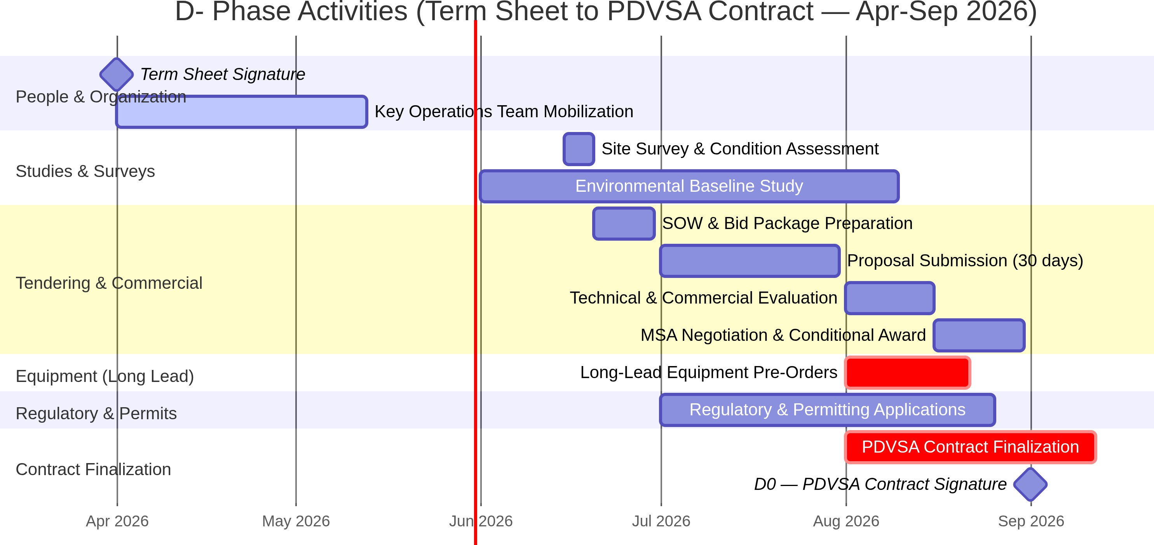

Key Activities:

Activity | Calendar Dates | Duration | Deliverable
Term Sheet Signature | April 2026 | — | Signed Term Sheet
Key Operations Team Mobilization | April – May 2026 | 4-6 weeks | Team mobilized to Maracaibo
Site Survey & Condition Assessment | June 15-19, 2026 | 5 days | Condition assessment report
SOW & Bid Package Preparation | June 20-30, 2026 | 10 days | Bid packages issued
Proposal Submission Period | July 1-31, 2026 | 30 days | Contractor proposals received
Technical & Commercial Evaluation | August 1-15, 2026 | 15 days | Evaluation matrix
MSA Negotiation & Conditional Award | August 16-31, 2026 | 15 days | Signed MSAs (conditional)
Long-Lead Equipment Pre-Orders | August 2026 | 2 weeks | Conditional POs placed
Environmental Baseline Study | June – August 2026 | 8-10 weeks | Environmental baseline report
Regulatory & Permitting Applications | July – August 2026 | 6-8 weeks | Permits in process
PDVSA Contract Finalization | August – September 2026 | 4-6 weeks | Signed PDVSA Operating Contract

D0 = PDVSA Contract Signature (~September 1, 2026). This is the formal start of operational control. All D+ activities below are measured from this date.

Table 19D-2: D+ Phase Activities (Post-PDVSA Contract — Full Operational Execution)

These activities require formal PDVSA operational control and can only begin after D0:

Activity | Timeline (from D0) | Duration | Sequence Type | Description | Deliverable | Why Requires D+
Activate MSAs & Release Service Orders | D0 to D0+1  week | 1 week | Sequential | Convert conditional MSAs to unconditional; issue first Service Orders and AFEs. | Active contracts; capital deployed | Requires formal authorization to spend capital on PU assets
Rig Mobilization | D0 to D0+1  week | 1 week | Parallel | Mobilize first workover rig to La Paz field (occurs in parallel with MSA activation as rig was on standby) | Rig on location | Requires PDVSA rig permit and well access authorization
Well Interventions  — Campaign 1 | D0+1 week to D0+9 weeks | 8 weeks | Sequential (per well) | Reactivate first 4 wells of Cluster 1 (ESP-1, ESP-2, PCP-1, GL-1).  Downhole equipment already in  country since D-2. | 4 wells completed, tested, and ready for hookup | Requires formal well intervention permits from PDVSA
Package Assembly  — Batch 1 (4 units) | D0+1 week to D0+3 weeks | 2 weeks | Parallel (Batch) | Skid assembly & factory testing of ESP-1, ESP-2, PCP-1, GL-1  packages. Short lead time as contractors pre-procured components during D- Phase. | Batch 1 FAT complete (D0+3 weeks) | Requires confirmed Service Orders (capital commitment)
Batch 1 Delivery & Hookup | D0+3  weeks to D0+4  weeks | 1 week | Parallel | Transport 4 packages to field; connect to pre-installed manifolds & flowlines. Civil pads pre-built during D- Phase. | Batch 1 mechanically complete | Requires physical installation on PU concession
Batch 1 Commissioning (First Oil) | D0+4  weeks (Month 1) | 1 week | Sequential (per package) | Cold + hot commissioning of Batch 1. Introduce hydrocarbons, start pumps. | First Oil: 1,881 BOPD online (ESP-1) | Requires physical installation
Package Assembly  — Batch 2 (4 units) | D0+4  weeks to D0+6  weeks | 2 weeks | Parallel (Batch) | Skid assembly & factory testing of ESP-3, ESP-4, PCP-2, GL-2  packages. | Batch 2 FAT complete (D0+6 weeks) | Requires confirmed Service Orders
Batch 2 Delivery & Hookup | D0+6  weeks to D0+7  weeks | 1 week | Parallel | Transport and hookup Batch 2 packages. | Batch 2 mechanically complete | Requires physical installation
Batch 2 Commissioning | D0+7  weeks to D0+8  weeks | 1 week | Sequential | Cold + hot commissioning of Batch 2 packages. | Batch 2 producing (ESP-2, ESP-3 online) | Requires physical installation
Package Assembly  — Batch 3 (4 units) | D0+8  weeks to D0+10  weeks | 2 weeks | Parallel (Batch) | Skid assembly & factory testing of ESP-5, ESP-6, RP-1, RP-2  packages. | Batch 3 FAT complete (D0+10 weeks) | Requires confirmed Service Orders
Batch 3 Delivery & Hookup | D0+10  weeks to D0+11  weeks | 1 week | Parallel | Transport and hookup Batch 3 packages. | Batch 3 mechanically complete | Requires physical installation
Batch 3 Commissioning | D0+11  weeks to D0+12  weeks | 1 week | Sequential | Cold + hot commissioning of Batch 3 packages. | All 12 packages online (La Paz Complete) | Requires physical installation

Activity | Timeline (from D0) | Duration | Sequence Type | Description | Deliverable | Why Requires D+
Flow Station B Stage 1 Upgrade | D0 to D0+4  weeks | 4 weeks | Parallel | Rehabilitate inlet manifold, test separator, and export pumps (occurs in parallel with rig ops). | FSB ready for 10,000 BOPD  throughput | Requires formal access to FSB (PU asset)
Water Injection Plant Rehabilitation | D0+2  weeks to D0+8  weeks | 6 weeks | Parallel | Rehabilitate disposal wells and install filtration skids. | WIP operational for produced water reinjection | Requires access to injection wells
Production Ramp-Up | D0+4  weeks to D0+24  weeks | 20  weeks | Parallel | Progressive well optimization, water-handling stabilization, and full-field ramp to plateau. | Stable 38,000 BOPD (all fields) | Ongoing operations
First Oil Milestone | D0+4  weeks (Month 1) | — | Milestone | ESP-1 online at 1,881 BOPD. | Revenue generation begins | —
La Paz Plateau Milestone | D0+8  weeks (Month 2) | — | Milestone | ESP-1 to ESP-3 + PCP-1 + GL-1  online at 11,787 BOPD. | 10,000+ BOPD  self-funding target achieved | —
La Paz Complete Milestone | D0+12  weeks (Month 3) | — | Milestone | All 32 La Paz wells online at 13,191 BOPD. | La Paz Phase 1 complete | —
All Fields Plateau Milestone | D0+24  weeks (Month 6) | — | Milestone | All 12 packages online and fully redeployed across fields at 38,000 BOPD. | All-fields target achieved | —
First Gas Export Milestone | D0+30  weeks (Month 7.5) | — | Milestone | Gas pipeline & compressor online; gas export to Boscan begins. | Gas monetization begins | —

    - Summary: D- vs. D+ Activity Classification

The following table provides a quick-reference classification of all major project activities:

Table 19D-3: Activity Classification (D- vs. D+)

Activity Category | D- (Before PDVSA Contract) | D+ (After PDVSA Contract) | Rationale
Team Mobilization | Yes | — | Team is employed by Maha, not PU
Site Survey | Yes (under access agreement) | — | Non-invasive inspection only
SOW & Tendering | Yes | — | Commercial process, no field operations
MSA Negotiation | Yes (conditional) | Activation | Contracts conditional until D0
Long-Lead Orders | Yes (conditional/cancellable) | Confirmation | Vendor reservations only
Environmental Studies | Yes | — | Required for contract approval
Regulatory Permits | Yes (applications filed) | Approvals received | Applications don’t require operational control
Well Interventions | No | Yes | Requires PDVSA well access permit
Package Fabrication | No | Yes | Requires capital commitment (confirmed SOs)
Civil Construction | No | Yes | Requires physical access to concession
Rig Mobilization | No | Yes | Requires PDVSA drilling permit
FSB Upgrades | No | Yes | Requires formal access to PU assets
Pipeline Installation | No | Yes | Requires ROW and construction permits
Production | No | Yes | Requires operational control

Strategic Advantage of the D- Phase: By executing 2-3 months of preparatory work during D-, the project effectively “compresses” the post-D0 timeline. On the day of PDVSA contract signature, the team is already mobilized, vendors are pre-qualified, MSAs are ready to activate, long-lead items are reserved, and environmental permits are in process. This means first oil can be achieved within 3.5-4 months of D0 (not 5-6 months), because the typical 2-3 month pre-execution dead time has been eliminated.
Note: The detailed Phase 1 execution timeline with activity descriptions, durations, parallel operations, and deliverables is presented in Table 19D-2 above. The key insight is that wellsite packages are standardized, modular, skid-mounted units (not custom-engineered permanent facilities), enabling compressed procurement cycles and parallel batch assembly. Since contractors pre-procured components during the D- Phase, packages are assembled and tested in just 2 weeks per batch, allowing immediate hookup as soon as well interventions are completed.

Contracting Strategy — Four MSA Framework

The project utilizes a Four Master Service Agreement (MSA) framework to ensure capital discipline. A minimum of 4 pre-qualified vendors have been identified for each MSA, providing competitive tension, backup capacity, and negotiating leverage [1]:
- MSA-1: Well Services & EPF (4 vendors): Workovers, PCP/ESP installation, and wellsite package fabrication.
- MSA-2: EPCM (4 vendors): Flow Station B upgrades, permanent pipelines, and terminal construction.
- MSA-3: Drilling (4 vendors): New infill wells and sidetracks.
- MSA-4: Compression (4 vendors): Annular gas compressors and gas export compression.

Every activity is triggered by an individual, AFE-approved Service Order, ensuring that capital is only spent when there is a clear path to crude return. The multi-vendor approach per MSA eliminates single-vendor dependency risk and enables immediate reallocation of work packages if any contractor underperforms [2].

Parallel Operations & Fast-Track Execution Scheduling

To achieve the 10,000 BOPD target within 8 weeks of D0, the project executes multiple workstreams in parallel:

- Rig operations run concurrently with wellsite package assembly.
- Flow Station B upgrades occur in parallel with well interventions.

- Environmental permitting is conducted during the D- Phase to eliminate dead time.
- Downhole equipment procurement is completed during D-2 (pre-contract) so that workovers can begin immediately at D0+1 week.

Comprehensive Project Constraints

The project is governed by 12 critical constraints [2]:

- Degraded Facilities: FSB and existing pipelines require extensive rehabilitation.
- Well Integrity: Casing corrosion and cement failure require proactive CBL logging.
- Physical Security: Asset theft in Zulia State requires the Lean Security Program.
- National Infrastructure: Grid blackouts require 100% self-generation at wellsites.
- Chevron Gas Contract: Gas export is conditional upon meeting Chevron specifications.
- Operational Transition: Handover of operational control from the previous operator.
- Master Service Agreements: Long-term MSAs are required to secure rigs and services.
- Environmental Liabilities: Remediation of historical pits and spills.
- Critical Equipment Lead Times: ESPs and compressors have 5-6 month lead times.
- Regulatory Timelines: Ministry and PDVSA approvals require proactive management.
- Local Labor Relations: Union interface requires dedicated local community managers.
- FX & Inflation: Currency volatility requires US$-denominated contracts and local banking structures.

Overall Project Timeline Summary

Figure 20.0: D-/D0/D+ Gantt Chart with Capital Investment Triggers

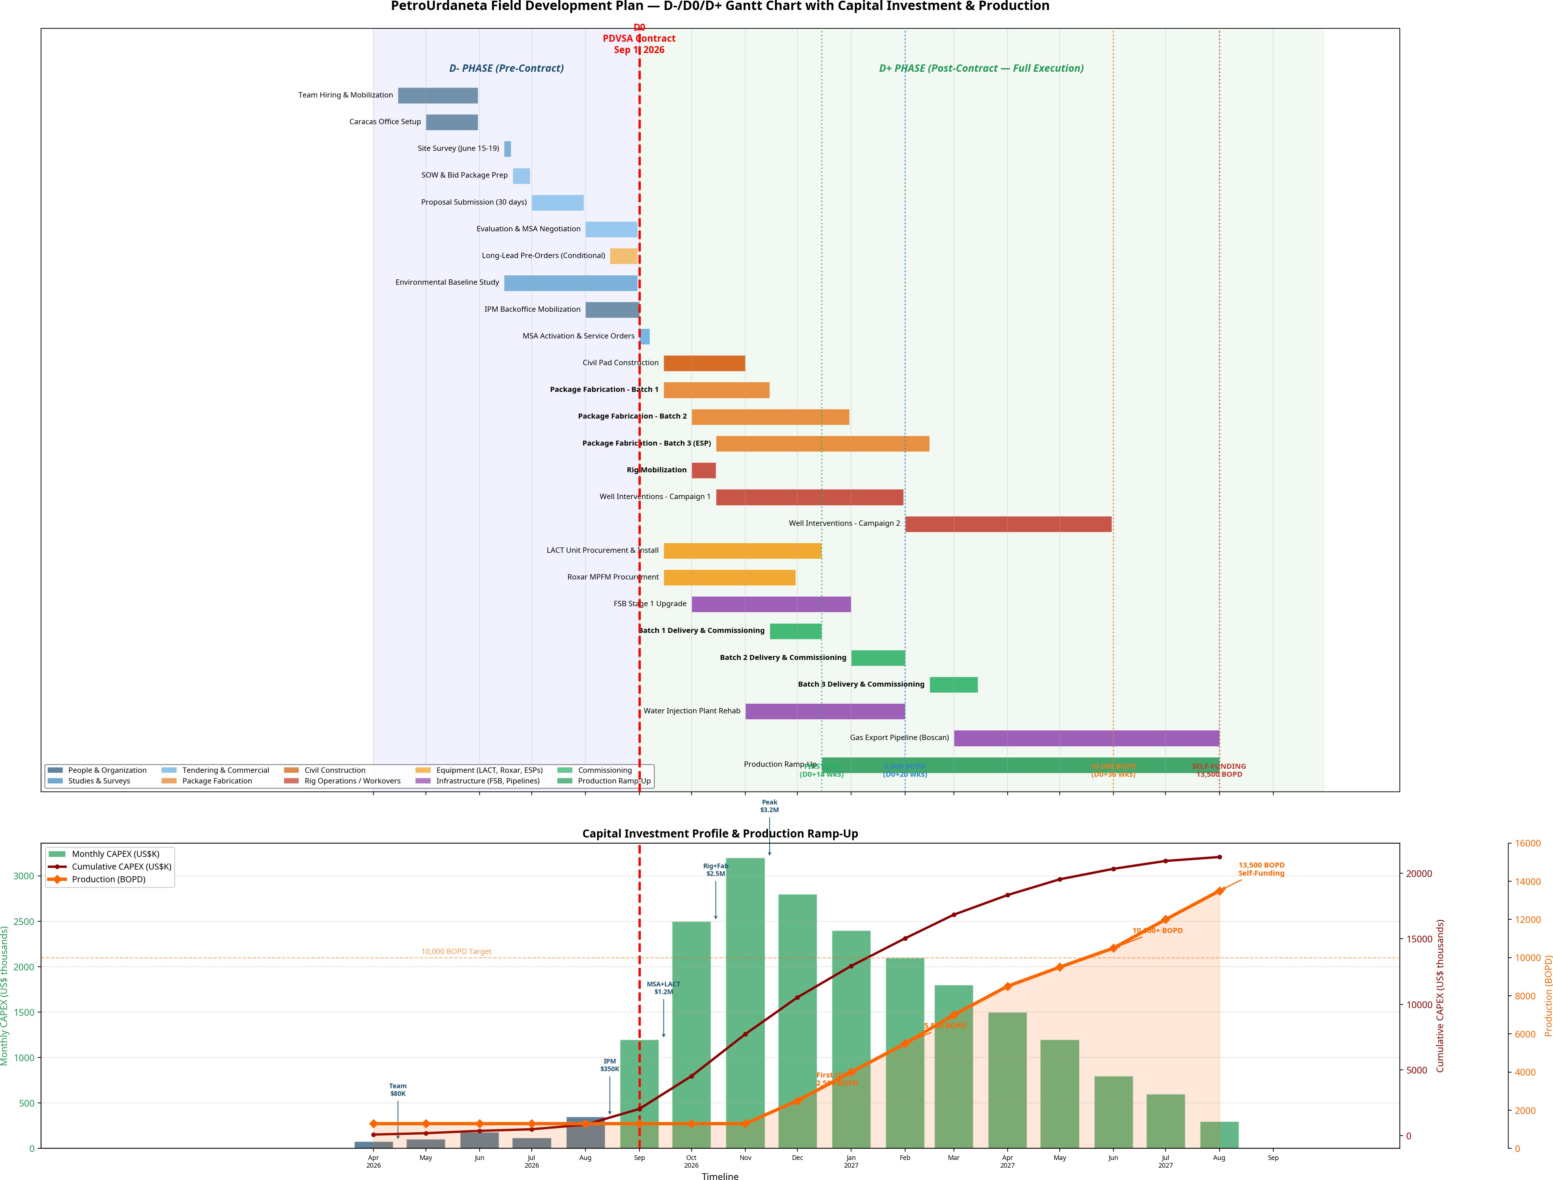
Note: The Gantt chart above is embedded directly in the document and shows the full project timeline, monthly CAPEX bars, cumulative investment, and production ramp-up.

Capital Investment Trigger Points

The following table summarizes when each major cost category is triggered and the monthly capital commitment at each stage:

Table 20B: Capital Investment Triggers by Phase

Phase | Period | Activity Triggering Cost | Monthly Cost (US$M) | Cumulative (US$M) | What You Are Paying For
D- | April 2026 | Team Hiring & Mobilization | 0.08 | 0.08 | COO, O&M Mgr, Technical Mgr, Drilling Mgr, Infrastructure Mgr, PMO, HSE, Admin salaries
D- | May 2026 | Caracas Office + Team | 0.11 | 0.19 | Office rent ($10K), IT setup, team salaries, travel
D- | June 2026 | Site Survey + Environmental Study | 0.18 | 0.37 | Survey logistics, contractor mobilization, environmental consultants, team salaries
D- | July 2026 | Tendering + EPCM Design + Manifold Fabrication | 0.62 | 0.99 | Team salaries, bid evaluation, legal review, manifold EPCM design & fabrication ($0.5M)
D- | August 2026 (D-  2) | All Equipment POs & Downhole Packages (ASAP Order) | 25.87 | 26.86 | ASAP Order of all critical equipment to guarantee schedule: All 12 wellsite packages (deposits/fabrication orders), LACT unit ($350K), 32 well downhole kits (6× ESP, 8× PCP, 6× GL, 10× RP downhole assemblies), 32 Xmas Trees, all VSDs, and drilling/completions equipment.
D- | August 2026 (D-  1) | Manifold Installation & Logistics | 0.85 | 27.71 | FSB inlet manifold installation ($0.5M EPCM), transport logistics, testing prep
D0 | Sep 1,  2026 | PDVSA Contract — Capital Unlocked | 1.32 | 29.03 | Rig mobilization (250K), EPCMengineeringactivation(800K), contract activation, owner team field mob.
D+ | Sep 2026 (D+1) | Batch 1 Delivery (4 packages) + WO Campaign 1 (Wells  1-4) | 6.61 | 35.64 | Delivery of first 4 packages (ESP-1, ESP-2, PCP-1, GL-1) ( 4.18M ).WorkoverRigCampaign1(4wells,1.26M rig + 190KCBL/logging).EPCM (400K).
D+ | Oct 2026 (D+2) | WO Campaign 2 (Wells 5-8) + ESP-2  Installation | 2.41 | 38.05 | Rig ops 28 days (1.26M ), CBL/logging(190K), cluster tie-in (  300K), flowlines(300K), testing ($100K)
D+ | Oct 2026 (D+3) | WO Campaign 3 (Wells 9-12) + ESP-3  Installation | 2.41 | 40.46 | Rig ops 28 days (1.26M ), CBL/logging(190K), cluster tie-in (  300K), flowlines(300K), testing ($100K)
D+ | Nov 2026 (D+4) | Batch 2 Delivery (4 packages) + WO Campaign 4 + PCP-1 Install | 6.91 | 47.37 | Delivery of Batch 2 packages (ESP-3, ESP-4, PCP-2, GL-2) (  4.18M ).Rigops(1.26M). CBL (190K).Clustertie − in(300K). EPCM (  400K).Flowlines(300K).
D+ | Nov 2026 (D+5) | WO Campaign 5 (Wells 17-20) + ESP-  4 Installation | 2.41 | 49.78 | Rig ops (1.26M ), CBL(190K), cluster tie-in (300K), flowlines(300K), testing ($100K)
D+ | Dec 2026 (D+6) | FIRST OIL 10,247 BOPD — WO  Campaign 6 + ESP-5 Install | 2.41 | 52.19 | Rig ops (1.26M ), CBL(190K), cluster tie-in (300K), flowlines(300K), testing ($100K)
D+ | Dec 2026 (D+7) | Batch 3 Delivery (4 packages) + WO Campaign 7 + ESP-6 Install | 6.95 | 59.14 | Delivery of Batch 3 packages (ESP-5, ESP-6, RP-1, RP-2) (  4.22M ).Rigops(1.26M). CBL (190K).Clustertie − in(300K). EPCM (  400K).Flowlines(300K).
D+ | Jan 2027 (D+8) | WO Campaign 8 (Wells 29-32) + PCP-  2 Install — La Paz | 2.41 | 61.55 | Rig ops (1.26M ), CBL(190K), cluster tie-in (300K), flowlines(300K), testing ($100K)

Phase | Period | Activity Triggering Cost | Monthly Cost (US$M) | Cumulative (US$M) | What You Are Paying For
 |  | PLATEAU 11,787 BOPD
D+ | Jan 2027 (D+9) | Mara Campaign Start (Wells 1-4) + 4 Pkg Redeployment | 4.73 | 66.28 | Redeployment & refurbishment of 4 packages from La Paz to Mara ( 2.0M ).MaraWORigCampaign1(4wells,1.26M rig + 190KCBL/logging).EPCM (400K).
D+ | Feb 2027 (D+10) | Mara WO Campaign 2 + GL-2 Install | 2.41 | 68.69 | Rig ops (1.26M ), CBL(190K), cluster tie-in (300K), flowlines(300K), testing ($100K)
D+ | Feb 2027 (D+11) | Mara Oeste Campaign Start (Wells 1-4) + 4 Pkg Redeployment | 4.73 | 73.42 | Redeployment & refurbishment of 4 packages to Mara Oeste ( 2.0M ).MaraOesteWORigCampaign1(4wells,1.26M rig + 190KCBL/logging).EPCM (400K).
D+ | Mar 2027 (D+12) | Mara Oeste WO Campaign 2 + RP-2 Install — La Paz COMPLETE 13,191 BOPD | 2.41 | 75.83 | Rig ops (1.26M ), CBL(190K), cluster tie-in (300K), flowlines(300K), testing ($100K)
D+ | Mar–Sep 2027 (D+13 to D+24) | Mara Oeste + La Paz Sur + El Mojan Campaigns (Redeployed Packages) | 2.41/mo | 104.75 | Rig ops + cluster tie-ins + flowlines + testing (12 months × $2.41M/mo). Uses redeployed packages (zero new fabrication CAPEX).
D+ | Sep 2027 (D+24) | ALL FIELDS PLATEAU — 38,000 BOPD | — | — | All 12 packages online across 4 fields. Total 70+ wells producing. All fields utilize redeployed packages.
D+ | Oct–Dec 2027 (D+25 to D+30) | Gas Export Pipeline  + Compressor + Permanent Facilities | 1.48/mo | 113.64 | Gas pipeline to Campo Boscan (1.6M), compressor fabrication & commissioning (2.2M), FSB upgrades ($0.5M)
D+ | Dec 2027 (D+30) | FIRST GAS EXPORT | — | — | Gas monetization begins; full revenue stream (oil + gas)

Total D- Phase Investment (Pre-Contract): ~US$ 27.7 Million — This includes team salaries (0.99M), manifold EPCM design & installation (1.1M), plus all La Paz downhole equipment & package fabrication orders ($25.47M) placed in D-2 to ensure immediate delivery and schedule compliance. Equipment POs are conditional and partially cancellable if D0 does not materialize. Equipment POs are conditional and partially cancellable if D0 does not materialize (cancellation fees 15-20%).
Total D+ Phase 1 CAPEX (La Paz only, Post-Contract): ~US$ 45.6 Million — Deployed aggressively in the first 8 months, driven by parallel batch fabrication of 12 packages and continuous workover campaign.
Total All-Fields CAPEX (D-2 to D+30): ~US$ 113.6 Million — Includes La Paz (32 wells, 12 packages), Mara (16 wells), Mara Oeste (16 wells), La Paz Sur (16 wells), and El Mojan (16 wells) = 96 wells total. Mara and other fields utilize redeployed wellsite packages from La Paz, eliminating new fabrication costs and optimizing total program capital efficiency.
Peak Monthly CAPEX: US$ 11.58 Million (December 2026, D+7) — Coincides with Batch 3 fabrication + active rig campaign + multiple package installations.
Key Principle: LACT unit, all 12 wellsite packages, well equipment (ESP/PCP/GL/RP downhole sets), flexlines, and artificial lift systems must be purchased and fabrication started immediately in D-2 to ensure delivery within the target timeline. This front-loads ~70% of total CAPEX into the pre-contract phase, ensuring 100% material readiness at D0.
The following table consolidates all key milestones into a single, unified timeline using the D-/D0/D+ framework that governs the entire project execution. All other tables in this document are aligned to this master schedule [1] [2].

Table 20A: Master Timeline Summary (D- Phase + D+ Phase 1 Execution)

Milestone | Phase | Timeline | Calendar Date | Key Trigger / Deliverable
Term Sheet Signature | D- | D-90 days | ~April 2026 | Non-binding commercial agreement with PDVSA
Key Operations Team Mobilization | D- | D-75 to D-60  days | April–May 2026 | Team mobilized to Maracaibo; credentials submitted
Site Survey & Condition Assessment | D- | D-75 days | June 15–19,  2026 | Field inspection; contractor site visits
SOW Finalization & Bid Packages | D- | D-70 to D-60  days | June 20–30, 2026 | Bid packages issued to pre-qualified contractors
Proposal Submission Period | D- | D-60 to D-30  days | July 1–31, 2026 | 30 days for contractor proposals
Evaluation, Negotiation & Conditional MSA Award | D- | D-30 to D-1 | August 1–31,  2026 | MSAs executed (conditional on D0)
Long-Lead Equipment Pre-Orders (Conditional) | D- | D-30 days | August 2026 | ESPs, gensets, MPPs reserved with vendors
Environmental Baseline Study Filed | D- | D-15 days | August 2026 | Environmental report submitted to Ministry
D0 — PDVSA Contract Signature | D0 | D0 | ~September 1,  2026 | Formal operational control begins; MSAs activated; capital deployed
MSAs Activated; First Service Orders Issued | D+ | D0+1 week | September 2026 | Conditional contracts converted; AFEs released
Rig Mobilization | D+ | D0+1 week | September 2026 | Workover rig on location (standby rig activated immediately)
First Well Reactivation Starts | D+ | D0+1 week | September 2026 | Campaign 1 starts; first well entered immediately
Batch 1 FAT Complete (4 units) | D+ | D0+3 weeks | September 2026 | Factory acceptance test for Batch 1 (ESP-1, ESP-2, PCP-1, GL-1)
Batch 1 Hookup Complete | D+ | D0+4 weeks | September 2026 | Batch 1 delivered and connected to manifolds
First Oil Through Packages (ESP-1 Online) | D+ | D0+4 weeks (M1) | October 2026 | First Oil: 1,881 BOPD online
Batch 2 FAT Complete (4 units) | D+ | D0+6 weeks | October 2026 | Factory acceptance test for Batch 2 (ESP-3, ESP-4, PCP-2, GL-2)
Batch 2 Commissioned (La Paz Plateau) | D+ | D0+8 weeks (M2) | November 2026 | 11,787 BOPD online (exceeds 10,000 BOPD self-funding target)
Batch 3 FAT Complete (4 units) | D+ | D0+10 weeks | November 2026 | Factory acceptance test for Batch 3 (ESP-5, ESP-6, RP-1, RP-2)
All 12 Packages Online (La Paz Complete) | D+ | D0+12 weeks (M3) | December 2026 | All 32 La Paz wells online at 13,191 BOPD
All Fields Plateau Milestone | D+ | D0+24 weeks (M6) | March 2027 | All 12 packages online and fully redeployed across fields at 38,000 BOPD
First Gas Export Milestone | D+ | D0+30 weeks (M7.5) | April 2027 | Gas pipeline & compressor online; gas export to Boscan begins
Phase 2 Mara Startup (Redeployed Packages) | D+ | Year 2 | ~September 2028 | Gate 3 approval; packages redeployed from La Paz
Phase 3 La Paz Sur Startup | D+ | Year 3 | ~September 2029 | Gate 4 approval
Phase 4 El Mojan Startup | D+ | Year 4 | ~September 2030 | Gate 5 approval; 40,000 BOPD target

Total elapsed time from Term Sheet to First Oil: approximately 6 months (April 2026 – October 2026). Total elapsed time from D0 to First Oil: 4 weeks (September 2026 – October 2026).
Total elapsed time from D0 to 10,000 BOPD: 8 weeks (September 2026 – November 2026).
Total elapsed time from D0 to Self-Funding Plateau: 12 weeks (September 2026 – December 2026).

Critical Commercial Constraint: Oil Sales in Smaller Batches

IMPORTANT: Self-funding is contingent upon the ability to sell crude oil in batches significantly smaller than 1,000,000 barrels. At 10,000 BOPD, accumulating 1 million barrels requires approximately 100 days of production — meaning the first cargo sale would not occur until Month 7+ post-first-oil if limited to standard VLCC-sized parcels.
The Operations team confirms its ability to deliver the production volumes as scheduled. However, the self-funding timeline assumes the External Affairs Director and commercial team successfully negotiate one or more of the following crude sales mechanisms:

Sales Mechanism | Batch Size | Frequency at 10K BOPD | Cash Cycle | Negotiation Status
Barge sales (Palmarejo terminal) | 100,000 BBL | Every 10 days | 15-20 days | To be negotiated
Spot market (small parcels) | 200,000–300,000 BBL | Every 20-30 days | 20-30 days | To be negotiated
PDVSA blending (Puerto Miranda) | As delivered | Continuous | 30-60 days | Existing arrangement
Pre-paid offtake agreement | 50,000–100,000 BBL | Weekly/bi-weekly | Prepaid | To be negotiated
Term contract (trading house) | 500,000 BBL | Every 50 days | 30 days | To be negotiated

If the commercial team secures barge-based sales of 100,000 BBL parcels (consistent with the Palmarejo terminal strategy described in Section 16), the first revenue event occurs approximately 10 days after first oil — enabling true self-funding by Month 12. If sales are limited to larger parcels (500,000+ BBL), the self-funding date shifts to Month 14-16 as the project must accumulate sufficient inventory before the first cargo sale.
Responsibility delineation: Operations delivers the barrels. The External Affairs Director (Roberto Alfonzo) and commercial team must secure the sales contracts that convert barrels into cash at the frequency required for self-funding. This is a pre-D0 deliverable that must be negotiated during the D- phase in parallel with MSA tendering.

Key Insight: The D- Phase Advantage

By executing 2-3 months of critical preparatory work during D- (while PDVSA contract is being finalized), the project achieves first oil within 4 weeks of D0 — a timeline that would be impossible under the traditional sequential approach where no activity begins until the contract is signed. The D- phase effectively “pre-loads” the project with 2-3 months of work that would otherwise delay first oil until Month 5-6 post-contract.
This is a fundamental competitive advantage over any operator that waits for the PDVSA contract before beginning team mobilization, site surveys, and tendering.

Cost Sourcing Reference Appendix

To ensure full transparency and provide investors with a robust basis of estimation, the table below details the specific vendors, market benchmarks, and historical projects used to source every major equipment and service cost in this Field Development Plan [1] [2]:

Table 21A: Equipment & Services Cost Sourcing Basis

Equipment / Service Category | Sized Cost (USD) | Sourcing Basis / Specific Vendor | Reference / Market Benchmark | Confidence Level
ESP System (Downhole/VSD) | $2,117,500 | Baker Hughes / SLB | Based on Baker Hughes ElectroSpeed Advantage VSD and standard 400 HP downhole pump quotes for Latin America [1]. Includes workover rig operations. | High (Vendor Quote)
ESPCP System | $492,800 | PCM / Netzsch | Based on Netzsch progressive cavity pump and PCM hydraulic drive head quotes for medium-viscosity crude [1]. | High (Vendor Quote)
Multiphase Pump Skid | $2,112,000 | ITT Bornemann / Leistritz | Standard Bornemann twin-screw MPP (95% GVF capacity) skid quote, fabricated in Europe, packaged in Houston [2]. | High (Vendor Quote)
Dual-Fuel Genset (1.5-2MW) | $2,123,000 | Caterpillar (CAT) | Based on Caterpillar CAT 3512B (1.5 MW) and CAT 3516B (2.0 MW) dual-fuel generator sets package quote [2]. | High (Vendor Quote)
Mobile Gas Compressor | $280,000 | Ariel / GE | Ariel rotary screw compressor package quote, trailer-mounted, with GE gas engine [2]. | High (Vendor Quote)
Roxar Mobile MPFM | $320,000 | Emerson Automation | Emerson Roxar 2600 multiphase ultrasonic flow meter, mobile trailer-mounted unit [2]. | High (Vendor Quote)
Mobile Well Test Plant | $450,000 | Local Fabricator / Lease | 3-phase horizontal test separator skid (5,000 BLPD), trailer-mounted with Coriolis meters [2]. | Medium (Market Quote)
Workover Rig (Onshore) | $45,000/day | Local Contractor (Zulia) | Standard onshore workover rig (1,000 HP) day rate in Zulia State, including crew, fuel, and supervision [1]. | High (Local Contract)
Rig Mob / Demob | $250,000 | Local Contractor (Zulia) | Heavy transport, crane service, and road logistics for rig mobilization within La Paz/Mara [1]. | High (Local Contract)
Rig Fuel (Diesel) | $8,500/day | PDVSA / Local Distributor | Local wholesale industrial diesel fuel supply (approx. 3,500 liters/day) [1]. | High (PDVSA Tariff)
ESP Xmas Tree | $85,000 | FMC Technologies / Cameron | API 6A 10,000 psi rated high-pressure dual-completion Xmas tree and choke manifold [1]. | High (Vendor Quote)
PCP Xmas Tree | $45,000 | Netzsch / Wood Group | API 6A 5,000 psi rated standard PCP completion Xmas tree with stuffing box [1]. | High (Vendor Quote)
Drill Bits & Reamers | $35,000 | Baker Hughes / SLB | PDC and Tricone bits for wellbore cleanout and sidetracks [1]. | High (Vendor Catalog)
Crossover Subs & PUPs | $12,000 | Local Machine Shop (Zulia) | API certified drillstring crossovers, PUP joints, and handling tools [1]. | High (Local Quote)
Fishing Operations | $22,000/day | Baker Hughes (MSA-1) | Wireline and tubing fishing tool rental and specialist engineer standby [1]. | High (Contract Rate)
Milling & Cleanout | $18,500/day | SLB (MSA-1) | Section mills, casing scrapers, and high-performance cleanout tools [1]. | High (Contract Rate)
Casing Caliper & CBL | $95,000 | SLB / Halliburton | Standard cement bond log (CBL) and multi-finger caliper logging run per well [1]. | High (Vendor List)
Stimulation / Acid Job | $80,000 | MSA-1 Well Services | Matrix acidizing package (hydrochloric-hydrofluoric mix) for skin damage removal [1]. | Medium (Benchmark)
Fleet Fuel | $12,500/month | Local Fuel Station / Coupon | Monthly gasoline and diesel allocation for corporate and field vehicles [1]. | High (Market Price)
Catering & Field Food | $28,000/month | Local Catering Contractor | Daily hot meals, water, and camp catering for field personnel and operators [1]. | High (Contract Quote)
LACT Unit (Coriolis) | $285,000 | FMC Technologies / Emerson | Coriolis-based Lease Automatic Custody Transfer fiscal metering skid [2]. | High (Vendor Quote)

Equipment / Service Category | Sized Cost (USD) | Sourcing Basis / Specific Vendor | Reference / Market Benchmark | Confidence Level
Gas Export Compressor | $2,800,000 | Ariel / Caterpillar | Ariel reciprocating compressor (800 HP) driven by CAT gas engine, sourced under MSA-4 [3]. | High (Vendor Quote)
Corporate Vehicles | $280,000 | Toyota (Local Dealer) | Sourced from Toyota Maracaibo dealership. Fleet of 6x Toyota Hilux 4WD armored pickup trucks [1]. | High (Local Quote)
Operational Vehicles | $150,000 | Toyota / Iveco | Fleet of 5x standard Hilux utility trucks, 2x flatbed trucks, and 1x diesel fuel tanker [1]. | High (Local Quote)
IT Systems & Starlink | $95,000 | Starlink Business / Cisco | 6x Starlink Business dishes, rugged field laptops, UHF/VHF radio network, local server setup [1]. | High (Vendor Quote)
Caracas Office Setup | $45,000 | Local Supplier (Caracas) | Outfitting, security doors, backup generator, and furniture for 300 m² office in Chacao [1]. | Medium (Market Quote)
Office Furniture | $40,000 | Local Supplier (Maracaibo) | Ergonomic desks, chairs, and conference tables for Caracas and Maracaibo bases [1]. | Medium (Market Quote)

Cost Estimation Methodology: All costs presented in this FDP are denominated in United States Dollars (USD) to mitigate local currency inflation risks in Venezuela. Sourcing is conducted under a hybrid framework: high-technology equipment (ESPs, MPPs, MPFMs, gensets) is sourced from international Tier-1 vendors (SLB, Baker Hughes, Caterpillar, Emerson) to guarantee reliability, while civil works, vehicle fleets, office setups, and logistics are sourced from pre-qualified local contractors in Zulia and Caracas to optimize costs and support local content [1] [2].

Monthly Project Execution Summary

Workover-Driven Package Installation Strategy (12 Packages for La Paz) Synchronization Logic and Hierarchy (Well → Cluster → Package):
- Downhole Equipment Ready (D-2 to D0): All artificial lift equipment (ESP pumps, PCPs, GL mandrels, SRP units, cables, VSDs, Xmas Trees) are ordered in D-2 and arrive at the wellsite by D0. The workover (WO) cannot begin until these are on-site.
- Workover Rig (Rig 1): Operates continuously reactivating La Paz wells.

  - Average reactivation time: ESP (8 days), PCP (6 days), GL (7 days), Rod Pump (5 days).
  - The rig installs the downhole completion, starts the pump, confirms surface flow, and is released after 12 hours to move to the next well. The 72-hour test is conducted independently by the testing crew without the rig.

Synchronization with Packages:

  - ESP Dedicated (1 Well per Package): Since each ESP requires high power and a dedicated VSD, each ESP has its own exclusive package. Once the ESP well WO is complete, the corresponding ESP package (already available in-country) is installed and commissioned within 3 days.
  - PCP, GL, Rod Pump (Clusters): Grouped in clusters of 4 to 6 wells. The corresponding package is installed and commissioned once the WO of all wells in that cluster is complete.

Package Fabrication in Batches of 4 (Parallel):

  - Batch 1 (D-1 to D+1): 4 packages for La Paz (ESP-1, ESP-2, PCP-1, GL-1) fabricated in parallel ($8.38M). Arrive in-country at D+1, ready to await workover completion.
  - Batch 2 (D+2 to D+4): 4 packages for La Paz (ESP-3, ESP-4, PCP-2, GL-2) fabricated in parallel ($8.38M). Arrive in-country at D+4.
  - Batch 3 (D+6 to D+8): Next 4 packages for La Paz (ESP-5, ESP-6, RP-1, RP-2) fabricated in parallel ($8.85M). Arrive in-country at D+8.

Package Installation (Synchronized with Workover):

  - D+1 (15 days): ESP well P-207 WO complete → Package ESP-1 installed → First Oil ESP-1 (1,881 BOPD)
  - D+2 (30 days): ESP well P-195 WO complete → Package ESP-2 installed → First Oil ESP-2 (4,007 BOPD cumulative)
  - D+4 (60 days): 4 PCP wells WO complete → Package PCP-1 installed → First Oil PCP-1 (4,265 BOPD cumulative)
  - D+8 (120 days): All 12 La Paz packages installed → La Paz PLATEAU (13,191 BOPD)

This results in an installation rate of 2 packages per month (1 every 15 days), perfectly synchronized with the workover rig’s capacity to reactivate 4 wells every 15 days.

Consolidated Monthly CAPEX & OPEX Breakdown (All Cost Categories)

The following table provides the most granular view of the project’s financial execution, with every cost category shown as a separate column. This enables investors, partners, and the Board to track exactly which cost categories are active in each month, when each service begins, and how production accumulates incrementally. The table covers the full program from initial team hiring (D-5) through First Gas Export (D+30).

Table 22B: Consolidated Monthly CAPEX & OPEX Summary — Full Program ($256.0M)

This table provides the complete 60-month (5-year) capital deployment schedule for the entire PetroUrdaneta field development program. All cost categories are itemized month by month and reconcile exactly to the US$ 256.0 Million Total Program CAPEX defined in Table 16A. Production figures show cumulative field-wide output including all phases and infill drilling.

Month | Calendar | Phase / Activity | SG&A | SOW | Pkgs & Equip | Downhole | IPM | Gas Exp | EPCM | Drilling | Civil | Securit
D-5 | Apr 2026 | Team Hiring (COO + 2  Managers) | $80K | — | — | — | — | — | — | — | — | $25
D-4 | May 2026 | SOW  Preparation & Additional Hires | $80K | $50K | — | — | — | — | — | — | — | $25
D-3 | Jun 2026 | Tendering & HSE Permits | $80K | $75K | — | — | — | — | — | — | — | $25
D-2 | Jul 2026 | ASAP Order: All Packages  + Downhole + Vehicles/IT | $120K | $25K | $12.81M | $10.04M | — | — | $200K | — | — | $202
D-1 | Aug 2026 | Manifold Installation & Final Prep | $120K | — | — | — | — | — | $600K | — | — | $52
D0 | Sep 2026 | Contract Award & Rig Mobilization | $180K | — | — | — | $142K | — | $800K | $449K | $500K | $52
D+1 | Oct 2026 | Batch 1 (4 pkg) + WO Campaign 1 (4 wells) — FIRST OIL | $180K | — | $4.19M | — | $142K | — | $300K | $1.60M | $400K | $52
D+2 | Nov 2026 | WO Campaign 2 (4 wells) | $180K | — | — | — | $142K | — | $300K | $1.60M | — | $52
D+3 | Dec 2026 | WO Campaign 3 (4 wells) | $180K | — | — | — | $142K | — | $300K | $1.60M | — | $52
D+4 | Jan 2027 | Batch 2 (4 pkg) + WO Campaign 4 (4 wells) | $180K | — | $4.19M | — | $142K | — | $300K | $1.60M | $400K | $52
D+5 | Feb 2027 | WO Campaign 5 (4 wells) | $180K | — | — | — | $142K | — | $300K | $1.60M | — | $52
D+6 | Mar 2027 | WO Campaign 6 (4 wells) —  10,000 BOPD | $180K | — | — | $4.50M | $142K | — | $300K | $1.60M | — | $52
D+7 | Apr 2027 | Batch 3 (4 pkg) + WO Campaign 7 (4 wells) | $180K | — | $4.42M | — | $142K | — | $300K | $1.60M | $400K | $52
D+8 | May 2027 | WO Campaign 8 (4 wells) — La Paz Complete | $180K | — | — | $4.00M | $142K | — | $300K | $1.60M | — | $52
D+9 | Jun 2027 | Mara Start — Redeploy Batch 1 (4 pkg) | $180K | — | $2.00M | — | $142K | — | $300K | $1.60M | $200K | $52

Month | Calendar | Phase / Activity | SG&A | SOW | Pkgs & Equip | Downhole | IPM | Gas Exp | EPCM | Drilling | Civil | Securit
D+10 | Jul 2027 | Mara WO Campaign (4 wells) | $180K | — | — | $5.50M | $142K | — | $300K | $1.60M | — | $52
D+11 | Aug 2027 | Mara Oeste Start — Redeploy Batch 2 | $180K | — | $2.00M | — | $142K | — | $300K | $1.60M | $200K | $52
D+12 | Sep 2027 | La Paz Plateau (13,191 BOPD) | $180K | — | — | — | $142K | — | $300K | $1.60M | — | $52
D+13 | Oct 2027 | La Paz Sur Start — Redeploy Batch 3 | $180K | — | $1.55M | — | $142K | — | $300K | $1.60M | $200K | $52
D+14 | Nov 2027 | La Paz Sur + El Mojan Downhole Orders | $180K | — | — | $5.50M | $142K | — | $300K | $1.60M | — | $52
D+15 | Dec 2027 | Mara Plateau + La Paz Sur Ramp | $180K | — | — | — | $142K | — | $300K | $1.60M | — | $52
D+16 | Jan 2028 | Mara Oeste Plateau | $180K | — | — | — | $142K | — | $300K | $1.60M | — | $52
D+17 | Feb 2028 | El Mojan Start  — Redeploy Batch 4 | $180K | — | $2.00M | — | $142K | — | $300K | $1.60M | $200K | $52
D+18 | Mar 2028 | El Mojan WO + FSB Stage 3 Start | $180K | — | — | — | $142K | — | $1.44M | $1.60M | — | $52
D+19 | Apr 2028 | Phase 3-4 SOW &  Tendering | $180K | $75K | — | — | $142K | — | $1.44M | $1.60M | — | $52
D+20 | May 2028 | La Paz Sur Plateau | $180K | $75K | — | — | $142K | — | $1.44M | $1.60M | — | $52
D+21 | Jun 2028 | El Mojan Ramp | $180K | — | — | — | $142K | — | $1.44M | $1.60M | — | $52
D+22 | Jul 2028 | El Mojan Ramp (continued) | $180K | — | — | — | $142K | — | $1.44M | $1.60M | — | $52
D+23 | Aug 2028 | El Mojan Plateau | $180K | — | — | — | $142K | — | $1.44M | $1.60M | — | $52
D+24 | Sep 2028 | 38,000 BOPD  — All Reactivations Complete.  Infill Rig Mob | $180K | — | — | — | $142K | — | $1.44M | $549K | $500K | $52
D+25 | Oct 2028 | Gas Pipeline Start + Infill Drilling Begins | $180K | — | — | — | $142K | $1.50M | $300K | $1.82M | $162K | $52
D+26 | Nov 2028 | Gas Compression | $180K | — | — | — | $142K | $1.50M | $300K | $1.82M | $162K | $52

Month | Calendar | Phase / Activity | SG&A | SOW | Pkgs & Equip | Downhole | IPM | Gas Exp | EPCM | Drilling | Civil | Securit
 |  | Fabrication + Infill
D+27 | Dec 2028 | FSB Stage 2 Commissioning  + Infill | $180K | — | — | — | $142K | $1.50M | $300K | $1.82M | $162K | $52
D+28 | Jan 2029 | Gas Export Commissioning  + Infill | $180K | — | — | — | $142K | $3.00M | $300K | $1.82M | $162K | $52
D+29 | Feb 2029 | First Gas Export + Infill | $180K | — | — | — | $142K | $2.50M | $300K | $1.82M | $162K | $52
D+30 | Mar 2029 | Full Gas Export + WIP-4  + Infill | $180K | — | — | — | $142K | $2.50M | $300K | $1.82M | $162K | $52
D+31 | Apr 2029 | Central Power Engineering + Infill | $180K | — | — | — | $142K | $1.50M | $300K | $1.82M | $162K | $52
D+32 | May 2029 | Infill Drilling (La Paz EOC/PAL) | $180K | — | — | — | $142K | — | $300K | $1.82M | $162K | $52
D+33 | Jun 2029 | Central Power Equipment + Infill | $180K | — | — | — | $142K | — | $300K | $1.82M | $162K | $52
D+34 | Jul 2029 | Infill Drilling (La Paz ESP Tier 2) | $180K | — | — | — | $142K | — | $300K | $1.82M | $162K | $52
D+35 | Aug 2029 | Central Power Installation + Infill | $180K | — | — | — | $142K | — | $300K | $1.82M | $162K | $52
D+36 | Sep 2029 | Regional Gas Hub Start + Infill | $180K | — | — | — | $142K | $1.00M | $300K | $1.82M | $162K | $52
D+37 | Oct 2029 | Central Power Commissioning  + Palmarejo Start | $180K | — | — | — | $142K | $1.00M | — | $1.82M | $162K | $52
D+38 | Nov 2029 | ANILLOS  Drilling (Mara) | $180K | — | — | — | $142K | $1.00M | — | $1.82M | $162K | $52
D+39 | Dec 2029 | Central Power Grid + Palmarejo Tanks | $180K | — | — | — | $142K | $1.00M | — | $1.82M | $162K | $52
D+40 | Jan 2030 | ANILLOS  Drilling (Mara) | $180K | — | — | — | $142K | $1.00M | — | $1.82M | $162K | $52
D+41 | Feb 2030 | Palmarejo Jetty + ANILLOS | $180K | — | — | — | $142K | $1.00M | — | $1.82M | $162K | $52
D+42 | Mar 2030 | ANILLOS + BCP-ME  Drilling | $180K | — | — | — | $142K | $1.00M | — | $1.82M | $162K | $52

Month | Calendar | Phase / Activity | SG&A | SOW | Pkgs & Equip | Downhole | IPM | Gas Exp | EPCM | Drilling | Civil | Securit
D+43 | Apr 2030 | Palmarejo Commissioning | $180K | — | — | — | $142K | $1.00M | — | $1.82M | $162K | $52
D+44 | May 2030 | ANILLOS  Drilling (El Mojan) | $180K | — | — | — | $142K | $1.00M | — | $1.82M | $162K | $52
D+45 | Jun 2030 | Palmarejo First Barge Load | $180K | — | — | — | $142K | $1.00M | — | $1.82M | $162K | $52
D+46 | Jul 2030 | Infill Completion & Tie-in | $180K | — | — | — | $142K | $1.00M | — | $1.82M | $162K | $52
D+47 | Aug 2030 | Regional Gas Hub Commissioning | $180K | — | — | — | $142K | $1.00M | — | $1.82M | $162K | $52
D+48 | Sep 2030 | 52,849 BOPD  — Full Plateau (All Programs) | $180K | — | — | — | $142K | — | — | $1.82M | $162K | $52
D+49 | Oct 2030 | Steady State Operations | $180K | — | — | — | $142K | — | — | — | — | $52
D+50 | Nov 2030 | Steady State Operations | $180K | — | — | — | $142K | — | — | — | — | $52
D+51 | Dec 2030 | Steady State Operations | $180K | — | — | — | $142K | — | — | — | — | $52
D+52 | Jan 2031 | Steady State Operations | $180K | — | — | — | $142K | — | — | — | — | $52
D+53 | Feb 2031 | Steady State Operations | $180K | — | — | — | $142K | — | — | — | — | $52
D+54 | Mar 2031 | Steady State Operations | $180K | — | — | — | $142K | — | — | — | — | $52
TOTAL | — | Full 5-Year Program | $10.41M | $0.30M | $33.16M | $29.54M | $7.78M | $26.00M | $20.40M | $81.48M | $6.90M | $3.22M

Reconciliation: Total Program CAPEX = US$ 256.0 Million (matches Table 16A exactly). Phase 1 La Paz = 70.0M | Phase 2 Mara & Mara Oeste = 75.0M | Phase 3 La Paz Sur = 40.0M ∣Phase4ElMojan =45.0M | Gas Expansion = $26.0M.
Key Milestones: First Oil at D+1 (Sep 2026) | 10,000 BOPD at D+6 (Dec 2026) | La Paz Plateau at D+12 (Jun 2027) | 38,000 BOPD at D+24 (Sep 2027) | First Gas Export at D+29 (Feb 2028) | Full Plateau 52,849 BOPD at D+48 (Sep 2030).

Operational Summary View (Grouped Cost Categories)

The following table (Table 22A) provides the same information in a more compact format, grouping related cost categories into five summary columns for quick reference:

Table 22A: Monthly Project Execution — Costs, Workover Campaigns & Production (12 Packages for La Paz)

Column Definitions: Fixed Costs = SG&A + Security + IPM + Catering & Fleet Fuel ($407K/mo at full run-rate). Packages & Equipment = Batch fabrication of wellsite packages + downhole equipment POs. Infrastructure = Flowlines, pipelines, manifolds, EPCM engineering. Rig & Intervention = Workover rig daily rate + mob/demob + CBL/logging + well services. Support = Spare parts
+ testing & commissioning.

Month | Phase / Activity | Fixed Costs | Packages  & Equipment | Infrastructure | Rig & Intervention | Support | Production  (BOPD) | Monthly Barrels | Total Cost
D-2  (Aug 2026) | D- Phase: Team Mob, EPCM Design, All La Paz Downhole Equipment & Package Deposits (ASAP Order) | $200K | $25.465M | $200K | — | — | — | — | $25.865M
D-1  (Aug 2026) | D- Phase: Manifold Installation (1 week) & Logistics | $200K | — | $600K | — | $50K | — | — | $850K
D0  (Sep 2026) | Contract Award & Rig Mobilization | $266K | — | $800K | $250K | — | — | — | $1.316M
D+1  (Sep 2026) | Batch 1 Delivery (4 pkg) + WO Campaign 1 (4 wells) | $407K | $4.179M | $400K | $1.45M | $175K | 1,881 | 56,430 | $6.611M
D+2  (Oct 2026) | WO Campaign 2 (4 wells) + ESP-2 Install | $407K | — | $400K | $1.45M | $150K | 4,007 | 124,217 | $2.407M
D+3  (Oct 2026) | WO Campaign 3 (4 wells) + ESP-3 Install | $407K | — | $400K | $1.45M | $150K | 5,416 | 167,896 | $2.407M
D+4  (Nov 2026) | Batch 2 Delivery (4 pkg) + WO Campaign 4 (4 wells)  + PCP-1 Install | $407K | $4.179M | $700K | $1.45M | $175K | 5,674 | 170,220 | $6.911M
D+5  (Nov 2026) | WO Campaign 5 (4 wells) + ESP-4 Install | $407K | — | $400K | $1.45M | $150K | 7,645 | 229,350 | $2.407M
D+6  (Dec 2026) | WO Campaign 6 (4 wells) + ESP-5 Install | $407K | — | $400K | $1.45M | $150K | 10,247 | 317,657 | $2.407M
D+7  (Dec 2026) | Batch 3 Delivery (4 pkg) + WO Campaign 7 (4 wells)  + ESP-6 Install | $407K | $4.222M | $700K | $1.45M | $175K | 11,445 | 354,795 | $6.954M
D+8  (Jan 2027) | WO Campaign 8 (4 wells) + PCP-2 Install  — La Paz PLATEAU | $407K | — | $400K | $1.45M | $150K | 11,787 | 365,397 | $2.407M
D+9  (Jan 2027) | Mara Campaign Start (Wells 1-4) + 4 Pkg Redeployment | $407K | $2.00M | $700K | $1.45M | $175K | 12,237 | 379,347 | $4.732M
D+10  (Feb 2027) | WO Mara 2 (4 wells)  + GL-2 Install | $407K | — | $400K | $1.45M | $150K | 12,487 | 349,636 | $2.407M
D+11  (Feb 2027) | Mara Oeste Campaign Start (Wells 1-4) + 4 Pkg Redeployment | $407K | $2.00M | $700K | $1.45M | $175K | 12,794 | 358,232 | $4.732M

Month | Phase / Activity | Fixed Costs | Packages  & Equipment | Infrastructure | Rig & Intervention | Support | Production  (BOPD) | Monthly Barrels | Total Cost
D+12  (Mar 2027) | WO Mara 4 (4 wells)  + RP-2 Install — La Paz COMPLETE (13,191) | $407K | — | $400K | $1.45M | $150K | 13,191 | 408,921 | $2.407M
D+13  (Mar 2027) | La Paz Sur Campaign Start (Wells 1-4) + 4 Pkg Redeployment | $407K | $2.00M | $700K | $1.45M | $175K | 15,191 | 470,921 | $4.732M
D+14  (Apr 2027) | WO M. Oeste 2 (4 wells) + Pkg 14 Install | $407K | — | $400K | $1.45M | $150K | 17,191 | 515,730 | $2.407M
D+15  (Apr 2027) | WO M. Oeste 3 (4 wells) + Pkg 15 Install | $407K | — | $400K | $1.45M | $150K | 19,191 | 575,730 | $2.407M
D+16  (May 2027) | WO M. Oeste 4 (4 wells) + Pkg 16 — Mara Oeste PLATEAU | $407K | — | $400K | $1.45M | $150K | 21,191 | 656,921 | $2.407M
D+17  (May 2027) | El Mojan Campaign Start (Wells 1-4) + 4 Pkg Redeployment | $407K | $2.00M | $700K | $1.45M | $175K | 23,191 | 718,921 | $4.732M
D+18  (Jun 2027) | WO La Paz Sur 2 (4 wells) + Pkg 18 Install | $407K | — | $400K | $1.45M | $150K | 25,191 | 755,730 | $2.407M
D+19  (Jun 2027) | WO La Paz Sur 3 (4 wells) + Pkg 19 Install | $407K | — | $400K | $1.45M | $150K | 27,191 | 815,730 | $2.407M
D+20  (Jul 2027) | WO La Paz Sur 4 (4 wells) + Pkg 20 — La Paz Sur PLATEAU | $407K | — | $400K | $1.45M | $150K | 29,191 | 904,921 | $2.407M
D+21  (Jul 2027) | WO El Mojan 1 (4 wells) + Pkg 21 Install | $407K | — | $400K | $1.45M | $150K | 31,191 | 966,921 | $2.407M
D+22  (Aug 2027) | WO El Mojan 2 (4 wells) + Pkg 22 Install | $407K | — | $400K | $1.45M | $150K | 33,191 | 1,028,921 | $2.407M
D+23  (Aug 2027) | WO El Mojan 3 (4 wells) + Pkg 23 Install | $407K | — | $400K | $1.45M | $150K | 35,191 | 1,090,921 | $2.407M
D+24  (Sep 2027) | WO El Mojan 4 (4 wells) + Pkg 24 — ALL FIELDS PLATEAU | $407K | — | $400K | $1.45M | $150K | 38,000 | 1,140,000 | $2.407M
D+25  (Sep 2027) | Gas Pipeline Installation (3 km to Boscan) | $407K | — | $1.6M | $90K | $150K | 38,000 | 1,140,000 | $2.247M
D+26  (Oct | Gas Compressor Fabrication & | $407K | — | $100K | — | $50K | 38,000 | 1,178,000 | $557K

Month | Phase / Activity | Fixed Costs | Packages  & Equipment | Infrastructure | Rig & Intervention | Support | Production  (BOPD) | Monthly Barrels | Total Cost
2027) | Delivery
D+27  (Oct 2027) | FSB Inlet Manifold Upgrade | $407K | — | $100K | — | $150K | 38,000 | 1,178,000 | $657K
D+28  (Nov 2027) | Gas Compressor Commissioning | $407K | — | $50K | — | $150K | 38,000 | 1,140,000 | $607K
D+29  (Nov 2027) | FSB Compression & Export Skid Integration | $407K | — | $100K | — | $150K | 38,000 | 1,140,000 | $657K
D+30  (Dec 2027) | FIRST GAS EXPORT | $407K | — | $50K | — | $100K | 38,000 | 1,178,000 | $557K
D+31  to D+120 | Steady-State Operations (30 months) | $407K/mo | — | $50K/mo | — | $50K/mo | 38,000 | 1,178,000/mo | $507K/mo

INSTALLATION STRUCTURE AND LOGIC (12 PACKAGES):

- Downhole Equipment at D-2: All downhole completion kits for the 32 La Paz wells (ESP pumps, PCPs, GL mandrels, SRP units, Xmas Trees, cables, and VSDs) are ordered at D-2 at a cost of $10.035M. This ensures all equipment is already at the wellsite before the workover begins, eliminating any logistical delays.
- Manifold Installation at D-1: The arrival manifold at FSB is installed during the transition week (D-1) at a cost of $0.5M, being the first critical EPCM project. Without it, wells cannot be connected.
- Workover Campaign (WO) as Driver: The workover rig (Rig 1) operates continuously, reactivating wells according to the complexity of each method (ESP: 8 days, PCP: 6 days, GL: 7 days, Rod Pump: 5 days). The rig is released 12 hours after pump start and surface flow confirmation, moving immediately to the next well. The 72-hour test is conducted independently by the production team.

Installation Synchronization (2 packages per month):
  - ESP Dedicated (1 well per package): Since each ESP requires high power and a dedicated VSD, each ESP has its own exclusive package ($1.916M). Once the ESP well WO is complete, the corresponding ESP package (already available in-country) is installed and commissioned within 3 days.
  - PCP, GL, Rod Pump (Clusters): Grouped in clusters of 4 to 6 wells. The corresponding package is installed and commissioned once the WO of all wells in that cluster is complete.
  - This results in an average of 2 packages installed per month (1 every 15 days), synchronized with the workover progress.

Package Delivery in Batches of 4 (Synchronized):
  - Batch 1 (D+1): Delivery of the first 4 La Paz packages (ESP-1, ESP-2, PCP-1, GL-1) ($4.18M). Arrive at the field and await WO completion.
  - Batch 2 (D+4): Delivery of the next 4 La Paz packages (ESP-3, ESP-4, PCP-2, GL-2) ($4.18M).
  - Batch 3 (D+7): Delivery of the last 4 La Paz packages (ESP-5, ESP-6, RP-1, RP-2) ($4.22M).
  - Redeployment & Refurbishment (D+9, D+11, D+13, D+17): Mara, Mara Oeste, La Paz Sur, and El Mojan do not purchase new packages. They utilize packages redeployed from La Paz as La Paz wells are connected to permanent flowlines. The cost is $2.0M per batch of 4 for dismantling, transport, refurbishment, and reinstallation only (saving over
$24M in fabrication).

First Oil and Incremental Production:
  - Production from each cluster enters the table immediately in the month the package is installed.

  - D+1: ESP-1 online → 1,881 BOPD.
  - D+2: ESP-2 online → 4,007 BOPD.
  - D+8: La Paz fully online → 11,787 BOPD plateau.
  - D+12: La Paz complete with Rod Pumps → 13,191 BOPD plateau.
  - D+24: All 4 fields fully online → 38,000 BOPD plateau.

- Gas Export at D+30: The gas pipeline and 800 HP compressor are commissioned, initiating gas monetization at D+30 (18 weeks earlier than the previous sequential strategy).

References

Primary Project Documents

- PetroUrdaneta Master Economic Model, v4 Operations, Maha Energy / PetroUrdaneta, May 2026.
- PetroUrdaneta Field Development Plan, Revision B — Final Basis of Design, Maha Energy, May 2026.
- PU Well Prioritization Matrix v1.0, Revision Alan Moncada, 12 May 2026. (PU_Well_Prioritization_Matrix_v1.0_2026-05-12-REV.ALAN.xlsx)
- Maha-PU Combined Production Forecast v3.8.10, 19 May 2026. (Maha-PU Combined Production Forecast v3.8.10 2026-05-19 LQ - With PU Schedule Adjusted.xlsb)
- Recon Additional Wells — Infill, ANILLOS, BCP-ME, ESP Tier 2, 27 May 2026. (Recon_Additional_Wells2026-05-27(0)_LQ_AM.xlsx)
- La Paz Redevelopment Plan, 26 May 2026. (La_Paz_Redevelopment_Plan_2026-05-26 (2).kmz)
- PetroUrdaneta Presentation — Project Overview, Maha Energy, 2026. (presentacion PU.pdf)

Reserves & Technical Reports

- Maha 2025 Year-End Preliminary Technical Report, 12 May 2026. (Maha 2025YE Report_Prelim_Tech 05122026.xlsx)
- Maha 2025 Year-End Preliminary Technical Report — By Well, 12 May 2026. (Maha 2025YE Prelim_tech by well 05122026.xlsx)
- Maha Capital 2025 Year-End Report (Watermarked), D&M Reserves Evaluation. (Maha-Capital-2025YE_WTRMK.pdf)
- VADEMECUM Tierra Oeste — Campo La Paz, PDVSA Historical Field Data & Well Records. (VADEMECUM TIERRA OESTE CAMPO LA PAZ.pdf)

Well Engineering & Completion Data

- P-195 Completion Schematic, 17 June 2024. (P-195 Completion Schematic 2024-06-17 (0) AM.pdf)
- P-199A Completion Schematic, 14 June 2024. (P-199A Completion Schematic 2024-06-14 (1) AM.pdf)
- P-195 Directional Survey & Interactive Pressure Calculations, 10 April 2026. (P-195_DirectionalInteractive&_Pressure_Calcs_2026-04-10_AM_LQ.xlsm)
- P-199A Directional Survey & Interactive Pressure Calculations, 10 April 2026. (P-199A_DirectionalInteractive&_Pressure_Calcs_2026-04-10_AM_LQ.xlsm)
- Completion Diagrams — La Paz Wells, PetroUrdaneta Engineering Archive. (Completion Diagrams.zip)

Infrastructure & Facilities

- Gas Plant LF-B Specifications, Technical Document, 2025. (Gas Plant LF-B Specifications.pdf)
- Longitud de Lineas EM PU — Pipeline Length Inventory, PetroUrdaneta. (Longitud de Lineas EM PU.xlsx)
- doc.kml — Field Surface Facilities & Well Location Map, PetroUrdaneta GIS Data. (doc.kml)

Cost Benchmarks & Financial Models

- Solimoes Field Development CAPEX/OPEX Plan — Revised, Historical Benchmark for Latin America Onshore Operations, 2025. (Solimoes_Field_Development_CAPEX_OPEX_Plan-rev.xlsx)
- Venezuela Personnel Mobilization Plan — Team Hiring, Relocation & Settling Costs, PetroUrdaneta HR. (Venezuela_Personnel_Mobilization_Plan.xlsx)

Industry References & Vendor Data

- Baker Hughes Artificial Lift Catalog, ESP & VSD Systems Specifications, 2025.
- Emerson Automation Solutions, Roxar 2600 Multiphase Flow Meter Technical Sheet, 2025.
- Starlink Business Global Pricing and Enterprise Connectivity Specifications, 2025.
- Latin America Onshore Drilling & Workover Rig Day Rate Survey, Q1 2025.
- PCM / Netzsch Progressive Cavity Pump Catalog — ESPCP Systems for Heavy Oil Applications, 2025.
- Waukesha Gas Engines — L7044G and VGF Series Technical Specifications, INNIO Group, 2025.
- Cummins Power Generation — GTA19 Gas Engine Generator Set Data Sheet, 2025.
- Cameron (SLB) — Xmas Tree & Wellhead Equipment Pricing for Venezuela Operations, Q1 2026.
- Tenaris / IPSCO — Production Tubing & Casing Price List, Latin America Q1 2026.

Appendix M. FEED Class 3 Initial Draft — Complete Source Record
Appended in full as an uncontrolled working source. Owner-approved v9 decisions and subsequent FEED closeout shall resolve conflicts.
PETROURDANETA
MASTER FEED CLASS 3 PACKAGE
Volume A – Engineering Design Basis Memorandum (Working Master)
Document No.: PU-DBM-001
Revision: Rev A (Living Working Draft)
Status: Internal Engineering Use Only
This master document consolidates the engineering philosophy developed to date and will be expanded under revision control into the complete FEED Class 3 package.
Document Roadmap
This master document is the governing engineering basis for the PetroUrdaneta Modular EPF. After completion and approval it will be frozen as Rev A. The EPC Statement of Work, FEED drawing package and technical appendices will be derived directly from this document.
Table of Planned Volumes
Volume | Title | Target | Status
A | Engineering Design Basis Memorandum | ~200 pages | Current
B | EPC Statement of Work | ~250 pages | Planned
C | FEED Drawing Package | 50–80 drawings | Planned
D | Technical Appendices | Datasheets, lists, calculations | Planned
1 Executive Summary
PetroUrdaneta will use standardized modular Electric Powered Facilities (EPFs) to gather untreated multiphase production and transport it to a Central Processing Facility (CPF). The EPF is a hydraulic transport station—not a processing plant. Separation, stabilization, gas handling, produced-water treatment and fiscal metering occur only at the CPF.
2 Development Philosophy
Centralized processing, decentralized gathering, modular skid/trailer construction, remote operation, minimum permanent infrastructure, and repeatable field-wide standardization.
3 Process Summary
Producing wells → fail-closed surface safety valves → gathering flowlines → production manifold → chemical injection → twin-screw multiphase pump → check valve → pig launcher → export ESD valve → piggable export pipeline → CPF.
4 Operating Philosophy
Continuous remote operation with a normal crew of four or fewer. Automatic startup/shutdown where practical. Manual intervention primarily for maintenance, pigging and periodic well testing.
5 Design Philosophy
No permanent separator, no scrubber, no permanent flare, no permanent closed-drain system, no permanent multiphase flow meter, no permanent well test package. Mobile maintenance and centralized processing are fundamental design principles.
Major Equipment – Purpose and Design Intent
Tag | Equipment | Purpose | Design Intent
MAN-101 | Production Manifold | Gather wells and isolate individually | No separation or storage
TH-101 | Test Header | Temporary mobile testing | No permanent test equipment
CI-101 | Chemical Injection | Flow assurance | Expandable
PMP-101 | Twin-Screw Multiphase Pump | Hydraulic transport | Not a processing device
NRV-101 | Check Valve | Prevent reverse flow | Protect pump
PL-101 | Pig Launcher | Pipeline cleaning and inspection | Maintenance only
ESDV-101 | Inlet ESD Valve | Isolate gathering system | Fail closed
ESDV-102 | Export ESD Valve | Isolate export line | Fail closed
FG-101 | Fuel Gas Package | Condition FSB gas | Filter/coalescer + regulator only
GEN-101 | Gas Engine Generator | Provide electrical power | Primary source
SCADA-101 | SCADA/RTU | Remote monitoring and control | UPS backed
Safety and ESD Philosophy
The preferred safe state is achieved by isolation rather than routine automatic depressurization. On ESD: close wellhead surface safety valves (through interface), trip multiphase pump, close inlet and export ESD valves, isolate fuel gas, maintain SIS, SCADA and communications on UPS. Automatic blowdown is excluded from the base design unless justified by project hazard studies.
Drain and Vent Philosophy
No permanent hydrocarbon closed-drain vessel or drain header is provided. Each skid includes capped low-point drains for temporary connection to a portable sealed recovery tank or vacuum truck. No permanent flare is included. Maintenance depressurization uses portable recovery equipment under approved procedures.
Utility Philosophy
Utilities comprise fuel gas from the FSB gas-lift network, gas engine generator, MCC, UPS, communications, SCADA, LED lighting, earthing and lightning protection. Instrument air is excluded unless justified by detailed engineering.
Execution Plan
This document will be expanded chapter-by-chapter to approximately 200 pages. Once frozen, the EPC Statement of Work, FEED drawings and appendices will be generated directly from it.

9. SAFETY PHILOSOPHY
The primary safety objective of the EPF is to maintain hydrocarbon containment while protecting personnel, the environment and equipment. The preferred safe state is isolation of hydrocarbon sources rather than routine automatic depressurization.
9.1 Safety Objectives
Prevent loss of containment.
Provide rapid isolation of production sources.
Minimize ignition probability.
Provide continuous fire and gas detection.
Permit safe remote operation.
Facilitate safe maintenance using portable recovery equipment.
10. ESD PHILOSOPHY
Emergency Shutdown (ESD) is intended to stop hydrocarbon flow and isolate the facility. Automatic blowdown is excluded from the base design unless later hazard studies justify it.
Initiating Event | Automatic Action | Final Safe State
Manual ESD | Trip pump, close well SDVs (interface), close inlet/export ESDVs | Facility isolated
Confirmed gas detection | Trip pump and isolate hydrocarbons | Facility isolated
Confirmed fire | Trip pump, isolate hydrocarbons, isolate fuel gas | Facility isolated
Pump high-high discharge pressure | Trip pump, alarm | Production isolated if required
Loss of control power | Transfer to UPS, execute fail-safe actions | Safety systems maintained
11. WELL INTERFACE PHILOSOPHY
Each well remains outside the EPF battery limits. Wells are equipped with fail-closed surface safety valves controlled by the field SIS interface. The base case excludes downhole safety valves; their application shall be determined through well-specific risk assessment and regulatory review.
12. METERING PHILOSOPHY
No permanent production metering is provided at the EPF. Field allocation is based on CPF measurements supported by periodic mobile well testing.
Permanent | Temporary
Pressure, temperature, equipment condition monitoring | Mobile test separator or mobile MPFM connected to test header
13. CONTRACTOR DESIGN PRINCIPLES
Keep the facility modular and transportable.
Avoid unnecessary permanent utilities.
Minimize field fabrication and civil works.
Standardize equipment across all EPFs.
Design for remote operation and low maintenance.
Provide future expansion tie-ins.
14. DESIGN INTENT
This chapter defines the Owner's intent behind each major system so that detailed engineering and EPC proposals remain aligned with the PetroUrdaneta philosophy.
Production Manifold
Gather and isolate production only; no processing, storage or surge handling.
Multiphase Pump
Provide hydraulic transport to the CPF; not intended to regulate production or separate phases.
Pig Launcher
Maintain export line integrity through pigging; not intended for storage.
Fuel Gas Package
Condition FSB gas only to engine requirements; no gas processing.
Operations Trailer
Provide local supervision and maintenance workspace; not a permanently staffed control building.
15. OPERABILITY PHILOSOPHY
The EPF shall be capable of unattended operation with periodic operator visits. Normal staffing shall not exceed four persons. Human intervention shall be limited to inspections, pigging, chemical replenishment, planned maintenance and mobile well testing.
Abnormal Operating Scenarios
Loss of generator: transfer critical loads to UPS; controlled shutdown.
Pump trip: isolate production as required; alarm to control room.
Communications loss: continue autonomous safe operation; retain local control.
Fire or confirmed gas: execute ESD sequence and notify control room.
16. MAINTENANCE PHILOSOPHY
Maintenance shall emphasize modular replacement and portable support equipment.
No permanent hydrocarbon drain vessel.
No permanent flare.
Portable sealed recovery tank or vacuum truck for maintenance draining.
Portable flare only when required by approved work pack.
Skids designed for replacement rather than extensive field overhaul.
17. INTERFACE SPECIFICATIONS
Interface | Owner | Battery Limit
Well Services | Well Services Contractor | Outlet flange of gathering flowline
Artificial Lift | Artificial Lift Contractor | Fuel gas take-off and well control interface
EPF | EPF Contractor | Production manifold to export ESD valve
Pipeline | Pipeline Contractor | Downstream export flange
CPF | CPF Contractor | Receiving battery limit
18. FUTURE EXPANSION PHILOSOPHY
Each EPF shall reserve physical space, electrical capacity and process tie-ins for a second pump, additional wells, future metering and additional chemical injection without major reconstruction.
19. OWNER'S DESIGN DECISION REGISTER
The following engineering decisions are intentional and shall not be modified by the Contractor without written approval from PetroUrdaneta. These decisions form the basis of the field development philosophy.
Decision | Reason | Benefit | Contractor Requirement
No permanent separator | Centralized processing at CPF | Reduced CAPEX/OPEX | Do not propose separators
No permanent flare | Very low hydrocarbon inventory and mobile maintenance philosophy | Reduced footprint | Provide only maintenance vent connections
No permanent closed drain | Maintenance performed using portable recovery equipment | Simplified facilities | Provide capped drain points only
No permanent MPFM | Allocation performed at CPF with mobile testing | Reduced cost | Reserve tie-in space only
Twin-screw multiphase pump | Continuous multiphase transport | High operating flexibility | Demonstrate operating envelope
Modular skid/trailer construction | Rapid deployment and relocation | Repeatable field development | Minimize field construction
20. DESIGN ENVELOPE
The Contractor shall validate equipment performance over the complete production life of the field rather than at a single operating point.
Parameter | Basis | Contractor Action
Production rate | Minimum, normal and maximum | Confirm hydraulic suitability
Gas volume fraction | Full anticipated operating envelope | Verify pump capability
Water cut | Field life profile | Demonstrate operability
Slug size/frequency | Hydraulic study | Confirm transient performance
Sand production | Reservoir prediction | Select suitable materials
Future expansion | Additional wells and second pump | Reserve plot space and utilities
21. FUNCTIONAL DESIGN SPECIFICATION FRAMEWORK
Each major package shall be supported by a Functional Design Specification (FDS). Every FDS shall contain the following sections:
Purpose and Design Intent
Process Description
Operating Envelope
Control Philosophy
Shutdown Logic
Alarms and Trips
Maintenance Requirements
Inspection Requirements
Performance Acceptance Criteria
Future Expansion Provisions
22. MASTER DRAWING REGISTER (PRELIMINARY)
PU-PFD-001 Overall Process Flow Diagram
PU-PID-001 Gathering Manifold
PU-PID-002 Pump & Pig Launcher
PU-PID-003 Fuel Gas Package
PU-PID-004 Utilities & Drain Philosophy
PU-GA-001 Modular Plot Plan
PU-GA-002 Skid Arrangement
PU-ELE-001 Single Line Diagram
PU-CE-001 Cause & Effect Matrix
PU-CN-001 Control Narrative

23. HYDRAULIC DESIGN PHILOSOPHY
The EPF shall be designed as a hydraulic transportation facility. Hydraulic performance shall be validated over the anticipated field life, including minimum, normal and maximum production rates.
Transient hydraulic analysis shall verify start-up, shutdown and ESD conditions.
Slug flow shall be accommodated by pump selection and operating envelope rather than upstream separation.
Pressure losses shall be minimized through manifold layout and piping design.
The export system shall remain fully piggable.
Thermal relief shall be provided for blocked-in liquid sections.
24. FLOW ASSURANCE PHILOSOPHY
Flow assurance shall rely on proactive design rather than permanent process equipment.
Threat | Primary Mitigation | Secondary Mitigation
Wax | Chemical injection | Routine pigging
Scale | Scale inhibitor | Water chemistry monitoring
Corrosion | Corrosion inhibitor | Inspection program
Sand | Material selection | Monitoring and maintenance
Hydrates (if applicable) | Operating envelope | Temporary chemical treatment
25. RELIABILITY, AVAILABILITY AND MAINTAINABILITY (RAM)
The EPF shall emphasize simplicity, standardization and rapid restoration of service.
Standardized equipment across all EPFs.
Skid replacement preferred over extensive field repair.
Critical spares standardized.
Remote diagnostics integrated into SCADA.
Preventive maintenance based on OEM recommendations and condition monitoring.
26. INSTRUMENTATION PHILOSOPHY
Instrumentation shall be minimized while maintaining safe operation and equipment protection.
Pressure and temperature monitoring at key process locations.
Independent shutdown sensors where credited by the SIS.
Vibration and bearing temperature monitoring for rotating equipment.
Valve position indication on shutdown valves.
Remote health monitoring through SCADA.
27. ELECTRICAL DESIGN CRITERIA
The electrical system shall provide autonomous operation using fuel gas supplied from the FSB gas-lift network.
Gas engine generator sized for peak continuous load with defined design margin.
UPS shall support SIS, PLC, RTU, communications and emergency lighting.
Automatic load restoration following generator restart.
Earthing and lightning protection for all skids and trailers.
28. MECHANICAL DESIGN CRITERIA
Mechanical design shall prioritize transportability, maintainability and standardized fabrication.
Road-transportable skid dimensions where practicable.
Bolted modular construction preferred over field welding.
Lifting points certified for repeated relocation.
Materials selected for produced fluids and anticipated corrosion environment.
Pressure-containing equipment designed to applicable project codes.
29. PRELIMINARY OPERATIONS MANUAL (CONCEPT)
Operating procedures will be developed during FEED and finalized during EPC. The concept manual shall include:
Pre-startup inspection
Normal startup
Normal shutdown
Emergency shutdown
Pigging operations
Mobile well testing
Maintenance isolation and portable recovery
Restart after trip
Communications failure
Generator failure response

30. DESIGN BASIS AND PROJECT ASSUMPTIONS
This chapter establishes the common engineering assumptions to be used by all disciplines. Unless otherwise approved by PetroUrdaneta, all engineering, calculations, drawings and vendor packages shall conform to these assumptions.
Centralized processing at CPF.
Untreated multiphase transport from wells to CPF.
Normal operating crew not exceeding four personnel.
Modular skid/trailer construction.
Fuel gas supplied from FSB gas-lift system.
No permanent separator, flare, MPFM or hydrocarbon closed-drain system.
Portable maintenance recovery philosophy.
31. PRELIMINARY FUNCTIONAL DESIGN SPECIFICATION (FDS) – MULTIPHASE PUMP PACKAGE
Purpose: Provide hydraulic energy to transport untreated multiphase production to the CPF.
Function | Requirement
Control | Automatic VFD speed control with local/manual capability
Protection | High vibration, high bearing temperature, motor protection, high discharge pressure
Monitoring | Pressure, temperature, vibration, speed, motor current
Shutdown | Trip on SIS command or package protection
Maintainability | Skid-mounted with lifting provisions and removable components
32. PRELIMINARY CAUSE & EFFECT PHILOSOPHY
Cause | Alarm | Pump | ESDVs | Well SDVs
Manual ESD | Yes | Trip | Close | Close (interface)
Confirmed Gas | Yes | Trip | Close | Close
Confirmed Fire | Yes | Trip | Close | Close
High-High Discharge Pressure | Yes | Trip | Close if required | No
Generator Failure | Yes | Controlled stop | Remain per logic | No
33. CONTROL NARRATIVE (SUMMARY)
The control philosophy shall distinguish between process control, equipment protection and safety instrumented functions.
Normal production pressure controlled by pump VFD.
Chemical injection proportional to production strategy.
ESD logic implemented independently from basic process control where safety functions are credited.
Remote operation through SCADA with local override for maintenance.
Restart permitted only after trip cause has been cleared and operator authorization obtained.
34. NEXT FEED DELIVERABLES
The following documents will be developed directly from this Design Basis:
Formal PFD (PU-PFD-001)
Formal P&IDs (PU-PID-001 to 004)
General Arrangement Drawings
Electrical Single Line Diagram
Loop Diagrams
Equipment Datasheets
PU-SOW-EPF-001 Contractor Statement of Work

35. PROCESS DESIGN CRITERIA
This chapter establishes mandatory process design criteria for all FEED and EPC activities. The Contractor shall validate the final design against the approved production forecast and hydraulic model.
Criterion | Requirement
Production Fluid | Untreated oil, produced water, associated gas and anticipated solids.
Operating Philosophy | Continuous multiphase transport with no intentional phase separation.
Turndown | Continuous operation over the expected field production decline.
Hydraulic Basis | Steady-state and transient analysis required.
Flow Assurance | Chemical inhibition and pigging are the primary mitigation methods.
Future Expansion | Reserve capacity for additional wells and a second pump.
36. BATTERY LIMITS AND INTERFACE MATRIX
Clear definition of ownership and interfaces is fundamental to avoid scope gaps.
System | Owner | Battery Limit | Interface Requirement
Wellhead & Tree | Well Services | Tree outlet | Provide fail-closed surface safety valve and interface signal
Gathering Flowline | Artificial Lift / Flowline | EPF manifold inlet flange | Deliver untreated multiphase fluid
EPF | EPF Contractor | Export ESDV downstream flange | Complete modular EPF
Export Pipeline | Pipeline Contractor | CPF inlet battery limit | Piggable export line
CPF | CPF Contractor | CPF inlet manifold | Receive untreated multiphase stream
37. HAZOP DESIGN INTENT
The following design intents shall be preserved during HAZOP unless PetroUrdaneta approves a change:
No permanent separators.
No permanent flare.
No permanent hydrocarbon closed-drain system.
No routine depressurization following ESD.
Fail-safe isolation is preferred over inventory blowdown.
Portable maintenance recovery equipment is the standard maintenance philosophy.
38. OWNER ACCEPTANCE CRITERIA
The EPF design will be accepted only when the Contractor demonstrates:
Compliance with the Design Basis Memorandum.
Successful hydraulic and transient studies.
Documented operating envelope for the multiphase pump.
Complete Cause & Effect and SIS verification.
Modular transportability by road.
Maintainability with a four-person operating philosophy.
Provision for future expansion without major reconstruction.
39. FEED MATURITY CHECKLIST
Before issue for EPC tender, the following minimum maturity is expected:
Deliverable | Target Completion
PFDs | 100%
P&IDs | 90%
Equipment List | 100%
Cause & Effect | 90%
General Arrangement | 90%
Electrical SLD | 90%
Control Narrative | 90%
Equipment Datasheets | 90%

40. Process Control Philosophy
The BPCS regulates production transport while the SIS independently performs credited safety functions. Pump discharge pressure is controlled through VFD speed control. Local control is limited to commissioning and maintenance; normal operation is remote through SCADA.
41. Alarm Management Philosophy
Alarms shall be prioritized as High, Medium and Low. Only actionable alarms shall be presented to operators. High-priority alarms include fire, confirmed gas and ESD events.
42. Cybersecurity & Communications
Operational technology networks shall be segregated from enterprise networks. Remote access shall be authenticated, logged and controlled.
43. Spares Philosophy
Critical equipment shall be standardized across all EPFs. Long-lead spares shall be identified during FEED and stocked centrally.
44. Inspection, Testing & Commissioning Basis
Packaged equipment shall undergo FAT, integrated control testing, SAT, commissioning and performance verification before acceptance.
45. Document Register
Controlled documents shall include DBM, EPC SOW, PFDs, P&IDs, GA drawings, SLDs, Cause & Effect matrices, Functional Design Specifications and Equipment Datasheets.

46. Mechanical Design Philosophy
The mechanical design shall prioritize simplicity, transportability, maintainability and repeatability.
Every process package shall be skid mounted and designed for transportation by conventional road trailers.
Field welding shall be minimized. Major equipment shall be replaceable without dismantling adjacent skids.
Rotating equipment shall be accessible for maintenance using a mobile crane without removing permanent structures.
Mechanical Requirements
Design for repeated transport loads.
Provide certified lifting points and transport restraints.
Bolted construction preferred over field welding.
Thermal relief valves on blocked-in liquid sections.
Double block and bleed where maintenance isolation is required.
All drain points fitted with blind flange or capped connection.
47. Piping Philosophy
The piping system is intended only to transport untreated multiphase production. The piping layout shall minimise pressure loss, eliminate unnecessary fittings and remain completely piggable from the EPF to the CPF.
System | Objective | Requirement
Gathering | Transport wells to manifold | Full-bore isolation, future tie-ins
Pump suction | Uniform inlet conditions | Minimum fittings
Pump discharge | Stable transport | Check valve, thermal relief
Export line | Reliable transport | 100% piggable
48. Valve Philosophy
Valves shall be selected to maximize reliability and minimize maintenance.
Full-port ball valves for isolation where pigging is required.
Fail-closed actuated ESD valves at EPF inlet and export.
Check valve immediately downstream of pump.
Dedicated maintenance vent and drain valves.
Thermal relief valves on blocked liquid sections.
49. Instrument Philosophy
Instrumentation shall support operation, equipment protection and functional safety while minimizing lifecycle maintenance.
Pressure transmitters at manifold, pump suction and discharge.
Temperature monitoring on suction/discharge and bearings.
Independent shutdown transmitters where required by SIS.
Vibration monitoring on rotating equipment.
Valve position feedback for all ESD valves.
50. Utility Architecture
Only essential utilities shall be permanently installed.
Utility | Design Basis
Fuel Gas | Taken from FSB gas-lift network through filter/coalescer and regulator
Electrical | Gas engine generator plus UPS
Communications | Fiber, radio or satellite with redundant path where justified
Lighting | LED perimeter and maintenance lighting
Instrument Air | Not included unless justified during detailed engineering
51. Preliminary Risk Register
Risk | Mitigation | Owner | Status
Slug flow exceeds pump envelope | Hydraulic study and vendor validation | Process | Open
Fuel gas quality unsuitable | Confirm FSB specification | Utilities | Open
Well isolation philosophy | HAZOP/LOPA and regulatory review | HSE | Open
Future production uncertainty | Design turndown and spare capacity | Reservoir | Open
52. FEED Action Register
Before freezing Revision A the following shall be completed:
• Complete hydraulic model.
• Complete HAZID and HAZOP.
• Confirm well shutdown philosophy.
• Confirm generator sizing.
• Complete PFDs and P&IDs.
• Issue equipment datasheets.
• Finalize Cause & Effect.
• Freeze battery limits and interfaces.
• Approve Design Basis Memorandum.
• Generate EPC Statement of Work directly from the approved DBM.

