Yet another epsilon meteor echo simulator
An interactive phenomenological model of overdense forward-scatter meteor echoes
International Meteor Conference 2026 Proceedings

Abstract
Overdense meteor forward-scatter echoes can display curved and rapidly evolving Doppler signatures. This contribution describes echoSim.py, an interactive Python simulator developed as a compact experiment for exploring how an extended meteor trail, bistatic observing geometry and a parameterised atmospheric wind field can combine to produce such signatures. The implementation defines an initially skewed trail, constructs the transmitter–trail–receiver geometry for every trail element, identifies the minimum total path as the specular location, and uses the local bistatic bisector to project the evolving velocity into Doppler frequency. A multi-harmonic wind field deforms the trail, while a slope-dependent weighting controls the relative contribution of different trail elements. The signal is generated by continuous phase accumulation and coherent summation, followed by a prescribed event envelope and optional Gaussian noise. The graphical interface exposes geometry, trail, wind and RF parameters and displays both trail evolution and a synthetic spectrogram. The simulator is intentionally phenomenological; its purpose is to provide a transparent environment for testing ideas about Doppler morphology rather than to provide a validated inversion model.

1. Introduction
Meteor forward-scatter echoes are produced by the interaction between an ionised trail and a bistatic transmitter–receiver geometry. In overdense events, an extended trail can contribute simultaneously at different Doppler frequencies, and the observed signature can evolve as the effective scattering region changes. The motivation for echoSim.py is therefore not to reproduce every aspect of meteor-plasma physics, but to construct a controllable numerical experiment in which the main geometrical and kinematic ingredients can be varied independently.
The deliberately provocative title reflects this role: echoSim.py is another attempt to build an epsilon-like meteor echo simulator, intended to be useful as a test bench for hypotheses about complex Doppler signatures.

2. Model description

2.1 Initial trail
The trail is represented by a relative-altitude coordinate z extending from −1.2 to +1.2 km around a reference altitude. Its initial horizontal position is x₀(z) = tan(α) z, where α is the trail-skew parameter. In the default GUI configuration α = 12.0°. The numerical derivative dx₀/dz is calculated and subsequently enters the specularity weighting.

2.2 Forward-scatter geometry
The transmitter and receiver are placed symmetrically about the reference point, with a default separation of 50 km. The reference altitude is 90 km. For each trail element, the code calculates the transmitter and receiver ranges, unit vectors and bistatic angle. The specular index is the trail element for which rₜ + rᵣ is minimum. The local bisector is the normalised sum of the two unit vectors. The wavelength is λ = c/f.
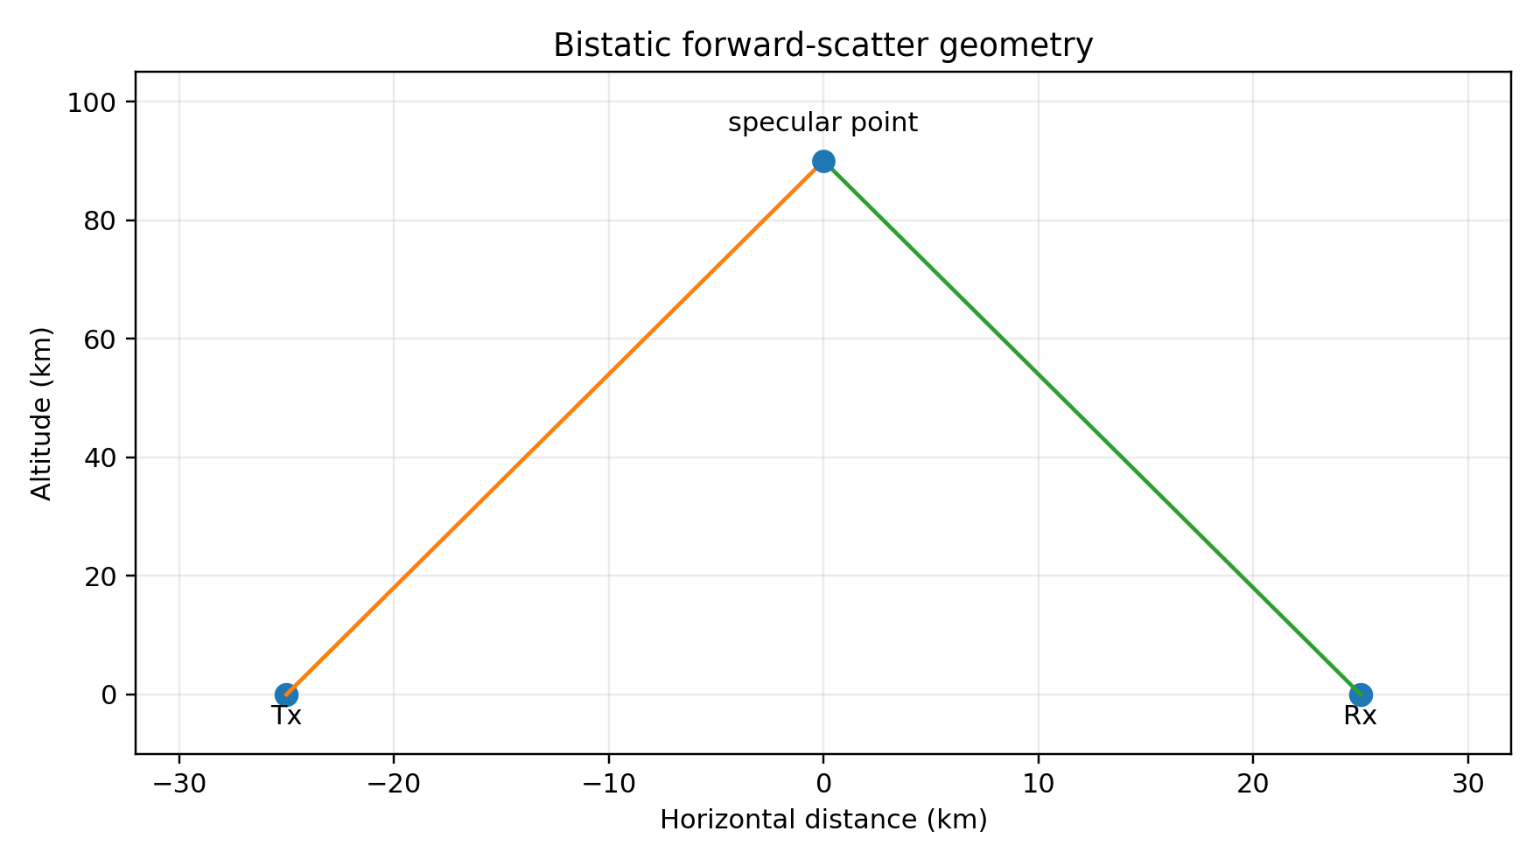
Figure 1. Simplified bistatic geometry represented by the model.

2.3 Meteor trajectory
The meteor trajectory is parameterised by azimuth and elevation. In the default configuration these are 180° and 45°, respectively. The resulting three-dimensional direction is used to construct the velocity vector associated with the horizontal velocity field.

2.4 Multi-harmonic wind field
The wind field is v(z) = V [R₁ sin(πz) + R₂ sin(2πz) + R₃ sin(3πz)]. The default parameters are V = 80 m/s, R₁ = 1.00, R₂ = 0.00 and R₃ = 0.10. The derivative dv/dz is evaluated numerically. These harmonic terms should be understood as a convenient test field; echoSim.py does not derive them from an atmospheric model.
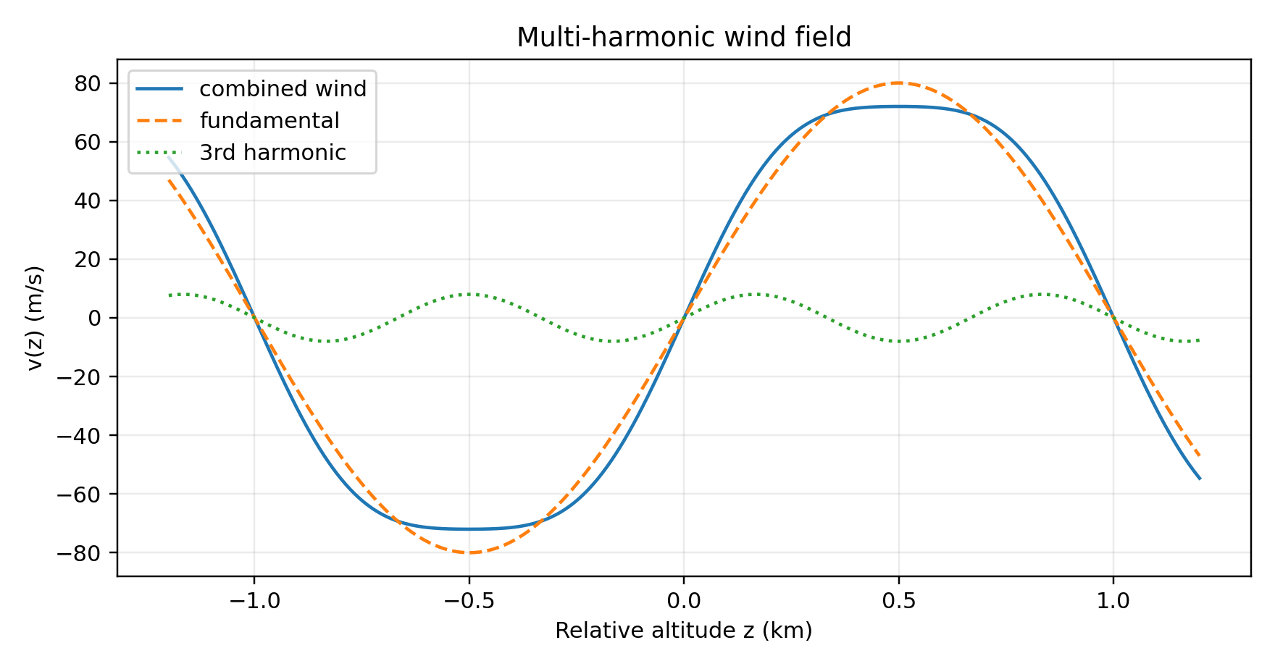
Figure 2. Example of the multi-harmonic wind field.

2.5 Time-dependent transition and trail deformation
The model combines an initial ping-like velocity field with the wind field. The ping weight is exp(−τ/0.12), while the wind-shear weight is 1 − exp(−τ/0.40). The resulting horizontal velocity is vₕ = wₚv_entry + wₛv_wind. Trail deformation is then introduced through the factor τwₛ0.0025. The numerical coefficient is an implementation parameter in the supplied code.
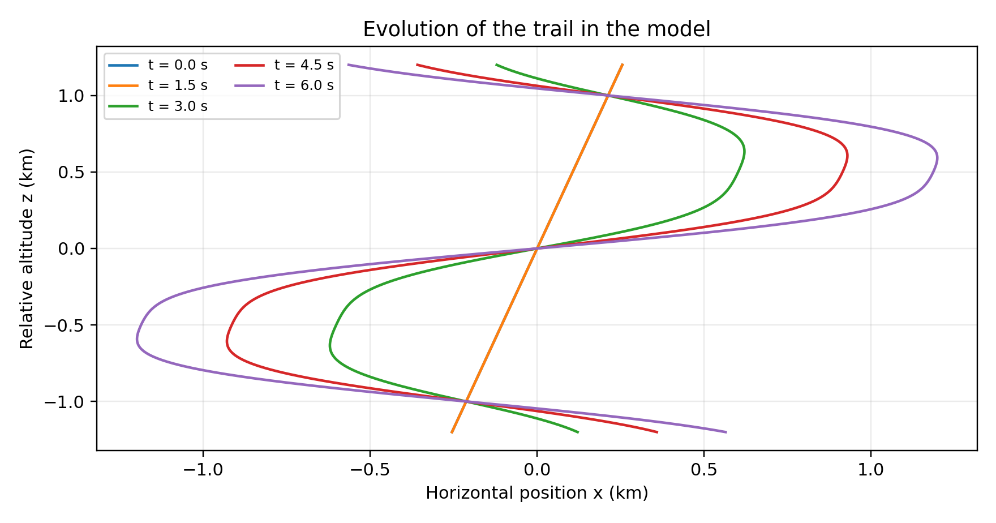
Figure 3. Illustrative trail evolution under the modelled wind field.

2.6 Doppler calculation
For every trail element, the three-dimensional velocity is projected onto the local bistatic bisector. The Doppler offset is f_D(z,t) = v(z,t)·b(z)/λ. Consequently, the same atmospheric velocity field can generate different Doppler contributions at different locations because the bistatic projection varies along the trail.

2.7 Specularity and coherent summation
The contribution of each trail element is weighted as W(z,t) = exp[−(∂x/∂z)²/A(t)]. The implementation therefore favours locally flatter portions of the evolving trail. A(t) begins at 0.005, grows with the wind-shear weight and receives an additional term after the diffusion start at t = 3 s.
The instantaneous frequency of each contribution is the 1 kHz audio carrier plus the calculated Doppler offset. The phase of each trail element is accumulated continuously at each sample. The weighted sinusoidal contributions are then summed over the trail. This coherent summation is an important feature: the resulting spectrum is not simply a histogram of local Doppler frequencies.

2.8 Event envelope and noise
The echo becomes active at t = 2 s. A rapid exponential rise is followed by a diffusion-related exponential decay beginning at t = 3 s. The signal is normalised, and Gaussian noise can be added according to the selected signal-to-noise ratio. These terms are prescribed in the current implementation and are not intended as a complete physical description of ionisation and diffusion.

3. Interactive implementation
The Matplotlib GUI exposes Tx–Rx distance, specular altitude, carrier frequency, trail skew, wind speed, the three harmonic ratios, azimuth and elevation. A checkbox enables background noise, and buttons run the simulation, play the generated audio and export WAV and PNG files. The RF frequency changes the wavelength used in the Doppler calculation, while the audible carrier remains at 1 kHz.

4. Example
The default GUI settings are d = 50 km, hspec = 90 km, f₀ = 50.0 MHz, α = 12.0°, V = 80 m/s, R₁ = 1.00, R₂ = 0.00, R₃ = 0.10, azimuth = 180° and elevation = 45°. These values are used as an illustrative case rather than as a fit to a particular observation.
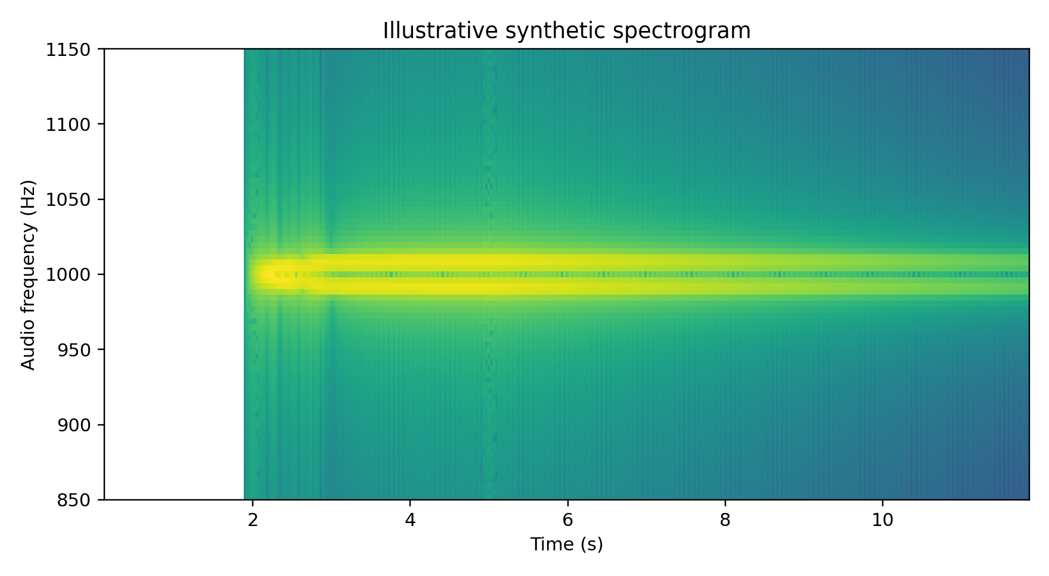
Figure 4. Illustrative synthetic spectrogram generated from the model structure.

5. Discussion
The strength of the present model is its transparency. Geometry, trail shape, wind structure, specularity and coherent summation are explicit and can be varied interactively. This makes the simulator useful for asking controlled questions about the origin of Doppler morphology.
At the same time, several elements limit its physical interpretation. The wind profile is a mathematical harmonic field, the event envelope is prescribed, and the trail-deformation coefficient and specularity aperture are phenomenological parameters. The supplied code does not establish that these choices reproduce the actual plasma physics of an overdense meteor trail. The present simulator should therefore not be used as a validated inversion tool without comparison to observations.

6. Future work
A natural next step is to replace the harmonic wind field with measured or atmospheric-model profiles and compare synthetic spectrograms with observations quantitatively. Further developments could include explicit trail density and diffusion, improved scattering efficiency, alternative specularity criteria and parameter-sensitivity studies. A particularly useful goal would be to determine whether distinctive Doppler morphologies can constrain combinations of geometry, trail orientation and atmospheric motion.

7. Conclusions
echoSim.py is a compact interactive simulator for experimenting with epsilon-like overdense meteor forward-scatter echo signatures. It combines explicit bistatic geometry, an initially skewed extended trail, multi-harmonic wind shear, time-dependent trail deformation, slope-dependent specularity and coherent phase summation. Its present value is as a transparent numerical test bench. Quantitative validation and more physically constrained trail and atmospheric models are the required next steps.

