# SQL DW Data Loading Scenarios and Best Practices

# (ADW In-A-Day Lab 01)

Contents

SQL DW Data Loading Scenarios and Best Practices (ADW In-A-Day Lab 01) 1

Overview 1

Pre-requisites: 1

Connect to your SQL Data Warehouse 1

Create your loading objects 2

Impact of file format on loading 3

Delimited Text 3

Parquet 5

GZIP Compressed Delimited Text 6

Impact of Single File Compression 8

Impact of Table Distribution on loading 9

Lets take a look again at the DMVS and compare our load speeds 11

Impact of CTAS vs Insert into Select 11

Closing 12

Side Bar: Simplified loading experience with COPY Command (out soon) 12

## Overview

This module will go over the internals of loading data with PolyBase and provide a deeper understanding of factors that can impact performance.

To simplify this experience, the entire lab is conducted using SSMS and T-SQL. In the real world, you would automate everything that you see in this lab with a tool like Azure Data Factory, SSIS, or another 3rd party tool; however, the learnings presented here are still valuable as you move into production scenarios.

## Pre-requisites:

* Existing Azure SQL Data Warehouse
* Existing Azure Storage Instance with datasets
* Azure subscription
* SQL USER in SQL DW with CONTROL Permissions

## Connect to your SQL Data Warehouse

Before you start loading data into your SQL Data Warehouse, you need to login into the DW with your user. We advise having a separate user for loading because it gives you greater control over security, resource allocation, and workload management by separating loading jobs from analytical queries.

In SQL Server Management Studio:

1. Connect to your Azure SQL Data Warehouse Server as admin user
2. Log in as ‘usgsLoader’

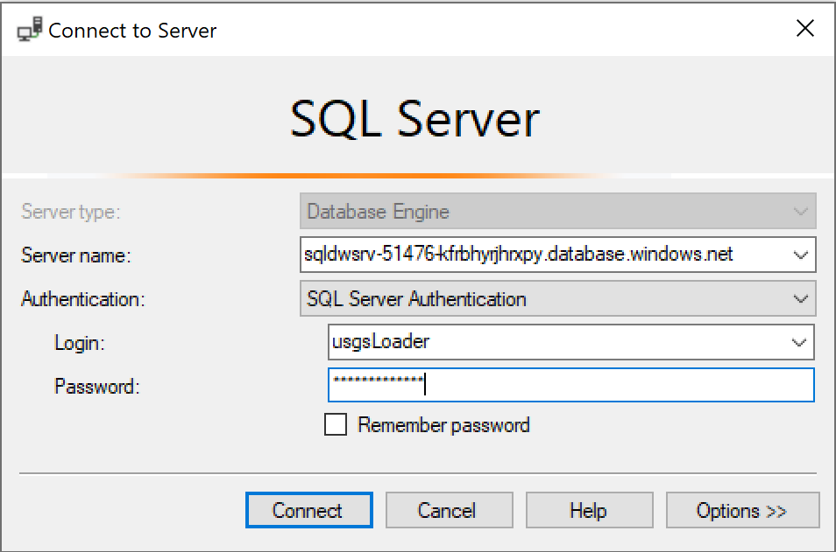

1. Click on ‘Options’, change the database name to your Azure Data Warehouse and click ‘Connect’.

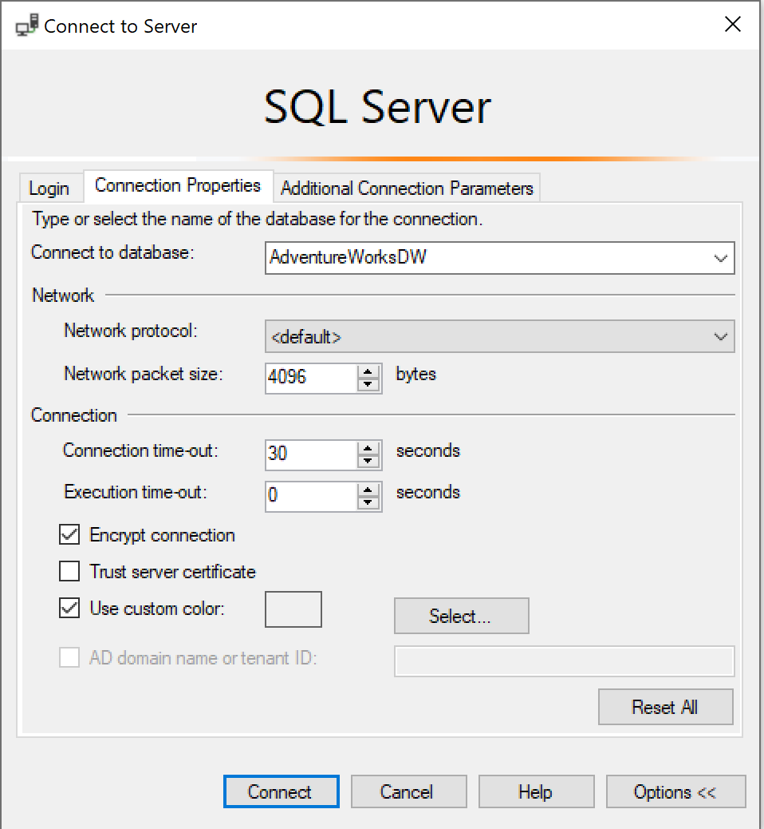

## Create your loading objects

When loading data into SQL DW it is a best practice to use PolyBase. PolyBase allows you to load files (Delimited Text, ORC, RC, and Parquet) from Azure Blob Storage, Azure Data Lake Store and Azure Data Lake Store Gen2.

To use PolyBase there are four objects that must be created:

* **Database Scoped Credential** – Credential used to authenticate to External Data Source.
* **External Data Source** – Describes where the data is located at a coarse grain.
* **External File** – Describes how the files are written.
* **External Table** – Describes the fine grain location and how the data is written in the file.

Let’s take a look at what this looks like!

Select New Query and verify that your Azure Data Warehouse is the selected database.

Execute the following TSQLs as admin user (sqldmin)

CREATE MASTER KEY

GO

CREATE DATABASE SCOPED CREDENTIAL Ready2019

WITH IDENTITY = 'mas',

SECRET = '<Access key for your storage account that contains the load files>'

GO

CREATE EXTERNAL DATA SOURCE Ready_store

WITH

(

TYPE = HADOOP,

LOCATION = N'wasbs://usgs**@<your storage account name>.**blob.core.windows.net/',

CREDENTIAL = Ready2019

)

GO

CREATE EXTERNAL FILE FORMAT TextFileFormat_Ready

WITH

(

FORMAT_TYPE = DELIMITEDTEXT,

FORMAT_OPTIONS

(

FIELD_TERMINATOR = '|'

)

)

GO

## Impact of file format on loading

Choosing the right file format for loading is often an overlooked choice when customers are designing their load jobs into SQL DW.

By far, the most popular format used to load data into SQL DW is the delimited text file. It is human readable, generic and the default output of many on-prem systems. However, the delimited text file can cause loading issues because it is essentially a collection of strings which are open to interpretation by the loading tool. Additionally, several delimited text generation tools do not enforce data quality during writes, which means you when the data is written is can no longer be interpreted as the same data. For example, the difference between a null value and an empty string is subtle in a delimited text file. If quotes are turned off, then all empty strings will be interpreted as a null! This is seemingly innocent form of data loss that can have large consequences.

Parquet is another very popular format that is gaining popularity in the big data ecosystem because of its binary data representation, strongly typed data, and compression capabilities. This format is popularized by the spark and hive ecosystem and we are seeing the increase in adoption as the Modern Data Warehouse Architecture continues to grow in popularity.

For this section of the lab, the same data is stored on Azure storage in Delimited Text, Parquet and Gzip Compressed Delimited text. We are going to load each in turn and look at storage size and load performance.

### Delimited Text

The data below was generated via a PolyBase export of 134,333,511 records. As you can see PolyBase tries to evenly distribute the data across multiple files. This is a best practice when writing data because it effectively parallelizes the DW resources to load each file simultaneously.

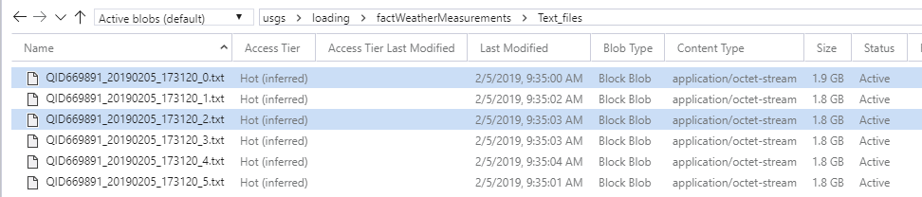

One should note that these are 1.8GB files because the files are uncompressed. This is raw data size which we will see change as we change file formats and compressions later in the lab.

The first thing that we need to do is create an external table over the files so that we can access the data from SQL DW. We can do this with the objects that we created above. Think of an External table as a pointer to the files on the storage system.

Execute the following TSQL to create an external table

CREATE SCHEMA staging;

GO

CREATE EXTERNAL TABLE [staging].[STG_factWeatherMeasurements_text]

(

[SiteName] [varchar](52) NOT NULL,

[ReadinType] [varchar](52) NOT NULL,

[ReadingTypeID] [real] NOT NULL,

[ReadingValue] [real] NOT NULL,

[ReadingTimestamp] [datetime2](7) NOT NULL,

[ReadingUnit] [varchar](52) NOT NULL,

[fpscode] [int] NOT NULL

)

WITH (

DATA_SOURCE = [Ready_store],

LOCATION = N'loading/factWeatherMeasurements/Text_files',

FILE_FORMAT = [TextFileFormat_Ready],

REJECT_TYPE = VALUE,

REJECT_VALUE = 0)

This statement points to the directory location of the files. PolyBase will traverse all files in a directory and all subdirectories (recursive directory traversal) up to 33k files.

The next step is to run a CREATE TABLE AS SELECT (CTAS) to create a new table from the external data. Let’s load some data!

CREATE TABLE [staging].[STG_text_load]

WITH

(

DISTRIBUTION = ROUND_ROBIN,

HEAP

)

AS

SELECT * FROM [staging].[STG_factWeatherMeasurements_text] option(label = 'STG_text_load')

While this is running you can view the steps with the Dynamic Management Views (DMVS)

Open another Query windows as admin user and execute

SELECT s.*

FROM

sys.dm_pdw_exec_requests r

JOIN

Sys.dm_pdw_request_steps s

ON r.request_id = s.request_id

WHERE r.[label] = 'STG_text_load'

You’ll probably notice that the operation is in the HadoopRoundRobinOperation operation_type for quite a while. This is the operation the reads the files from the data source into SQL DW. Notice that this step has a DMS location_type. DMS stands for Data Movement Service. This component of the DW architecture is responsible for data movement between nodes and data movement from outside sources into SQL DW.

We can see more detailed information about what is happening in this step with the following.

SELECT ew.*

FROM[sys].[dm_pdw_dms_external_work] ew

JOIN sys.dm_pdw_exec_requests r

ON r.request_id = ew.request_id

JOIN Sys.dm_pdw_request_steps s

ON r.request_id = s.request_id

WHERE r.[label] = 'STG_text_load'

ORDER BY input_name, read_location

This is particularly interesting because it shows how we effectively load uncompressed Delimited Text files in parallel. For large files >512 MB, we split the file into multiple chunks so it can be read more efficiently.

### Parquet

For Parquet, let’s kick off the code and then talk what’s happening while the data loads.

Execute the following statements as admin user (sqldmin)

CREATE EXTERNAL FILE FORMAT [Parquet] WITH (FORMAT_TYPE = PARQUET)

GO

CREATE EXTERNAL TABLE [staging].[STG_factWeatherMeasurements_parquet]

(

[SiteName] [varchar](52) NOT NULL,

[ReadinType] [varchar](52) NOT NULL,

[ReadingTypeID] [real] NOT NULL,

[ReadingValue] [real] NOT NULL,

[ReadingTimestamp] [datetime2](7) NOT NULL,

[ReadingUnit] [varchar](52) NOT NULL,

[fpscode] [int] NOT NULL

)

WITH (

DATA_SOURCE = [Ready_store],

LOCATION = N'loading/factWeatherMeasurements/Parquet_files',

FILE_FORMAT = [Parquet],

REJECT_TYPE = VALUE,

REJECT_VALUE = 0)

GO

Execute the following CTAS as load user (usgsLoader)

CREATE TABLE [staging].[STG_parquet_load]

WITH

(

DISTRIBUTION = ROUND_ROBIN,

HEAP

)

AS

SELECT *

FROM [staging].[STG_factWeatherMeasurements_parquet]

OPTION (label = 'STG_parquet_load')

GO

The first thing that we did above was create a new External File Format named Parquet. Notice that this didn’t require a lot of information because the Parquet file format is predefined unlike delimited text. This helps keep data consistent when it moves around an open big data ecosystem.

If we look at the files on the storage layer, we can see that the data size is much smaller than delimited text files. This is because Parquet is a columnar format and has compression built into the file format.

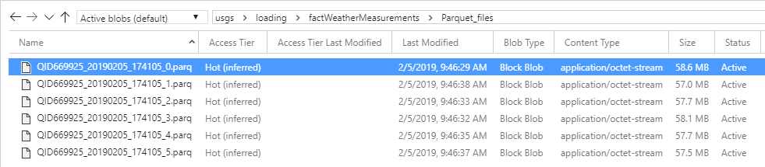

Let’s take a look at the DMVs again to see what happens with Parquet load.

SELECT DISTINCT ew.*

FROM[sys].[dm_pdw_dms_external_work] ew

JOIN sys.dm_pdw_exec_requests r

ON r.request_id = ew.request_id

JOIN Sys.dm_pdw_request_steps s

ON r.request_id = s.request_id

WHERE r.[label] = 'STG_parquet_load'

ORDER BY start_time ASC, dms_step_index

Parquet is not split-able today in SQL DW. This is shown by each file only appearing once. Also, notice that DMS_Step_Index values show up more than once. This means that the reader read one file through to its entirety then went back and started reading the next one.

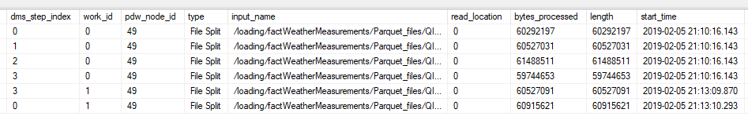

### GZIP Compressed Delimited Text

Again, let’s go ahead and execute the following statements before discussing

As admin user:

CREATE EXTERNAL FILE FORMAT compressed_TextFileFormat_Ready

WITH

(

FORMAT_TYPE = DELIMITEDTEXT,

FORMAT_OPTIONS

(

FIELD_TERMINATOR = '|'

), DATA_COMPRESSION = N'org.apache.hadoop.io.compress.GzipCodec'

)

GO

CREATE EXTERNAL TABLE [staging].[STG_factWeatherMeasurements_CompressedText]

(

[SiteName] [varchar](52) NOT NULL,

[ReadinType] [varchar](52) NOT NULL,

[ReadingTypeID] [real] NOT NULL,

[ReadingValue] [real] NOT NULL,

[ReadingTimestamp] [datetime2](7) NOT NULL,

[ReadingUnit] [varchar](52) NOT NULL,

[fpscode] [int] NOT NULL

)

WITH

(

DATA_SOURCE = [Ready_store],

LOCATION = N'loading/factWeatherMeasurements/Compressed_Text_files',

FILE_FORMAT = [compressed_TextFileFormat_Ready],

REJECT_TYPE = VALUE,

REJECT_VALUE = 0

)

GO

CREATE TABLE [staging].[STG_compressed_text_load]

WITH

(

DISTRIBUTION = ROUND_ROBIN,

HEAP

)

AS

SELECT *

FROM [staging].[STG_factWeatherMeasurements_CompressedText]

OPTION (label = 'STG_compressed_text_load')

GO

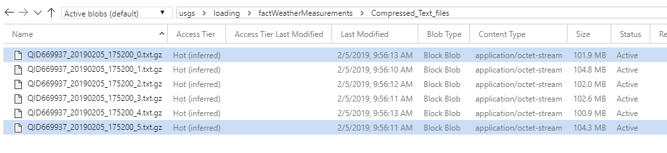

Again, you will notice that SQL DW does not split GZIP compressed files. This is because the compression algorithm itself is not split-able. More on this problem later!

Let’s take a moment and compare performance of the three file formats that we used. (NOTE: Wait until the CTAS is completed before you execute the statement below)

SELECT AVG(total_elapsed_time) AS [avg_loadTime_ms], [label]

FROM sys.dm_pdw_exec_requests

WHERE [label] IS NOT NULL

AND [label] <> 'System'

AND Status = 'Completed'

GROUP BY [label]

|  |  |
| --- | --- |
| **avg_loadTime_ms** | **label** |
| 253246 | STG_compressed_text_load |
| 263624 | STG_parquet_load |
| 274567 | STG_text_load |

It’s clear that for this particular table and data volume that compression helped. Gzip compression was the fastest, then Parquet and finally uncompressed text files. Now there are drawbacks with this. Both Gzip and Parquet files are not splittable in SQL DW. If not done correctly, this will severely impact load performance. Additionally, we have found that for wider tables with lots of strings, the CPU overhead of converting the strings slows down the overall performance. Finally, neither of the fastest two file formats are human readable. There is no easy way to visually inspect the data which can make them hard to debug in the case that anything happens during the load.

## Impact of Single File Compression

Let’s take the same data and try to load it from a single compressed Gzip file.

CREATE EXTERNAL TABLE [staging].[STG_factWeatherMeasurements_CompressedText_single_file]

(

[SiteName] [varchar](52) NOT NULL,

[ReadinType] [varchar](52) NOT NULL,

[ReadingTypeID] [real] NOT NULL,

[ReadingValue] [real] NOT NULL,

[ReadingTimestamp] [datetime2](7) NOT NULL,

[ReadingUnit] [varchar](52) NOT NULL,

[fpscode] [int] NOT NULL

)

WITH

(

DATA_SOURCE = [Ready_store],

LOCATION = N'loading/factWeatherMeasurements/singlefile/Compressed_Text_files',

FILE_FORMAT = [compressed_TextFileFormat_Ready],

REJECT_TYPE = VALUE,

REJECT_VALUE = 0)

GO

CREATE TABLE [staging].[STG_CompressedText_single_file]

WITH

(

DISTRIBUTION = ROUND_ROBIN, HEAP

)

AS

SELECT *

FROM [staging].[STG_factWeatherMeasurements_CompressedText_single_file]

OPTION(label = 'STG_single_compressed_load')

GO

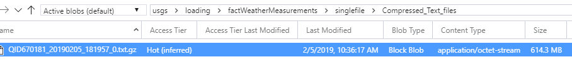

You’ve probably notice that this is taking quite a bit a time. While the load is running, we would like for you to think about the following questions and discuss with the person next to you.

Challenge Questions:

Using what you have learned above, how would you explain to a customer the behavior of SQL DW on this load?

Would scaling the DW to DWU30000c increase load performance in this case? Why or Why not?

What would you do if a customer loaded a 150 GB compressed file to Azure Storage?

How long would that 150 GB load take?

## Impact of Table Distribution on loading

So far, we have run Create Table as Select (CTAS) statements with Round_Robin distributions and Heap indexes. This is the theoretical maximum speed that you can load a set of data into SQL DW. Fixing file format issues as describe above or scaling the DW are the only ways to improve performance. However, there are ways to *degrade* performance off of this standard.

The most common problem is data skew. This occurs when the cardinality of the distribution column is low or skewed to a certain set of values. The canonical case is a key that has a lot of NULL or 0 values.

Let’s suppose that we wanted to load that same data again but hash the data on the readingUnit column

CREATE TABLE [staging].[STG_Hash_ReadingUnit]

WITH

(

DISTRIBUTION = HASH(ReadingUnit),

HEAP

)

AS

SELECT *

FROM [staging].[STG_factWeatherMeasurements_CompressedText]

OPTION (label = 'STG_Hash_ReadingUnit')

While this is running, run the following in another query window as admin user (sqldmin):

Select *

FROM sys.dm_pdw_dms_workers dw

JOIN sys.dm_pdw_exec_requests r

ON r.request_id = dw.request_id

WHERE r.[label] = 'STG_Hash_ReadingUnit'

This shows how the data is being read from files, how that data is being converted to SQL data type format and how it is being written to SQL DW distributions. The steps are the following:

* EXTERNAL_READER = Each line is an individual thread reading data from files
* HASH_CONVERTER = Thread responsible for converting the data generated by the EXTERNAL_READER
* WRITER = Thread responsible for writing to the correct distribution based on sink table definition.

Notice how many writers are sitting around with 0 bytes_processed. This is because of the table skew! Table skew occurs when certain distributions receive more data than others. Distributions receive data based on the hash value of the distribution.

If we did a simple check on how many rows per readingUnit, we would see that there are only 17 unique readingUnit values. When writing, these 17 distributions receive all of the load causing a bottleneck. Now, some skew is natural, but this is extreme! The table would be better suited to a ROUND_ROBIN distribution.

|  |  |
| --- | --- |
| **RowCount** | **readingUnit** |
| 6658050 | T |
| 47216 | D |
| 11394 | A |
| 134061 | B |
| 10871562 | 7 |
| 36655 | M |
| 9902661 | W |
| 75345491 | 0 |
| 16481 | 6 |
| 126562 | S |
| 615070 | H |
| 13002585 | N |
| 9373275 | U |
| 755951 | K |
| 91195 | Z |
| 293697 | R |
| 7051605 | X |

## Lets take a look again at the DMVs and compare our load speeds

Execute the following query as admin user (wait until the previous load is completed):

Select avg(total_elapsed_time) as [avg_loadTime_ms], [label]

FROM sys.dm_pdw_exec_requests

where [label] is not null

and [label] <> 'System'

and Status = 'Completed'

GROUP BY [label] order by 1 desc

|  |  |
| --- | --- |
| **avg_loadTime_ms** | **label** |
| 502164 | STG_Hash_ReadingUnit |
| 306790 | STG_single_compressed_load |
| 274567 | STG_text_load |
| 263624 | STG_parquet_load |
| 253246 | STG_compressed_text_load |

As you can see, table structure had the biggest impact on my loading performance!

## Impact of CTAS vs Insert into Select

Depending on your ELT pattern, you can either use a CTAS to create a brand-new table or an INSERT INTO SELECT from external table to append records to an existing table. Both methods have their purposes, but the two syntaxes are not functionally equivalent.

Let’s take a look and see the performance differences. Since we have already done several CTAS statements lets focus on INSERT INTO SELECT and compare.

CREATE TABLE [staging].[STG_factWeatherMeasurements_Insert_Into]

(

[SiteName] [varchar](52) NOT NULL,

[ReadinType] [varchar](52) NOT NULL,

[ReadingTypeID] [real] NOT NULL,

[ReadingValue] [real] NOT NULL,

[ReadingTimestamp] [datetime2](7) NOT NULL,

[ReadingUnit] [varchar](52) NOT NULL,

[fpscode] [int] NOT NULL

)

WITH

(

DISTRIBUTION = ROUND_ROBIN,

HEAP

)

GO

INSERT INTO [staging].[STG_factWeatherMeasurements_Insert_Into]

SELECT * FROM [staging].[STG_factWeatherMeasurements_text] option (label = 'STG_insertInto')

GO

Wait until the above insert has completed and execute the following query as admin user:

SELECT avg(total_elapsed_time) as [avg_loadTime_ms], [label]

FROM sys.dm_pdw_exec_requests

WHERE [label] is not null

and [label] <> 'System'

and Status = 'Completed'

GROUP BY [label] ORDER BY 1 DESC

As you can see CTAS is slightly faster (~10%) than writing directly into a table via insert into select, but that isn’t why we suggest loading to a staging table via CTAS statements. CTAS is a fully parallelize, minimally logged operation while Insert INTO has normal logging enabled. This functional difference accounts for the difference in load speeds.

## Closing

You’ve reached the end of the DW loading lab. Hopefully you are now comfortable with the concepts behind loading data into SQL DW and better understand some of the levers you can utilize to optimize your data loads

## Side Bar: Simplified loading experience with COPY Command (out soon)

There has been substantial feedback from customers and the field that loading data into SQL DW is too difficult with the syntax above. In the near future, the service will have a new loading syntax (in additional to External Tables) COPY INTO. The COPY INTO functionality will provide a single statement to define data location, file format, authentication and destination table. In addition to changing the syntax, the copy command will provide capabilities to handle other common issues with loading delimited text files today including: NullValue, CarriageReturns in strings, etc.

--The wildcard operator '*' in the file path means SQL DW will automatically find all 60 files representing the table and load them in parallel

COPY INTO [staging].[STG_dimWeatherObservationSites]

FROM 'abfss://usgsdatalake##.blob.core.windows.net/usgs/weatherdata/QID59672_20190117_11949_*.txt'

WITH

(

FILE_FORMAT = 'DELIMITEDTEXT',

SECRET = '<TODO>'

);