Analyzing cake's terrible loss against KR ML

- I think I see a pattern of bm on 13 vs wm on 17 that happens all the time and makes cake lose
- 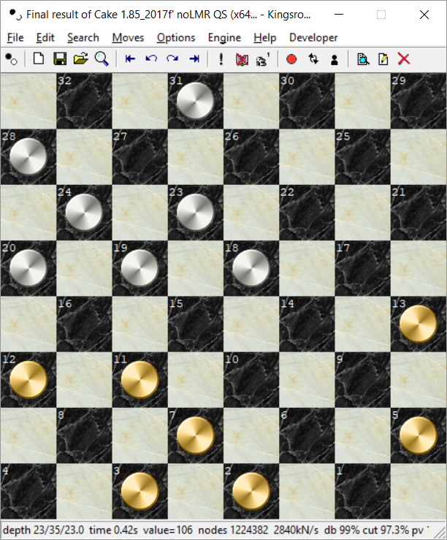
- Black man on 13 is not recognized as runaway
- General pattern of ungrounded men blocked

I write a program to optimize evaluation (OptmizeCakeEvaluation.c). It needs a set of positions together with evaluations as input. To start, I use Oplib ~1.3 Mio positions with evaluations. Letting all parameters start at 0 except king value I get
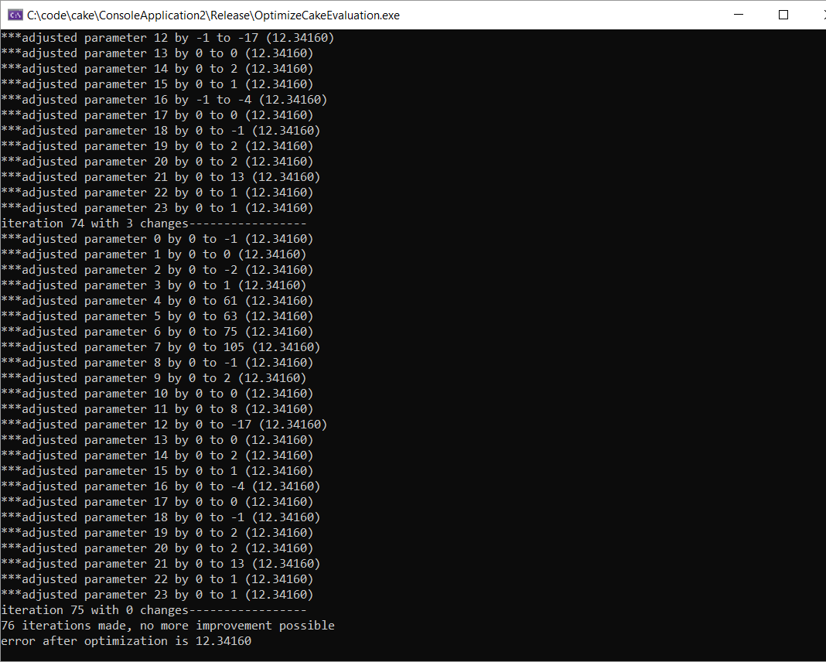

Then I run this again with the default parameter values. I get nearly the same!
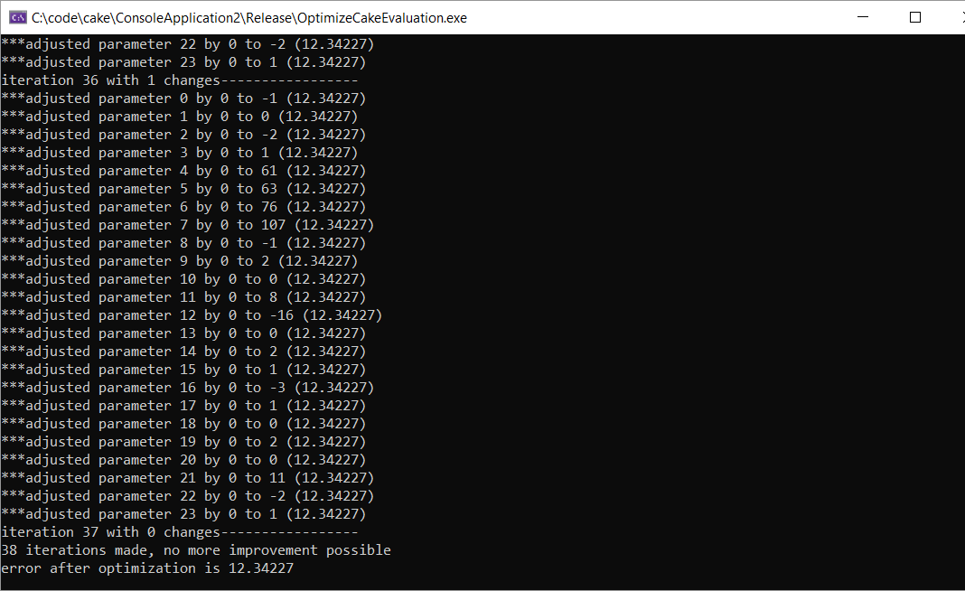
Obviously, local minima might exist. Astonishing/surprising to see how far away this is from my default parameters!
Of course, the oplib data set is not very representative, and the evaluations are from very deep searches = have little to do with evaluation function.

I try another data set: ~50'000 positions from a 1000-game 11-man-ballot match between Cake 185f' and Ed's impressive Kingsrow 1.18f. The games are saved as a pdn file, and my OptimizeCakeEval can read the pdn file and produce an output file with bm bk wm wk color result.
TestCake now includes the ability to read this output file and add to it a short search value. I use this to optimize regarding the search value.
After removing captures it's only 34'000 positions, and the optimization is much much faster. Here's what I get this time:
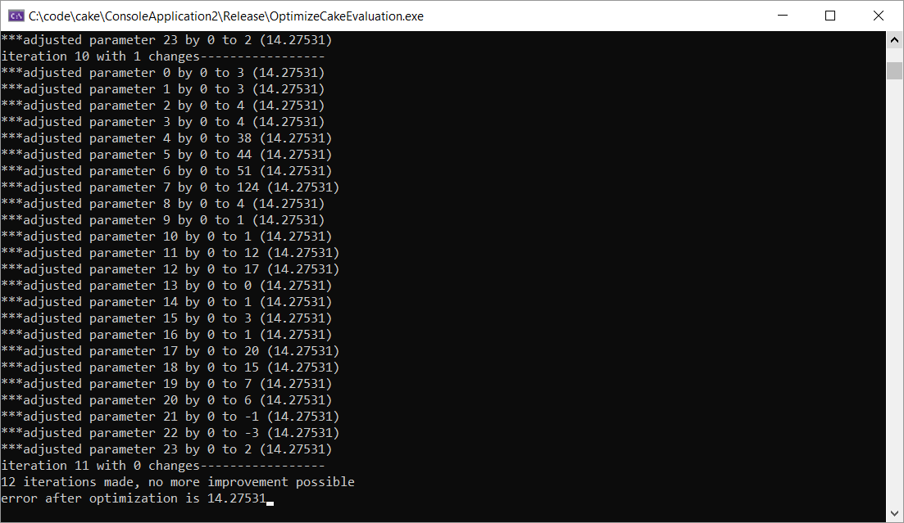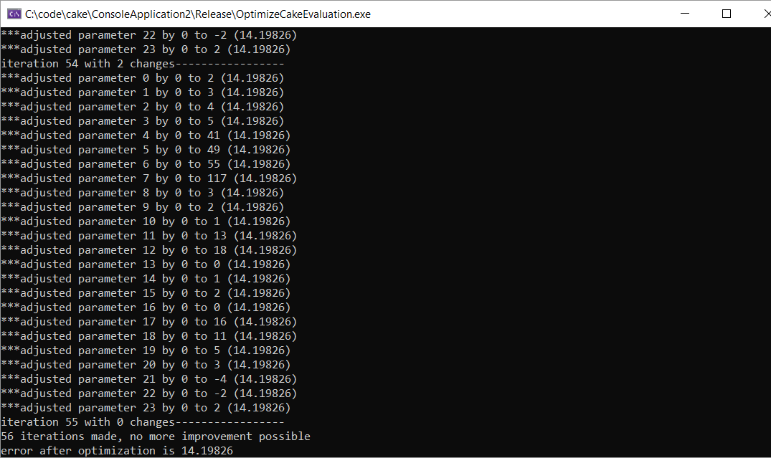
Left: starting out with original values; right starting out with 0.
Much closer to the original values – this data set is certainly better balanced with less opening positions. But I obviously need more – luckily, I should be able to easily make a 2400-game match giving me a 4.8x increase in games + positions = around 163'000 positions. If I need even more, I can probably do these first 163'000 positions, then optimize eval, then run again.
It seems everybody is doing logistic regression on the result rather than what I did here.I need to try that too later!

24.4.2019
I program the logistic regression but find a very strange result when starting to fit c in the logistic regression (which would describe how the winning percentage scales with evaluation). It's much too small, implying that a 100 point advantage is not really a big win %-age:
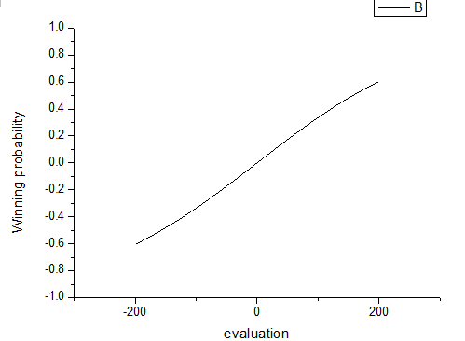
This is strange! 200 point advantages should translate to ~100% winning chance. I print out some stuff and notice that there are many positions that are quite (no captures for either side) but the side to move can do something good that a shallow search will see but the eval not => the eval will claim a 100 point disadvantage, but because it can capture a man with a shot or a squeeze it's really 0. Since such positions would give a huge error penalty for a larger c, c is not fitted to a higher value. I remove all positions where the shallow search in the file is more than 50 points different than the static eval; this rejects about 6% of all "quiet" positions (think about this! In 6% of all cases eval is way off!!). One example:
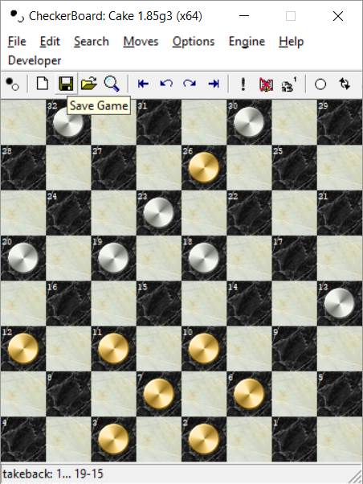
White to move will win his missing man back with 19-15.

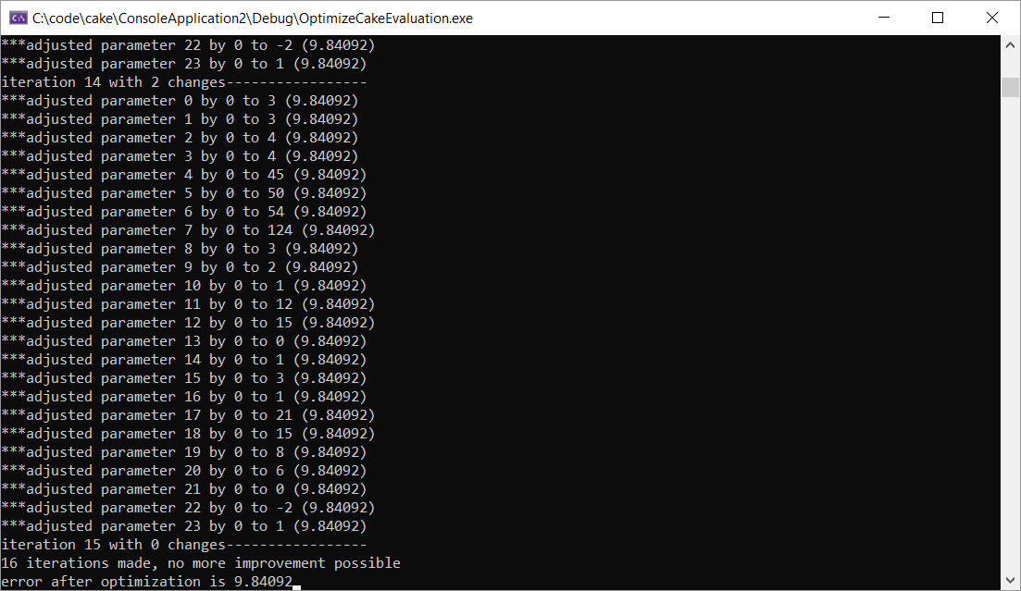
Optimizing with all positions (left) and with 6% large differences rejected. Some differences visible, especially in the total error which is much lower, but overall, parameters are similar (which is nice)
Then I make a version doing logistic regression on game result.
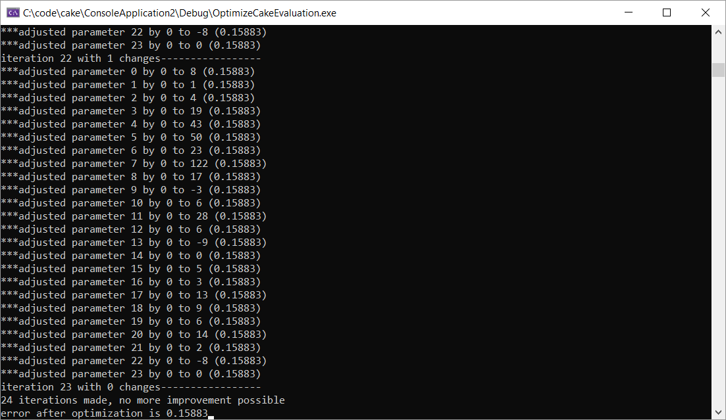
Eval regression (left) and logistic regression (right), using a L2 metric for the logistic regression but L1 for eval regression.
I try next doing L1 regression for the logistic version
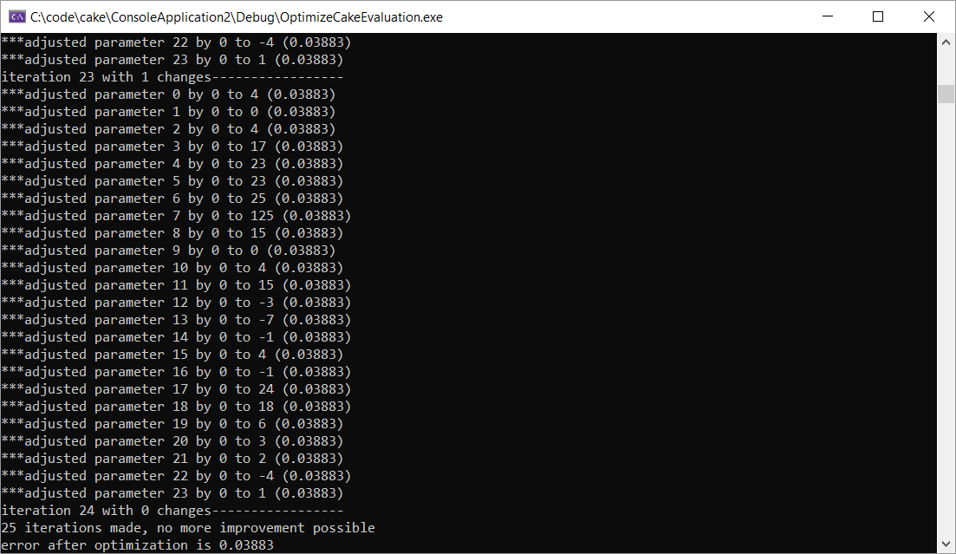

L1 eval regression (left) and L1 logistic regression (right)

I used the L1 eval regression, and got +30-220 in a 1000 game match instead of a more typical +40-200 result so this didn't work at all.

Workflow for the optimization:
- Run a long match (11-man-ballot, 4800 games) at 0.1s (takes xxx seconds) (in checkerboard.h change #define MAX_ENGINEMATCH_GAMES 1000 to something larger)
- Run OptimizeCakeEvaluation with pdnload enabled (lines 113-120) – this will extract all positions from the PDN and tag them with the result (WIN LOSS DRAW UNKNOWN 2 1 0 3) from black's point of view into the file C:\code\checkersdata\taggedpositions.txt file format is bm bk wm wk color gameresult
- Run …

Plans:
- Rerun non-optimized match 0.5s 1000 games – check it is similar to before
- Run 4800 game match at 0.1s (should be similar time as before) as baseline result and as training database for further optimization.

