Analyzing cake's terrible loss against KR ML

- I think I see a pattern of bm on 13 vs wm on 17 that happens all the time and makes cake lose
- 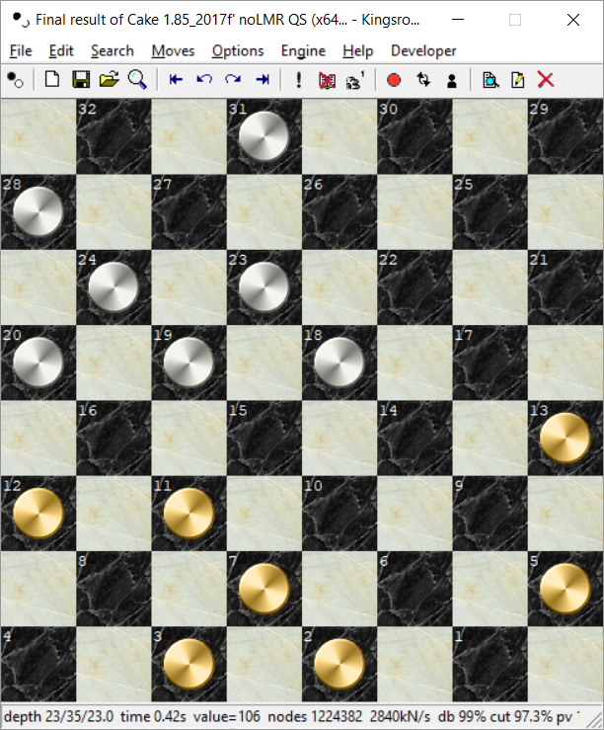
- Black man on 13 is not recognized as runaway
- General pattern of ungrounded men blocked

I write a program to optimize evaluation (OptmizeCakeEvaluation.c). It needs a set of positions together with evaluations as input. To start, I use Oplib ~1.3 Mio positions with evaluations. Letting all parameters start at 0 except king value I get
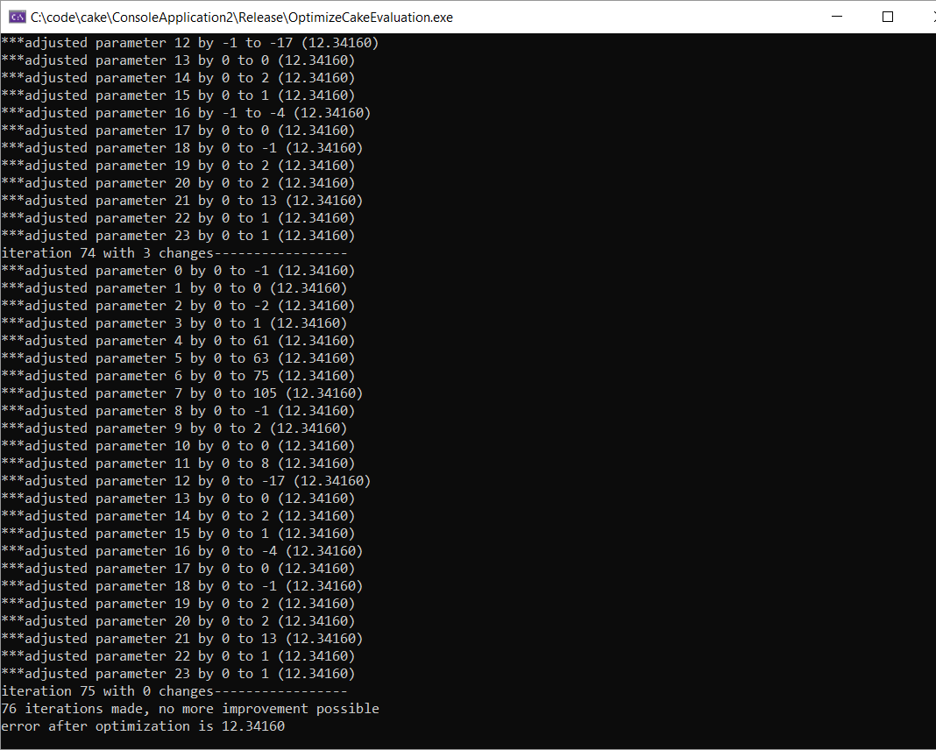

Then I run this again with the default parameter values. I get nearly the same!
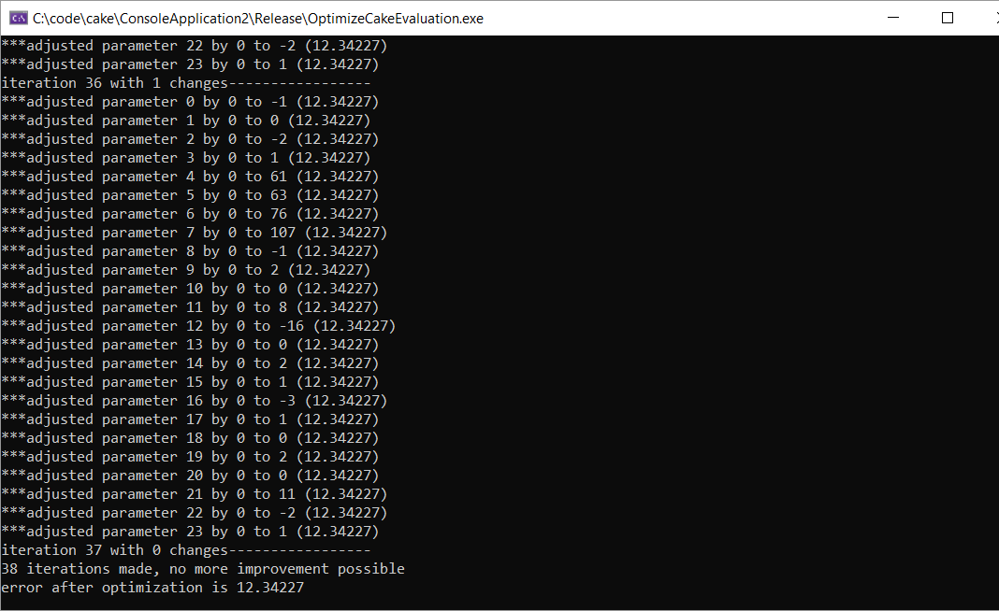
Obviously, local minima might exist. Astonishing/surprising to see how far away this is from my default parameters!
Of course, the oplib data set is not very representative, and the evaluations are from very deep searches = have little to do with evaluation function.

I try another data set: ~50'000 positions from a 1000-game 11-man-ballot match between Cake 185f' and Ed's impressive Kingsrow 1.18f. The games are saved as a pdn file, and my OptimizeCakeEval can read the pdn file and produce an output file with bm bk wm wk color result.
TestCake now includes the ability to read this output file and add to it a short search value. I use this to optimize regarding the search value.
After removing captures it's only 34'000 positions, and the optimization is much much faster. Here's what I get this time:
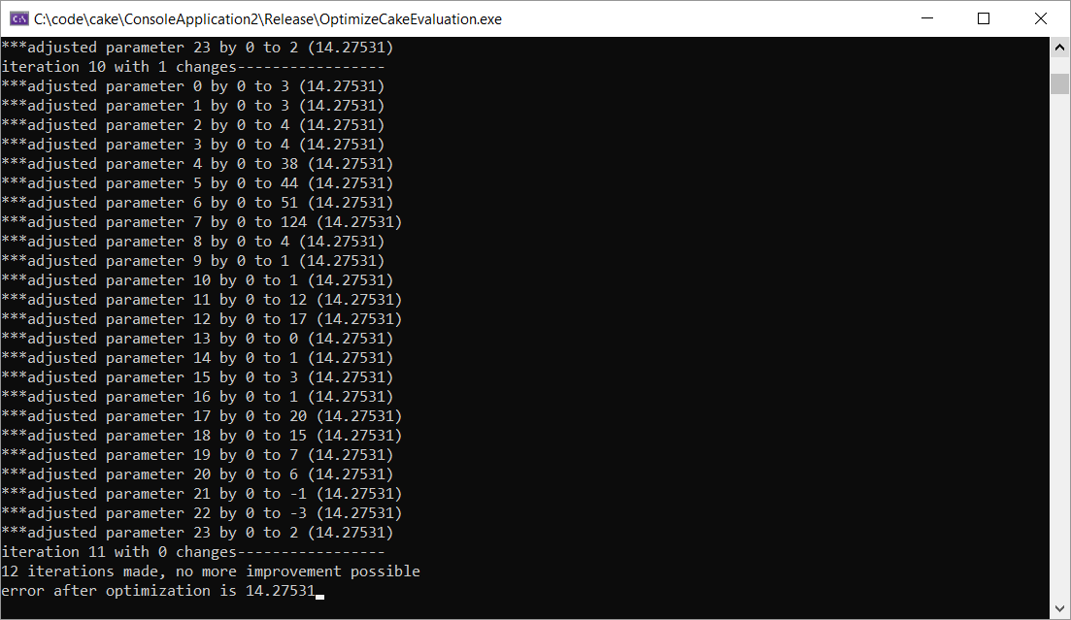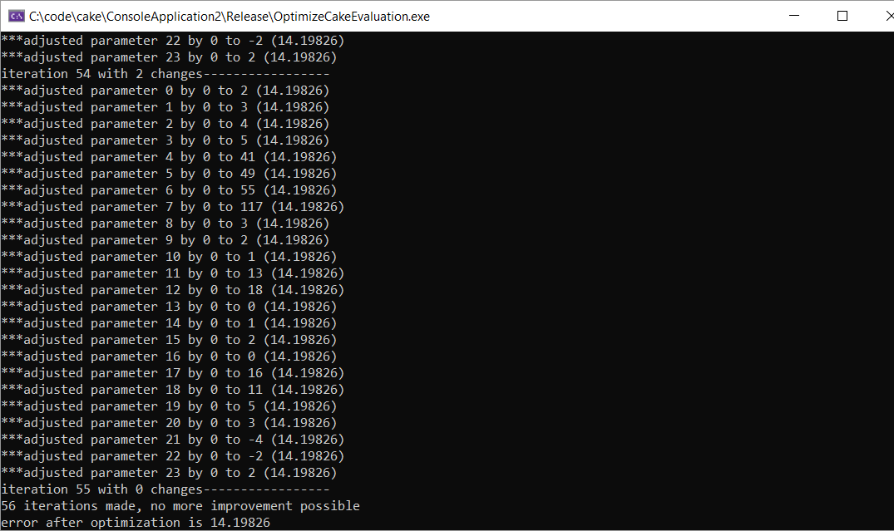
Left: starting out with original values; right starting out with 0.
Much closer to the original values – this data set is certainly better balanced with less opening positions. But I obviously need more – luckily, I should be able to easily make a 2400-game match giving me a 4.8x increase in games + positions = around 163'000 positions. If I need even more, I can probably do these first 163'000 positions, then optimize eval, then run again.
It seems everybody is doing logistic regression on the result rather than what I did here.I need to try that too later!

24.4.2019
I program the logistic regression but find a very strange result when starting to fit c in the logistic regression (which would describe how the winning percentage scales with evaluation). It's much too small, implying that a 100 point advantage is not really a big win %-age:
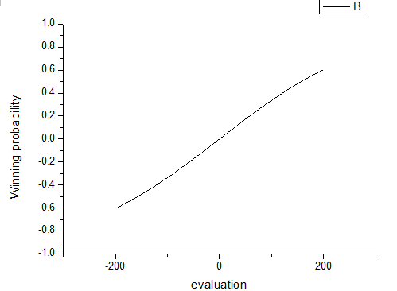
This is strange! 200 point advantages should translate to ~100% winning chance. I print out some stuff and notice that there are many positions that are quite (no captures for either side) but the side to move can do something good that a shallow search will see but the eval not => the eval will claim a 100 point disadvantage, but because it can capture a man with a shot or a squeeze it's really 0. Since such positions would give a huge error penalty for a larger c, c is not fitted to a higher value. I remove all positions where the shallow search in the file is more than 50 points different than the static eval; this rejects about 6% of all "quiet" positions (think about this! In 6% of all cases eval is way off!!). One example:
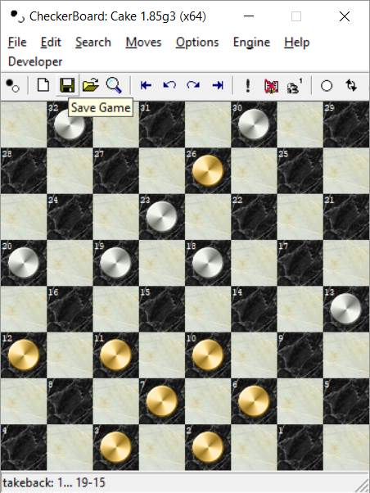
White to move will win his missing man back with 19-15.

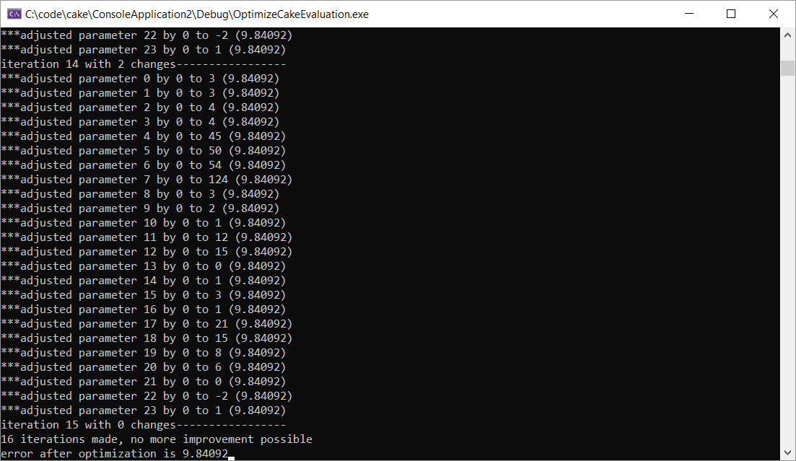
Optimizing with all positions (left) and with 6% large differences rejected. Some differences visible, especially in the total error which is much lower, but overall, parameters are similar (which is nice)
Then I make a version doing logistic regression on game result.
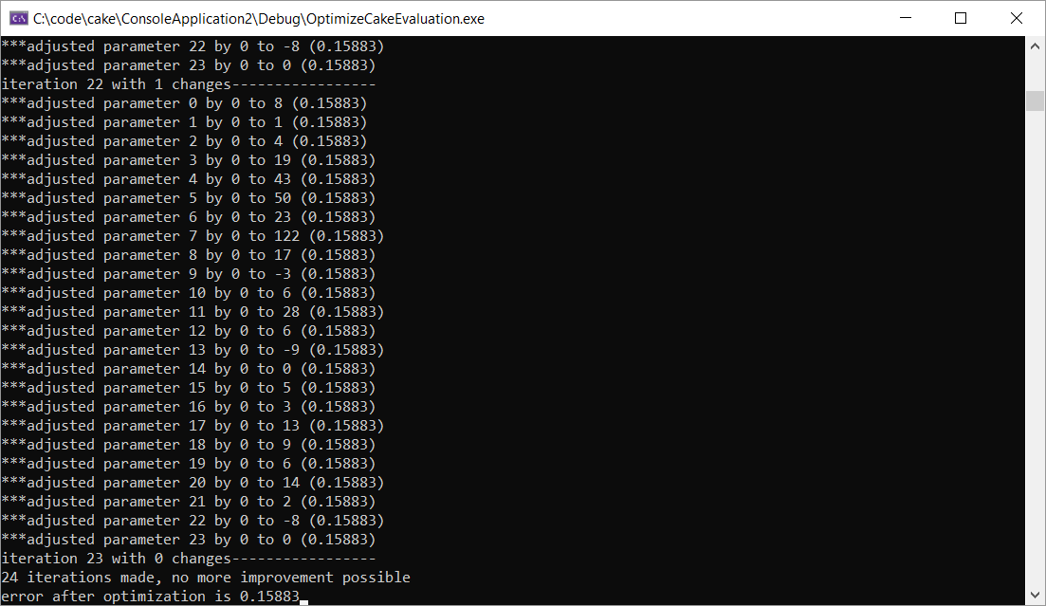
Eval regression (left) and logistic regression (right), using a L2 metric for the logistic regression but L1 for eval regression.
I try next doing L1 regression for the logistic version
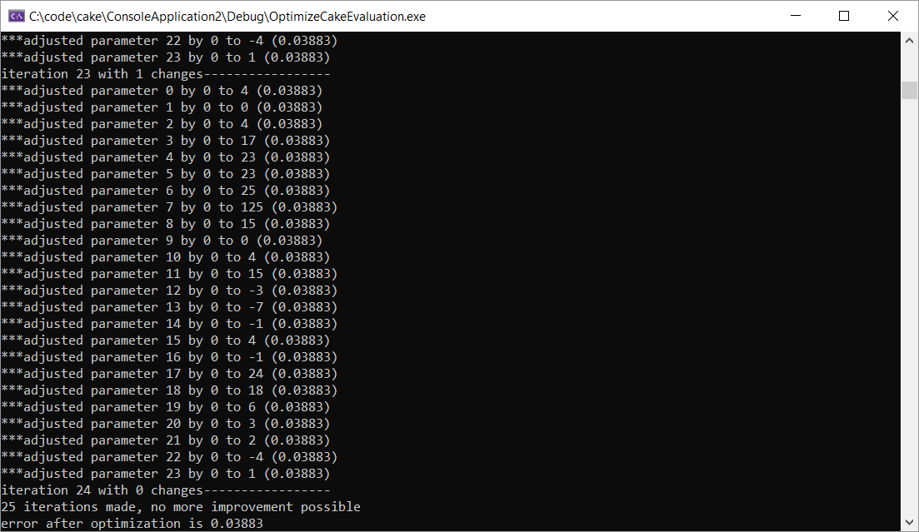

L1 eval regression (left) and L1 logistic regression (right)

I used the L1 eval regression, and got +30-220 in a 1000 game match instead of a more typical +40-200 result so this didn't work at all.

Workflow for the optimization:
- Run a long match (11-man-ballot, 4800 games) at 0.1s (takes xxx seconds) (in checkerboard.h change #define MAX_ENGINEMATCH_GAMES 1000 to something larger)
- Run ReadMatchFile (in OptimizeCakeEvaluation) – this will extract all positions from the PDN and tag them with the result (WIN LOSS DRAW UNKNOWN 2 1 0 3) from black's point of view into the file C:\code\checkersdata\taggedpositions.txt file format is bm bk wm wk color gameresult
- Run testcake

Plans:
- Rerun non-optimized match 0.5s 1000 games – check it is similar to before ( a bit worse but OK)
- Run 4800 game match at 0.1s (should be similar time as before) as baseline result and as training database for further optimization.
Cake 1.85g unopt (x64) - Kingsrow(x64) 1.18f : W-L-D:147-1594-3059
+:147 =:2999 -:1594 unknown:60 +B:961 -B:780
- Extract training positions from games for taggedpositions.txt – 151'074 positions stored.
- and evaluate them with 1/3 ply search – done. (151073 positions left, why not 152414?)
- Run logistic regression with L1, L2, with and without non-quiet positions; I find c = 0.0165 as best parameter for L2 regression; I find that L2 regression starts out with 0.30574 and ends with 0.28458
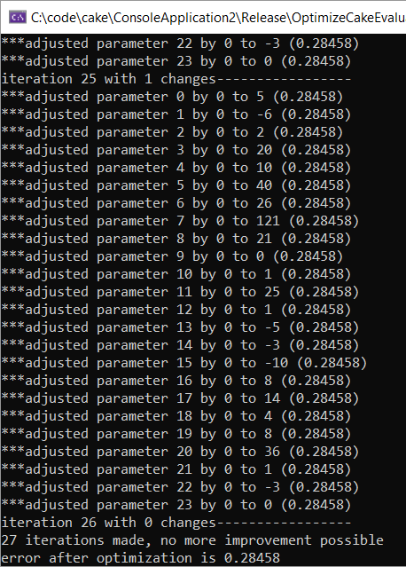 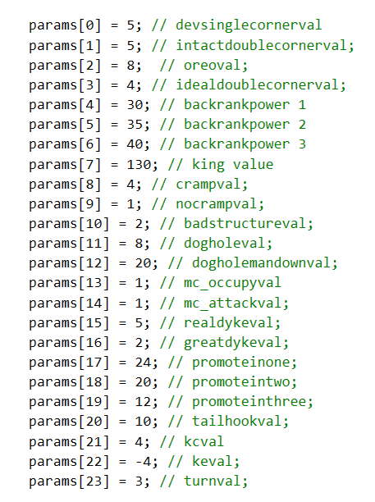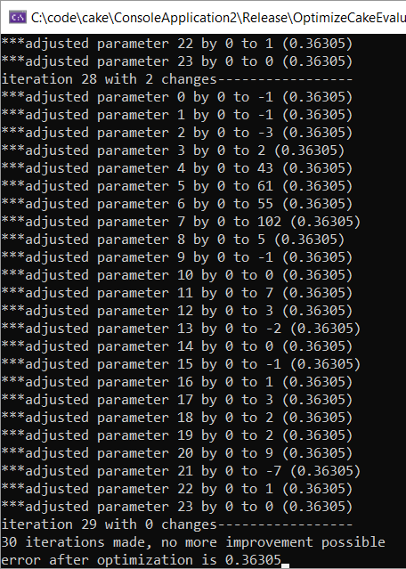
L2 regression left, L1 regression right
- Refactor evaluation to make all parameters accessible – check with testcake that I don't break anything
- Optimize parameters with either logistic regression, 1,3,5 ply result;

Values by search depth 3 evaluation regression:

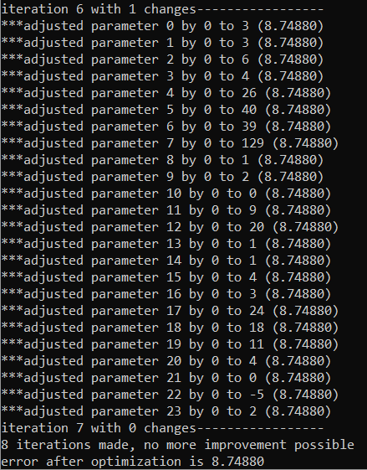

Match result with logistic regression:
1st L2 optimized version of Eval:
Cake 1.85g opt L2 (x64) - Kingsrow(x64) 1.18f : W-L-D:100-2104-2596
+:100 =:2536 -:2104 unknown:60 +B:1179 -B:1025
Very bad!
Match result with v3-based regression
Cake 1.85g opt eval (x64) - Kingsrow(x64) 1.18f : W-L-D:153-1586-3061
+:153 =:3004 -:1586 unknown:57 +B:996 -B:743
With un-optimized values I got
Cake 1.85g unopt (x64) - Kingsrow(x64) 1.18f : W-L-D:147-1594-3059
+:147 =:2999 -:1594 unknown:60 +B:961 -B:780
So it's a teeny weeny bit better with the optimized values, but probably nothing significant!

Trying again with logistic regression:

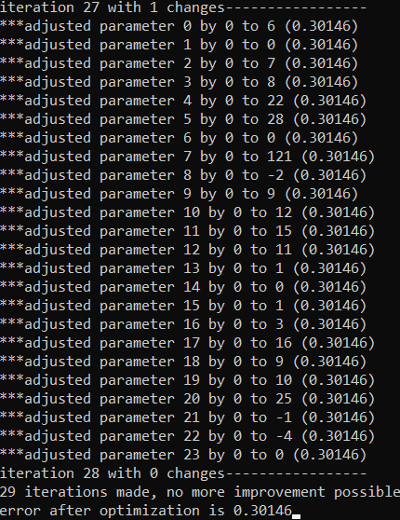

Add another match of Cake L2 optimized v2 vs kr ML, and add a Match of Cake standard vs kr118 with 5-man PDN of ed, so that now I have about 530'000 positions.
I get c = 0.021 and optimization starts out at 0.31925and ends at 0.29783 (when starting with 0s except for king)
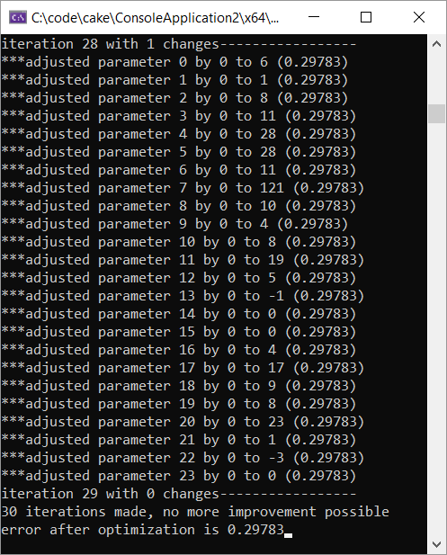

Match results with this version:
Cake 1.85g logit L2 opt 500k (... - Kingsrow(x64) 1.18f : W-L-D:184-1571-3045
+:184 =:2991 -:1571 unknown:54 +B:1003 -B:752
Cake 1.85g logit L2 opt 500k (... - Kingsrow(x64) 1.18 : W-L-D:685-853-2194 (match7)
+:685 =:2184 -:853 unknown:10 +B:400 -B:1138 (47.76%) (80.30% relative wins)

play a 5 man match between Cake logit and Cake original:
Cake 1.85g logit L2 opt 500k (... - Cake 1.85g standard (x64) : W-L-D:845-779-2108 (match8)
+:845 =:1949 -:779 unknown:159 +B:479 -B:1145 (50.88%) (52.03% relative wins)
- This version is better than the hand-tuned version!! It works against all 3 opponents (kr ML, kr 118, and Cake original) – so no effect of "training" to a specific opponent can be seen!

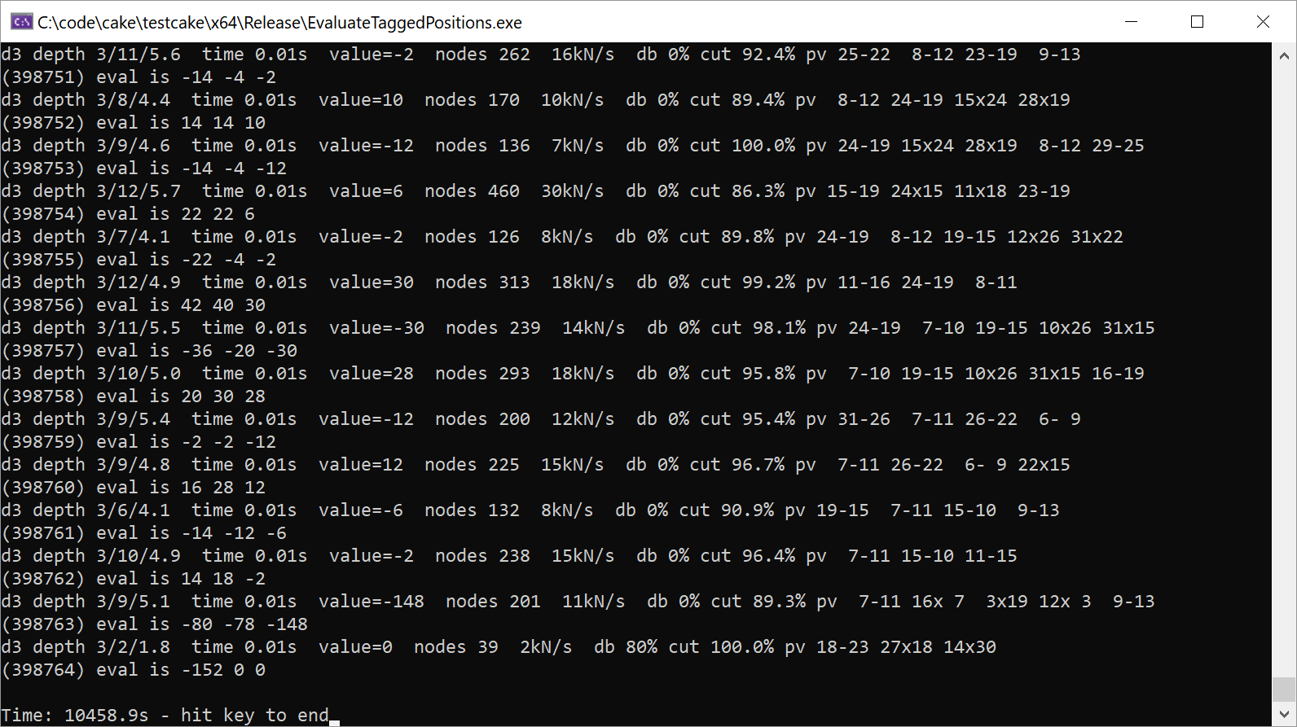

Use all these 3 matches to generate a 900k-opt Cake – this gives c = 0.022 and starts with 0.30497 and ends with
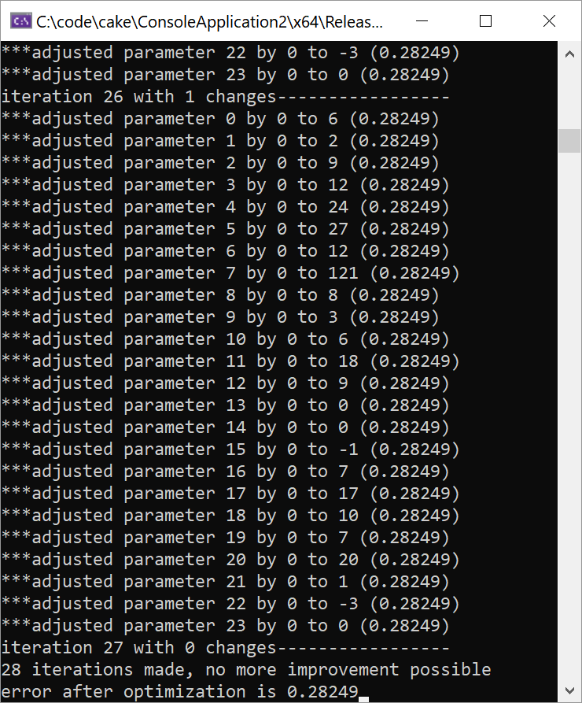
500k positions (left), 900k positions (right) – no big changes any more, it looks pretty converged.
900k parameters:


900 k parameters optimized when starting from standard values (left), and zero (right)

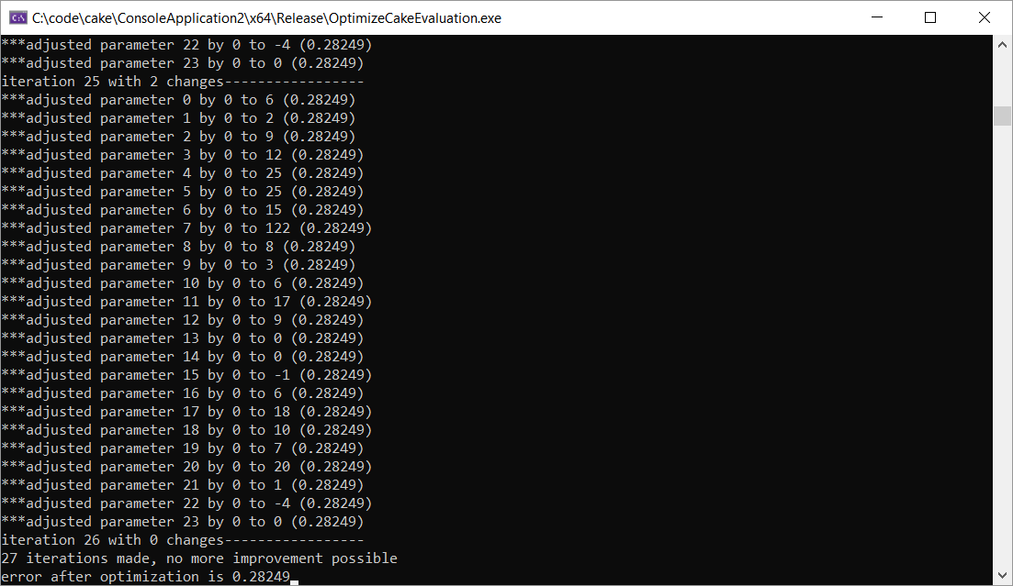

Optimizing 36 parameters (things with kings), and later an additional 25 for tempo doesn't really bring anything any more. The tempo parameters that I calculate are way higher than what I had coded:
static int tmodopt[25] = { 0,11,1,-1,-2,-2,-2,-2,-2,-2,-2,-4,-4,-5,-7,-6,-9,-8,-12,-12,-14,-17,-14,-7,-22 };

I replace my old values with
static int tmod[25] = { 0,5 ,2, 2, 2, 1, 1, 1, 0, 0, 0, -1, -1,-2,-2,-3,-3,-4,-4, -5, -5, -6, -6, -7, -7 };
since the version with the optimized tempo eval played worse. I optimize the rest of the parameters, and add skewness and balance to the optimizer (38 parameters in total now) and get this output:
900k positions left, 1500k right

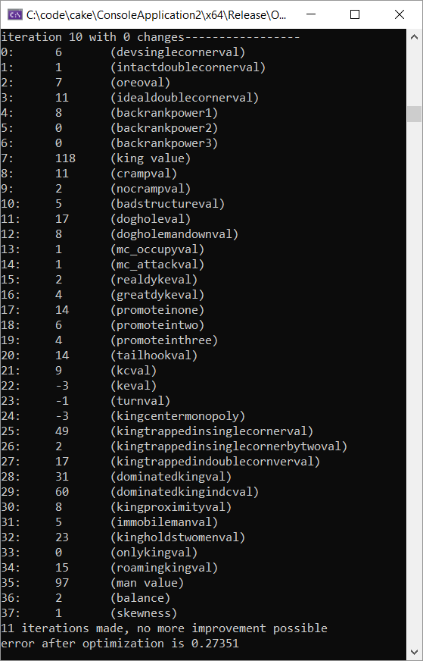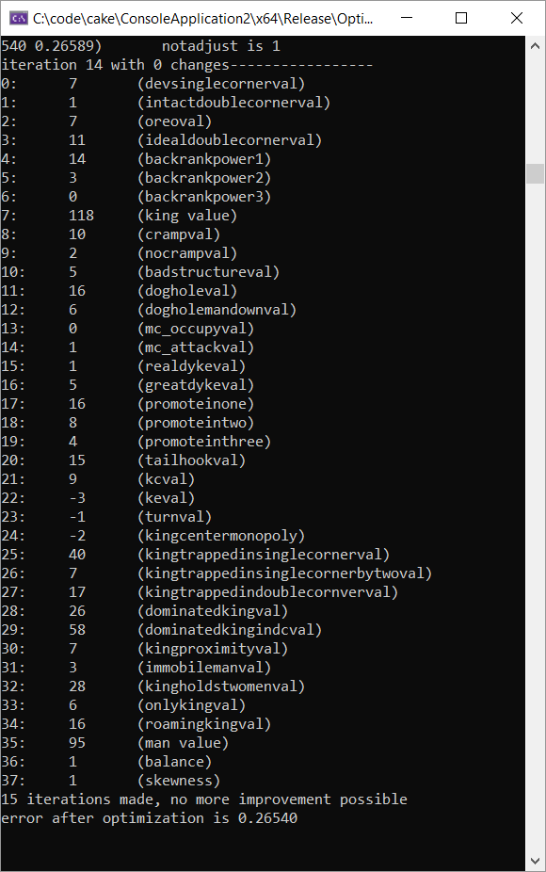

I add the br array to the optimizer, and get:
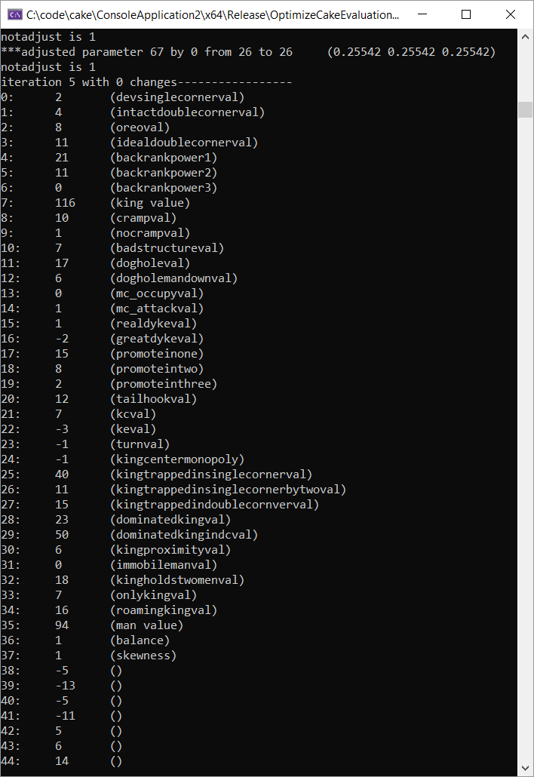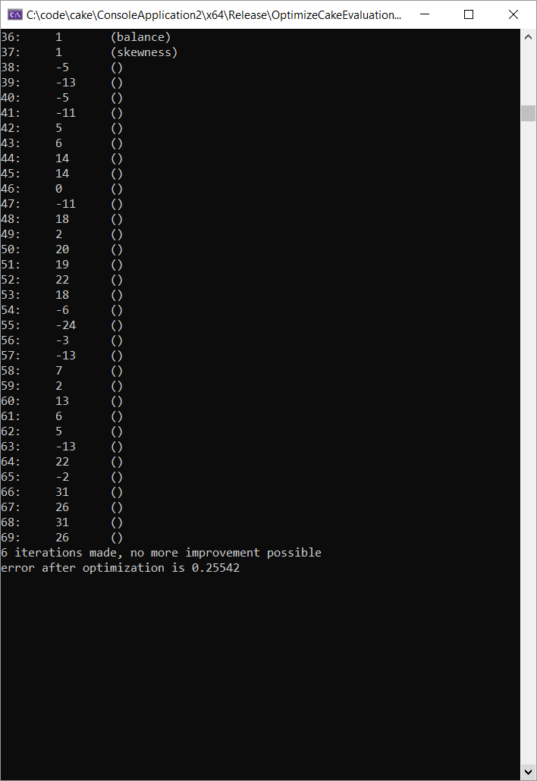

I add further parameters: back rank, for a 70p version (which plays worse) and then also ungroundedpenalty for a 83p version (which is still being tested).

5.5.2019
Increase number of parameters more, add br array (32 parameters) to optimizer

Cake 1.85g 1522k (70p) (x64) - Kingsrow(x64) 1.18f : W-L-D:246-1199-3355
+:246 =:3319 -:1199 unknown:36 +B:839 -B:606 (40.08% wins, 20.52% relative wins)
Cake 1.85g 1522k (70p) (x64) - Kingsrow(x64) 1.18 : W-L-D:856-646-2230
+:856 =:2215 -:646 unknown:15 +B:376 -B:1126 (52.81%, 132.5% relative)
--- looks like this was a bad idea

8.5.2019:
54-parameter version (cramps differentiated), with all parameters starting at 0 and needing to give at least 1e-6 change; to avoid crazy high values of parameters that hardly matter.
I also noticed that I forgot to adapt the tmod array in Cake that I had hand-coded-changed in the optimizer => I really need to make a version that will do everything automatically…
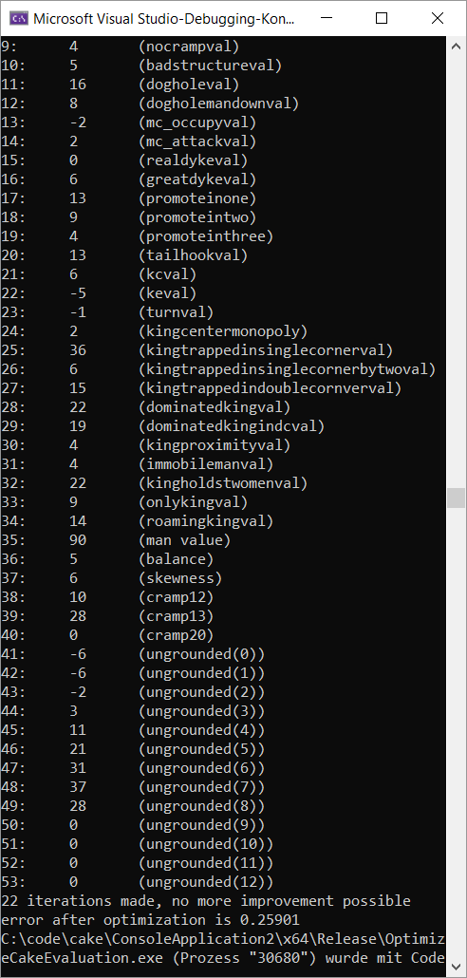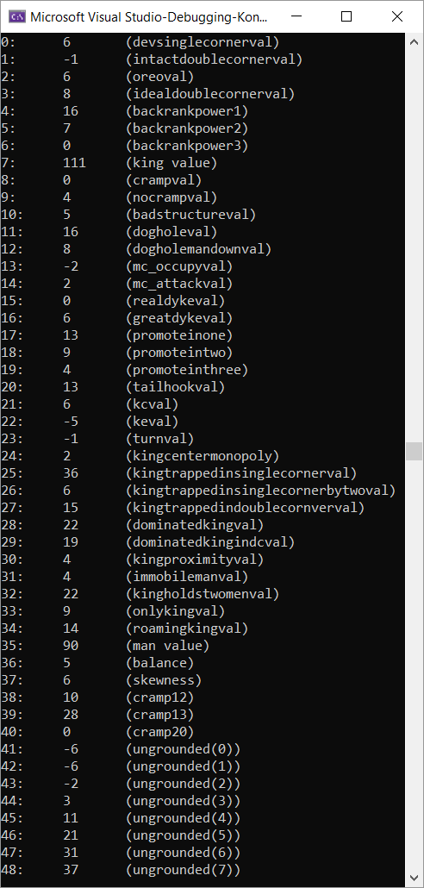

I assemble all new matches + a match on my old laptop for a whopping 3162k positions.
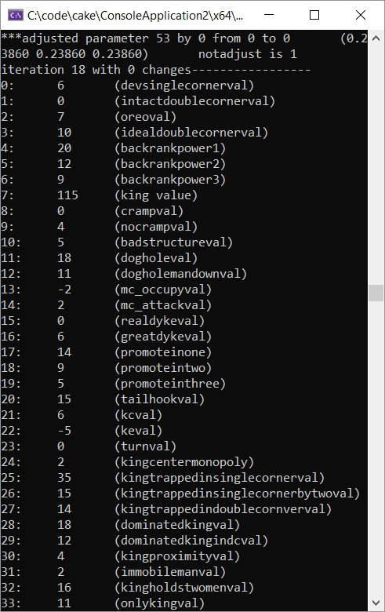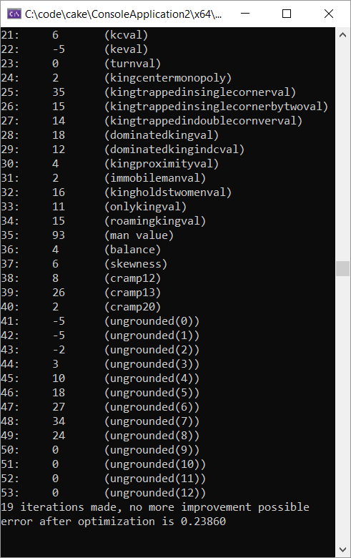

This version also plays better than ever before:
Cake 1.85g 3162k (54p) - Kingsrow(x64) 1.18 : W-L-D:966-599-2167 (54.92% total, 161.3% relative wins)
+:966 =:2159 -:599 unknown:8 +B:415 -B:1150

Cake 1.85g 3162k (54p) - Kingsrow(x64) 1.18f : W-L-D:250-1090-3460 (41.25% total, 22.94% relative wins)
+:250 =:3414 -:1090 unknown:46 +B:753 -B:587

I add further parameters and now have 67, again optimizing with 3.1M Pos:
It's worse in the match.

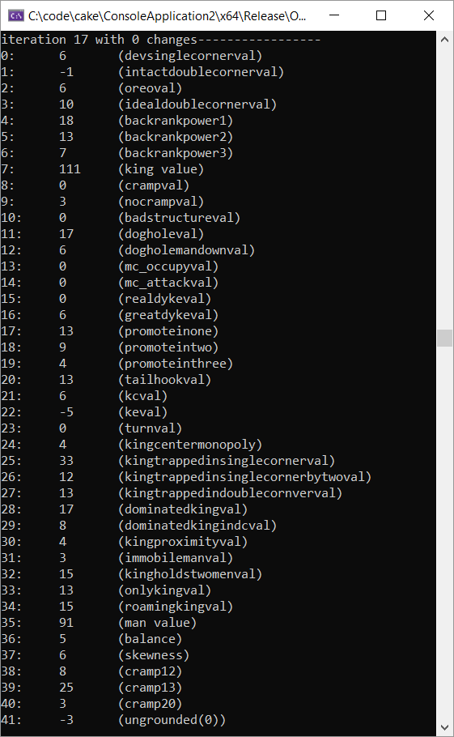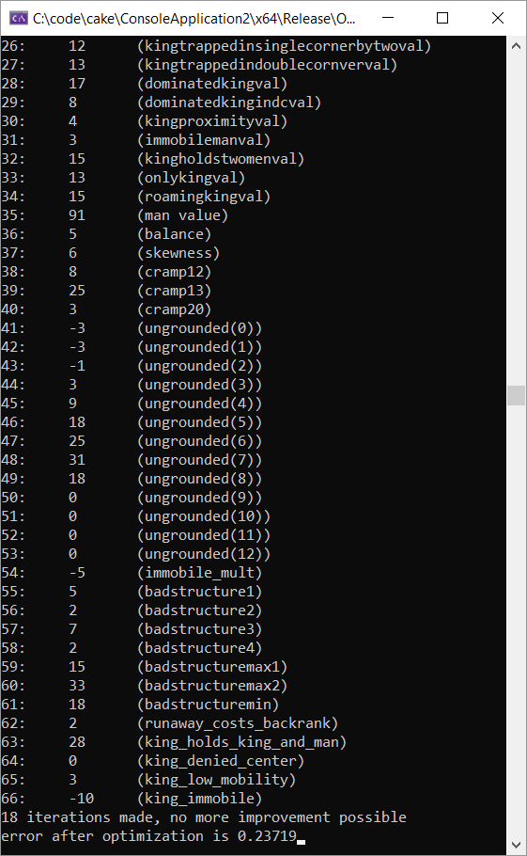
I revert these changes and try the tempo array again instead

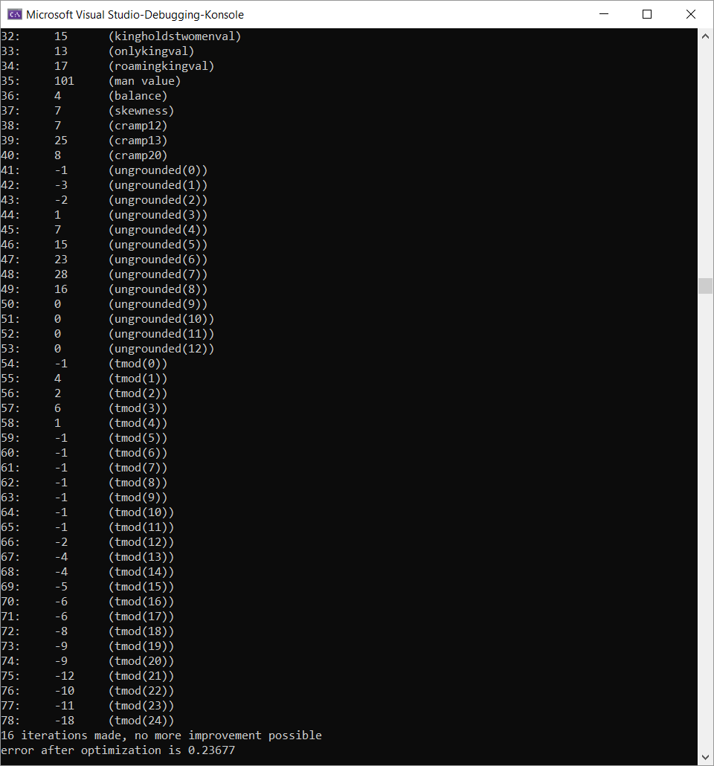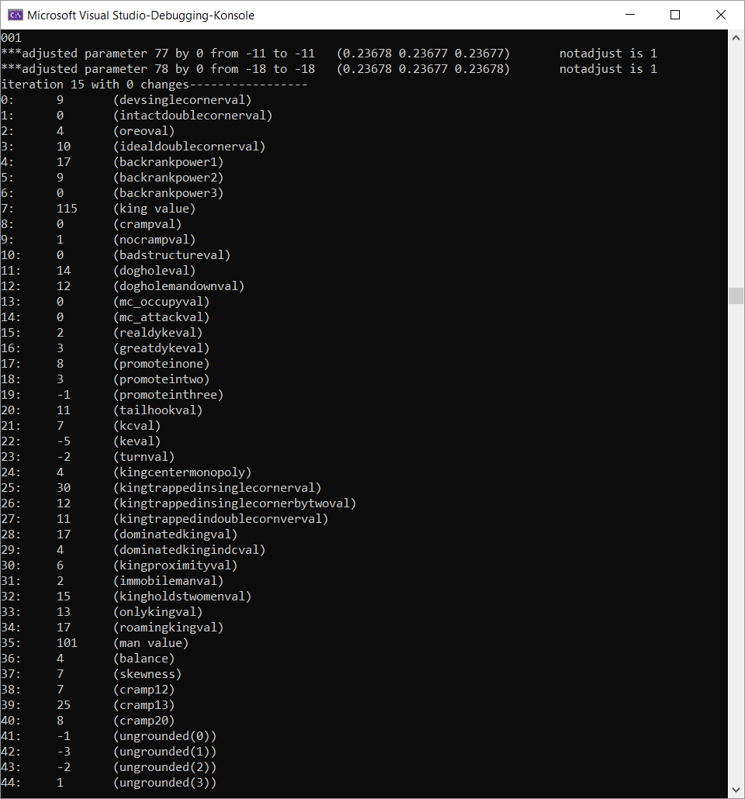

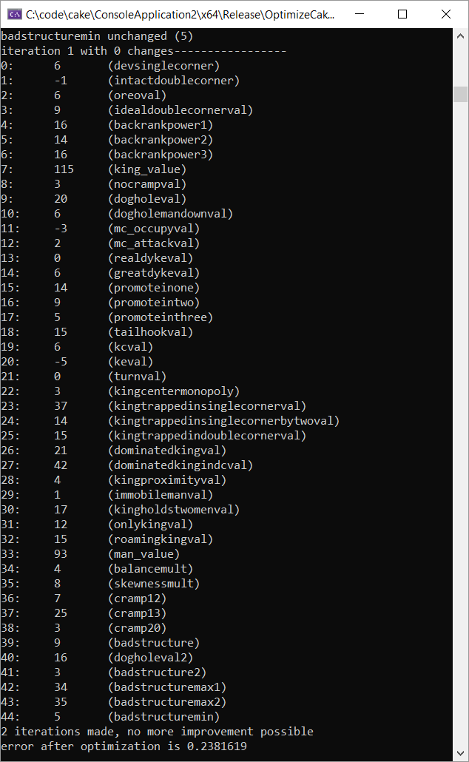
13.5.2019 new 45-param version with identical cake_eval_parametrized in cake and OptimizeCake so errors in translation should now be a thing of the past.

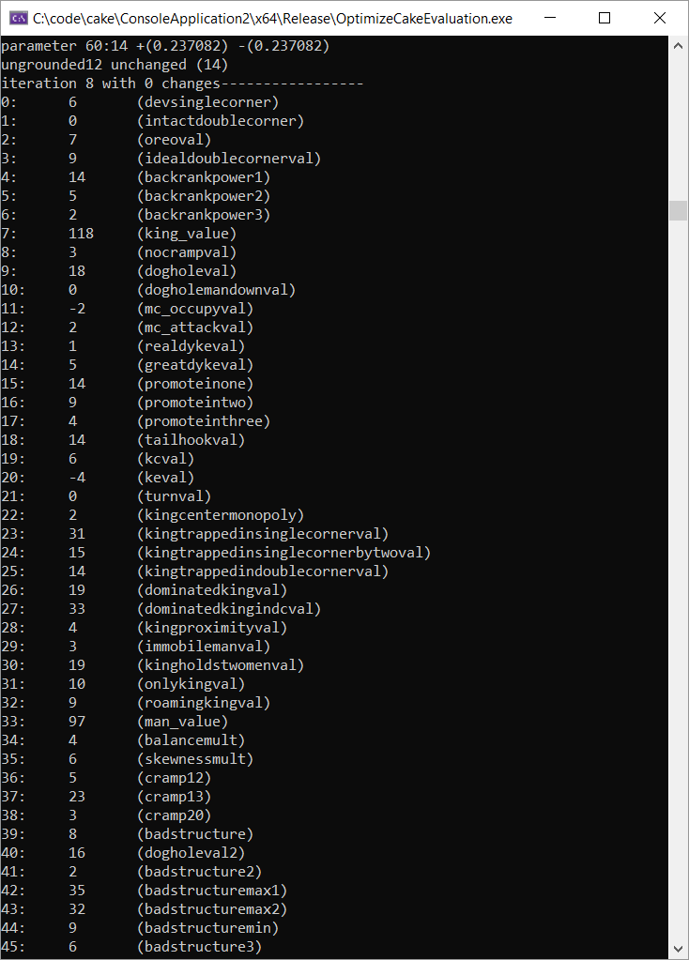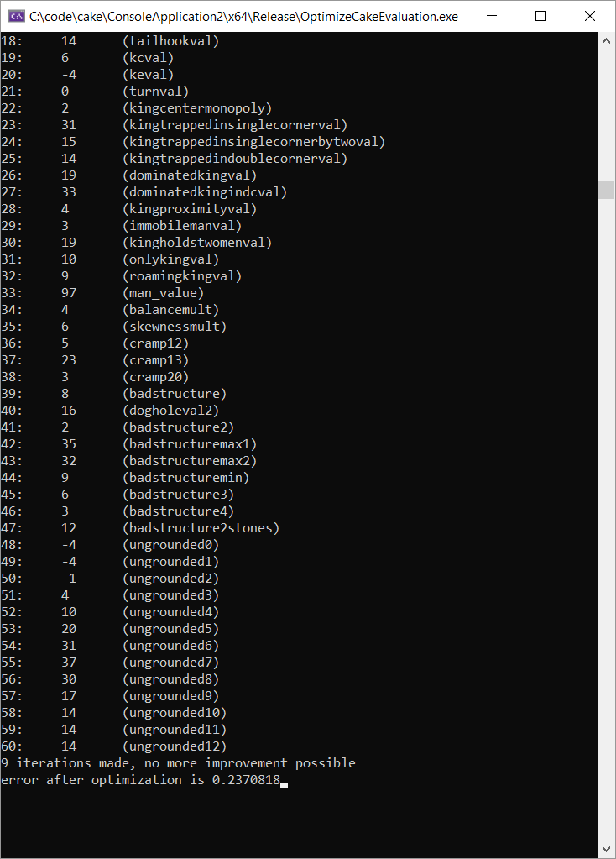

1 or two games before this
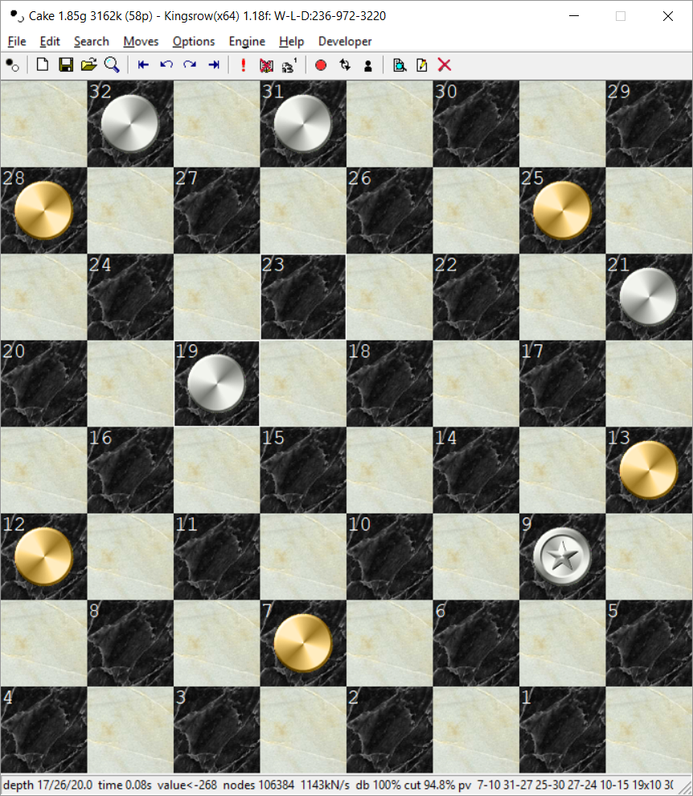
In match34 Cake didn't win as white with an extra man on 29 because it repeated moves!? Check this game and move rep code?
[Event "game 4426: "]
[Date ""]
[Black "Kingsrow(x64) 1.18f"]
[White "Cake 1.85g 3162k (58p)"]
[Result "1/2-1/2"]
[FEN "B:W17,22,24,25,26,27,28,29,30,31,32:B1,2,3,4,6,7,8,9,10,12,16"]
1. 1-5 17-13 2. 9-14 25-21 3. 7-11 13-9 4. 6x13 24-19 5. 16x23 27x9 6. 5x14 30-25 7. 13-17
22x13 8. 2-6 26-22 9. 14-18 22x15 10. 11x18 21-17 11. 3-7 25-21 12. 18-22 32-27 13. 8-11
27-23 14. 12-16 23-18 15. 10-15 17-14 16. 6-10 21-17 17. 16-20 13-9 18. 15-19 9-6 19.
19-23 6-2 20. 23-27 31x24 21. 20x27 2-6 22. 11-16 6x15 23. 7-11 15x8 24. 4x11 14-10 25.
27-31 10-7 26. 16-19 7-3 27. 31-27 3-7 28. 11-16 18-15 29. 19-23 7-10 30. 23-26 15-11 31.
27-23 11-8 32. 26-30 8-3 33. 23-18 3-7 34. 22-26 7-11 35. 16-20 10-15 36. 18-22 17-14 37.
26-31 14-10 38. 30-26 10-7 39. 31-27 7-2 40. 27-23 2-7 41. 22-17 11-8 42. 17-22 8-11 43.
22-17 7-2 44. 17-22 11-7 45. 26-30 2-6 46. 30-26 7-10 47. 26-30 10-14 48. 30-26 6-10 49.
26-30 10-7 50. 30-26 7-10 51. 26-30 10-7 52. 30-26 7-10 53. 26-30 10-7 54. 30-26 7-10 55.
26-30 10-7 56. 30-26 7-10 57. 26-30 10-7 58. 30-26 7-10 59. 26-30 10-7 60. 30-26 7-10 61.
26-30
{value=3, depth 29/14.6/25, 0.1s, 3848 kN/s, pv 26-30 : gameover claimed} *

