## The White Agency Java Coding Question - 2014

Please allow for 1-2 hour to complete this exercise.

Design and implement in Java.

Given data describing a maze with diagonal walls;

1. count the number of fully enclosed areas and
2. the size of the largest enclosed area.

The maze pictured below has 2 enclosed areas, the larger of which has an area of 8.

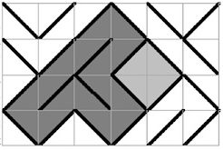

Data Type:

# Type 0 Type 1

#

# +----+ +----+

# | /| |\ |

# |0 / | | \ 0|

# | / 1| |1 \ |

# |/ | | \|

# +----+ +----+

Sample static data:

maze = [[1,0,0,1,1,0],  
 [1,0,0,0,1,1],  
 [0,0,1,1,0,1],  
 [1,0,1,0,0,0]]