Activity in the d3 github repository

Martin Gascon

11/20/2015

# Procedure

**a) Fork the mbostock/d3 repository into my github account (terminal)**

* git clone <https://github.com/martingascon/d3>

**b) retrieve the commit activity and drop it into a log file**

* git log --pretty=format:"%h,%an,%ad,%s" > log.txt

**c) Load log file, format the date column**

# read log.txt  
log = read.csv("./d3/log.txt", sep=",",head=F,)   
colnames(log) <-c("commit","author","date","subject")  
  
# remove those with empty spaces in subject  
log <-log[-which(log$subject == ""),]  
  
# Convert the date column into a date type  
log$date <- as.Date(log$date , "%a %b %d %H:%M:%S %Y %z")

# Responses

#### **1. What week in the last year had the greatest number of commits?**

1.1 There are three possible answers depending on the ISO coding

* %U - Week Nb, starting with the first Sunday as the first day of the first week (00..53)
* %V - Week number of year according to ISO-8601 (01..53)
* %W - Week number of the year, starting with the first Monday as the first day of the first week (00..53)

Week_nb1 <- format(log$date, format="%y/%U")  
sort(table(Week_nb1),decreasing=T)[1:3]

## Week_nb1  
## 15/05 15/42 15/06   
## 19 19 14

Week_nb2 <- format(log$date, format="%y/%V")  
sort(table(Week_nb2),decreasing=T)[1:3]

## Week_nb2  
## 15/06 15/43 14/49   
## 25 23 8

Week_nb3 <- format(log$date, format="%y/%W")  
sort(table(Week_nb3),decreasing=T)[1:3]

## Week_nb3  
## 15/05 15/42 14/48   
## 25 23 8

* *%U -> Weeks 5 and 42 in 2015 are ones with more commits (19)*
* *%V -> Week 6 in 2015 is one with more commits (25)*
* *%W -> Week 5 in 2015 is one with more commits (25)*

#### **2. Over the last year, what day of the week had the most commits?**

sort(table(log$date),decreasing=T)[1:3]

##   
## 2015-02-07 2015-10-21 2014-12-06   
## 16 8 7

* *Feb 7th, 2015 is the day with more commits (16)*

#### **3. Graph the number of commits per day of the week.**

library(lubridate)  
barplot(table(wday(log$date, label=TRUE)))

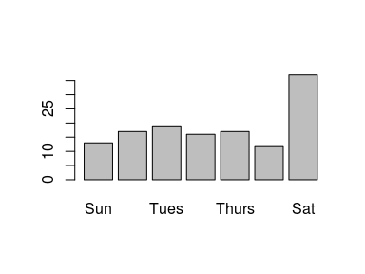

* *Saturday is the day with more commits (37)*

#### **4. Show us something else interesting about the d3 repository**

* *Let's plot the most used words in the subject of every commit*

# tm: text mining library for R  
library(tm)

## Loading required package: NLP

# paste every subject together  
subject_vector <- paste(log$subject, collapse=" ")  
  
# set up the source and create a corpus  
subject_source <- VectorSource(subject_vector)  
corpus <- Corpus(subject_source)  
  
# Now, we transform to lower, remove punctuation, whitespace, stopwords  
corpus <- tm_map(corpus, content_transformer(tolower))  
corpus <- tm_map(corpus, removePunctuation)  
corpus <- tm_map(corpus, stripWhitespace)  
corpus <- tm_map(corpus, removeWords, stopwords("english"))  
  
# create the document-term matrix.  
dtm <- DocumentTermMatrix(corpus)  
dtm2 <- as.matrix(dtm)  
  
#most frequently used words  
  
frequency <- colSums(dtm2)  
frequency <- sort(frequency, decreasing=TRUE)  
head(frequency)

## merge branch fix add pull request   
## 36 26 25 10 10 10

barplot(frequency[1:5], label=TRUE)

## Warning in plot.window(xlim, ylim, log = log, ...): "label" is not a  
## graphical parameter

## Warning in axis(if (horiz) 2 else 1, at = at.l, labels = names.arg, lty =  
## axis.lty, : "label" is not a graphical parameter

## Warning in title(main = main, sub = sub, xlab = xlab, ylab = ylab, ...):  
## "label" is not a graphical parameter

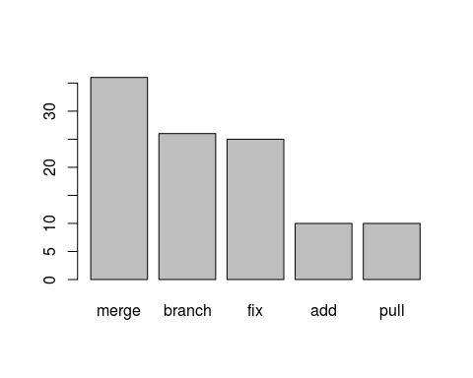

* *Merge, branch and fix are the three most popular words in the subject of every commit.*
* *Another way to plot the 15 most frequently used words.*

library(wordcloud)

## Loading required package: RColorBrewer

words <- names(frequency)  
wordcloud(words[1:15], frequency[1:15])

